**Problem statement :**

Given a set of interacting processes that exchange neighbor adjacency data. The process works like this:

1. Each process reads neighbor information and cost from a file
2. Each process builds a network graph from all nodes using this neighbor information
3. Find the shortest path from any to any node given.
4. Find the minimum spanning tree.

Also, reconfigure the network connectivity graph on a node when a node (process) dies or an edge is lost

**Approach and steps:**

1. Each node reads the neighbour information and cost from a file
2. Build a graph network from all nodes using neighbour information
3. Find the shortest path from any to any node with help of neighbour information table

From step2

1. Optimise the network by finding minimum spanning tree

If any link found down, update the route information table by a distance of infinite and network will be converged for every 30 seconds

**Algorithms :**

**Shortest path :**

1) Create a set sptSet (shortest path tree set) that keeps track of vertices included in shortest path tree, i.e., whose minimum distance from source is calculated and finalized. Initially, this set is empty.

2) Assign a distance value to all vertices in the input graph. Initialize all distance values as INFINITE. Assign distance value as 0 for the source vertex so that it is picked first.

3) While sptSet doesn’t include all vertices

a) Pick a vertex u which is not there in sptSet and has minimum distance value.

b) Include u to sptSet.

c) Update distance value of all adjacent vertices of u. To update the distance values, iterate through all adjacent vertices. For every adjacent vertex v, if sum of distance value of u (from source) and weight of edge u-v, is less than the distance value of v, then update the distance value of v.

Example :

[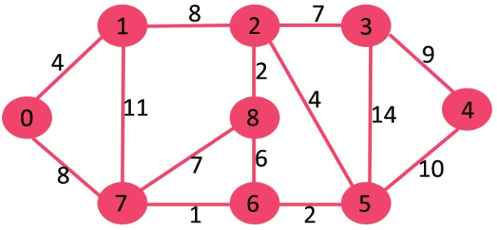](http://www.geeksforgeeks.org/wp-content/uploads/Fig-11.jpg)

The set sptSetis initially empty and distances assigned to vertices are {0, INF, INF, INF, INF, INF, INF, INF} where INF indicates infinite. Now pick the vertex with minimum distance value. The vertex 0 is picked, include it in sptSet. So sptSet becomes {0}. After including 0 to sptSet, update distance values of its adjacent vertices. Adjacent vertices of 0 are 1 and 7. The distance values of 1 and 7 are updated as 4 and 8. Following subgraph shows vertices and their distance values, only the vertices with finite distance values are shown. The vertices included in SPT are shown in green color.

[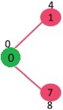](http://www.geeksforgeeks.org/wp-content/uploads/MST1.jpg)

Pick the vertex with minimum distance value and not already included in SPT (not in sptSET). The vertex 1 is picked and added to sptSet. So sptSet now becomes {0, 1}. Update the distance values of adjacent vertices of 1. The distance value of vertex 2 becomes 12.

[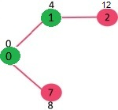](http://www.geeksforgeeks.org/wp-content/uploads/DIJ2.jpg)

Pick the vertex with minimum distance value and not already included in SPT (not in sptSET). Vertex 7 is picked. So sptSet now becomes {0, 1, 7}. Update the distance values of adjacent vertices of 7. The distance value of vertex 6 and 8 becomes finite (15 adn 9 respectively).

[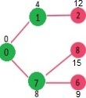](http://www.geeksforgeeks.org/wp-content/uploads/DIJ3.jpg)

Pick the vertex with minimum distance value and not already included in SPT (not in sptSET). Vertex 6 is picked. So sptSet now becomes {0, 1, 7, 6}. Update the distance values of adjacent vertices of 6. The distance value of vertex 5 and 8 are updated.

[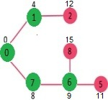](http://www.geeksforgeeks.org/wp-content/uploads/DIJ4.jpg)

We repeat the above steps until sptSet doesn’t include all vertices of given graph. Finally, we get the following Shortest Path Tree (SPT).

[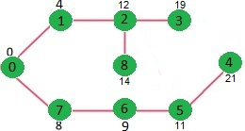](http://www.geeksforgeeks.org/wp-content/uploads/DIJ5.jpg)

**Minimum spanning tree:**

Starts with an empty spanning tree. The idea is to maintain two sets of vertices. The first set contains the vertices already included in the MST, the other set contains the vertices not yet included. At every step, it considers all the edges that connect the two sets, and picks the minimum weight edge from these edges. After picking the edge, it moves the other endpoint of the edge to the set containing MST.  
A group of edges that connects two set of vertices in a graph. So, at every step we find a cut (of two sets, one contains the vertices already included in MST and other contains rest of the verices), pick the minimum weight edge from the cut and include this vertex to MST Set (the set that contains already included vertices).The idea behind Prim’s algorithm is simple, a spanning tree means all vertices must be connected. So the two disjoint subsets (discussed above) of vertices must be connected to make a Spanning Tree. And they must be connected with the minimum weight edge to make it a Minimum Spanning Tree.

**1)** Create a set mstSet that keeps track of vertices already included in MST.  
**2)** Assign a key value to all vertices in the input graph. Initialize all key values as INFINITE. Assign key value as 0 for the first vertex so that it is picked first.  
**3)** While mstSet doesn’t include all vertices  
 **a)** Pick a vertex u which is not there in mstSet and has minimum key value.  
 **b)** Include u to mstSet.  
 **c)** Update key value of all adjacent vertices of u. To update the key values, iterate through all adjacent vertices. For every adjacent vertex v, if weight of edge u-v is less than the previous key value of v, update the key value as weight of u-v

The idea of using key values is to pick the minimum weight edge from cut. The key values are used only for vertices which are not yet included in MST, the key value for these vertices indicate the minimum weight edges connecting them to the set of vertices included in MST.

Example:

[](http://www.geeksforgeeks.org/wp-content/uploads/Fig-11.jpg)

The set mstSet is initially empty and keys assigned to vertices are {0, INF, INF, INF, INF, INF, INF, INF} where INF indicates infinite. Now pick the vertex with minimum key value. The vertex 0 is picked, include it in mstSet. So mstSet becomes {0}. After including to mstSet, update key values of adjacent vertices. Adjacent vertices of 0 are 1 and 7. The key values of 1 and 7 are updated as 4 and 8. Following subgraph shows vertices and their key values, only the vertices with finite key values are shown. The vertices included in MST are shown in green color.

[](http://www.geeksforgeeks.org/wp-content/uploads/MST1.jpg)

Pick the vertex with minimum key value and not already included in MST (not in mstSET). The vertex 1 is picked and added to mstSet. So mstSet now becomes {0, 1}. Update the key values of adjacent vertices of 1. The key value of vertex 2 becomes 8.

[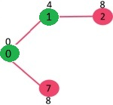](http://www.geeksforgeeks.org/wp-content/uploads/MST2.jpg)

Pick the vertex with minimum key value and not already included in MST (not in mstSET). We can either pick vertex 7 or vertex 2, let vertex 7 is picked. So mstSet now becomes {0, 1, 7}. Update the key values of adjacent vertices of 7. The key value of vertex 6 and 8 becomes finite (7 and 1 respectively).

[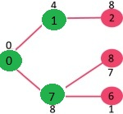](http://www.geeksforgeeks.org/wp-content/uploads/MST3.jpg)

Pick the vertex with minimum key value and not already included in MST (not in mstSET). Vertex 6 is picked. So mstSet now becomes {0, 1, 7, 6}. Update the key values of adjacent vertices of 6. The key value of vertex 5 and 8 are updated.

[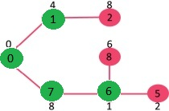](http://www.geeksforgeeks.org/wp-content/uploads/MST4.jpg)

We repeat the above steps until mstSet includes all vertices of given graph. Finally, we get the following graph.

[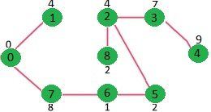](http://www.geeksforgeeks.org/wp-content/uploads/MST5.jpg)

**Sudo code :**

/* Updating */

Unit test :

/* Updating */