Understanding Document of Yope App
Table of Contents

Introduction……………………………………………………………………………………………………………………………………………1
Main Features…………………………………………………………………………………………………………………………………………2
Description and flow ………………………………………………………………………………………………………………………………3

- Introduction: The purpose of this document is to understand flow and working of “Yope App” application on IOS and to discuss various scenarios related to this.

- Main Features: Yope App which identify

- Allow user to create profile on the application.
- Allow user to capture and share image.
- Allow users to post text comment on image.
- Allow user to delete a shared image.
- Allow user to interact and can have chat with another users.
- Allow user to share image in the chat screen.
- No login feature is there in the application.
What will be the app icon for the application?
In Yope icon folder in google drive.

- Description and flow of Application:

User Verification Process

Screen 3.1(Map_Photo_Top)

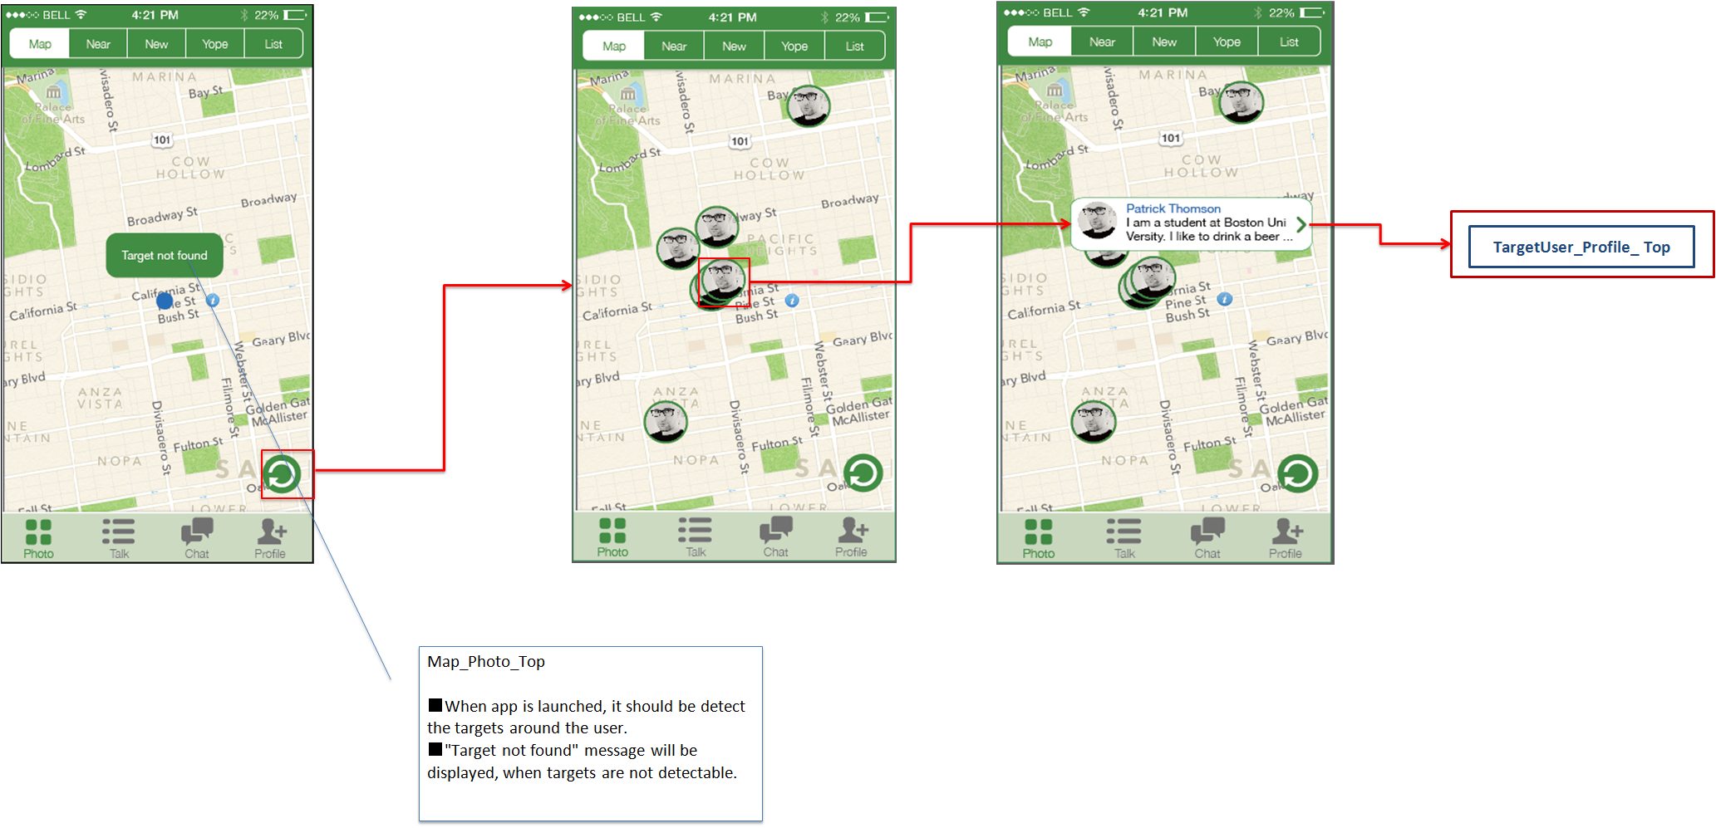

- Screen 3.1 is the Map_Photo_Top screen of the application. This will be the default Home screen.
- User can see all the other app users(target) on this screen. These users will be displayed according to their geographical location.
- In case no user found in proximity “Target not found” message will appear.
- no user found in proximity = no user present on the visible map
- Default zoom level should show entire city.
- Refresh button will be there on lower-right corner of the map.
- All the users shown on the map are clickable. If user clicks on any of these users, he/she can see username, punch line of selected user.
- When user further click on > , he/she will be redirected to the next screen Near-People2.
- When user clicks anywhere on the white box they will be redirected not only on >
- This screen contains 5 tabs at above i.e. Map, Near, New, Yope, List. And Map tab highlighted.
- This screen contains 4 tabs at below i.e. Photos, Talk,chat, Profile. And Photos tab highlighted.

Screen 3.2 (Near_Photo_ Top)

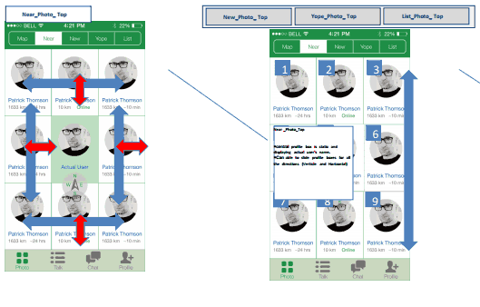

- Screen 3.2 is the Near_Photo_ Top screen of the application.
- User can see other app users’ profile Boxes with their profile picture (round shaped), username, distance in KM, current login status.
- Should show in meters when other user is within 1 km (e.g. 30m)
- 9 Profile boxes (8 Others + 1 self, static) will appear on the screen at a time. App user can slide the profile boxes to see remaining user.
- These users will be shown as per the geographical location on the screen
- Will reload when near button is pressed
- Profile picture and username is clickable. If user clicks on either of these, he/she will be redirected to the next screen Near-People2.
- If someone is located on the left side of the user, he will be displayed on the left side of the screen. Same concept will be followed on the other side.
- This screen contains 5 tabs at above i.e. Map, Near, New, Yope, List. And Near tab highlighted.
- This screen contains 4 tabs at below i.e. Photos, Say, Talk, Profile. And Photos tab highlighted.
- 4 tabs = Photo, Talk, Chat, Profile

Screen 3.3 (TargetUser_Profile_Top)

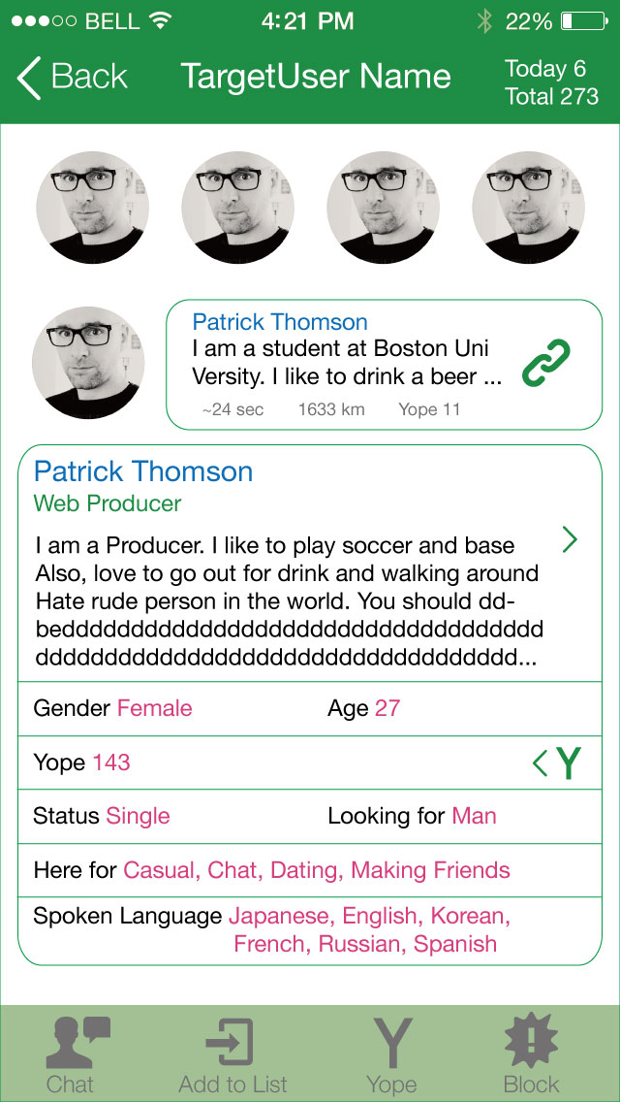

- Screen 3.3 is the TargetUser_Profile_Top screen of the application.
- When the user clicks on other user’s profile picture or his/her username, then user will be redirected to the profile of that particular user.
- On this screen user can see a Back button on the left upper corner. On clicking Back button user will get navigated to the previous screen.
- At the middle top, username of that particular user.
- At the right top ‘Today’ shows that how many users have visited this profile on that day. And ‘Total’ shows how many users have visited this profile till date.
- User is able to upload 4 pictures. They will be displayed as shown in screen shot.
- When user touches a picture, they can see the picture full screen as in the wireframe.
- Last post will appear under profile images.
- If user selects the last post they can see comment on the post (please refer to wireframe)
- All the details of the user will be there on the profile. Like his name, designation, about, gender, age, yope, relationship status, current login status etc.
- The “ Y “ appearing on right side will clickable, when current user click on Y, he will be redirected to Yoped user list screen here he can see the list of peoples he yoped.
- There will be 4 tabs at the bottom of the screen i.e. Chat, Add to list, Yope, Blocked.
- The tabs change when selected for example when Add to list is selected is becomes “remove from list” as indicated in the wireframes.
- On clicking ‘Chat’ tab, user will be redirected to the Chat screen where current user can start new chat with selected user.
- On clicking ‘Add to List’ tab, this user will get added in the user’s list.
- On clicking ‘Yope’ tab, this user will be added in the list of users .
- Onclicking ‘Block’ tab , this user will be added in to his blocked user list.

Screen 3.4 (Near_Talk_Top)
4
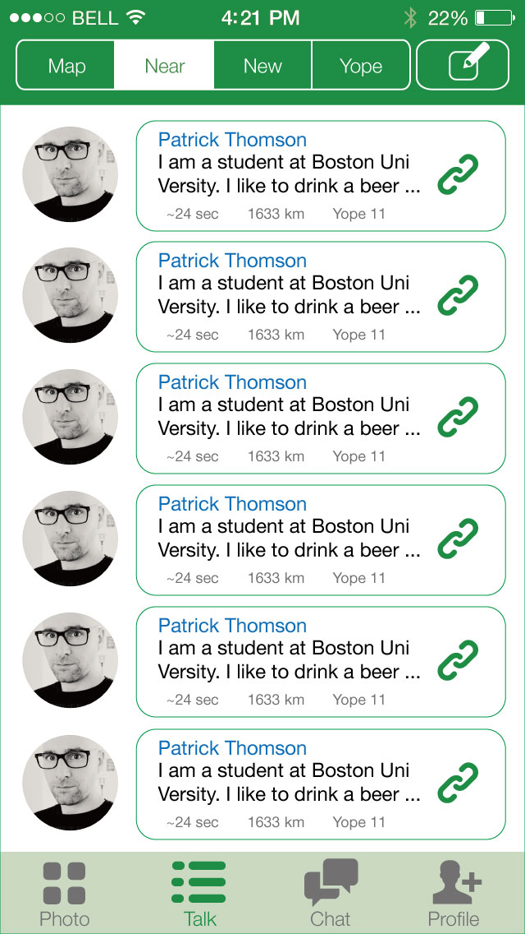

- Screen 3.4 is the Near_Talk_top screen of the application.
- This screen contains list of posts that other users have posted. This posts will appear with profile picture, username, caption, the time when this post had posted, KM shows the distance the poster was from the user when they posted the image, number of yopes that user has, sign of attached image.
- These profile pictures and rectangular box is further clickable and it will redirect user to the Near Say2 screen.
- This screen contains 5 tabs at above i.e. Map, Near, New, Yope, List. And Near tab highlighted.
- This screen contains 4 tabs at below i.e. Photo, Talk, Chat, Profile. And talk tab highlighted.

Screen No 3.5 (TargetUser_Talk_Top)

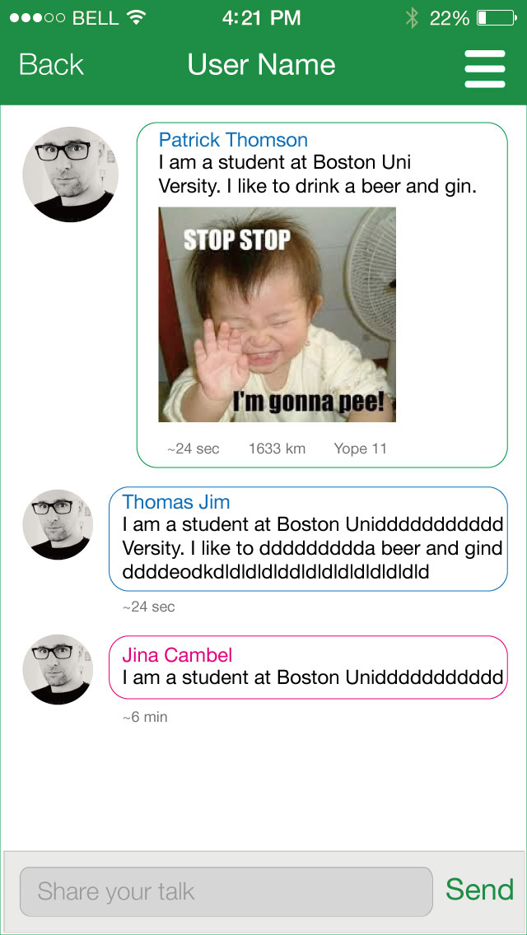

- Screen 3.5 is the TargetUser_Talk_Top screen of the application.
- Screen contains posted image with profile picture, caption, the time when this post had posted, KM shows the distance the poster was from the user when they posted the image, number of yopes that post owner(poster) has.
- Current user can comment on the posts. This can be done by typing comment in the edit text given in the bottom of the screen and then clicking on the Send button.
- There is a 250 character limit
- Comments will appear with profile picture of commenter, his/her username, and time when the comment is posted.
- On the upper left corner, there is a Back button. On clicking back button user will get redirected to the previous screen.
- Screen has the slider on the right top, which will navigate user to the Near Say3 screen when user slides from right to left.

Screen No:3.6 (TargetUser_Talk_History)

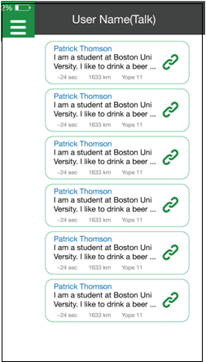

- Screen 3.6 is the TargetUser_Talk_History screen of the application.
- This screen contains list of past posts by the author of present post.
- These posts are further clickable and will show details when we click on any post.
- User will get back to the previous screen when slides from left to right.

Screen 3.7 (Chat_ Top)

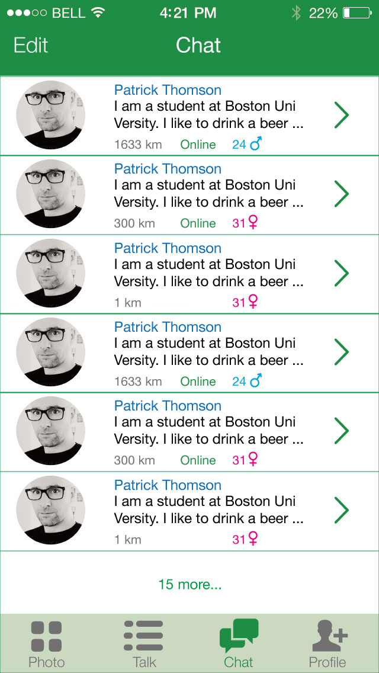

- Screen 3.7 is the Chat_ Top screen of the application.
- Screen has Edit button on the top left corner and a header at top middle. When user click on it, a Delete button appears with every chat. By clicking on which user can delete that particular chat with that user.
- As IOS7 native imessage app
- Screen has the list users with their profile picture, username, last sent message, current login status, KM shows the distance of the messager was from the user when they sent last message.
- When we click on profile picture or username, user will get navigated to the Chat_ Top screen.
- User can swipe down to reveal search box like Apple’s native images ios.

Screen 3.8 (Chat_box)

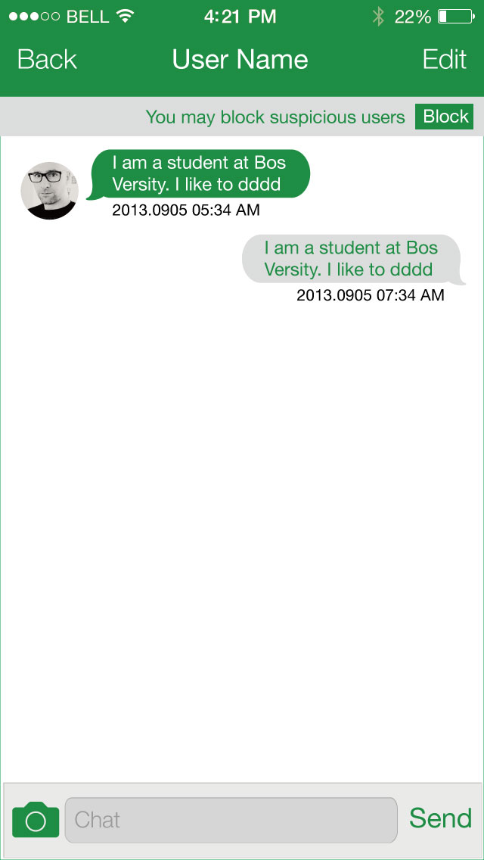

- Screen 3.8 is the chat_box screen of the application.
- Screen has a Talk button on the top left, by clicking on which user will navigated to the Talk1 screen.
- At the top middle there will be username of the user, with whom user is chatting.
- On the top right there will be an Edit button.
- There will be a Block button below Edit button. When we click on Block button it will show user two options i.e. either you want to block and report or block only. User will have to choose any 1 of them.
- This has been changed, there is no option to block and report. Block button will block immediately please refer to wireframe 1.6
- In the chat box user can either send a text message by typing in the edit text field given below and then clicking on the send button or an image message by clicking on the camera icon given on the left lower corner.
- Every message has time attached with it in bottom, which shows when that message had posted.
What kind of change can a user make by clicking on Edit button.
Please refer to updated wireframe 1.6.

Screen 3.10 (Profile Screen)

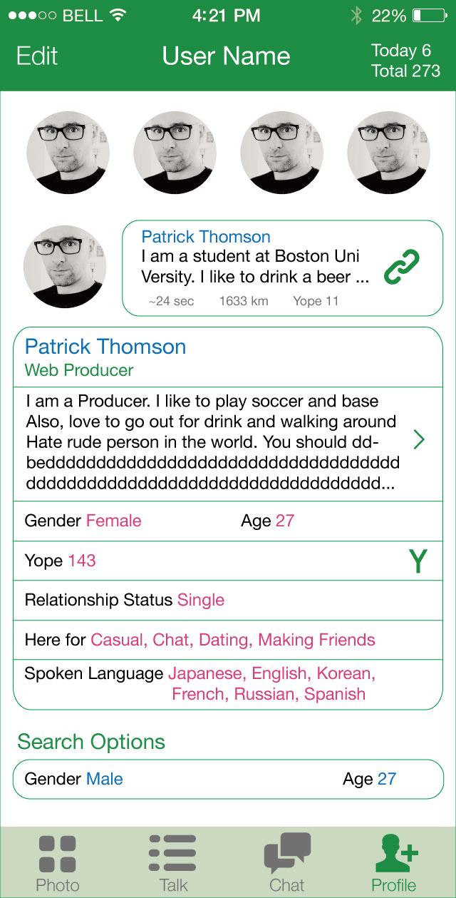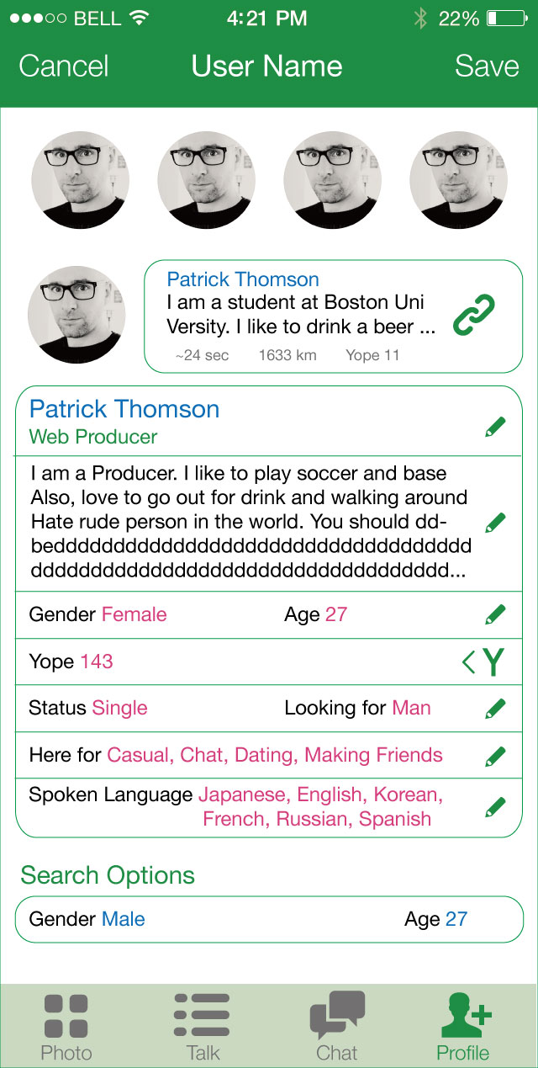

- Screen 3.10 is the Profile screen of the application.
- On this screen user can see a Edit button on the left upper corner. On clicking Edit button user can edit information of their own displayed on the screen.
- At the middle top, username of that user which is editable.
- At the right top ‘Today’ shows that how many users have visited this profile on that day. And ‘Total’ shows how many users have visited this profile till date. This option is not editable.
- User is able to upload 4 pictures. They will be displayed as shown in screen shot.
- Among 4 pictures 1 picture will be featured which will appear on map screen and treated as profile picture for other users.
- User can remove existing picture and upload another one at any time.
- Last post will appear under profile images.
- All the details of the user will be there on the profile. Like his name, designation, about, gender, age, yope, relationship status, current login status. All editable. All will be shown publicaly on user’s profile.
- The “ Y “ appearing on right side will clickable, when current user click on Y, he will be redirected to Yoped user list screen here he can see the list of peoples he yoped.
- Search option is the criteria for the other users for whom we are searching. They must fulfill this criteria. This criteria is editable at any time. This criteria isn’t visible for other users.
- Default is blank, there is no search criteria by default
- Privacy setting has 4 options i.e. Passcode, Block user, My ‘Say’ appearance, Message.
- There is no privacy setting
- Block user has same functionality as discussed above.
- When we click on Message, it gives us 4 options –
- From everyone.
- From user you have yoped.
- From users in list.
- From no one.
- This has been removed
- There will be 4 tabs at the bottom of the screen i.e. Photos, Say, Talk, Profile. With Profile tab highlighted.
- Profile screen can be created by user when app starts or anytime afterwards.

OVERALL FLOW OF THE APPLICATION IS SHOWN IN BELOW IMAGE.
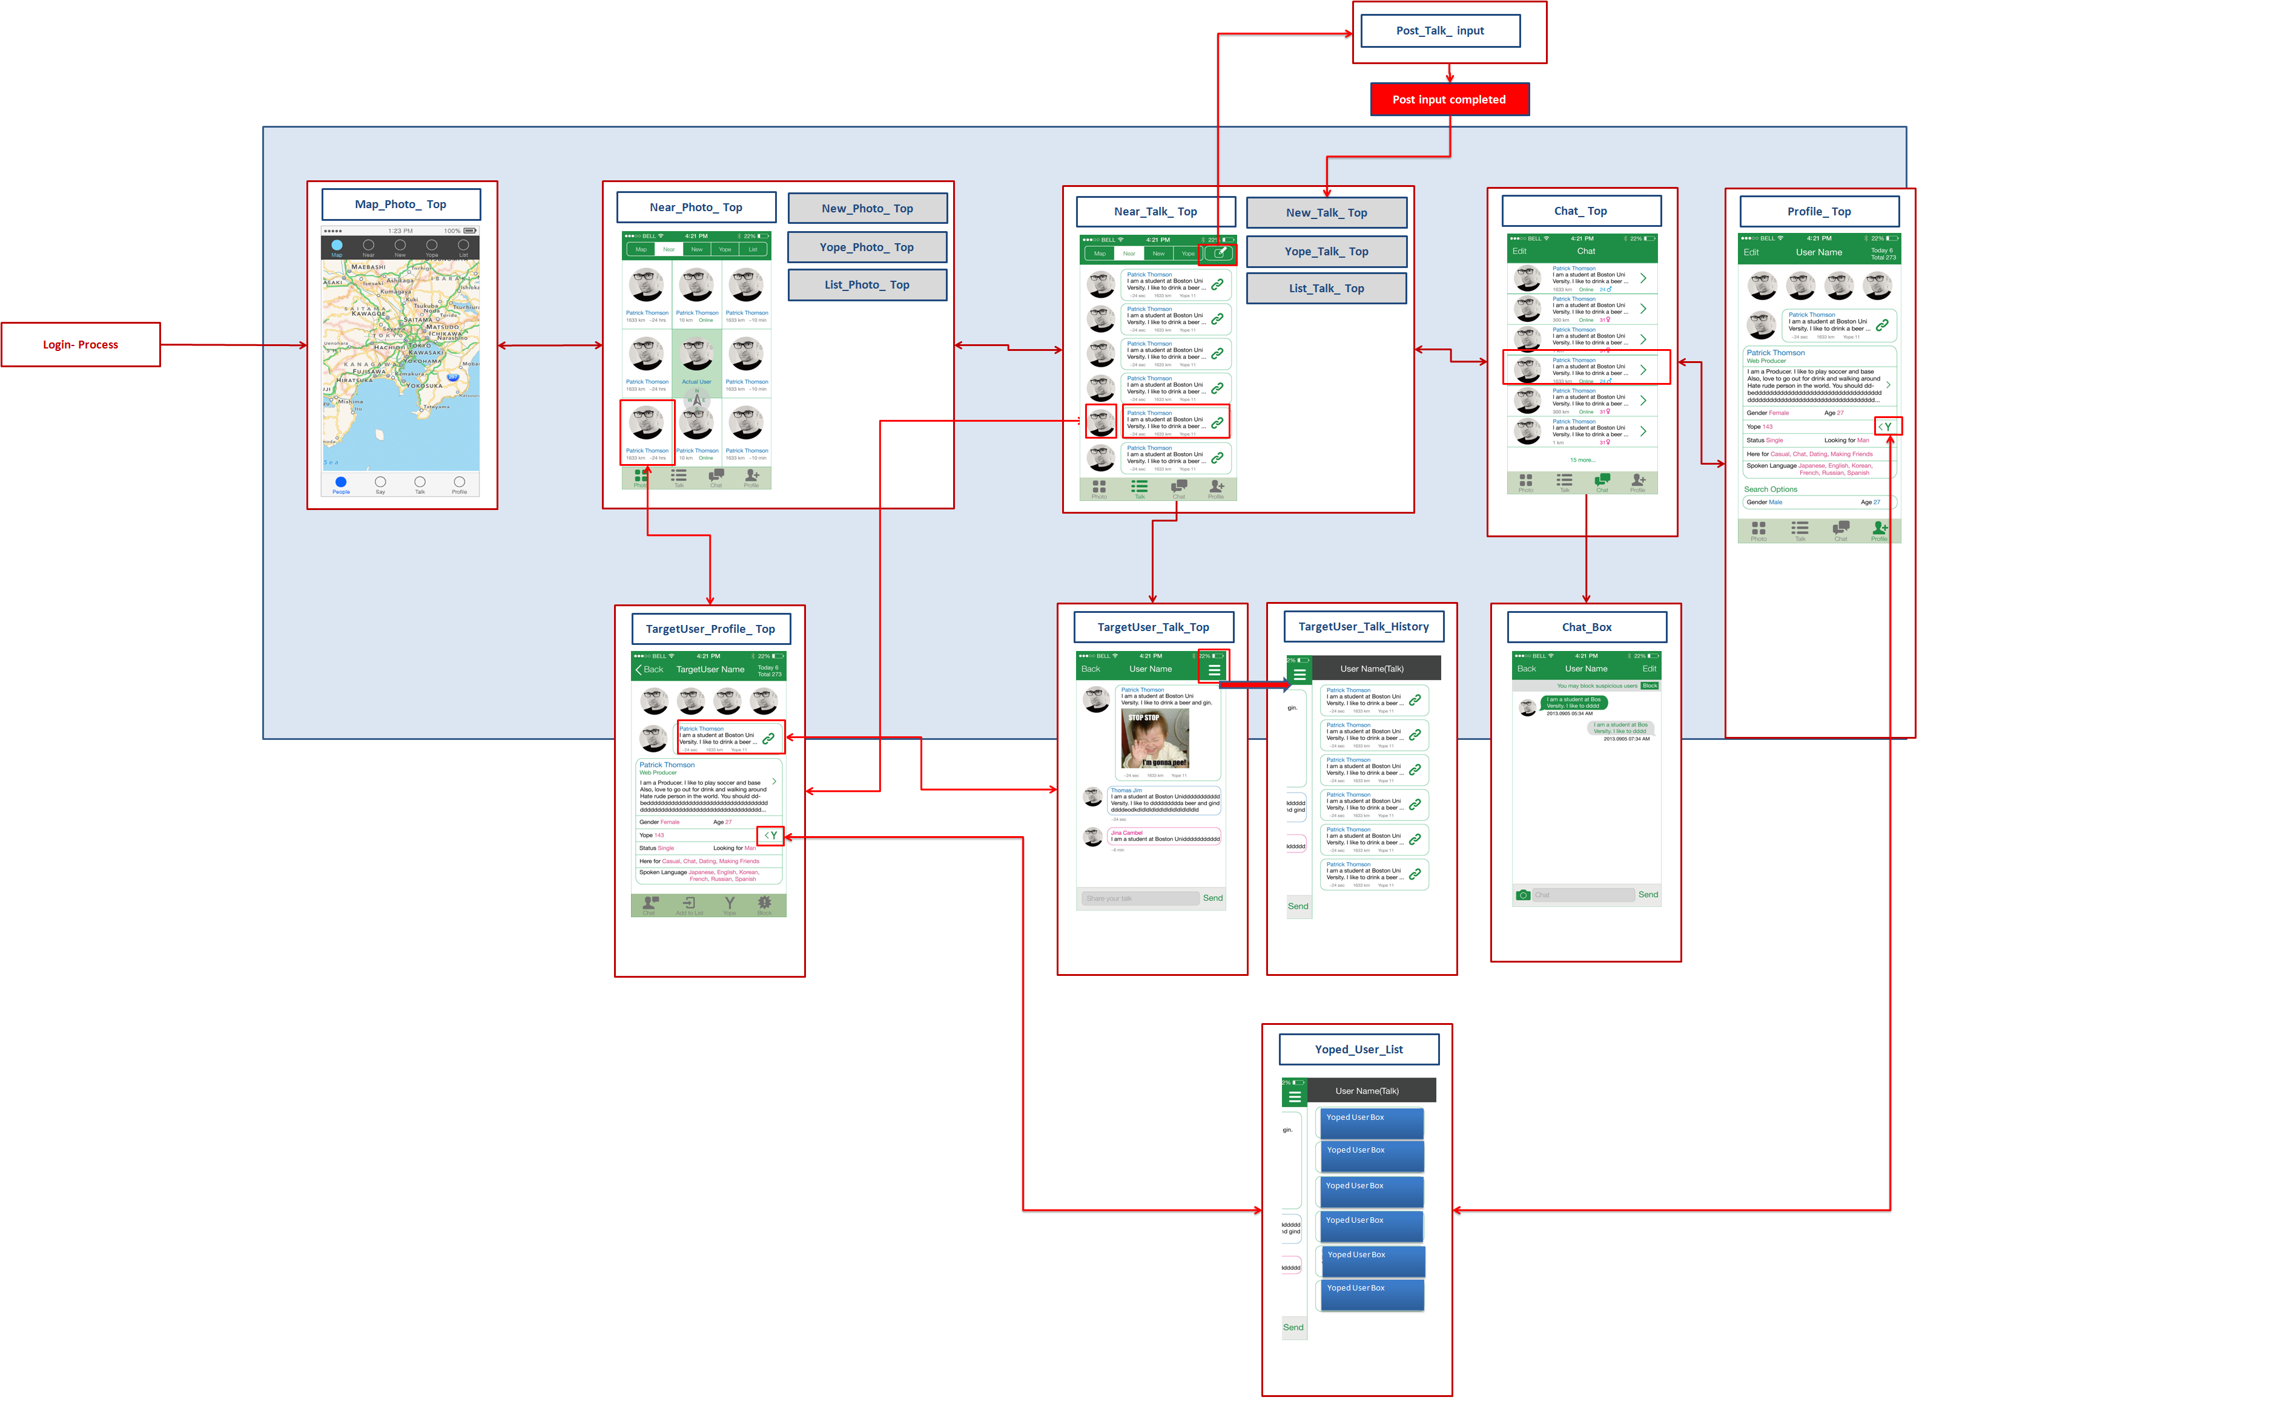
Additions

- App will support the following languages:
  - English
  - French
  - German
  - Japanese
  - Spanish
  - Italian
  - Chinese (Traditional)
  - Korean
    - We will provide translation.

- There will be limits on
  - Number of charaters
    - Profile description
      - maximum 400 characters
    - Chat
      - Maximum 250 characters
    - Talk
      - Maximum 250 Characters
    - Reply
      - Maximum 250 Characters
  - Number of talk posts
    - 10 posts per 24 hours
  - Number of chat messages
    - 10 messages per 24 hours per recipient
    - 5 recipients per 24 hours
  - Number of talk replies
    - 5 replies per talk poster per 24 hours
    - 5 recipients per 24 hours

ADMIN PANEL

  - User management
    - Add manually or by csv
    - Edit
    - Delete
    - Download CSV

  - Tracking

    - Track actions of each user
    - Can view individual log for each action user takes per user inside interface

    - Example per user
    - USER NAME
    - 22.00 UST, open app, New York, 40.711581,-74.004643
    - 22.02 UST, select near screen, New York, 40.711581,-74.004643
    - 22.02 UST, scroll down near screen, New York, 40.711581,-74.004643
    - 22.03 UST, scroll left near screen, New York, 40.711963,-74.005743
    - 22.04 UST, select user Patrick Thomson, New York, 40.711963,-74.005743
    - 22.04 UST select picture 2, New York, 40.711963,-74.005743
    - 22.07 UST view picture 4, New York, 40.711963,-74.005743
    - 22.07 UST close picture 4, New York, 40.711963,-74.005743
    - 22.08 UST chat tab, New York, 40.711963,-74.005743
    - 22.08 UST send message “hello”, New York, 40.711963,-74.005743
    - etc.
      - Can download complete event log to CSV

        - TIME, USERID, ACTION, CONTENT, LOCATION
        - e.g. This user open this user
        - 22.08 UST, 04124, OPEN PROFILE, 04321, New York, IP address

  - Statistics
    - Can view count graph inside admin interface and download csv

    - y
    - New users
    - X
    - Date

    - y
    - Talk posts
    - X
    - Date

    - y
    - Chat messages
    - X
    - Date

    - y
    - Profiles viewed
    - X
    - Date

  - Push notifications
    - Can send push notifications to users manually.
      - Click on user, type notification, send.

    - Can set variables to automatically send push notifications to users e.g.
      - IF user within 100 km of Tokyo, viewed profiles <5, sent chat messages >2, Yoped users >3, time since last action >2 days
Then send notification “example”.

    - Possible variables include all logged actions and all profile properties:
      - Accessed screens (all individual tabs)
      - Number of profiles visited
      - Number of users yoped
      - Number of users been yoped by
      - Gender
      - Number of messages sent
      - Everything. EVERYTHING.

    - Can send push notifications by csv e.g.
USERID, NOTIFICATION CONTENTS

  - Other
    - Can see list of blocked users

