**Global Food Production Trends and Analysis:**

**A Comprehensive Study from 1961 to 2023 Using Power BI**

**Dashboard:**

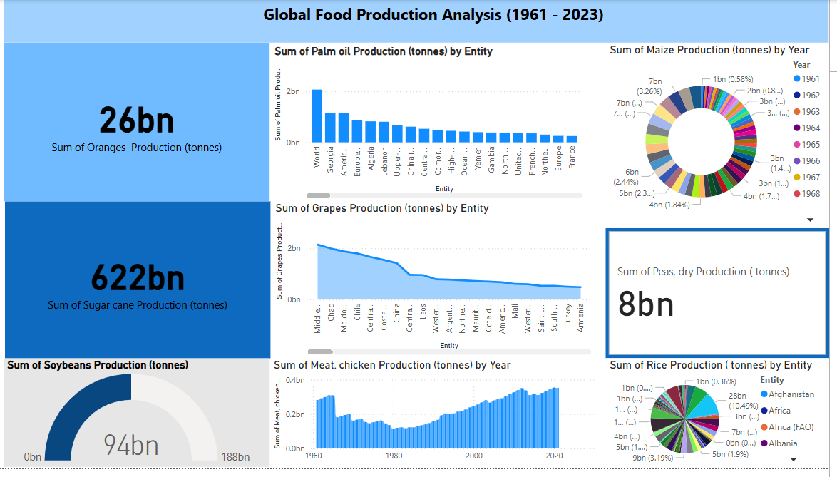

**Report**

