

 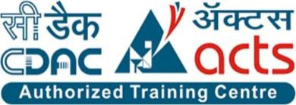

### INSTITUTE FOR ADVANCED COMPUTING AND SOFTWARE DEVELOPMENT AKURDI, PUNE

###### Documentation On

### “Sahayak”

### (For The People By The People)

###### PG-DAC SEP 2023

Submitted By:

**Group No: 02**

Abhijeet Singh (239002)

Lokesh Bothra(239167)

##### Mrs. Manjiri Deshpande Mr. Rohit Puranik

##### Project Guide Centre Coordinator



Table of Contents

1. **Introduction** 1

Document Purpose Problem Statement Product Scope Aim & Objectives

1. **Overall Description** 3
2. **Software Requirements Specification** 4

External Interface Requirements Non-Functional Requirements

1. **System Diagram** 12

ER Diagram

Activity Diagram Data Flow Diagram Class Diagram

Use Case Diagram

1. **Table Structure** 18

Admin

User

Donor

Beneficiary Hospital

Camp

Organ

City,State,District

Stock

1. **Screenshots** 21
2. **Conclusion** 26
3. **Future Scope** 27
4. **References** 28



# ACKNOWLEDGEMENT

I take this occasion to thank God, almighty for blessing us with his grace and taking our endeavour to a successful culmination. I extend my sincere and heartfelt thanks to our esteemed guide, Mrs. Manjiri Deshpande for providing me with the right guidance and advice at the crucial juncture sand for showing me the right way. I extend my sincere thanks to our respected Centre Coordinator Mr.Rohit Puranik, for allowing us to use the facilities available. Also I am very thankful to our Course Coordinator Mr. Narendra Pawar for guiding me throughout this CDAC journey and I would like to thank all the Lab Faculty Members because this project is the result of their full dedication they gave us during this CDAC journey. Last but not the least, I would like to thank my Family and Friends for the support and encouragement they have given me during the course of our work.

Abhijeet Singh (239002)

Lokesh Bothra (239167)



# ABSTRACT

In healthcare systems worldwide, the efficient management of blood and organ resources is crucial for saving lives and improving patient outcomes. The Blood and Organ Management System (SAHAYAK) is a comprehensive software solution designed to address the complex logistical challenges associated with the procurement, distribution, and tracking of blood and organs for transplantation.

Sahayak serves as a centralized platform that automates and optimizes various aspects of blood and organ management, including inventory management, donor registration, recipient matching, and transportation logistics. By harnessing the power of technology, Sahayak enhances operational efficiency, improves patient care, and ensures the timely and equitable allocation of life-saving resources.

Key features of Sahayak include real-time inventory tracking, donor and recipient profiling, compatibility matching algorithms, and integrated logistics management tools. These features enable healthcare providers to streamline processes, minimize waste, and facilitate timely interventions, ultimately saving lives and improving patient outcomes.

In addition to its operational benefits, Sahayak provides valuable insights and analytics to healthcare administrators, enabling informed decision-making, resource allocation, and performance monitoring. By leveraging data-driven insights, healthcare organizations can optimize their blood and organ management practices, enhance patient safety, and improve overall healthcare delivery.

In conclusion, the Blood and Organ Management System represents a critical tool for healthcare organizations seeking to optimize the use of blood and organ resources, improve patient outcomes, and save lives. By providing a centralized platform for efficient resource management and data-driven decision-making, Sahayak empowers healthcare providers to deliver high-quality care and make a meaningful impact on the lives of patients in need of blood transfusions and organ transplants.



## Introduction:

## The effective management of blood and organ resources is crucial for saving lives, improving patient outcomes, and advancing medical science. The procurement, distribution, and utilization of blood and organs for transplantation are complex processes that require meticulous coordination, adherence to regulatory standards, and timely interventions. However, the current landscape of blood and organ management is fraught with challenges, including limited accessibility, inefficient distribution channels, and resource constraints. To address these challenges and enhance the efficiency and effectiveness of blood and organ management, there is a pressing need for innovative technological solutions. The primary objective of the Blood and Organ Management System (Sahayak) project is to develop a comprehensive software solution that addresses the challenges associated with the procurement, distribution, and tracking of blood and organs for transplantation. Specifically, the objectives of the Sahayak project include implementing automation to streamline key processes such as inventory management, donor registration, recipient matching, and transportation logistics, enhancing accessibility to blood and organ inventory data for healthcare providers, improving patient care by facilitating timely provision of blood transfusions and organ transplants, and equipping healthcare administrators with valuable insights and analytics to optimize resource allocation and improve operational efficiency. The scope of the Sahayak project encompasses a wide range of functionalities designed to streamline and optimize blood and organ management processes, including inventory management, donor and recipient management, transplant coordination, logistics and transportation, and communication and collaboration. The implementation of the Blood and Organ Management System is expected to yield numerous benefits for healthcare organizations, patients, and stakeholders, including improved patient outcomes, enhanced efficiency, cost savings, and access to data-driven insights. In conclusion, the Blood and Organ Management System project represents a transformative initiative in the field of healthcare logistics, with the potential to revolutionize the way blood and organs are managed and distributed. Through collaboration between healthcare organizations, technology developers, regulatory agencies, and other stakeholders, the Sahayak project aims to address the challenges associated with blood and organ management and pave the way for a more efficient, equitable, and patient-centered healthcare system.

## Overall Description:



The Blood and Organ Management System (Sahayak) is a platform project aimed at revolutionizing the management of blood and organ resources in healthcare systems worldwide. With the objective of improving patient outcomes and advancing medical science, Sahayak seeks to address the complex logistical challenges associated with the procurement, distribution, and tracking of blood and organs for transplantation.

At its core, Sahayak is a comprehensive software solution designed to streamline and optimize key processes involved in blood and organ management. The project encompasses a wide range of functionalities, including inventory management, donor and recipient management, transplant coordination, logistics and transportation, and communication and collaboration.

One of the primary objectives of Sahayak is to automate manual processes and enhance operational efficiency. By implementing automation techniques, such as real-time inventory tracking, donor-recipient matching algorithms, and route optimization for transportation logistics, Sahayak aims to reduce manual effort, minimize errors, and improve overall workflow efficiency. This automation not only saves time and resources but also ensures timely access to life-saving blood transfusions and organ transplants for patients in need.

Another key objective of Sahayak is to enhance accessibility to blood and organ resources. Through the development of user-friendly interfaces and real-time data access, healthcare providers can easily track and manage blood and organ inventory, enabling timely interventions and equitable allocation of resources to patients. This improved accessibility ensures that patients receive the care they need when they need it, ultimately leading to better patient outcomes and improved quality of life.

Furthermore, Sahayak aims to facilitate communication and collaboration between stakeholders involved in blood and organ management. By providing a centralized platform for stakeholders to share information, coordinate workflows, and communicate effectively, Sahayak promotes seamless collaboration across healthcare organizations, blood banks, organ procurement organizations, transplant centers, regulatory agencies, and patients. This enhanced collaboration not only streamlines processes but also improves coordination and decision-making, ultimately benefiting patient care and outcomes.



**Software Requirement Specification(SRS) for**

**Sahayak -For the people by the People**

**1. Introduction**

**1.1 Purpose**

The purpose of this Software Requirements Specification (SRS) document is to outline the requirements for the development of an Online Blood Management System. This system aims to facilitate the management and distribution of blood resources efficiently by connecting blood donors, recipients, and blood banks through an online platform.

1.2 Scope

The Online Blood and Organ Donation Management System will provide a comprehensive platform for:

Blood donors to register, schedule appointments, and donate blood.

Blood banks to manage inventory, requests, and donations.

Recipients to search for and request blood units as per their requirements.

Admins to oversee the entire system, manage users, and ensure smooth operation.

**1.3 Definitions, Acronyms, and Abbreviations**

SRS: Software Requirements Specification

UI: User Interface

API: Application Programming Interface

DB: Database

1. **Overall Description**

**2.1 Product Perspective**

The Online Blood Management System will be a standalone web-based application interacting with users through a browser-based UI. It will integrate with existing databases of blood banks for inventory management and facilitate communication between donors, recipients, and blood banks.



**2.2 Product Features**

User Registration,Admin Registration and Authentication:

Users can register with the system as donors, recipients.

Admin can register BloodBanks,add the camps and show lists of bloodBanks..

Authentication mechanisms will ensure secure access to user accounts.

**Donor Management:**

Donors can create and manage their profiles, including personal details and blood type.

They can schedule donation appointments.

Blood Bank Management:

Blood banks can manage their inventory, including blood type, quantity, and expiration dates.

Admin can handle incoming blood donations, update inventory, and track usage.

**Admin Panel:**

Admins will have access to an administrative dashboard to manage users, blood bank accounts, and system settings.

They can monitor system activity and generate reports.

**2.3 User Classes and Characteristics**

**Donors:**

Individuals willing to donate blood.

Should have valid personal information and be medically eligible to donate.

Recipients:

Individuals in need of blood transfusions.

Should have valid medical requirements for blood.

**Admins:**

System administrators overseeing the entire platform.

Should have access to all features and system settings.

**2.4 Operating Environment**

The system will be deployed on a web server with support for modern web technologies. It should be accessible via popular web browsers such as Google Chrome, Mozilla Firefox, and Safari.

**2.5 Design and Implementation Constraints**

The system should comply with relevant data protection regulations, ensuring the privacy and security of user data.

It should be designed with scalability in mind to accommodate potential growth in user base and data volume.



**3. Specific Requirements**

**3.1 External Interface Requirements**

User Interface:

The UI should be intuitive and user-friendly, accessible from both desktop and mobile devices.

Different UI views for donors, recipients and admins.

APIs:

The system should expose APIs for integration with external systems, such as blood bank databases and notification services.

Database:

Interaction with the database should be efficient and secure.

Proper indexing and normalization to ensure data integrity and performance.

**3.2 Functional Requirements**

**User Registration:**

Users should be able to register with the system by providing necessary details.

Validation of user input to prevent incorrect or incomplete registration.

Authentication:

**Donation Appointment:**

Donors should be able to schedule appointments for blood donation.

Availability of time slots based on donor preferences and blood bank schedules.

**Inventory Management:**

Blood banks should be able to add, update, and remove blood units from inventory.

**Request Management:**



Recipients should be able to search for blood units based on type, location, and availability.

Submit requests for blood units with necessary details.

Admin Controls:

Admins should be able to manage user accounts, blood bank profiles, and system settings.

Access to system logs and audit trails for monitoring.

**3.3 Non-functional Requirements**

**Security:**

Data encryption in transit and at rest.

Role-based access control to restrict unauthorized access.

Performance:

Fast response times for user interactions.

Scalability to handle concurrent users and large datasets.

**Reliability:**

High availability with minimal downtime.

Regular backups and disaster recovery mechanisms.



**Usability:**

Intuitive UI with clear navigation and informative error messages.

Accessibility features for users with disabilities.

Compatibility:

Compatibility with major web browsers and devices.



**Users And Characteristics :-**



**:Admin :-**

Admin can login to System

Manage the donors

Manage the hospitals

Manage and verify the Beneficiary.

**:Donor:-**

Register himself

Can Book Appointment

**:Hospitals:**

Will resister themselves

Manage the patients ,connect with the donors

Organize the respective camps for donation



**HARDWARE REQUIREMENT**

Hardware requirements for insurance on internet

will be same for both parties which are as follows:

|  |  |
| --- | --- |
| **RAM** | 2 GB |
| **Hard disk** | 320 GB |
| **Processor** | Dual Core |

**Software Requirements**

**Client side:**

|  |  |
| --- | --- |
| **Web Browser** | Google Chrome or any  compatible browser |
| **Operating System** | Windows or any equivalent OS |

**Server side:**

|  |  |
| --- | --- |
| **Web Server** | TOMCAT |
| **Server side Language** | J2EE, Springboot,Java |
| **Database Server** | MYSQL |
| **Web Browser** | Google Chrome or any  compatible browser |
| **Operating System** | Windows or any equivalent OS |



**Design and Implementation Constraints**



The application will use Springboot, React,Mysql as main technologies.

HTTP and FTP protocols are used as communication protocols. FTP is used to upload the web application in live domain and the client can access it via HTTP protocol.

Several types of validations make this web application a secured one and SQL Injections can also be prevented.

Since Sahayak(online services) is a web-based application, internet connection must be established.

The Sahayak(online services) will be used on PCs and will function via internet or intranet in any web browser.



**System Diagram :**

**1.ER Diagram:**



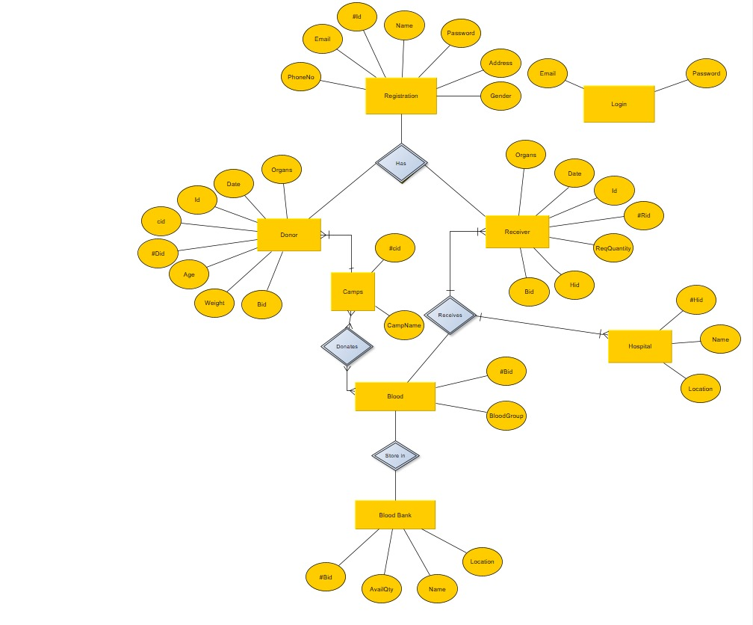

**2.Activity Diagrams :- Admin Activity Diag.**



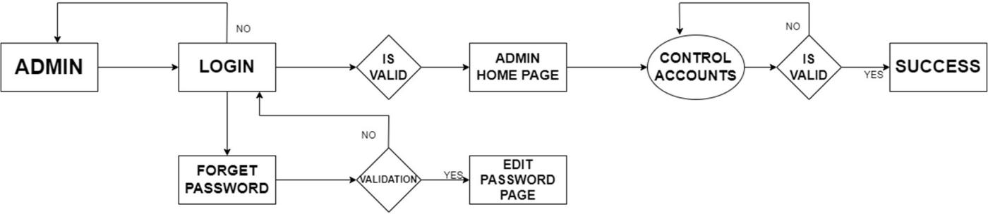

**Blood Bank Diagram**



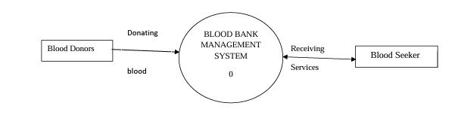

**Admin Use Case Diagram:**



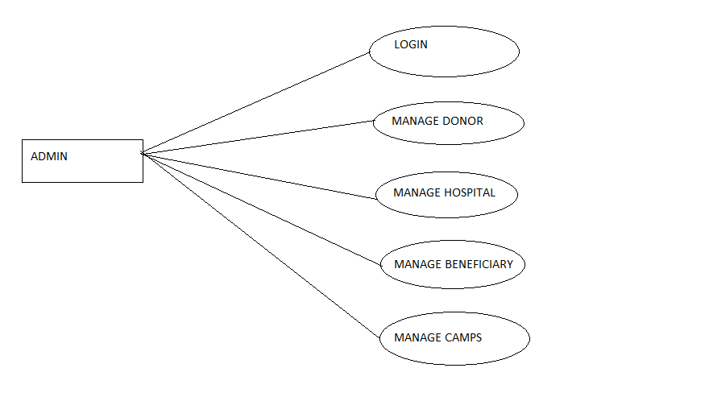

**Customer Use Case Diagram:**



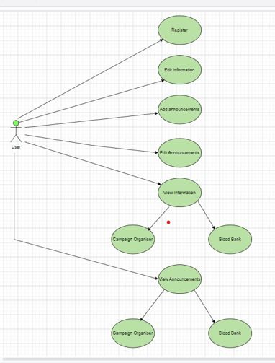

**Use Case Diagram:**



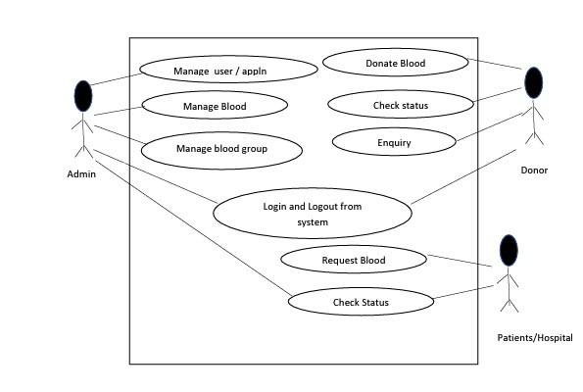



## Table Structure:

**User table:**

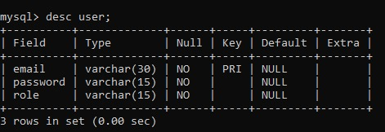

**Stock table:**

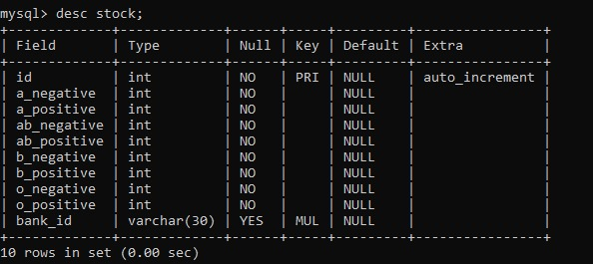

**Organs table:**

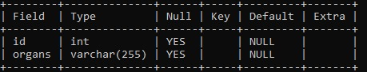



**Donor table:**



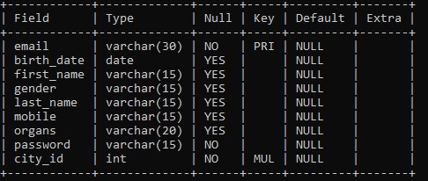

**State table:**

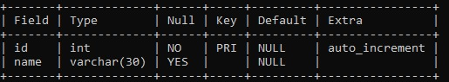

**District table:**

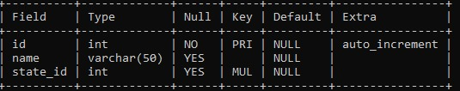



**Blood bank_table:**

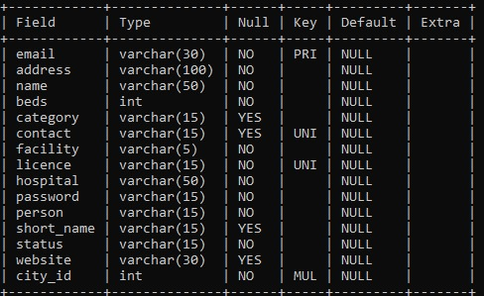

**Receiver_table:**

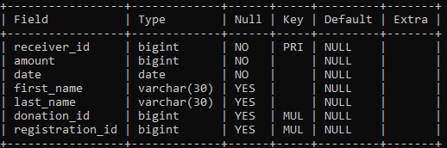



## Screenshots:

**Welcome Page:**

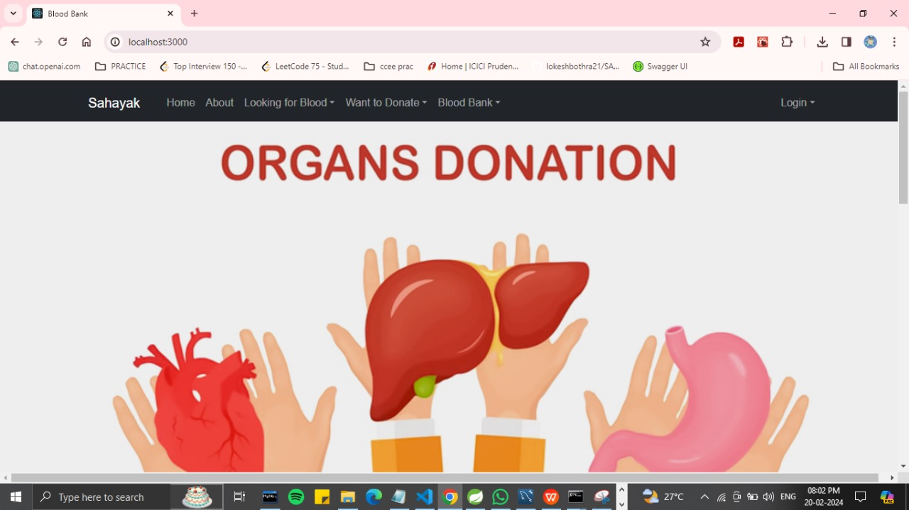

**About:**

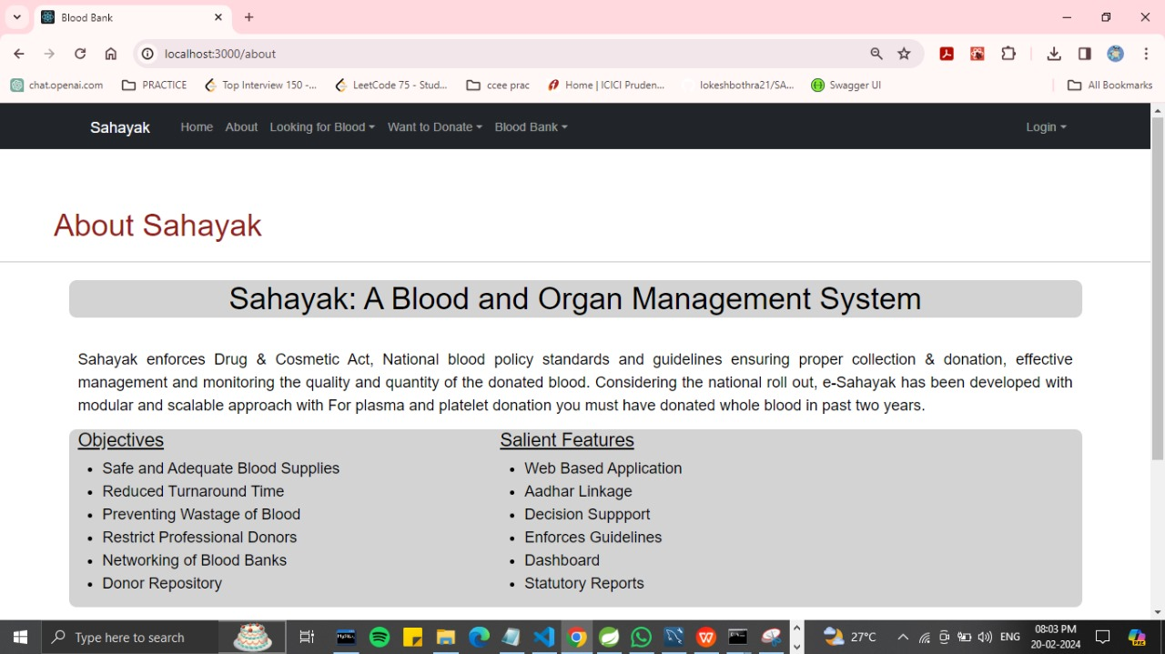

**Donor Reg. Page:**

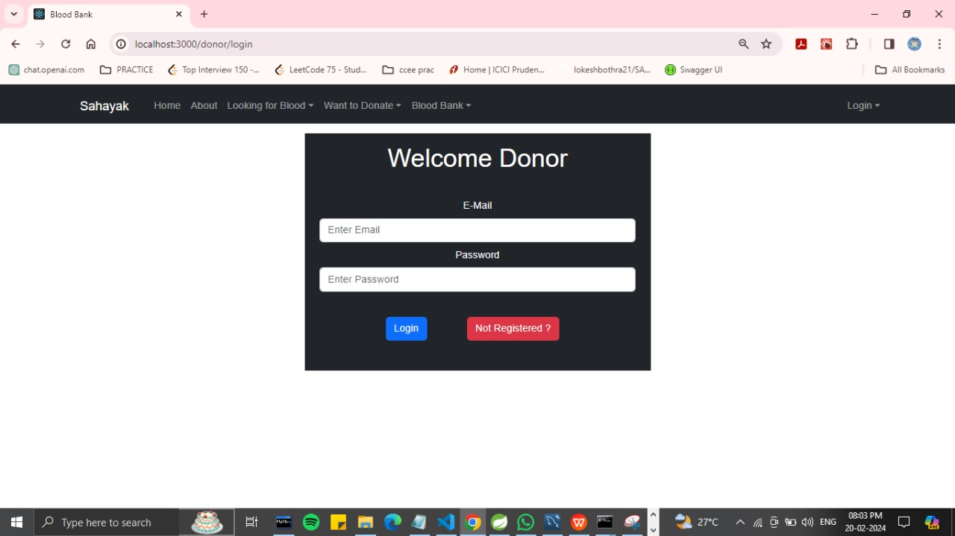



**Admin Page:**

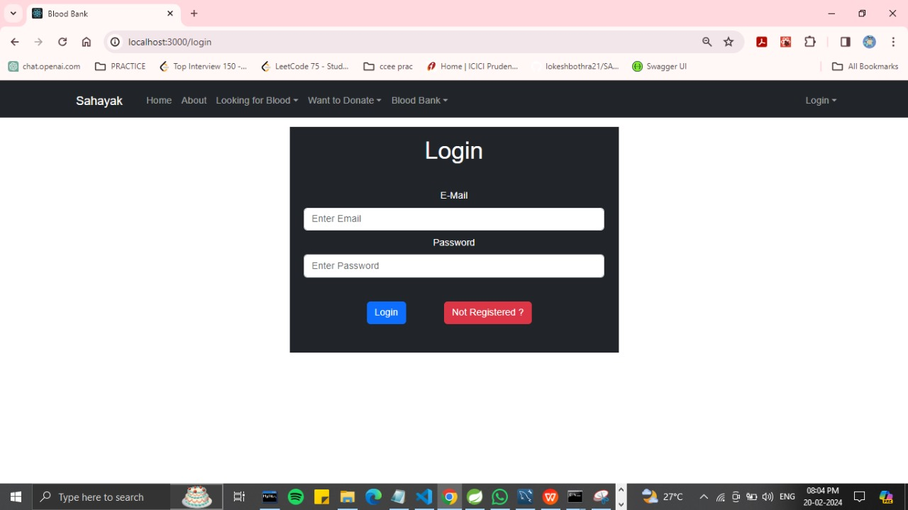

**Blood Bank Registration Page:**



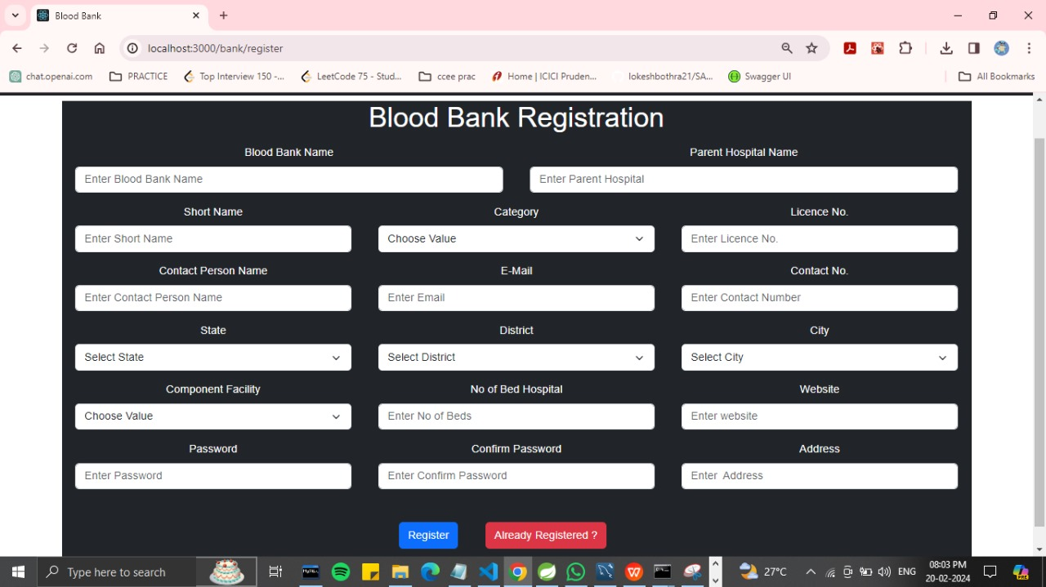

**Donor Reg. Page:**

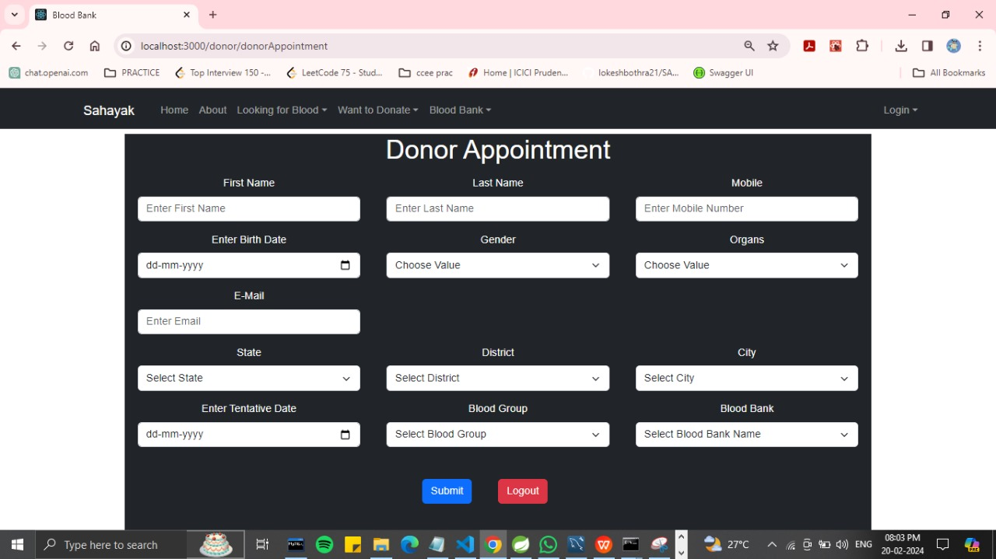



**Blood Bank Availabilty:**

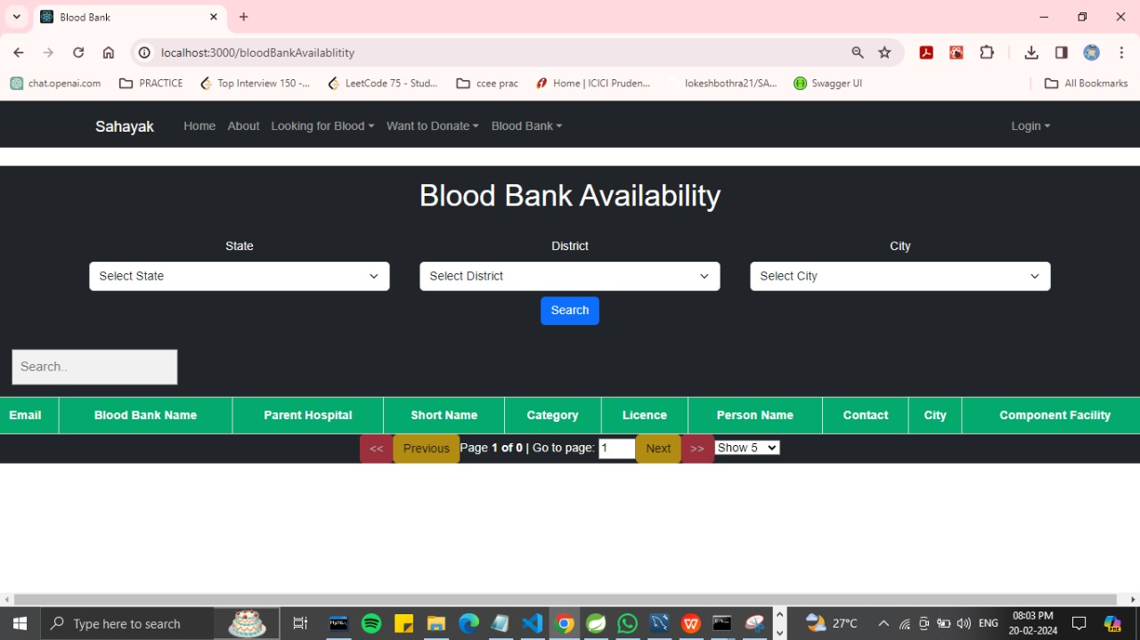

**Camp Schedule:**

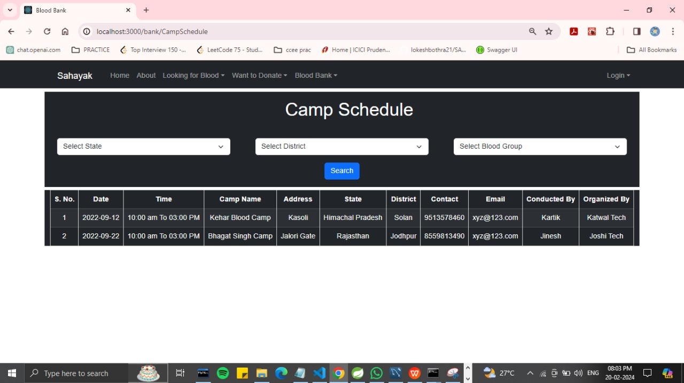

**FAQ’S:**



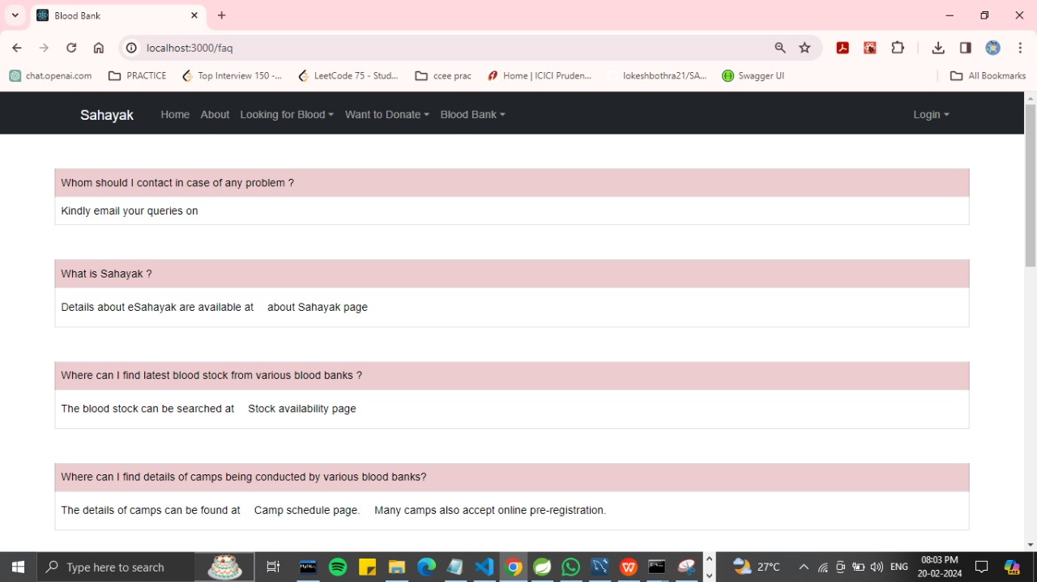

## Conclusion:



SAHAYAK (By the people ,for the people ): Empowering Organ and Blood Donation with Technology

This project successfully breathed life into a comprehensive Organ and Blood Donation Management System, offering a powerful technological solution to enhance accessibility, streamline processes, and ultimately, save lives. Integrating the user-friendly interface of React with the robust data storage of MySQL and the powerful backend capabilities of Spring Boot, we've crafted a system with several advantages:

Enhanced Efficiency: Gone are the days of cumbersome procedures. Automated workflows and intelligent algorithms now optimize donation scheduling, inventory management, and allocation, minimizing wait times and wastage, ensuring resources reach those in need promptly.

Increased Accessibility: User-friendly interfaces have replaced complex processes, simplifying donor registration, appointment booking, and information access. This encourages wider participation, creating a wider pool of life-saving resources.

Improved Transparency: Real-time data tracking and secure reporting provide accurate insights into donation activities, fostering trust and confidence among all stakeholders, from donors to medical professionals.

Streamlined Communication: Integrated communication channels break down barriers, facilitating seamless interaction between donors, hospitals, and healthcare professionals. This ensures accurate information exchange and swift action when needed.



## Future Scope:

While the current version of the Organ and Blood Donation Management System offers significant advancements, the journey towards optimizing donation processes and saving lives doesn't end here. Here's a glimpse into the exciting possibilities that lie ahead for the project's future scope:

Partner with National Registries: Integrate with national organ and blood donation registries for seamless donor and resource matching across broader geographical areas.

Targeted Outreach Campaign i.e. Utilize AI-powered analytics to identify potential donor groups and tailor personalized outreach campaigns based on demographics and preference

Predictive Analytics i.e. Leverage machine learning to predict future demand for specific organs and blood types, facilitating proactive resource management and preparation.

Continuously evolve legal and ethical frameworks: Ensure the system adheres to evolving regulations and ethical guidelines surrounding organ and blood donation.

Data privacy and security: Implement robust measures to protect sensitive donor information and maintain data privacy throughout the system.

Promote equitable access: Continuously review and adjust practices to ensure fair and equitable access to donation opportunities for all communities.

Social Media Integration: Facilitate sharing donation stories and experiences on social media platforms to raise awareness and inspire others.

Real-time Impact Tracking: Allow donors to see the direct impact of their contribution through personalized reports and stories of recipients they helped.



References:

https://www.w3schools.com/html/

https://stackoverflow.com/questions/tagged/reactjs

https://stackoverflow.com/questions/tagged/mysql

https://stackoverflow.com/questions/tagged/spring-b

https://www.ima-india.org/ima/