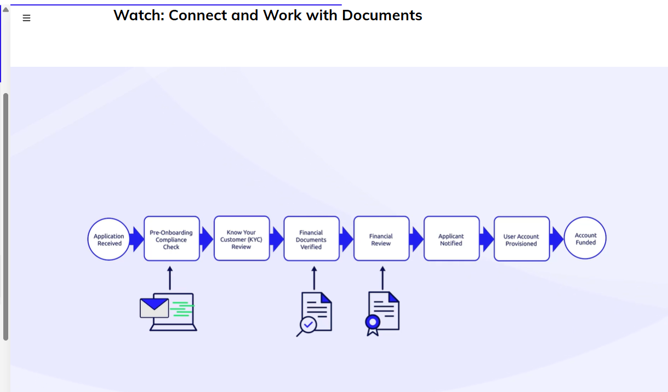
A common use case requires new customers to upload documents as part of an onboarding process
At different steps in the process, they need to upload identity documents
financial disclosure forms, and letters of recommendation

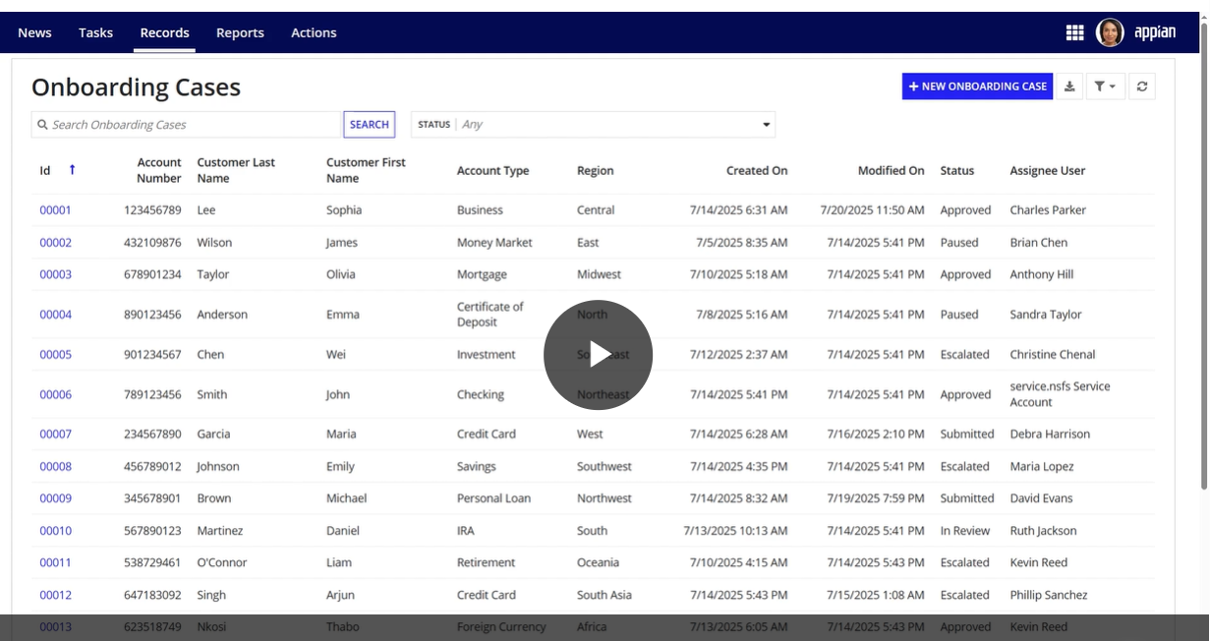

Upload various types of documents as part of a workflow in apian

Click on new onboarding case

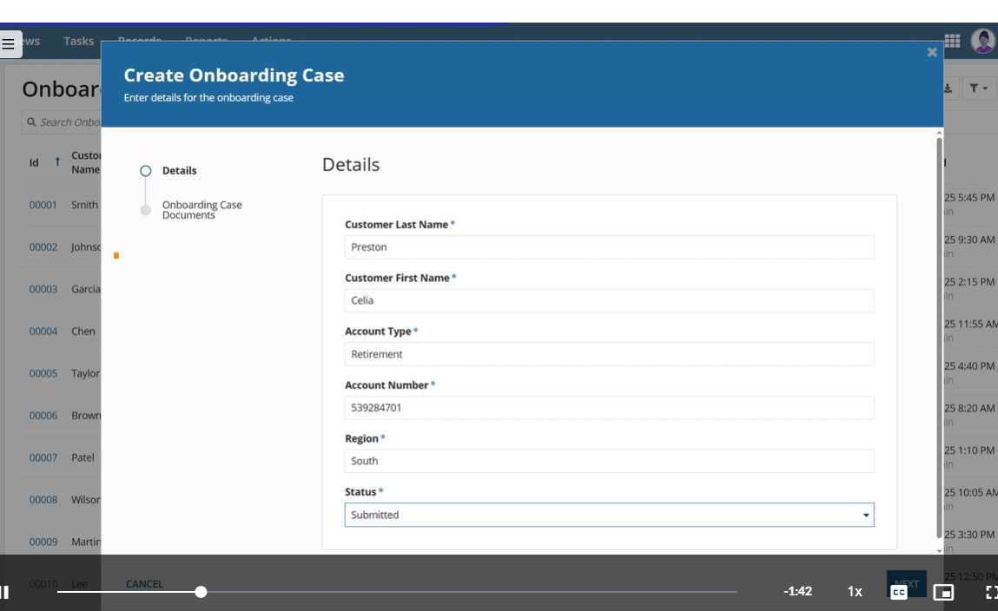

Enter the accounts detail as the first of two steps (step1 details and step2 onboarding Case Documents) as indicated in the milestone wizard on the left

Click on next
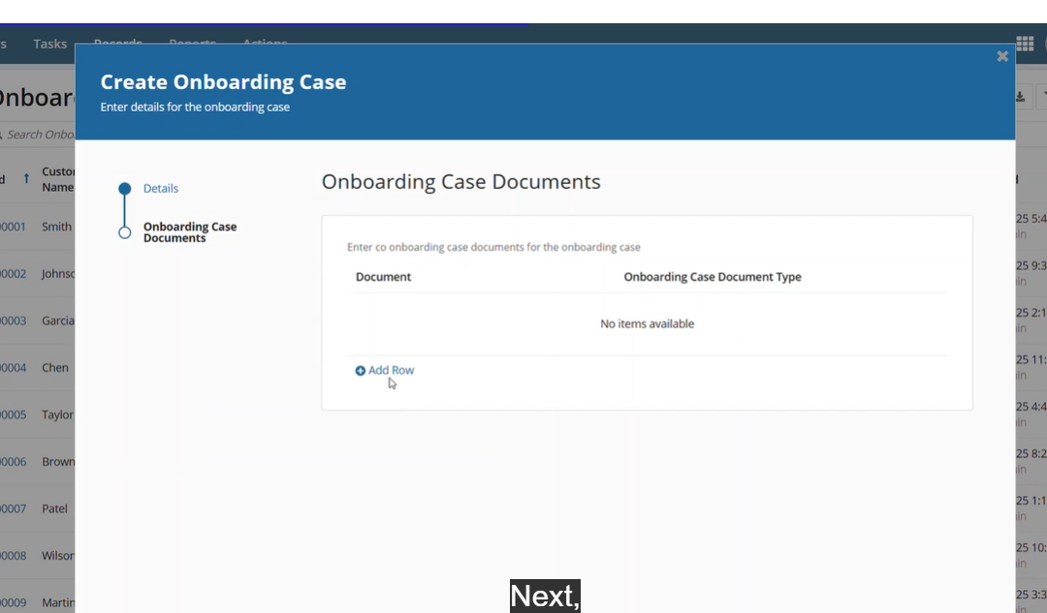
in onboarding case Documents its easy to either drag and drop or pastea document in the rpocided fields
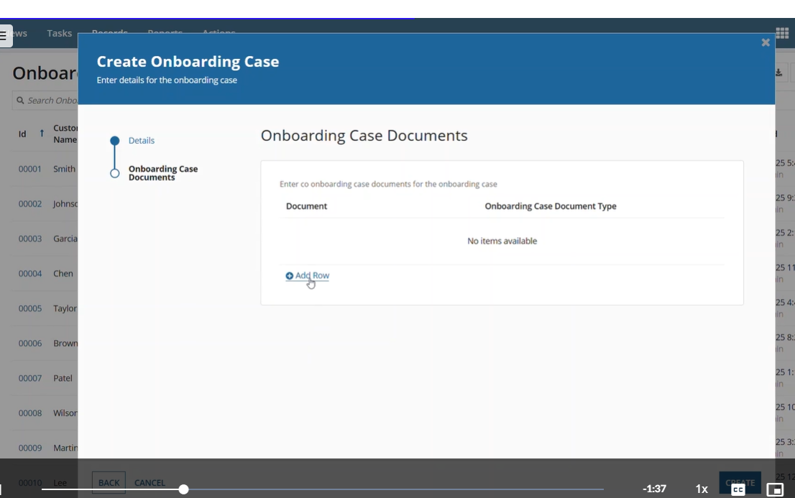

Click on add Row
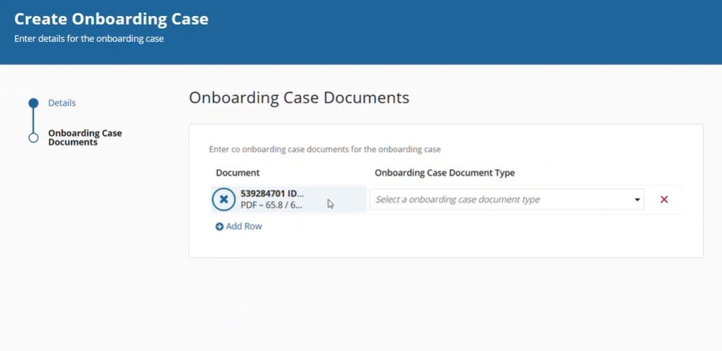
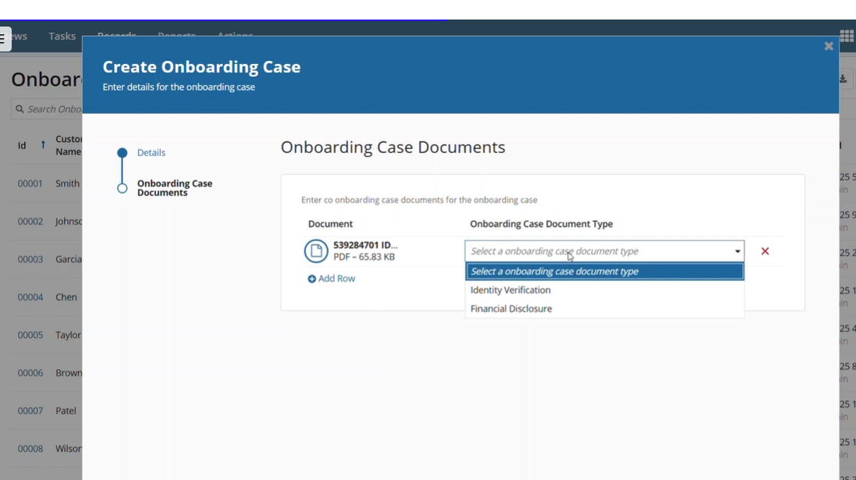

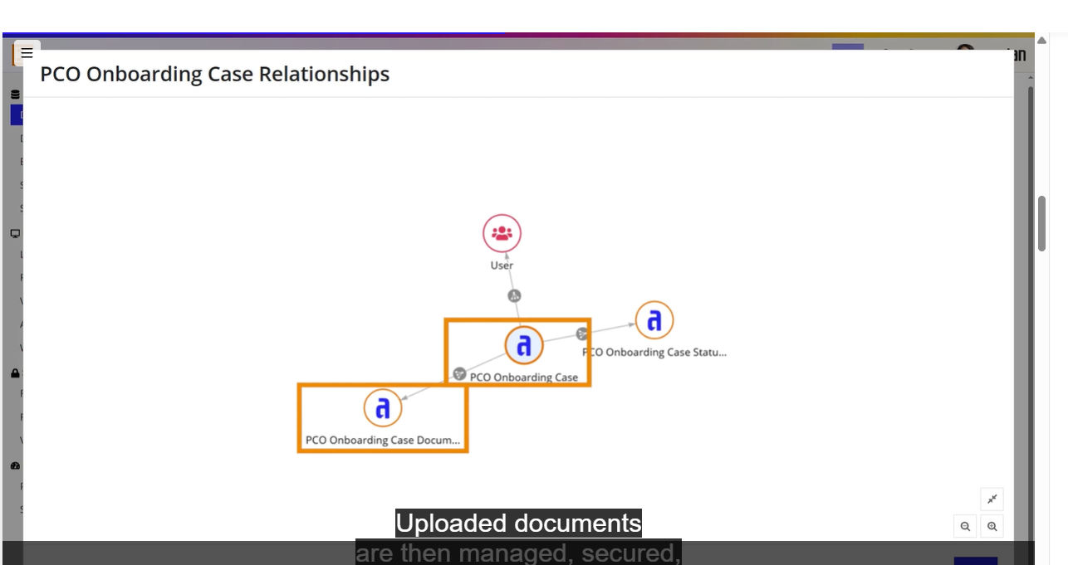

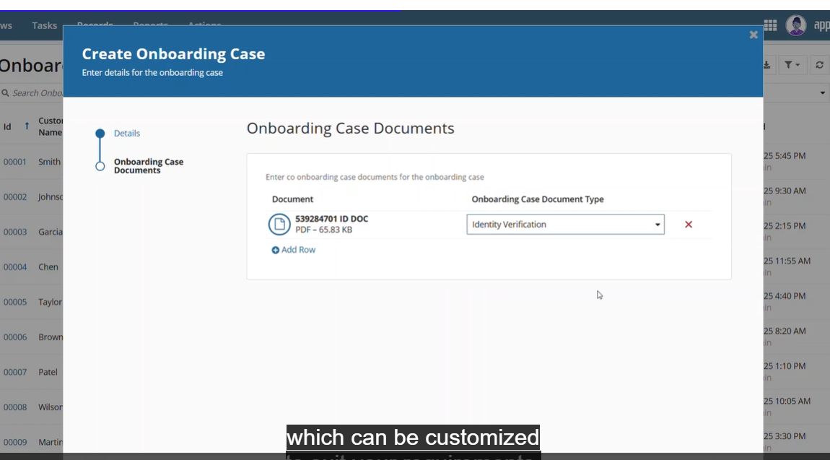

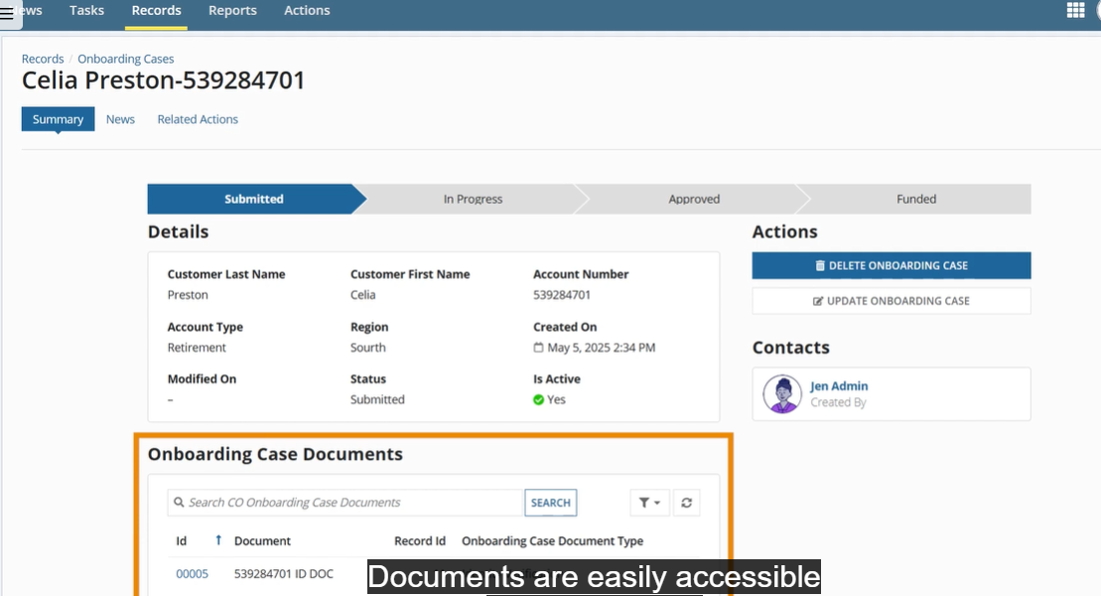

Only users with the appropriate security privileges can access them
Documents are secured using Appian’s standard security rules

Finally onboarding case documents we can view and down load

