Dr. D. Y. Patil School of MCA

Affiliated To Savitribai Phule University

NAAC Accredited ‘A’ Grade

Department MCA

PROJECT Review II

ON

Blog Platform with CMS

Academic Year 2025-2026

MCA- I Semester-1

Submitted to: Submitted by:

Prof. Dr. Zameer S Mulla Lokesh Patil

Project Guide DYPSOMCA

INDEX

Sr.No | Content | Page No
1. | Database Design Verification | 3
2. | ERD Diagram | 4
3. | UML Diagram | 5
3.1 | Class Diagram | 5
3.2 | Use Case Diagram | 6
3.3 | Activity Diagram | 7-8
4 | Sequence Diagram | 9

Database Design Verification

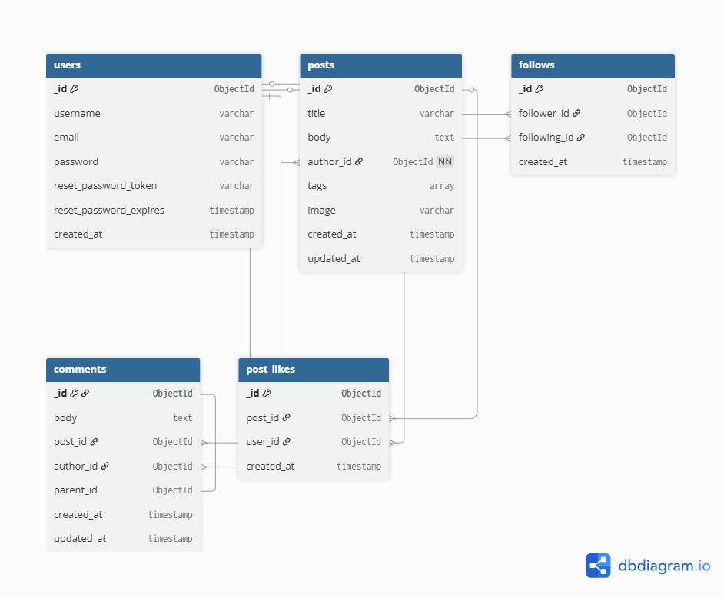

ERD Diagram
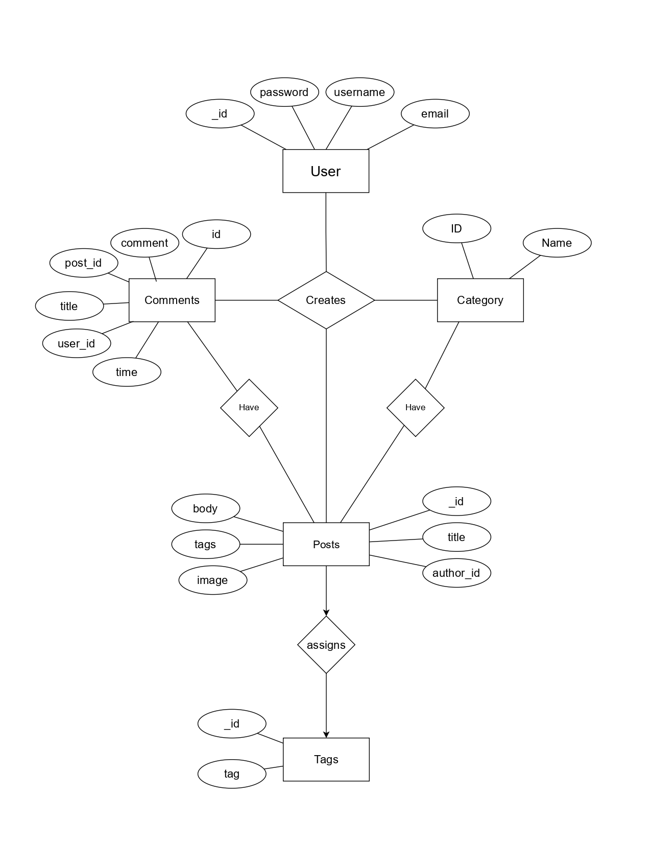

UML Diagrams
- Class Diagram
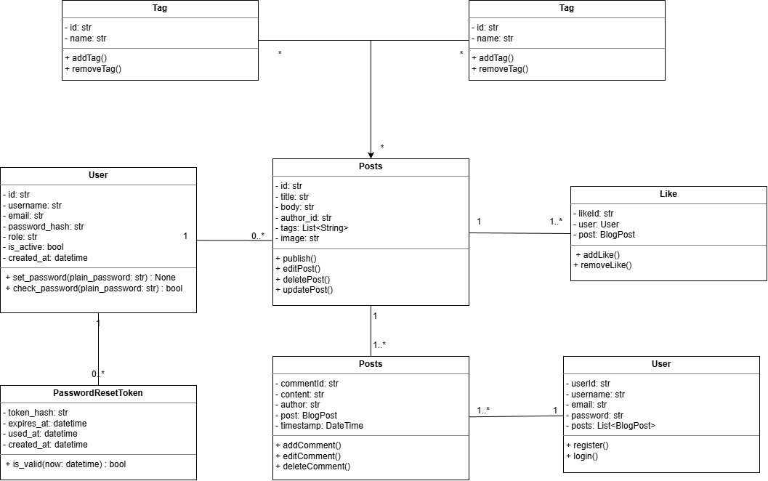

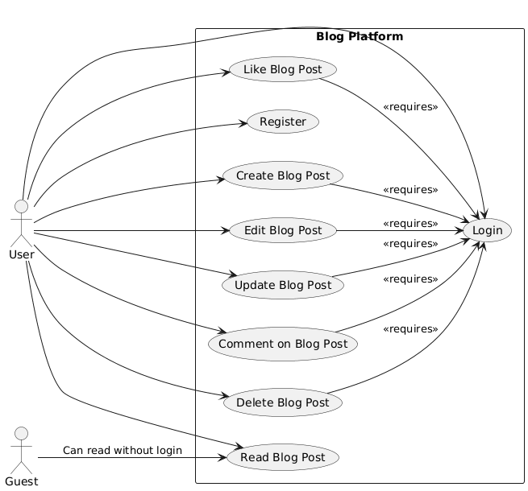
- Use Case Diagram

- Activity Diagram
-Login Register

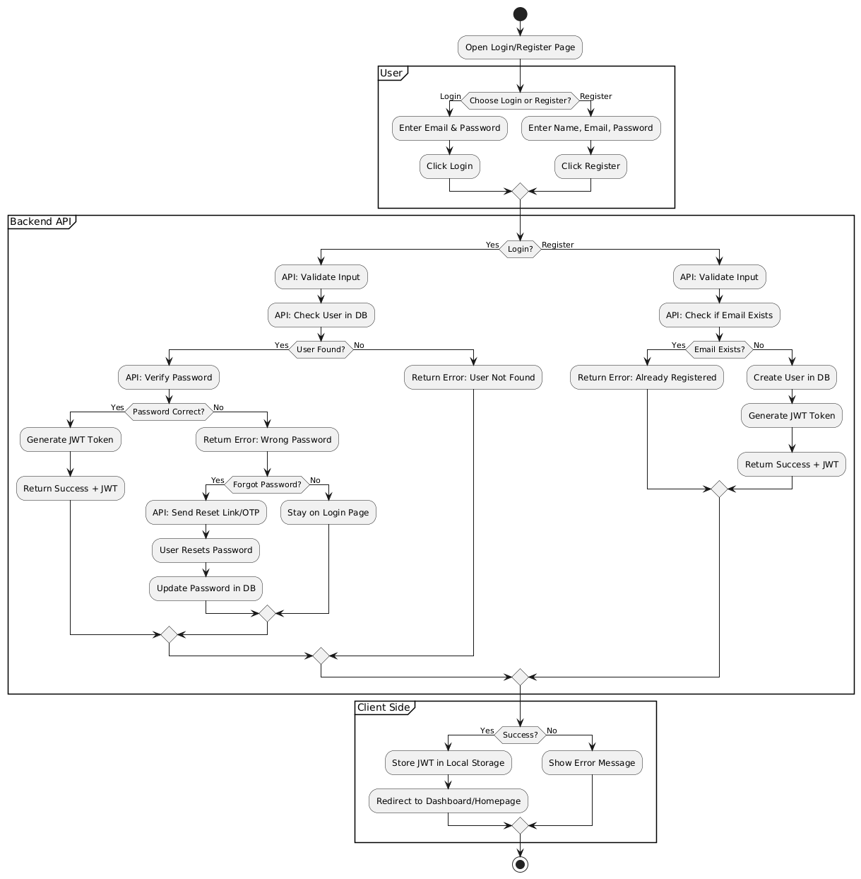

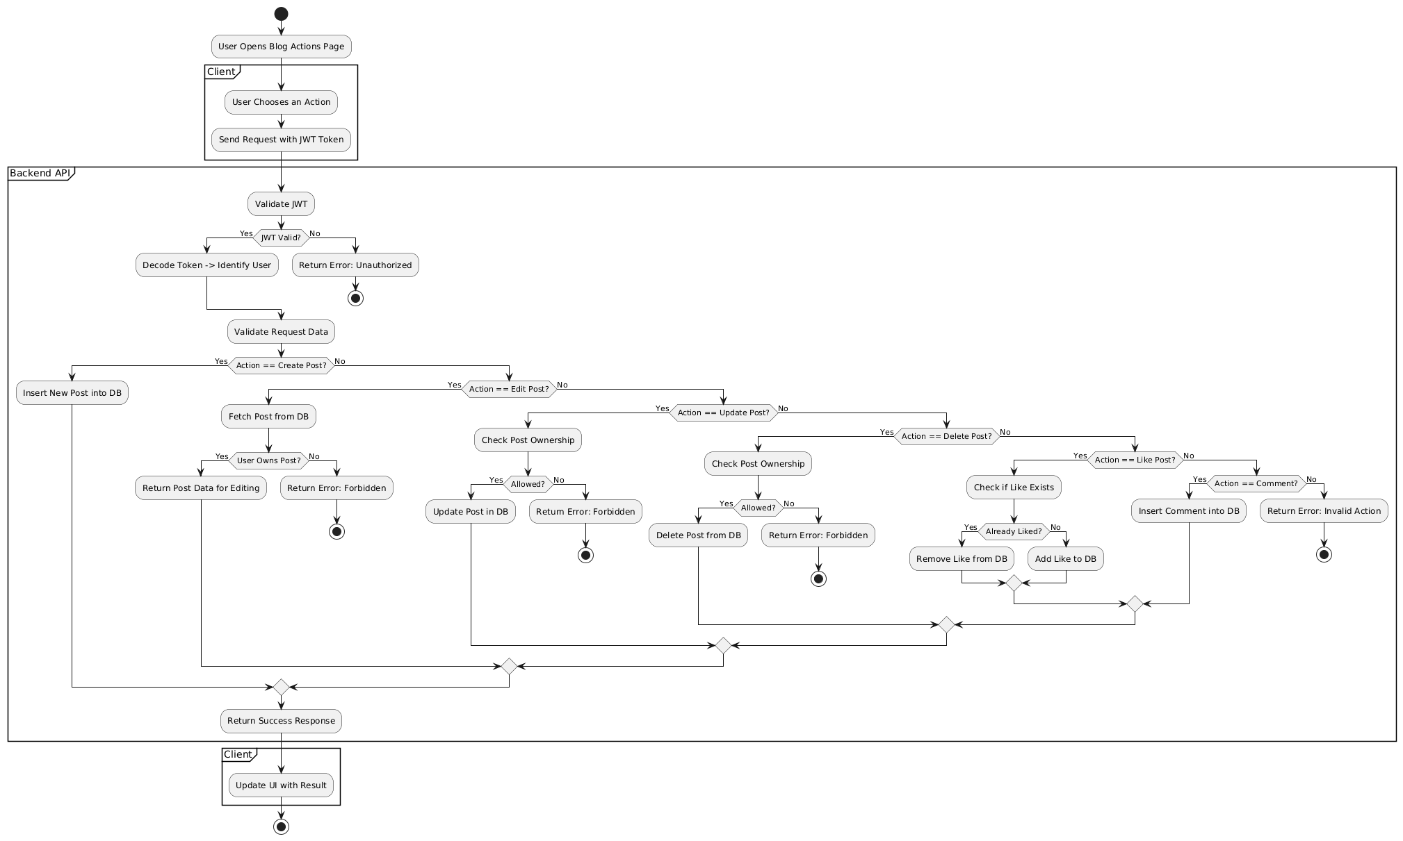
- Post Activity Diagram

- Sequence Diagram 