Linux Commands Assignment Report

# Task 1: Creating and Renaming Files/Directories

Commands Used:

***mkdir test_dir***

***cd test_dir***

***touch example.txt***

***mv example.txt renamed_ex.txt***

Explanation:

- mkdir creates a new directory.  
- cd navigates into the directory.  
- touch creates an empty file.  
- mv renames the file.

Screenshot:  
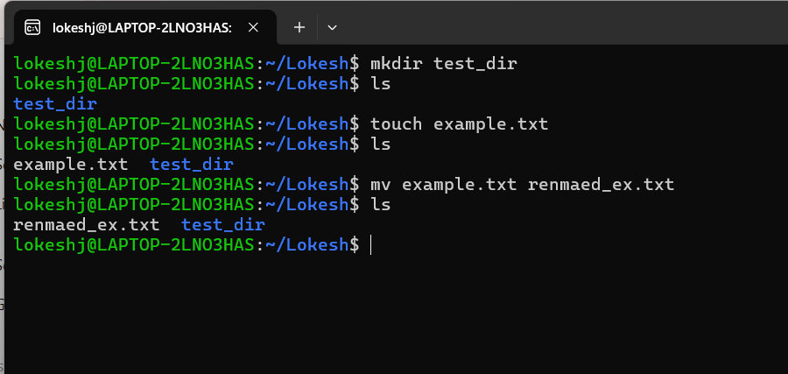

# Task 2: Viewing File Contents

Commands Used:

***cat /etc/passwd***

***head -n 5 /etc/passwd***

***tail -n 5 /etc/passwd***

Explanation:

- cat displays the whole file.  
- head -n 5 shows the first 5 lines.  
- tail -n 5 shows the last 5 lines.

Screenshot:  
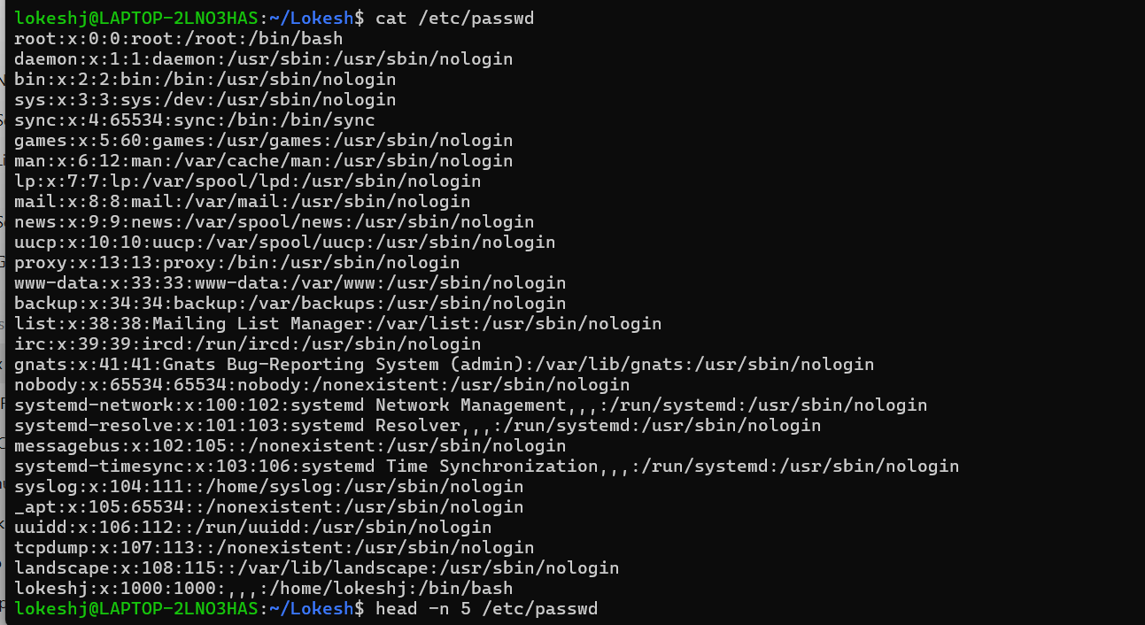

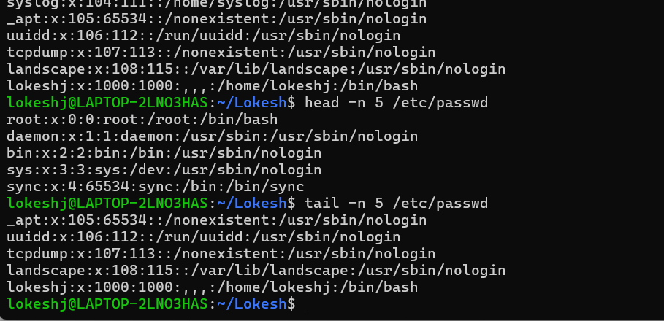

# Task 3: Searching for Patterns

Commands Used:

***grep "root" /etc/passwd***

Explanation:

- grep searches for lines that contain the word "root" in the file.

Screenshot:  
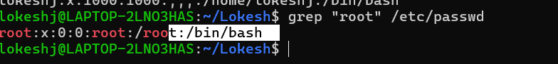

# Task 4: Zipping and Unzipping

Commands Used:

***zip -r test_dir.zip test_dir***

***mkdir unzipped_dir***

***unzip test_dir.zip -d unzipped_dir***

Explanation:

- zip -r compresses the folder.  
- mkdir creates a new directory.  
- unzip -d extracts files into the new directory.

Screenshot:  
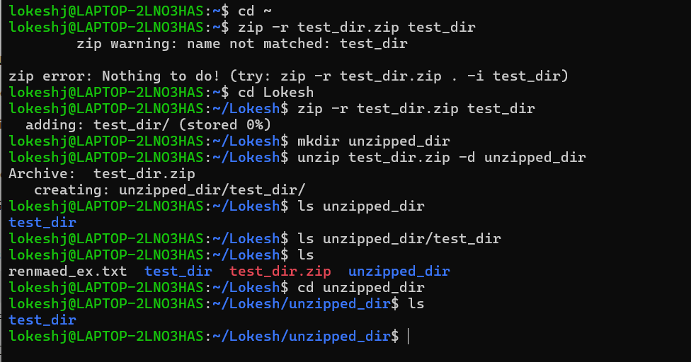

# Task 5: Downloading Files using wget

Commands Used:

***wget https://www.learningcontainer.com/wp-content/uploads/2020/04/sample-text-file.txt***

Explanation:

- wget downloads a file from the given URL.

Screenshot:  
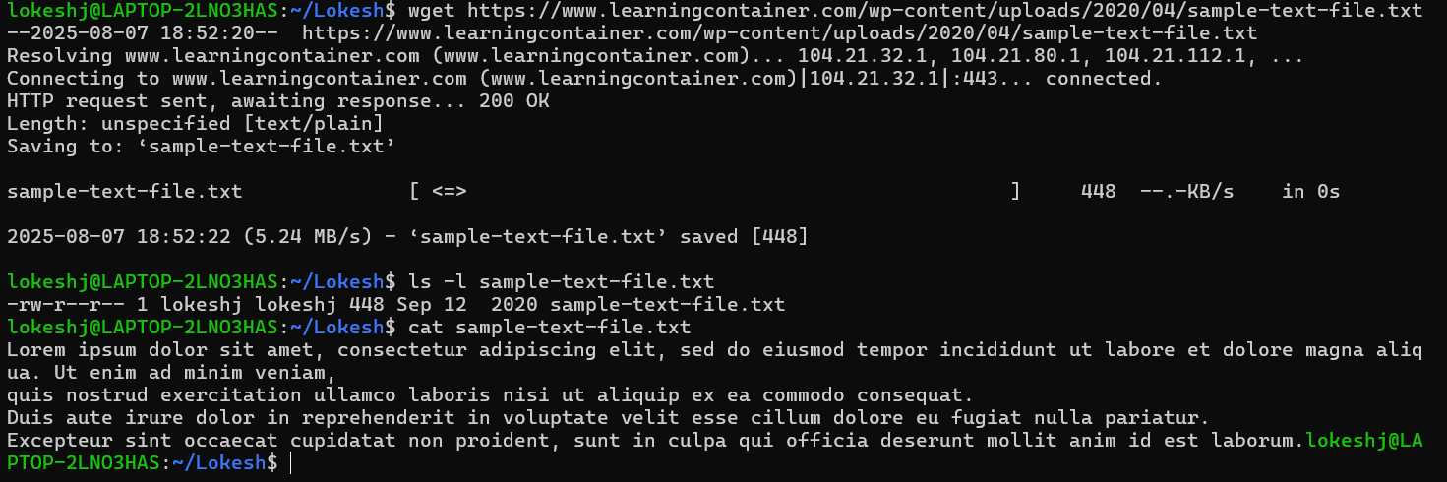

# Task 6: Changing File Permissions

Commands Used:

***Touch secure.txt***

***Chmod444 secure.txt***

***ls -l secure.txt***

Explanation:

- touch creates an empty file.  
- chmod 444 sets read-only permission for everyone.  
- ls -l shows file permissions.

Screenshot:  
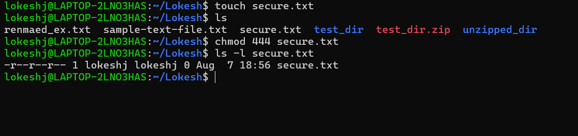

# Task 7: Environment Variables

Commands Used:

***Export MY_VAR=”Hello,Linux!”***

***Echo $MY_VAR***

Explanation:

- export sets a variable in the environment.  
- echo displays its value.

Screenshot:  
