# Scripting Basics Assignment Report

## Task 1: Grade Checker

This program takes a score as input and prints the corresponding grade using if-elif-else statements.

Code:  
marks = int(input("Enter your score: "))  
  
if marks >= 90:  
 print("Grade: A")  
elif marks >= 80:  
 print("Grade: B")  
elif marks >= 70:  
 print("Grade: C")  
elif marks >= 60:  
 print("Grade: D")  
else:  
 print("Grade: F")

Explanation: Based on the score input, the program determines the grade according to predefined ranges.

Screenshot: 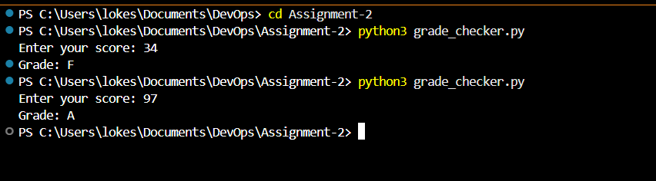

## Task 2: Student Grades

This program manages a dictionary of student names and their grades, allowing adding, updating, and viewing grades.

Code:  
grades = {  
 "Alice": "A",  
 "Bob": "B",  
 "Charlie": "C"  
}  
  
while True:  
 print("\n1. Add Student")  
 print("2. Update Grade")  
 print("3. View All Grades")  
 print("4. Exit")  
  
 choice = input("Enter choice: ")  
  
 if choice == "1":  
 name = input("Enter student name: ")  
 grade = input("Enter grade: ")  
 grades[name] = grade  
 print(f"{name} added with grade {grade}")  
 elif choice == "2":  
 name = input("Enter student name to update: ")  
 if name in grades:  
 grade = input("Enter new grade: ")  
 grades[name] = grade  
 print(f"{name}'s grade updated to {grade}")  
 else:  
 print("Student not found.")  
 elif choice == "3":  
 for student, grade in grades.items():  
 print(f"{student}: {grade}")  
 elif choice == "4":  
 break  
 else:  
 print("Invalid choice. Try again.")

Explanation: Uses a dictionary for storing grades, with menu options for adding, updating, and viewing students.

Screenshot: 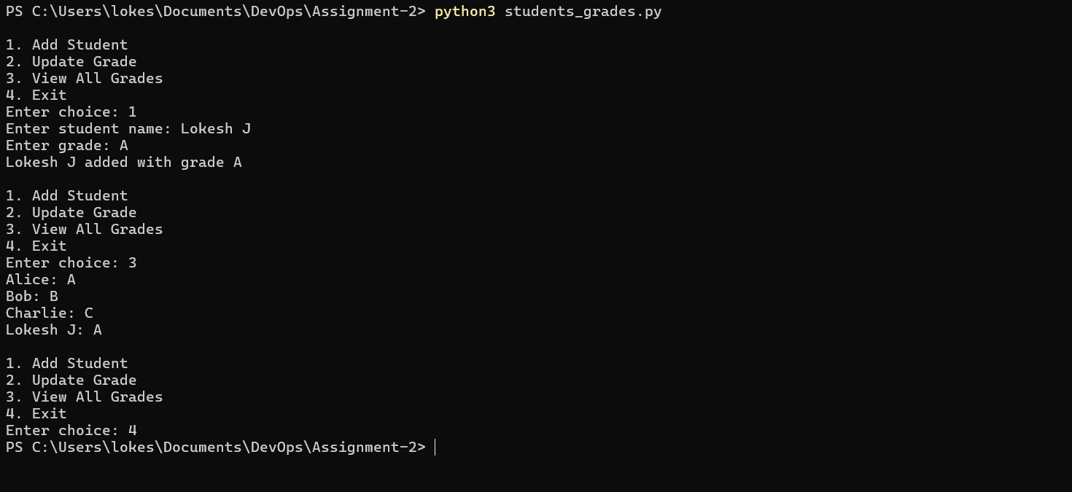

## Task 3: Write to a File

This program creates a text file and writes multiple lines to it using the write() method.

Code:  
with open("write_sample.txt", "w") as file:  
 file.write("Hello, this is a sample text file.\n")  
 file.write("Python file handling is easy!\n")  
  
print("Data written to write_sample.txt successfully.")

Explanation: Opens a file in write mode, writes data, and automatically closes it after use.

Screenshot: 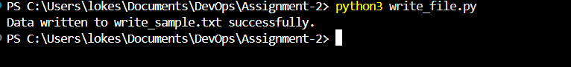

## Task 4: Read from a File

This program reads the content of a text file and prints it to the terminal.

Code:  
with open("write_sample.txt", "r") as file:  
 content = file.read()  
  
print("File Contents:\n")  
print(content)

Explanation: Opens a file in read mode and reads its entire content using read().

Screenshot: 