**Flask API & Frontend-MongoDB Integration**

**1. Objective**

The objective of this project is twofold:

1. **Flask API** — Create a /api route that reads a JSON list from a backend file and returns it as a response.
2. **Frontend + MongoDB** — Create a form that inserts data into MongoDB Atlas and handles success/error responses accordingly.

**2. Task 1 — Flask API Implementation**

**2.1 Folder Structure**

flask_api/

│── app.py

│── data.json

│── requirements.txt

**3. Steps to Run**

1. Start backend:
2. Open index.html in browser.
3. Fill form & submit.

**3.4 Output Screenshots**

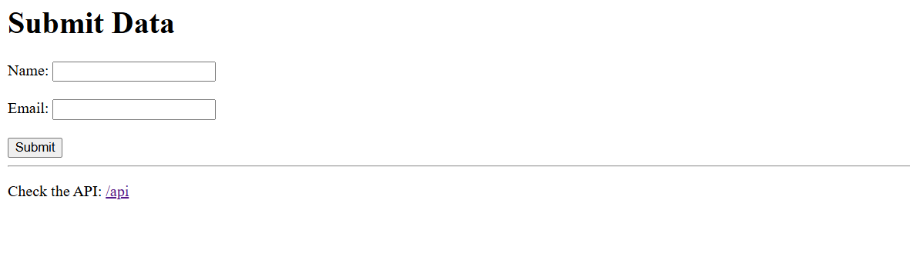

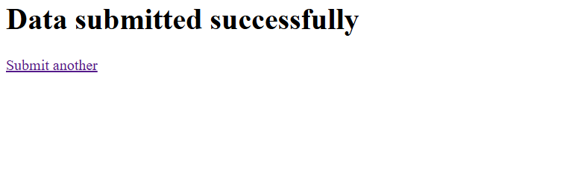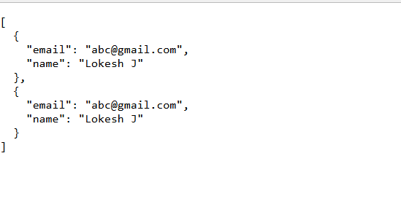

**4. GitHub Repository**

**Repository Link:** https://github.com/lokeshj2403/DevOps/tree/main/Flask-Assignment

**5. Conclusion**

* Successfully created a Flask API to return JSON data from a backend file.
* Developed a frontend form integrated with MongoDB Atlas to store user data with proper success/error handling.