**TypeScript**

* TypeScript is a Superset of JavaScript-> A language building up on JavaScript by adding new features + Advantages to JavaScript.
* Browser can’t directly execute TypeScript
* TypeScript is a tool which compiles TypeScript code into JavaScript code.
* TypeScript will check error during the compilation process, that’s why compile time error will not generated directly on browser
* TypeScript is a powerful, open-source programming language. It is built on JavaScript by adding static type definition, making it a superset of JavaScript.
* TypeScript enhances the development experience by enabling developers to catch errors in early stage through the type checking and it facilitates the development of large-scale applications with improved code quality and maintainability.

* **Key Features of TypeScript:**

1. **Static Typing:**

* TypeScript’s type system helps catch errors at compile time, reducing runtime errors and improving code reliability.

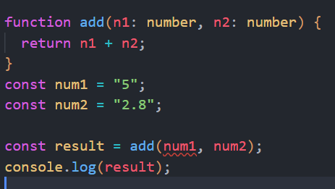

1. **Better Code Readability and Maintainability:**

* Type definition and interface make the code more understandable and easier to maintain.

1. **Adding Non-JavaScript Features like interface or Generics**
2. **It also gives Meta-programming Feature like Decorators**
3. **Rich configuration Options.**

* **Data Types:**

1. **Number:**

* All numbers, no differentiation between integers or float
* 1, 5.3, -10

1. **String:**

* All text values

1. **Boolean:**

* Just these two, no “truthy” or “falsy” values
* True or false



1. **Object:**

* Any JavaScript object, more specific types are possible
* {age:30}

1. **Array:**

* Any JavaScript array, with more specific types declaration
* [1,2,3]

1. **Tuple:**

* Tuple is fixed length array
* [number, string] = [1, “Lokesh”]

1. **Enum:**

* Automatically enumerated global constant identifiers
* enum {New, Old}
* It gives us numerated index which starting at 0

1. **any:**

* Any can used to assign any type of value in variables
* It is not type safe
* We should avoid use of any in TypeScript
* const variable: any [] = [1, true, “Lokesh”]
* **JavaScript vs TypeScript:**

|  |  |
| --- | --- |
| **TypeScript** | **JavaScript** |
| 1. TypeScript is a superset of JavaScript | 1. JavaScript is a subset of TypeScript |
| 1. Ts provide static typing checking | 1. Js provide dynamically typed |
| 1. Syntax is similar to JS with additional features | 1. Standard JavaScript syntax |
| 1. Stronger typing can help identify errors | 1. May require more debugging and testing |
| 1. Adding non-js feature like interface or generics | 1. Interface or generics are not present in js. |
| 1. In TS Error will identify during compilation phase | 1. In JS error will identify during runtime phase |

* **Type Assignment & type inference:**

* If we assign variable with value at a time of declaration, then no need to explicitly mention **type** for that variable.
* If we only declare variables without initializing value and we want to initialize value later then we should mention **type** for that variable.
* **Type Inference:**
* Type inference allows the compiler to automatically determine data types of variables, functions return type, Object types and Array types based on the context in which they are used.
* TypeScript uses inference extensively to provide type safety while still maintaining the flexibility of JavaScript.
* **Type Assignment:**
* In Type Assignment we need to explicitly defined type of variable
* So typescript compiler can easily understand what type of data is present in that variable.
* **Objects:**
* An **object** in typescript is an instance that contains a set of key-value pairs.
* These pairs can hold various data types, including scalar values, functions, or even arrays of other objects.
* Typescript object refers to any value that isn’t primitive. This is different from the empty object type **{}**, and also different from the global type Object.

**Syntax:**let Name_of_object = {

object_property : value,

}

* Eg:  
  A computer screen shot of text

  Description automatically generated
* We can explicitly mention type of field while declaring object with object property or we can directly declare object than TypeScript automatically like this.

* TypeScript detect property in compile time which is not exist in object
* **Array:**
* An array is a user defined data type.
* An array is a homogeneous collection of similar types of elements that have a contiguous memory location, and which can store multiple values of different data types.
* We can explicitly mention type of array and this array can only store that type of values.

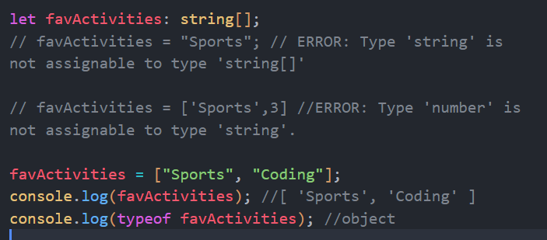

* If we want to multiple type of array then we can use **any** of simply mention that types.

* If we iterate over an array element than TypeScript help us by suggesting supported method on that element

If we use another method which is not supported for this elements, then it will throw error on compile time.

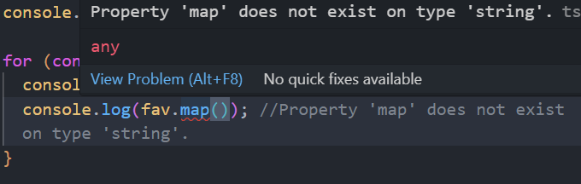

* We can use array for code optimization and for randomly access elements.
* **Tuples:**
* As we know array consists of values of homogeneous (same) types but sometimes when we need to store a collection of different types value in a single variable, then we will go with **Tuples.**
* Tuples may be one or more than one type of data.
* Eg:

* Tuples have a **fixed size,** and we cannot store element more than its size.
* Also, we can store value of **fixed type,** we cannot store number in string place.
* Even we cannot assign empty array to tuple variable.
* **Enum:**
* TypeScript **Enum Type** is not natively supported by JavaScript, but it’s a notable feature of the TypeScript Programming Language.
* In general, enumeration shortly called **enum.**
* Enums allow us to create a set of named constant, Making it easier for us by being self-explanatory while declaring a set of predefined value, by default enum variables has value form **0**.

Eg:

* While Enums are constant by default that’s why we cannot reassign value to enum variables after declaring it.
* Enum is user defined type that’s why we can access enum variable using **(.)** operator.
* **Any:**
* **any** type is a dynamic type that can represent values of any data type.
* It allows for flexible typing but sacrifice type safety, as it lacks compile-time checking
* We can avoid use of any in TypeScript because it affect big feature of TypeScript which is **type safety.**

* **Union Type:**
* The TypeScript union has the ability to combine one or two different types of data.
* It is the most powerful way to express a variable with multiple types.
* Use **pipe (‘|’)** symbol to combine two or more data types to achieve union type.

Eg:

* **Literal Types:**
* The string literal type was added in TypeScript version 1.8.
* String literal types work well with union types and type aliases in practice. These properties can be combined to give strings enum-like functionality.
* The string literal type allows you to specify a set of possible string values for a variable, only those string values can be assigned to a variable.
* TypeScript throws a compile-time error if we tries to assign a value to the variable that isn’t defined by the string literal type
* Syntax:

**Let** variableName : **‘stringLiteral’;**

* Eg:

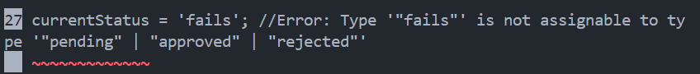

* **Alias type:**
* Type alias give a type a new name.
* They are similar to interfaces in that they can be used to name primitives and any other kinds that you’d have to define by hand otherwise.
* Aliasing doesn’t create a new type, instead , it gives that type a new name.

* String literals as type alias.

* **Function Return Type:**
* TypeScript support function with return types where JavaScript does not support functions with return type

Eg:  
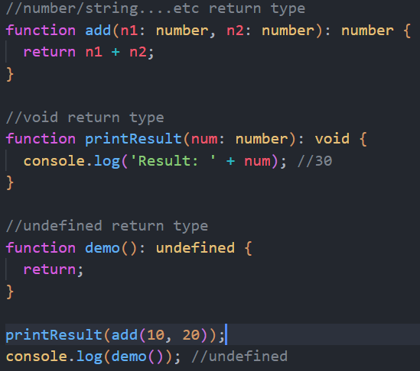

* There are 3 major return type
  + Number, string, Boolean …. etc.
  + Void return type: if we want to print something than we use void
  + Undefined return type: if we want to return nothing or undefined value then we use this
* If we want to return nothing or undefined value, we can also use void
* **Function as a Type:**

* **Callback Function:**
* Callback function mean passing a function as a arguments to another function.

* **Unknown Type:**
* In TypeScript any value can assign to unknown, but without a type assertion, unknown can’t be assigned to anything.
* **Unknown** type is used to make our code type-safe, when we deal with unknown type.
* it looks like **any** type but it is different, **any** is fully flexible and not type safe while **unknown** if partially flexible and type safe.
* If we declare two variables one with **unknown** and other with **string/number** type and store string in **unknown type** variable and then try to assign **unknown type** variable in **string** type variable then it will throw error

* Unknown type variable can only be assigned to another unknown type variable or a variable of type **any,** unknown type is displayed as **undefined.**
* **Never type:**
* When we are certain that a particular situation will never happen, we use the never type.
* Eg: suppose we construct a function that never returns or always throws an exception then we can use the **never** type on than function.
* Neve is a new type in TypeScript that denotes values that will never be encountered.

This function doesn’t return anything.

* **null** value cannot be assigned to **never type.**
* We are not able to store any value in **never type** variables.

* **NOTE:**

1. To run TypeScript file in watch mode use following syntax

**tsc filename.ts -w**

**or**

**tsc filename.ts –watch**

1. To compile entire project at one time
   1. **tsc --init 🡪**it will create **tsconfig.json** file for configuration.
   2. **tsc** or **tsc –w**
2. To exclude any file from compilation when we compiling entire project for that we make changes in **tsconfig.json** file
   1. Open **tsconfig.json**  file

1. Also there is **include** property in that file which indicate all file which mention in **include** property only compile that files remaining file is not compiled
2. If we want to set folder path for compiled file then enable following property in **tsconfig.json** file



* **Intersection Type:**
* An intersection type is a type that merges several kinds into one.
* This allows you to combine many types to create a single type with all of the properties that you require.
* An object of this type will have members from all of the types given.
* The ‘**&**’ operator is used to create the intersection type.

* By intersection multiple type in single type, we can access all properties of all types by assigning only single type to that variable.
* If we do not mention any filed from all types then it will throw error.
* Intersection and union type almost work same but with some difference which is when we declare intersection type with **&** then we need to compulsory used all properties in that object of all types. But when we declare union type then we don’t need to compulsory mention all the field/Properties of all types.

|  |  |
| --- | --- |
| **Intersection type** | **Union type** |
|  |  |
| This will throw the error **& , and** | This is not throwing error **‘|’ , or** |

* **Type Guards:**
* Type Guards are TypeScript features that allow developers to narrow down the type of a variable within a conditional block.
* They are particularly useful when dealing with union types or when the types of variables cannot be determined by TypeScript’s static analysis alone.
* Type Guard provides a way to ensure type safety at runtime, thereby preventing potential errors.
* There are several type of Type Guard:  
  **1. typeOf():**

* + it can be used to check the type of a variable using the **typeOf** operator.

**2. instanceof:**

- This **instanceof** operator checks if an object is an instance of a particular class or constructor function.

**3. in:**

**-** it is used to check given property present in the object or not

**4. Discriminated Union type:**

- It is also called ‘tagged union type’ or ‘algebraic data types’.

- it is a type that can represents a value that can be one of several different type, with a tag indicating the type of the value.

* **Type Casting:**
* In TypeScript type casting happen by two ways

1. **as:**
   * A straightforward way to cast a variable is using the **as** keyword, which will directly change the type of the given variables.
   * **as** is used to set return type of variable
2. **<>:**
   * Itworks the same as casting with **as.**

* **Index type Properties:**
* It is a feature that allow us to create object more flexible regarding the property they might hold.
* We can also set types on object properties/keys
* Then we cannot create property of other type like if we create property with number type then we cannot create property of string type in that variable

* **Function Overloading:**
* Function overloading is the process in which one method could be used multiple times with same name and different parameter types or return types.
* Function name and number of parameters in overloaded functions should be same.

* **Optional Chaining(?.):**
  + The optional chaining is an error-proof way to access nested object properties, even if an intermediate property doesn’t exist.
  + It is similar to **chaining ‘.’** Except that it does not report the error, instead it returns a value which is **undefined**.
  + It also works with a function call when we try to make a call to a method which may not exist.
  + When we want to check a value of the property which is deep inside a tree-like structure, we often must perform check whether intermediate nodes exist.

* + It is also work on method, it checks method exists or not if exist then it execute that method or return undefined.

* **Nullish Value:**
  + Nullish value are **null** and **undefined** only it is not contain other falsy value like **0,’ ’, NaN.**
  + It is fix that error

* **Access Modifiers:**
* Access modifiers is used to protect data/variable for accessing outside the class
* It set accessibility on that variable or functions.
  + 1. **Private:**
       - If we declare variable with private modifier than this variable/method is only accessible in that class



* + 1. **Public:**
       - By default, all TypeScript object/variables/function are public.
       - We don’t need to mention **public** modifier on that variables/function
       - We can access public variable from anywhere in program after its declaration



* + 1. **Protected:**
       - Protected field/function only accessible in inherited classes and its own class



* + 1. **Readonly:**
       - Readonly property is used to set field/method to readonly.
       - We cannot be able to modify the value of that variable after declaring
       - To make field/property/method readonly, **readonly** keyword is used.



* **NOTE:**
  + By adding modifier in constructor parameters then we don’t need to explicitly be defined that property in field

* **Getter and Setter:**
  + Getter and setter is used get value and set value

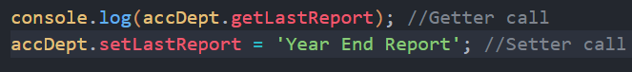

* **Abstract Class Syntax:**
* Abstract classes are mainly for inheritance where other classes may derive from them.
* We cannot be able to create an instance of an abstract class.
* An abstract class typically include one or more abstract method or property declarations.
* The class which extends the abstract class must define all the abstract methods.
* To declare abstract method or property the class should be abstract.
* We can also add regular method in abstract class.

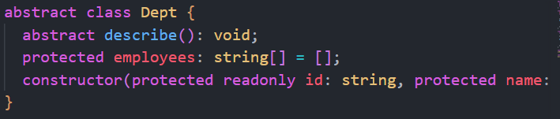

* **Interface:**
* An interface in TypeScript defines the structure or skeleton of an object.
* It enforce a specific syntax on classes, specifying the types of data an object must have.
* Essentially, an interface acts as a contract that describes the shape of an object.
* In interface we cannot implement or initialize any field or method

* **Eg:**

* **Difference Between type and interface.**

|  |  |
| --- | --- |
| **Type** | **Interface** |
| It is a collection of data types. | It is a form of syntax. |
| Types are more flexible. | Interface is less flexible when compared to typescript types. |
| It uses the ‘**type’** keyword for creating new type. | It uses the **‘interface’** keyword for declaring an interface |
| It supports the creation of new name for a type. | It provides a way to define the entities. |
| Two types having same name raise an exception. | Two interfaces having same name get merged. |
| It does not have implementation purpose | It has an implementation purpose. |
| we cannot implement it using classes | We can implement it using classes |
|  |  |

* Interface is mainly used to describe the structure of objects. While types aliases can be used for a wider range of types including primitives, unions, intersections, and tuples in addition to object shapes.
* **Interface as a functions:  
  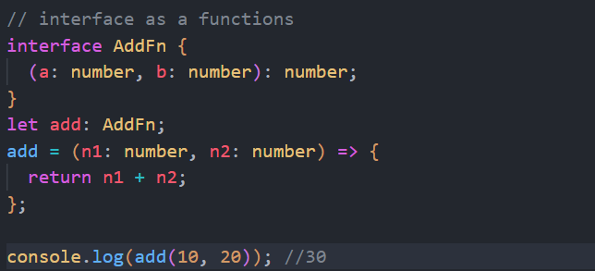**
* **Optional Properties and parameter:**
  + You can add optional property/method in interface.
  + So if we don’t want to use that property/method in implementation we can avoid it
  + It will not throw any error if we did not define that property

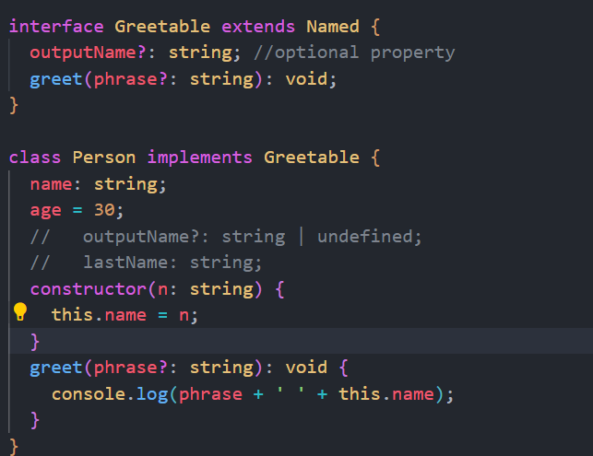

outputName and phrase are optional property and parameter

* **Generics:** [🖇**️**](https://www.freecodecamp.org/news/how-typescript-generics-work/)
* Generics in TypeScript enable writing code that can work with a variety of data types while maintaining **type safety.**
* They allow the creation of reusable components, functions, and data structures without sacrificing type checking.
* Generics are represented by type parameters, which act as placeholders for types. These parameters are specified within angle brackets (**<>**) and can be used throughout the code to define types of variables, function parameters, return types, and more.

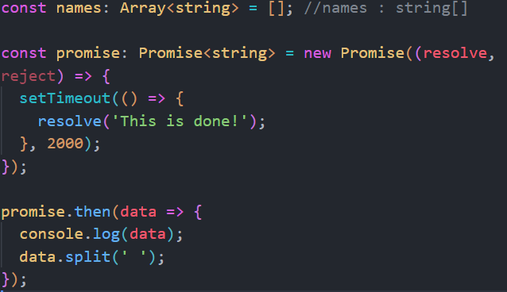

* To set a constraint on generics type we use **extends** keyword



Then we can only set type of given type in this case object type

* **Decorators:**
* A Decorator is a special kind of declaration that can be attached to a **class declaration, method, accessor, property** or **parameter.**
* Decorators are the language-specific feature used to modify and transform the classes and their members at the time of their declarations.
* Decorators are simple functions defined using the **@** symbol before their names.
* Decorators use the form **@**expression, where **expression** must evaluate to a function that will be called at runtime with information about the decorated declaration.
* Decorators’ compulsory received arguments which is **constructor function.**
* Decorators can execute before the class will execute
* Decorator can execute when the class is define

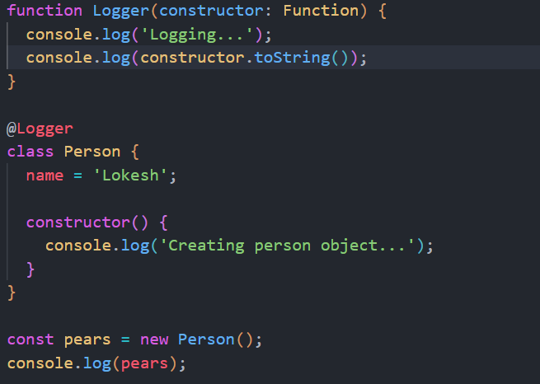

**O/P:**

* To pass a custom parameter to decorators we used the following syntax.

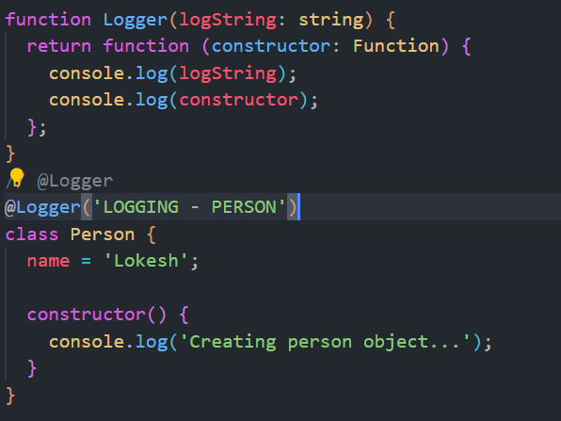

* Decorators provide a way to add both annotation and a meta-programming syntax for class decorations and members.
* **Namespaces and File Bundling:**
* In TypeScript, a namespace is a way to organize code into logical groups and avoid naming collisions between identifiers.
* Namespaces provide a way to group related code into a single namespace or module so that we can manage, reuse and maintain our code easily. w
* Namespaces provide a way to create modular code by breaking up a large codebase into smaller, more manageable pieces.
* Use **namespace** code syntax to group code.

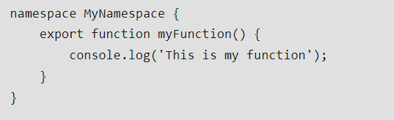

* To import file in project we use following syntax:  
  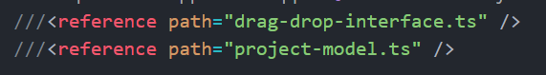

Where **///** are not comment it’s a special syntax for **import** files.

* **Import and export file using ES Module**
  + Remove all namespaces and export functions directly

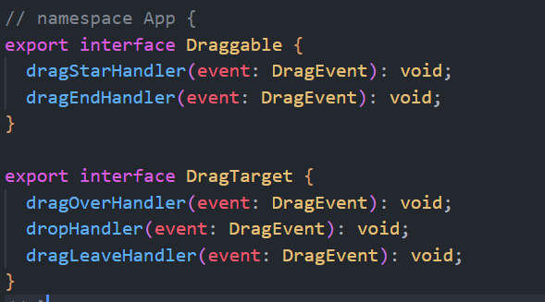

* + Then import like this

