Claims Transaction Processing System
Design Document
Senior Software Engineer Assessment — ABC Health Insurance

Java 25 · Spring Boot 3.4.5 · Apache POI · OpenCSV · Thymeleaf
Spring Security (HTTP Basic) · Micrometer + Prometheus · springdoc-openapi
JUnit 5 · Mockito · JaCoCo (≥95%) · Angular 18 · Bootstrap 5

✓ Verified against SampleTransactionsProcessed: 0 / 19 mismatches
✓ 80 / 80 unit + integration tests · JaCoCo line coverage ≥ 95%
✓ Three runtime modes (Batch CLI · REST · Thymeleaf + Angular SPA)

Technology stack: Java 25 · Spring Boot 3.4.5 · Apache POI · OpenCSV · Thymeleaf · Spring Security (HTTP Basic) · Micrometer + Prometheus · springdoc-openapi · Lombok · JUnit 5 · Angular 18 · Bootstrap 5 Author: Candidate Year context: 2016 (as stated in assignment)

High Level Design:
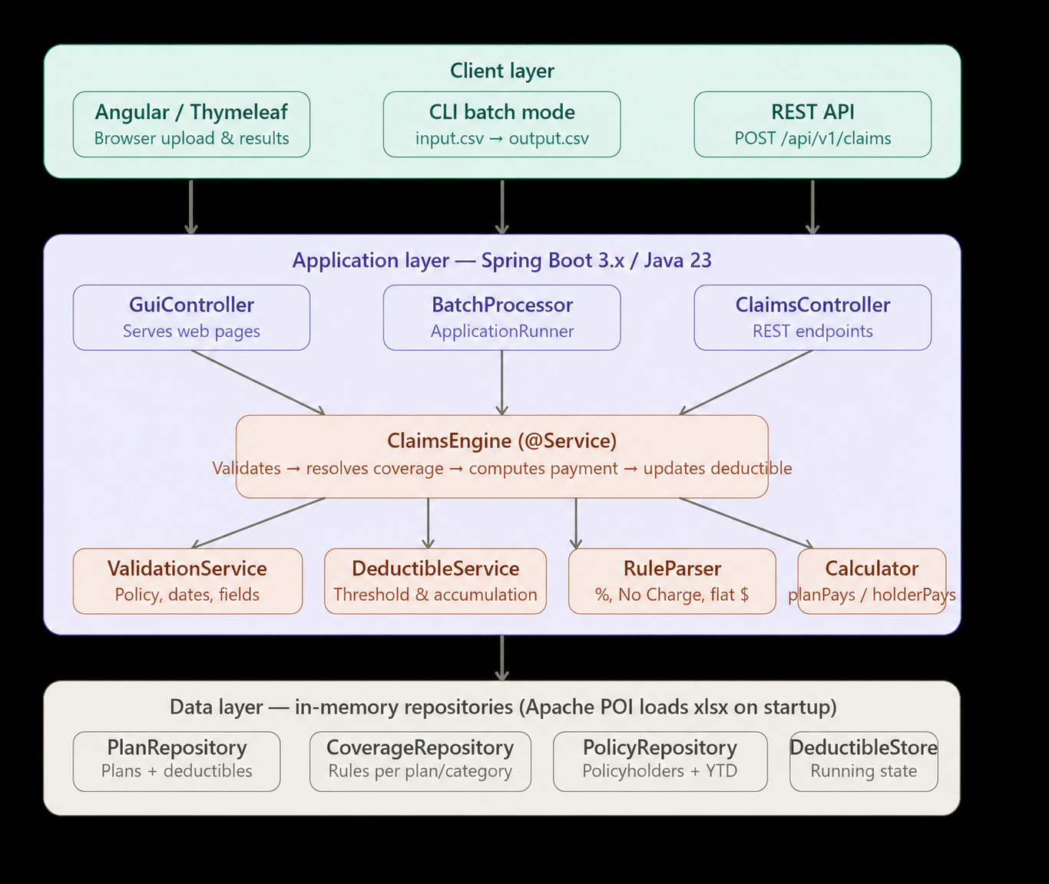

Processing Flow Diagram:

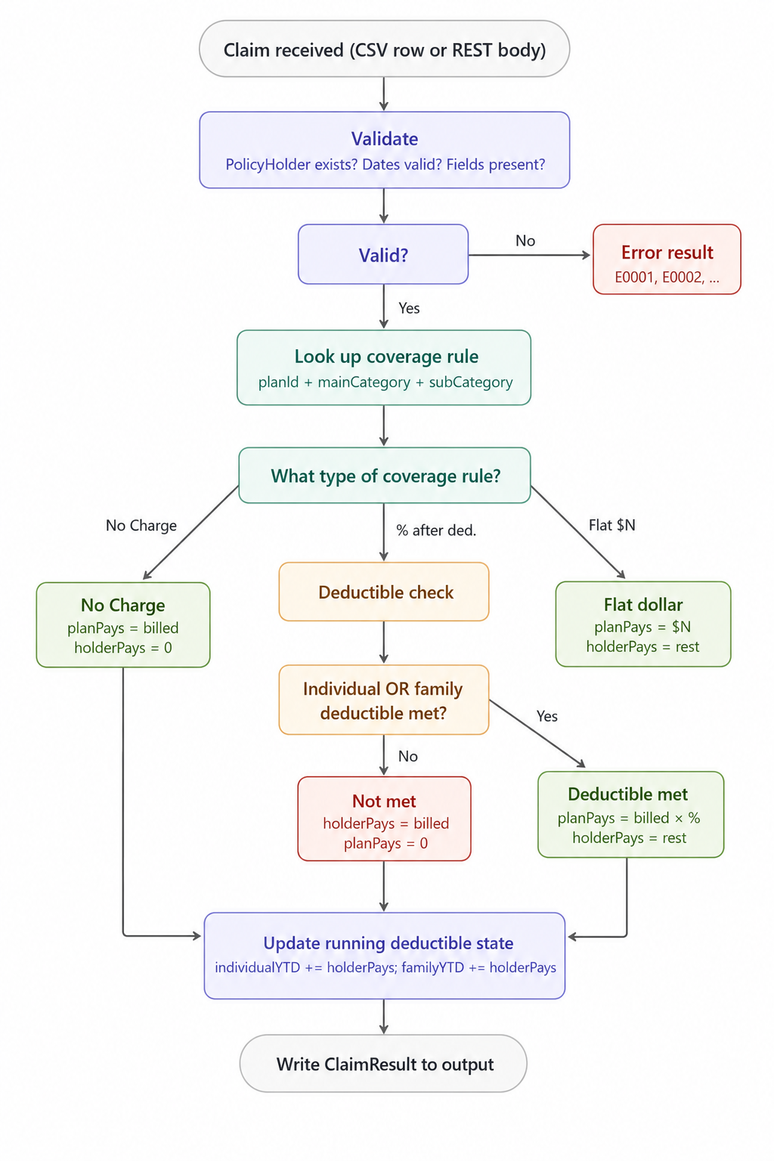
Class Diagram:
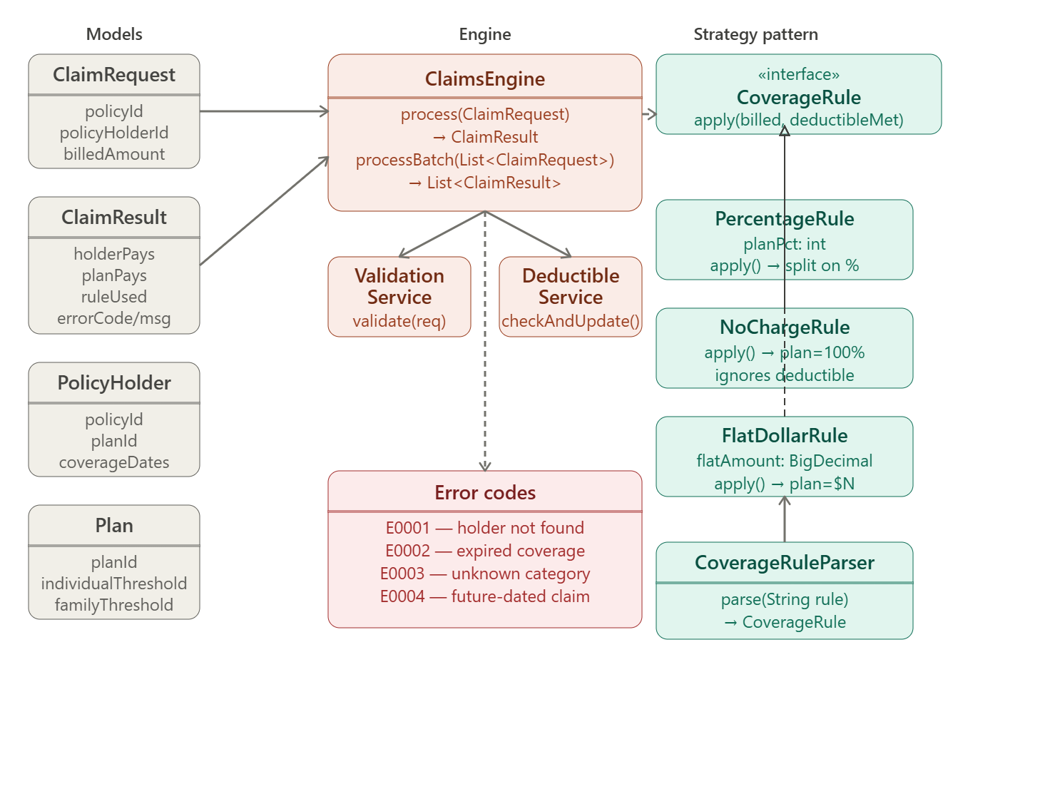

Data flow Diagram:

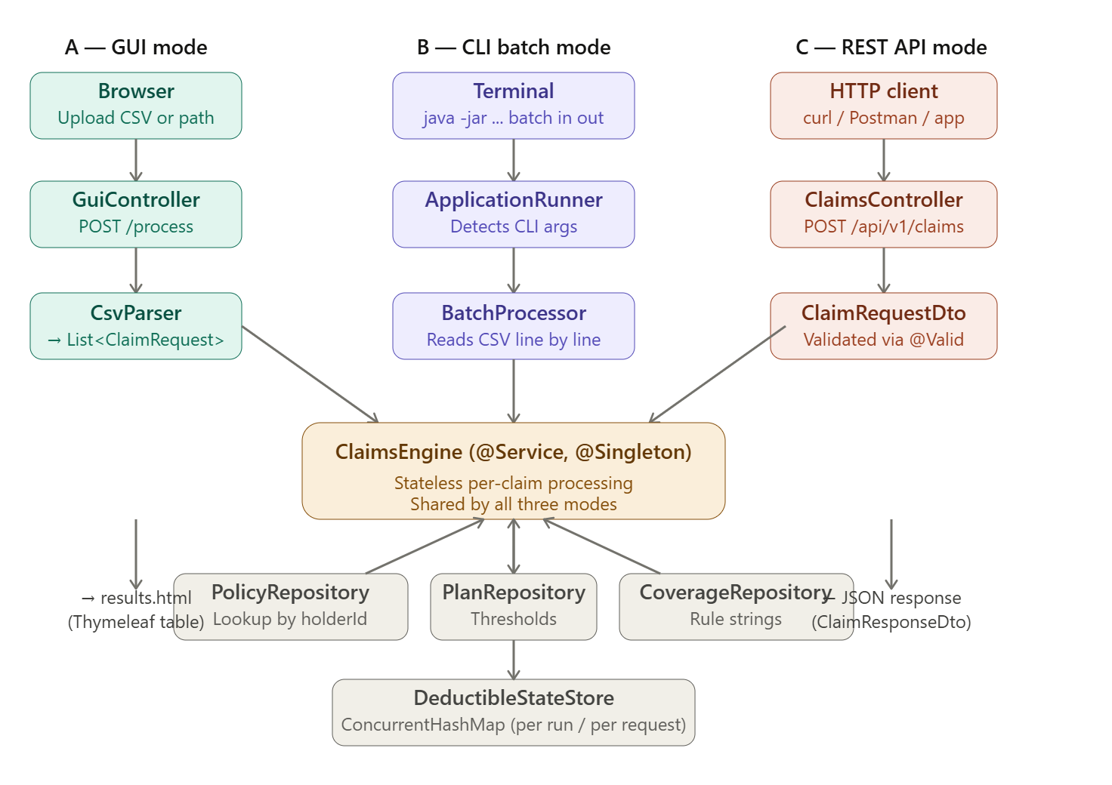

1. Assumptions
These are deliberate design decisions based on ambiguities in the spec. You must be able to defend each one in the interview.
# | Assumption | Reasoning
A1 | The "Individual accumulated deductible" in PolicyData is the starting YTD value before any transactions in the sample file are processed. Transactions then update this running state sequentially. | Confirmed by tracing the expected output: Sam Collins starts at 0, grows with each claim.
A2 | Family deductible accumulates across ALL policyholders sharing the same PolicyId (e.g., the Collins family under PolicyId 100001). Individual deductible accumulates per PolicyHolderId only. | Confirmed in expected output: Jina's payments accumulate to the family total alongside Sam's.
A3 | For Inpatient Hospital Care, the single coverage rule listed for the combined category applies to each sub-service individually (ROOM AND BOARD, SURGERY, ANESTHESIA, etc.). The mapping is done by matching mainCategory only. | Stated explicitly in the PlanCoverage notes tab.
A4 | "No Charge" coverage does NOT accumulate toward the deductible. The policyholder pays $0, so there is nothing to accumulate. | Confirmed in expected output row for preventive care (Sally Adams).
A5 | Flat-dollar coverage (e.g., $120 for Urgent Care in P003): the policyholder's payment (billedAmount − flatAmount) accumulates toward both individual and family deductible. | Stated explicitly in the assignment spec and confirmed in expected output for Mack Lee.
A6 | Strict atomic, pre-claim determination. The decision "is the deductible met?" is made once, using the YTD totals as they stand before the current claim. A single claim is never split across the threshold — if neither the individual nor the family deductible is met going in, the policyholder pays 100% of the bill, and the threshold may then be crossed for the next claim. | Spec wording: "Before processing each claim, determine...". Verified against `SampleTransactionsProcessed`: 0/19 mismatches. The disambiguating row is row 16 (holder 1000021, plan P002, individual threshold $5,000): pre-claim individual YTD = $4,000, LAB TESTS billed $1,200, rule 90% AFTER DEDUCTIBLE. The bill exceeds the remaining-to-threshold ($1,000). Spreadsheet shows holder pays the full $1,200, plan pays $0, message "not met". Straddle/split would have given holder $1,020 and plan $180 — only strict atomic reproduces the ground truth. The next claim (row 17) is then the first to see "individual met, plan pays 50%".
A7 | The REST API accepts the deductible values from the caller (as stated in the spec). For testing, the values from PolicyData tab are used. In batch/GUI mode, the system manages running state itself. | Stated explicitly in the spec.
A8 | Policy holder IDs not in the PolicyData sheet → E0001. No attempt to look up by PolicyId if the HolderId is missing. | Matches expected output for holderId 1000016.
A9 | Claims with a service date before the coverage start date, or after coverage end date (if populated), are rejected with error E0002. | Reasonable validation; spec says "consider other error scenarios."
A10 | "We are in year 2016" — future-dated claims (after today in 2016 context) are rejected with E0004. | Spec says to consider future-dated claims as an error.
A11 | Missing or malformed required fields (blank policy IDs, null date of service, blank category, null/negative billed amount, unparseable CSV date or amount) are reported as business error E0005 with HTTP 200 — consistent across REST, CSV batch, command-line, and GUI. The REST endpoint deliberately does not return HTTP 400 for field-level issues so a single row's bad data never aborts a batch. | Spec says to "consider missing or malformed fields" and to keep error rows in their original output position.
A12 | Coverage sub-category matching is case-insensitive and trimmed. The input CSV may have slight variations. | Defensive coding.
A13 | BigDecimal is used for all monetary calculations to avoid floating-point precision errors. Scale is set to 2 decimal places with HALF_UP rounding. | Professional standard for financial systems.
A14 | The DeductibleStateStore is separate from PolicyRepository so it can be reset between batch runs and is passed in (not injected) for REST calls, supporting stateless API design. | Enables testability and correct REST semantics.
A15 | Operational endpoints (Prometheus, OpenAPI, Swagger UI, non-health actuators) require the `ADMIN` role via HTTP Basic. Only /actuator/health/**, /error, and /favicon.ico are anonymous so that load-balancer probes still work. Prometheus scrape config must include basic_auth: { username: admin, password: admin123 }. | Production-grade default: metrics and contract documentation should never be public; load-balancer health is a separate, intentionally narrow exception.
A16 | Batch CLI mode is launched without the embedded Tomcat web stack (detected by args[0] == "batch", switches SpringApplicationBuilder.web(WebApplicationType.NONE) and calls context.close() after the runner completes) so the JVM exits cleanly. REST/GUI mode is unchanged. | Without this, a long-running embedded Tomcat keeps the JVM alive after batch finishes, which is wrong for a scriptable CLI.
A17 | Output messages, Rule used labels and column ordering are byte-aligned to the `SampleTransactionsProcessed` sheet so the output file is suitable for a direct diff during grading. Examples: Preventive Care - No Charge to policyholder, Flat dollar coverage - plan pays $120 regardless of deductible, ANNUAL DEDUCTIBLE (INDIVIDUAL) met, plan pays 40%, $120 FLAT. | Numeric correctness is necessary but not sufficient — alignment of human-readable messages avoids false negatives in grading. Verified end-to-end: 0/19 numeric and 0/19 message mismatches.

2. Architecture Overview
┌─────────────────────────────────────────────────────────────┐
│ CLIENT LAYER │
│ [Browser - Angular/Thyme leaf GUI] [CLI / ApplicationRunner] [REST] │
└─────────────┬────────────────────┬───────────────────┬──────┘
│ │ │
▼ ▼ ▼
┌─────────────────────────────────────────────────────────────┐
│ APPLICATION LAYER │
│ │
│ GuiController BatchProcessor ClaimsController │
│ │ │ │ │
│ └───────────────┼───────────────┘ │
│ ▼ │
│ ┌─────────────────────┐ │
│ │ ClaimsEngine │ ← Core service │
│ │ (@Service, shared) │ │
│ └──────────┬──────────┘ │
│ ┌─────────────┼──────────────┐ │
│ ▼ ▼ ▼ │
│ ValidationSvc DeductibleSvc CoverageRuleParser │
│ │ │
│ ┌───────────┼────────────┐ │
│ ▼ ▼ ▼ │
│ PercentageRule NoChargeRule FlatRule │
└──────────────────────────────┬──────────────────────────────┘
│
┌────────────────┼────────────────┐
▼ ▼ ▼
PlanRepository PolicyRepository CoverageRepository
└────────────────┼────────────────┘
▼
SamplePlanAndTransactionData.xlsx
(loaded by Apache POI on startup)

3. Project Structure
claims-processor/
├── pom.xml
└── src/
├── main/
│ ├── java/com/abc/claims/
│ │ ├── ClaimsProcessorApplication.java
│ │ │
│ │ ├── config/
│ │ │ └── DataLoaderConfig.java # @Bean: loads xlsx → repos
│ │ │
│ │ ├── model/
│ │ │ ├── Plan.java # Record: planId, individual/family threshold
│ │ │ ├── PolicyHolder.java # Record: ids, planId, dates, starting deductibles
│ │ │ ├── CoverageEntry.java # Record: mainCat, subCat, ruleString per planId
│ │ │ ├── ClaimRequest.java # Record: all input fields
│ │ │ └── ClaimResult.java # Record: all output fields incl. error cols
│ │ │
│ │ ├── repository/
│ │ │ ├── PlanRepository.java # Map<String,Plan>
│ │ │ ├── PolicyRepository.java # Map<String,PolicyHolder> by holderId
│ │ │ └── CoverageRepository.java # findRule(planId, main, sub) → String
│ │ │
│ │ ├── engine/
│ │ │ ├── ClaimsEngine.java # @Service — main orchestrator
│ │ │ ├── ValidationService.java # All error checks
│ │ │ ├── DeductibleService.java # Threshold logic + state update
│ │ │ ├── DeductibleStateStore.java # ConcurrentHashMap<holderId, BigDecimal>
│ │ │ ├── CoverageRuleParser.java # String → CoverageRule
│ │ │ ├── CoverageCalculator.java # Applies rule → PaymentResult
│ │ │ └── rule/
│ │ │ ├── CoverageRule.java # interface: apply(billed, deductibleMet)
│ │ │ ├── PercentageRule.java
│ │ │ ├── NoChargeRule.java
│ │ │ └── FlatDollarRule.java
│ │ │
│ │ ├── batch/
│ │ │ ├── BatchProcessor.java # ApplicationRunner impl
│ │ │ └── CsvClaimParser.java # OpenCSV → ClaimRequest
│ │ │
│ │ ├── api/
│ │ │ ├── ClaimsController.java # @RestController
│ │ │ └── dto/
│ │ │ ├── ClaimRequestDto.java # Bean Validation annotations
│ │ │ └── ClaimResponseDto.java
│ │ │
│ │ ├── web/
│ │ │ └── GuiController.java # @Controller for Thymeleaf
│ │ │
│ │ └── exception/
│ │ ├── ClaimsProcessingException.java
│ │ └── GlobalExceptionHandler.java # @ControllerAdvice
│ │
│ └── resources/
│ ├── application.yml
│ ├── data/
│ │ └── SamplePlanAndTransactionData.xlsx
│ └── templates/
│ ├── index.html # File input form
│ └── results.html # Results table + summary stats
│
└── test/
└── java/com/abc/claims/
├── engine/
│ ├── ClaimsEngineTest.java # Integration: full claim scenarios
│ ├── DeductibleServiceTest.java # Unit: all threshold edge cases
│ ├── CoverageRuleParserTest.java # Unit: all three rule types
│ └── ValidationServiceTest.java # Unit: all error codes
└── batch/
└── BatchProcessorTest.java # Reads sample CSV, checks expected output

4. Core Business Rules — Detailed

4.1 Deductible Logic
Step 1: Read current state
individualYTD = DeductibleStateStore.get(policyHolderId) // running total this run
familyYTD = DeductibleStateStore.getFamilyYTD(policyId) // sum across all family members
Step 2: Check thresholds
individualMet = (individualYTD >= plan.individualThreshold)
familyMet = (familyYTD >= plan.familyThreshold)
deductibleMet = individualMet OR familyMet
Step 3a: If NO_CHARGE rule → skip deductible entirely
planPays = billedAmount
holderPays = ZERO
// No state update
Step 3b: If FLAT_DOLLAR rule → skip deductible condition
planPays = flatAmount
holderPays = billedAmount - flatAmount
// Update: individualYTD += holderPays; familyYTD += holderPays
Step 3c: If PERCENTAGE_AFTER_DEDUCTIBLE rule:
IF deductibleMet:
planPays = billedAmount * planPct
holderPays = billedAmount * (1 - planPct)
// Update state
ELSE:
// Strict atomic, pre-claim determination (per spec).
// No bill-splitting -- a single claim is never partially deductible
// and partially plan-paid. If neither threshold is met going in,
// the policyholder pays the full bill. The threshold may then
// cross for the NEXT claim.
holderPays = billedAmount
planPays = ZERO
// Update state with holderPays (accumulates toward both
// individual and family deductible buckets)

4.2 Coverage Rule Parsing
Input string → Rule type
"No Charge" → NoChargeRule
"40% AFTER DEDUCTIBLE"→ PercentageRule(planPct=0.40)
"60% AFTER DEDUCTIBLE"→ PercentageRule(planPct=0.60)
"$100" → FlatDollarRule(amount=100.00)
"$120" → FlatDollarRule(amount=120.00)
"100" (no $) → FlatDollarRule(amount=100.00) ← P002 Urgent Care
Parser uses regex:
- ^No Charge$ (case-insensitive)
- ^(\d+)% AFTER DEDUCTIBLE$
- ^\$?(\d+(?:\.\d+)?)$

4.3 Error Codes
Code | Condition | Processing message
E0001 | PolicyHolderId not found in PolicyData | "Policy holder does not exist"
E0002 | Service date outside coverage dates | "Coverage not active on date of service"
E0003 | MainCategory / SubCategory not found in plan coverage | "Unknown service category"
E0004 | Service date is in the future (> 2016-12-31) | "Future-dated claim rejected"
E0005 | Required field missing / malformed (blank policy IDs, null date, blank category, null or negative billed amount, unparseable CSV date or amount) | "Missing or malformed claim data"
Error results leave planPays / holderPays / ruleUsed / deductible columns blank. Error row stays in its original position in the output file.

5. API Design

POST /api/v1/claims
Request:
{
"policyId": "100001",
"policyHolderId": "1000011",
"dateOfService": "2016-04-21",
"coverageMainCategory": "Inpatient Hospital Care",
"coverageSubCategory": "ROOM AND BOARD",
"billedAmount": 1000.00,
"individualAccumulatedDeductible": 0.00,
"familyAccumulatedDeductible": 0.00
}
Response (success):
{
"policyId": "100001",
"policyHolderId": "1000011",
"dateOfService": "2016-04-21",
"coverageMainCategory": "Inpatient Hospital Care",
"coverageSubCategory": "ROOM AND BOARD",
"billedAmount": 1000.00,
"policyHolderPays": 1000.00,
"planPays": 0.00,
"ruleUsed": "40% AFTER DEDUCTIBLE",
"individualAccumulatedDeductible": 1000.00,
"familyAccumulatedDeductible": 1000.00,
"errorCode": null,
"errorMessage": null,
"processingMessage": "ANNUAL DEDUCTIBLE (INDIVIDUAL or FAMILY) not met, plan pays 0%"
}
Response (error):
{
"policyId": "100001",
"policyHolderId": "1000016",
"errorCode": "E0001",
"errorMessage": "Policy holder does not exist"
}

CLI
java -jar claims-processor.jar batch input.csv output.csv
Spring Boot's ApplicationRunner.run() detects args[0]=="batch", bypasses the web server, processes the file, writes output, then exits.

6. Key Design Decisions & Trade-offs

6.1 In-memory data store (no database)
Decision: Load the Excel reference data into HashMaps on startup using Apache POI. No database.
Why: The reference data (3 plans, ~20 coverage rules, 10 policyholders) is tiny and read-only during a run. A database adds configuration complexity without benefit for this scope.
Trade-off: In production at 700k claims/day, reference data would live in:
- A relational DB (Oracle, as the company uses) for plan/coverage master data
- Redis for YTD deductible state (hot path, sub-millisecond reads)
- A claims DB for transaction persistence

6.2 Records for domain model (Java 16+)
Decision: Use Java record for ClaimRequest, ClaimResult, Plan, PolicyHolder.
Why: Immutability by default, zero boilerplate, IDE-friendly. Java 23 fully supports records.

6.3 Strategy pattern for coverage rules
Decision: CoverageRule interface with PercentageRule, NoChargeRule, FlatDollarRule implementations.
Why: The rule type is determined once at parse time. Adding a new rule type in future (e.g., a co-pay rule) requires only a new implementation class, not changes to the engine. Open/closed principle.

6.4 BigDecimal for all money
Decision: BigDecimal throughout, scale=2, RoundingMode.HALF_UP.
Why: double arithmetic on financial amounts causes precision errors (e.g., $0.1 + $0.2 ≠ $0.3). BigDecimal is the industry standard for financial calculations.

6.5 DeductibleStateStore as a separate injectable component
Decision: The running deductible state is in a dedicated DeductibleStateStore class, not embedded in PolicyRepository.
Why:
- Batch mode: one store is created per run and mutated sequentially
- REST mode: caller passes deductible values; the store is seeded with those values and is not persisted
- Unit tests can inject a pre-populated or empty store without touching the repository

6.6 ApplicationRunner for CLI mode
Decision: Implement ApplicationRunner. If args contain "batch", run batch and exit. Otherwise, start as a web server.
Why: Single JAR, single deployable artifact, two modes. No need for a separate CLI module or entry point.

6.8 Servlet context root: /claims-svc
Decision: All HTTP traffic (REST, GUI, actuator, swagger) is served under server.servlet.context-path: /claims-svc.
Why:
- In production this service lives behind an ingress (Azure App Gateway / APIM, AWS ALB, NGINX). Multiple Spring Boot microservices share the same host; a per-service context root removes path collisions.
- Audit / log scraping per-app is easier (request_uri =~ ^/claims-svc/).
- The REST URI already uses /api/v1/claims for versioning, so a different word (claims-svc) for the context root avoids the redundant-looking /claims/api/v1/claims/....
Trade-off: Slightly longer URLs in dev; one extra config line every client must know. Mitigation: documented in README, Postman, curl scripts, Angular service constant, OpenAPI server URL.

7. Patterns Used
Pattern | Where | Why
Strategy | CoverageRule ↦ PercentageRule, NoChargeRule, FlatDollarRule | Adding a new coverage type = new class, no engine change (OCP)
Factory | CoverageRuleParser.parse(String) | Hides the if/else that picks the right strategy from caller
Repository / DAO | PolicyRepository, PlanRepository, DeductibleService interfaces with InMemory*, Oracle*, Mongo*, Redis* impls | Lets the engine stay storage-agnostic; today in-memory, tomorrow Oracle + Redis
Dependency Injection | All Spring @Component/@Service wiring with constructor injection (@RequiredArgsConstructor via Lombok) | Testability, no new in business code
Template Method | AbstractCoverageRule (BigDecimal scale + rounding helper) | DRY for monetary math
Builder | ClaimResult record's static factories (ok(...), error(...)) | Readable construction of immutable results
Adapter | CsvClaimParser adapts CSV row → ClaimRequest; WorkbookDataLoader adapts XLSX → repository state | Isolates parsing concerns
Facade | ClaimsEngine.process(req) shields callers from validation + rule lookup + deductible math | Single entry point shared by Batch / REST / GUI
Decorator (observer-like) | ClaimAuditLogger.audit(...) wraps every successful/failed call with structured log + Micrometer counter | Cross-cutting concern outside the engine
Strategy + Channel enum | BatchProcessor.processRequests(list, Channel) with Channel ∈ {REST, BATCH, GUI} | One pipeline, three tagged sources for metrics & audit
Open API contract-first via annotations | @Operation, @ApiResponses, @Tag on REST controller | Swagger UI auto-generated, no separate spec to drift

8. Diagrams — Current state (assessment scope)
All diagrams in this section describe the **delivered modular monolith**. §10 covers the future microservices target on Azure / Kubernetes.
The flowchart in §8.6 reflects **A6 (strict atomic, pre-claim determination)** — there is no split-payment path inside a single claim. Threshold crossings happen *between* claims.

8.1 HLD — System architecture
Three client modes converge on one Spring Boot engine, backed by one in-process data layer that is loaded from the Excel workbook at application startup.
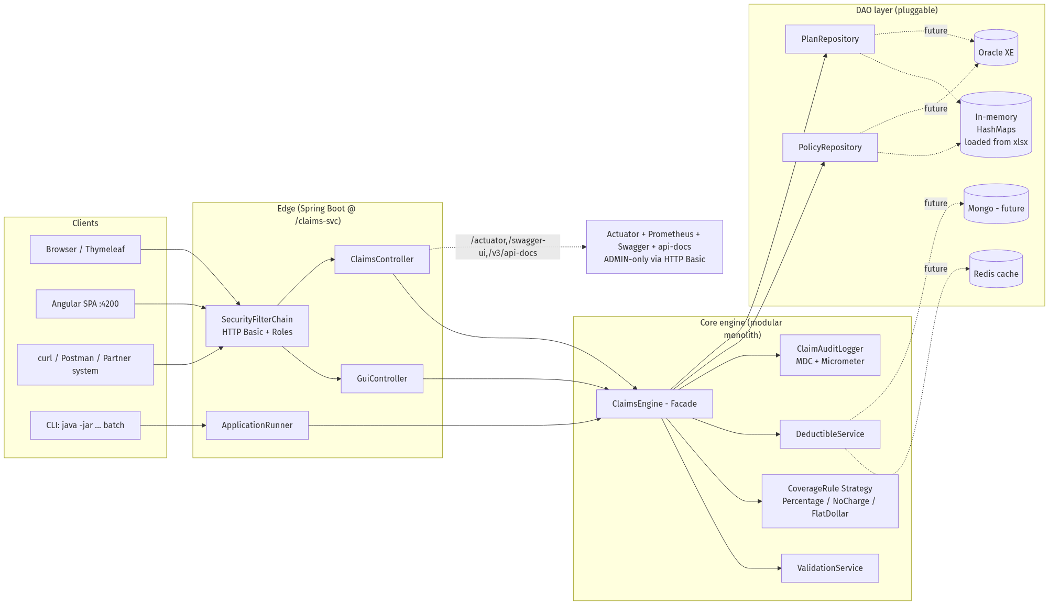

8.2 LLD — Domain class diagram
Strategy pattern for coverage rules. The engine orchestrates four collaborators behind interfaces so every dependency is swappable (in-memory today, Oracle / Redis tomorrow).
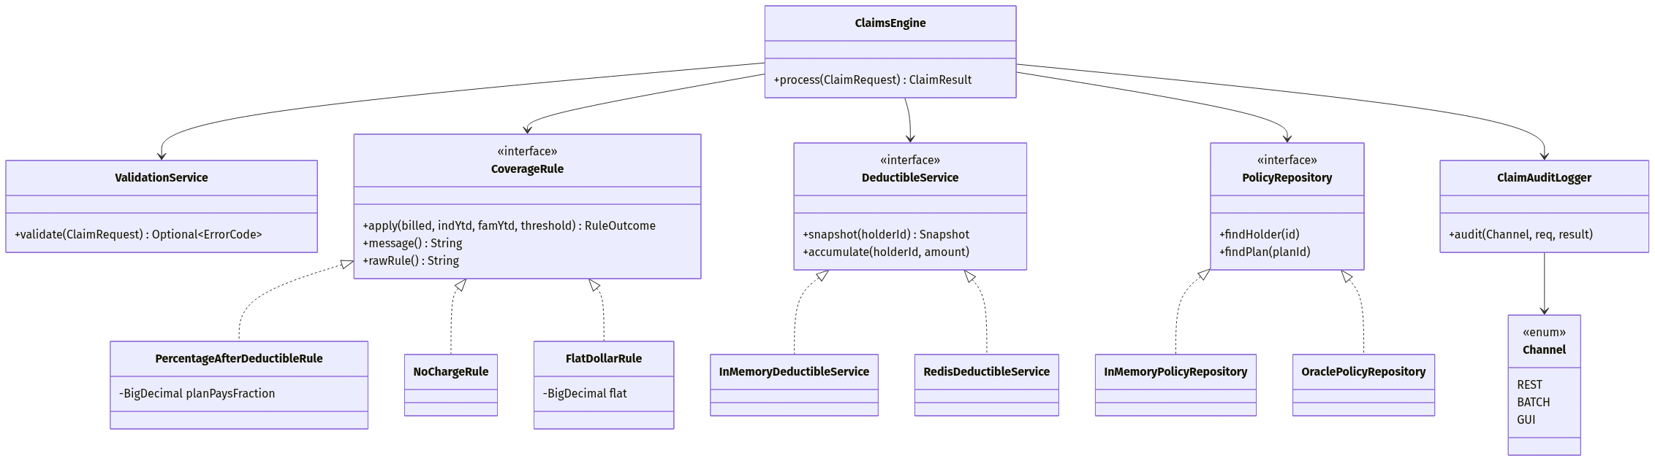

8.3 Data flow — three operating modes
GUI, CLI, and REST all funnel into the same ClaimsEngine.process(...). Only the I/O adapter differs.
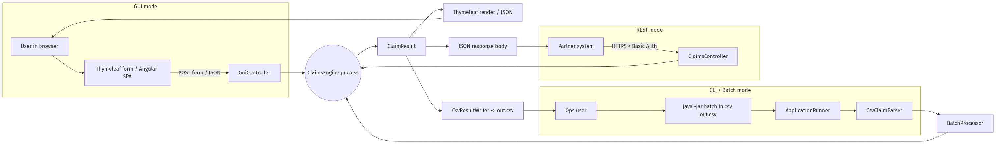

8.4 Sequence flow — REST claim adjudication
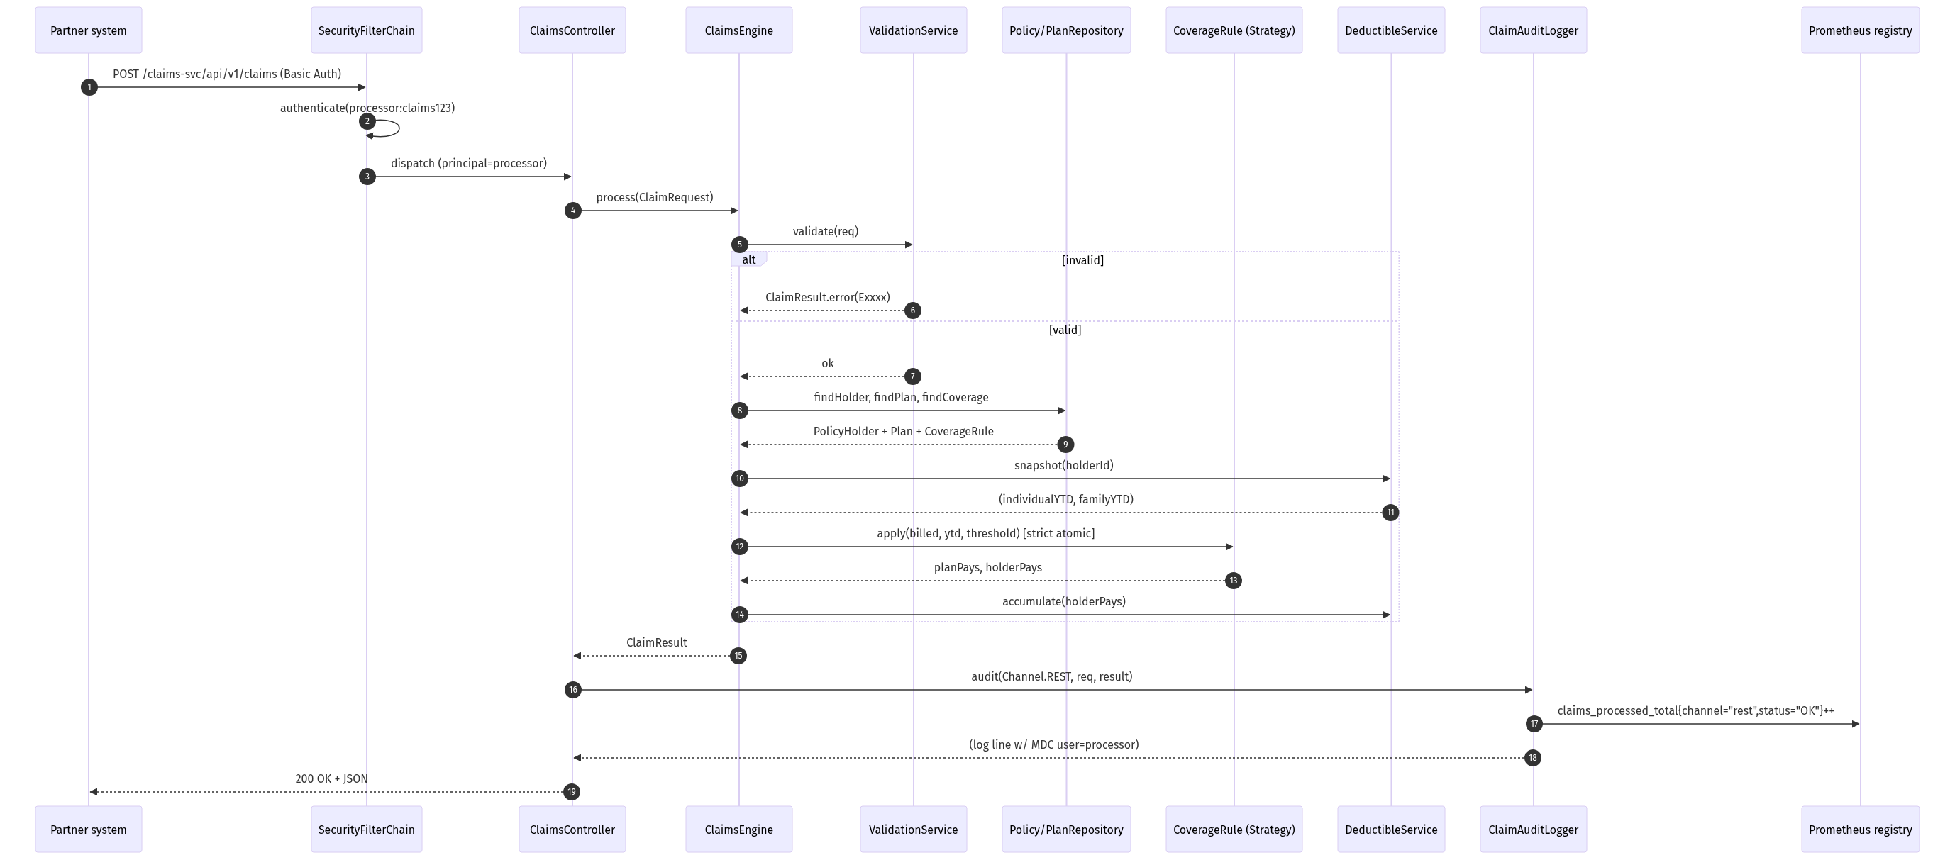

8.5 Sequence flow — Batch CSV processing
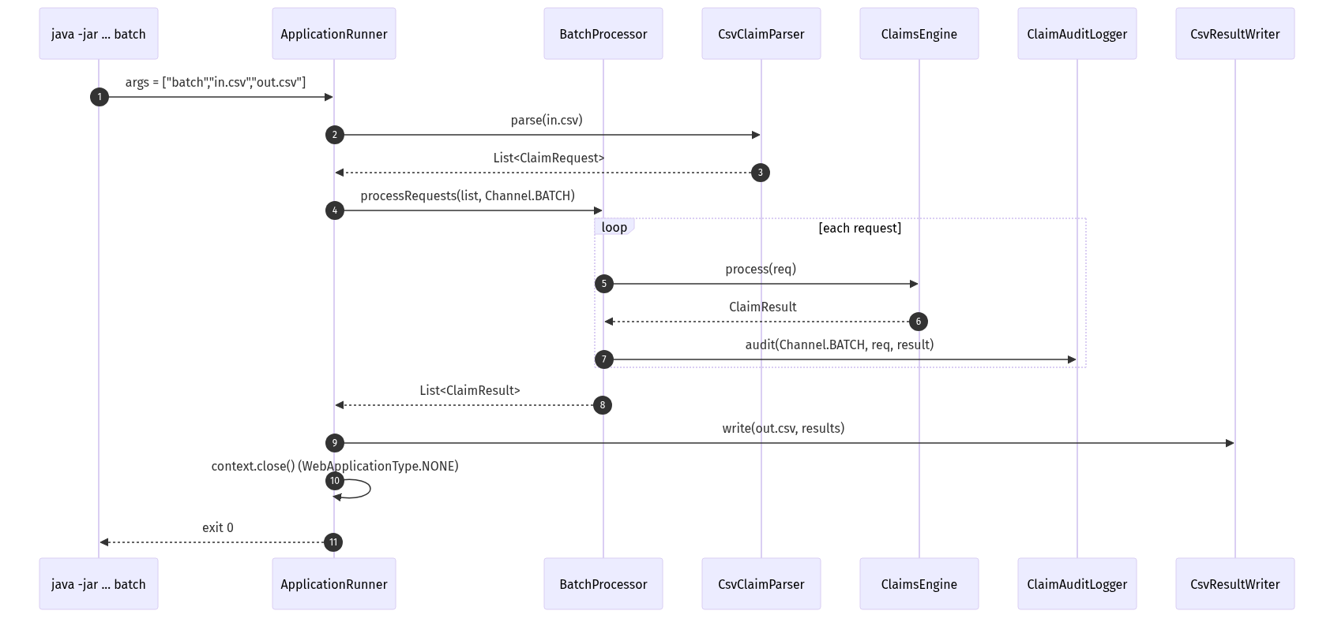

8.6 Flowchart — Claims engine decision tree (strict atomic)
The decision tree below is the exact path every claim follows. Per A6, the "deductible met?" check is made once against pre-claim YTD; a single claim is never split across the threshold.
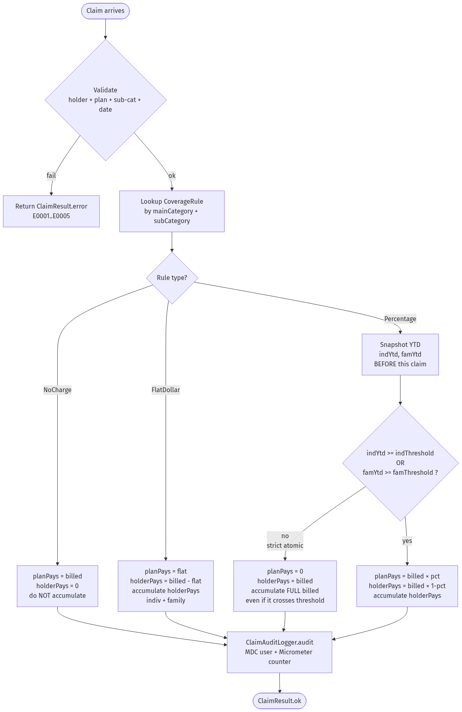

9. Non-Functional Considerations

Performance
- 700k claims/day ≈ 8 claims/second average, but real hospital systems spike at end-of-day
- Batch processing is I/O-bound (CSV read/write), not CPU-bound — parallelism via parallelStream() or Spring Batch partitioning could increase throughput
- REST endpoint is stateless; horizontal scaling behind a load balancer handles peak real-time volume
- In-memory map lookups are O(1) — no bottleneck at this data size

Reliability
- Input CSV validation before processing — fail fast on malformed headers
- Error rows do not abort the batch — they are recorded and processing continues
- Log every claim with correlation ID (policyId + holderId + date) for auditability

Security
- REST API: add spring-boot-starter-security with API key header (X-API-Key) for internal systems
- Input sanitization: all strings validated and trimmed; numeric fields bounded (billedAmount > 0)
- No SQL injection risk (no SQL used), but still validate that string inputs don't exceed expected lengths

Extensibility
- New plan: add a row to PlanDescriptions + PlanCoverage tabs — no code changes
- New coverage rule type: add one CoverageRule implementation and update CoverageRuleParser
- New error type: add enum value + validation check in ValidationService

10. Future State — Azure Public Cloud

10.1 HLD — Target architecture (Azure / AKS)
Three microservices behind APIM. Each service owns its own data — no shared writes — and the deductible hot path lives in Redis, not Oracle.
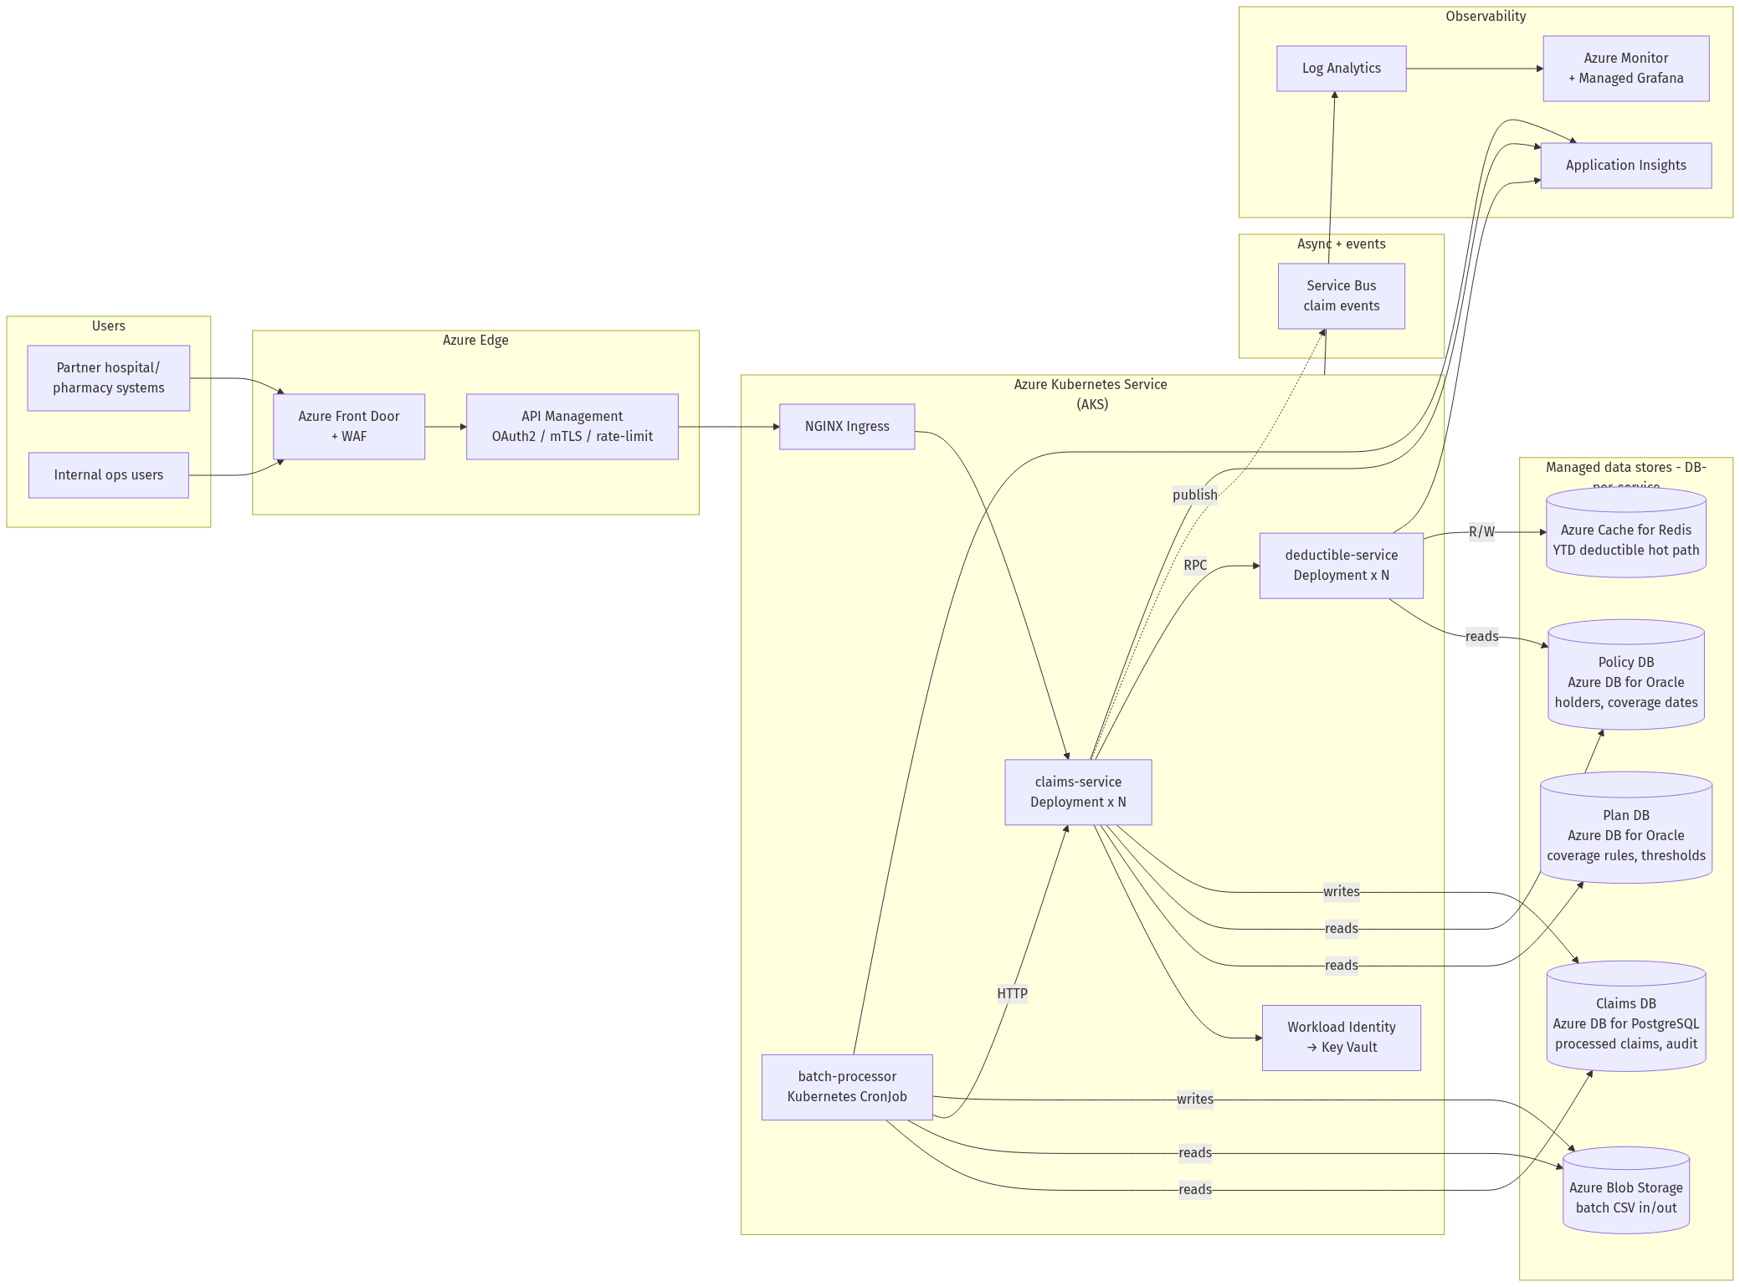

10.2 LLD — Internal structure of each microservice
Each pod contains the same layered structure (controller → service → repository), so engineers move between services with zero ramp-up. Only the persistence adapters and exposed endpoints differ.
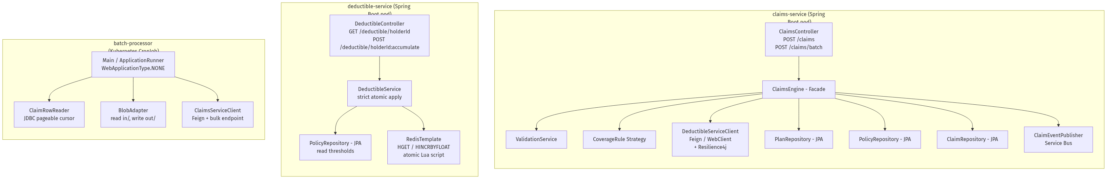

10.3 Data flow — Database ownership (DB-per-service)
claims-service
├── reads Plan DB (coverage rules, thresholds)
├── reads Policy DB (policyholder, coverage dates)
└── writes Claims DB (processed result + audit row)
deductible-service
├── reads Policy DB (individual / family thresholds)
└── reads/writes Redis (hot YTD state — NOT an Oracle DB)
batch-processor (CronJob)
├── reads Claims DB (unprocessed rows / replay file)
├── reads Blob Storage (incoming CSV)
├── writes Blob Storage (outgoing CSV)
└── calls claims-service (delegates processing — no direct DB write)
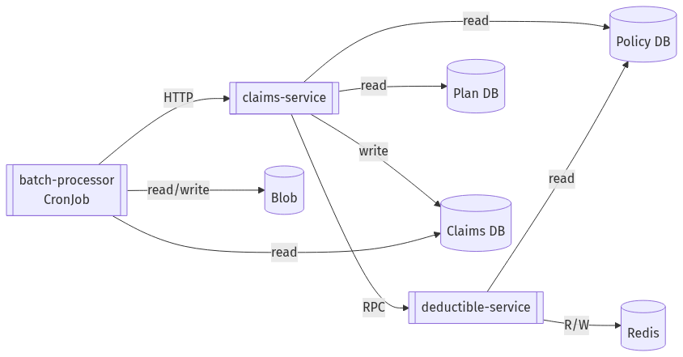

10.4 Sequence flow — Real-time REST claim on AKS
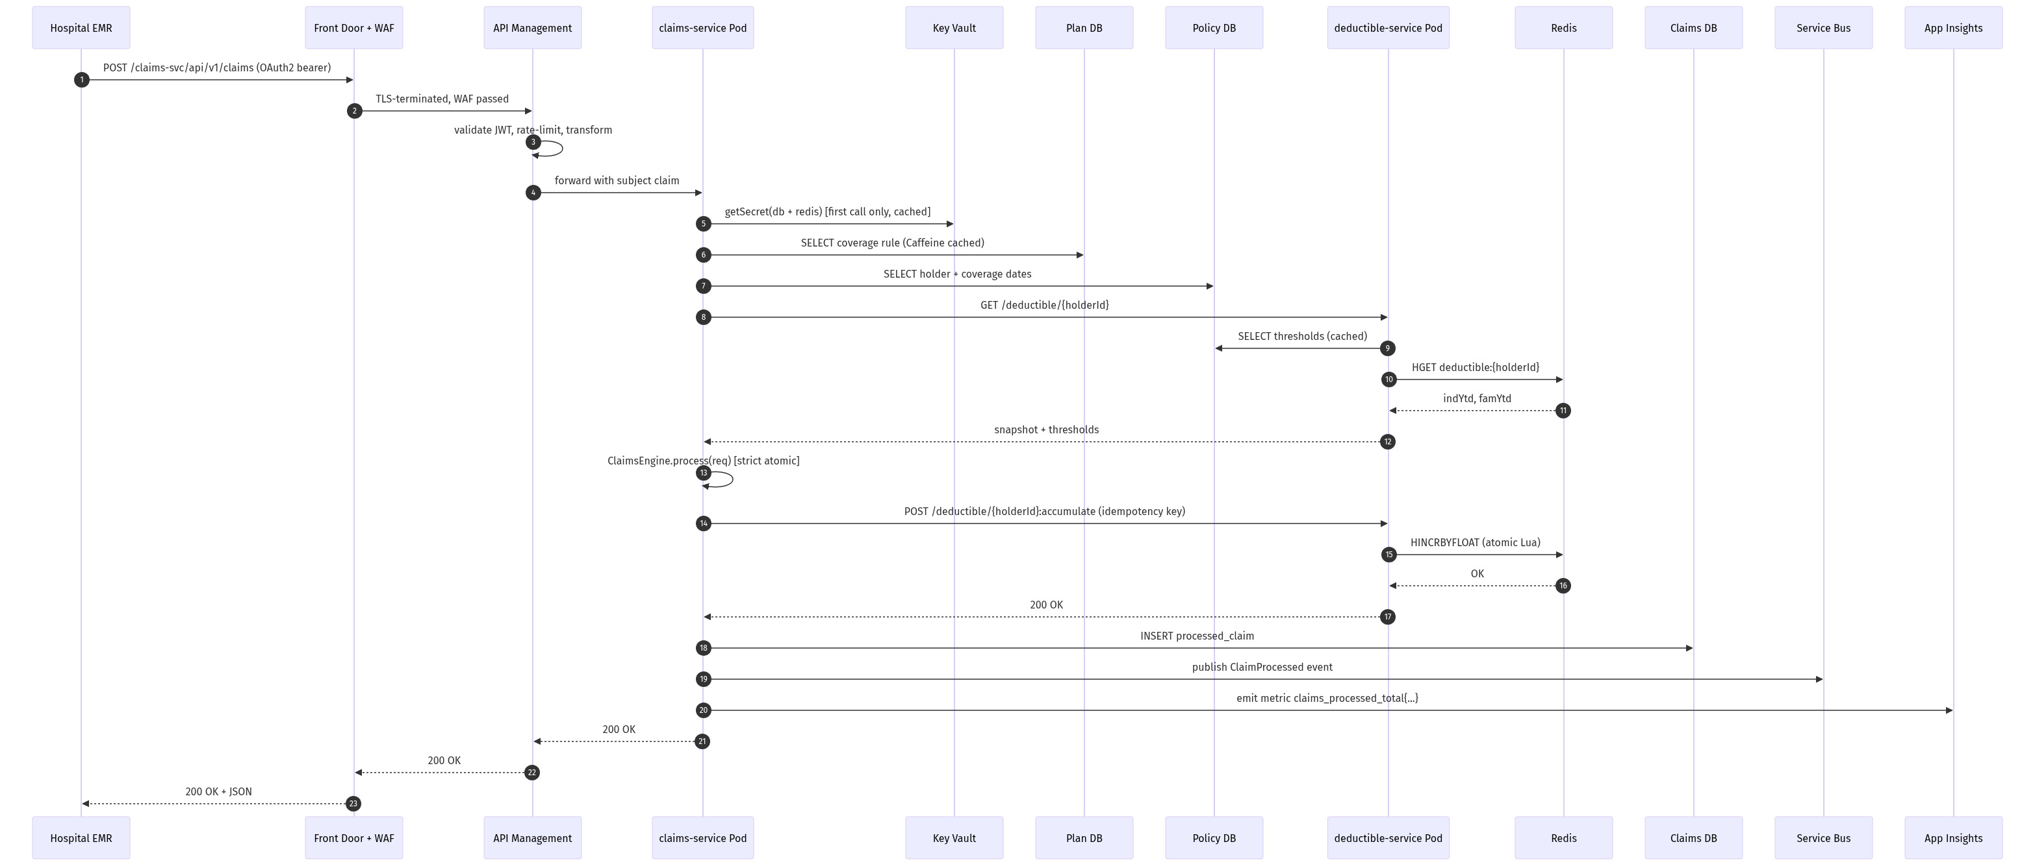

10.5 Sequence flow — Batch processor (Kubernetes CronJob)
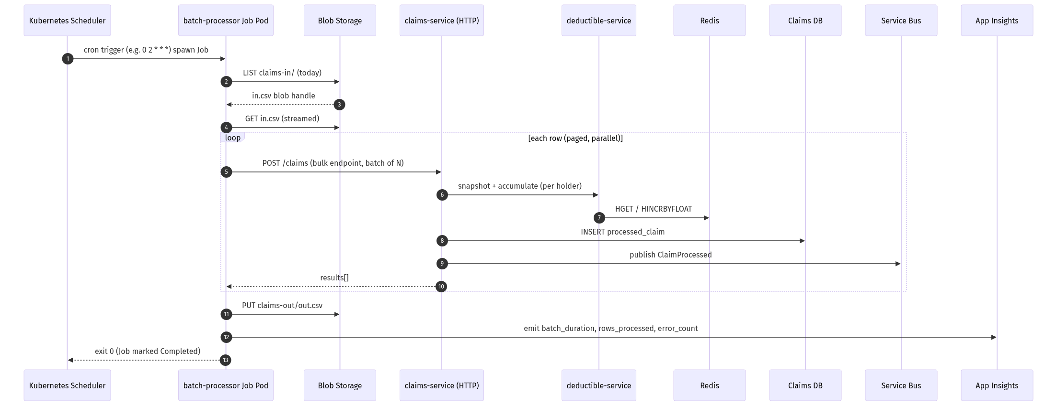

10.6 Modular monolith → microservices extraction path
The current modular monolith was designed so that the DeductibleService can be lifted out into its own microservice without touching the engine — only its injected implementation changes.
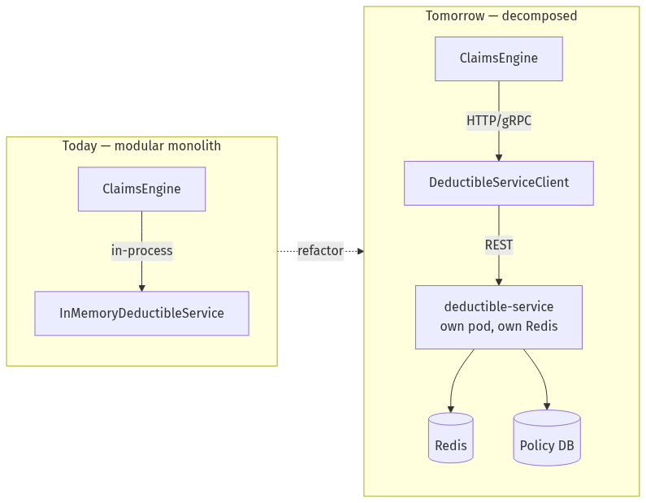
Extraction checklist:
- Replace @Component InMemoryDeductibleService with @Component DeductibleServiceClient implements DeductibleService (Feign / WebClient).
- New repo deductible-service: copy the engine/deductible package + Redis impl + REST controller exposing GET /deductible/{holderId} and POST /deductible/{holderId}:accumulate.
- Add idempotency key on the accumulate call (Service Bus message-id).
- Add Resilience4j circuit-breaker + fallback (use stale Redis snapshot or degrade to "deductible-not-applied" with E0005).
- Roll out behind a feature flag (Azure App Configuration) — toggle per tenant.

10.7 Azure mapping cheat-sheet
Concern | Local today | Azure target
Compute | mvn spring-boot:run | AKS Deployment (3+ pods) per service
Batch | java -jar ... batch | Kubernetes CronJob spawning Job Pods
Plan DB | In-memory HashMap (loaded from xlsx) | Azure DB for Oracle
Policy DB | In-memory HashMap | Azure DB for Oracle
Claims DB | none (output CSV only) | Azure DB for PostgreSQL
Deductible cache | In-memory ConcurrentHashMap | Azure Cache for Redis (Premium, geo-replicated)
Audit store | Logback console + file | Claims DB audit table + Log Analytics
Batch trigger | CLI arg | Kubernetes CronJob (schedule: "0 2 * * *") — Blob trigger optional
Secrets | none | Key Vault + Workload Identity
Auth | HTTP Basic in-mem | APIM OAuth2 (Entra ID) → JWT validated by Spring Security resource server
Metrics | /actuator/prometheus (ADMIN) | Application Insights + Azure Managed Grafana
Tracing | logs only | OpenTelemetry → App Insights (W3C trace-context already propagated by Spring Boot)
CI/CD | local mvn | GitHub Actions / Azure DevOps → ACR → AKS rollout
Frontend | Angular dev server | Static Web Apps (with APIM as backend)

10.8 Cross-cutting concerns added on the cloud path
- Idempotency: every REST call accepts Idempotency-Key header; APIM dedupes; engine cache (holder, dos, billed) for 24 h.
- Circuit-breaker / retry: Resilience4j around Oracle + Redis + downstream deductible-svc.
- Dead-letter: Service Bus DLQ for poison messages; Logic App alerts ops.
- Zero-trust: mTLS pod-to-pod via Azure Service Mesh (or Istio); Key Vault for all secrets; Managed Identity, no passwords in application.yml.
- Multi-region DR: Front Door active-active, AKS in two paired regions, Cosmos DB multi-write, Redis geo-replication.
- Compliance: HIPAA — audit log immutable in Cosmos with TTL=7y; PII redaction filter in Logback before App Insights sink.

11. Test Strategy

Unit tests (JUnit 5 + AssertJ)
Test class | What it covers
CoverageRuleParserTest | All three rule type parsings, edge cases (no $ sign, "100" as flat dollar, mixed case)
DeductibleServiceTest | Individual met only, family met only, neither met (holder pays 100%), both met, and a strict-atomic boundary case (YTD just under threshold, single claim does NOT cross within itself)
ValidationServiceTest | Each error code triggered correctly, valid claim passes
ClaimsEngineTest | Full claim-to-result for each row in SampleTransactionsProcessed (golden path)

Integration test
BatchProcessorTest: reads the full SampleTransactions CSV and compares output row-by-row against SampleTransactionsProcessed. This is the demo test.

Additional test cases (beyond sample data)
- Claim exactly at the deductible threshold (boundary test)
- Family deductible met before individual (P001 family scenario)
- Service date = coverage start date (inclusive)
- Service date = coverage end date (inclusive)
- billedAmount = $0 edge case
- malformed billedAmount in CSV (e.g., "abc")
- Empty CSV file
- CSV with only a header row

12. pom.xml dependencies
<dependencies>
<!-- Spring Boot Web + Thymeleaf -->
<dependency>
<groupId>org.springframework.boot</groupId>
<artifactId>spring-boot-starter-web</artifactId>
</dependency>
<dependency>
<groupId>org.springframework.boot</groupId>
<artifactId>spring-boot-starter-thymeleaf</artifactId>
</dependency>
<dependency>
<groupId>org.springframework.boot</groupId>
<artifactId>spring-boot-starter-validation</artifactId>
</dependency>
<!-- Apache POI for Excel -->
<dependency>
<groupId>org.apache.poi</groupId>
<artifactId>poi-ooxml</artifactId>
<version>5.3.0</version>
</dependency>
<!-- OpenCSV for CSV parsing/writing -->
<dependency>
<groupId>com.opencsv</groupId>
<artifactId>opencsv</artifactId>
<version>5.9</version>
</dependency>
<!-- Test -->
<dependency>
<groupId>org.springframework.boot</groupId>
<artifactId>spring-boot-starter-test</artifactId>
<scope>test</scope>
</dependency>
</dependencies>
<build>
<plugins>
<plugin>
<groupId>org.springframework.boot</groupId>
<artifactId>spring-boot-maven-plugin</artifactId>
</plugin>
</plugins>
</build>

13. Interview Talking Points
"Walk me through your assumptions"
Start with A1 (running YTD state), A2 (family vs individual accumulation), and A6 (strict atomic, pre-claim deductible determination — never split a single claim across the threshold). These are the three most important and likely to generate discussion. Back A6 up with row 16 of `SampleTransactionsProcessed` (holder 1000021, LAB TESTS $1,200 with remaining-to-threshold only $1,000) — only strict atomic reproduces holder=$1,200 / plan=$0; straddle would give $1,020 / $180.
"Explain your design"
Three modes, one engine. The `ClaimsEngine` is the single source of truth for claims logic. All three modes (GUI, CLI, REST) call the same service — no duplication of business logic. The Strategy pattern makes adding new coverage rule types trivial.
"What would you do differently at production scale?"
Move reference data to Oracle (as the company already uses). Move deductible state to Redis for sub-millisecond reads across distributed instances. Break into microservices: claims-validator, deductible-service, coverage-service, each independently scalable. Use AWS Step Functions for batch orchestration with retry and DLQ support.
"What are the trade-offs of your approach?"
In-memory store is simple to implement and fully correct for the test scenario, but does not support multiple instances running concurrently (a distributed batch would have race conditions on the deductible state). The fix is optimistic locking in a database, or a Redis INCR operation which is atomic.
"How long did this take and what tools did you use?"
Be honest. Mention Claude / GitHub Copilot if used. The interviewers explicitly said AI tools are allowed — what matters is that you understand every line.

Appendix — Security (Spring Security + HTTP Basic, JWT-ready)

Current implementation
- spring-boot-starter-security is on the classpath. SecurityConfig registers
- admin / admin123 &mdash; roles ADMIN, PROCESSOR
- processor / claims123 &mdash; role PROCESSOR
- /api/**, /, and /process/** require role PROCESSOR.
- CSRF is disabled (no server-rendered forms post outside the same session;
- Sessions are IF_REQUIRED &mdash; APIs are stateless, Thymeleaf GUI uses a
- All curl scripts, Postman collection, and Angular interceptor

Why HTTP Basic and not JWT
For a single Spring Boot deployment fronting an Angular SPA over TLS, HTTP Basic is the simpler, more honest choice:
Concern | HTTP Basic | JWT
Single trusted backend | ✅ enough | overkill
Stateless | ✅ | ✅
Standard browser support | ✅ | needs script
Multiple microservices verify identity | ❌ revalidate | ✅ self-contained
Federated identity / SSO | ❌ | ✅ via OIDC
Issuing and rotating JWTs without an identity provider would mean writing key material, signing logic, and revocation lists into the application &mdash; all risk surface that delivers no value today.

Migration path to JWT (Azure / AWS)
When the deductible service or coverage service is extracted as an independent microservice, drop in spring-boot-starter-oauth2-resource-server and point spring.security.oauth2.resourceserver.jwt.issuer-uri at:
- Azure Entra ID &mdash; https://login.microsoftonline.com/<tenant>/v2.0
- AWS Cognito &mdash; https://cognito-idp.<region>.amazonaws.com/<userPoolId>
SecurityConfig becomes a five-line oauth2ResourceServer(jwt()) configuration and the same hasRole("PROCESSOR") rules continue to work &mdash; map the issuer&#39;s roles or groups claim to Spring authorities with a JwtAuthenticationConverter. The Angular interceptor switches from sending Basic <token> to sending Bearer <token> obtained from MSAL.js or Amplify. No other code changes.

