LAB-1
NETWORK COMMANDS

BY:
LOKESH KUMAR R
CH.EN.U4CSE20140

BASIC NETWORK COMMANDS:
- Ping[address]-
ping is the primary TCP/IP command used to troubleshoot connectivity, reachability, and name resolution. Used without parameters, this command displays Help content. You can also use this command to test both the computer name and the IP address of the computer
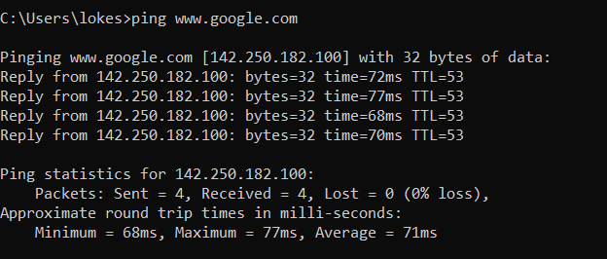
- Ipconfig:
ipconfig (standing for "Internet Protocol configuration") is a console application program of some computer operating systems that displays all current TCP/IP network configuration values and refreshes Dynamic Host Configuration Protocol (DHCP) and Domain Name System (DNS) settings.
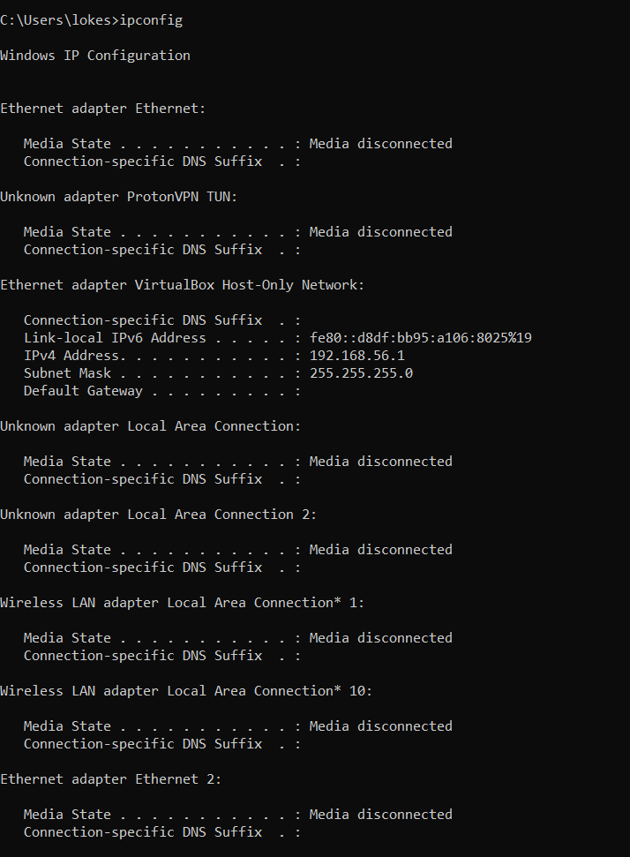
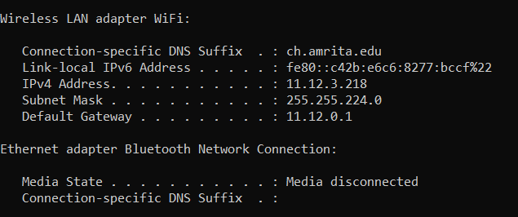
- Getmac:
Returns the media access control (MAC) address and list of network protocols associated with each address for all network cards in each computer, either locally or across a network. This command is particularly useful either when you want to enter the MAC address into a network analyzer, or when you need to know what protocols are currently in use on each network adapter on a computer.
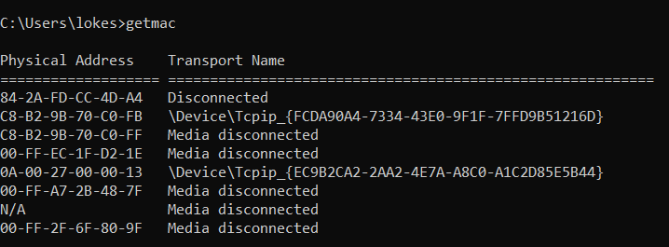
- Systeminfo:
Displays detailed configuration information about a computer and its operating system, including operating system configuration, security information, product ID, and hardware properties (such as RAM, disk space, and network cards).
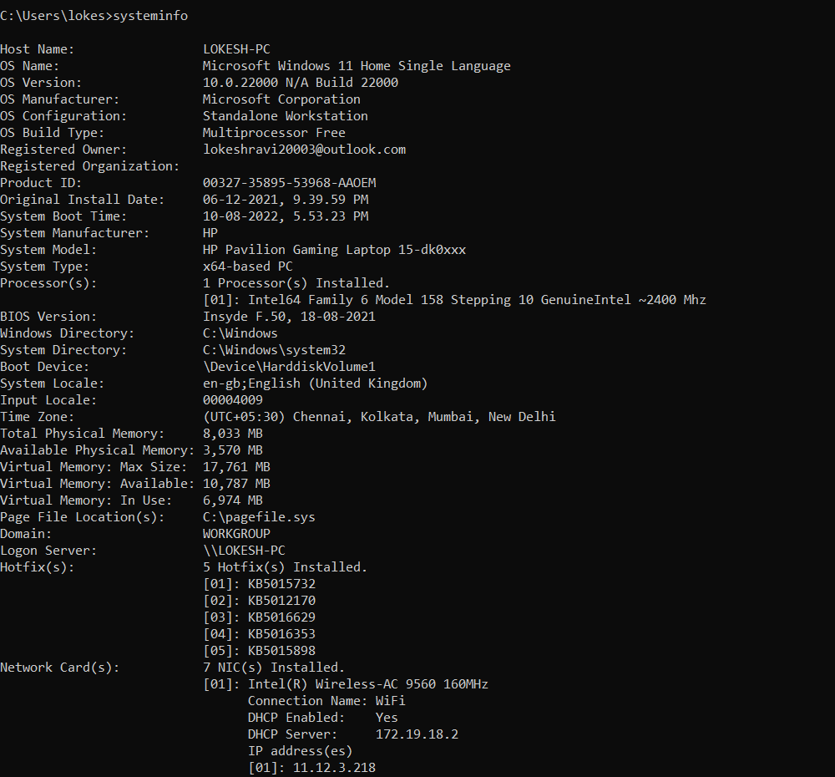
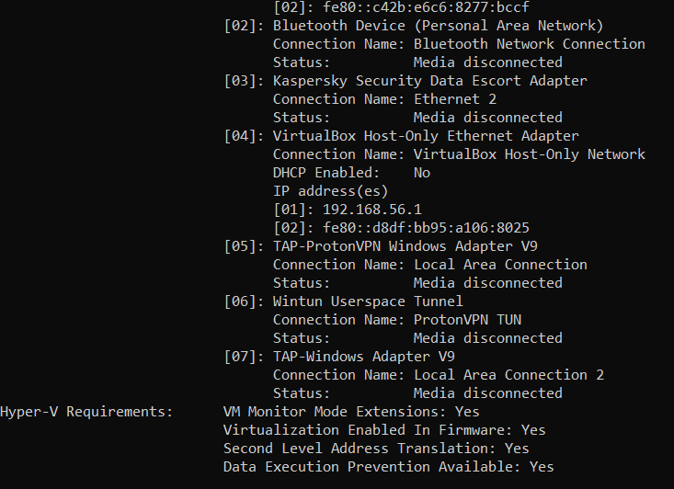
- Tracert[address]:-
to trace the path that an Internet Protocol (IP) packet takes to its destination.
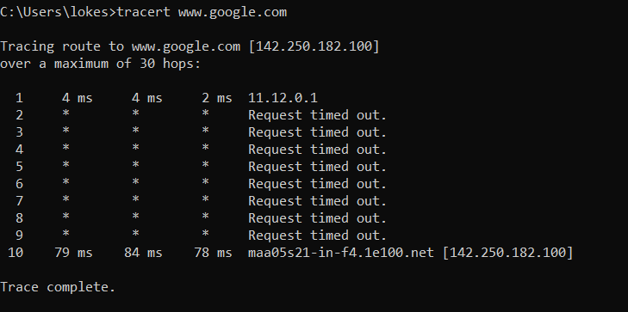
- Hostname:
The /usr/bin/hostname command displays the name of the current host system. Only users with root user authority can set the host name. The mkdev command and the chdev commands also set the host name permanently. Use the mkdev command when you are defining the TCP/IP instance for the first time.

- Nslookup:
The nslookup command queries internet domain name servers in two modes. Interactive mode allows you to query name servers for information about various hosts and domains, or to print a list of the hosts in a domain. In noninteractive mode, the names and requested information are printed for a specified host or domain.
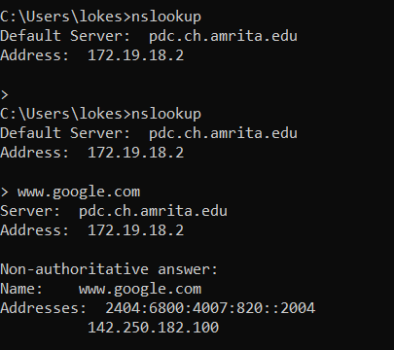
- Arp /a:
The arp command displays and modifies the Internet-to-adapter address translation tables used by the Address in Networks and communication management. The arp command displays the current ARP entry for the host specified by the HostName variable.
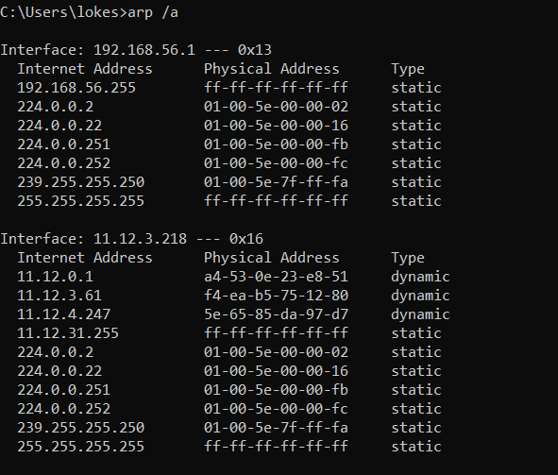
- Netstat:
The netstat command generates displays that show network status and protocol statistics. You can display the status of TCP and UDP endpoints in table format, routing table information, and interface information. The most frequently used options for determining network status are: s , r , and i .
