1 . Write a Python program to check that a string contains only a certain set of characters (in this case a-z, A-Z and 0-9)

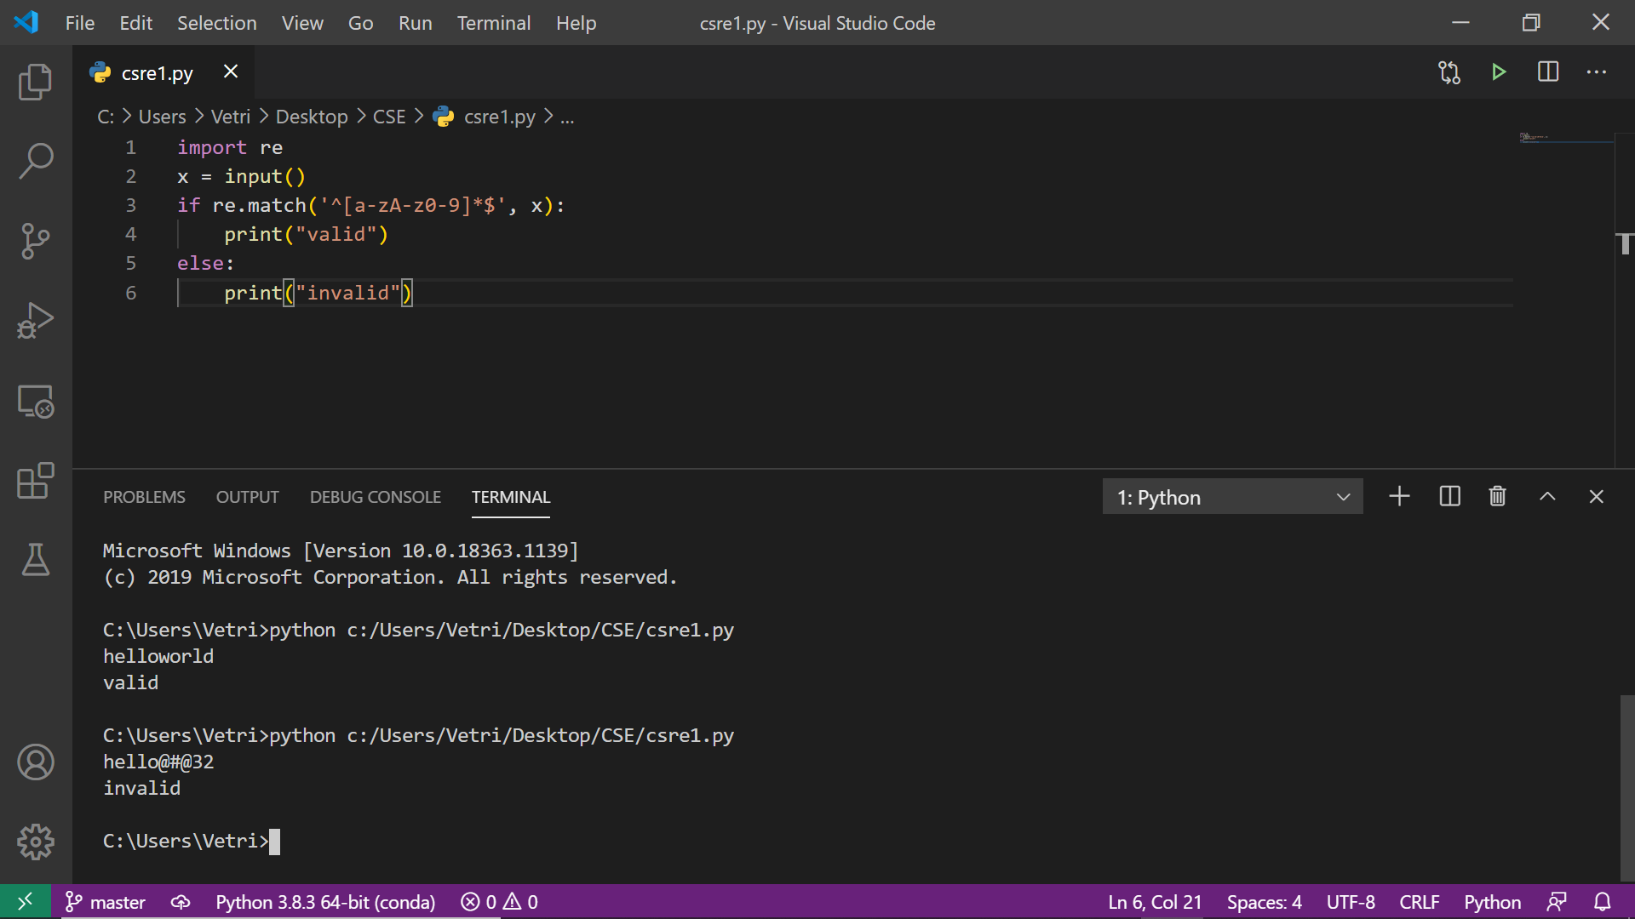

2. Write a Python program to find sequences of lowercase letters joined with a underscore.

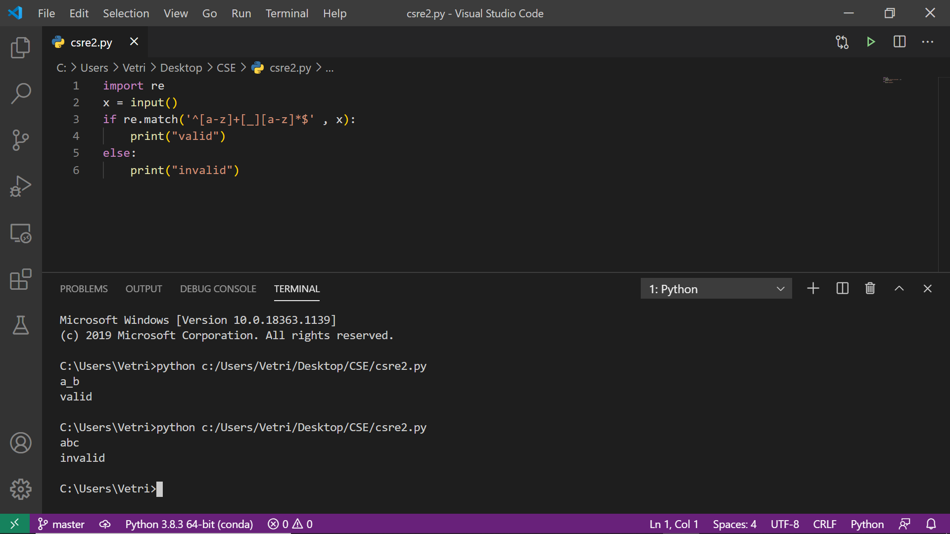

3. Write a Python program to find the sequences of one upper case letter followed by lower case letters

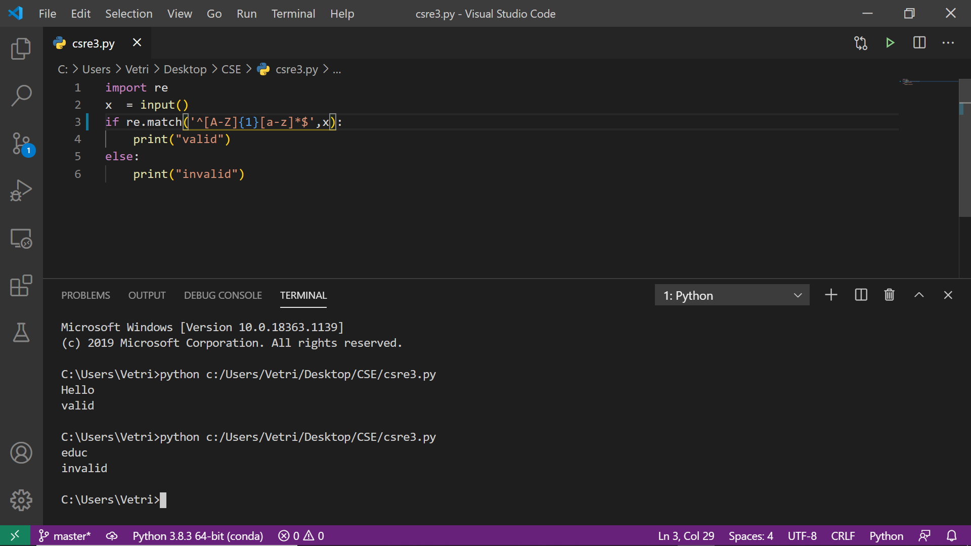

4.write a python program that matches a word at the beginning of the string

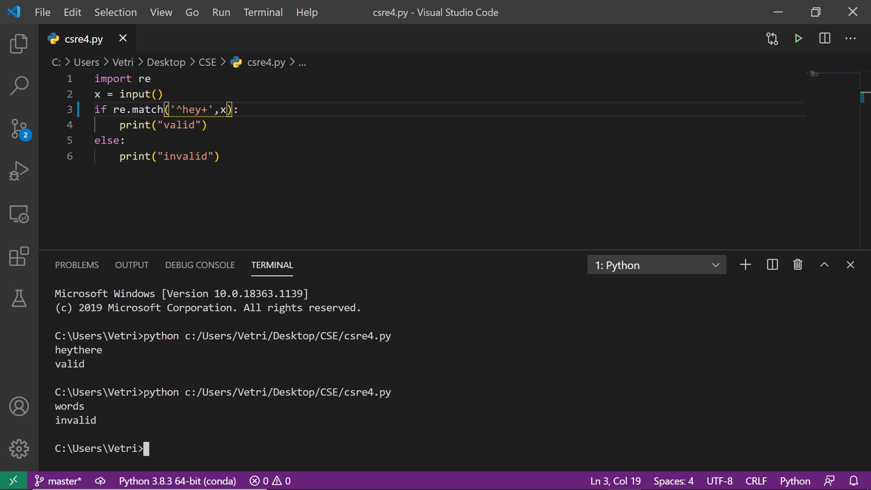

5. Write a Python program that matches a word at the end of string, with optional punctuation

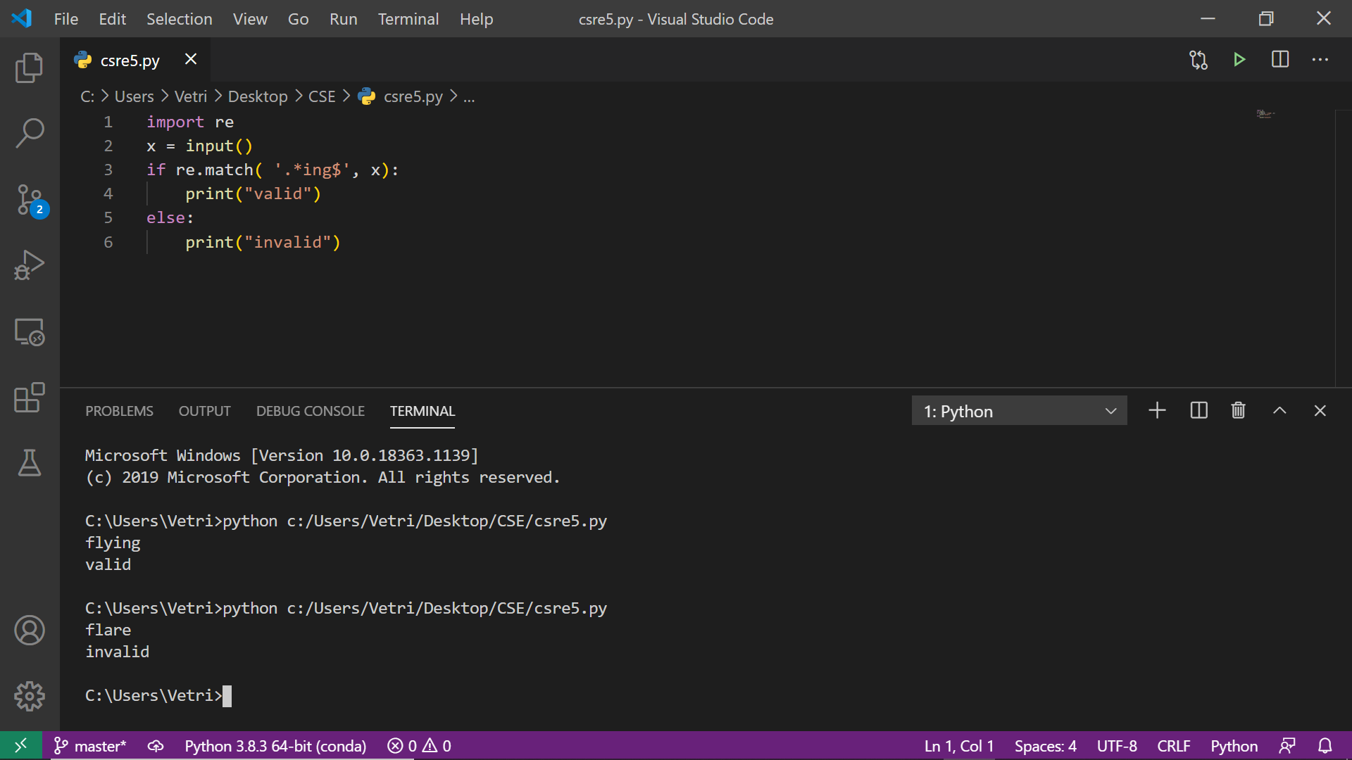

6. Write a Python program that matches a word containing 'z'.

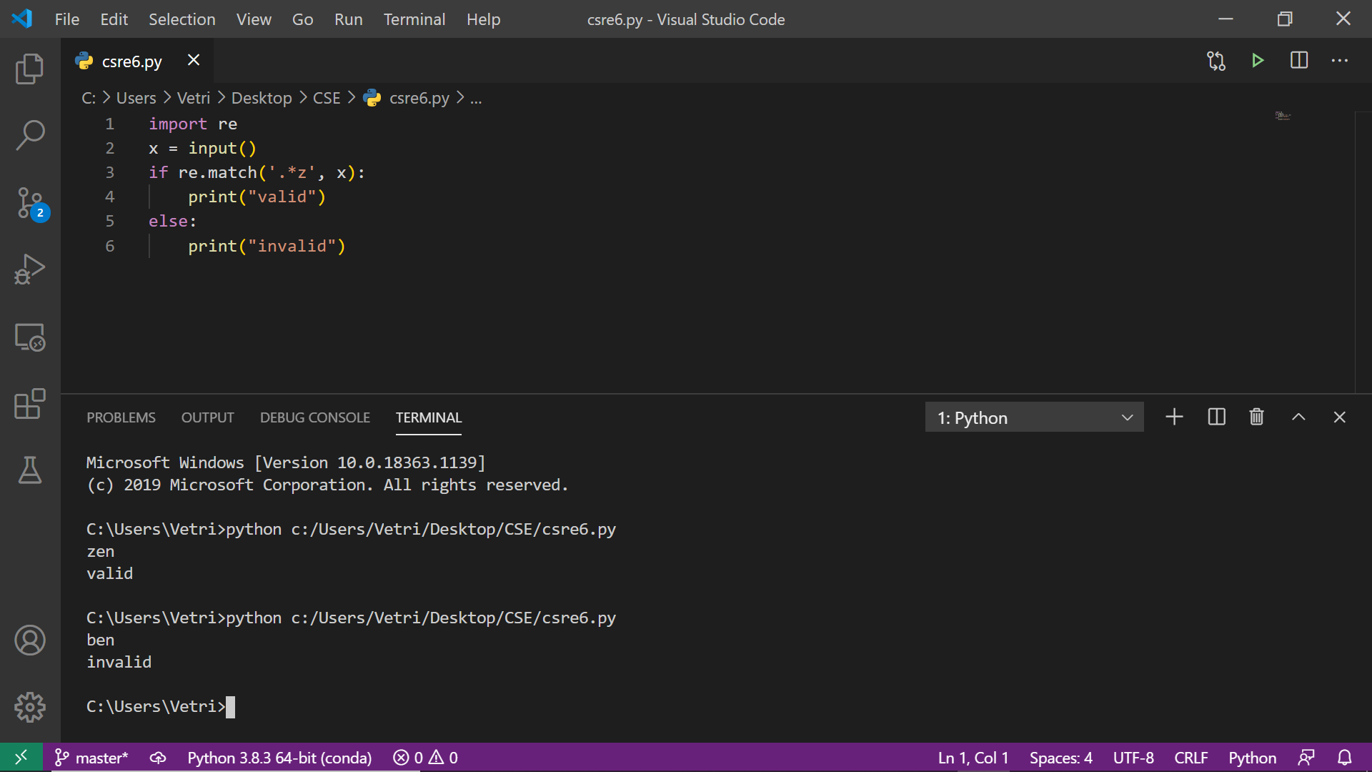

7. Write a Python program to match a string that contains only upper and lowercase letters, numbers, and underscores

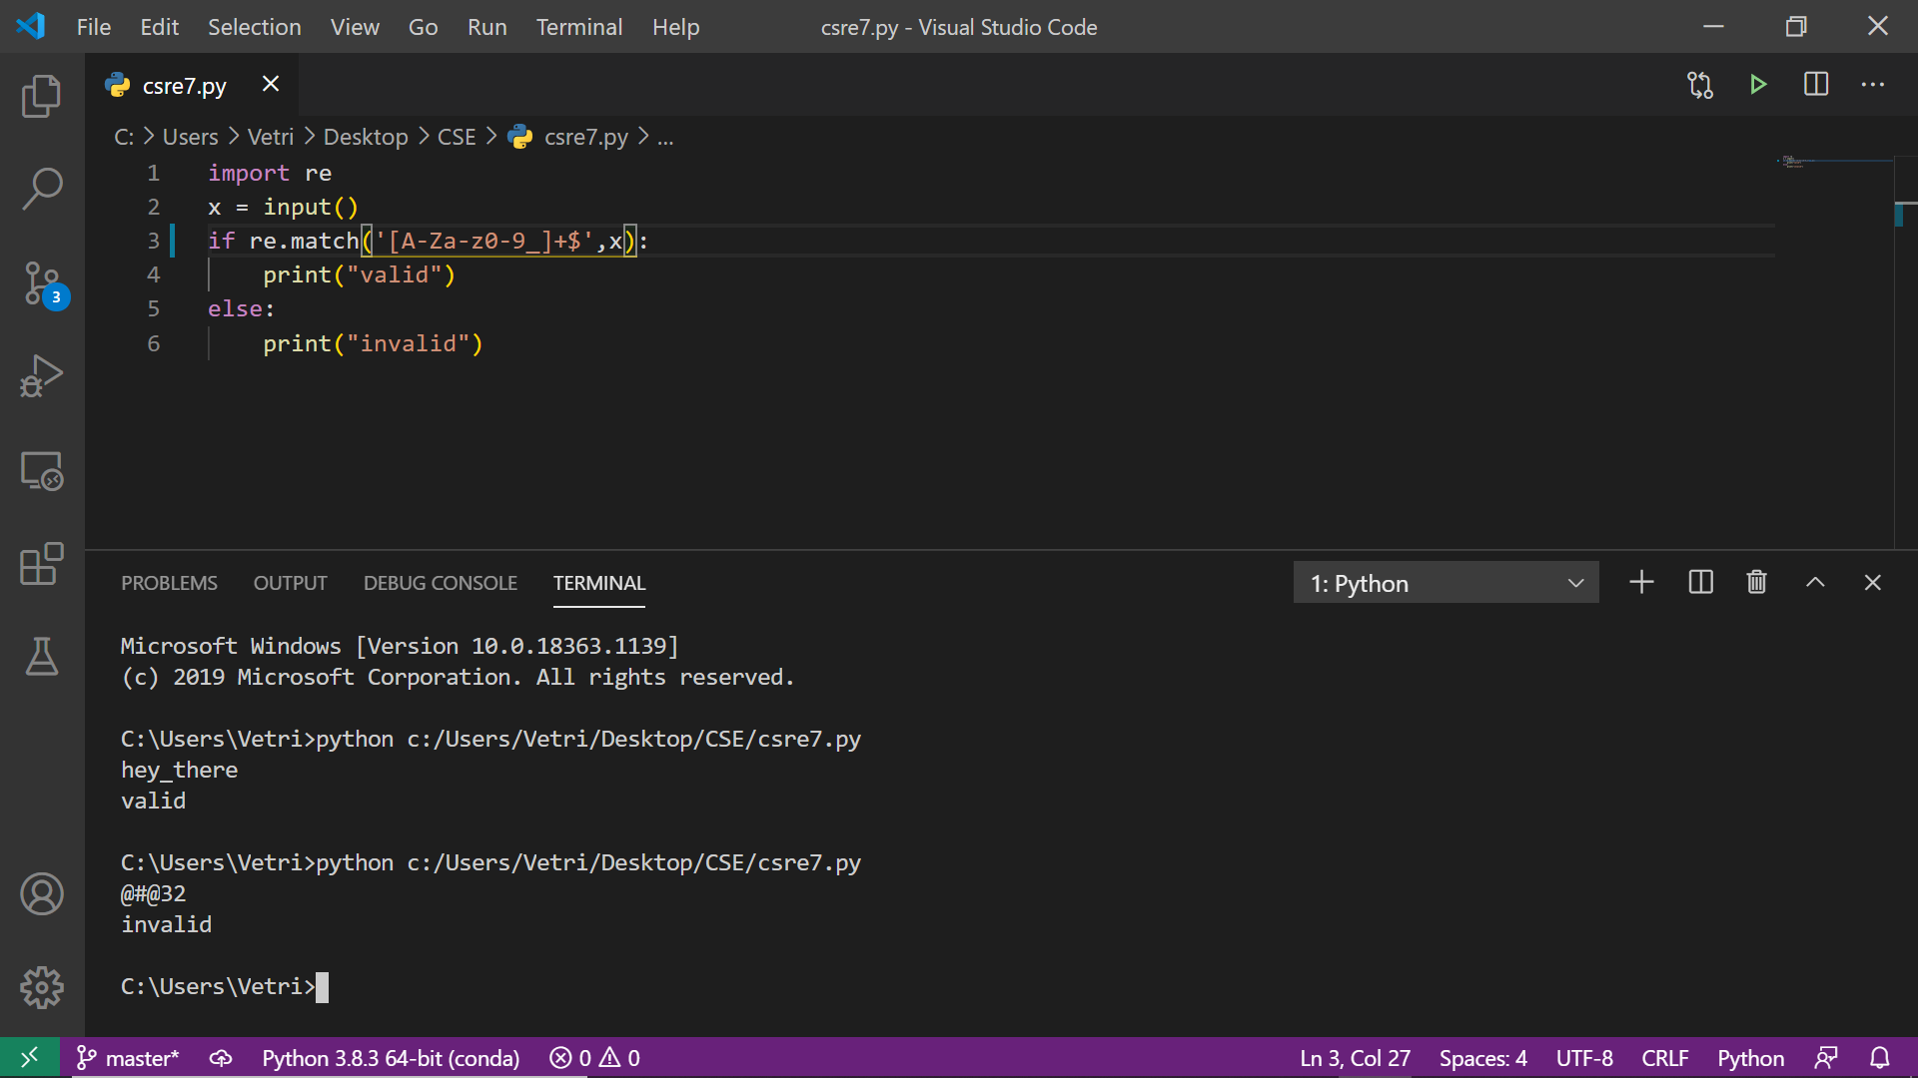

8. Write a Python program that matches a word containing 'z', not at the start or end of the word

