

SWIGGY FUNNEL ANALYSIS

REPORT

Dr. Bhawna Malik

16 July 2023

**Aim of the Project :**

The goal of this project is to analyze a Swiggy dataset and conduct an in-depth analysis to understand the reasons behind the rise and fall in orders using funnel analysis. We need to understand the root causes that go up and down, starting with different conversions. Also to make possible suggestions for improvement in a growing company.

**Key Analysis:**

1. **Identify if traffic fluctuated as compared to the same day last week:**

| Date of low orders | DATE w.r.t same day last week | Change in orders | Change in traffic | Source of traffic change |
| --- | --- | --- | --- | --- |
| 10/01/19 | 03/01/19 | -45% | **-49%** | Decline in Fb users |
| 29/01/19 | 22/01/19 | -72% | **-40%** | Decline in twitter users and other sources |
| 19/02/19 | 12/02/19 | -56% | -4% | Negligible change |
| 02/03/19 | 23/02/19 | -38% | 8% | Negligible change |
| 19/03/19 | 12/03/19 | -46% | 2% | Negligible change |
| 04/04/19 | 28/03/19 | -52% | 3% | Negligible change |
| 12/04/19 | 05/04/19 | -27% | -9% | Negligible change |
| 25/04/19 | 18/04/19 | -39% | 0% | Negligible change |
| 20/06/19 | 13/06/19 | -54% | **-53%** | Drop in traffic due to  Festivals, weekends or other technical glitch |
| 16/07/19 | 09/07/19 | -63% | -10% | Negligible change |
| 11/08/19 | 04/08/19 | -54% | 0% | Negligible change |
| 14/09/19 | 07/09/19 | -54% | -5% | Negligible change |
| 17/11/19 | 10/11/19 | -57% | -7% | Negligible change |

| DATE of HIGH orders | Date w.r.t same day last week | Change in orders | Change in traffic | Source of traffic change |
| --- | --- | --- | --- | --- |
| 17/01/19 | 10/01/19 | 106% | **110%** | **Increase in all users due to weekends, festivals , available discounts** |
| 21/01/19 | 14/01/19 | 23% | 5% | Negligible change |
| 22/01/19 | 15/01/19 | 85% | **77%** | **Increase in twitter users** |
| 31/01/19 | 24/01/19 | 20% | 1% | Negligible change |
| 05/02/19 | 29/01/19 | 115% | 0% | Negligible change |
| 26/02/19 | 19/02/19 | 120% | 2% | Negligible change |
| 28/02/19 | 21/02/19 | 22% | 8% | Negligible change |
| 09/03/19 | 02/03/19 | 102% | 0% | Negligible change |
| 24/03/19 | 17/03/19 | 22% | 6% | Negligible change |
| 26/03/19 | 19/03/19 | 78% | -5% | Negligible change |
| 11/04/19 | 04/04/19 | 92% | -7% | Negligible change |
| 14/04/19 | 07/04/19 | 28% | 8% | Negligible change |
| 18/04/19 | 11/04/19 | 73% | 11% | Negligible change |
| 19/04/19 | 12/04/19 | 25% | 7% | Negligible change |
| 27/06/19 | 20/06/19 | 115% | **119%** | **Increase in all users due to weekends, festivals , available discounts** |
| 23/07/19 | 16/07/19 | 135% | 3% | Negligible change |
| 18/08/19 | 11/08/19 | 107% | 3% | Negligible change |
| 21/09/19 | 14/09/19 | 112% | -1% | Negligible change |
| 09/10/19 | 02/10/19 | 22% | -4% | Negligible change |
| 21/10/19 | 14/10/19 | 32% | 9% | Negligible change |
| 09/11/19 | 02/11/19 | 26% | 7% | Negligible change |
| 24/11/19 | 17/11/19 | 135% | 5% | Negligible change |
| 01/12/19 | 24/11/19 | 21% | 1% | Negligible change |
| 22/12/19 | 15/12/19 | 21% | 0% | Negligible change |

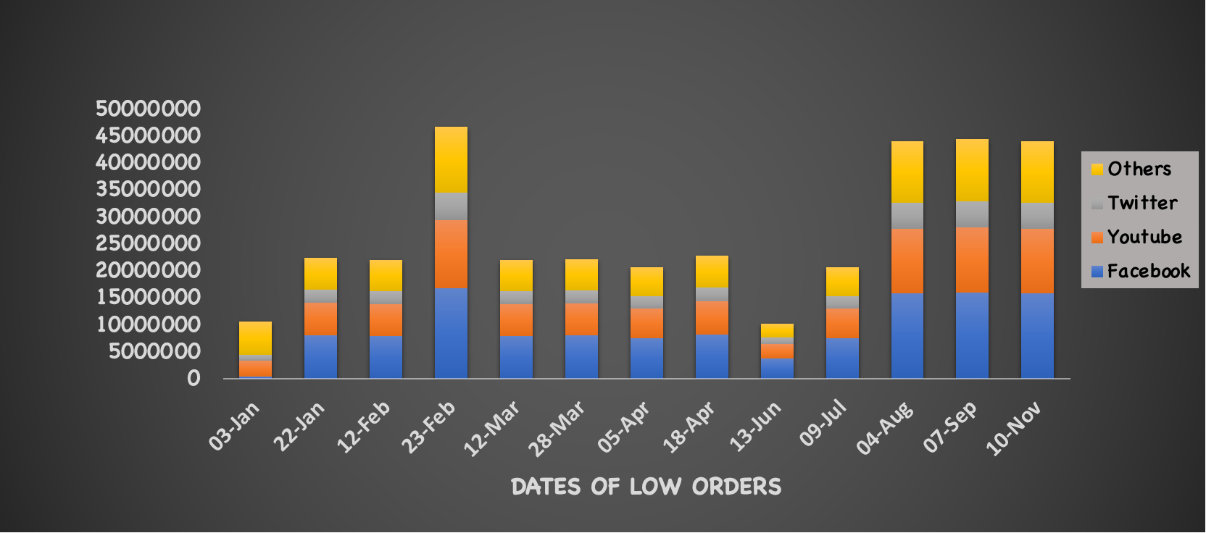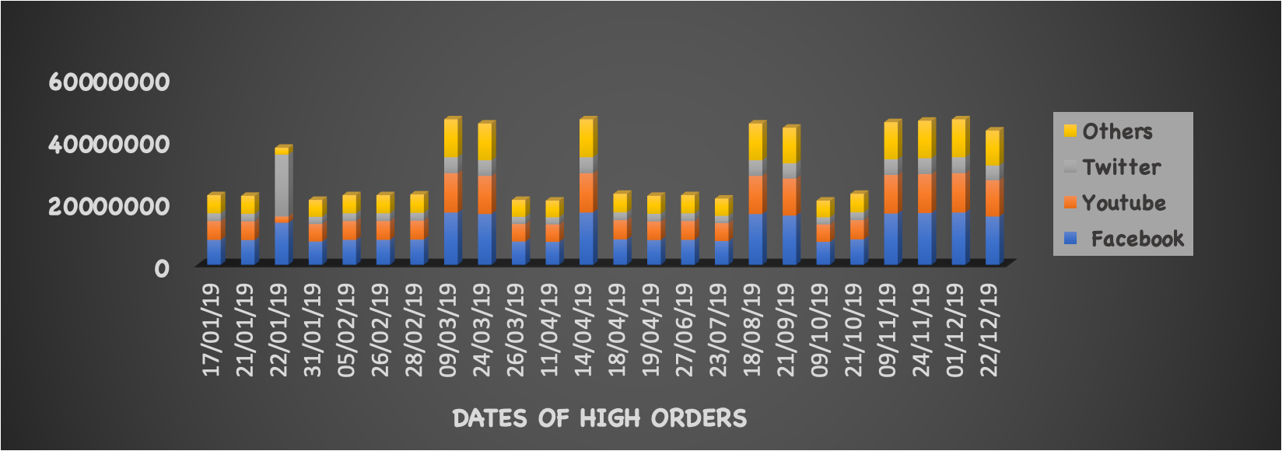

2. **Identify if Overall conversion fluctuated as compared to same day last week.**

| Date of low orders | DATE w.r.t same day last week | Overall conversion | L2M | M2C | C2P | P20 |
| --- | --- | --- | --- | --- | --- | --- |
| 10/01/19 | 03/01/19 | 6% | 3% | 1% | 2% | 1% |
| 29/01/19 | 22/01/19 | 3% | **-55%** | 8% | 2% | -5% |
| 19/02/19 | 12/02/19 | 3% | 1% | **-57%** | 1% | 4% |
| 02/03/19 | 23/02/19 | 2% | 0% | 5% | -49% | 7% |
| 19/03/19 | 12/03/19 | 3% | 4% | 6% | 2% | **-53%** |
| 04/04/19 | 28/03/19 | 3% | 7% | **-49%** | -8% | -8% |
| 12/04/19 | 05/04/19 | 6% | -7% | -7% | -5% | -4% |
| 25/04/19 | 18/04/19 | 6% | 5% | **-43%** | -5% | 7% |
| 20/06/19 | 13/06/19 | 6% | -2% | 7% | -7% | -1% |
| 16/07/19 | 09/07/19 | 2% | -60% | 0% | -1% | 2% |
| 11/08/19 | 04/08/19 | 2% | 7% | 1% | -54% | -9% |
| 14/09/19 | 07/09/19 | 2% | 5% | **-56%** | 4% | 0% |
| 17/11/19 | 10/11/19 | 2% | -1% | **-58%** | 7% | 3% |

| DATE of HIGH orders | Date w.r.t same day last week | Overall conversion | L2M | M2C | C2P | P2O |
| --- | --- | --- | --- | --- | --- | --- |
| 17/01/19 | 10/01/19 | 6% | -2% | -1% | -1% | 2% |
| 21/01/19 | 14/01/19 | 7% | 2% | 7% | 9% | -2% |
| 22/01/19 | 15/01/19 | 6% | 9% | -5% | -2% | 3% |
| 31/01/19 | 24/01/19 | 6% | 7% | 6% | -1% | 5% |
| 05/02/19 | 29/01/19 | 6% | 123% | -3% | -2% | 1% |
| 26/02/19 | 19/02/19 | 6% | -5% | 145% | -3% | -5% |
| 28/02/19 | 21/02/19 | 6% | 6% | 3% | -4% | 7% |
| 09/03/19 | 02/03/19 | 4% | -1% | -1% | 112% | -3% |
| 24/03/19 | 17/03/19 | 4% | 2% | 5% | 2% | 5% |
| 26/03/19 | 19/03/19 | 6% | -7% | -5% | -5% | 121% |
| 11/04/19 | 04/04/19 | 6% | -6% | 94% | 9% | 3% |
| 14/04/19 | 07/04/19 | 4% | 4% | 3% | 4% | 6% |
| 18/04/19 | 11/04/19 | 9% | -4% | 73% | -4% | -2% |
| 19/04/19 | 12/04/19 | 6% | 2% | 8% | 5% | 0% |
| 27/06/19 | 20/06/19 | 6% | 4% | -6% | 7% | -7% |
| 23/07/19 | 16/07/19 | 6% | 137% | 0% | 3% | -7% |
| 18/08/19 | 11/08/19 | 3% | -5% | 1% | 98% | 5% |
| 21/09/19 | 14/09/19 | 3% | -4% | 130% | -4% | 1% |
| 09/10/19 | 02/10/19 | 7% | 7% | 1% | 9% | 7% |
| 21/10/19 | 14/10/19 | 6% | 2% | 7% | 4% | 6% |
| 09/11/19 | 02/11/19 | 4% | -1% | 6% | 5% | 6% |
| 24/11/19 | 17/11/19 | 4% | -1% | 150% | -8% | -2% |
| 01/12/19 | 24/11/19 | 4% | 4% | 1% | 6% | 7% |
| 22/12/19 | 15/12/19 | 4% | 5% | 11% | 0% | 4% |

**Hypothesis for fluctuation**

* Availability of Discounts
* Availabilty of Restaurants
* Out of Stock items/ Restaurants

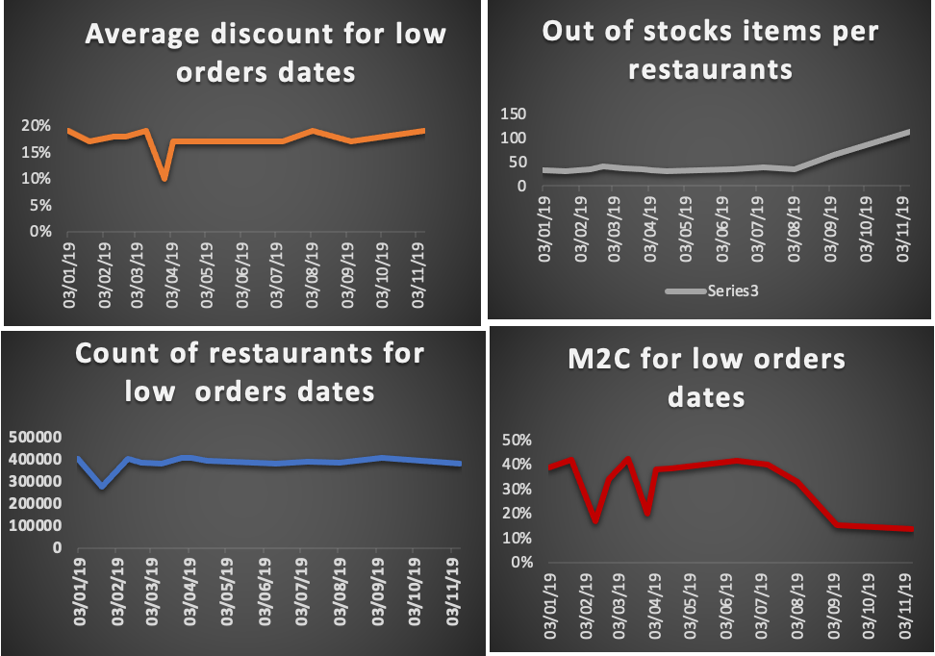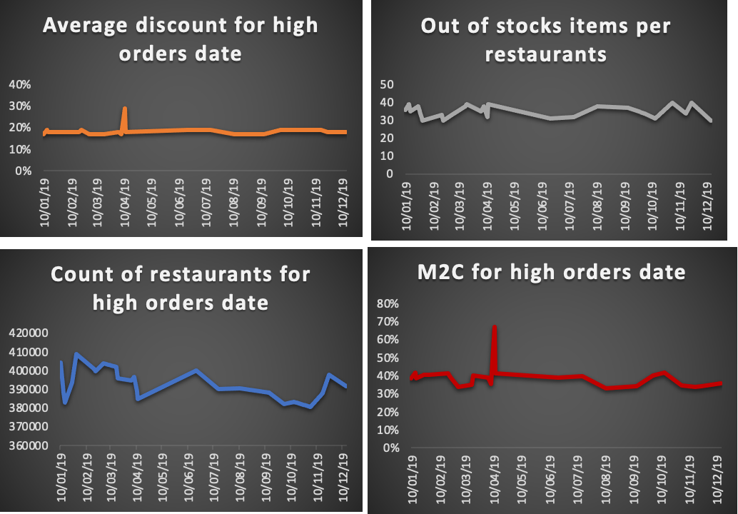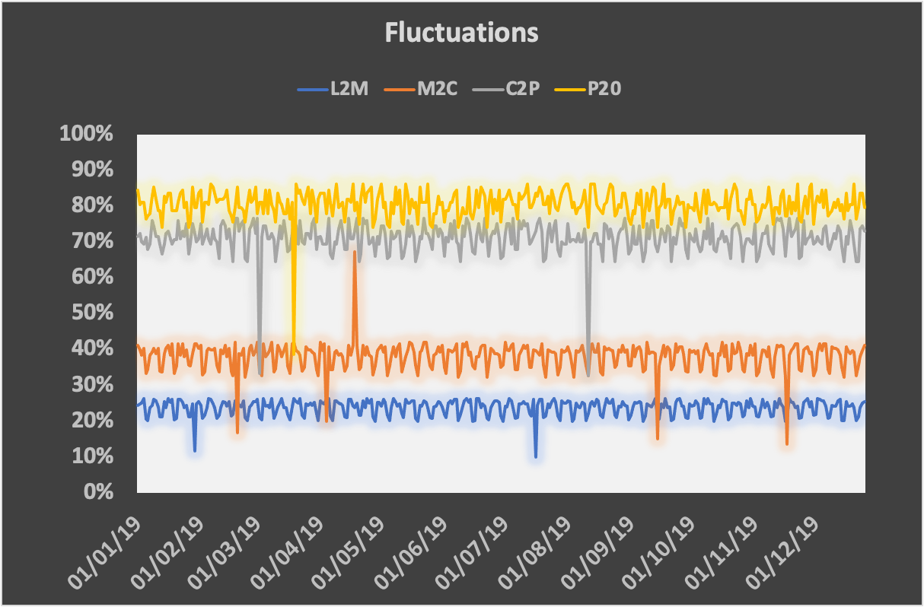







**We can clearly analyse that M2C(MENU TO CART) is highly fluctuating and through the analysis, the factors are count of restaurants, average discounts, out of stocks items per restaurants.**

**Summary:**

* We have analysed the data of swiggy using the funnel analysis techniques which helped us to fetch the vital importation through smaller steps about the increase/ decrease in orders.
* M2C(MENU TO CART) was most frequent and fluctuating based on the charts and the reasons behind such trends can be that restaurants were not able to provide delivery, most of the dishes listed by the customers were out of stock due to which there was decline in the customers as compared to customers to same day last week (highlighted dates in excel).