**BUSINESS DATA WAREHOUSING**

**MIS 6309**

**ASSIGNMENT – 2**

**Dimensional Modelling**

**Airbnb website**

**BY,**

**LOKESH KUMAR LOLLA**

**(UTD ID: LXL163230)**

**The Dim Model was created in Erwin and executed in SQL. The screenshots are shared below.**

**Table 1: Dim_User_LokeshL –** This table showcases the user details both the Guest and Host. This includes the BGC of Host. This is created under the assumption that a host can be guest too.

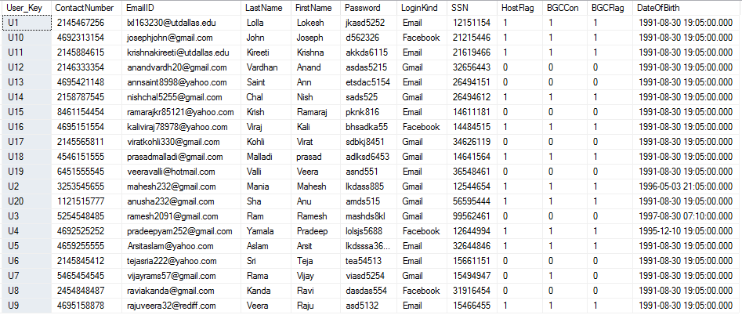

**Table 2: Dim_Property_LokeshL –** The property table talks about the various comprehensive details regarding the listings.

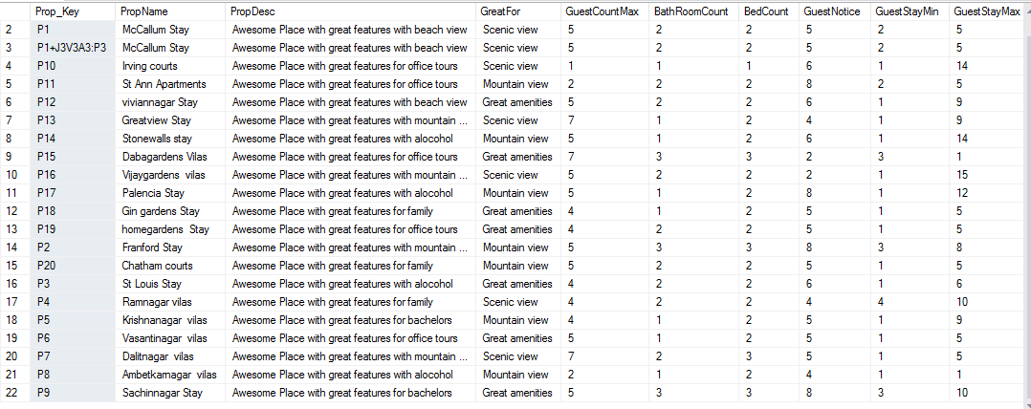

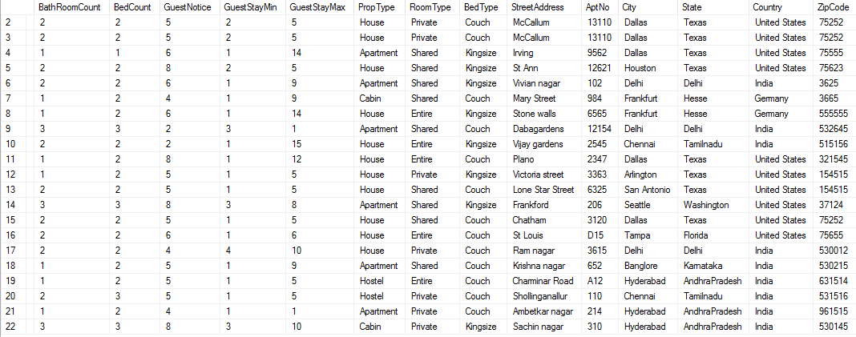

**Table 3: Dim_Time_LokeshL –** This is a time dimension used for various fact tables.

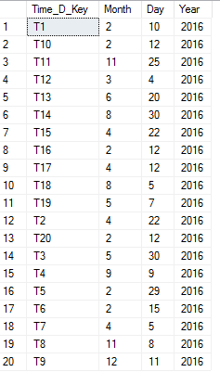

**Table 4: Dim_TimeSec_LokeshL –** This is a second time dimension aliased for capturing the checkout date in Booking table and future use.

This can be created as a degenerate, but I created to showcase the alias concept.

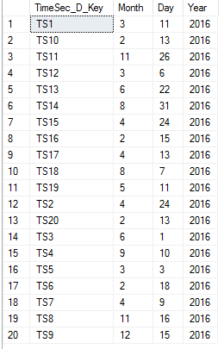

**Table 5: Dim_TimeTh_LokeshL –** This is a Third time dimension aliased for capturing the booking date in Booking table and future requirement.

This can be created as a degenerate, but I created to showcase the alias concept.

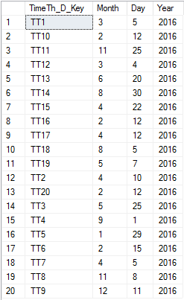

**Table 6: Fact_Booking_LokeshL –** This table has the information regarding the booking details of property.

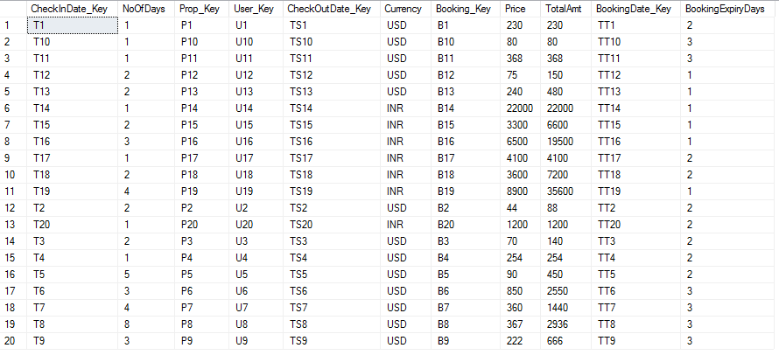

**Table 7: Fact_Payment_LokeshL –** This table talks about the payment details for the booking done.

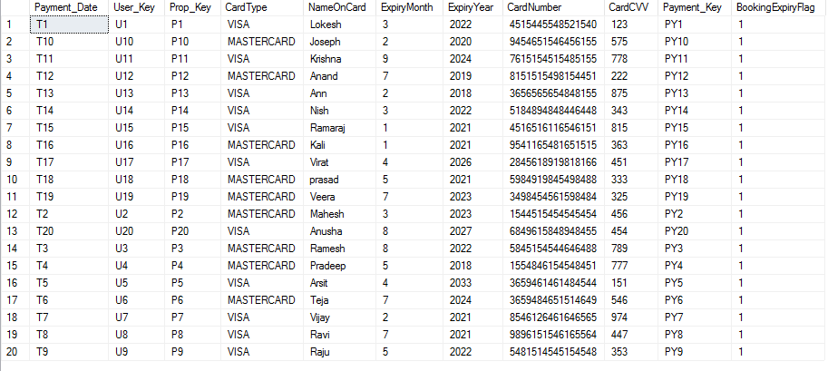

**Table 8: Fact_Feedback_LokeshL –** This table holds the information regarding the feedback given by the Guest.

