**BUSINESS DATA WAREHOUSING**

**MIS 6309**

**ASSIGNMENT – 1**

**Airbnb ER Model**

**BY,**

**LOKESH KUMAR LOLLA**

**(UTD ID: LXL163230)**

**The ER Model was created in Erwin and executed in SQL express. The screenshots are shared below.**

**Table 1: UserID_LokeshL –** This table showcases the user details both the Guest and Host. This is created under the assumption that a host can be guest too.

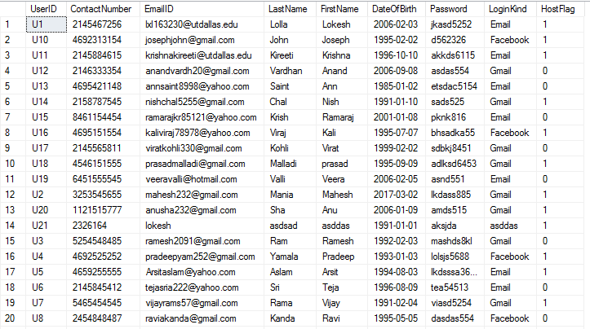

Table 2: **BGC_LokeshL** – The BGC table talks about the background check of the users.

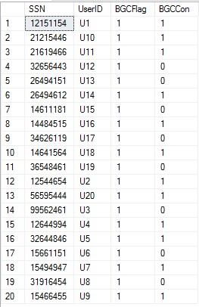

Table 3: **Property_LokeshL** – The property table talks about the various details regarding the listings.

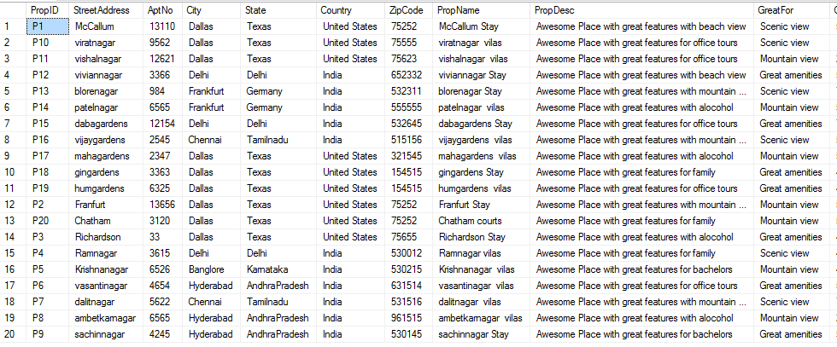

Contd. Table below

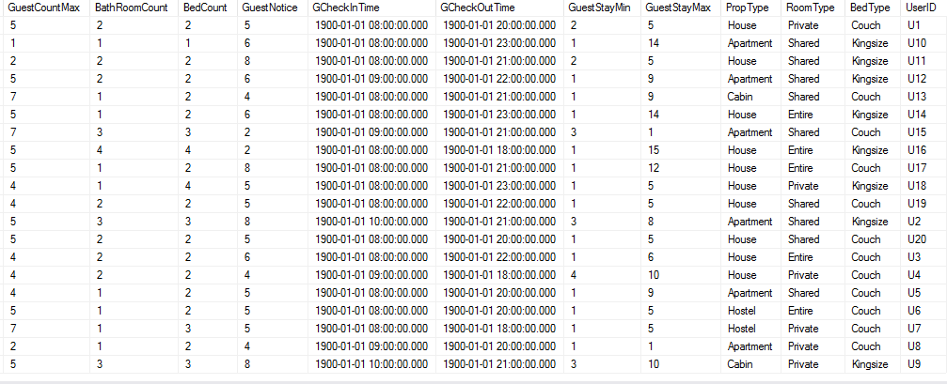

Table 4: Amenities_LokeshL – This table stores the information regarding the amenities offered at the listings.

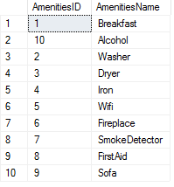

Table 5: PropAmenities_LokeshL – This table provides the details regarding the which property has which amenities details.

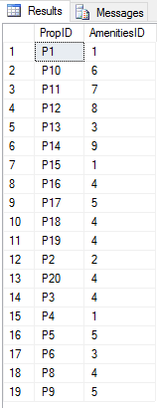

Table 6: PaymentCard_Lokesh – This table talks about the paymentcard details.

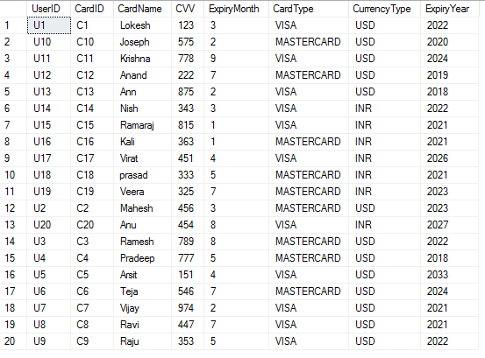

Table 7: Booking_LokeshL – This table holds the information regarding the booking of the listing for a particular user.

