**BUSINESS DATA WAREHOUSING**

**MIS 6309**

**ASSIGNMENT – 3**

**Airbnb website**

**BY,**

**LOKESH KUMAR LOLLA**

**(UTD ID: LXL163230)**

**The ER Model is created in UDT and Dim Model is created in IDT. The screenshots are shared below.**

1. **Universe Design for Airbnb – UDT tool**
2. **Universe Structure**

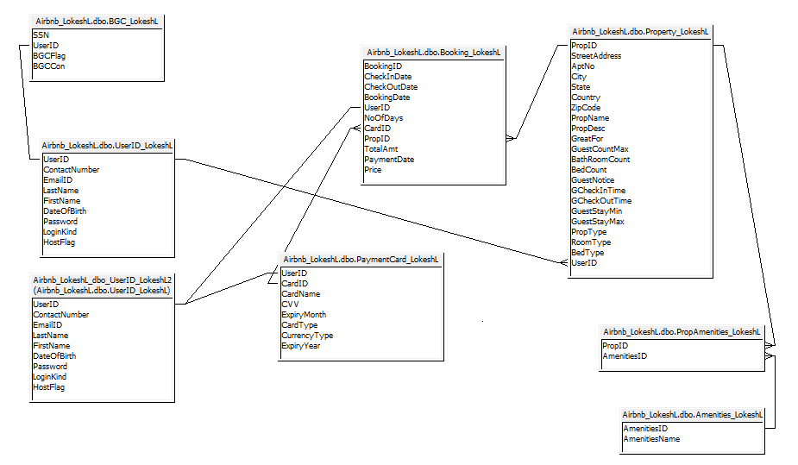

1. **Objects Structure**

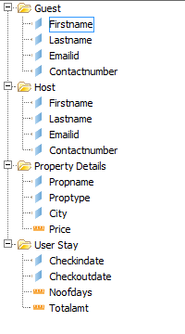

1. **Successful Parsing**

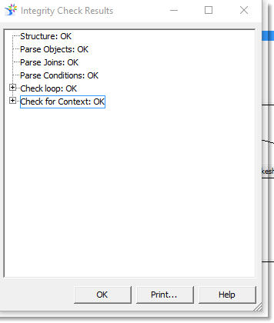

1. **Universe Design of Airbnb – IDT tool**
2. **Universe Structure**

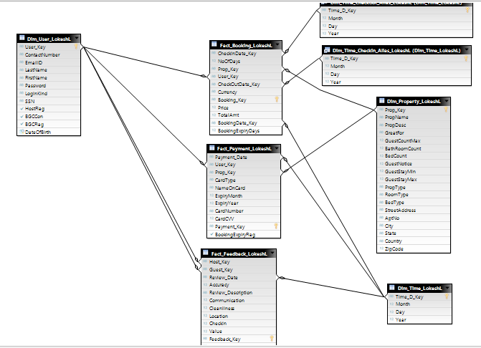

1. **Object Structure**

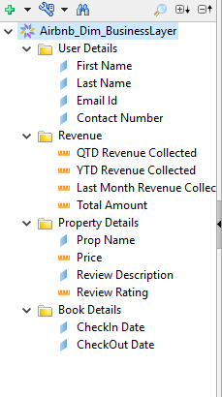

1. **Successful Parsing**

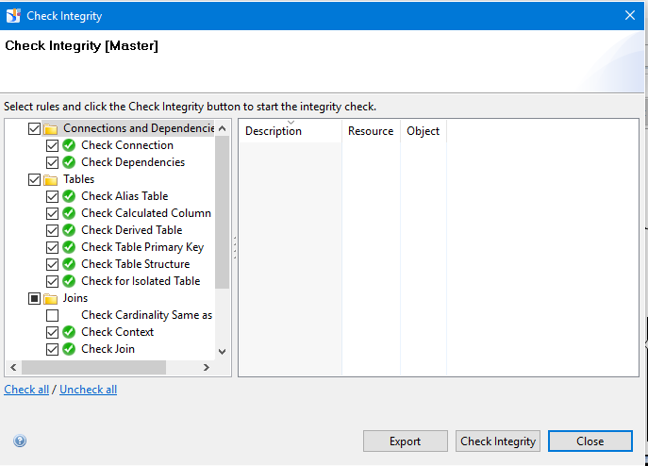

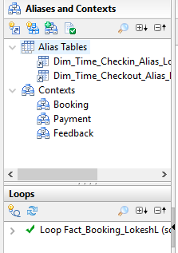

1. **Calculated Fields**
2. **QTD Revenue Collected**

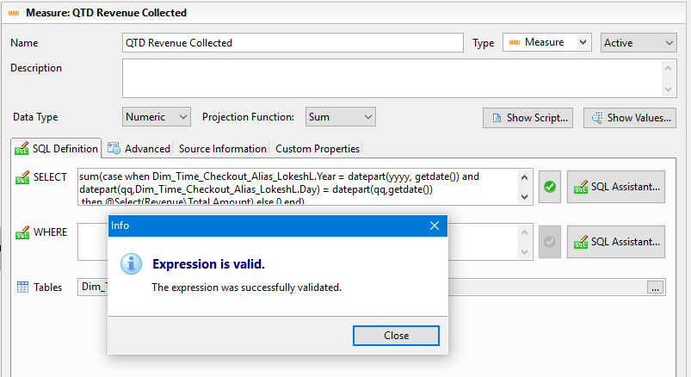

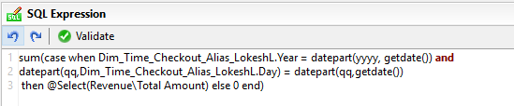

1. **YTD Revenue collected**

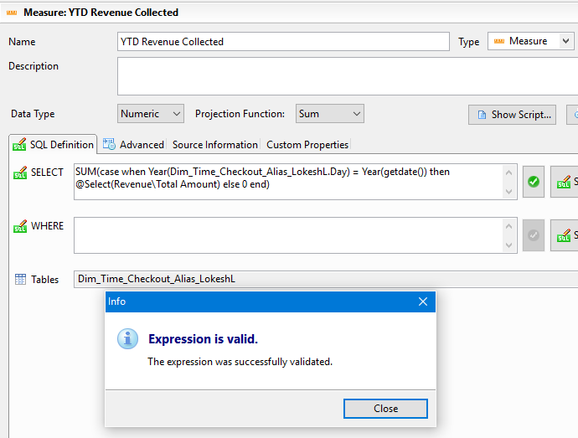

1. **Last Month Revenue collected**

