
CAPSTONE ASSIGNMENT
Assignment Title: Design Your Career Roadmap with SMART Goals

Department: SOET

Program: B. Tech CSE (Specialization in AI & ML) | Semester: 1
Course Code: ETCCCP105 | Faculty: Mr. Aryan Sharma
Course Name: Computer Science Fundamentals & Career Pathways | Roll No.: 2501730182
Name: Lokesh Verma | Section: B

Computational Thinking in Action (CO1)

Chosen System: Job Application Tracker
Problem definition
Students/job-seekers apply to many roles across portals. They need a simple system to track applications, status (Applied / Interview / Offer / Rejected), company, position, applied date, follow-up reminders, and notes. The system should allow adding, updating, searching (by company, status, date), and exporting a CSV report.
Functional requirements
- Add new application (company, role, link, date, status, notes)
- Update status and notes
- Search/filter by status or company
- List upcoming follow-ups (reminders)
- Export data to CSV
Non-functional requirements
- Simple text-file or CSV storage
- Command-line or basic GUI
- Runs locally, low resource

Algorithm (pseudocode)
BEGIN
LOAD applications from file (applications.csv) IF exists ELSE create empty list
WHILE True:
DISPLAY menu:
1. Add application
2. Update application
3. Search / Filter
4. Show follow-ups
5. Export CSV
6. Exit
READ choice
IF choice == 1:
PROMPT for company, role, link, applied_date, status, followup_date, notes
CREATE record with unique id and fields
APPEND record to applications
SAVE applications to file
DISPLAY confirmation
ELSE IF choice == 2:
PROMPT for application id (or search and select)
PROMPT for new status, new notes, new followup_date (optional)
UPDATE the record
SAVE applications to file
DISPLAY confirmation
ELSE IF choice == 3:
PROMPT filter_type (company/status/date_range)
FILTER applications accordingly
DISPLAY results
ELSE IF choice == 4:
TODAY = current date
SELECT applications where followup_date is within next 7 days and status is not "Offer" or "Rejected"
DISPLAY list sorted by followup_date
ELSE IF choice == 5:
WRITE applications to export.csv
DISPLAY export path
ELSE IF choice == 6:
BREAK
END IF
END WHILE
END

Flowchart

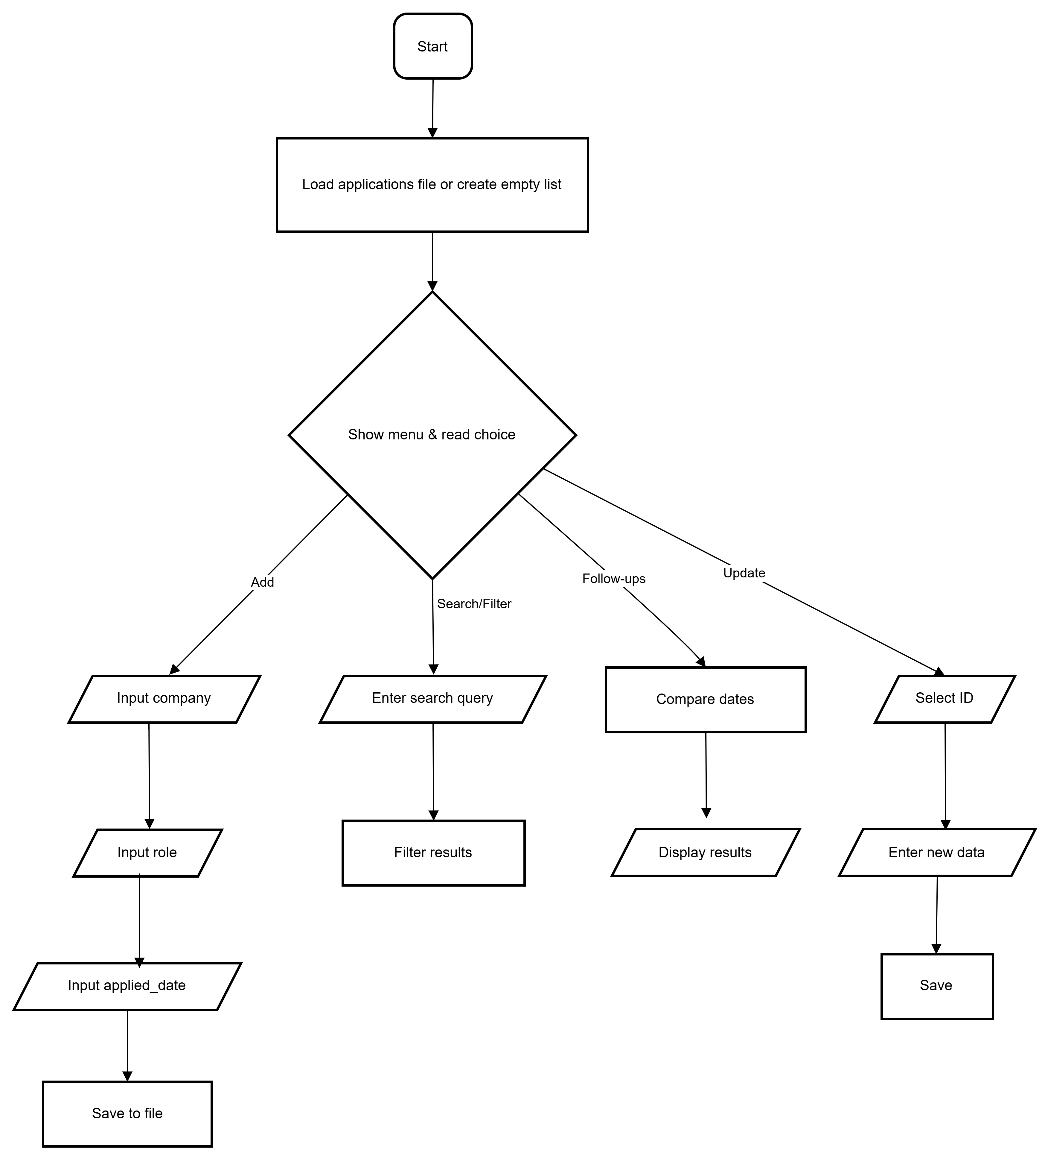

Step 2 — Linux and Automation Practice (CO2)
- pwd — print working directory.
- ls -la — list files including hidden with permissions and owners.
- mkdir — create nested folders.
- touch — create an empty file.
- cp data/applications.csv data/applications.bak.csv — copy (backup) file.
- mv data/applications.bak.csv docs/ — move/rename backup into docs.
- rm -i docs/applications.bak.csv — remove file interactively.
- chmod 640 data/applications.csv — set permissions (owner read/write, group read).
- chown $(whoami):$(whoami) data/applications.csv — change ownership to current user.
- find . -type f -name "*.csv" -exec wc -l {} + — find CSV files and count lines (useful for quick checks).

Bash script — create_career_structure.sh (automates making folders, template CSV, and initial README)
#!/bin/bash
# create_career_structure.sh
# Usage: ./create_career_structure.sh MyCareerFolder

ROOT=${1:-CareerTracker}
TIMESTAMP=$(date +"%Y%m%d_%H%M%S")
mkdir -p "$ROOT"/{data,scripts,docs,infographic,reports}
cat > "$ROOT/data/applications.csv" <<EOF
id,company,role,link,applied_date,status,followup_date,notes
# Example: 1,ExampleCorp,Software Intern,https://example.com,2025-11-29,Applied,2025-12-06,Applied via portal
EOF
cat > "$ROOT/README.md" <<EOF
# $ROOT

Auto-created career tracker structure on $TIMESTAMP

- data/: CSV storage
- scripts/: automation scripts
- docs/: supporting docs and screenshots
- infographic/: infographic files
- reports/: final report PDF
EOF
chmod -R 750 "$ROOT/scripts"
echo "Created folder structure at $(realpath "$ROOT")"
How to run and capture
- Save script as create_career_structure.sh and chmod +x create_career_structure.sh.
- Run ./create_career_structure.sh MyCareerFolder.
- Take screenshots showing the command and ls -R MyCareerFolder output.

Step 3 — Exploring Emerging Technology Domain (CO3)
Chosen domain: Artificial Intelligence (AI)
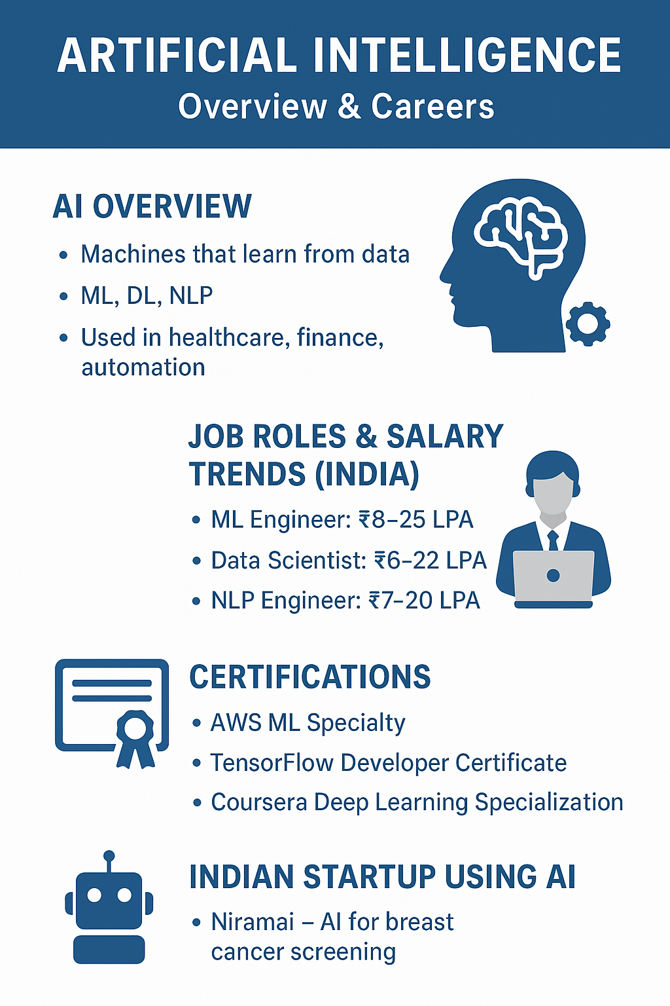

Step 4 — Career Planning & Professional Readiness (CO4)

Step 1: SMART Goals (3 goals)
Short-term (3 months)
- S: Complete a guided project that implements a job-application tracker (CLI) and publish the code on GitHub.
- M: Finish, test, and push 1 repository with README, sample data, and screenshots.
- A: Use the scripts and pseudocode provided; spend 5–7 hours/week.
- R: Directly relevant to building a portfolio and automation skills.
- T: Complete within 3 months.
Medium-term (9–12 months)
- S: Obtain a certification (e.g., AWS Certified Cloud Practitioner or Coursera ML specialization) and complete 2 real projects (one ML, one automation) deployed publicly.
- M: Certification passed + 2 repositories with README and live demo (or recorded demo).
- A: Enroll in an online course and set weekly study hours (6–8 hours/week).
- R: Builds credibility for internships and graduate roles.
- T: Within 9–12 months.
Long-term (2–3 years)
- S: Secure a full-time role as an ML Engineer or Software Developer in an AI-focused team.
- M: 2+ internships/projects, one certification, contributions to open-source, and an interview pipeline (applications submitted to 50 companies).
- A: Follow roadmap below and network on LinkedIn/GitHub.
- R: Aligns with career ambitions.
- T: 2–3 years.

Step 2: Certification Research (two suggested certificates)
1) AWS Certified Machine Learning — Specialty (example)
- Provider: Amazon Web Services (AWS)
- Duration: Self-study 2–4 months (varies by background)
- Cost: Exam fee typically around USD 300 (confirm on AWS site)
- Skills covered: ML problem framing, data engineering, exploratory data analysis, modeling, deployment, and monitoring on AWS.
- Alignment: Fits medium-term goal — proves cloud + ML competence useful for production ML roles.
2) Coursera — Deep Learning Specialization (Andrew Ng / DeepLearning.AI)
- Provider: Coursera (DeepLearning.AI)
- Duration: 3–4 months if paced part-time (or faster)
- Cost: Coursera subscription (approx. USD 39–59/month) or one-time purchase for certificate (varies) — check current pricing.
- Skills covered: Neural networks, CNNs, RNNs, sequence models, and deployment considerations.
- Alignment: Directly builds skills for AI/ML projects and complements the AWS certificate.
Tip: Always verify current exam fees, schedules, and prerequisites on the official certification pages prior to registering.

Step 3: LinkedIn Update & CV
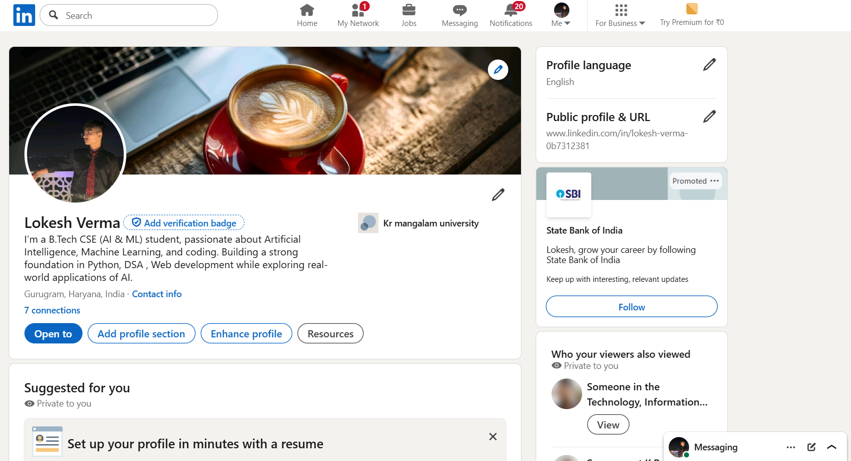
Profile url : https://www.linkedin.com/in/lokesh-verma-0b7312381/
LinkedIn checklist
- Add a professional profile photo (clear headshot, plain background).
- Write a concise summary (2–4 sentences) focusing on your current status, skills, and goals (example provided in the document).
- Add education: degree, institution, dates.
- Add at least 3 skills (e.g., Python, Machine Learning, Linux).
- Add links to GitHub and project repos in the Featured section.
CV template
- Header: Name, contact, LinkedIn URL, GitHub URL
- Summary (2–3 lines)
- Education
- Skills (technical & soft)
- Projects (3—include GitHub links)
- Certifications
- Experience / Internships
- Achievements & Extracurriculars

Open-Source Contribution Plan (GitHub)
Project Options: Scikit-learn / TensorFlow Docs / Open-Source AI Tools
Timeline: 30 Days

Steps:
- Identify beginner-friendly issues labeled “good first issue”
- Fork the repository and clone it to the local system
- Set up the project environment and understand folder structure
- Fix documentation errors, typos, examples, or small bugs
- Commit changes with clean, meaningful messages
- Submit a pull request (PR) to the main repository
- Engage with maintainers during the review process and make updates if requested
- Track PR status and add final proof

