**Experiment 23**

**AIM:** Transport layer protocol header analysis using Wireshark- TCP

**Requirements:**

Wireshark software

Network connected to broadband connection.

**Procedure:**

* From the menu bar, select capture -> options -> interfaces.
* In the interfaces, choose a particular Ethernet adapter and note down its IP, and click the start button of the selected adapter.
* Now we shall be capturing packets. Browse to a particular web address to generate traffic to capture packets from the communication .
* In the display filter bar on the screen, enter TCP and apply the filter.
* From analyzing the menu in the menu bar select display filters or from capture select capture filters and then TCP only and ok

**Tcp :**

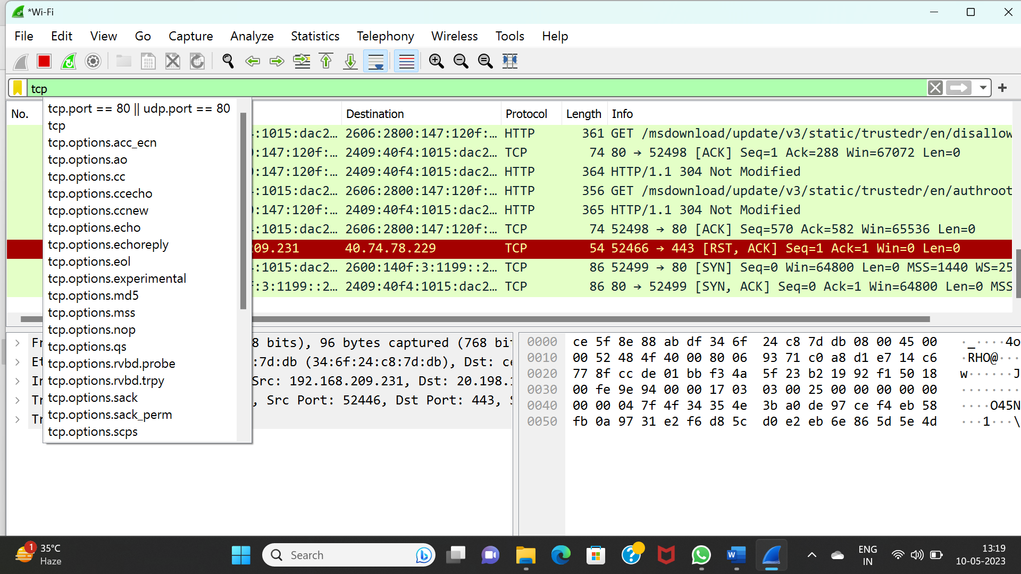

**Result:** Thus the determining data packets transmission using wireshark of tcp protocol is observed.