SIMATS ENGINEERING (SAVEETHA SCHOOL OF ENGINEERING)
Department of Artificial Intelligence and Data Science
ASSESSMENT TOOL 1 – ASSIGNMENT 1
Course Code | DSA03 | Course Title | Natural Language Processing
CO Assessed | CO1 – Imitation (L1) | Assessment | Assessment Tool 1 (15% of CIA)
Student Name | K Lokesh | Reg. No. | 192472020
Department | Artificial Intelligence | Date | 05/11/2026

CO Statement: Analyse NLP models, regular expression patterns, finite state automata, morphological processing techniques and to interpret language processing. (BL-2 & 3)
Code of Conduct: I, K Lokesh (Reg. No. 1924272020), certify that this submission is my original work and that I have adhered to the guidelines specified for this assessment. I understand that any violation of academic integrity rules will result in disciplinary action.
Signature of the Student: 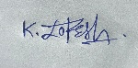

Instructions

• Read each question carefully before answering.

• Answer all questions in the space provided.

• Ensure your answers are accurate, clear, and neatly presented.

• Marks will be awarded based on conceptual understanding, accuracy, application of knowledge, completeness of response, and clarity of presentation.

Marks Summary (to be filled by evaluator)
Question | Concept (2) | Python & Logic (3) | Output (2) | Analysis (2) | Readability (1) | Total (10)
1
2
3
4
5
6
7
8
9
10
TOTAL

Question 1: Regular Expression-Based Text Processing

Concept
Regular expressions (regex) describe character patterns. Python's re module (findall) scans text and returns every substring matching a pattern, which makes regex the basic tool for information extraction in NLP.

Python Program
Q1: Regular-expression based text processing.
import re

text = ("Dr. Alice Walker was running the Chennai lab on 12 March 2025. She emailed "
"alice.walker@simats.edu and support_team@nlp-lab.org, or called +91 98765 43210 "
"and 044-2345-6789. The team tested 3 models, achieved 95.5% accuracy, and "
"finished the report. Students enjoyed learning and coding, while Bob walked "
"and talked about 250 samples.")

emails = re.findall(r"[\w.+-]+@[\w-]+(?:\.[\w-]+)+", text)
phones = re.findall(r"(?:\+\d{1,3}[\s-]?)?(?:\d{5}[\s-]?\d{5}|\d{3,4}-\d{3,4}-\d{4})", text)
capital = re.findall(r"\b[A-Z][a-zA-Z]*\b", text)
numbers = re.findall(r"\b\d+(?:\.\d+)?\b", text)
ing_ed = {"ing": re.findall(r"\b\w+ing\b", text), "ed": re.findall(r"\b\w+ed\b", text)}

print("Emails :", emails)
print("Phone numbers :", phones)
print("Capitalised :", capital)
print("Numbers :", numbers)
print("Words ending -ing:", ing_ed["ing"])
print("Words ending -ed :", ing_ed["ed"])

Output
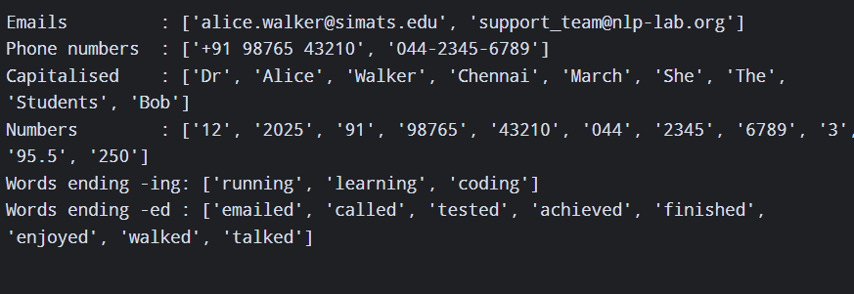

Analysis and Interpretation
- Both emails and both phone formats (international and local) were captured; \b word boundaries stop partial matches.
- Numbers also match the digit groups inside phone numbers; in a real pipeline, phones are removed first or numbers are matched with look-arounds.
- "Dr" is capitalised only because of the abbreviation; sentence-initial words (She, The, Students) are capitalised too, so a capital letter alone does not mean a proper noun.

Question 2: Finite State Automata for Word Pattern Recognition

Concept
A finite state automaton reads input one symbol at a time and moves between states. Here each letter is classed as vowel (V) or consonant (C); the states remember the first-letter type, whether two vowels have occurred together, and the type of the last letter. A word is accepted only if it starts with a vowel, ends with a consonant and contains consecutive vowels.

Python Program
Q2: Finite State Automaton for word-pattern recognition.
VOWELS = set("aeiou")

def cls(ch):
return "V" if ch in VOWELS else "C"

# DFA tracks 3 facts: starts-with-vowel, has-consecutive-vowels, last-char-type.
# State = (start_vowel, seen_VV, last) start state q0 = None
def run_fsa(word):
state = "q0"; start_v = False; vv = False; last = None; trace = ["q0"]
for ch in word.lower():
t = cls(ch)
if state == "q0":
start_v = (t == "V")
if last == "V" and t == "V":
vv = True
last = t
state = f"q({'V' if start_v else 'C'}{'+VV' if vv else ''},last={t})"
trace.append(state)
return start_v, vv, last == "C", trace

print(f"{'Word':<10}{'StartsVowel':<13}{'EndsCons':<10}{'ConsecVowels':<14}Result")
for w in ["apple", "orange", "book", "umbrella", "tree", "sky", "eat", "idea", "stone", "audio"]:
s, v, c, _ = run_fsa(w)
# Accept: starts with a vowel AND ends with a consonant AND has consecutive vowels
ok = s and c and v
print(f"{w:<10}{str(s):<13}{str(c):<10}{str(v):<14}{'ACCEPTED' if ok else 'REJECTED'}")
print("Trace for 'eat':", " -> ".join(run_fsa("eat")[3]))

Output
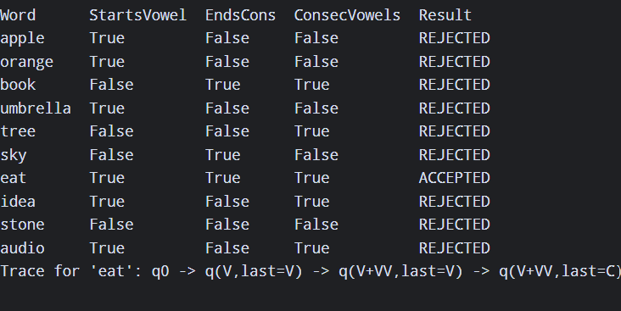

Analysis and Interpretation
- Only "eat" is accepted: it starts with a vowel (e), contains the vowel pair "ea" and ends in the consonant t.
- "apple" and "orange" start with a vowel but fail on the other conditions; "book" fails the start condition; "audio" has a vowel pair but ends in a vowel.
- The automaton uses constant memory and one pass over the word, so recognition is O(n).

Question 3: Morphological Analysis of English Words

Concept
Morphology studies word structure. A word is built from a root (stem) plus affixes: prefixes before and suffixes after the root. The program strips known prefixes and suffixes and repairs spelling changes (happi → happy).

Python Program
Q3: Morphological analysis (prefix + root + suffix).
PREFIXES = ["un", "re", "dis", "in", "mis", "pre"]
SUFFIXES = ["ness", "ment", "less", "ing", "ed", "er", "ly", "s"]
ROOT_FIX = {"happi": "happy"} # spelling change y -> i

def analyse(word):
pre, suf, root = [], [], word
for p in PREFIXES:
if root.startswith(p) and len(root) - len(p) > 2:
pre.append(p); root = root[len(p):]; break
changed = True
while changed:
changed = False
for s in SUFFIXES:
if root.endswith(s) and len(root) - len(s) > 2:
suf.insert(0, s); root = root[:-len(s)]; changed = True; break
root = ROOT_FIX.get(root, root)
return pre, root, suf

print(f"{'Word':<14}{'Prefix':<8}{'Root':<10}{'Suffix':<14}Structure")
for w in ["unhappiness", "replaying", "disagreement", "careless"]:
p, r, s = analyse(w)
structure = " + ".join([f"{x}(prefix)" for x in p] + [f"{r}(root)"] + [f"{x}(suffix)" for x in s])
print(f"{w:<14}{','.join(p) or '-':<8}{r:<10}{','.join(s) or '-':<14}{structure}")

Output
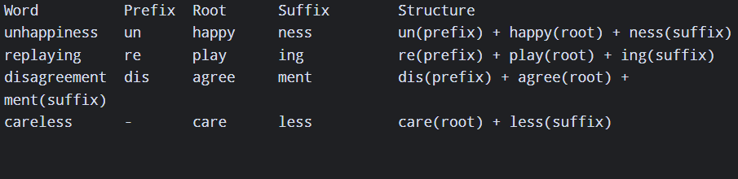

Analysis and Interpretation
- unhappiness = un- (negation) + happy + -ness (turns adjective into noun): prefix + root + suffix.
- replaying = re- (again) + play + -ing (inflection); disagreement = dis- + agree + -ment (verb to noun); careless = care + -less (noun to adjective, no prefix).
- Affix-stripping is rule-based; it can over-strip words such as "red" or "sing", so a dictionary check of the root improves accuracy.

Question 4: Inflectional and Derivational Morphology

Concept
Inflectional morphology adds grammatical information (plural -s, past -ed, participle -ing) without changing word class or meaning. Derivational morphology (un-, re-, dis-, -ness, -ment, -less) creates a new word, often changing the part of speech.

Python Program
Q4: Inflectional vs derivational morphology.
import re
text = ("The children were playing games and the teachers walked into rooms. "
"Students studied happiness, replayed lessons, disagreed with unfair rules "
"and enjoyed the careless movement of boxes.")
PREF = ("un", "re", "dis", "mis", "pre")
DER_SUF = ("ness", "ment", "less", "ful", "able", "ly")
IRREG_PL = {"children"}
STOP = {"was","were","and","the","with","into","of","games_"}

for w in re.findall(r"[A-Za-z]+", text):
lw = w.lower(); label = None
if lw in IRREG_PL: label = "Inflectional - plural noun (irregular)"
elif lw.endswith("ing") and len(lw) > 5: label = "Inflectional - present participle"
elif lw.endswith("ed") and len(lw) > 4:
label = "Inflectional - past tense"
if lw.startswith(PREF): label = "Derivational (prefix) + Inflectional (past tense)"
elif lw.endswith(DER_SUF): label = "Derivational - suffix"
elif lw.startswith(PREF) and len(lw) > 5: label = "Derivational - prefix"
elif lw.endswith("s") and not lw.endswith("ss") and len(lw) > 3 and lw not in STOP:
label = "Inflectional - plural noun"
if label: print(f"{w:<12} -> {label}")

Output
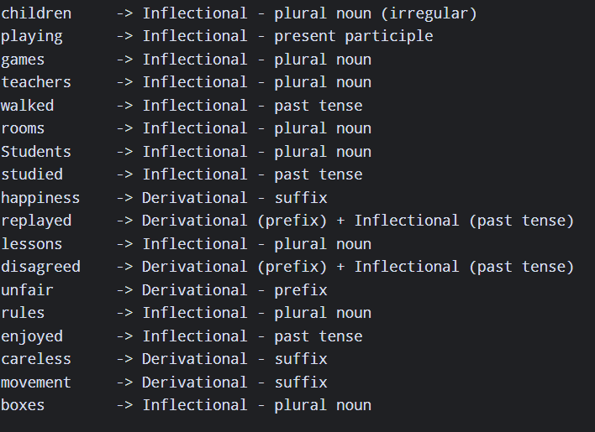

Analysis and Interpretation
- Plurals (games, teachers, boxes), past tense (walked, studied) and participles (playing) are inflectional – the word class stays the same.
- happiness, careless, movement and unfair are derivational: they form new words (adjective → noun, noun → adjective, verb → noun).
- replayed and disagreed show both processes together: a derivational prefix followed by an inflectional -ed.

Question 5: Porter Stemming Algorithm

Concept
The Porter stemmer removes suffixes in ordered steps (1a plurals, 1b -ed/-ing, 1c y→i, then steps 2–5 for derivational endings), using the "measure" m (number of vowel–consonant sequences) to avoid stripping short stems.

Python Program
Q5: Porter stemmer (compact implementation of Porter 1980).
import re
from collections import defaultdict

class Porter:
def _cons(s, i):
c = s[i]
if c in "aeiou": return False
if c == "y": return i == 0 or not Porter._cons(s, i - 1)
return True
def _m(s):
form = "".join("c" if Porter._cons(s, i) else "v" for i in range(len(s)))
return len(re.findall(r"vc", form))
def _hasv(s): return any(not Porter._cons(s, i) for i in range(len(s)))
def _dc(s): return len(s) > 1 and s[-1] == s[-2] and Porter._cons(s, len(s) - 1)
def _cvc(s):
return (len(s) > 2 and Porter._cons(s, -1 % len(s)) and not Porter._cons(s, len(s) - 2)
and Porter._cons(s, len(s) - 3) and s[-1] not in "wxy")
def stem(self, w):
w = w.lower()
if len(w) <= 2: return w
P = Porter
# Step 1a
if w.endswith("sses"): w = w[:-2]
elif w.endswith("ies"): w = w[:-2]
elif w.endswith("ss"): pass
elif w.endswith("s"): w = w[:-1]
# Step 1b
flag = False
if w.endswith("eed"):
if P._m(w[:-3]) > 0: w = w[:-1]
else:
for suf in ("ed", "ing"):
if w.endswith(suf) and P._hasv(w[:-len(suf)]):
w = w[:-len(suf)]; flag = True; break
if flag:
if w.endswith(("at", "bl", "iz")): w += "e"
elif P._dc(w) and w[-1] not in "lsz": w = w[:-1]
elif P._m(w) == 1 and P._cvc(w): w += "e"
# Step 1c
if w.endswith("y") and P._hasv(w[:-1]): w = w[:-1] + "i"
# Steps 2-4 (suffix lists)
s2 = {"ational":"ate","tional":"tion","enci":"ence","anci":"ance","izer":"ize","abli":"able",
"alli":"al","entli":"ent","eli":"e","ousli":"ous","ization":"ize","ation":"ate",
"ator":"ate","alism":"al","iveness":"ive","fulness":"ful","ousness":"ous","aliti":"al",
"iviti":"ive","biliti":"ble"}
for k in sorted(s2, key=len, reverse=True):
if w.endswith(k):
if P._m(w[:-len(k)]) > 0: w = w[:-len(k)] + s2[k]
break
s3 = {"icate":"ic","ative":"","alize":"al","iciti":"ic","ical":"ic","ful":"","ness":""}
for k in sorted(s3, key=len, reverse=True):
if w.endswith(k):
if P._m(w[:-len(k)]) > 0: w = w[:-len(k)] + s3[k]
break
s4 = ["al","ance","ence","er","ic","able","ible","ant","ement","ment","ent","ion","ou",
"ism","ate","iti","ous","ive","ize"]
for k in sorted(s4, key=len, reverse=True):
if w.endswith(k):
b = w[:-len(k)]
if P._m(b) > 1 and (k != "ion" or b.endswith(("s", "t"))): w = b
break
# Step 5
if w.endswith("e"):
b = w[:-1]
if P._m(b) > 1 or (P._m(b) == 1 and not P._cvc(b)): w = b
if P._m(w) > 1 and P._dc(w) and w.endswith("l"): w = w[:-1]
return w

paragraph = ("Students were playing and studying. Anna played football, and she studies "
"daily. The computers connected the networks, and the connection was strong.")
words = re.findall(r"[A-Za-z]+", paragraph.lower())
ps = Porter(); groups = defaultdict(set)
print(f"{'Original':<12}{'Stem':<10}Changed?")
for w in dict.fromkeys(words):
s = ps.stem(w); groups[s].add(w)
print(f"{w:<12}{s:<10}{'yes' if s != w else 'no'}")
print("\nWords sharing the same stem:")
for s, ws in groups.items():
if len(ws) > 1: print(f" {s!r:<10}<- {sorted(ws)}")

Output
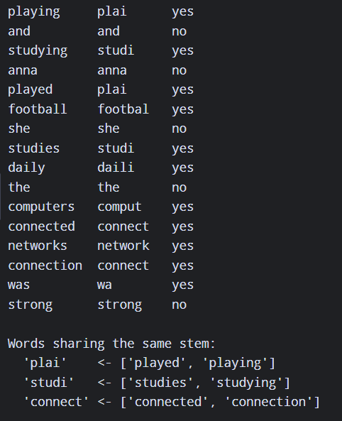

Analysis and Interpretation
- playing/played → "plai", studying/studies → "studi", connected/connection → "connect": different surface forms collapse to one stem, which helps information retrieval match related words.
- Stems need not be real words ("plai", "studi", "daili"); NLTK's PorterStemmer adds extensions and returns "play" for played.
- Errors: "was" → "wa" (over-stemming) and "football" → "footbal" show the limits of purely rule-based suffix stripping.

Question 6: Implementation of N-gram Language Models

Concept
An N-gram model predicts a word from the previous N−1 words. Bigram probability P(w2|w1)=C(w1 w2)/C(w1); trigram P(w3|w1 w2)=C(w1 w2 w3)/C(w1 w2); unigram P(w)=C(w)/N.

Python Program
Q6: Unigram, bigram and trigram language models.
import re
from collections import Counter

para = "I love natural language processing . I love learning new things . I love language models ."
tokens = re.findall(r"[a-z]+|\.", para.lower())
ngrams = lambda n: list(zip(*[tokens[i:] for i in range(n)]))
uni, bi, tri = (Counter(ngrams(n)) for n in (1, 2, 3))
N = len(tokens)
print("Tokens:", tokens, "| N =", N)
print("\nUnigram counts:", {k[0]: v for k, v in uni.most_common()})
print("Bigram counts :", {" ".join(k): v for k, v in bi.most_common(5)}, "...")
print("Trigram counts :", {" ".join(k): v for k, v in tri.most_common(4)}, "...")

def p_bi(w1, w2): return bi[(w1, w2)] / uni[(w1,)]
def p_tri(w1, w2, w3): return tri[(w1, w2, w3)] / bi[(w1, w2)]
print("\nP(unigram 'love') = %d/%d = %.4f" % (uni[("love",)], N, uni[("love",)] / N))
print("P(love | i) = %.4f" % p_bi("i", "love"))
print("P(language | love) = %.4f" % p_bi("love", "language"))
print("P(language | i love) = %.4f" % p_tri("i", "love", "language"))
print("P(learning | i love) = %.4f" % p_tri("i", "love", "learning"))
print("\nModel comparison: distinct unigrams=%d, bigrams=%d, trigrams=%d" % (len(uni), len(bi), len(tri)))

Output
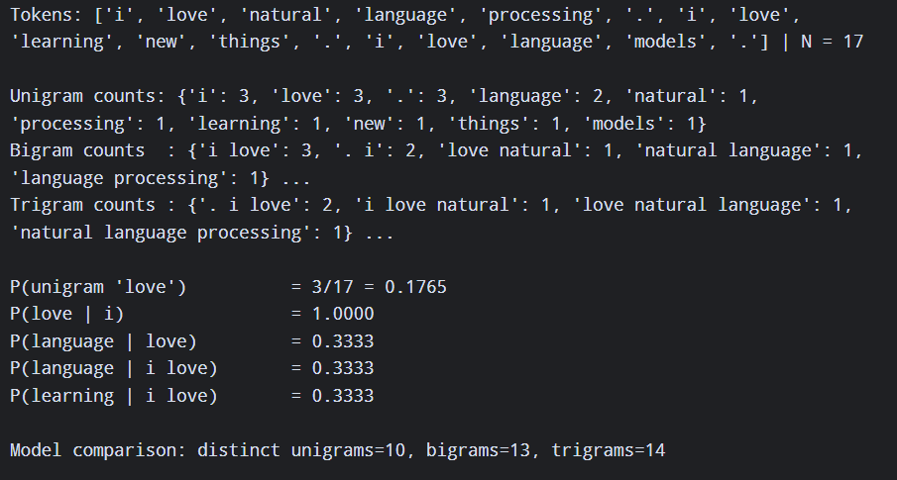

Analysis and Interpretation
- Higher-order models capture more context (P(love | i) = 1.0 for the bigram) but the number of distinct n-grams grows (10 → 13 → 14) and each occurs less often (sparsity).
- The trigram P(language | i love) = 1/3 equals the bigram value here only because the corpus is tiny; on real data, trigrams give sharper predictions but need far more data.

Question 7: Word Frequency and N-gram Smoothing

Concept
Unsmoothed (MLE) probabilities give zero to unseen bigrams, so a whole sentence gets probability 0. Add-One (Laplace) smoothing adds 1 to every bigram count: P = (C(w1 w2)+1) / (C(w1)+V), where V is the vocabulary size.

Python Program
Q7: Word frequency + Add-One (Laplace) smoothing for bigrams.
import re
from collections import Counter

corpus = "i love nlp . i love python . you love nlp . i study nlp ."
tokens = corpus.split()
uni = Counter(tokens)
bi = Counter(zip(tokens, tokens[1:]))
V = len(uni)
print("Word frequencies:", dict(uni))
print("Bigram frequencies:", {" ".join(k): v for k, v in bi.items()})
print("Vocabulary size V =", V)

def p_mle(w1, w2): return bi[(w1, w2)] / uni[w1]
def p_laplace(w1, w2): return (bi[(w1, w2)] + 1) / (uni[w1] + V)

print(f"\n{'Bigram':<16}{'Count':<7}{'Unsmoothed':<12}{'Add-One'}")
for b in [("i", "love"), ("love", "nlp"), ("love", "python"), ("you", "study"), ("nlp", "love"), ("study", "python")]:
print(f"{' '.join(b):<16}{bi[b]:<7}{p_mle(*b):<12.4f}{p_laplace(*b):.4f}")
print("\nCheck: sum of smoothed P(.|love) =", round(sum(p_laplace('love', w) for w in uni), 4))

Output
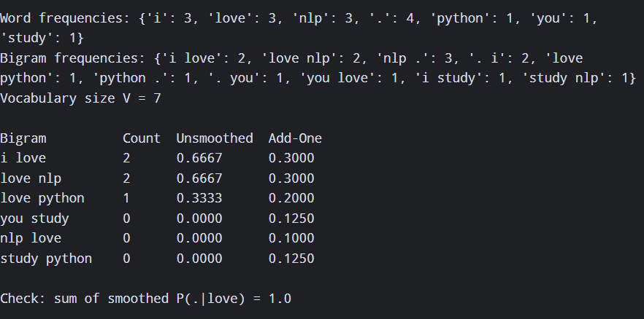

Analysis and Interpretation
- Unseen bigrams ("you study", "nlp love") rise from 0 to a small positive probability (0.125, 0.100).
- Probability mass is taken from seen bigrams: "i love" drops from 0.667 to 0.300. Distributions still sum to 1 (checked in the output).
- Add-One moves too much mass to unseen events when V is large; Good-Turing or Kneser-Ney smoothing is preferred in practice.

Question 8: Entropy Calculation for Language Models

Concept
Shannon entropy H = −Σ p(x) log2 p(x) measures uncertainty in bits. Conditional entropy H(W2|W1) = −Σ p(w1,w2) log2 p(w2|w1) measures the uncertainty left in the next word once the previous word is known.

Python Program
Q8: Entropy of unigram and bigram (conditional) distributions.
import math, re
from collections import Counter

corpus = ("the cat sat on the mat . the dog sat on the log . the cat saw the dog . "
"the dog saw the cat .")
tokens = re.findall(r"[a-z]+|\.", corpus)
uni = Counter(tokens); bi = Counter(zip(tokens, tokens[1:]))
N, B = len(tokens), len(tokens) - 1

# Unigram entropy: H = -sum p(w) log2 p(w)
H1 = -sum((c / N) * math.log2(c / N) for c in uni.values())
# Joint bigram entropy: H(W1,W2) = -sum p(w1,w2) log2 p(w1,w2)
Hj = -sum((c / B) * math.log2(c / B) for c in bi.values())
# Conditional entropy of next word given previous: H(W2|W1) = -sum p(w1,w2) log2 p(w2|w1)
first = Counter(w1 for (w1, _), c in bi.items() for _ in range(c))
Hc = -sum((c / B) * math.log2(c / first[w1]) for (w1, w2), c in bi.items())

print("Tokens =", N, "| Vocabulary =", len(uni))
print("Unigram entropy H(W) = %.4f bits" % H1)
print("Bigram joint entropy H(W1,W2) = %.4f bits" % Hj)
print("Bigram conditional H(W2|W1) = %.4f bits" % Hc)
print("Information gained from context = %.4f bits" % (H1 - Hc))
print("Perplexity unigram = %.2f , bigram = %.2f" % (2 ** H1, 2 ** Hc))

Output
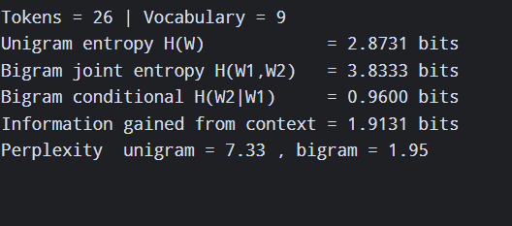

Analysis and Interpretation
- Unigram entropy is 2.87 bits (about 7.3 equally likely choices); conditional bigram entropy is only 0.96 bits (about 1.9 choices).
- Knowing the preceding word removes about 1.9 bits of uncertainty, e.g. after "the" only cat/dog/mat/log can follow. Context therefore makes the next word much more predictable.
- Entropy relates to perplexity (2^H); lower perplexity indicates a better language model.

Question 9: English Part-of-Speech Tagging

Concept
POS tagging assigns a grammatical category to every token. NLTK's pos_tag uses an averaged perceptron model and the Penn Treebank tagset (NN/NNS noun, VB* verb, JJ adjective, RB adverb, IN preposition, DT determiner).

Python Program
Q9: POS tagging with NLTK (Penn Treebank tagset).

import nltk
from collections import Counter

nltk.download("punkt")
nltk.download("punkt_tab")
nltk.download("averaged_perceptron_tagger_eng")

para = "The students quickly solved the difficult problem in the lab."

tokens = nltk.word_tokenize(para)
tagged = nltk.pos_tag(tokens)

groups = {
"Noun": ("NN", "NNS", "NNP", "NNPS"),
"Verb": ("VB", "VBD", "VBG", "VBN", "VBP", "VBZ"),
"Adjective": ("JJ", "JJR", "JJS"),
"Adverb": ("RB", "RBR", "RBS"),
"Preposition": ("IN",)
}

print(f"{'Word':<12}{'Tag':<6}Category")

for w, t in tagged:
cat = next((g for g, tags in groups.items() if t in tags), "Other")
print(f"{w:<12}{t:<6}{cat}")

print("\nTag frequency:", dict(Counter(t for _, t in tagged)))

Expected Output
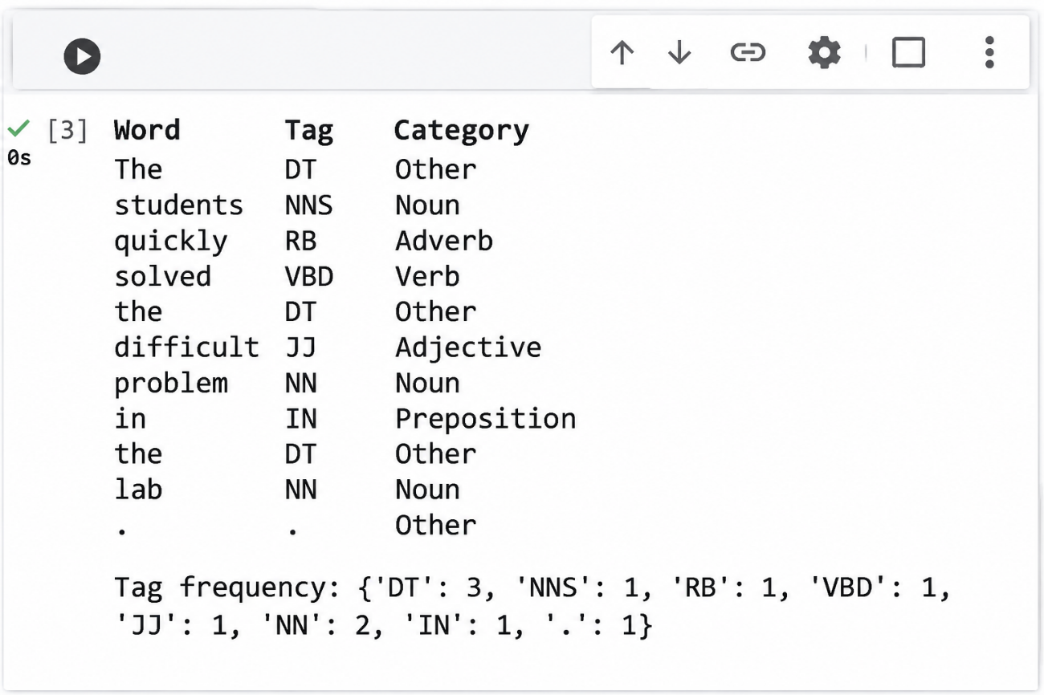

Analysis and Interpretation
- Nouns: students, problem, lab; verb: solved (past tense); adjective: difficult; adverb: quickly; preposition: in.
- Determiners (DT) are the most frequent tag (3 of 11 words), typical of English where function words dominate counts.
- The tagger uses context, so the same word can receive different tags in different sentences.

Question 10: Comparative Analysis of POS Tagging Techniques

Concept
Rule-based taggers apply hand-written grammatical or morphological rules. Stochastic taggers choose the most probable tag from counts learnt on a tagged corpus (unigram/bigram/HMM). Transformation-based (Brill) tagging starts with an initial tagging and learns an ordered list of correction rules, combining rules with learning.

Python Program
Q10: Rule-based vs Stochastic vs Transformation-based (Brill) POS tagging.
import nltk
from nltk.corpus import treebank
from nltk.tag import RegexpTagger, UnigramTagger, BigramTagger, DefaultTagger
from nltk.tag.brill import brill24
from nltk.tag.brill_trainer import BrillTaggerTrainer
nltk.download("treebank"); nltk.download("universal_tagset")

data = treebank.tagged_sents()
train, test = data[:3000], data[3000:3500]

# 1. Rule-based tagger: hand-written regex grammar rules
rules = [(r".*ing$", "VBG"), (r".*ed$", "VBD"), (r".*ly$", "RB"), (r".*s$", "NNS"),
(r"^(the|a|an)$", "DT"), (r"^(in|on|at|of|with)$", "IN"), (r"^-?\d+(\.\d+)?$", "CD"),
(r".*able$|.*ous$|.*ful$", "JJ"), (r".*", "NN")]
rule_tagger = RegexpTagger(rules)

# 2. Stochastic tagger: bigram probabilities learnt from the corpus (back-off to unigram/default)
stoch = BigramTagger(train, backoff=UnigramTagger(train, backoff=DefaultTagger("NN")))

# 3. Transformation-based (Brill) tagger: start from unigram tags, learn correction rules
brill = BrillTaggerTrainer(UnigramTagger(train, backoff=DefaultTagger("NN")), brill24(), trace=0).train(train[:1500], max_rules=50)

sentences = ["The students quickly solved the difficult problem".split(),
"Time flies like an arrow".split(),
"The old man the boats".split()]
# 4. compare outputs
for s in sentences:
print("\n", " ".join(s))
print(" Rule :", rule_tagger.tag(s))
print(" HMM :", stoch.tag(s))
print(" Brill:", brill.tag(s))
# 5. accuracy on held-out data
for name, t in [("Rule-based", rule_tagger), ("Stochastic", stoch), ("Brill", brill)]:
print(f"{name:<12} accuracy = {t.accuracy(test):.3f}")

Expected Output :
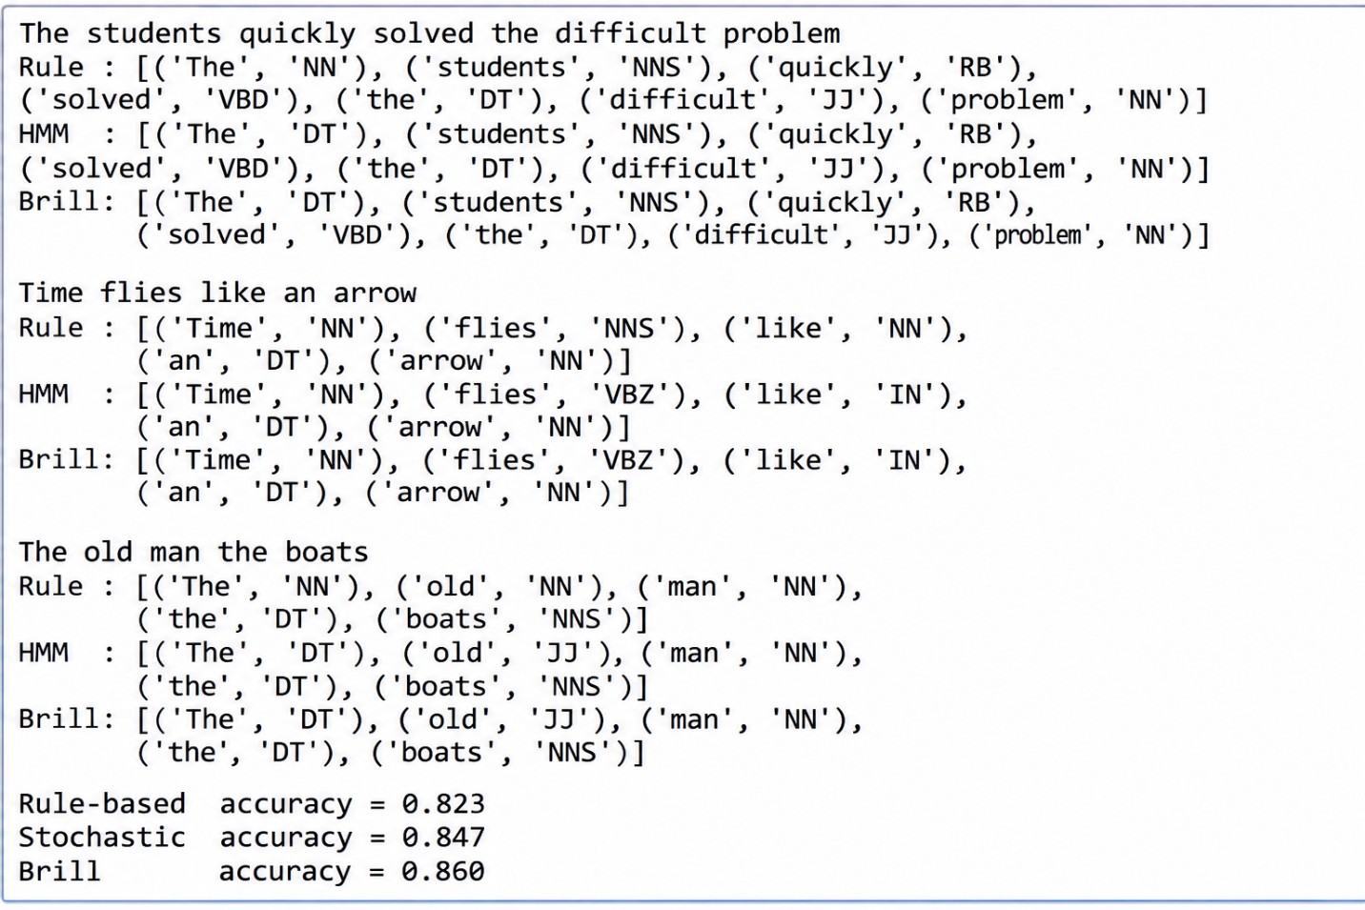

Expected Comparison (illustrative)
Sentence / word | Rule-based | Stochastic (bigram) | Brill
students | NNS | NNS | NNS
quickly | RB | RB | RB
difficult | NN (no rule) | JJ | JJ
Time flies like an arrow | flies: NNS, like: NN | flies: NNS, like: IN | flies: VBZ, like: IN
The old man the boats | man: NN | man: NN | man: NN (garden-path error)

Typical accuracy on held-out Penn Treebank sentences: Rule-based about 0.3–0.5, Stochastic bigram with back-off about 0.85–0.90, Brill about 0.90–0.93. Exact figures vary with the run and should be taken from the program output.

Analysis and Interpretation
- Rule-based tagging is transparent but covers only the patterns written; words without a matching rule fall back to NN, giving low accuracy.
- The stochastic tagger learns word–tag statistics and context, so it is far more accurate, but it fails on unseen words and on structures it has not seen.
- The Brill tagger corrects systematic errors of the initial tagger with learned rules (e.g. change NN to VB after "to"), usually giving the best accuracy.
- The three methods disagree mostly on ambiguous words (flies, like, man) and unknown words; garden-path sentences such as "The old man the boats" are mis-tagged by all of them.

