**Velagapudi Ramakrishna Siddhartha Engineering College Department of Information Technology**

Class: 3rdYear Section: B Year: 2020-2021

**Braille Text to Speech Conversion**

**Problem Discription:**

The visually impaired people face so many difficulties in interacting and gaining full advantage of computers. As technology is growing fastly, by keeping their difficulty in mind, we are trying to overcome this by converting braille to text and then to speech using an optimization technique. Braille is a special type of language used by the visually impaired people for reading and writing, which cannot be understood by common people. Our idea is to convert braille text to speech by making it easy to understand to each and every users.   
 The braille language can be represented by using 6 dots as shown in below image.

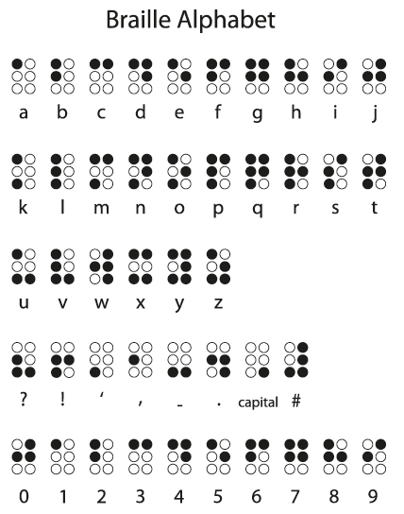

A Braille text image is taken and it is converted into appropriate alphabets of the english language using an optimization technique in Computer Vision .This technique helps in image processing by capturing the spatial features of the image

that help us to identify the object accurately .Then by using python we will convert

this text to speech.

The following diagram show the text extraction

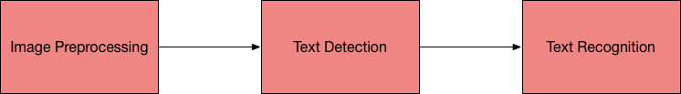

**Uniqueness of the idea:**

As of now, braille to speech conversions is done by using the Internet Of Things and also invented a hardware devices to do this conversion. But, now in this project we are trying to convert the braille to text and then to speech using an optimization technique

**Implementation challenges:**

* Computer Vision
* Image Processing
* Python

**Benefits of the Community:**

* It helps resource teachers in Inclusive Education, who do not know Braille.
* Acts as an aid for visually impaired people who may be handicapped or paralyzed providing audio support.
* A further improvement can translate the text to different languages and hence English braille will be available as audio in multiple languages

|  |  |  |  |
| --- | --- | --- | --- |
| ROLL NUMBER | NAME | EMAIL-ID | SIGNATURE |
| 188W1A1217 | DUDLA V JOSHITA LAVANYA | lavanyabose123@gmail.com |  |
| 188W1A1231 | MANDATTIL KEERI SNIGDHA | [mksnigdha7778@gmail.com](mailto:mksnigdha7778@gmail.com) |  |
| 188W1A1235 | NAGELLA SANKEERTHANA | vinnynagella@gmail.com |  |
| 198W5A1206 | LOKESH PAPPALA | lokeshpappala10@gmail.com |  |

A.SRISAILA

[FACULTY GUIDE]