2025 Spring MCIS 6333 Data Visualization

# Homework 2

# Iris Dataset Visualization Analysis

This document presents the visualization analysis of the Iris dataset, showing the relationships between different features through scatter plots.

## 1. Scatter Plot Matrix of All Feature Pairs

The following visualization shows the relationships between all pairs of features in the Iris dataset, colored by species:

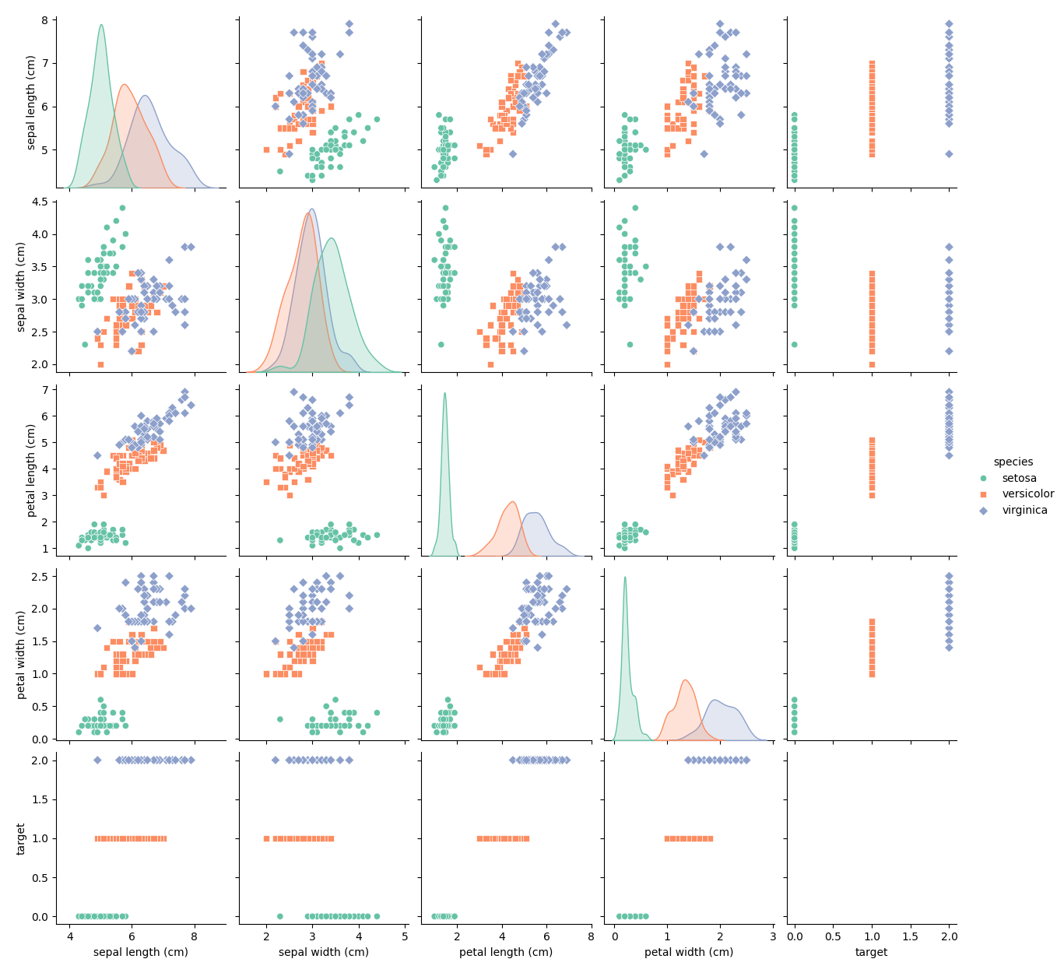

## 2. Strongest Positive Correlation Plot

This plot shows the scatter plot of the most strongly correlated feature pair:

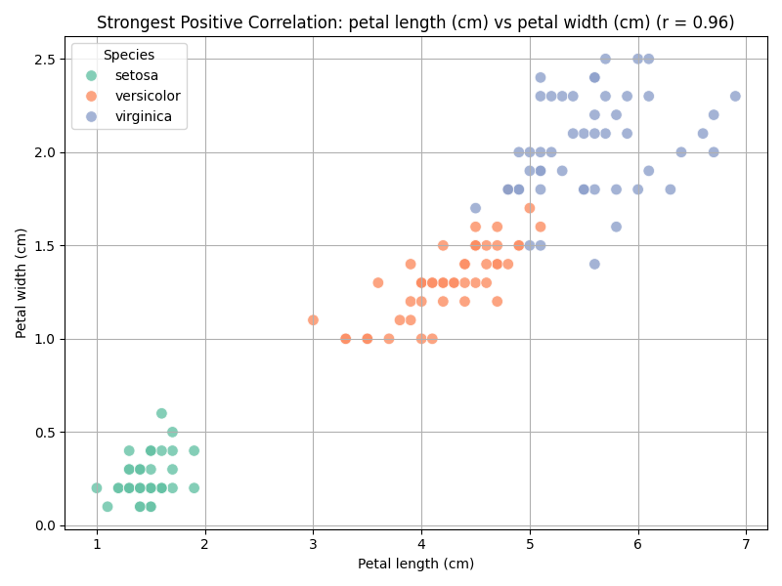

Author: Lokesh Para