INTRODUCTION

Investment in financial markets involves allocating available funds among different assets with the objective of earning satisfactory returns while managing the associated risk. Since the prices of stocks fluctuate over time, investors face uncertainty regarding the future performance of their investments. As a result, constructing a portfolio that provides a suitable balance between return and risk becomes an important decision-making problem.
Portfolio optimisation is a well-known concept in finance and Operations Research, where mathematical models are used to determine the most efficient way of distributing investments across multiple assets. One of the most widely used approaches for this purpose is the mean–variance model proposed by Harry Markowitz. In this framework, the expected return of a portfolio is treated as a measure of profitability, while the variance of returns is considered as a measure of risk.
In this project, historical stock price data of selected companies listed on the National Stock Exchange (NSE) has been used to study the portfolio optimisation problem. The expected returns and covariance of asset returns are estimated from the data, and a quadratic programming model is formulated to determine the optimal investment weights. The model aims to minimise portfolio risk while ensuring that a specified target return is achieved, subject to realistic constraints such as full investment of available funds and non-negativity of portfolio weights.
The results obtained from the optimisation model help in understanding how diversification across different stocks can reduce overall portfolio risk. In addition, the concept of the efficient frontier is used to analyse the trade-off between expected return and volatility for different investment strategies.

Problem Statement
The aim of this project is to determine an optimal allocation of investment among a set of selected financial assets in such a way that the overall risk of the portfolio is minimised while achieving a desired level of expected return. This problem arises because returns from financial assets are uncertain and fluctuate over time. Therefore, investors must consider both profitability and risk while constructing an investment portfolio.
Let the portfolio consist of $n$assets. The decision variable of the problem is the portfolio weight vector
$$x=(x_{1},x_{2},x_{3},…,x_{n})^{T}$$
where $x_{i}$represents the proportion of total available capital invested in the $i^{th}$asset. The vector of expected returns of the assets is denoted by
$$μ=(μ_{1},μ_{2},μ_{3},…,μ_{n})^{T}$$
and the covariance matrix of asset returns is denoted by
$$Σ=\left[\begin{matrix}σ_{11} & σ_{12} & … & σ_{1n} \\ σ_{21} & σ_{22} & … & σ_{2n} \\ ⋮ & ⋮ & ⋱ & ⋮ \\ σ_{n1} & σ_{n2} & … & σ_{nn}\end{matrix}\right]$$
The expected return of the portfolio is given by
$$μ^{T}x=\sum_{i=1}^{n}{μ_{i}}x_{i}$$
which represents the weighted average of expected returns of individual assets.
The risk associated with the portfolio is measured using the variance of portfolio returns, which is expressed as the quadratic form
$$x^{T}Σx$$
This term captures not only the individual variability of each asset but also the correlation between different assets through the covariance terms.
The portfolio optimisation problem is therefore formulated as the following quadratic programming problem:
$$\text{Minimise}x^{T}Σx$$
Subject to:
$$μ^{T}x=T \\ \sum_{i=1}^{n}{x_{i}}=1 \\ x_{i}≥0\text{for all }i=1,2,…,n$$
where $T$ represents the target expected return specified by the investor.
The first constraint ensures that the portfolio achieves the required level of expected return.
The second constraint is the budget constraint, which states that the entire available capital must be invested across the selected assets.
The non-negativity constraints enforce a long-only investment policy, meaning that short selling is not permitted.
Since the covariance matrix $Σ$ is positive semi-definite, the objective function is convex. As a result, the quadratic programming problem has a unique global optimum. The Karush–Kuhn–Tucker (KKT) optimality conditions are used to transform the constrained quadratic optimisation problem into a system of linear equations. Solving this system provides the optimal portfolio weights corresponding to the specified target return.
This mathematical formulation enables the analysis of the trade-off between risk and return and provides a systematic framework for constructing an efficient investment portfolio using techniques from Operations Research.

Data Collection and Processing
In order to study the portfolio optimisation problem using real market information, historical price data of selected stocks listed on the National Stock Exchange (NSE) was collected. The data was obtained using the Python library yfinance, which provides access to publicly available financial market data.
The portfolio considered in this study consists of ten assets representing different sectors of the market. These include exchange traded funds and stocks from banking, pharmaceutical, technology, energy and consumer goods sectors. Daily closing price data for each stock was downloaded for a recent six-month period. The use of multiple sectors helps in capturing the diversification effect in portfolio construction.
After collecting the price data, the daily returns of each stock were calculated using percentage change in closing prices. If $P_{t}$denotes the closing price of a stock on day $t$, the daily return $r_{t}$is computed as
$$r_{t}=\frac{P_{t}-P_{t-1}}{P_{t-1}}$$
These daily returns were then used to estimate the statistical parameters required for the optimisation model. The expected return of each asset was obtained by computing the average of its daily returns over the selected time period. The covariance matrix of asset returns was also calculated in order to capture the variability and interdependence between different stocks.
The processed data, including the expected return vector and covariance matrix, was stored in numerical form and used as input to the quadratic programming model. This data preparation step is essential as it transforms raw financial price data into meaningful quantities required for portfolio optimisation analysis.
Mathematical Solution Approach
The quadratic programming model formulated for portfolio optimisation is solved using the method of Lagrange multipliers and the Karush–Kuhn–Tucker (KKT) optimality conditions. The optimisation problem can be written as
Minimise
$$f(x)=x^{T}Σx$$
Subject to
$$μ^{T}x=T \\ e^{T}x=1 \\ x≥0$$
where $e$is a vector of ones.
To solve the equality constrained optimisation problem, the Lagrangian function is constructed as
$$L(x,λ_{1},λ_{2})=x^{T}Σx+λ_{1}(μ^{T}x-T)+λ_{2}(e^{T}x-1)$$
where $λ_{1}$and $λ_{2}$are Lagrange multipliers corresponding to the return constraint and the budget constraint respectively.
The first-order optimality condition is obtained by differentiating the Lagrangian with respect to the decision variable vector $x$and equating it to zero:
$$∇_{x}L=2Σx+λ_{1}μ+λ_{2}e=0$$
This leads to the system of linear equations
$$2Σx+λ_{1}μ+λ_{2}e=0 \\ μ^{T}x=T \\ e^{T}x=1$$
These equations can be written in matrix form as
$$\left[\begin{matrix}2Σ & μ & e \\ μ^{T} & 0 & 0 \\ e^{T} & 0 & 0\end{matrix}\right]\left[\begin{aligned}x \\ λ_{1} \\ λ_{2}\end{aligned}\right]=\left[\begin{aligned}0 \\ T \\ 1\end{aligned}\right]$$
Solving this system provides the optimal portfolio weights $x$along with the associated Lagrange multipliers. The non-negativity constraints are then enforced to obtain a feasible long-only portfolio. Because the covariance matrix is positive semi-definite, the objective function is convex and the obtained solution corresponds to the global minimum variance portfolio for the specified target return.

Result Analysis
The quadratic programming model was solved using historical return data of the selected NSE stocks. For the specified target level of expected return, the optimisation process produced the following optimal portfolio allocation.

The total allocation across all assets is equal to 100%, which confirms that the budget constraint $∑x_{i}=1$is satisfied. The non-negativity condition $x_{i}≥0$is also satisfied, indicating that the model generates a long-only portfolio.
Portfolio Performance Measures
- Expected portfolio return (daily): 0.0585 %
- Portfolio variance: 0.004715 %²
- Portfolio volatility (daily risk): 0.687 %
The expected return represents the average percentage gain anticipated per trading day based on historical data. The variance value obtained from the quadratic expression $x^{T}Σx$ measures the uncertainty associated with portfolio returns. The volatility, which is the square root of variance, indicates the typical daily fluctuation in portfolio performance around the mean return.
From the allocation pattern, it can be observed that higher investment weights are assigned to assets such as SUNPHARMA, TITAN and NESTLEIND, which provide a favourable balance between expected return and risk. Assets like INDIGO and LT receive zero allocation because their inclusion would increase the value of the quadratic risk function without significantly improving the expected return constraint. In optimisation terms, the non-negativity constraints for these assets become binding at the optimal solution.
The diversification of investment across multiple assets helps in reducing overall portfolio risk by accounting for both individual asset variability and covariance effects. This demonstrates the practical usefulness of the quadratic programming approach in constructing an efficient investment portfolio.
In addition, the efficient frontier generated by solving the optimisation model for different target return levels illustrates the fundamental trade-off between risk and return. The convex upward shape of the frontier confirms that portfolios with higher expected returns are associated with higher volatility, which is consistent with the theoretical predictions of the mean–variance framework.
Efficient Frontier Analysis (Mathematical Interpretation)
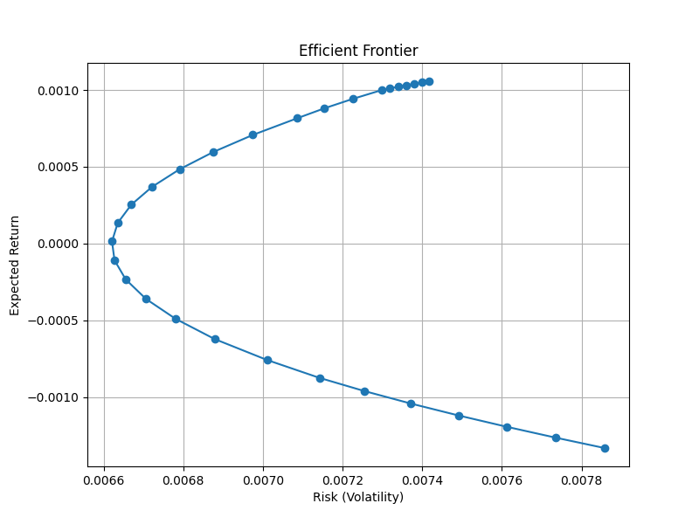

The efficient frontier shown in Figure __ represents the set of optimal portfolios obtained by solving the quadratic programming problem for different levels of target return. Mathematically, each point on the curve corresponds to the solution of the constrained optimisation problem
$$min⁡ x^{T}Σx$$
subject to
$$μ^{T}x=T,e^{T}x=1,x_{i}≥0$$
where $Σ$is the covariance matrix of asset returns, $μ$is the expected return vector and $T$denotes the required portfolio return.
Since the covariance matrix is positive semi-definite, the objective function $x^{T}Σx$is convex. As a result, the feasible set together with the quadratic objective produces a convex efficient frontier in the risk–return plane. This explains the curved shape observed in the graph.
For each value of the target return $T$, the optimisation process determines a unique portfolio weight vector $x^{*}(T)$that minimises portfolio variance. The corresponding portfolio risk is given by
$$σ_{p}=\sqrt{x^{*T}Σx^{*}}$$
and the expected return is
$$R_{p}=μ^{T}x^{*}$$
Thus, every point on the frontier satisfies the optimality condition derived from the Karush–Kuhn–Tucker framework
$$2Σx^{*}+λ_{1}μ+λ_{2}e=0$$
which indicates that the gradient of the quadratic risk function is a linear combination of the gradients of the constraints.
The left-most point on the frontier corresponds to the minimum variance portfolio, where
$$\underset{x}{min⁡} x^{T}Σx\text{subject to}e^{T}x=1$$
This portfolio achieves the lowest possible volatility among all feasible portfolios. As the required return level increases, the optimisation forces the solution to move along the frontier toward portfolios with larger variance. Hence, the upward-sloping portion of the curve mathematically represents the trade-off
$$\frac{dσ_{p}}{dR_{p}}>0$$
which means that an increase in expected return necessarily results in higher portfolio risk.
Therefore, the efficient frontier provides a complete mathematical description of all Pareto-optimal portfolios, where no further reduction in risk is possible without decreasing the expected return.

Conclusion
In this project, the portfolio optimisation problem was studied using the quadratic programming framework based on the classical mean–variance model. Historical price data of selected stocks listed on the National Stock Exchange was used to estimate expected returns and the covariance matrix of asset returns. Using these inputs, a convex quadratic optimisation problem was formulated with the objective of minimising portfolio variance while satisfying constraints on expected return, full investment of available capital and non-negativity of portfolio weights.
The optimal portfolio obtained from the model demonstrates the importance of diversification in reducing overall risk. By allocating investment across multiple assets with different return characteristics and covariance relationships, the optimisation process was able to construct a portfolio that achieves the desired level of expected return with controlled variability. The generation of the efficient frontier further illustrated the trade-off between risk and return and highlighted how higher return requirements lead to increased portfolio volatility.
The results confirm that quadratic programming provides a systematic and quantitative approach for portfolio selection. The use of mathematical optimisation techniques allows investors to make more informed decisions compared to heuristic or intuition-based allocation strategies.

Limitations
While the optimisation model provides useful insights, certain simplifying assumptions have been made in this study. The model assumes that historical returns are a reliable indicator of future performance, which may not always hold in real financial markets. Transaction costs, liquidity constraints and market impact have also been ignored. In addition, the analysis is based on a limited time period and a fixed set of assets, which may affect the robustness of the results.

Future Scope
The present work can be extended in several ways to make the portfolio model more realistic. Future studies may incorporate additional constraints such as sector-wise investment limits or maximum exposure to individual assets. The inclusion of transaction costs and dynamic rebalancing strategies can also improve the practical applicability of the model. Furthermore, alternative risk measures such as Value at Risk (VaR) or Conditional Value at Risk (CVaR) can be considered for more advanced portfolio optimisation analysis.

Team Info

Members:
Lokesh Patil (24IM10011)
Akshat Gupta (24IM10025)
P. Sai Kashyap (24IM10053)

Appendix

Github Repo: Github
This contains all the codes, data files and the detailed results. Please hereby once check it out.

