INTERNSHIP ASSESSMENT SUBMISSION

Data Science Fundamentals
Assessment
Python · NumPy · pandas · Statistics · Data Cleaning · EDA · Visualization

Level: Beginner Data Science Intern
Includes: Practical Assessment (22 tasks) and Mini Project
Name: | Lokesh Patwal
Internship/Program: | Data Analyst Intern
Organization: | Yuva Intern
Date: | 4 October 2026

Table of Contents
1. Introduction
1.1 Purpose of this Document
1.2 Scope and Intended Audience
1.3 Tools and Environment
1.4 How this Document is Organised
1.5 Files Supplied with this Submission
2. Objectives
2.1 General Objectives
2.2 Specific Learning Objectives
2.3 Assessment Structure and Evaluation Criteria
3. Python Fundamentals
3.1 Variables
3.2 Numbers, Strings and Booleans
3.3 Lists
3.4 Tuples
3.5 Sets
3.6 Dictionaries
3.7 Operators
3.8 Conditional Statements
3.9 for and while Loops
3.10 Functions
3.11 Lambda Functions
3.12 List Comprehensions
3.13 Exception Handling
3.14 Basic File Handling
4. NumPy Fundamentals
4.1 NumPy Arrays
4.2 Array Creation
4.3 Indexing and Slicing
4.4 Mathematical Operations
4.5 Mean, Median and Standard Deviation
4.6 Reshaping Arrays
5. Pandas Fundamentals
5.1 Series
5.2 DataFrame
5.3 Reading CSV Files
5.4 Inspecting a Dataset
5.5 Selecting and Filtering Data
5.6 Adding and Removing Columns
5.7 Sorting
5.8 Handling Missing Values
5.9 Removing Duplicates
5.10 GroupBy
5.11 Basic Aggregation
6. Statistics Fundamentals
6.1 Population versus Sample
6.2 Mean, Median and Mode
6.3 Range, Variance and Standard Deviation
6.4 Percentiles and Quartiles
6.5 Probability Basics
6.6 Correlation
6.7 Outliers
7. Data Types
7.1 Overview of Data Types
7.2 How the Types Relate
7.3 Classifying Columns of a Real Dataset
7.4 Why Data Types Matter
8. Data Cleaning and Preprocessing
8.1 Data Quality Checklist
8.2 A Small Messy Dataset
8.3 Duplicates, Incorrect Types and Missing Values
8.4 Data Validation and Inconsistent Text
8.5 Outliers
8.6 Encoding Categorical Variables
8.7 Feature Scaling: Normalization versus Standardization
9. Exploratory Data Analysis (EDA)
9.1 The EDA Workflow
9.2 Worked Example: Employee Data
10. Data Visualization
10.1 Bar Chart
10.2 Line Chart
10.3 Histogram
10.4 Scatter Plot
10.5 Box Plot
10.6 Heatmap
10.7 Choosing the Right Chart
11. Industry Best Practices
12. Practical Assessment: Student Performance Analysis
12.1 Scenario and Dataset
12.2 Part A: Loading and Inspecting the Data (Tasks 1 – 5)
12.3 Part B: Cleaning the Data (Tasks 6 – 7)
12.4 Part C: Descriptive Statistics (Tasks 8 – 11)
12.5 Part D: Filtering, Grouping and New Features (Tasks 12 – 15)
12.6 Part E: Correlation and Visualization (Tasks 16 – 20)
12.7 Part F: Insights and Conclusion (Tasks 21 – 22)
13. Mini Project: Exploratory Data Analysis
13.1 Problem Statement
13.2 Dataset Description
13.3 Objectives
13.4 Data Loading
13.5 Data Cleaning
13.6 Exploratory Data Analysis
13.7 Statistical Analysis
13.8 Visualizations
13.9 Key Findings
13.10 Conclusion
14. Conclusion
15. Learning Outcomes
16. References
Appendix A: Dataset Generation Script
Appendix B: Submission Checklist

1. Introduction

1.1 Purpose of this Document
This document is the written submission for the Data Science Fundamentals Assessment, completed as part of a data science internship. It brings together the core ideas a beginner needs to start working with data: writing basic Python, handling numbers with NumPy and tables with pandas, understanding statistics and data types, cleaning messy data, exploring it, and presenting findings visually.
Every concept is explained in plain language, followed by a short Python example and the actual output produced when that code was run. The second half of the document applies these ideas in a hands-on practical assessment (22 tasks) and a complete mini project.

1.2 Scope and Intended Audience
The content is written for a beginner-level data science intern. It assumes no prior experience with data analysis, but it expects the reader to be comfortable installing software and running Python code in a notebook or script. Topics are limited to fundamentals; machine learning and advanced statistics are deliberately outside the scope of this assessment.

1.3 Tools and Environment
Table 1: Software used in this assessment
Tool | Purpose | Version used
Python | General-purpose programming language used for all examples | 3.12
NumPy | Fast numerical arrays and mathematical functions | 2.4
pandas | Tables (DataFrames), cleaning, grouping and aggregation | 3.0
Matplotlib | Core plotting library | 3.10
Seaborn | Statistical charts built on top of Matplotlib | 0.13
Jupyter Notebook / VS Code | Interactive environment to run and document code | Any recent version

Version note
Recent pandas versions (3.x) display text columns as str, while older versions (1.x and 2.x) display them as object. Both mean "text". All other outputs in this document are the same in older versions.

1.4 How this Document is Organised
Table 2: Structure of the document
Section | Content | Type
3 – 5 | Python, NumPy and pandas fundamentals | Theory + code
6 – 7 | Statistics fundamentals and data types | Theory + code
8 – 10 | Data cleaning, Exploratory Data Analysis (EDA) and visualization | Theory + code
11 | Industry best practices for beginners | Guidelines
12 | Practical Assessment – 22 tasks on student performance data | Hands-on
13 | Mini Project – EDA on retail sales data | Hands-on
14 – 16 | Conclusion, learning outcomes and references | Summary
Appendix | Script used to generate the sample datasets; submission checklist | Reference

1.5 Files Supplied with this Submission
Table 3: Datasets provided
File | Description | Used in
student_performance.csv | 123 rows × 10 columns of student marks, study habits and background (includes deliberate data-quality problems) | Section 12
retail_sales.csv | 305 rows × 9 columns of retail orders for the year 2025 (includes deliberate data-quality problems) | Section 13
gen_data.py | Python script that regenerates both datasets (see Appendix A) | Appendix A

Both datasets are synthetic: they were generated by code with a fixed random seed so that every result in this document is reproducible. No real student or customer information is used.

2. Objectives

2.1 General Objectives
- Demonstrate understanding of core data science concepts.
- Cover Python basics, statistical foundations, data types, data analysis and industry best practices.
- Include practical assignments and tasks that demonstrate hands-on understanding.

2.2 Specific Learning Objectives
After completing this assessment, the intern should be able to:
- Write clear Python programs using variables, data structures, loops, functions and exception handling.
- Create and manipulate NumPy arrays and compute basic statistics with them.
- Load, inspect, filter, sort, group and summarise data with pandas.
- Explain and calculate mean, median, mode, variance, standard deviation, percentiles and correlation.
- Classify any column of a dataset as numerical, categorical, nominal, ordinal, discrete or continuous.
- Identify and fix missing values, duplicates, wrong data types and outliers.
- Encode categorical variables and scale numerical features.
- Carry out a complete Exploratory Data Analysis (EDA) and summarise the findings in plain English.
- Choose and create suitable charts using Matplotlib and Seaborn.
- Follow basic professional practices for reproducible, readable and responsible data work.

2.3 Assessment Structure and Evaluation Criteria
Table 4: Marking scheme
Component | What is assessed | Marks
Concepts and examples | Correct understanding of Sections 3 – 11, shown through working examples | 20
Practical Assessment | Correct code, expected output and short explanation for all 22 tasks (Section 12) | 40
Mini Project | Complete EDA workflow, sound findings and clear conclusion (Section 13) | 30
Documentation quality | Clear structure, readable code, consistent formatting, honest interpretation | 10
Total |  | 100

3. Python Fundamentals
Python is the most widely used language in data science because it is easy to read, has a huge community and offers powerful libraries for numbers, tables and charts. This section covers the language features that every later section depends on. Each concept has a short example followed by its real output.

3.1 Variables
A variable is a name that refers to a value stored in the computer's memory. You create one with the assignment operator =. Python works out the type of the value automatically (this is called dynamic typing).
- Names may contain letters, digits and underscores, but cannot start with a digit.
- Names are case-sensitive: Age and age are different variables.
- The convention (PEP 8) is snake_case, for example total_marks.
Python code
name = "Asha"
age = 22
height_m = 1.65
is_intern = True

print(name, age, height_m, is_intern)
print(type(name), type(age), type(height_m), type(is_intern))

Output
Asha 22 1.65 True
<class 'str'> <class 'int'> <class 'float'> <class 'bool'>

3.2 Numbers, Strings and Booleans
Table 5: Basic Python data types
Type | Python name | Example | Typical data science use
Whole number | int | 42 | Counts, years, IDs
Decimal number | float | 3.14 | Prices, measurements, scores
Text | str | "Delhi" | Names, categories, descriptions
True / False | bool | True | Conditions and filters

Numbers support the usual arithmetic operators. Strings can be cleaned with methods such as strip(), upper() and replace(), and combined with values using f-strings (f"..."). Booleans are the result of every comparison and are the basis of data filtering.
Python code
a, b = 17, 5
print(a + b, a - b, a * b)
print(a / b)
print(a // b)
print(a % b)
print(a ** 2)

text = " Data Science "
print(text.strip().upper())
print(text.strip().replace("Science", "Analytics"))
print(f"Length after strip: {len(text.strip())}")

Output
22 12 85
3.4
3
2
289
DATA SCIENCE
Data Analytics
Length after strip: 12

Python code
x = 10
print(x > 5, x == 3, not (x > 5))
print(bool(0), bool(""), bool("data"))

Output
True False False
False False True

3.3 Lists
A list is an ordered, changeable collection written in square brackets. Items are accessed by position (starting from 0) and lists can be sliced with [start:stop], where the stop position is not included.
Python code
scores = [72, 85, 90, 66]
scores.append(78)
scores[0] = 75
print(scores)
print(scores[1:4], len(scores), max(scores), sum(scores) / len(scores))
scores.sort()
print(scores)

Output
[75, 85, 90, 66, 78]
[85, 90, 66] 5 90 78.8
[66, 75, 78, 85, 90]

3.4 Tuples
A tuple is like a list but immutable: it cannot be changed after creation. Tuples are written in round brackets and are useful for fixed values such as coordinates or (row, column) shapes. NumPy and pandas return shapes as tuples, for example (120, 10).
Python code
point = (3, 4)
x, y = point
print(point, x, y)

Output
(3, 4) 3 4

3.5 Sets
A set is an unordered collection of unique items written in curly braces. Sets are ideal for removing duplicates and for comparing groups using union (|), intersection (&) and difference (-). Because sets have no order, the example sorts the results before printing.
Python code
skills_a = {"python", "sql", "excel"}
skills_b = {"python", "tableau"}
print(sorted(skills_a | skills_b))
print(sorted(skills_a & skills_b))
print(sorted(skills_a - skills_b))
print(set([1, 2, 2, 3, 3, 3]))

Output
['excel', 'python', 'sql', 'tableau']
['python']
['excel', 'sql']
{1, 2, 3}

3.6 Dictionaries
A dictionary stores data as key: value pairs. Values are looked up by key rather than by position, which makes dictionaries perfect for records such as one student or one employee. The .get() method returns a default value instead of an error when a key is missing.
Python code
student = {"name": "Ravi", "age": 21, "course": "Data Science"}
student["grade"] = "A"
print(student["name"], student.get("city", "Not given"))
for key, value in student.items():
print(key, "->", value)
print(list(student.keys()))

Output
Ravi Not given
name -> Ravi
age -> 21
course -> Data Science
grade -> A
['name', 'age', 'course', 'grade']

Table 6: Comparison of Python collections
Feature | List | Tuple | Set | Dictionary
Syntax | [1, 2] | (1, 2) | {1, 2} | {"a": 1}
Ordered | Yes | Yes | No | Yes (by insertion)
Changeable | Yes | No | Yes | Yes
Allows duplicates | Yes | Yes | No | Keys must be unique
Best used for | Sequences of values | Fixed groups of values | Unique items, membership tests | Labelled records

3.7 Operators
Table 7: Python operators
Category | Operators | Example
Arithmetic | + - * / // % ** | 17 // 5 gives 3
Comparison | == != > < >= <= | 10 > 3 gives True
Logical | and or not | (x > 5) and (x < 20)
Membership | in not in | 3 in [1, 2, 3] gives True
Assignment | = += -= *= | a += 3 means a = a + 3

Python code
a, b = 12, 5
print("Arithmetic:", a + b, a % b)
print("Comparison:", a > b, a == b, a != b)
print("Logical:", (a > 10) and (b < 3), (a > 10) or (b < 3))
print("Membership:", 3 in [1, 2, 3], "x" not in "data")
a += 3
print("Assignment:", a)

Output
Arithmetic: 17 2
Comparison: True False True
Logical: False True
Membership: True True
Assignment: 15

3.8 Conditional Statements
Conditional statements let a program choose between actions. Python checks if, then each elif (short for "else if") in order, and finally runs else if nothing matched. Indentation (four spaces) defines which lines belong to each branch.
Python code
marks = 78
if marks >= 90:
grade = "A"
elif marks >= 75:
grade = "B"
elif marks >= 60:
grade = "C"
else:
grade = "Fail"
print("Grade:", grade)

Output
Grade: B

3.9 for and while Loops
A for loop repeats once for each item in a sequence, and range(start, stop) generates a sequence of numbers. A while loop keeps repeating as long as its condition is true, so the loop body must change something that eventually makes the condition false; otherwise it never ends.
Python code
for i in range(1, 6):
print(i, i ** 2)

total, n = 0, 1
while n <= 5:
total += n
n += 1
print("Sum of 1 to 5:", total)

Output
1 1
2 4
3 9
4 16
5 25
Sum of 1 to 5: 15

3.10 Functions
A function is a reusable block of code defined with def. It can take parameters (inputs), have default values and return a result. Functions remove repetition and make programs easier to test. The text in triple quotes directly under def is a docstring that documents what the function does.
Python code
def average(numbers):
"""Return the average of a list of numbers."""
return sum(numbers) / len(numbers)

def greet(name, greeting="Hello"):
return f"{greeting}, {name}!"

print(average([70, 80, 90]))
print(greet("Meera"))
print(greet("Meera", greeting="Welcome"))

Output
80.0
Hello, Meera!
Welcome, Meera!

3.11 Lambda Functions
A lambda is a small anonymous function written on one line: lambda inputs: expression. It is commonly passed as an argument to other functions, such as sorted(), or to pandas methods like apply().
Python code
square = lambda x: x ** 2
print(square(6))

words = ["data", "sql", "python"]
print(sorted(words, key=lambda w: len(w)))

Output
36
['sql', 'data', 'python']

3.12 List Comprehensions
A list comprehension builds a new list in a single readable line: [expression for item in sequence if condition]. It replaces a loop that creates an empty list and appends to it.
Python code
squares = [n ** 2 for n in range(1, 6)]
evens = [n for n in range(1, 11) if n % 2 == 0]
print(squares)
print(evens)

Output
[1, 4, 9, 16, 25]
[2, 4, 6, 8, 10]

3.13 Exception Handling
Errors that occur while a program is running are called exceptions. Instead of letting the program crash, a try block can attempt risky code, an except block handles a specific error, and a finally block runs no matter what. This is essential when reading files or converting messy data.
Python code
def safe_divide(a, b):
try:
return a / b
except ZeroDivisionError:
return "Cannot divide by zero"
finally:
print("Division attempted")

print(safe_divide(10, 2))
print(safe_divide(5, 0))

try:
int("abc")
except ValueError as e:
print("ValueError:", e)

Output
Division attempted
5.0
Division attempted
Cannot divide by zero
ValueError: invalid literal for int() with base 10: 'abc'

3.14 Basic File Handling
The built-in open() function reads and writes files. Using it inside a with statement is best practice because the file is closed automatically, even if an error occurs. The mode is "r" to read, "w" to write (overwriting) and "a" to append.
Python code
with open("notes.txt", "w") as f:
f.write("Line 1: Data Science\n")
f.write("Line 2: Python\n")

with open("notes.txt", "a") as f:
f.write("Line 3: Pandas\n")

with open("notes.txt", "r") as f:
for line in f:
print(line.strip())

Output
Line 1: Data Science
Line 2: Python
Line 3: Pandas

4. NumPy Fundamentals
NumPy (Numerical Python) provides the ndarray, a fast, memory-efficient grid of numbers that all of the same type. Libraries such as pandas, Matplotlib and scikit-learn are built on top of it. Its main advantage over a Python list is vectorisation: an operation is applied to every element at once, without writing a loop.

4.1 NumPy Arrays
Table 8: List versus NumPy array
Aspect | Python list | NumPy array
Element types | Can mix types | One type for all elements
Speed on large data | Slower | Much faster
list * 2 | Repeats the list | Multiplies every element
Maths on whole collection | Needs a loop | Built in (vectorised)

4.2 Array Creation
Table 9: Common ways to create arrays
Function | What it creates
np.array([1, 2, 3]) | Array from a Python list
np.zeros((2, 3)) / np.ones(3) | Array filled with 0s or 1s
np.arange(0, 10, 2) | Values from start up to (not including) stop, in steps
np.linspace(0, 1, 5) | A fixed number of evenly spaced values, including both ends
np.random.default_rng(42).normal(...) | Reproducible random numbers

Python code
import numpy as np

arr = np.array([10, 20, 30, 40, 50])
zeros = np.zeros((2, 3))
seq = np.arange(0, 10, 2)
lin = np.linspace(0, 1, 5)

print(arr, arr.dtype, arr.shape)
print(zeros)
print(seq, lin)

Output
[10 20 30 40 50] int64 (5,)
[[0. 0. 0.]
[0. 0. 0.]]
[0 2 4 6 8] [0. 0.25 0.5 0.75 1. ]

4.3 Indexing and Slicing
Arrays are indexed like lists, but 2-D arrays take [row, column]. A colon means "all". Boolean masking (arr[arr > 25]) selects elements that satisfy a condition, the same idea pandas uses to filter rows.
Python code
m = np.array([[1, 2, 3],
[4, 5, 6],
[7, 8, 9]])
print(m[0, 1])
print(m[1])
print(m[:, 2])
print(m[0:2, 1:3])
print(arr[arr > 25])

Output
2
[4 5 6]
[3 6 9]
[[2 3]
[5 6]]
[30 40 50]

4.4 Mathematical Operations
Arithmetic between arrays happens element by element. When an array is combined with a single number, NumPy automatically stretches ("broadcasts") that number across every element. Functions such as np.sqrt, np.exp and np.log also work on whole arrays.
Python code
a = np.array([1, 2, 3])
b = np.array([10, 20, 30])
print(a + b, a * b, b / a, a ** 2)
print(a * 10)
print(np.sqrt(np.array([4, 9, 16])))

Output
[11 22 33] [10 40 90] [10. 10. 10.] [1 4 9]
[10 20 30]
[2. 3. 4.]

4.5 Mean, Median and Standard Deviation
Statistics are available as functions (np.mean(a)) and as array methods (a.mean()). For 2-D arrays, axis=0 works down the columns and axis=1 works across the rows. Note that np.std divides by *n* by default (population standard deviation); use ddof=1 for the sample standard deviation, which is what pandas uses.
Python code
data = np.array([62, 70, 75, 75, 80, 88, 95])
print("Mean:", np.mean(data))
print("Median:", np.median(data))
print("Std Dev (population):", round(np.std(data), 2))
print("Std Dev (sample):", round(np.std(data, ddof=1), 2))
print("Min / Max:", data.min(), data.max())

sales = np.array([[100, 120, 90],
[80, 110, 95]])
print(sales.sum(axis=0))
print(sales.sum(axis=1))

Output
Mean: 77.85714285714286
Median: 75.0
Std Dev (population): 10.22
Std Dev (sample): 11.04
Min / Max: 62 95
[180 230 185]
[310 285]

4.6 Reshaping Arrays
reshape() changes the layout of an array without changing its data, as long as the total number of elements stays the same. Using -1 for one dimension lets NumPy calculate it. .T transposes rows and columns.
Python code
x = np.arange(1, 13)
print(x.reshape(3, 4))
print(x.reshape(2, 6).shape)
print(x.reshape(3, 4).T.shape)
print(x.reshape(3, -1).shape)

Output
[[ 1 2 3 4]
[ 5 6 7 8]
[ 9 10 11 12]]
(2, 6)
(4, 3)
(3, 4)

5. Pandas Fundamentals
pandas is the main Python library for working with tabular data (like Excel sheets or database tables). It has two core structures: the Series (one column) and the DataFrame (a whole table). By convention it is imported as import pandas as pd.

5.1 Series
A Series is a one-dimensional labelled array. The labels are called the index. Each column of a DataFrame is a Series.
Python code
import pandas as pd

s = pd.Series([85, 90, 78], index=["Math", "Science", "English"])
print(s)
print(s["Science"], s.mean())

Output
Math 85
Science 90
English 78
dtype: int64
90 84.33333333333333

5.2 DataFrame
A DataFrame is a two-dimensional table with labelled rows and columns. It is most often created by reading a file, but it can also be built from a dictionary of lists. Missing values are shown as NaN ("not a number").
Python code
data = {
"Name": ["Asha", "Ravi", "Meera", "John", "Sara"],
"Dept": ["HR", "IT", "IT", "Finance", "HR"],
"Salary": [42000, 65000, 70000, 58000, None],
"Experience": [2, 5, 7, 4, 3],
}
df = pd.DataFrame(data)
print(df)

Output
Name Dept Salary Experience
0 Asha HR 42000.0 2
1 Ravi IT 65000.0 5
2 Meera IT 70000.0 7
3 John Finance 58000.0 4
4 Sara HR NaN 3

5.3 Reading CSV Files
CSV (comma-separated values) is the most common format for sharing tabular data. pd.read_csv("file.csv") loads it into a DataFrame; df.to_csv("file.csv", index=False) saves one. Useful options include sep= for other separators, usecols= to load only some columns and parse_dates= to convert date columns.
Python code
df.to_csv("employees.csv", index=False)
emp = pd.read_csv("employees.csv")
print(emp.head(3))

Output
Name Dept Salary Experience
0 Asha HR 42000.0 2
1 Ravi IT 65000.0 5
2 Meera IT 70000.0 7

5.4 Inspecting a Dataset
Table 10: Commands for inspecting a DataFrame
Command | What it tells you
df.head(n) / df.tail(n) | First / last n rows
df.shape | Number of (rows, columns)
df.info() | Column names, data types and non-null counts
df.describe() | Count, mean, standard deviation, min, quartiles and max of numeric columns
df.columns, df.dtypes | Column names and types
df["col"].value_counts() | How often each value appears in a column

Python code
print(emp.shape)
emp.info()
print(emp.describe().round(1))
print(emp.columns.tolist())

Output
(5, 4)
<class 'pandas.DataFrame'>
RangeIndex: 5 entries, 0 to 4
Data columns (total 4 columns):
# Column Non-Null Count Dtype
--- ------ -------------- -----
0 Name 5 non-null str
1 Dept 5 non-null str
2 Salary 4 non-null float64
3 Experience 5 non-null int64
dtypes: float64(1), int64(1), str(2)
memory usage: 292.0 bytes
Salary Experience
count 4.0 5.0
mean 58750.0 4.2
std 12203.1 1.9
min 42000.0 2.0
25% 54000.0 3.0
50% 61500.0 4.0
75% 66250.0 5.0
max 70000.0 7.0
['Name', 'Dept', 'Salary', 'Experience']

5.5 Selecting and Filtering Data
Use df["col"] for one column and df[["a", "b"]] for several. loc selects by label and iloc by position. Filtering uses a Boolean condition inside square brackets. Combine conditions with & (and) and | (or), and always wrap each condition in parentheses.
Python code
print(emp["Name"].tolist())
print(emp[["Name", "Salary"]].head(2))
print(emp.loc[1, "Name"], emp.iloc[0, 2])

it_staff = emp[emp["Dept"] == "IT"]
print(it_staff)
print(emp[(emp["Experience"] >= 3) & (emp["Salary"] > 50000)])

Output
['Asha', 'Ravi', 'Meera', 'John', 'Sara']
Name Salary
0 Asha 42000.0
1 Ravi 65000.0
Ravi 42000.0
Name Dept Salary Experience
1 Ravi IT 65000.0 5
2 Meera IT 70000.0 7
Name Dept Salary Experience
1 Ravi IT 65000.0 5
2 Meera IT 70000.0 7
3 John Finance 58000.0 4

5.6 Adding and Removing Columns
A new column is created by assigning to a new name. Calculations are applied to the whole column at once. drop(columns=[...]) removes columns and returns a new DataFrame.
Python code
emp["Bonus"] = emp["Salary"] * 0.10
emp["Senior"] = emp["Experience"] >= 5
print(emp)

emp = emp.drop(columns=["Bonus"])
print(emp.columns.tolist())

Output
Name Dept Salary Experience Bonus Senior
0 Asha HR 42000.0 2 4200.0 False
1 Ravi IT 65000.0 5 6500.0 True
2 Meera IT 70000.0 7 7000.0 True
3 John Finance 58000.0 4 5800.0 False
4 Sara HR NaN 3 NaN False
['Name', 'Dept', 'Salary', 'Experience', 'Senior']

5.7 Sorting
sort_values() orders rows by one or more columns. Use ascending=False for largest first.
Python code
print(emp.sort_values("Experience", ascending=False))
print(emp.sort_values(["Dept", "Salary"]))

Output
Name Dept Salary Experience Senior
2 Meera IT 70000.0 7 True
1 Ravi IT 65000.0 5 True
3 John Finance 58000.0 4 False
4 Sara HR NaN 3 False
0 Asha HR 42000.0 2 False
Name Dept Salary Experience Senior
3 John Finance 58000.0 4 False
0 Asha HR 42000.0 2 False
4 Sara HR NaN 3 False
1 Ravi IT 65000.0 5 True
2 Meera IT 70000.0 7 True

5.8 Handling Missing Values
isnull().sum() counts missing values per column. There are two common remedies: drop the affected rows with dropna(), or fill them with fillna() using a sensible value such as the median. Dropping loses information, so filling is preferred when only a few values are missing.
Python code
print(emp.isnull().sum())
emp["Salary"] = emp["Salary"].fillna(emp["Salary"].median())
print(emp["Salary"].tolist())

Output
Name 0
Dept 0
Salary 1
Experience 0
Senior 0
dtype: int64
[42000.0, 65000.0, 70000.0, 58000.0, 61500.0]

5.9 Removing Duplicates
Duplicate records inflate counts and distort averages. duplicated() flags repeated rows and drop_duplicates() removes them, keeping the first occurrence.
Python code
dup = pd.concat([emp, emp.iloc[[0]]], ignore_index=True)
print("Duplicates:", dup.duplicated().sum())
dup = dup.drop_duplicates()
print("Rows after cleaning:", len(dup))

Output
Duplicates: 1
Rows after cleaning: 5

5.10 GroupBy
groupby() follows the split – apply – combine pattern: it splits the data into groups, applies a function such as mean or count to each group, and combines the results. It answers questions like "what is the average salary in each department?".
Python code
print(emp.groupby("Dept")["Salary"].mean())

summary = emp.groupby("Dept").agg(
Employees=("Name", "count"),
Avg_Salary=("Salary", "mean"),
Max_Experience=("Experience", "max"),
)
print(summary)

Output
Dept
Finance 58000.0
HR 51750.0
IT 67500.0
Name: Salary, dtype: float64
Employees Avg_Salary Max_Experience
Dept
Finance 1 58000.0 4
HR 2 51750.0 3
IT 2 67500.0 7

5.11 Basic Aggregation
Aggregation reduces many values to one. Common aggregation functions are sum, mean, median, min, max, count, std and nunique. value_counts() is a quick way to count categories.
Python code
print(emp["Salary"].sum(), emp["Salary"].mean(), emp["Salary"].max())
print(emp["Dept"].value_counts())

Output
296500.0 59300.0 70000.0
Dept
HR 2
IT 2
Finance 1
Name: count, dtype: int64

6. Statistics Fundamentals
Statistics is the science of collecting, summarising and interpreting data. In data science it provides the tools to describe what a dataset looks like, to judge whether a pattern is real, and to avoid being misled by unusual values. This section uses small, real-world examples and confirms every number with Python.

6.1 Population versus Sample
A population is the complete group you want to learn about; a sample is the smaller part of it that you actually measure. Measuring everyone is usually too slow or expensive, so analysts study a sample and use it to estimate facts about the population. A good sample is chosen randomly so that it represents the whole group.
Table 11: Population and sample
 | Population | Sample
Meaning | Every member of the group of interest | A selected subset of the group
Example | All 50,000 students of a university | 500 students randomly surveyed
Summary values are called | Parameters (e.g. population mean μ) | Statistics (e.g. sample mean x̄)
Variance divides by | N | n − 1

Python code
rng = np.random.default_rng(42)
population = rng.normal(loc=70, scale=10, size=10000)
sample = rng.choice(population, size=100, replace=False)
print("Population mean:", round(population.mean(), 2))
print("Sample mean :", round(sample.mean(), 2))

Output
Population mean: 69.9
Sample mean : 71.11

The sample mean (71.11) is close to, but not exactly equal to, the population mean (69.90). This small difference is called sampling error, and it usually shrinks as the sample gets larger.

6.2 Mean, Median and Mode
These three measures describe the centre of the data.
- Mean – the sum of all values divided by how many there are. It uses every value but is pulled by extreme values.
- Median – the middle value when the data is sorted (or the average of the two middle values). It is not affected by extreme values.
- Mode – the most frequent value. It is the only measure that also works for categories (for example, the most common department).
Real-world example
Eight students scored 55, 60, 65, 65, 70, 75, 80 and 95. One very high mark (95) lifts the mean to 70.6 even though most students scored in the 60s and 70s, so the median (67.5) describes a "typical" student better. When data is skewed, report the median as well as the mean.

6.3 Range, Variance and Standard Deviation
These measures describe the spread of the data, meaning how far values typically lie from the centre.
- Range = maximum − minimum. Simple, but depends only on two values.
- Variance = the average squared distance from the mean. For a sample: s² = Σ(x − x̄)² ÷ (n − 1).
- Standard deviation = the square root of the variance. It is in the same units as the data, so it is easier to interpret.
Two classes can have the same average mark but very different consistency: a class with a small standard deviation has students who all scored close to the average, while a large standard deviation means marks were scattered widely.
Python code
import numpy as np
import pandas as pd
from statistics import mode

marks = [55, 60, 65, 65, 70, 75, 80, 95]
s = pd.Series(marks)
print("Mean:", s.mean())
print("Median:", s.median())
print("Mode:", mode(marks))
print("Range:", s.max() - s.min())
print("Variance (sample):", round(s.var(), 2))
print("Std Dev (sample):", round(s.std(), 2))

Output
Mean: 70.625
Median: 67.5
Mode: 65
Range: 40
Variance (sample): 160.27
Std Dev (sample): 12.66

The mean is 70.625, the median 67.5 and the mode 65 (it appears twice). The range is 95 − 55 = 40, and the sample standard deviation of about 12.7 marks says a typical student scores roughly 12.7 marks away from the mean.

6.4 Percentiles and Quartiles
The p-th percentile is the value below which p% of the data falls. The 25th, 50th and 75th percentiles are the quartiles (Q1, Q2, Q3), and Q2 is the median. The distance Q3 − Q1 is the interquartile range (IQR), a spread measure that ignores extreme values. For example, being in the 90th percentile of an exam means scoring higher than 90% of candidates.
Python code
print("25th percentile:", s.quantile(0.25))
print("50th percentile:", s.quantile(0.50))
print("75th percentile:", s.quantile(0.75))
print(np.percentile(marks, [25, 50, 75]))

Output
25th percentile: 63.75
50th percentile: 67.5
75th percentile: 76.25
[63.75 67.5 76.25]

6.5 Probability Basics
Probability measures how likely an event is, on a scale from 0 (impossible) to 1 (certain).
- Basic rule: P(event) = number of favourable outcomes ÷ total number of equally likely outcomes.
- Complement: P(not A) = 1 − P(A).
- Independent events: P(A and B) = P(A) × P(B). The chance of two heads in two coin tosses is 0.5 × 0.5 = 0.25.
Real-world example: if 2 out of every 100 products from a factory are faulty, the probability that a randomly chosen product is faulty is 2 ÷ 100 = 0.02 (2%). A simulation confirms the theory: rolling a die 10,000 times gives about 50% even numbers.
Python code
outcomes = [1, 2, 3, 4, 5, 6]
favourable = [o for o in outcomes if o % 2 == 0]
print("P(even number) =", len(favourable) / len(outcomes))
print("P(two heads in two tosses) =", 0.5 * 0.5)

rng = np.random.default_rng(1)
rolls = rng.integers(1, 7, size=10000)
print("Simulated P(even):", (rolls % 2 == 0).mean())

Output
P(even number) = 0.5
P(two heads in two tosses) = 0.25
Simulated P(even): 0.492

6.6 Correlation
Correlation measures how strongly two numerical variables move together. The Pearson correlation coefficient *r* ranges from −1 to +1.
Table 12: Interpreting correlation
Value of r | Meaning | Example
Close to +1 | Strong positive: both rise together | Study hours and exam marks
Close to −1 | Strong negative: one rises as the other falls | Outdoor temperature and heater sales
Close to 0 | No linear relationship | Shoe size and exam marks

Python code
df = pd.DataFrame({
"hours": [1, 2, 3, 4, 5, 6, 7, 8],
"score": [52, 55, 61, 64, 70, 74, 79, 85],
})
print(round(df["hours"].corr(df["score"]), 3))
print(df.corr().round(3))

Output
0.998
hours score
hours 1.000 0.998
score 0.998 1.000

Correlation is not causation
A strong correlation shows that two things move together, not that one causes the other. Ice-cream sales and drowning incidents both rise in summer, but ice cream does not cause drowning: hot weather drives both. Always look for the underlying reason before drawing conclusions.

6.7 Outliers
An outlier is a value that lies unusually far from the rest. It may be a data-entry error (an age of 250), a measurement fault, or a genuine rare event (a CEO's salary). Two common detection rules are:
- IQR rule: a value is an outlier if it is below Q1 − 1.5 × IQR or above Q3 + 1.5 × IQR. This is also how box plots decide which points to draw as dots.
- Z-score rule: a value is an outlier if it is more than 3 standard deviations from the mean.
Python code
salaries = pd.Series([38, 40, 42, 45, 47, 50, 52, 55, 200])
q1, q3 = salaries.quantile(0.25), salaries.quantile(0.75)
iqr = q3 - q1
lower, upper = q1 - 1.5 * iqr, q3 + 1.5 * iqr
print("Q1, Q3, IQR:", q1, q3, iqr)
print("Bounds:", lower, upper)
print("Outliers:", salaries[(salaries < lower) | (salaries > upper)].tolist())

Output
Q1, Q3, IQR: 42.0 52.0 10.0
Bounds: 27.0 67.0
Outliers: [200]

The salary of 200 thousand is far above the upper bound of 67, so it is flagged. Before removing an outlier, always ask whether it is an error or a real observation, and record the decision.

7. Data Types
Knowing the type of each variable decides which summaries, charts and cleaning steps are valid. For example, an average of "Department" is meaningless, and a bar chart is a poor choice for a continuous measurement. Data can be described along three independent dimensions: its nature (numerical or categorical), its sub-type and its organisation (structured or unstructured).

7.1 Overview of Data Types
Table 13: Data types with examples
Data type | Definition | Examples | Typical pandas dtype
Numerical | Quantities that can be measured or counted and used in arithmetic | Age, salary, temperature | int64, float64
Categorical | Labels that place items into groups | Gender, city, grade | str / object, category
Nominal | Categories with no natural order | Blood group, colour, department | str / category
Ordinal | Categories with a meaningful order but unequal gaps | Rating (Low, Medium, High), education level | category (ordered)
Discrete | Numerical values that can only be counted in whole steps | Number of children, orders per day | int64
Continuous | Numerical values that can take any value in a range, usually measured | Height, weight, time, temperature | float64
Structured | Data organised in rows and columns with a fixed schema | SQL tables, CSV and Excel files | DataFrame
Unstructured | Data with no predefined table layout | Emails, images, audio, PDFs, social media posts | Needs processing first

A related type, semi-structured data (such as JSON and XML), has tags or keys but no fixed table layout. Roughly speaking, most real-world data is unstructured, but most beginner analysis is done on structured data.

7.2 How the Types Relate
Table 14: Decision guide for classifying a variable
Level 1 | Level 2 | Key question to ask
Numerical | Discrete or Continuous | Can I count it in whole steps, or measure it on a scale?
Categorical | Nominal or Ordinal | Do the categories have a natural order?

7.3 Classifying Columns of a Real Dataset
Applying the definitions to the columns of the student dataset used later in this document:
Table 15: Data types in the student dataset
Column | Example | Data type | Reason
Student_ID | S001 | Nominal (identifier) | A label with no order or arithmetic meaning
Gender | Male | Nominal | Categories without order
Class | B | Nominal | Group label
Study_Hours | 18.4 | Numerical – continuous | Measured; can have decimals
Attendance | 80.6 | Numerical – continuous | Percentage measured on a scale
Internet | Yes | Nominal (binary) | Only two categories
Parent_Edu | Bachelor | Ordinal | School < Bachelor < Master
Math, Science, English | 87.9 | Numerical – continuous | Marks on a 0 – 100 scale

7.4 Why Data Types Matter
Table 16: Matching data types to analysis
Data type | Suitable summaries | Suitable charts
Continuous numerical | Mean, median, standard deviation, percentiles | Histogram, box plot, scatter plot
Discrete numerical | Mean, median, counts | Bar chart, histogram
Nominal | Mode, counts, percentages | Bar chart
Ordinal | Median, mode, counts | Ordered bar chart
Time-ordered values | Trends, growth rates | Line chart

8. Data Cleaning and Preprocessing
Real data is almost always messy. Industry surveys regularly report that analysts spend a large share of their time (often cited as 60 – 80%) preparing data before any analysis begins. Poor-quality data leads to wrong conclusions however clever the analysis is, which is often summarised as "garbage in, garbage out".

8.1 Data Quality Checklist
Table 17: Common data quality problems
Problem | How to detect it | Typical fix
Missing values | df.isnull().sum() | Fill with median / mode, or drop rows
Duplicate records | df.duplicated().sum() | drop_duplicates()
Incorrect data types | df.dtypes, df.info() | pd.to_numeric(), pd.to_datetime(), astype()
Inconsistent text | value_counts(), unique() | str.strip(), str.lower(), str.title()
Outliers | IQR rule, box plot | Investigate; keep, cap or remove
Invalid values | Validation rules (ranges, uniqueness) | Correct, or remove and log

8.2 A Small Messy Dataset
The following employee table deliberately contains problems: age stored as text, a missing age, a duplicated row, inconsistent department spelling (it and HR with a trailing space) and a suspicious salary of 950,000.
Python code
import pandas as pd
import numpy as np

raw = pd.DataFrame({
"Employee_ID": [101, 102, 103, 104, 104, 106, 107],
"Age": ["25", "31", "29", None, None, "45", "28"],
"Dept": ["IT", "HR", "it", "Finance", "Finance", "HR ", "IT"],
"Salary": [50000, 62000, 58000, 71000, 71000, 950000, 54000],
"Rating": ["Low", "High", "Medium", "High", "High", "Medium", "Low"],
})
print(raw)
print(raw.dtypes)

Output
Employee_ID Age Dept Salary Rating
0 101 25 IT 50000 Low
1 102 31 HR 62000 High
2 103 29 it 58000 Medium
3 104 NaN Finance 71000 High
4 104 NaN Finance 71000 High
5 106 45 HR 950000 Medium
6 107 28 IT 54000 Low
Employee_ID int64
Age str
Dept str
Salary int64
Rating str
dtype: object

8.3 Duplicates, Incorrect Types and Missing Values
The duplicate employee 104 is removed first. The Age column is then converted from text to numbers with pd.to_numeric(), which allows the missing age to be filled with the median (29).
Python code
print(raw.isnull().sum())

clean = raw.drop_duplicates().copy()
print("Rows:", len(raw), "->", len(clean))

clean["Age"] = pd.to_numeric(clean["Age"])
clean["Age"] = clean["Age"].fillna(clean["Age"].median())
print(clean[["Employee_ID", "Age"]])

Output
Employee_ID 0
Age 2
Dept 0
Salary 0
Rating 0
dtype: int64
Rows: 7 -> 6
Employee_ID Age
0 101 25.0
1 102 31.0
2 103 29.0
3 104 29.0
5 106 45.0
6 107 28.0

8.4 Data Validation and Inconsistent Text
Data validation means testing the data against rules that must be true, such as "age is between 18 and 65", "salary is positive" and "employee IDs are unique". Text is standardised so that it, IT and IT are treated as one category. An assert statement stops the program with a clear message if a rule is broken.
Python code
clean["Dept"] = clean["Dept"].str.strip().str.upper()
print(sorted(clean["Dept"].unique()))

print("All ages valid (18-65):", clean["Age"].between(18, 65).all())
print("All salaries positive :", (clean["Salary"] > 0).all())
assert clean["Employee_ID"].is_unique, "Duplicate employee IDs found"
print("ID check passed")

Output
['FINANCE', 'HR', 'IT']
All ages valid (18-65): True
All salaries positive : True
ID check passed

8.5 Outliers
The salary of 950,000 is far above the upper IQR bound. It could be a typing mistake (an extra zero) or a real executive salary. Here it is capped at the upper bound so it no longer distorts averages; removing the row is the alternative.
Python code
q1, q3 = clean["Salary"].quantile([0.25, 0.75])
iqr = q3 - q1
upper = q3 + 1.5 * iqr
print("Upper bound:", upper)
print(clean[clean["Salary"] > upper][["Employee_ID", "Salary"]])

clean["Salary_Capped"] = clean["Salary"].clip(upper=upper)
print(clean["Salary_Capped"].tolist())

Output
Upper bound: 89375.0
Employee_ID Salary
5 106 950000
[50000, 62000, 58000, 71000, 89375, 54000]

8.6 Encoding Categorical Variables
Most analysis and machine-learning algorithms need numbers, not text, so categories must be encoded.
- Ordinal (label) encoding – replaces each category by a number that respects its order (Low = 1, Medium = 2, High = 3). Use it for ordinal data.
- One-hot encoding – creates one 0/1 column per category (Dept_HR, Dept_IT, ...). Use it for nominal data so that the model does not assume that IT "is greater than" HR.
Python code
order = {"Low": 1, "Medium": 2, "High": 3}
clean["Rating_Code"] = clean["Rating"].map(order)

encoded = pd.get_dummies(clean, columns=["Dept"], dtype=int)
print(encoded[["Employee_ID", "Rating_Code", "Dept_FINANCE", "Dept_HR", "Dept_IT"]])

Output
Employee_ID Rating_Code Dept_FINANCE Dept_HR Dept_IT
0 101 1 0 0 1
1 102 3 0 1 0
2 103 2 0 0 1
3 104 3 1 0 0
5 106 2 0 1 0
6 107 1 0 0 1

8.7 Feature Scaling: Normalization versus Standardization
Features measured on very different scales (salary in tens of thousands versus age in tens) can dominate calculations that depend on distances, such as k-nearest neighbours. Feature scaling puts them on comparable scales.
Table 18: Normalization versus standardization
 | Normalization (Min-Max) | Standardization (Z-score)
Formula | (x − min) ÷ (max − min) | (x − mean) ÷ standard deviation
Resulting range | 0 to 1 | Mean 0, standard deviation 1 (no fixed limits)
Sensitive to outliers? | Very – one outlier squeezes the rest | Less so
Use when | A fixed range is needed or data is not bell-shaped | Data is roughly bell-shaped or has outliers
scikit-learn class | MinMaxScaler | StandardScaler

Python code
x = clean["Salary_Capped"]
minmax = (x - x.min()) / (x.max() - x.min())
zscore = (x - x.mean()) / x.std()

print(pd.DataFrame({"Salary": x, "MinMax": minmax.round(3), "ZScore": zscore.round(3)}))

Output
Salary MinMax ZScore
0 50000 0.000 -0.980
1 62000 0.305 -0.144
2 58000 0.203 -0.423
3 71000 0.533 0.484
5 89375 1.000 1.765
6 54000 0.102 -0.701

The smallest salary becomes 0 and the largest becomes 1 under Min-Max scaling, while Z-scores show how many standard deviations each salary is from the mean. (pandas uses the sample standard deviation, whereas scikit-learn's StandardScaler uses the population one, so tiny differences are expected.)

9. Exploratory Data Analysis (EDA)
Exploratory Data Analysis is the process of examining a dataset to understand its structure, quality and patterns *before* drawing conclusions or building models. The term was popularised by the statistician John Tukey. EDA answers three questions: *What is in the data? Is it trustworthy? What patterns does it contain?*

9.1 The EDA Workflow
Table 19: Ten-step EDA workflow
Step | Activity | Typical commands
1 | Load the dataset | pd.read_csv()
2 | Understand the dataset (size, columns, meaning) | head(), shape, columns
3 | Check data types | info(), dtypes
4 | Check missing values | isnull().sum()
5 | Check duplicates | duplicated().sum()
6 | Calculate descriptive statistics | describe(), value_counts()
7 | Identify patterns | groupby(), corr()
8 | Detect outliers | IQR rule, box plot
9 | Visualize data | Histogram, scatter, box plot
10 | Summarise findings | Written conclusions and next steps

9.2 Worked Example: Employee Data
A small employee dataset (13 records, salary in thousands) demonstrates each step. It contains one duplicated record and two missing salaries so that the cleaning steps have something to find.

Step 1 – Load the dataset
Python code
import pandas as pd
import numpy as np
import matplotlib.pyplot as plt

data = {
"Emp_ID": [1, 2, 3, 4, 5, 6, 7, 8, 9, 10, 11, 12, 12],
"Dept": ["IT", "IT", "HR", "Sales", "Sales", "IT", "HR",
"Sales", "IT", "HR", "Sales", "IT", "IT"],
"Experience": [2, 5, 3, 4, 8, 10, 1, 6, 12, 7, 3, 4, 4],
"Salary": [40, 62, 38, 45, 70, 95, 30, 58, 150, 52, 41, None, None],
"Rating": [3.5, 4.2, 3.8, 4.0, 4.5, 4.8, 3.0, 4.1, 4.9, 4.0, 3.6, 3.9, 3.9],
}
df = pd.DataFrame(data)
print(df.head())

Output
Emp_ID Dept Experience Salary Rating
0 1 IT 2 40.0 3.5
1 2 IT 5 62.0 4.2
2 3 HR 3 38.0 3.8
3 4 Sales 4 45.0 4.0
4 5 Sales 8 70.0 4.5

Step 2 – Understand the dataset
Python code
print("Shape:", df.shape)
print("Columns:", df.columns.tolist())
print(df["Dept"].value_counts())

Output
Shape: (13, 5)
Columns: ['Emp_ID', 'Dept', 'Experience', 'Salary', 'Rating']
Dept
IT 6
Sales 4
HR 3
Name: count, dtype: int64

The table has 13 rows and 5 columns. Dept is a nominal category; Experience, Salary and Rating are numerical.

Step 3 – Check data types
Python code
df.info()

Output
<class 'pandas.DataFrame'>
RangeIndex: 13 entries, 0 to 12
Data columns (total 5 columns):
# Column Non-Null Count Dtype
--- ------ -------------- -----
0 Emp_ID 13 non-null int64
1 Dept 13 non-null str
2 Experience 13 non-null int64
3 Salary 11 non-null float64
4 Rating 13 non-null float64
dtypes: float64(2), int64(2), str(1)
memory usage: 652.0 bytes

Salary is float64 and has only 11 non-null values, which already hints at missing data.

Step 4 – Check missing values
Python code
print(df.isnull().sum())
print((df.isnull().mean() * 100).round(1))

Output
Emp_ID 0
Dept 0
Experience 0
Salary 2
Rating 0
dtype: int64
Emp_ID 0.0
Dept 0.0
Experience 0.0
Salary 15.4
Rating 0.0
dtype: float64

Step 5 – Check duplicates and clean
Python code
print("Duplicate rows:", df.duplicated().sum())
df = df.drop_duplicates()
df["Salary"] = df["Salary"].fillna(df["Salary"].median())
print("Rows after cleaning:", len(df), "| Missing values:", df.isnull().sum().sum())

Output
Duplicate rows: 1
Rows after cleaning: 12 | Missing values: 0

Employee 12 appeared twice with a missing salary. After removing the duplicate and filling the salary with the median, the dataset has 12 clean rows.

Step 6 – Descriptive statistics
Python code
print(df[["Experience", "Salary", "Rating"]].describe().round(2))

Output
Experience Salary Rating
count 12.00 12.00 12.00
mean 5.42 61.08 4.02
std 3.32 32.91 0.54
min 1.00 30.00 3.00
25% 3.00 40.75 3.75
50% 4.50 52.00 4.00
75% 7.25 64.00 4.28
max 12.00 150.00 4.90

The mean salary (61.08) is noticeably higher than the median (52.00) and the maximum (150) is far above the 75th percentile (64), which suggests a right-skewed distribution caused by a few high earners.

Step 7 – Identify patterns
Python code
print(df.groupby("Dept")[["Experience", "Salary", "Rating"]].mean().round(2))
print("Correlation (Experience vs Salary):", round(df["Experience"].corr(df["Salary"]), 2))
print("Correlation (Experience vs Rating):", round(df["Experience"].corr(df["Rating"]), 2))

Output
Experience Salary Rating
Dept
HR 3.67 40.0 3.60
IT 6.60 79.8 4.26
Sales 5.25 53.5 4.05
Correlation (Experience vs Salary): 0.91
Correlation (Experience vs Rating): 0.94

IT has the highest average experience, salary and rating, and HR the lowest. Experience is strongly positively correlated with both salary (0.91) and rating (0.94), but with only 12 records these correlations should be treated as indicative, not conclusive.

Step 8 – Detect outliers
Python code
q1, q3 = df["Salary"].quantile([0.25, 0.75])
iqr = q3 - q1
low, high = q1 - 1.5 * iqr, q3 + 1.5 * iqr
print(f"Salary bounds: {low:.1f} to {high:.1f}")
print(df[(df["Salary"] < low) | (df["Salary"] > high)])

Output
Salary bounds: 5.9 to 98.9
Emp_ID Dept Experience Salary Rating
8 9 IT 12 150.0 4.9

Step 9 – Visualize
Python code
fig, ax = plt.subplots(1, 3, figsize=(11, 3.6))

ax[0].hist(df["Salary"], bins=6, color="steelblue", edgecolor="black")
ax[0].set_title("Salary Distribution")
ax[0].set_xlabel("Salary (thousands)")

ax[1].scatter(df["Experience"], df["Salary"], color="darkorange")
ax[1].set_title("Experience vs Salary")
ax[1].set_xlabel("Experience (years)")

df.boxplot(column="Salary", by="Dept", ax=ax[2])
ax[2].set_title("Salary by Department")
fig.suptitle("")

plt.tight_layout()
plt.savefig("fig_eda_sample.png", dpi=150)
plt.show()

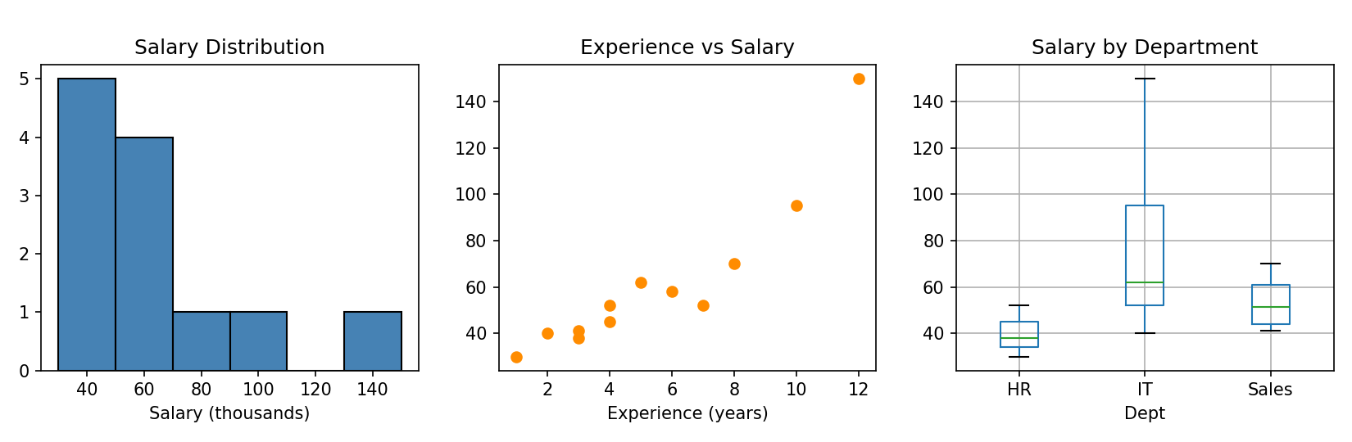
Figure 1: Histogram, scatter plot and box plot of the employee data

Step 10 – Summarise findings
- The data had one duplicate record and two missing salaries; both were handled before analysis.
- Salaries are right-skewed: median 52 versus mean 61.1 (thousands).
- Employee 9 (IT, 12 years of experience, salary 150) is the only salary outlier; it is plausible for a very senior employee, so it was kept and flagged.
- Salary and rating rise with experience, and IT staff earn the most on average.
- Next steps: collect more records before drawing firm conclusions, and check whether department or experience matters more for salary.

10. Data Visualization
Charts turn rows of numbers into patterns that people can see quickly. Matplotlib is the foundation plotting library, giving full control over every element. Seaborn builds on Matplotlib to produce attractive statistical charts with less code and works directly with DataFrames. All examples below use the following setup and sample data.
Python code
import matplotlib.pyplot as plt
import seaborn as sns
import pandas as pd
import numpy as np

sns.set_theme(style="whitegrid")

rng = np.random.default_rng(7)
df = pd.DataFrame({"study_hours": rng.uniform(1, 10, 60)})
df["score"] = 45 + 4.5 * df["study_hours"] + rng.normal(0, 5, 60)
df["group"] = rng.choice(["A", "B", "C"], 60)
print(df.head(3).round(1))

Output
study_hours score group
0 6.6 71.4 C
1 9.1 86.9 A
2 8.0 78.6 C

Every chart needs
A clear title, labelled axes (with units), a legend when more than one series is shown, and a sensible choice of chart type for the data.

10.1 Bar Chart
What it shows | Compares a numerical value across separate categories using bars of different heights.
When to use it | Comparing groups: sales per region, headcount per department, count of each category.
Main functions | plt.bar(), sns.barplot(), sns.countplot()

Python code
departments = ["IT", "HR", "Sales", "Finance"]
headcount = [25, 10, 18, 12]

plt.bar(departments, headcount, color="steelblue")
plt.title("Employees per Department")
plt.xlabel("Department")
plt.ylabel("Number of Employees")
plt.show()

10.2 Line Chart
What it shows | How a value changes over an ordered sequence, usually time, by joining points with a line.
When to use it | Trends and seasonality: monthly sales, daily temperature, website visits per week.
Main functions | plt.plot(), sns.lineplot()

Python code
months = ["Jan", "Feb", "Mar", "Apr", "May", "Jun"]
sales = [120, 135, 150, 145, 170, 190]

plt.plot(months, sales, marker="o", color="darkgreen")
plt.title("Monthly Sales Trend")
plt.xlabel("Month")
plt.ylabel("Sales (thousands)")
plt.show()

10.3 Histogram
What it shows | The distribution of one numerical variable: values are grouped into bins and the bar height is how many values fall into each bin.
When to use it | Seeing the shape of the data (bell-shaped, skewed), its centre and its spread, and spotting unusual values.
Main functions | plt.hist(), sns.histplot()

Python code
sns.histplot(df["score"], bins=10, kde=True, color="steelblue")
plt.title("Distribution of Scores")
plt.xlabel("Score")
plt.ylabel("Number of Students")
plt.show()

10.4 Scatter Plot
What it shows | The relationship between two numerical variables: each point is one record.
When to use it | Checking for correlation, trends and outliers, for example study hours against exam score.
Main functions | plt.scatter(), sns.scatterplot(), sns.regplot()

Python code
sns.scatterplot(data=df, x="study_hours", y="score")
plt.title("Study Hours vs Score")
plt.show()

10.5 Box Plot
What it shows | The five-number summary (minimum, Q1, median, Q3, maximum) in one box. Dots beyond the whiskers are potential outliers (IQR rule).
When to use it | Comparing the spread and centre of a numerical variable across groups, and detecting outliers.
Main functions | plt.boxplot(), sns.boxplot()

Python code
sns.boxplot(data=df, x="group", y="score")
plt.title("Score by Group")
plt.show()

10.6 Heatmap
What it shows | A table of values drawn as colours. For data science it is most often used to display a correlation matrix.
When to use it | Seeing at a glance which numerical variables are strongly related, especially when there are many columns.
Main functions | sns.heatmap()

Python code
corr = df[["study_hours", "score"]].corr()
sns.heatmap(corr, annot=True, cmap="coolwarm", vmin=-1, vmax=1)
plt.title("Correlation Heatmap")
plt.show()

10.7 Choosing the Right Chart
Table 20: Chart selection guide
Question you want to answer | Recommended chart
How do categories compare? | Bar chart
How does a value change over time? | Line chart
What does the distribution of one variable look like? | Histogram
Are two numerical variables related? | Scatter plot
How do groups differ in spread and median? Are there outliers? | Box plot
Which numerical variables are correlated? | Heatmap of the correlation matrix

Working examples of the histogram, scatter plot, box plot and heatmap, with their output figures, appear in the Practical Assessment (Tasks 17 – 20); the bar chart and line chart are produced in the Mini Project (Section 13).

11. Industry Best Practices
Good data scientists are not only accurate; they are also organised, transparent and responsible. The following practices are expected of professional teams and are worth building as habits from the start of an internship.
Table 21: Professional practices for data work
Area | Best practice | Why it matters
Code quality | Use meaningful names, follow PEP 8, write small functions and add comments or docstrings | Other people (and your future self) can understand and reuse the work
Reproducibility | Set random seeds, record library versions, keep code in scripts or notebooks that run top to bottom | Anyone can obtain the same results
Raw data protection | Never overwrite the original file; save cleaned data under a new name | Mistakes can always be undone
Data validation | Check types, ranges, uniqueness and totals after every major step | Catches errors before they spread
Version control | Use Git with clear commit messages | Tracks changes and enables teamwork
Documentation | Record assumptions, cleaning decisions and data sources | Makes the analysis auditable
Honest analysis | Do not cherry-pick results; state limitations and sample size; remember that correlation is not causation | Prevents misleading conclusions
Data privacy and ethics | Remove or anonymise personal data; follow organisational policy and relevant data protection laws; watch for bias in the data | Protects individuals and the organisation
Clear communication | Lead with the key finding, use simple charts, explain in plain language | Decision-makers act on what they understand
Keep learning | Ask for code reviews, read documentation, and compare results with a second method | Improves quality and skills

Example workflow habit
1. Keep raw/ data untouched. 2. Clean it with a script and save to clean/. 3. Analyse the cleaned file in a notebook. 4. Save figures and a short written summary together.

12. Practical Assessment: Student Performance Analysis

12.1 Scenario and Dataset
A school wants to understand how study habits and background relate to student marks. You are given a CSV file, student_performance.csv, with one row per student. Your job is to load, clean, analyse and visualise this data and report what it shows. The tasks must be completed in order, because later tasks use the cleaned DataFrame produced by earlier ones.
Table 22: Student performance dataset: data dictionary
Column | Description | Type | Example
Student_ID | Unique student identifier | Nominal | S001
Gender | Male or Female | Nominal | Male
Class | Class section (A, B or C) | Nominal | B
Study_Hours | Self-study hours per week | Continuous | 18.4
Attendance | Attendance percentage | Continuous | 80.6
Internet | Internet access at home (Yes / No) | Nominal | Yes
Parent_Edu | Highest parental education (School, Bachelor, Master) | Ordinal | Bachelor
Math | Mathematics mark out of 100 | Continuous | 87.9
Science | Science mark out of 100 | Continuous | 85.4
English | English mark out of 100 | Continuous | 42.0

Instructions
Place student_performance.csv in the same folder as your notebook or script.
Run each code block in order. The outputs shown below were produced by running exactly this code.
Write your own explanation for each task before comparing with the one given.

12.2 Part A: Loading and Inspecting the Data (Tasks 1 – 5)

Task 1: Load the Dataset
Task description: Import the required libraries and load student_performance.csv into a DataFrame named df.
Python code
import pandas as pd
import numpy as np
import matplotlib.pyplot as plt
import seaborn as sns

df = pd.read_csv("student_performance.csv")
print("Dataset loaded successfully.")

Output
Dataset loaded successfully.

Explanation: pd.read_csv() reads the file into a DataFrame. The libraries are imported with their standard short names (pd, np, plt, sns). No error message means the file was found and read.

Task 2: Display the First 5 Rows
Task description: Display the first five rows of the dataset to get a feel for its contents.
Python code
print(df.head())

Output
Student_ID Gender Class Study_Hours Attendance Internet Parent_Edu Math Science English
0 S001 Male B 18.4 80.6 Yes Bachelor 87.9 85.4 42.0
1 S002 Female C 11.0 84.3 Yes School 57.4 60.1 65.2
2 S003 Female B 7.9 81.9 Yes Bachelor 62.0 67.6 73.8
3 S004 Male B 12.7 87.3 Yes Bachelor 82.3 71.4 52.5
4 S005 Male C 12.9 75.7 No Bachelor 51.8 56.2 59.3

Explanation: head() shows five rows by default. Each row is one student. We can already see numeric marks, text categories and the Internet and Parent_Edu background columns.

Task 3: Display the Number of Rows and Columns
Task description: Find out how many records and variables the dataset contains.
Python code
rows, cols = df.shape
print(f"Rows: {rows}, Columns: {cols}")

Output
Rows: 123, Columns: 10

Explanation: df.shape returns a tuple (rows, columns). The dataset has 123 records and 10 variables. Because there are only 120 students (S001 – S120), we expect some duplicated records, which Task 6 will confirm.

Task 4: Check Data Types
Task description: Display the data type of every column.
Python code
print(df.dtypes)

Output
Student_ID str
Gender str
Class str
Study_Hours float64
Attendance float64
Internet str
Parent_Edu str
Math float64
Science float64
English float64
dtype: object

Explanation: The five score and habit columns are float64 (decimal numbers), which is correct for continuous data. Text columns appear as str (shown as object in older pandas versions). All types are appropriate, so no conversion is needed.

Task 5: Check Missing Values
Task description: Count the missing values in each column.
Python code
print(df.isnull().sum())

Output
Student_ID 0
Gender 0
Class 0
Study_Hours 5
Attendance 5
Internet 0
Parent_Edu 0
Math 0
Science 0
English 4
dtype: int64

Explanation: isnull() marks each missing cell as True and sum() counts them. Study_Hours has 5 missing values, Attendance 5 and English 4, so 14 cells are missing out of 1,230 (about 1.1%). Such a small share can be filled rather than deleted.

12.3 Part B: Cleaning the Data (Tasks 6 – 7)

Task 6: Check Duplicate Records
Task description: Count the fully duplicated rows and display them.
Python code
print("Duplicate rows:", df.duplicated().sum())
dups = df[df.duplicated(keep=False)].sort_values("Student_ID")
print(dups[["Student_ID", "Class", "Study_Hours", "Attendance", "Math", "English"]])

Output
Duplicate rows: 3
Student_ID Class Study_Hours Attendance Math English
5 S006 B 17.4 NaN 65.3 58.7
120 S006 B 17.4 NaN 65.3 58.7
40 S041 C 10.0 96.3 51.0 60.6
121 S041 C 10.0 96.3 51.0 60.6
77 S078 A 8.4 85.9 50.9 NaN
122 S078 A 8.4 85.9 50.9 NaN

Explanation: duplicated() marks the second and later copies of a row. There are 3 duplicates: students S006, S041 and S078 each appear twice (rows 120 – 122 are copies). keep=False was used so that both the original and its copy are displayed. Left in place, these students would be counted twice in every average.

Task 7: Clean the Data
Task description: Remove duplicate rows and fill the missing numeric values with the median of each column.
Python code
df = df.drop_duplicates().reset_index(drop=True)
for col in ["Study_Hours", "Attendance", "English"]:
df[col] = df[col].fillna(df[col].median())

print("Rows after removing duplicates:", len(df))
print("Missing values remaining:", df.isnull().sum().sum())

Output
Rows after removing duplicates: 120
Missing values remaining: 0

Explanation: drop_duplicates() restores the 120 students. The median is used for filling because it is not affected by extreme values, and Study_Hours is known to contain some very high values (see Task 11). After cleaning there are no missing values.

12.4 Part C: Descriptive Statistics (Tasks 8 – 11)

Task 8: Mean, Median and Mode
Task description: Calculate the mean and median of the numerical columns and the mode of a numerical and a categorical column.
Python code
cols = ["Study_Hours", "Attendance", "Math", "Science", "English"]
print("MEAN"); print(df[cols].mean().round(2))
print("MEDIAN"); print(df[cols].median().round(2))
print("Mode of Math (first of several ties):", df["Math"].mode()[0])
print("Number of tied modes in Math:", len(df["Math"].mode()))
print("Mode of Class:", df["Class"].mode()[0])

Output
MEAN
Study_Hours 12.58
Attendance 88.42
Math 67.59
Science 67.25
English 62.20
dtype: float64
MEDIAN
Study_Hours 11.80
Attendance 89.10
Math 66.90
Science 69.05
English 62.10
dtype: float64
Mode of Math (first of several ties): 57.5
Number of tied modes in Math: 15
Mode of Class: B

Explanation: The mean and median of Math are close (67.59 and 66.90), so its distribution is fairly symmetric. For Study_Hours the mean (12.58) is higher than the median (11.80), because a few students study for very long hours and pull the mean up. The mode is not useful for Math because it is continuous: 15 different values tie as "most frequent". For the categorical column Class, the mode is meaningful and shows that class B has the most students.

Task 9: Standard Deviation, Variance and Range
Task description: Calculate the standard deviation of the numerical columns, and the variance and range of Math.
Python code
print(df[cols].std().round(2))
print("Variance of Math:", round(df["Math"].var(), 2))
print("Range of Math:", round(df["Math"].max() - df["Math"].min(), 1))

Output
Study_Hours 5.35
Attendance 6.76
Math 9.66
Science 8.84
English 9.20
dtype: float64
Variance of Math: 93.26
Range of Math: 41.6

Explanation: Standard deviation measures typical distance from the mean: Math marks vary by about 9.7 points, Science by 8.8 and English by 9.2. The variance of Math (93.26) is the square of its standard deviation (9.66² ≈ 93.3). The best and worst Math marks differ by 41.6 points.

Task 10: Percentiles and Quartiles
Task description: Find the 25th, 50th, 75th and 90th percentiles of the Math marks.
Python code
print(df["Math"].quantile([0.25, 0.50, 0.75, 0.90]))

Output
0.25 59.925
0.50 66.900
0.75 74.725
0.90 81.120
Name: Math, dtype: float64

Explanation: A quarter of the students scored below 59.9, half below 66.9 (the median) and three-quarters below 74.7. The interquartile range is 74.7 − 59.9 ≈ 14.8 marks. A student needs about 81.1 marks to be in the top 10%.

Task 11: Identify Outliers
Task description: Use the IQR rule to find outliers in Study_Hours and Math.
Python code
def iqr_outliers(series):
q1, q3 = series.quantile([0.25, 0.75])
iqr = q3 - q1
low, high = q1 - 1.5 * iqr, q3 + 1.5 * iqr
return series[(series < low) | (series > high)], low, high

for col in ["Study_Hours", "Math"]:
found, low, high = iqr_outliers(df[col])
print(f"{col}: bounds = ({low:.1f}, {high:.1f}), outliers = {found.tolist()}")

Output
Study_Hours: bounds = (1.5, 22.5), outliers = [38.0, 23.7, 42.5]
Math: bounds = (37.7, 96.9), outliers = []

Explanation: A reusable function applies the IQR rule. Study_Hours has three outliers: 23.7, 38.0 and 42.5 hours per week. The values 38.0 and 42.5 are extreme (over five hours a day, every day) and should be checked with the school; 23.7 is only just outside the upper bound. They are kept in the data but flagged, since they are possible. Math has no outliers.

12.5 Part D: Filtering, Grouping and New Features (Tasks 12 – 15)

Task 12: Filter Records Based on Conditions
Task description: Find the students who scored at least 80 in Math and have at least 90% attendance. Also count students with attendance below 75%.
Python code
top = df[(df["Math"] >= 80) & (df["Attendance"] >= 90)]
print("Students with Math >= 80 and Attendance >= 90:", len(top))
print(top[["Student_ID", "Class", "Study_Hours", "Attendance", "Math"]].head())

low_att = df[df["Attendance"] < 75]
print("Students with Attendance below 75%:", len(low_att))

Output
Students with Math >= 80 and Attendance >= 90: 8
Student_ID Class Study_Hours Attendance Math
10 S011 B 38.0 100.0 80.6
42 S043 B 8.1 91.4 81.3
61 S062 A 13.1 90.3 81.1
72 S073 B 18.9 96.2 82.0
85 S086 A 14.6 93.3 80.1
Students with Attendance below 75%: 3

Explanation: Conditions are written in parentheses and joined with &. Eight students meet both conditions (the first five are shown). Interestingly, S011 appears here with 38 study hours, one of the outliers from Task 11. Only 3 students have attendance below 75%.

Task 13: GroupBy Analysis by Class
Task description: Calculate the average Math, Science and English marks of each class.
Python code
print(df.groupby("Class")[["Math", "Science", "English"]].mean().round(2))

Output
Math Science English
Class
A 67.54 68.62 62.44
B 67.81 67.33 62.35
C 67.36 65.85 61.77

Explanation: groupby("Class") splits the data into classes A, B and C and mean() is applied to each. All three classes perform very similarly (Math between 67.36 and 67.81), so class membership has little effect on results. Class C has the lowest Science average (65.85).

Task 14: GroupBy Analysis by Background
Task description: Compare Math performance by internet access, parental education and gender.
Python code
summary = df.groupby("Internet").agg(
Students=("Student_ID", "count"),
Avg_Math=("Math", "mean"),
Avg_Study=("Study_Hours", "mean"),
).round(2)
print(summary)
print(df.groupby("Parent_Edu")["Math"].mean().round(2).sort_values(ascending=False))
print(df.groupby("Gender")["Math"].mean().round(2))

Output
Students Avg_Math Avg_Study
Internet
No 24 64.60 12.03
Yes 96 68.33 12.72
Parent_Edu
School 67.99
Bachelor 67.90
Master 66.15
Name: Math, dtype: float64
Gender
Female 67.02
Male 68.21
Name: Math, dtype: float64

Explanation: agg() calculates several statistics at once. Students with home internet score about 3.7 points higher in Math on average (68.33 versus 64.60) and study slightly longer. Differences by parental education (66.15 – 67.99) and gender (about 1.2 points) are small. Note that only 24 students have no internet, so that group is small.

Task 15: Create a New Feature
Task description: Create an Average column from the three subject marks and use pd.cut() to place each student in a performance level.
Python code
df["Average"] = df[["Math", "Science", "English"]].mean(axis=1).round(2)
df["Level"] = pd.cut(df["Average"],
bins=[0, 50, 65, 80, 100],
labels=["Needs Support", "Average", "Good", "Excellent"])
print(df["Level"].value_counts().sort_index())

Output
Level
Needs Support 0
Average 57
Good 60
Excellent 3
Name: count, dtype: int64

Explanation: mean(axis=1) averages across columns for each row. pd.cut() places continuous values into labelled bins (0 – 50, 50 – 65, 65 – 80, 80 – 100). Most students are "Good" (60) or "Average" (57), only 3 are "Excellent" and nobody falls into "Needs Support".

12.6 Part E: Correlation and Visualization (Tasks 16 – 20)

Task 16: Find Correlations Between Numerical Variables
Task description: Calculate the correlation matrix of the numerical columns.
Python code
num_cols = ["Study_Hours", "Attendance", "Math", "Science", "English"]
corr = df[num_cols].corr().round(2)
print(corr)

Output
Study_Hours Attendance Math Science English
Study_Hours 1.00 0.05 0.58 0.43 0.20
Attendance 0.05 1.00 0.20 0.16 0.15
Math 0.58 0.20 1.00 0.75 0.16
Science 0.43 0.16 0.75 1.00 0.08
English 0.20 0.15 0.16 0.08 1.00

Explanation: Each cell is the correlation *r* between two columns (the diagonal is always 1). The strongest relationship is between Math and Science (0.75). Study_Hours is moderately correlated with Math (0.58) and Science (0.43). Attendance is only weakly related to the marks (0.15 – 0.20).

Task 17: Visualization 1: Histogram
Task description: Draw a histogram of the Math scores to see how they are distributed.
Python code
sns.set_theme(style="whitegrid")
plt.figure(figsize=(7, 4))
sns.histplot(df["Math"], bins=12, kde=True, color="steelblue")
plt.title("Distribution of Math Scores")
plt.xlabel("Math Score")
plt.ylabel("Number of Students")
plt.tight_layout()
plt.savefig("fig_p_hist.png", dpi=150)
plt.show()

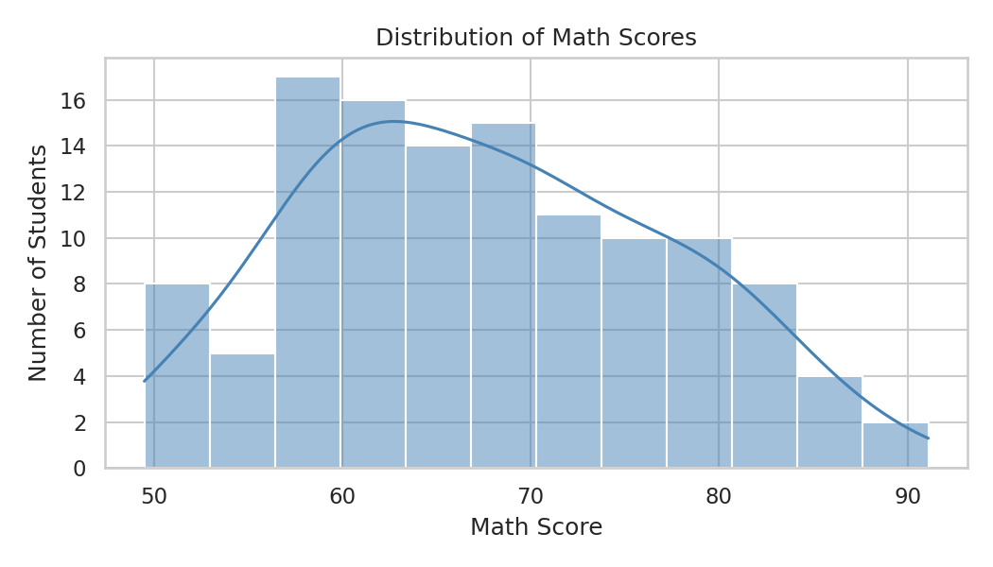
Figure 2: Distribution of Math scores
Explanation: The histogram shows that most Math marks lie between about 55 and 80 and the shape is roughly bell-shaped (symmetric), with no extreme values, which agrees with the mean and median being almost equal in Task 8.

Task 18: Visualization 2: Scatter Plot
Task description: Draw a scatter plot of Study_Hours against Math with a trend line.
Python code
plt.figure(figsize=(7, 4))
sns.regplot(data=df, x="Study_Hours", y="Math",
scatter_kws={"alpha": 0.6}, line_kws={"color": "red"})
plt.title("Study Hours vs Math Score")
plt.xlabel("Study Hours per Week")
plt.ylabel("Math Score")
plt.tight_layout()
plt.savefig("fig_p_scatter.png", dpi=150)
plt.show()

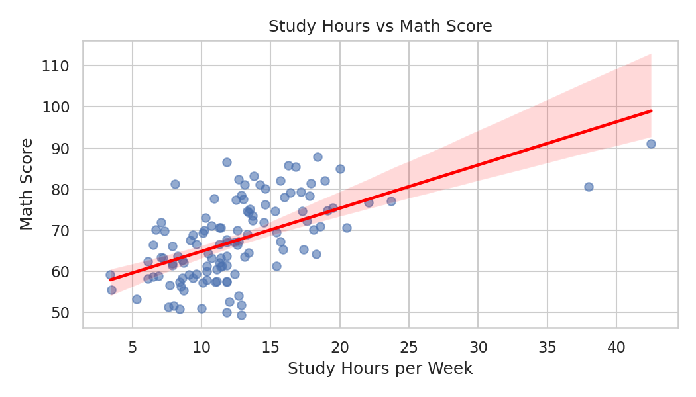
Figure 3: Study hours versus Math score
Explanation: The upward-sloping red line confirms the positive relationship (r = 0.58): students who study more tend to score higher. The two points far to the right are the 38 and 42.5 hour outliers. The scatter around the line also shows that study time is not the only factor.

Task 19: Visualization 3: Box Plot
Task description: Draw box plots of Math scores for each class.
Python code
plt.figure(figsize=(7, 4))
sns.boxplot(data=df, x="Class", y="Math", hue="Class", palette="Set2", legend=False)
plt.title("Math Scores by Class")
plt.tight_layout()
plt.savefig("fig_p_box.png", dpi=150)
plt.show()

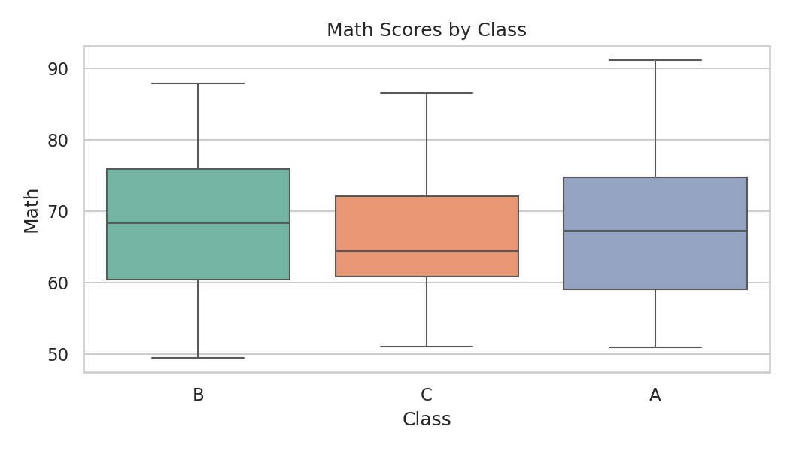
Figure 4: Math scores by class
Explanation: Each box spans Q1 to Q3 with the median as the line inside. The three classes have almost the same median and spread, which supports the group averages found in Task 13.

Task 20: Visualization 4: Correlation Heatmap
Task description: Display the correlation matrix from Task 16 as an annotated heatmap.
Python code
plt.figure(figsize=(7, 4.5))
sns.heatmap(corr, annot=True, cmap="coolwarm", vmin=-1, vmax=1, fmt=".2f")
plt.title("Correlation Heatmap")
plt.tight_layout()
plt.savefig("fig_p_heat.png", dpi=150)
plt.show()

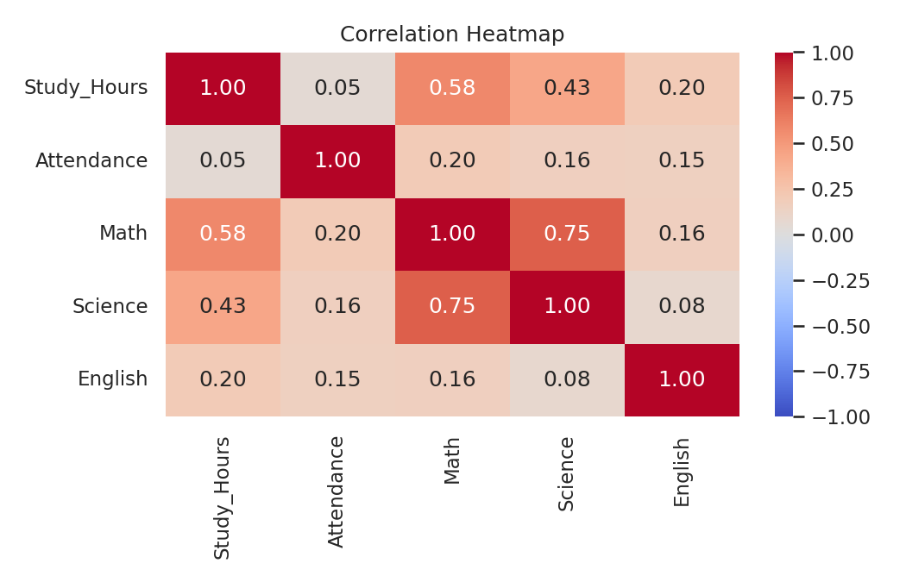
Figure 5: Correlation heatmap of numerical variables
Explanation: Warm (red) colours indicate strong positive correlation and cool (blue) colours indicate weak or negative correlation. The Math – Science cell and the Study_Hours – Math cell stand out as the strongest relationships.

12.7 Part F: Insights and Conclusion (Tasks 21 – 22)

Task 21: Write Meaningful Insights
Task description: Calculate supporting figures and write 5 – 10 insights that a school principal could understand and act on.
Python code
print("Corr (Study_Hours, Math) :", round(df["Study_Hours"].corr(df["Math"]), 2))
print("Corr (Attendance, Math) :", round(df["Attendance"].corr(df["Math"]), 2))
print("Corr (Math, Science) :", round(df["Math"].corr(df["Science"]), 2))
print("Corr (Study_Hours, English):", round(df["English"].corr(df["Study_Hours"]), 2))
print("Avg Math with internet :", round(df[df["Internet"] == "Yes"]["Math"].mean(), 1))
print("Avg Math without internet :", round(df[df["Internet"] == "No"]["Math"].mean(), 1))
level = df["Level"]
print("Share of 'Excellent' level :", round((level == "Excellent").mean() * 100, 1), "%")
print("Share needing support :", round((level == "Needs Support").mean() * 100, 1), "%")
print("Best class by Math :", df.groupby("Class")["Math"].mean().idxmax())
print("Students studying > 20 hrs :", (df["Study_Hours"] > 20).sum())

Output
Corr (Study_Hours, Math) : 0.58
Corr (Attendance, Math) : 0.2
Corr (Math, Science) : 0.75
Corr (Study_Hours, English): 0.2
Avg Math with internet : 68.3
Avg Math without internet : 64.6
Share of 'Excellent' level : 2.5 %
Share needing support : 0.0 %
Best class by Math : B
Students studying > 20 hrs : 5

Insights:
- Study time is the strongest influence on marks. Study hours correlate 0.58 with Math and 0.43 with Science, much more than any other habit measured.
- Math and Science marks move together (r = 0.75), so students who struggle in one subject are likely to struggle in the other and could be supported together.
- Attendance has only a weak link to marks (r = 0.20 with Math). Good attendance helps, but attending alone does not guarantee high marks.
- English behaves differently. It is only weakly related to study hours (0.20) and to Math (0.16), so English results probably depend on other factors such as reading habits or language background, and need a separate investigation.
- Students with home internet access score higher in Math (68.3 versus 64.6). Because only 24 students lack access and this is an observed association, a school may consider supporting these students, but should not conclude that internet access alone causes the gap.
- Classes are well balanced. Average Math scores of classes A, B and C are within 0.5 points of each other, so no class needs special intervention.
- Parental education and gender show small differences (under 2 points in Math), so they do not explain performance differences in this sample.
- Few students reach the top level. Only 3 students (2.5%) are "Excellent" overall and nobody is below the "Needs Support" threshold, which points to an opportunity to stretch high performers.
- Data quality needs attention. The raw file had duplicates and 14 missing values, and two study-hour entries of 38 and 42.5 hours that need verification. Validation at the time of data entry would prevent this.

Task 22: Final Conclusion
Task description: Write a short overall conclusion for the analysis.
Conclusion of the practical assessment
The student performance data was loaded, checked and cleaned: 3 duplicate records were removed and 14 missing values were filled with column medians, leaving 120 clean records. Descriptive statistics show that marks are roughly bell-shaped with an average of about 67 in Math and Science and 62 in English.
The analysis indicates that weekly study time is the most important factor related to Math and Science marks, that Math and Science results are closely linked, and that class, gender and parental education make little difference. Internet access at home is associated with somewhat higher Math marks. Outliers in study hours should be verified.
The recommended actions are to encourage structured study habits, to support students without home internet access, to investigate English separately and to introduce data validation when records are entered. All findings are based on one sample and show association, not proof of cause.

13. Mini Project: Exploratory Data Analysis
Title: Understanding 2025 Retail Sales Performance
This mini project applies the complete EDA workflow from Section 9 to a new, realistic dataset without step-by-step instructions: the analyst must decide what to check and what to do about the problems found.

13.1 Problem Statement
BrightMart, a fictional retail company selling electronics, furniture, clothing and stationery in four regions, has exported its 2025 order records. Management wants to know which product categories and regions generate most revenue, how sales change over the year, whether discounts lead to larger orders and how satisfied customers are. Before any of this can be answered, the export must be checked for data-quality problems.

13.2 Dataset Description
The file retail_sales.csv contains one row per order. It has 305 raw records and 9 columns. It is a synthetic dataset created for this assessment, in which several quality problems were introduced on purpose.
Table 23: Retail sales data dictionary
Column | Description | Type | Example
Order_ID | Unique order number | Nominal | ORD1003
Order_Date | Date of the order (year 2025) | Date (stored as text) | 2025-01-04
Region | North, South, East or West | Nominal | North
Category | Electronics, Furniture, Clothing or Stationery | Nominal | Furniture
Units | Number of items in the order | Discrete | 8
Unit_Price | Price of one item | Continuous | 339.46
Discount | Discount percentage given (0, 5, 10, 15, 20) | Discrete | 10
Rating | Customer rating from 1 to 5 | Ordinal | 5.0
Revenue | Units × Unit_Price × (1 − Discount ÷ 100) | Continuous | 2444.11

13.3 Objectives
- Load the data and assess its quality (missing values, duplicates, data types, inconsistent text, validity).
- Clean the dataset and document every decision.
- Describe the distribution of orders, prices and ratings.
- Find which categories and regions bring in the most revenue.
- Examine monthly revenue and seasonal patterns.
- Test whether discounts are associated with larger orders, and find which variables relate to revenue.
- Communicate the findings clearly with charts and a short conclusion.

13.4 Data Loading
Python code
import pandas as pd
import numpy as np
import matplotlib.pyplot as plt
import seaborn as sns

sales = pd.read_csv("retail_sales.csv")
print("Shape:", sales.shape)
print(sales.head())
sales.info()

Output
Shape: (305, 9)
Order_ID Order_Date Region Category Units Unit_Price Discount Rating Revenue
0 ORD1001 2025-01-03 EAST Electronics 2 477.37 0 4.0 954.74
1 ORD1002 2025-01-04 North Clothing 2 34.98 0 5.0 69.96
2 ORD1003 2025-01-04 North Furniture 8 339.46 10 5.0 2444.11
3 ORD1004 2025-01-07 south Furniture 3 283.00 10 NaN 764.10
4 ORD1005 2025-01-07 East Clothing 8 34.97 10 4.0 251.78
<class 'pandas.DataFrame'>
RangeIndex: 305 entries, 0 to 304
Data columns (total 9 columns):
# Column Non-Null Count Dtype
--- ------ -------------- -----
0 Order_ID 305 non-null str
1 Order_Date 305 non-null str
2 Region 305 non-null str
3 Category 305 non-null str
4 Units 305 non-null int64
5 Unit_Price 305 non-null float64
6 Discount 305 non-null int64
7 Rating 291 non-null float64
8 Revenue 305 non-null float64
dtypes: float64(3), int64(2), str(4)
memory usage: 21.6 KB

Observations: the file has 305 rows and 9 columns. Rating has only 291 non-null values (14 missing). Order_Date is stored as text (str) and must be converted to a real date type. The Region column shows EAST and south in the first rows, which already suggests inconsistent spelling.

13.5 Data Cleaning

Step 1: Diagnose the problems
Python code
print(sales.isnull().sum())
print("Duplicate rows:", sales.duplicated().sum())
print(sales["Region"].value_counts())

expected = (sales["Units"] * sales["Unit_Price"] * (1 - sales["Discount"] / 100)).round(2)
print("Revenue mismatches:", (abs(expected - sales["Revenue"]) > 0.01).sum())

Output
Order_ID 0
Order_Date 0
Region 0
Category 0
Units 0
Unit_Price 0
Discount 0
Rating 14
Revenue 0
dtype: int64
Duplicate rows: 5
Region
South 84
North 80
West 76
East 57
EAST 2
south 1
north 1
west 1
SOUTH 1
WEST 1
east 1
Name: count, dtype: int64
Revenue mismatches: 0

The checks confirm four problems: 14 missing ratings, 5 duplicate rows and 11 different spellings of what should be only four regions (for example EAST, east and East). On the positive side, the Revenue column matches the formula for every row (0 mismatches).

Step 2: Fix the problems and validate
Python code
sales = sales.drop_duplicates().reset_index(drop=True)
sales["Order_Date"] = pd.to_datetime(sales["Order_Date"])
sales["Region"] = sales["Region"].str.strip().str.title()
sales["Rating"] = sales["Rating"].fillna(sales["Rating"].median())
sales["Month"] = sales["Order_Date"].dt.month

assert (sales["Units"] > 0).all() and (sales["Revenue"] > 0).all()
assert sales["Order_ID"].is_unique
print("Rows after cleaning:", len(sales))
print(sales["Region"].value_counts())
print(sales[["Order_Date", "Rating"]].dtypes)
print("Missing values left:", sales.isnull().sum().sum())

Output
Rows after cleaning: 300
Region
South 84
North 81
West 76
East 59
Name: count, dtype: int64
Order_Date datetime64[us]
Rating float64
dtype: object
Missing values left: 0

Table 24: Summary of cleaning decisions
Problem found | Action taken | Result
5 duplicate rows | drop_duplicates() | 300 unique orders
Order_Date stored as text | pd.to_datetime() | Dates usable for monthly analysis
11 spellings of 4 regions | str.strip().str.title() | Exactly 4 regions
14 missing ratings | Filled with the median (4.0) | 0 missing values
Validity rules (units > 0, revenue > 0, unique IDs) | assert statements | All checks passed

13.6 Exploratory Data Analysis
Python code
print(sales[["Units", "Unit_Price", "Discount", "Rating", "Revenue"]].describe().round(2))
print(sales["Category"].value_counts())
first, last = sales["Order_Date"].min(), sales["Order_Date"].max()
print("Date range:", first.date(), "to", last.date())

Output
Units Unit_Price Discount Rating Revenue
count 300.00 300.00 300.00 300.00 300.00
mean 7.78 173.21 6.30 3.96 1183.41
std 8.82 187.42 6.63 0.98 2120.47
min 1.00 6.85 0.00 1.00 7.41
25% 5.00 8.92 0.00 4.00 76.57
50% 7.00 42.59 5.00 4.00 328.14
75% 9.00 353.70 10.00 5.00 1964.49
max 95.00 517.06 20.00 5.00 29382.48
Category
Clothing 95
Stationery 84
Electronics 75
Furniture 46
Name: count, dtype: int64
Date range: 2025-01-03 to 2025-12-31

Orders span the whole year (3 January – 31 December 2025). The average revenue per order (1,183.41) is far above the median (328.14), and the standard deviation (2,120.47) is larger than the mean. This is a strongly right-skewed distribution caused by a mix of very cheap items (stationery at about 8) and expensive ones (electronics at about 450). Customer ratings are high overall (median 4.0). Clothing is the most frequently ordered category (95 orders).

Outlier check on order size
Python code
q1, q3 = sales["Units"].quantile([0.25, 0.75])
iqr = q3 - q1
high = q3 + 1.5 * iqr
bulk = sales[sales["Units"] > high]
print("Upper bound for Units:", high)
print(bulk[["Order_ID", "Category", "Units", "Revenue"]])

Output
Upper bound for Units: 15.0
Order_ID Category Units Revenue
30 ORD1031 Clothing 65 2553.20
120 ORD1121 Stationery 80 548.00
210 ORD1211 Electronics 72 29382.48
260 ORD1261 Clothing 95 3690.75

Four orders have more than the upper bound of 15 units (65, 80, 72 and 95 units). Their revenue is consistent with price and quantity, so they look like genuine bulk orders rather than errors. They were therefore kept, but the analysis reports medians alongside means because one of them (72 electronics units, revenue 29,382) is large enough to influence totals.

13.7 Statistical Analysis
Python code
print("Total revenue :", round(sales["Revenue"].sum(), 2))
print("Average order :", round(sales["Revenue"].mean(), 2))
print("Median order :", round(sales["Revenue"].median(), 2))

by_cat = sales.groupby("Category")["Revenue"].agg(["count", "sum", "mean"]).round(2)
print(by_cat.sort_values("sum", ascending=False))
print(sales.groupby("Region")["Revenue"].sum().round(2).sort_values(ascending=False))

Output
Total revenue : 355022.59
Average order : 1183.41
Median order : 328.14
count sum mean
Category
Electronics 75 234258.53 3123.45
Furniture 46 86048.68 1870.62
Clothing 95 29888.12 314.61
Stationery 84 4827.26 57.47
Region
North 104824.01
South 86915.05
West 84422.27
East 78861.26
Name: Revenue, dtype: float64

Total revenue is 355,022.59. Electronics alone produces 234,258.53 (66.0%) from only 75 orders, while stationery, with 84 orders, produces just 1.4% because of its low prices. The North region leads with 104,824.01 (29.5%) and East is lowest with 78,861.26.
Python code
monthly = sales.groupby("Month")["Revenue"].sum().round(0)
print(monthly)
q4_share = monthly.loc[[10, 11, 12]].sum() / monthly.sum() * 100
print("Q4 share of revenue (%):", round(q4_share, 1))
print(sales.groupby("Discount")["Units"].mean().round(2))

Output
Month
1 21552.0
2 26360.0
3 14347.0
4 25244.0
5 23303.0
6 23920.0
7 19498.0
8 23382.0
9 16413.0
10 60564.0
11 41092.0
12 59346.0
Name: Revenue, dtype: float64
Q4 share of revenue (%): 45.3
Discount
0 7.94
5 6.74
10 7.76
15 8.56
20 8.74
Name: Units, dtype: float64

Revenue is far higher in October (60,564) and December (59,346), and the fourth quarter contributes 45.3% of annual revenue; March is the weakest month (14,347). Average units per order are 7.94 with no discount and 6.74 at a 5% discount, then rise to 8.74 at 20%. The pattern is not clear-cut, and the correlation analysis below shows that the overall link between discount and order size is very weak.
Python code
corr = sales[["Units", "Unit_Price", "Discount", "Rating", "Revenue"]].corr().round(2)
print(corr)
print("Top 5 orders by revenue:")
print(sales.nlargest(5, "Revenue")[["Order_ID", "Category", "Units", "Revenue"]])

Output
Units Unit_Price Discount Rating Revenue
Units 1.00 -0.04 0.03 0.07 0.45
Unit_Price -0.04 1.00 0.04 -0.06 0.59
Discount 0.03 0.04 1.00 -0.08 0.03
Rating 0.07 -0.06 -0.08 1.00 0.00
Revenue 0.45 0.59 0.03 0.00 1.00
Top 5 orders by revenue:
Order_ID Category Units Revenue
210 ORD1211 Electronics 72 29382.48
231 ORD1232 Electronics 14 5279.79
62 ORD1063 Electronics 12 5004.29
106 ORD1107 Electronics 11 4965.84
13 ORD1014 Electronics 11 4958.11

Revenue is moderately correlated with unit price (0.59) and units (0.45). Discount (0.03) and customer rating (0.00) have almost no relationship with revenue. The top order, ORD1211, is the 72-unit electronics order and alone accounts for about 8.3% of annual revenue.

13.8 Visualizations
Python code
sns.set_theme(style="whitegrid")
monthly_rev = sales.groupby("Month")["Revenue"].sum()
plt.figure(figsize=(7, 4))
plt.plot(monthly_rev.index, monthly_rev.values, marker="o", color="darkgreen")
plt.title("Monthly Revenue (2025)")
plt.xlabel("Month")
plt.ylabel("Revenue")
plt.xticks(range(1, 13))
plt.tight_layout()
plt.savefig("fig_m_line.png", dpi=150)
plt.show()

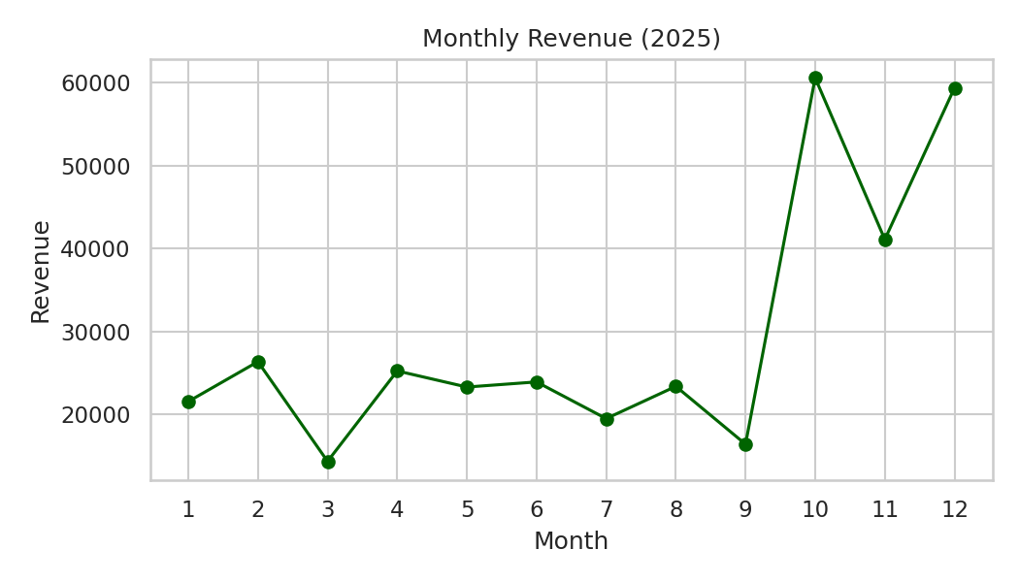
Figure 6: Monthly revenue in 2025
The line chart shows a flat first nine months with small ups and downs, then a sharp rise in October, a dip in November and another high in December: a clear year-end seasonal peak.
Python code
cat_rev = sales.groupby("Category")["Revenue"].sum().sort_values(ascending=False)
plt.figure(figsize=(7, 4))
sns.barplot(x=cat_rev.index, y=cat_rev.values, hue=cat_rev.index,
palette="viridis", legend=False)
plt.title("Total Revenue by Category")
plt.xlabel("Category")
plt.ylabel("Revenue")
plt.tight_layout()
plt.savefig("fig_m_bar.png", dpi=150)
plt.show()

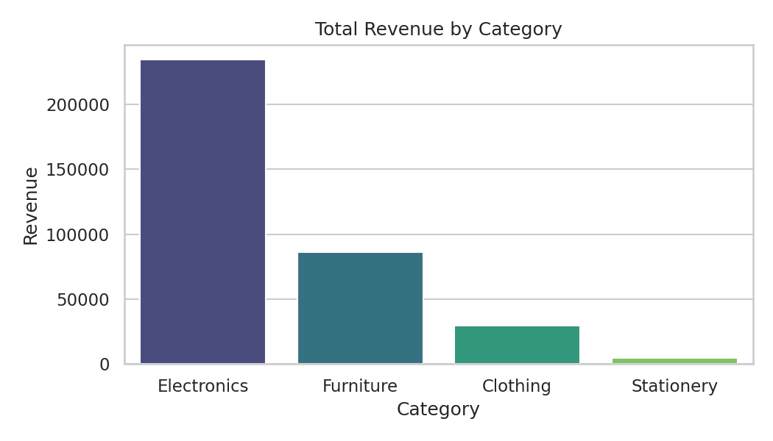
Figure 7: Total revenue by product category
The bar chart makes the dominance of Electronics (about two-thirds of revenue) and Furniture obvious, while Clothing and Stationery contribute very little in comparison.
Python code
plt.figure(figsize=(7, 4))
sns.boxplot(data=sales, x="Region", y="Revenue", hue="Region",
palette="Set3", legend=False)
plt.title("Order Revenue by Region")
plt.tight_layout()
plt.savefig("fig_m_box.png", dpi=150)
plt.show()

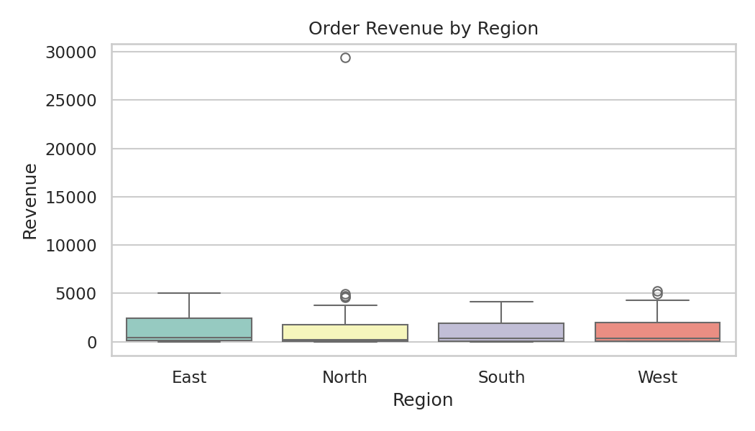
Figure 8: Distribution of order revenue by region
The box plots show that order revenue is similar across regions, with most orders in the low range and a number of high-value orders (dots) in every region, again reflecting the skew caused by expensive categories.
Python code
plt.figure(figsize=(7, 4.5))
sns.heatmap(corr, annot=True, cmap="coolwarm", vmin=-1, vmax=1, fmt=".2f")
plt.title("Correlation Heatmap - Retail Sales")
plt.tight_layout()
plt.savefig("fig_m_heat.png", dpi=150)
plt.show()

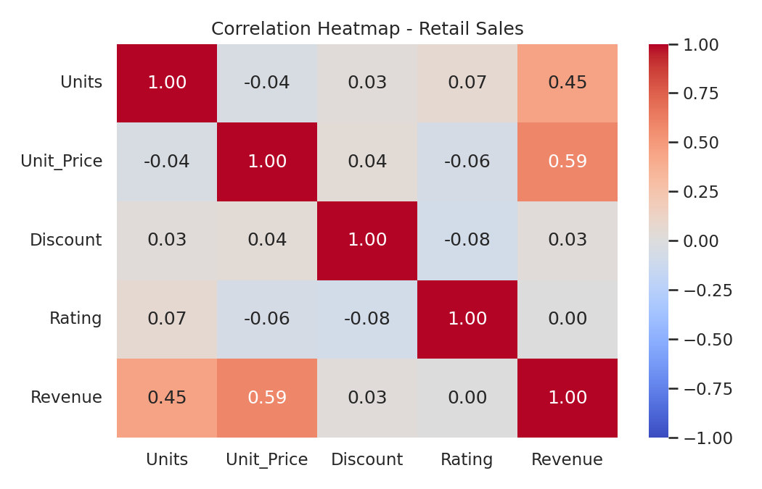
Figure 9: Correlation heatmap for the retail sales data
The heatmap confirms that Revenue is related mainly to Unit_Price and Units, while Discount and Rating are close to zero with everything else.
Python code
print("Average rating by category:")
print(sales.groupby("Category")["Rating"].mean().round(2))
print("Share of bulk orders (> 25 units) in revenue (%):",
round(sales[sales["Units"] > 25]["Revenue"].sum() / sales["Revenue"].sum() * 100, 1))
print("Average units: no discount vs 20% discount:",
round(sales[sales["Discount"] == 0]["Units"].mean(), 1), "vs",
round(sales[sales["Discount"] == 20]["Units"].mean(), 1))

Output
Average rating by category:
Category
Clothing 3.96
Electronics 3.84
Furniture 4.02
Stationery 4.02
Name: Rating, dtype: float64
Share of bulk orders (> 25 units) in revenue (%): 10.2
Average units: no discount vs 20% discount: 7.9 vs 8.7

13.9 Key Findings
- Data quality: 5 duplicates, 14 missing ratings, text dates and 11 spellings of 4 regions were found and fixed; revenue values were verified against the formula.
- Revenue is dominated by Electronics (66.0%) followed by Furniture (24.2%). Clothing (8.4%) and Stationery (1.4%) are high in order count but low in revenue.
- Strong seasonality: the fourth quarter delivers 45.3% of the year's revenue, with peaks in October and December.
- Regional ranking: North (29.5%) > South > West > East, but differences between regions are moderate.
- Average order value is misleading: the mean order (1,183) is more than three times the median (328) because a few high-priced orders dominate. Medians should be reported with means.
- Four bulk orders (65 – 95 units) exist; the largest electronics order alone makes up 8.3% of revenue, so results are sensitive to single large customers.
- Discounts show only a weak link to order size: average units rise from 6.7 (5% discount) to 8.7 (20%), but there is no gain at the lowest level and the overall correlation is only 0.03 (partly because a few bulk orders distort it), so the discount policy should be tested more carefully.
- Customer satisfaction is good (average rating about 4.0), with Electronics rated slightly lowest (3.84) and Furniture and Stationery highest (4.02).

Recommendations
- Plan stock, staff and promotions for October – December, particularly for Electronics.
- Investigate why the East region trails the others and whether marketing can close the gap.
- Run a controlled test of discount levels before continuing broad discounts.
- Review the lower rating for Electronics (delivery, product quality or support).
- Add validation rules at data entry (drop-down regions, required rating, unique order IDs) to prevent the issues found.

13.10 Conclusion
The mini project demonstrated the full EDA cycle on realistic, imperfect data: the dataset was loaded, diagnosed, cleaned and validated; statistics and groupings answered the business questions; and four charts communicated the results. The main conclusion is that BrightMart's revenue depends heavily on Electronics and on a strong year-end season, that discounts do not clearly increase order size, and that a small number of large orders strongly influences averages. These results describe one synthetic year and show association, not causation; further data would be needed before making major business decisions.

14. Conclusion
This assessment covered the foundations of data science from first principles: writing Python, working with arrays and tables, understanding statistical measures and data types, cleaning and preparing data, exploring it systematically and communicating results with charts. Each topic was explained in simple language, demonstrated with code and verified with real outputs.
The practical assessment and mini project showed that the individual skills combine into one workflow: load → inspect → clean → summarise → explore → visualise → interpret. Three lessons stand out:
- Data quality comes first. Duplicates, missing values, wrong types and inconsistent text appeared in both datasets and would have produced wrong answers if ignored.
- Choose measures that match the data. Medians and quartiles described skewed data better than means; correlations and group comparisons revealed relationships that single numbers hid.
- Interpret honestly. Correlation is not causation, small samples limit conclusions, and every cleaning decision should be documented.
With these fundamentals in place, the natural next steps are deeper statistics (hypothesis testing, regression), SQL for databases, and an introduction to machine learning with scikit-learn.

15. Learning Outcomes
By completing this assessment, the intern demonstrates the following skills:
Table 25: Skills demonstrated by the intern
Skill area | What the intern can do | Evidence
Python programming | Use variables, data structures, operators, conditions, loops, functions, lambdas, comprehensions, exception handling and file I/O | Section 3
Numerical computing | Create, index, reshape and summarise NumPy arrays using vectorised operations | Section 4
Data handling with pandas | Load CSV files; inspect, select, filter, sort, group and aggregate tabular data | Section 5; Tasks 1 – 5, 12 – 15
Statistical thinking | Calculate and interpret mean, median, mode, spread, percentiles, probability and correlation; distinguish sample from population | Section 6; Tasks 8 – 10, 16
Data types | Classify variables as numerical, categorical, nominal, ordinal, discrete or continuous, and choose suitable analysis | Section 7
Data cleaning | Detect and handle missing values, duplicates, wrong types, inconsistent text and outliers; validate data; encode and scale features | Section 8; Tasks 6, 7, 11; Section 13.5
Exploratory analysis | Carry out and document a complete EDA workflow and summarise findings | Section 9; Section 13
Data visualization | Create and interpret bar, line, histogram, scatter, box and heatmap charts with Matplotlib and Seaborn | Section 10; Tasks 17 – 20; Section 13.8
Analytical communication | Turn numerical results into clear insights, conclusions and recommendations | Task 21 – 22; Sections 13.9 – 13.10
Professional practice | Work reproducibly, document decisions, protect raw data and respect privacy and ethics | Section 11; Appendix A

16. References
Python Software Foundation. (2024). Python 3 Documentation. https://docs.python.org/3/
van Rossum, G., Warsaw, B., & Coghlan, A. (2001). PEP 8 – Style Guide for Python Code. https://peps.python.org/pep-0008/
NumPy Developers. NumPy Documentation. https://numpy.org/doc/
The pandas Development Team. pandas Documentation. https://pandas.pydata.org/docs/
Hunter, J. D. (2007). Matplotlib: A 2D graphics environment. Computing in Science & Engineering, 9(3), 90–95. https://matplotlib.org/stable/
Waskom, M. L. (2021). seaborn: statistical data visualization. Journal of Open Source Software, 6(60), 3021. https://seaborn.pydata.org/
scikit-learn Developers. Preprocessing data. https://scikit-learn.org/stable/modules/preprocessing.html
McKinney, W. (2022). Python for Data Analysis (3rd ed.). O'Reilly Media.
VanderPlas, J. (2016). Python Data Science Handbook. O'Reilly Media.
Downey, A. B. (2014). Think Stats: Exploratory Data Analysis (2nd ed.). O'Reilly Media.
Tukey, J. W. (1977). Exploratory Data Analysis. Addison-Wesley.
Wickham, H. (2014). Tidy data. Journal of Statistical Software, 59(10), 1–23.
Wilson, G., Bryan, J., Cranston, K., Kitzes, J., Nederbragt, L., & Teal, T. K. (2017). Good enough practices in scientific computing. PLOS Computational Biology, 13(6), e1005510.

Appendix A: Dataset Generation Script
The script below (gen_data.py) creates both datasets with fixed random seeds so that the results in this document can be reproduced exactly. It also shows how the data-quality problems (missing values, duplicates, outliers and inconsistent text) were introduced on purpose. Run it with python gen_data.py.
gen_data.py
import numpy as np
import pandas as pd

rng = np.random.default_rng(42)
n = 120

students = pd.DataFrame({
"Student_ID": [f"S{i:03d}" for i in range(1, n + 1)],
"Gender": rng.choice(["Male", "Female"], n),
"Class": rng.choice(["A", "B", "C"], n),
})
study = np.clip(rng.normal(12, 4, n), 2, 25)
study[[10, 57]] = [38.0, 42.5]
attend = np.clip(rng.normal(88, 7, n), 55, 100)
students["Study_Hours"] = study.round(1)
students["Attendance"] = attend.round(1)
students["Internet"] = rng.choice(["Yes", "No"], n, p=[0.8, 0.2])
students["Parent_Edu"] = rng.choice(["School", "Bachelor", "Master"], n, p=[0.4, 0.4, 0.2])

base = 20 + 1.6 * np.minimum(study, 25) + 0.3 * attend
base += np.where(students["Internet"] == "Yes", 3, 0)
students["Math"] = np.clip(base + rng.normal(0, 7, n), 0, 100).round(1)
science = 0.7 * students["Math"] + 20 + rng.normal(0, 6, n)
students["Science"] = np.clip(science, 0, 100).round(1)
english = 55 + 0.6 * np.minimum(study, 25) + rng.normal(0, 9, n)
students["English"] = np.clip(english, 0, 100).round(1)

for col, k in [("Study_Hours", 5), ("Attendance", 4), ("English", 3)]:
students.loc[rng.choice(n, k, replace=False), col] = np.nan
students = pd.concat([students, students.iloc[[5, 40, 77]]], ignore_index=True)
students.to_csv("student_performance.csv", index=False)

rng = np.random.default_rng(2025)
n = 300
cat_price = {"Electronics": 450, "Furniture": 300, "Clothing": 40, "Stationery": 8}
days = np.arange(365)
w = np.where(days >= 273, 1.8, 1.0)
w = w / w.sum()
offsets = np.sort(rng.choice(days, n, p=w))
dates = pd.to_datetime("2025-01-01") + pd.to_timedelta(offsets, unit="D")

category = rng.choice(list(cat_price), n, p=[0.25, 0.15, 0.35, 0.25])
discount = rng.choice([0, 5, 10, 15, 20], n, p=[0.4, 0.2, 0.2, 0.1, 0.1])
units = rng.integers(1, 11, n) + discount // 5
units[[30, 120, 210, 260]] = [65, 80, 72, 95]
price = np.array([cat_price[c] for c in category]) * rng.uniform(0.85, 1.15, n)

sales = pd.DataFrame({
"Order_ID": [f"ORD{1001 + i}" for i in range(n)],
"Order_Date": dates.strftime("%Y-%m-%d"),
"Region": rng.choice(["North", "South", "East", "West"], n, p=[0.30, 0.25, 0.25, 0.20]),
"Category": category,
"Units": units,
"Unit_Price": price.round(2),
"Discount": discount,
"Rating": rng.choice([1, 2, 3, 4, 5], n,
p=[0.04, 0.08, 0.20, 0.38, 0.30]).astype(float),
})
sales["Revenue"] = (sales["Units"] * sales["Unit_Price"]
* (1 - sales["Discount"] / 100)).round(2)

sales.loc[rng.choice(n, 14, replace=False), "Rating"] = np.nan
idx = rng.choice(n, 8, replace=False)
sales.loc[idx[:4], "Region"] = sales.loc[idx[:4], "Region"].str.lower()
sales.loc[idx[4:], "Region"] = sales.loc[idx[4:], "Region"].str.upper() + " "
sales = pd.concat([sales, sales.iloc[[15, 90, 150, 222, 280]]], ignore_index=True)
sales.to_csv("retail_sales.csv", index=False)
print("Created student_performance.csv", students.shape)
print("Created retail_sales.csv", sales.shape)

Appendix B: Submission Checklist
 | Item
☐ | Title page placeholders (name, program, organization, date) are filled in
☐ | Table of contents lists all sections correctly
☐ | All code runs from top to bottom without errors
☐ | student_performance.csv, retail_sales.csv and gen_data.py are included
☐ | Every practical task has a description, code, output and explanation
☐ | All charts have titles, labelled axes and a figure caption
☐ | Insights and conclusions are written in the intern's own words
☐ | Document is proofread and saved as .docx (and PDF if requested)

