1)

**Ticket Id : WEB-2**

Background image is displayed as blank. The image is not loading but the layout was working.

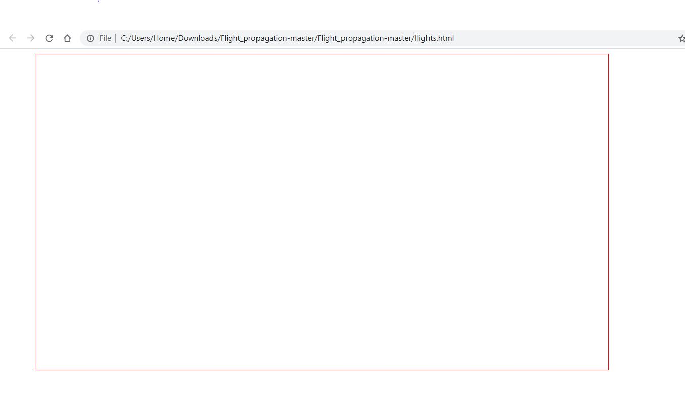

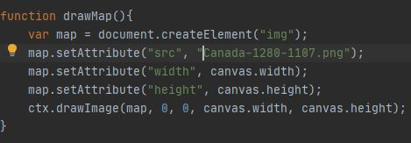

Here we can see that the image source was correct but the path is not correct.

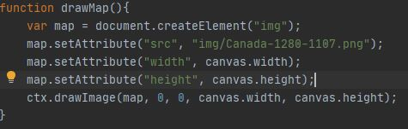

By giving the correct path of the image, it helps to load the image properly.

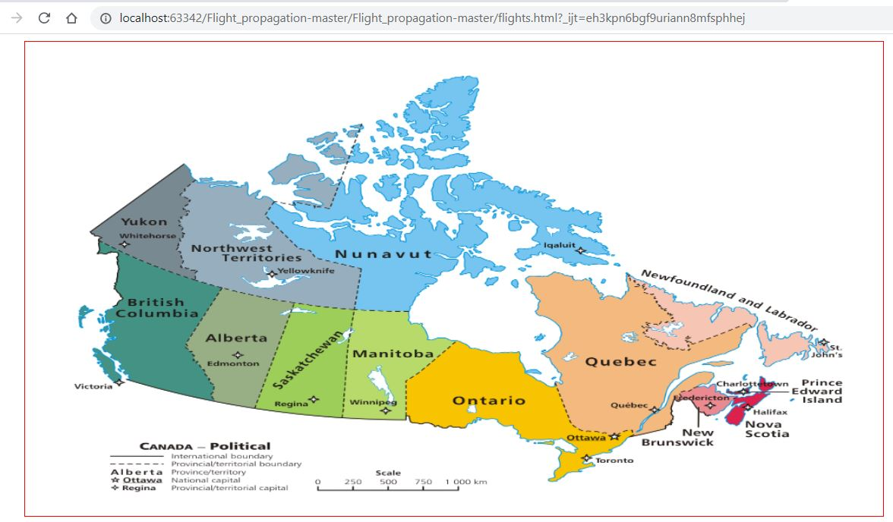

**TICKET: WEB-1**

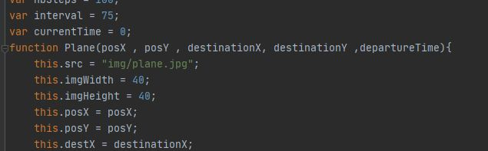

Function plane positions was pointing to null before.



As mentioned in comment, JSON structure was incorrect as the map co-ordinates are in quotations which will be taken as string.



In “var flights= JSONObject.flight”, there is no variable as flight. It has to be changed to flights.



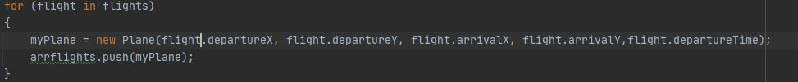

In the for loop, the co-ordinate flight.departureX will return 0,1,2.. as loop repeats which is not a co-ordinate. It has to replaced by the JSON co-ordinates which can be obtained by giving the array values.



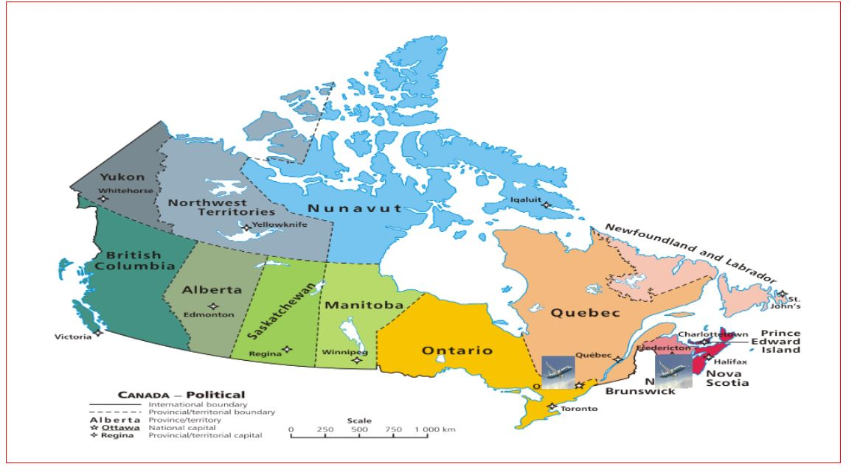

**TICKET: WEB-3**

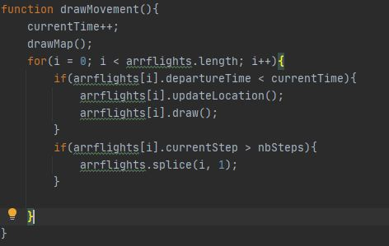

Initially the currentTime was 0 , When the function was called the currentTime is incrementing, which will be 1 rather than 0.

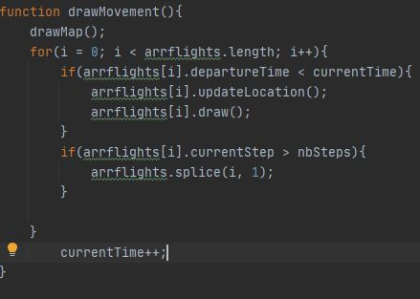

Now the currentTime variable is incrementing after the loops and it is starting from 0.