**DESIGN**

Application design phase is one of the important one. In this application design starts from Mockup template which got from template providers. There is no header files were used in our project except Jquery API. It’s a three tier architecture are Client side, Server side and Database.

Hyper text markup language is used for creating pages with its tags. The page layout done by HTML. Cascading style sheet is full of properties which help to format HTML elements completely. Jquery we have used as Client side scripting language for validation, popup box etc. PHP is a server side scripting language used for Database connectivity, session and upload, download etc. We used MySQL application for string data as centralized. So that through network all users can access the data simultaneously.

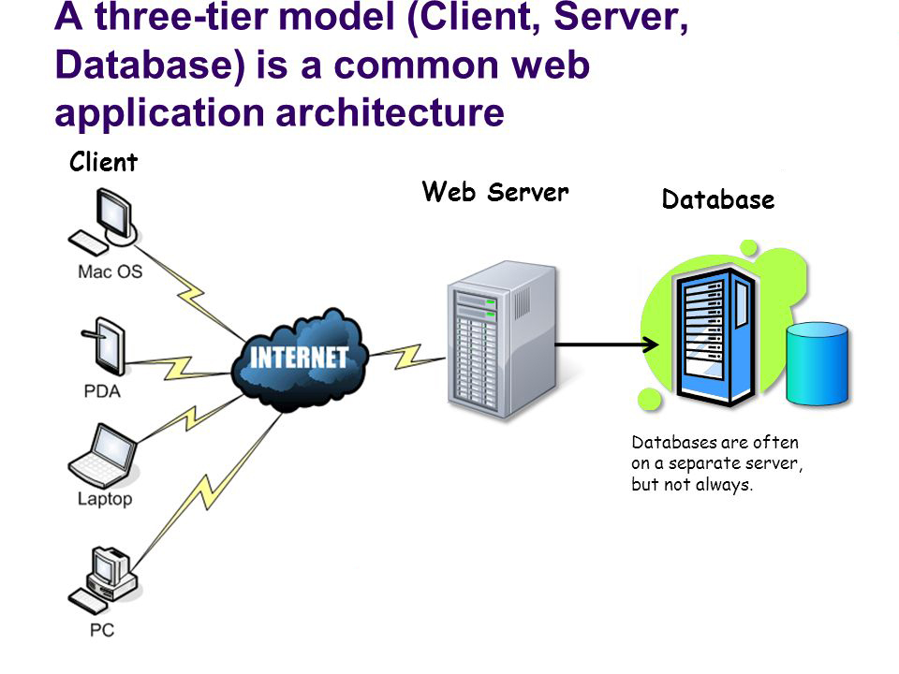

Academia is basically multi user application which means application can access by multi user on time. And distributed server will respond for all requests individually so that people can access the information without any delay.

**Modules and Description**

* Admin Login Module
* Upload Module
* Manage Post Module
* Approve Post Module
* Add Faculty Module
* Approve and Manage Student
* Announcement Module
* Manage Announcement Module
* Lecturer Login Module
* Change Password Module
* Student Module
* Change Photo Module
* Comment Module
* Search Module

**Admin Login Module**

Admin login into his account with the help of login credentials through this form. There is no Admin Signup form here. Admin login information was added through directly database by owner of the application.

**Upload Module**

After login into account admin can share post by accessing this upload module. He can upload multimedia application by selecting radio buttons which given in form like PDF, Document, Video and Image. This post will be published immediately in pages without any verification or approval.

**Manage Post Module**

Manage module is used for mange existing post done by Admin or Lecturer. Admin can block, activate, view and delete any post. When admin delete a post from manage module page, trigger will execute behind the screen from database catalog, so deleted post will be stored in another backup table using trigger concept.

**Approve Post Module**

Lecturer’s shared content will not be published in application immediately like Admin posts. The posts done by Lecturer will be immediately verified by Admin for trusty reason. After admin approval only post will published in application.

**Add Faculty**

Lecturer’s accounts are created by Admin. There is no separate signup page for Lecturers. Admin will feed lecturer personal information including login information to create account. Using this information each lecturer can login into their account and share materials.

**Approve and Manage Student**

Registered student’s accounts are approved by Admin. After approve only students can login into the account. And Students account can block and delete by Admin.

**Announcement Module**

By entering Announcement Title and Description admin can post announcement. That will be shared in front screen based on limit query. Only recent 10 announcements will be visible in screen.

**Manage Announcement Module**

Manage module is used to view and delete existing announcements by admin.

**Lecturer Login Module**

Lecturer login module is used for faculties to login into their accounts which created by Admin. Lecturer’s can login into their account with registered Email-ID and encrypted password. After login into their accounts they can upload information for posting and they can manage only their post’s, but not others.

**Change Password**

Lecturer’s can change their account password. Change password module asks current password and new password from user. After verifying current password only new password will be update in their account. If password updated also, not updated also account logout by destroying session for security purpose.

**Change Photo**

Lecturer’s can change their photos frequently which helps students as well admin to find post information very easily that who uploaded.

**Comment**

Lecturer and Student both can comment on particular post after login into their account with secret login information. Through this they can ask questions to concern people. It act like a academic blog.

**Search**

Students can search any posts by Lecturer name or Uploaded Date or Keyword of post title. So that students can avoid scrolling the post from top to bottom for all time. They can easily filter and get information.