**Methodology:**

**Water fall Model**

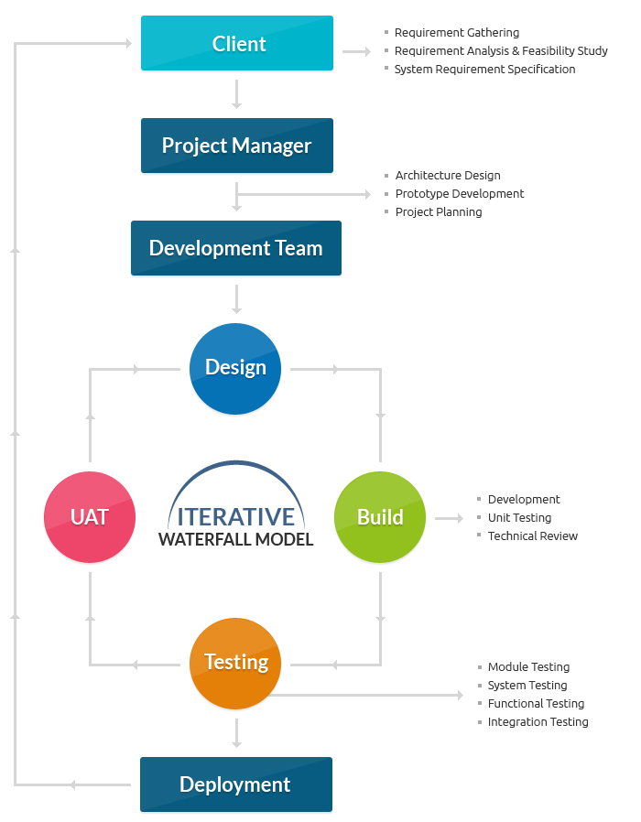

Waterfall model is one of a system development life cycle(SDLC) model. Users proceed to next phase if and only if current phase is complete. Users are not allowed go back to previous phases if there are any mistake so they named it waterfall model, just like the water is always fall down from the waterfall and not flow upward.

In Royce's original waterfall model, the waterfall model originally consists of 7 phases which is Requirement Specification, Design, Construction, Integration, Testing and Debugging, Installation and Maintenance.

Firstly, we collect the requirement for the material details and we analyzed it. After analyzed the requirement, we proceed to design stage. In the design phase, we design not only the user interface, but also the database design. The next phase in waterfall model after design phase is Construction phase. Construction phase is an important phase in waterfall model and it is a time consuming phase depends on programmer’s ability. In Academia application development, construction phase is using PHP coding to write the program. It is very time consuming if the programmer don’t understand the logic or still fresh to the coding. After done the coding phase, we will proceed to integration phase. The next phase after integration is the testing and debugging phase. For testing module, it is separated into few types which are module testing, system testing, unit testing and user acceptance test. Once there is a bug founded, it will be solve immediately before the system is launched to ensure the application launched is bug free. Lastly, it is implementation and maintenance phase. In this phase, the application will be installed at user side. After deployed the application, maintenance is compulsory needed to ensure the application is always-on and up to date with latest technologies or latest business process. In my opinion, the time spent on earlier phases of SDLC can lead to greater economy in later stages. It is because in the earlier phase, a bug can be fixed in short time, less cost and less effort compared to later phases

#### **Advantages of Waterfall Model:**

* Waterfall model is very simple and easy to understand and use a method that is why it is really beneficial for the beginner or novice developer
* It is easy to manage, because of the rigidity of the model. Moreover, each phase has specific deliverables and individual review process
* In this model phases are processed and completed are at once in a time thus it saves a significant amount of time
* This type of development model works more effectively in the smaller projects where requirements are very well understood
* The testing is easier as it can be done by reference to the scenarios defined in the earlier functional specification

#### **Disadvantages of Waterfall Model:**

* This model can only be used when very precise up-front requirements are available
* This model is not applicable for maintenance type of projects
* The main drawback of this method is that once an application is in the testing stage, it is not possible to go back and edit something
* There is no possibility to produce any working software until it reaches the last stage of the cycle
* In this model, there is no option to know the end result of the entire project
* This model is good for a small project but not ideally suitable for long and ongoing projects
* Not ideal for the projects where requirements are very moderates, and there is great scope for modification

## Agile Software Development Methodology :

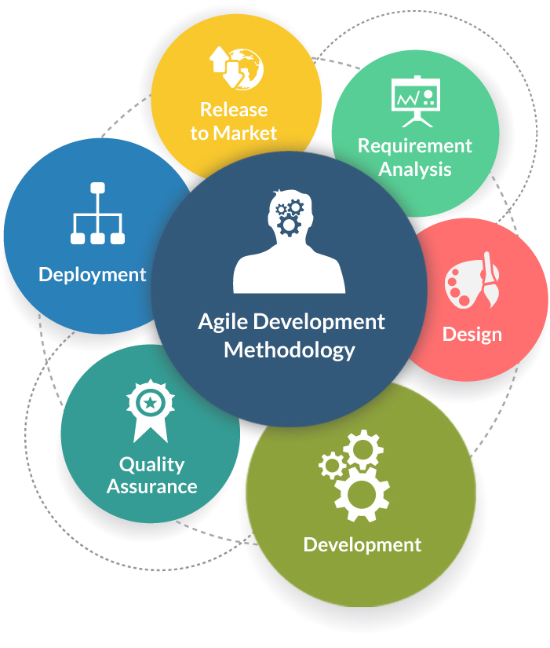

**Agile Software Development** is an approach that is used to design a disciplined [software management process](https://www.tatvasoft.com/software-outsourcing/software-outsourcing-development) which also allows some frequent alteration in the development project. This is a type of software development methodologies which is one conceptual framework for undertaking various software engineering projects. It is used to minimize risk by developing software in short time boxes which are called iterations that generally last for one week to one month.

#### ****Advantages of Agile Development Methodology:****

* Agile methodology has an adaptive approach which is able to respond to the changing requirements of the clients
* Direct communication and constant feedback from customer representative leave no space for any guesswork in the system

#### ****Disadvantages of Agile Development Methodology:****

* This methodology focuses on working software rather than documentation, hence it may result in a lack of documentation
* The software development project can get off track if the customer is not very clear about the final outcome of his project

## Spiral Model Methodology :

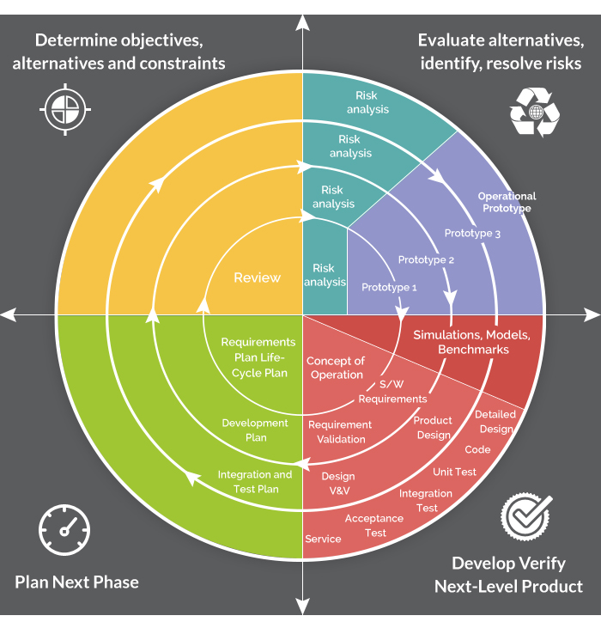

The **Spiral Model**is a sophisticated model that focuses on early identification and reduction of project risks. In this software development methodology, developers start on a small scale then explores the risks involved in the project, makes a plan to handle the risks, and finally decides whether to take the next step of the project to do the next iteration of the spiral. The success of any Spiral Lifecycle Model depends on the reliable, attentive, and knowledgeable management of the project.

#### **Advantages of Spiral Model:**

* The high amount of risk analysis hence, avoidance of possible risk is certainly reduced
* This model is good for large size and critical projects
* In the spiral model, additional functionality can be added at a later date
* It is more suited for high-risk projects, where business needs may differ from time to time basis

#### ****Disadvantages of Spiral Model:****

* It is certainly the costly model to use in terms of development
* The success of the entire project is dependent on the risk analysis phase thus, failure in this phase may damage entire project
* It is not appropriate for low-risk projects
* The big risk of this methodology is that it may continue indefinitely and never finish

**Limitation of the project:**

* The system requires very low system resources and the system will work in almost all configurations.
* It can be used with internet and intranet.
* It can be use as mobile application also.
* Cannot access unauthorized students.
* Can watch offline streaming from pages, can download only.
* Proposed system developed with only one admin.
* Cannot customize the materials for particular group of students.

**Application of the project:**

* Data Accuracy
* Data filter option, can easily search datas
* Students and Lecturer interaction by entering comments
* Can enhance for assignment submission application
* Responsive user friendly application
* Secure Password updating system
* For easy identification profile photo manipulation
* Material filter option to search particular type of Data.
* Reliable and multi platform application.