**ABSTRACT :**

The MLX90614 from Melexis is an infrared thermometer for non-contact temperature measurements. Both the IR sensitive thermopile detector chip and the signal conditioning ASIC are integrated in the same TO-39 can.

Integrated into the MLX90614 are a low noise amplifier, 17-bit ADC and powerful DSP unit thus achieving high accuracy and resolution of the thermometer.

Factory calibrated in wide temperature range: -40 to 125째C for sensor temperature and -70 to 380째C for object temperature

SMBus ( I2C based) compatible digital interface for fast temperature readings and building sensor networks.

In this project we shall use the MLX90614 with OLED & ULTRASONIC sensor.Arduino NANO is used as controller.Calibration procedure for correct object temperature reading is also explained.

**INTRODUCTION :**

In order to realize the human body temperature fast and non-contact measurement, an infrared thermometer is designed. The infrared human body temperature sensor is mainly used to convert the human body's infrared into voltage signal, an operational amplifier to amplify the signal, filter circuit to filter the signal, the analog signal into digital signal by the A/D conversion circuit, data processing by the MCU, LCD display and voice reporting body temperature and time, so the human body non-contact measurement is realized. The experimental results show that: the device can realize the temperature and time of acquisition, the measurement error is not more than 0.5°C, voice broadcast and liquid crystal display the temperature and time, overrun alarm and other functions.

**EXISTING SYSTEM :**

Contactless thermometer (MLX) sensor used with man power mechanism .A man press the button provided in contactless thermometer gun, laser beam facing toward the head for the correct position, then scan result shows in display.

**PROPOSED SYSTEM :**

We uses MLX90614 contactless temperature measurement device and oled display. This device is Automatic temperature scanning system with help of IR Sensor (Infrared). If the person approach this device, device automatically detect the person with the help of IR sensor and send scanned the person temperature and show the result in oled display. If person infected with common fever , temperature raises above the normal level(96 - 98 degree ).if temperature raises above the normal level , this device send signal to microcontroller ,then buzzer tone increase so we easily identify the affected person.

**ADVANTAGES :**

1. Man power Reduced.
2. Waiting time will be half of the existing system.
3. Cost effective.
4. Practical and affordable.
5. Ensure security, lower maintenance.
6. Less power consumption.

**WORKING PRINCIPLE :**

We uses ardiuno UNO microcontroller to process this device .If person approach this device the infrared sensor sense the signal send signal to arduino microcontroller then arduino uno read the embedded code and Ardiuno read the mlx sensor temperature and show the result in OLED screen fitted in this device. For correct position we provided laser beam towards the head.

**USES :**

* Reduce Manpower
* Automatic scanning process.
* Contactless communication.
* Low power consumption.
* Manpower salary reduced.

**Application :**

* Exam Center
* Institution
* Corporate Field
* Medicine testing lab.
* Government Sector.
* SCHOOL
* COLLEGE
* BUSES

**CONCLUSION :**

We concluded with this device reduces manpower and reduces virus transmission rate for the tester. Automatic process help the people to reduce time and reduces expense for man power .In future situation help to overcome the virus.

This system everyone can use easily so this system is User-friendly.

**Arduino UNO :**

[Arduino](http://arduino.cc/) is an open-source platform used for building electronics projects. Arduino consists of both a physical programmable circuit board (often referred to as a [microcontroller](http://en.wikipedia.org/wiki/Microcontroller)) and a piece of [software](http://arduino.cc/en/Main/Software), or IDE (Integrated Development Environment) that runs on your computer, used to write and upload computer code to the physical board.

The Arduino platform has become quite popular with people just starting out with electronics, and for good reason. Unlike most previous programmable circuit boards, the Arduino does not need a separate piece of hardware (called a programmer) in order to load new code onto the board -- you can simply use a USB cable. Additionally, the Arduino IDE uses a simplified version of C++, making it easier to learn to program. Finally, Arduino provides a standard form factor that breaks out the functions of the micro-controller into a more accessible package.

### **Power (USB / Barrel Jack)**

Every Arduino board needs a way to be connected to a power source. The Arduino UNO can be powered from a USB cable coming from your computer or a wall power supply ([like this](https://www.sparkfun.com/products/8269)) that is terminated in a barrel jack. In the picture above the USB connection is labeled  and the barrel jack is labeled .

The USB connection is also how you will load code onto your Arduino board. More on how to program with Arduino can be found in our [Installing and Programming Arduino](https://learn.sparkfun.com/tutorials/installing-arduino-ide) tutorial.

****NOTE:**** Do NOT use a power supply greater than 20 Volts as you will overpower (and thereby destroy) your Arduino. The recommended voltage for most Arduino models is between 6 and 12 Volts.

### Pins (5V, 3.3V, GND, Analog, Digital, PWM, AREF)

The pins on your Arduino are the places where you connect wires to construct a circuit (probably in conjuction with a [breadboard](https://learn.sparkfun.com/tutorials/how-to-use-a-breadboard/) and some [wire](https://learn.sparkfun.com/tutorials/working-with-wire). They usually have black plastic ‘headers’ that allow you to just plug a wire right into the board. The Arduino has several different kinds of pins, each of which is labeled on the board and used for different functions.

* ****GND**** : Short for ‘Ground’. There are several GND pins on the Arduino, any of which can be used to ground your circuit.
* ****5V & 3.3V**** : As you might guess, the 5V pin supplies 5 volts of power, and the 3.3V pin supplies 3.3 volts of power. Most of the simple components used with the Arduino run happily off of 5 or 3.3 volts.
* ****Analog**** : The area of pins under the ‘Analog In’ label (A0 through A5 on the UNO) are Analog In pins. These pins can read the signal from an analog sensor (like a [temperature sensor](https://www.sparkfun.com/products/10988)) and convert it into a digital value that we can read.
* ****Digital**** : Across from the analog pins are the digital pins (0 through 13 on the UNO). These pins can be used for both digital input (like telling if a button is pushed) and digital output (like powering an LED).
* ****PWM**** : You may have noticed the tilde (~) next to some of the digital pins (3, 5, 6, 9, 10, and 11 on the UNO). These pins act as normal digital pins, but can also be used for something called Pulse-Width Modulation (PWM). We have [a tutorial on PWM](https://learn.sparkfun.com/tutorials/pulse-width-modulation), but for now, think of these pins as being able to simulate analog output (like fading an LED in and out).
* ****AREF****: Stands for Analog Reference. Most of the time you can leave this pin alone. It is sometimes used to set an external reference voltage (between 0 and 5 Volts) as the upper limit for the analog input pins.

### **Reset Button**

Just like the original Nintendo, the Arduino has a reset button .Pushing it will temporarily connect the reset pin to ground and restart any code that is loaded on the Arduino. This can be very useful if your code doesn’t repeat, but you want to test it multiple times. Unlike the original Nintendo however, blowing on the Arduino doesn't usually fix any problems.

### Power LED Indicator

Just beneath and to the right of the word “UNO” on your circuit board, there’s a tiny LED next to the word ‘ON’ . This LED should light up whenever you plug your Arduino into a power source. If this light doesn’t turn on, there’s a good chance something is wrong. Time to re-check your circuit!

### **TX RX LEDs**

TX is short for transmit, RX is short for receive. These markings appear quite a bit in electronics to indicate the pins responsible for [serial communication](https://learn.sparkfun.com/tutorials/serial-communication). In our case, there are two places on the Arduino UNO where TX and RX appear -- once by digital pins 0 and 1, and a second time next to the TX and RX indicator LEDs . These LEDs will give us some nice visual indications whenever our Arduino is receiving or transmitting data (like when we’re loading a new program onto the board).

### Main IC

The black thing with all the metal legs is an IC, or Integrated Circuit . Think of it as the brains of our Arduino. The main IC on the Arduino is slightly different from board type to board type, but is usually from the ATmega line of IC’s from the ATMEL company. This can be important, as you may need to know the IC type (along with your board type) before loading up a new program from the Arduino software. This information can usually be found in writing on the top side of the IC. If you want to know more about the difference between various IC's, reading the datasheets is often a good idea.

**OLED DISPLAY :**

An organic light-emitting diode (OLED or organic LED), also known as organic electroluminescent (organic EL) diode, is a [light-emitting diode](https://en.wikipedia.org/wiki/Light-emitting_diode) (LED) in which the [emissive](https://en.wikipedia.org/wiki/Emission_(electromagnetic_radiation)) [electroluminescent](https://en.wikipedia.org/wiki/Electroluminescence) layer is a film of [organic compound](https://en.wikipedia.org/wiki/Organic_compound) that emits light in response to an electric current. This organic layer is situated between two electrodes; typically, at least one of these electrodes is transparent. OLEDs are used to create [digital displays](https://en.wikipedia.org/wiki/Digital_display)in devices such as [television](https://en.wikipedia.org/wiki/Television_set) screens, [computer monitors](https://en.wikipedia.org/wiki/Computer_monitor), portable systems such as [smartphones](https://en.wikipedia.org/wiki/Smartphone), [handheld game consoles](https://en.wikipedia.org/wiki/Handheld_game_console) and [PDAs](https://en.wikipedia.org/wiki/Personal_digital_assistant). A major area of research is the development of white OLED devices for use in [solid-state lighting](https://en.wikipedia.org/wiki/Solid-state_lighting) applications.

There are two main families of OLED: those based on small molecules and those employing [polymers](https://en.wikipedia.org/wiki/Polymer). Adding mobile [ions](https://en.wikipedia.org/wiki/Ion) to an OLED creates a [light-emitting electrochemical cell](https://en.wikipedia.org/wiki/Light-emitting_electrochemical_cell) (LEC) which has a slightly different mode of operation. An OLED display can be driven with a [passive-matrix](https://en.wikipedia.org/wiki/Passive_matrix_addressing)(PMOLED) or [active-matrix](https://en.wikipedia.org/wiki/Active_matrix) ([AMOLED](https://en.wikipedia.org/wiki/AMOLED)) control scheme. In the PMOLED scheme, each row (and line) in the display is controlled sequentially, one by one,[[6]](https://en.wikipedia.org/wiki/OLED" \l "cite_note-6) whereas AMOLED control uses a [thin-film transistor](https://en.wikipedia.org/wiki/Thin-film_transistor) backplane to directly access and switch each individual pixel on or off, allowing for higher resolution and larger display sizes.

An OLED display works without a [backlight](https://en.wikipedia.org/wiki/Backlight) because it emits [visible light](https://en.wikipedia.org/wiki/Visible_light). Thus, it can display deep [black levels](https://en.wikipedia.org/wiki/Black_level) and can be thinner and lighter than a [liquid crystal display](https://en.wikipedia.org/wiki/Liquid_crystal_display) (LCD). In low ambient light conditions (such as a dark room), an OLED screen can achieve a higher [contrast ratio](https://en.wikipedia.org/wiki/Contrast_ratio) than an LCD, regardless of whether the LCD uses [cold cathode fluorescent lamps](https://en.wikipedia.org/wiki/Cold_cathode) or an [LED backlight](https://en.wikipedia.org/wiki/LED-backlit_LCD_display). OLED displays are made in the same way as LCDs, but after TFT (for active matrix displays), addressable grid (for passive matrix displays) or ITO segment (for segment displays) formation, the display is coated with hole injection, transport and blocking layers, as well with electroluminescent material after the 2 first layers, after which ITO or metal may be applied again as a cathode and later the entire stack of materials is encapsulated. The TFT layer, addressable grid or ITO segments serve as or are connected to the anode, which may be made of ITO or metal.OLEDs can be made flexible and transparent, with [transparent displays](https://en.wikipedia.org/wiki/Transparent_display) being used in smartphones with optical fingerprint scanners and [flexible displays](https://en.wikipedia.org/wiki/Flexible_display)being used in foldable smartphones.

**LASER DIODE :**

A laser diode, (LD), injection laser diode (ILD), or diode laser is a [semiconductor](https://en.wikipedia.org/wiki/Semiconductor) device similar to a [light-emitting diode](https://en.wikipedia.org/wiki/Light-emitting_diode) in which a diode pumped directly with electrical current can create [lasing](https://en.wikipedia.org/wiki/Active_laser_medium) conditions at the diode's [junction](https://en.wikipedia.org/wiki/P-n_junction).[[1]](https://en.wikipedia.org/wiki/Laser_diode" \l "cite_note-ColdrenCorzine2012-1):3 Laser diodes can directly convert electrical energy into light. Driven by voltage, the doped p-n-transition allows for [recombination](https://en.wikipedia.org/wiki/Carrier_generation_and_recombination) of an electron with a [hole](https://en.wikipedia.org/wiki/Electron_hole). Due to the drop of the electron from a higher energy level to a lower one, radiation, in the form of an emitted photon is generated. This is spontaneous emission. Stimulated emission can be produced when the process is continued and further generate light with the same phase, coherence and wavelength.

The choice of the semiconductor material determines the wavelength of the emitted beam, which in today's laser diodes range from infra-red to the UV spectrum. Laser diodes are the most common type of lasers produced, with a wide range of uses that include [fiber optic communications](https://en.wikipedia.org/wiki/Fiber_optic_communication), [barcode readers](https://en.wikipedia.org/wiki/Barcode_reader), [laser pointers](https://en.wikipedia.org/wiki/Laser_pointer), [CD](https://en.wikipedia.org/wiki/CD)/[DVD](https://en.wikipedia.org/wiki/DVD)/[Blu-ray](https://en.wikipedia.org/wiki/Blu-ray) disc reading/recording, [laser printing](https://en.wikipedia.org/wiki/Laser_printing), [laser scanning](https://en.wikipedia.org/wiki/Laser_scanning) and [light beam](https://en.wikipedia.org/wiki/Light_beam) illumination. With the use of a phosphor like that found on white [LEDs](https://en.wikipedia.org/wiki/LED), Laser diodes can be used for general illumination.

**IR SENSOR :**

Types of IR Sensor

There are two types of IR sensors are available and they are,

Active Infrared Sensor

Passive Infrared Sensor

Active Infrared Sensor

Active infrared sensors consist of two elements: infrared source and infrared detector. Infrared sources include the LED or infrared [laser diode](https://robu.in/product-category/electronic-module/laser-module/" \t "/Users/karthick/Documents\\x/_blank). Infrared detectors include photodiodes or phototransistors. The energy emitted by the infrared source is reflected by an object and falls on the infrared detector.

Passive Infrared Sensor

Passive infrared [sensors](https://robu.in/product-category/sensor/" \t "/Users/karthick/Documents\\x/_blank) are basically Infrared detectors. Passive infrared sensors do not use any infrared source and detector. They are of two types: quantum and thermal. Thermal infrared sensors use infrared energy as the source of heat. [Thermocouples](https://robu.in/product/max6675-thermocouple-sensor-module/" \t "/Users/karthick/Documents\\x/_blank), pyroelectric detectors and bolometers are the common types of thermal infrared detectors. Quantum type infrared sensors offer higher detection performance. It is faster than thermal type infrared detectors. The photo sensitivity of quantum type detectors is wavelength dependent.

IR Sensor Working Principle

There are different types of infrared transmitters depending on their wavelengths, output power and response time. An IR sensor consists of an IR LED and an IR Photodiode, together they are called as PhotoCoupler or OptoCoupler.

IR Transmitter or IR LED

Infrared Transmitter is a light emitting diode (LED) which emits infrared radiations called as IR LED’s. Even though an IR LED looks like a normal LED, the radiation emitted by it is invisible to the human eye.

The picture of an Infrared LED is shown below.

[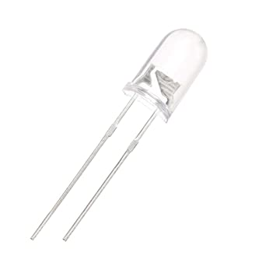](https://aws.robu.in/wp-content/uploads/2020/05/51fibl-5xL._SX342_.jpg)

IR Receiver or Photodiode

Infrared receivers or infrared sensors detect the radiation from an IR transmitter. IR receivers come in the form of photodiodes and phototransistors. Infrared Photodiodes are different from normal photo diodes as they detect only infrared radiation. Below image shows the picture of an IR receiver or a photodiode,

[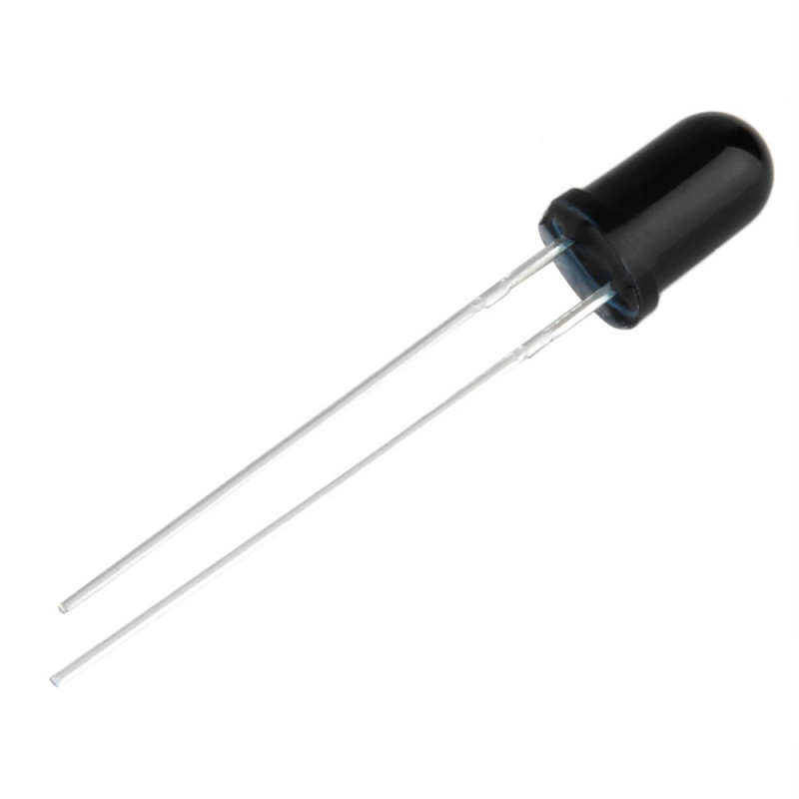](https://aws.robu.in/wp-content/uploads/2020/05/SN-IR-R-0-1-1-800x800-1.jpg)

Different types of IR receivers exist based on the wavelength, voltage, package, etc. When used in an infrared transmitter – receiver combination, the wavelength of the receiver should match with that of the transmitter.

The emitter is an IR LED and the detector is an IR photodiode. The IR photodiode is sensitive to the IR light emitted by an IR LED. The photo-diode’s resistance and output voltage change in proportion to the IR light received. This is the underlying working principle of the IR sensor.