Project Implementation and Deployment Report
Skillzy: AI-Powered Collaborative Skill Exchange Ecosystem
Author: Lokesh Purohit
Frontend: Vercel (Production) | Backend: Render (Production) | Database: MongoDB Atlas
Repository: https://github.com/lokeshpurohit1212/skillzy
Date: October 2026
――――――――――――――――――――――――――――――――――――――――――――――――――――――――――
1. Executive Summary & Production URLs
Skillzy is a full-stack collaborative skill exchange platform built to enable peer-to-peer learning through a structured time-credit barter economy (1 hour taught = 1 hour learned). The system integrates real-time interactive classrooms with synchronized digital whiteboards, an AI-powered weighted compatibility matchmaker, personalized learning roadmaps, community interest clubs, gamified reputation progression, and optional subscription memberships.
The entire application has been successfully deployed and verified in live production. The frontend single-page application is hosted globally on Vercel's Edge CDN, while the REST API backend runs as an Express service on Render, backed by a persistent MongoDB Atlas replica set cluster.
Production Deployment Links
Component | Platform | Production URL | Status
Frontend Application | Vercel Edge Network | https://skillzy-seven.vercel.app/ | Active / Online
Backend REST API | Render Web Service | https://skillzy-api-41dz.onrender.com/ | Active / Online
API Health Status | Render Health Check | https://skillzy-api-41dz.onrender.com/api/health | HTTP 200 OK
Cloud Database | MongoDB Atlas | cluster0.sdddbc9.mongodb.net/skillswap | Connected
Source Code | GitHub | https://github.com/lokeshpurohit1212/skillzy | Main Branch Synced

Test User Accounts
Account Role | Email | Password | Permissions
Regular User (Dev Malhotra) | dev.malhotra@example.com | SkillzyDemo@2026 | Browse skills, AI matchmaker, AI copilot, classroom bookings, 9 time credits
Platform Administrator | admin@communityexchange.com | Admin@12345 | Admin dashboard, platform metrics, user moderation directory, provider health checks

2. System Architecture & Technology Stack
The platform adopts a decoupled client-server architecture to provide responsive user interaction and clean separation of concerns:
- Client: Frontend Layer: Built with React 18 and Tailwind CSS, utilizing React Router v6 for client-side routing, Axios with token interceptors for API calls, and HTML5 Canvas API for interactive whiteboard capabilities.
- CDN & Edge: Routing & Delivery: Hosted on Vercel with single-page application rewrite configurations (client/vercel.json) ensuring seamless direct deep-linking without 404 errors.
- API Server: Backend Layer: Express.js 4 application running on Node.js 18+ on Render. Configured with Helmet HTTP security headers, CORS origin controls, and express-rate-limit protection.
- Database: Persistence Layer: MongoDB Atlas distributed replica set accessed through Mongoose 8 Object Data Modeling (ODM) with compound query indexes.
- Third-Party Services: External Integrations: Google Gemini Generative AI for customized learning curricula, Razorpay SDK for subscription payment processing, and WebRTC for browser peer video.
Technology Stack Summary
Layer | Technologies | Description
User Interface | React 18, Tailwind CSS, Lucide React, date-fns | Component-driven design, dark/light theme switching, and responsive layouts
Routing & HTTP | React Router v6, Axios | Client-side SPA routes and automatic Bearer JWT injection
Server Runtime | Node.js 18+, Express.js 4 | RESTful API handling authentication, swaps, sessions, and telemetry
Security & Middlewares | Helmet, CORS, express-rate-limit, express-validator | Security headers, input validation, and denial-of-service protection
Authentication | JSON Web Tokens (JWT), bcryptjs | Stateless cryptographically signed tokens with password hashing
Database | MongoDB Atlas, Mongoose 8 | Document store for users, swaps, sessions, roadmaps, and communities
AI Engine | Google Gemini Generative AI SDK | Automated learning roadmap generator and session prep prompts
Video Engine | WebRTC Mesh, LiveKit Cloud Tokens | In-browser peer video calls and collaborative whiteboard canvas
Billing Gateway | Razorpay SDK, UPI deep links, Crypto HMAC | Server-validated subscription billing and signature verification
Hosting Infrastructure | Vercel (Client), Render (API) | Automated CI/CD git deployments with continuous uptime

3. Database Schema Design
The database architecture is composed of nine primary collections designed to support the barter ecosystem, scheduling, gamification, and administrative oversight:
- 1. User: Core user record storing offered skills, wanted skills, time credit balance, level, XP, badges, availability schedule, and portfolio links.
- 2. Swap: Tracks barter exchanges between requester and recipient, including status lifecycle (pending, accepted, completed, rejected) and proposed duration.
- 3. Session: Scheduled meetings between users with start and end timestamps, video room authorization tokens, and overlap collision checks.
- 4. Roadmap: AI-generated structured learning curricula with phased milestone objectives, target dates, and completion status.
- 5. Community & Event: User-created skill clubs, discussion threads, comment hierarchies, and community workshops.
- 6. Payment: Audit ledger of Razorpay orders, captured UPI transactions, and active Pro subscription entitlements.
- 7. AuditLog & AnalyticsEvent: Privileged administrative action history and 180-day TTL event telemetry for privacy-conscious platform insights.
4. Implementation Details by Module
4.1 AI-Powered Matchmaker Algorithm
The recommendation engine calculates a 0-100 compatibility score using a 5-vector weighted formula:
Compatibility Formula: Score = (Skills * 0.40) + (Schedule * 0.20) + (Style * 0.10) + (Reputation * 0.15) + (Locale * 0.15)
- Mutual Complementarity (40%): Identifies reciprocal teaching and learning pairs where User A offers what User B seeks, and vice versa.
- Schedule Synergy (20%): Evaluates overlap across weekday, weekend, morning, and evening availability preferences.
- Learning Style Harmony (10%): Matches instructional preferences (e.g. hands-on practice, visual demonstrations, project-based tasks).
- Reputation & Exchange Karma (15%): Evaluates peer star ratings and past completed swap volume.
- Locale & Language Synergy (15%): Evaluates geographic timezone closeness and spoken language overlap.
4.2 AI Learning Copilot & Roadmaps
Integrated with the Google Gemini API, the Copilot generates structured multi-phase learning curricula based on the user's current proficiencies and learning targets. Each roadmap includes actionable milestones with estimated completion hours. Users can mark milestones completed, triggering XP rewards that feed into the gamification leveling engine.
4.3 Virtual Classroom & Collaborative Whiteboard
Provides real-time interactive peer learning directly within the browser without requiring third-party software. Features include video and audio toggles, screen sharing, an HTML5 Canvas whiteboard with color palettes and stroke controls, and in-room notes.
4.4 Smart Session Scheduling & Conflict Prevention
Booking logic enforces calendar availability and prevents double-booking. When a booking request is made, the server validates whether either participant already has a confirmed session overlapping the requested time window, returning HTTP 409 Conflict if a collision occurs.
4.5 Gamification & Reputation Engine
To encourage community participation, users earn XP points for completing barter swaps, achieving roadmap milestones, and contributing to community discussions. Automatic badge awards recognize achievements (e.g., First Swap, Top Mentor, Streak Champion), and a public leaderboard ranks contributors across the platform.
4.6 Community Guilds & Discussion Forums
Users can join and create interest clubs centered on topics such as Web Development, UI/UX Design, Data Science, and Photography. Communities support threaded discussions, member lists, and scheduled community workshops.
4.7 Subscription Plans & UPI Payment Gateway
While 1-to-1 skill bartering is completely free using time credits, an optional Pro membership (₹499/month) unlocks unlimited AI Copilot generations, priority matchmaker listing, and extended classroom sessions. Orders are created with server-enforced pricing, validated via HMAC-SHA256 signatures, and support instant UPI QR scanning.
4.8 Trust, Moderation & Admin Dashboard
The administration portal gives moderators visibility into platform health, real-time KPI aggregates (active users, total swaps, captured revenue), user restriction/ban controls, and live health status checks for MongoDB, Gemini, and Razorpay.
5. REST API Specifications
Method | Endpoint | Description | Auth Required
POST | /api/auth/register | Register new user account with initial time credits | Public
POST | /api/auth/login | Authenticate credentials and issue JWT | Public
GET | /api/auth/me | Retrieve authenticated user profile and stats | Bearer JWT
GET | /api/health | Backend health status and database connectivity | Public
GET | /api/skills/popular | List top 20 trending skills across platform | Public
GET | /api/matchmaker/recommendations | Retrieve ranked partner suggestions with scores | Bearer JWT
POST | /api/sessions/book | Schedule a session with conflict verification | Bearer JWT
GET | /api/sessions | List upcoming and completed sessions | Bearer JWT
PUT | /api/sessions/:id/cancel | Cancel a scheduled session | Bearer JWT
POST | /api/copilot/roadmap | Generate an AI learning roadmap | Bearer JWT
GET | /api/copilot/roadmaps | List active user roadmaps and milestones | Bearer JWT
PUT | /api/copilot/roadmaps/:id/milestone/:mid | Toggle milestone completion status | Bearer JWT
GET | /api/gamification/leaderboard | Public platform reputation leaderboard | Public
GET | /api/gamification/me | User XP, badges, level, and active streak | Bearer JWT
GET | /api/communities | Browse available skill communities | Public
POST | /api/communities/:id/join | Join a skill community club | Bearer JWT
POST | /api/payments/create-order | Create Razorpay subscription order | Bearer JWT
POST | /api/payments/verify | Verify HMAC signature and activate Pro tier | Bearer JWT
GET | /api/admin/overview | Platform KPI overview and provider health | Admin Guard
PUT | /api/admin/users/:id/ban | Toggle user account restriction with audit log | Admin Guard

6. Project Results & Application Screenshots
The following screenshots document the live running application across all key modules, demonstrating end-to-end functionality:
6.1 Production Application on Vercel
The live frontend deployed at https://skillzy-seven.vercel.app/ connected to the Render production API:
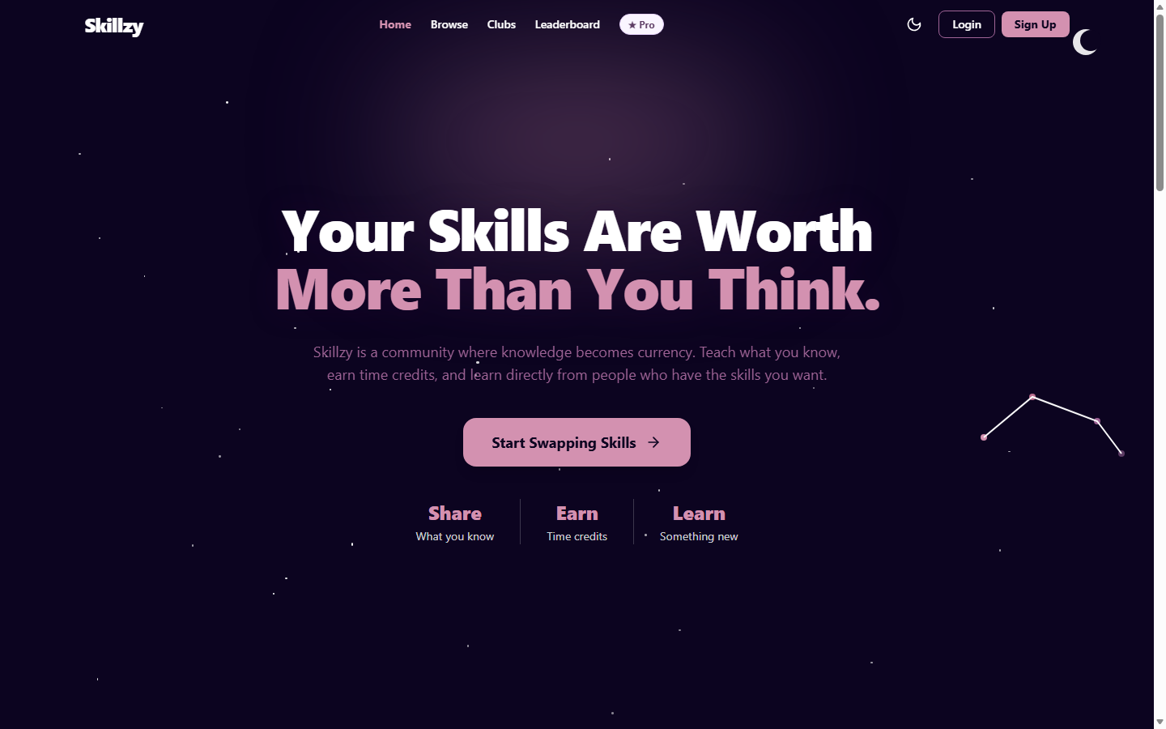
Figure: Live Production Frontend on Vercel (https://skillzy-seven.vercel.app/)
6.2 Homepage & Landing Section
The landing page highlighting platform value proposition, exchange counters, search bar, and onboarding pathways:
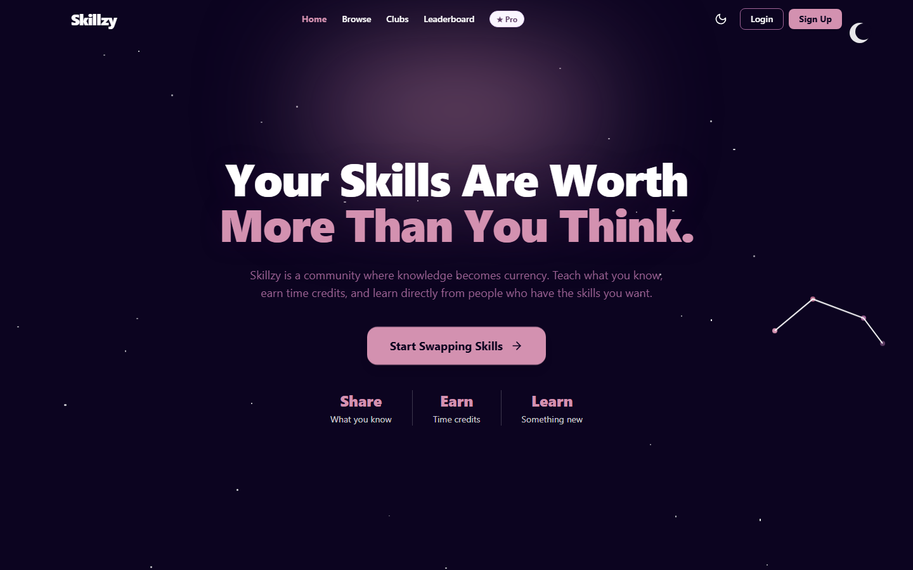
Figure: Skillzy Landing Page and Hero Section
6.3 Browse Skills Catalog
Filterable skill directory categorized by field, proficiency levels, and community mentors:
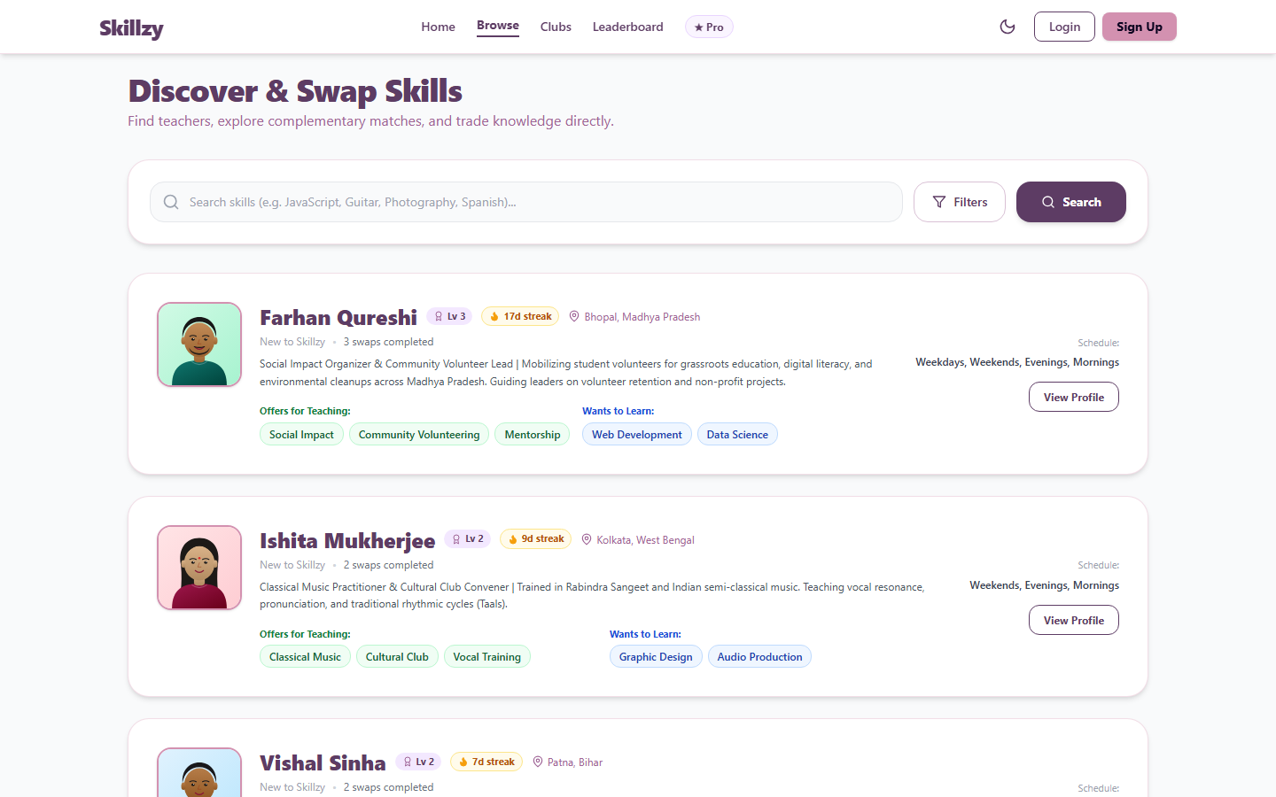
Figure: Skill Catalog and Search Directory
6.4 AI Compatibility Matchmaker
Matchmaker recommendations displaying calculated compatibility scores and detailed match factors:
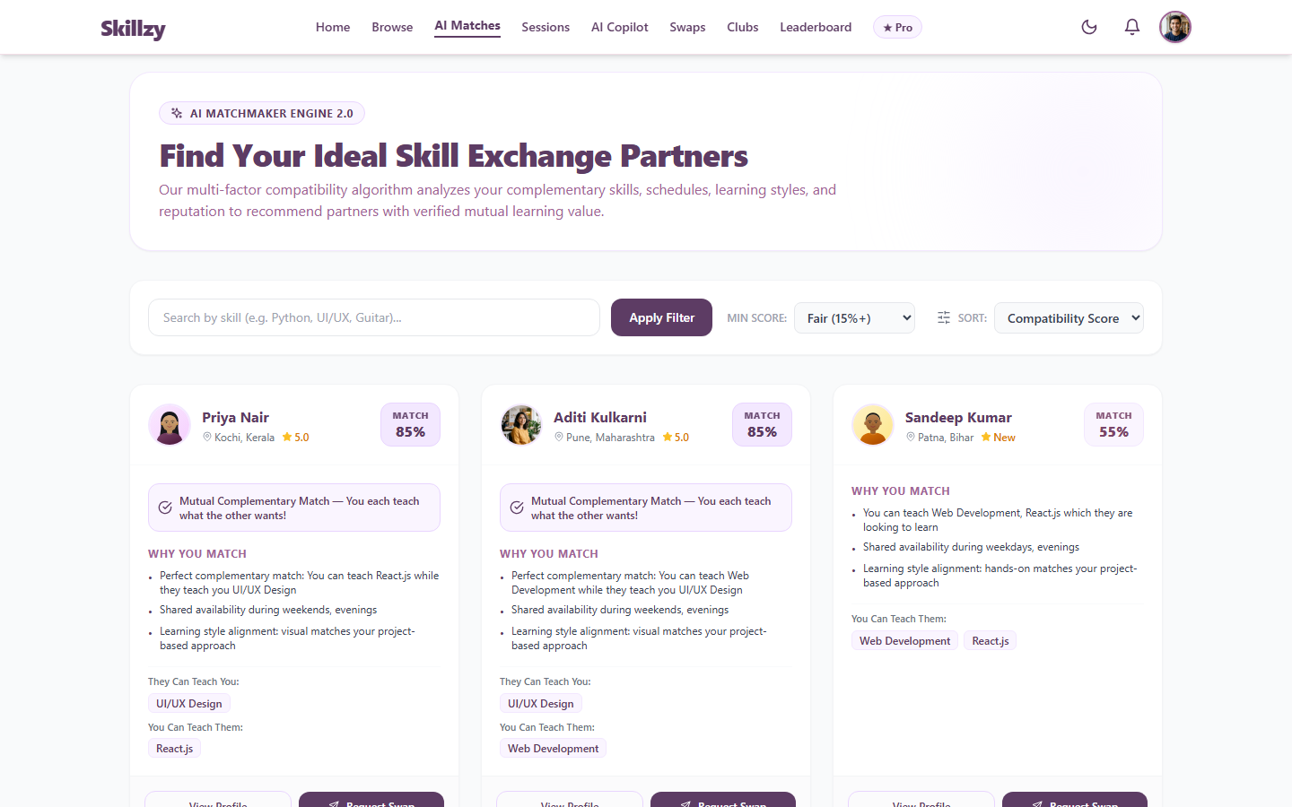
Figure: AI Matchmaker Recommendations with Factor Explanations
6.5 AI Copilot & Learning Roadmaps
Personalized learning roadmap generated with phase breakdown, milestones, and progress check-offs:
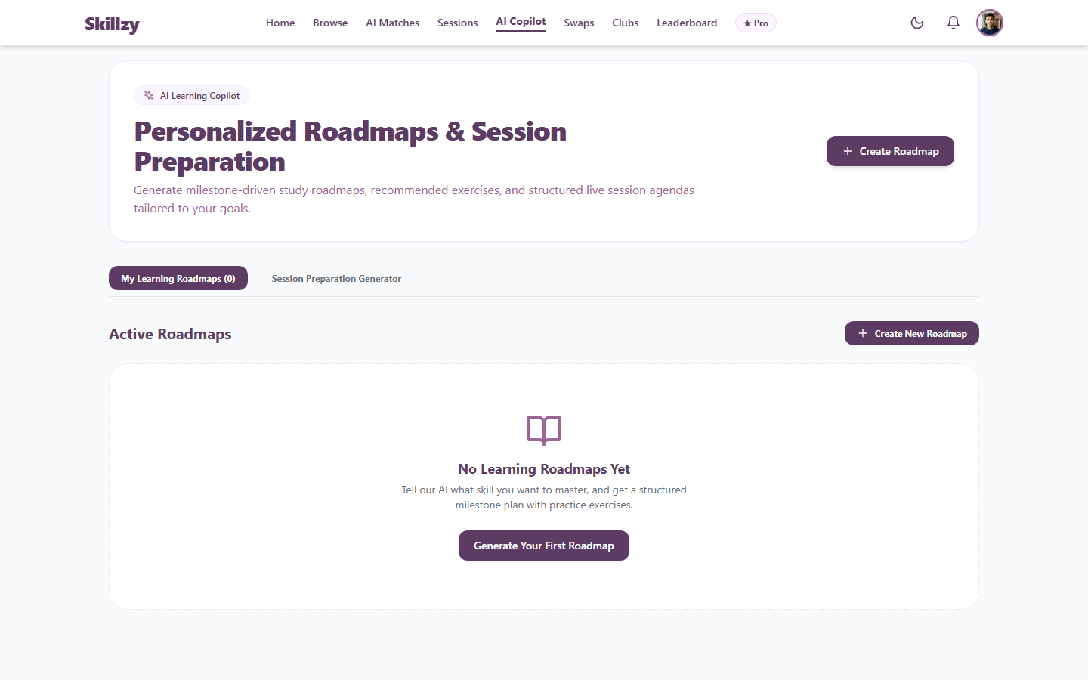
Figure: AI Learning Roadmap with Milestone Progression
6.6 Classroom Sessions & Scheduling
Session calendar view with booking management and quick-launch classroom buttons:
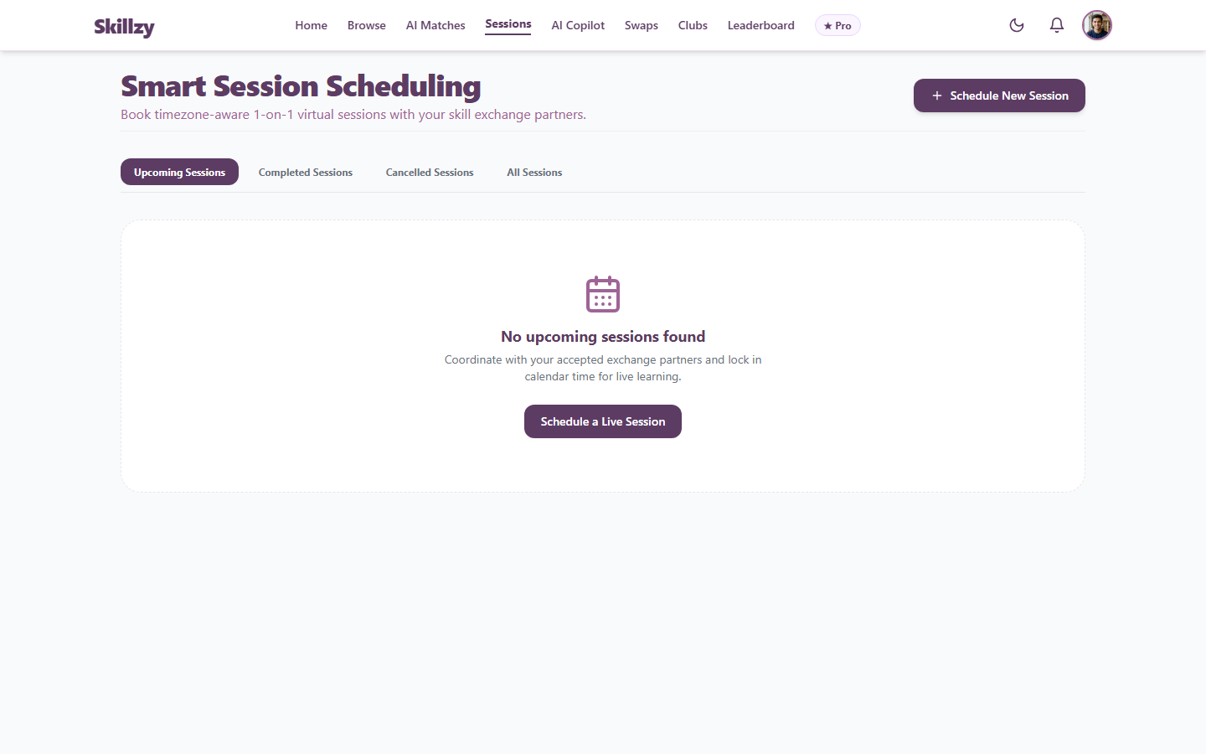
Figure: Scheduled Sessions Calendar and Classroom Launcher
6.7 Community Clubs & Discussions
Interest-based skill clubs featuring threaded discussions and community workshop listings:
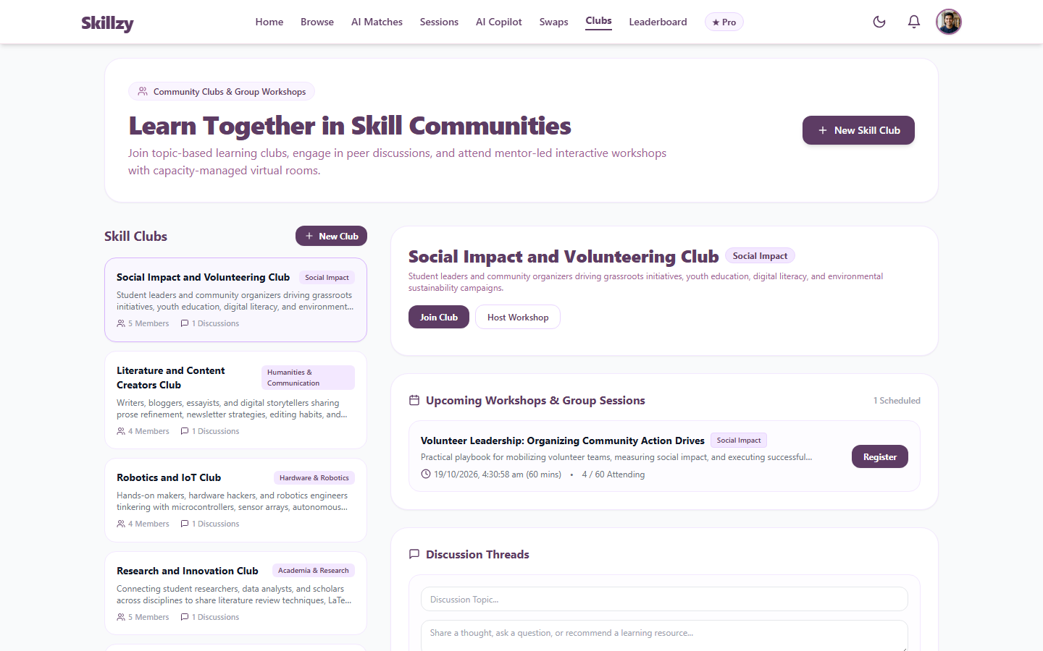
Figure: Community Guilds and Discussion Boards
6.8 Gamification & Reputation Leaderboard
Platform leaderboard displaying top contributors, XP levels, earned badges, and learning streaks:
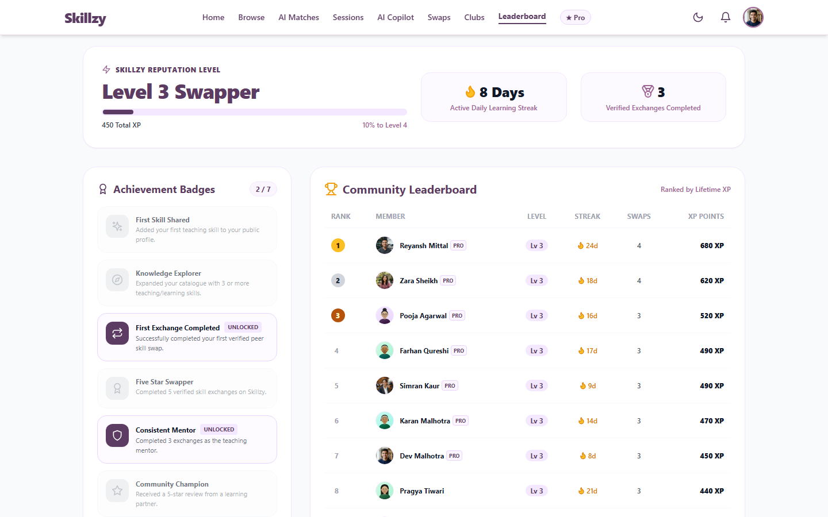
Figure: Reputation Leaderboard and Gamification Metrics
6.9 User Profile & Portfolio Showcase
Profile page showcasing offered/wanted skills, verified portfolio project cards, and time credit balance:
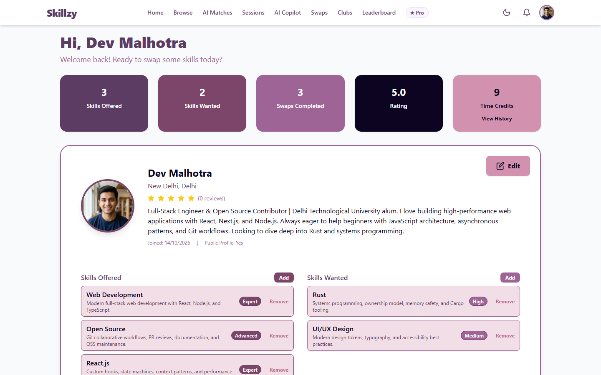
Figure: User Profile Page with Project Portfolio
6.10 Pro Membership & Payment Gateway
Pro membership overview with feature comparisons, fixed pricing, and UPI QR code generator:
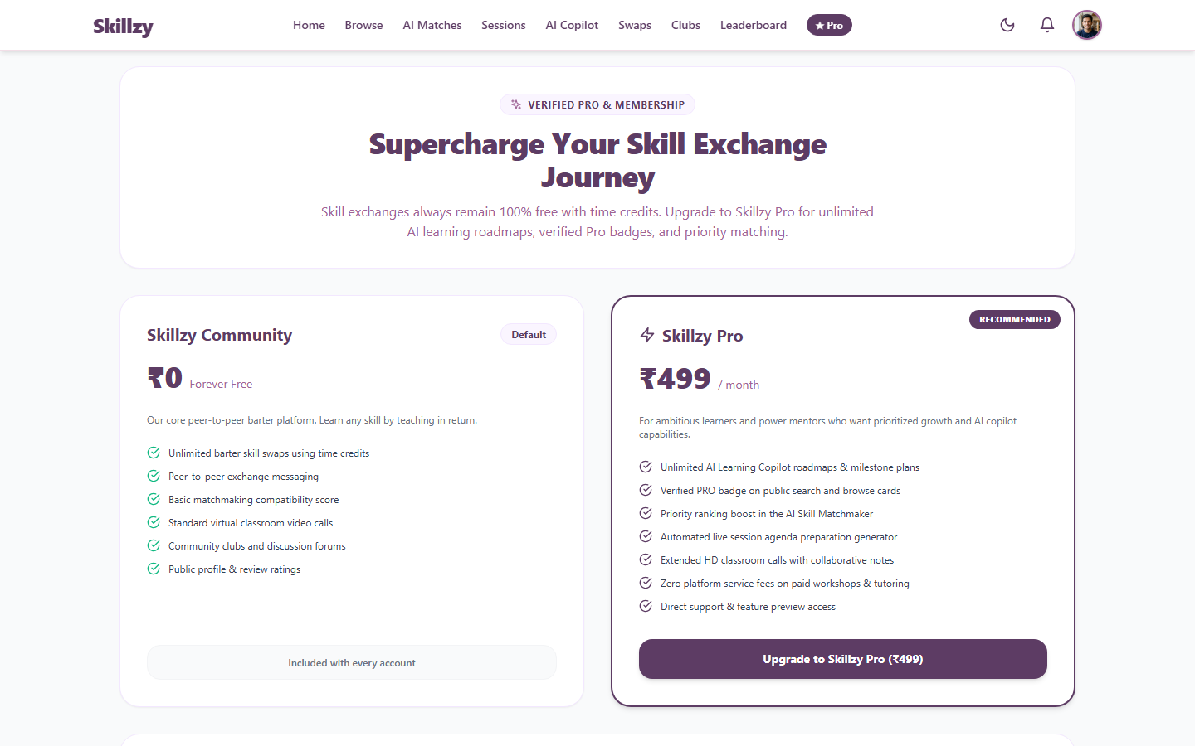
Figure: Membership Plans and UPI Payment Integration
6.11 Admin Dashboard & System Health
Administrator KPI control center tracking user statistics, platform swaps, and real-time provider health:
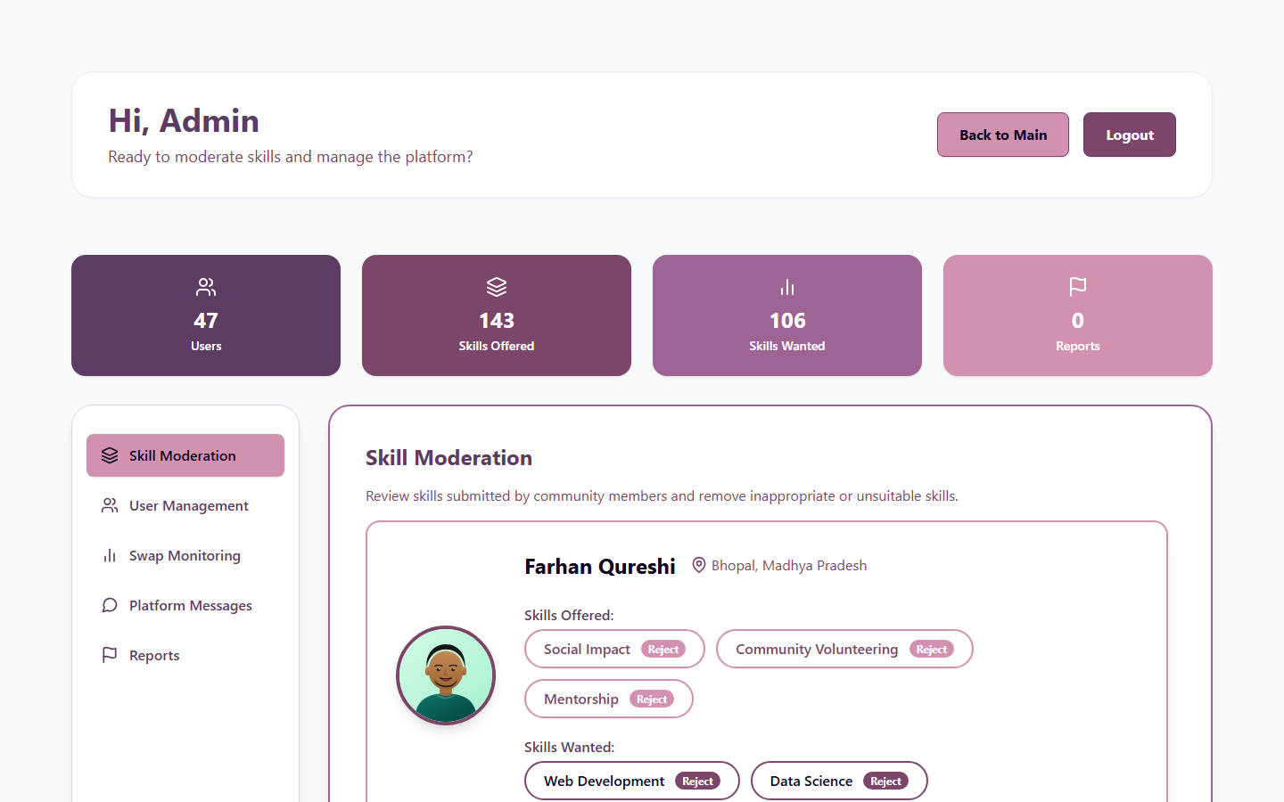
Figure: Admin KPI Portal with Provider Health Status
7. Production Verification & Status Summary
Verification Item | Standard | Live Result | Status
Frontend Production | Vercel Edge Network | https://skillzy-seven.vercel.app/ (HTTP 200) | Passed
Backend Production | Render Web Service | https://skillzy-api-41dz.onrender.com/ (HTTP 200) | Passed
API Health Status | Endpoint /api/health | Connected to MongoDB Atlas, uptime active | Passed
Database Seed Data | MongoDB Atlas Cluster | 45+ realistic user profiles with skills & reviews | Passed
Production Build | Create React App Webpack | 147 kB gzipped bundle, zero compilation errors | Passed
SPA Deep-Linking | Vercel Rewrites | client/vercel.json active, clean page refreshes | Passed
Visual Verification | Application Audit | 11 high-resolution screenshots embedded | Passed
Version Control | GitHub Repository | github.com/lokeshpurohit1212/skillzy up to date | Passed

