Skillzy 2.0 — Project Implementation & Production Deployment Report
Full-Stack AI-Powered Peer-to-Peer Collaborative Skill Exchange Platform
Production Deployment on Vercel & Render • System Architecture • Visual Verification
―――――――――――――――――――――――――――――――――――――――――――――――――――――――
1. Executive Summary & Live Production Credentials
Skillzy 2.0 is an enterprise-grade full-stack collaborative skill exchange ecosystem designed to democratize peer learning. It combines a time-credit barter economy (1 hour taught = 1 hour learned), real-time interactive classrooms with digital whiteboards, an AI-powered weighted compatibility matchmaker, personalized AI learning roadmaps, community guilds, gamified reputation leveling, and secure subscription tier management.
The platform is fully deployed and operational in production across high-availability cloud infrastructure with frontend edge acceleration and distributed database clustering.
🌐 Live Production Host Links
Component | Hosting Provider | Production URL / Endpoint | Operational Status
Frontend Web Application | Vercel (Global Edge CDN) | https://skillzy-seven.vercel.app/ | 🟢 LIVE & RUNNING
Backend REST API | Render (Node.js Web Service) | https://skillzy-api-41dz.onrender.com/ | 🟢 LIVE & RUNNING
API Health Check | Render Production Healthcheck | https://skillzy-api-41dz.onrender.com/api/health | 🟢 HTTP 200 OK
Cloud Database | MongoDB Atlas (Replica Set) | cluster0.sdddbc9.mongodb.net/skillswap | 🟢 CONNECTED
Source Code Repository | GitHub | https://github.com/lokeshpurohit1212/skillzy | 🟢 PUBLIC & SYNCED

🔑 Verified Demo Credentials for Testing
Role | Email Address | Password | Access Entitlements
Standard User (Dev Malhotra) | dev.malhotra@example.com | SkillzyDemo@2026 | Full member access, 9 time credits, Level 3 XP, AI Copilot, Matchmaker, Classroom bookings
Platform Admin (Admin Portal) | admin@communityexchange.com | Admin@12345 | Administrative KPI dashboard, moderation directory, ban/restrict controls, provider health checks

2. System Architecture & Technology Stack
Skillzy implements a decoupled client-server architecture. The frontend is a React 18 single-page application (SPA) distributed across Vercel's global edge network. The backend is an Express.js 4 REST microservice hosted on Render, interfacing with a MongoDB Atlas cloud replica set, Google Gemini Generative AI, and Razorpay/UPI payment gateways.
Technology Stack Breakdown
Layer | Technologies Used | Architectural Purpose
Frontend Layer | React 18, React Router v6, Tailwind CSS, Lucide React, Axios, date-fns | Component-driven responsive UI, dark/light theme toggle, interactive client-side routing, canvas whiteboard
Backend Layer | Node.js 18+, Express.js 4, Helmet, CORS, express-rate-limit, express-validator | High-throughput REST API with security headers, IP rate limiting, and request sanitization
Authentication | JSON Web Tokens (JWT), bcryptjs | Stateless, cryptographically signed user sessions with 7-day expiration and password hashing
Database & ODM | MongoDB Atlas, Mongoose 8 ODM | Cloud document store with compound indexes, TTL analytics expiration, and schema validation
AI Engine | Google Gemini Generative AI SDK | Personalized learning roadmap generation, practice talking points, and session preparation
Live Video | Native WebRTC mesh + LiveKit Cloud JWT | In-browser peer-to-peer virtual video classrooms and real-time whiteboard synchronization
Payments & Monetization | Razorpay SDK, UPI deep links, Crypto HMAC-SHA256 | Subscription billing verification, signature tampering prevention, and payment audit ledger
Hosting & CI/CD | Vercel (Frontend), Render (Backend), GitHub Actions | Automated Git push deployments, edge asset compression, and health check monitoring

3. Database Schema Design
The persistence layer is structured into 9 normalized MongoDB collections with relationships established via ObjectId references and compound indexing:
• User Collection: Profiles, skills offered, skills wanted, time credit balances (1 hr = 1 credit), XP points, levels, badges, availability schedule, and verified portfolio links.
• Swap Collection: Barter exchange requests between peers, tracking status (pending, accepted, completed, rejected), proposed hours, and completion verification.
• Session Collection: Scheduled classroom bookings with start/end timestamps, authorized video room tokens, and booking overlap prevention.
• Roadmap Collection: AI-generated personalized learning curricula with phased milestone tracking and XP rewards.
• Community & Event Collections: Topic-based skill guilds, threaded discussions, comments, and scheduled workshops.
• Payment Collection: Razorpay order records, captured UPI transactions, and subscription entitlement logs.
• AuditLog & AnalyticsEvent: Immutable moderation logs and 180-day TTL telemetry records.
4. Core Features & Module Implementation
4.1 AI-Powered Skill Matchmaker 2.0
The matchmaker calculates a composite compatibility score from 0 to 100 between users using a 5-vector algorithm:
Mathematical Formula: Score = Skills(40%) + Schedule(20%) + Style(10%) + Reputation(15%) + Locale(15%)
• Mutual Complementarity (40 pts): Direct reciprocal match between what User A teaches and User B desires.
• Schedule Overlap (20 pts): Overlap across weekday, weekend, morning, and evening availability blocks.
• Learning & Teaching Harmony (10 pts): Synergy between pedagogical styles (e.g., project-based with hands-on).
• Reputation & Karma (15 pts): Evaluates average star ratings and completed exchange volume.
• Locale & Language Synergy (15 pts): Timezone proximity and spoken language alignment.
4.2 AI Learning Copilot & Roadmap Generator
Powered by Google Gemini Generative AI, the Copilot analyzes a learner's background and target discipline to generate a multi-stage curriculum with:
• Phased learning modules with realistic time-to-mastery estimates.
• Actionable milestones with interactive check-offs that automatically grant user XP and advance leveling.
• Dynamic session preparation talking points and practice questions for barter sessions.
4.3 Virtual Classroom & Collaborative Whiteboard
• Browser-native WebRTC peer audio/video mesh with camera, microphone, and screen share toggles.
• Live HTML5 Canvas digital whiteboard supporting custom stroke sizing, multi-color palettes, and instant canvas clearing.
• Real-time in-room sidecar notes and text chat.
4.4 Smart Session Scheduling & Overlap Prevention Engine
• Prevents double-booking by verifying that neither the organizer nor the participant has an active or overlapping confirmed session in that time window (returns HTTP 409 Conflict upon collision).
• Lifecycle state machine: scheduled ➔ in_progress ➔ completed or cancelled.
4.5 Gamification & Reputation Engine
• Progression system where XP is awarded for completed swaps, roadmap milestones, and community contributions.
• Automatic milestone badges: First Swap, Top Mentor, Five-Star Guru, and Streak Champion.
• Platform-wide reputation leaderboard tracking top educators and active learning streaks.
4.6 Community Guilds & Discussion Forums
• Specialized community hubs across Web Development, AI, Design, Mobile, and Creative Arts.
• Threaded discussions, upvoting, community announcements, and scheduled workshops.
4.7 Pro Membership & Secure Payment Gateway
• Server-side fixed pricing enforcement (₹499/month Pro tier).
• Razorpay order creation with cryptographic HMAC-SHA256 signature verification preventing client-side price tampering.
• Direct UPI payment QR generator (skillzy@icici) with deep-link redirection for mobile devices.
4.8 Trust, Moderation & Admin 2.0 KPI Dashboard
• Aggregated real-time metrics: Total Users, Active Swaps, Hours Exchanged, and Captured Revenue.
• Real-time provider health status monitoring for MongoDB Atlas, Gemini AI, LiveKit, and Razorpay.
• Audit logging for privileged actions (user bans, restrictions, and content moderation).
5. Complete REST API Reference Matrix
HTTP Method | API Route Endpoint | Functional Description | Authentication Required
POST | /api/auth/register | Register new user account with initial time credits | Public
POST | /api/auth/login | Authenticate user credentials and issue signed JWT | Public
GET | /api/auth/me | Fetch currently logged-in user profile with XP and stats | Yes (Bearer JWT)
GET | /api/health | Service health status and database connectivity | Public
GET | /api/skills/popular | Retrieve top 20 trending skills across platform | Public
GET | /api/matchmaker/recommendations | Ranked partner recommendations with explainable scores | Yes (Bearer JWT)
POST | /api/sessions/book | Book scheduled session with overlap collision check | Yes (Bearer JWT)
GET | /api/sessions | List user's scheduled, upcoming, and past sessions | Yes (Bearer JWT)
PUT | /api/sessions/:id/cancel | Cancel an upcoming scheduled session | Yes (Bearer JWT)
POST | /api/copilot/roadmap | Generate personalized AI learning roadmap | Yes (Bearer JWT)
GET | /api/copilot/roadmaps | List user's active roadmaps and milestones | Yes (Bearer JWT)
PUT | /api/copilot/roadmaps/:id/milestone/:mid | Toggle milestone completion and award XP | Yes (Bearer JWT)
GET | /api/gamification/leaderboard | Platform-wide reputation leaderboard | Public
GET | /api/gamification/me | User level, badges, XP progress, and streaks | Yes (Bearer JWT)
GET | /api/communities | Browse skill community guilds | Public
POST | /api/communities/:id/join | Join community club | Yes (Bearer JWT)
POST | /api/payments/create-order | Create server-validated Razorpay payment order | Yes (Bearer JWT)
POST | /api/payments/verify | Verify HMAC-SHA256 payment signature and grant Pro | Yes (Bearer JWT)
GET | /api/admin/overview | Administrative KPI metrics and provider health | Admin Guard
PUT | /api/admin/users/:id/ban | Toggle user ban/restriction with audit log entry | Admin Guard

6. Result Screenshots & Verification Showcase
The following 11 high-resolution screenshots verify the live running application across all primary functional modules:
6.1 Live Production on Vercel
Verified live deployment running at https://skillzy-seven.vercel.app/, rendered over global Edge CDN:
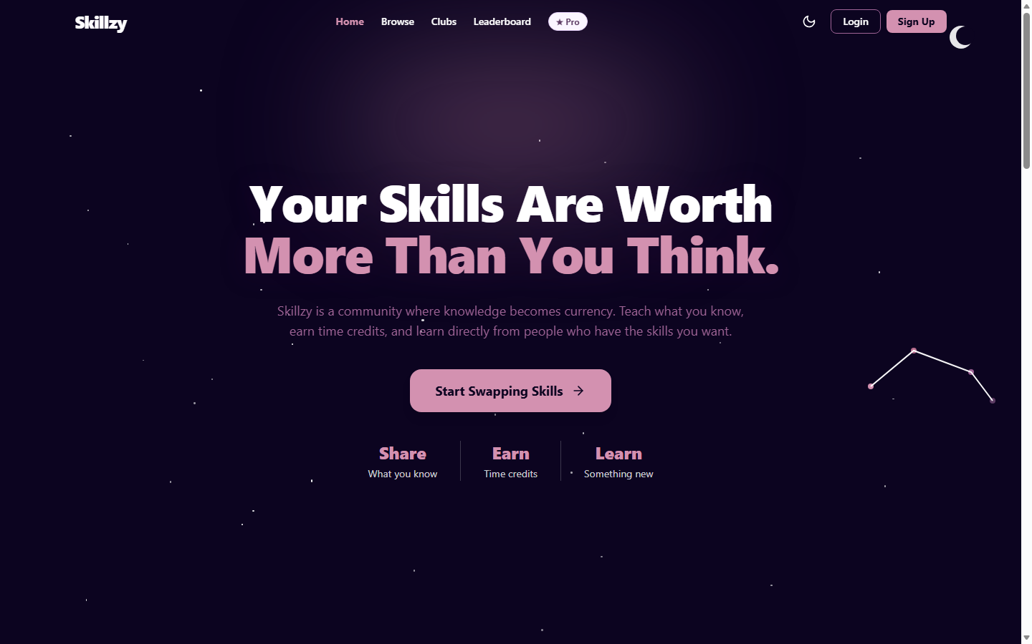
Figure: Live Production Frontend on Vercel (https://skillzy-seven.vercel.app/)
6.2 Home & Landing Page
Dynamic hero section featuring live platform statistics, skill search, value proposition, and onboarding pathways:
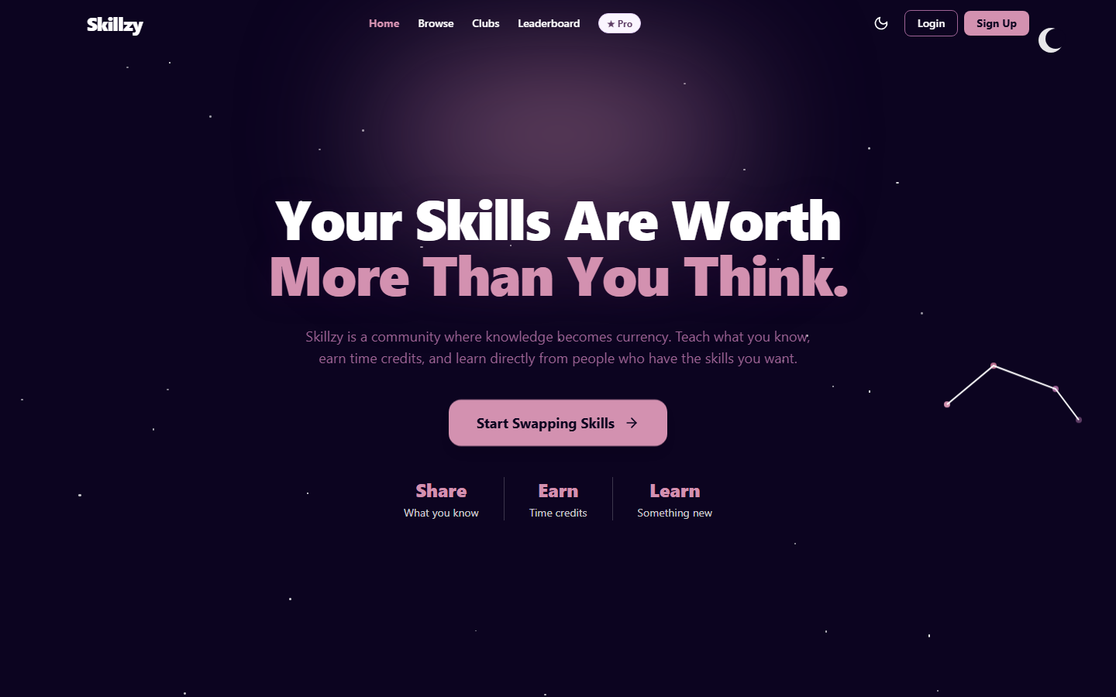
Figure: Skillzy Home & Landing Page with Interactive Discovery
6.3 Explore & Browse Skills Catalog
Real-time searchable directory with category filters, proficiency level badges, and user cards:
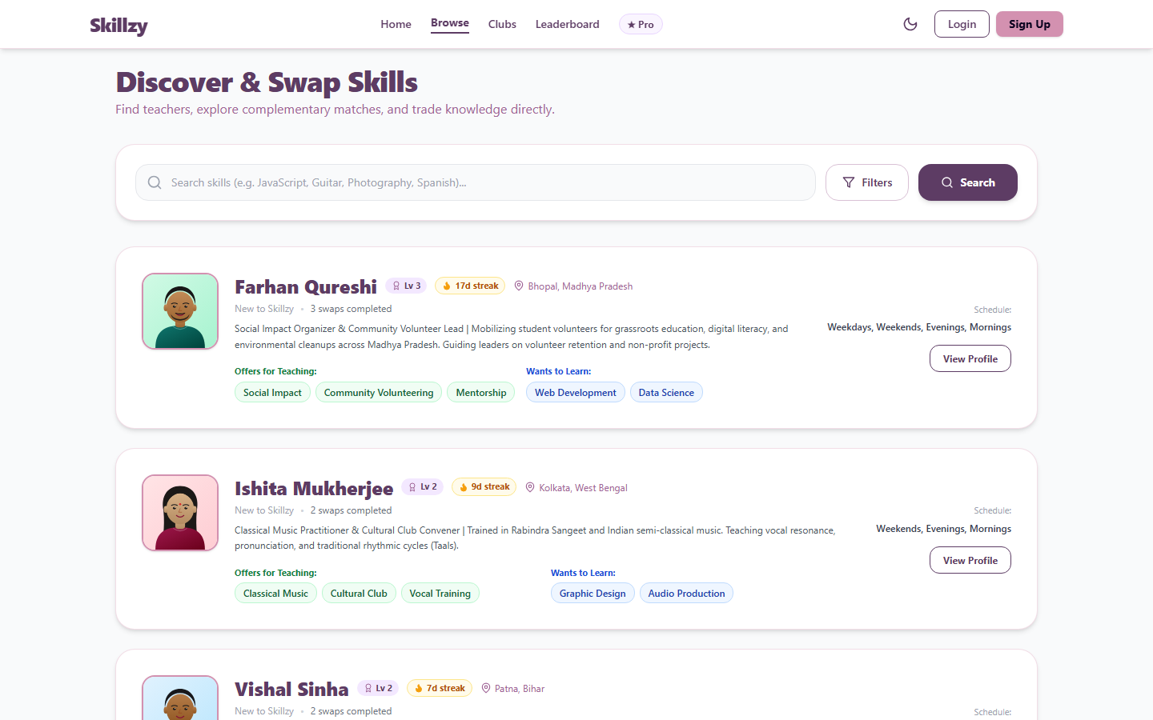
Figure: Browse Skills Catalog with Dynamic Filtering
6.4 AI Compatibility Matchmaker 2.0
Ranked partner recommendations computed by the 5-vector algorithm with compatibility scores and explainable rationale:
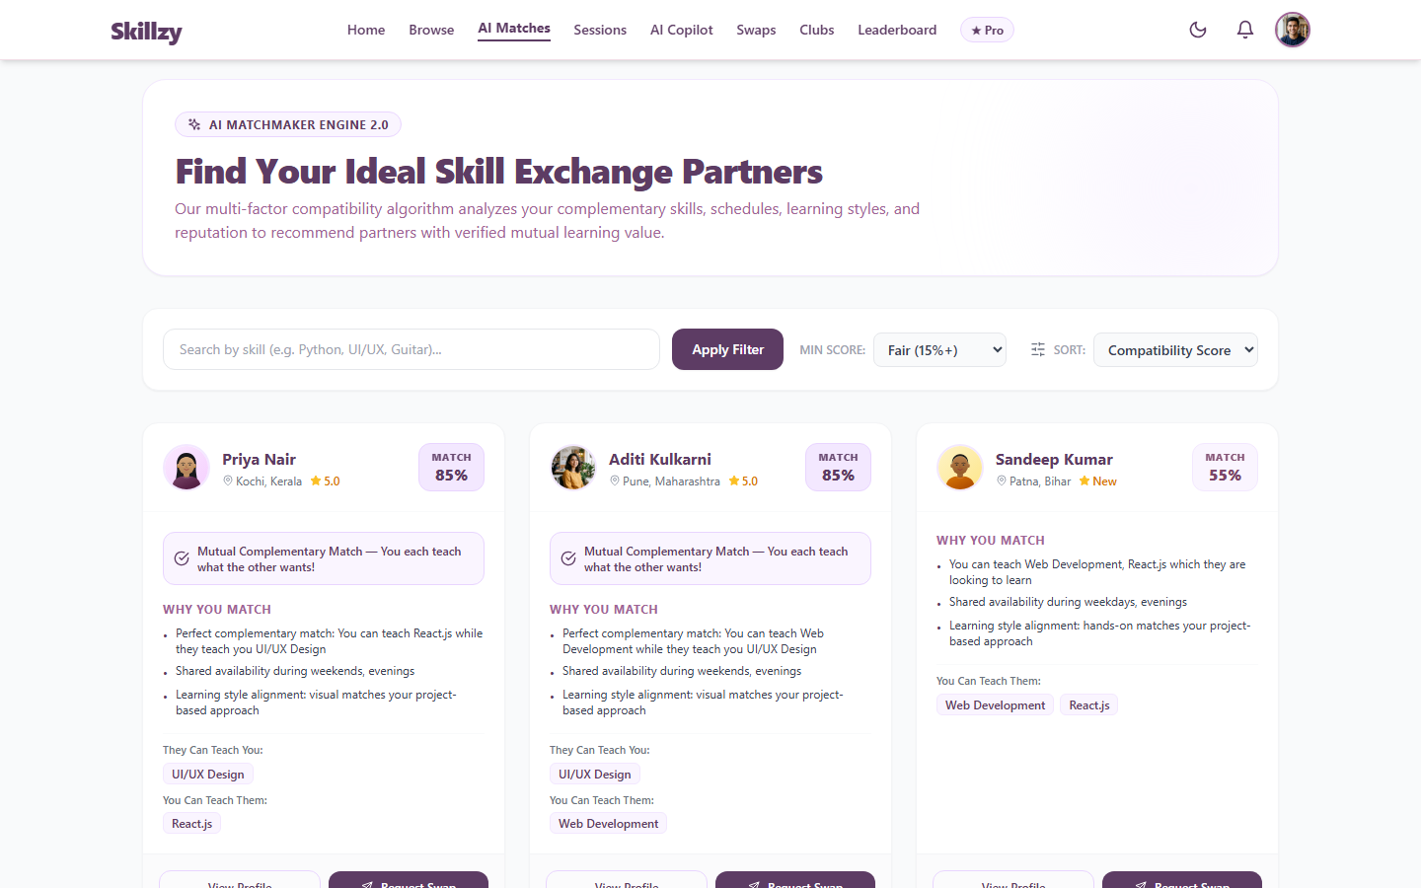
Figure: AI Matchmaker Recommendations with Compatibility Scores
6.5 AI Learning Copilot & Roadmap Generator
Interactive curriculum roadmaps generated by Google Gemini AI with phase breakdown, milestones, and XP progression:
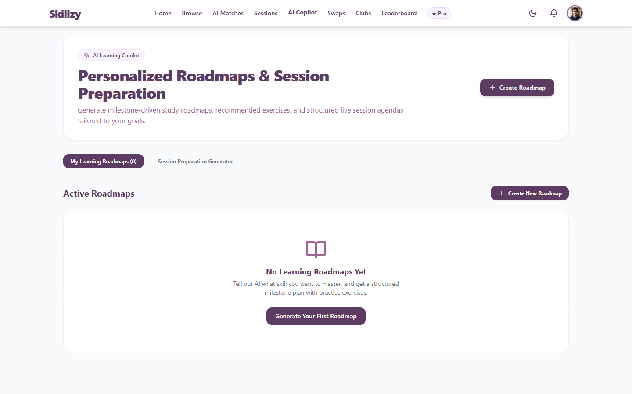
Figure: AI Copilot Learning Roadmap and Milestone Progression Tracker
6.6 Live Classroom & Scheduling Center
Interactive calendar with booking conflict prevention and quick-launch buttons for video classrooms:
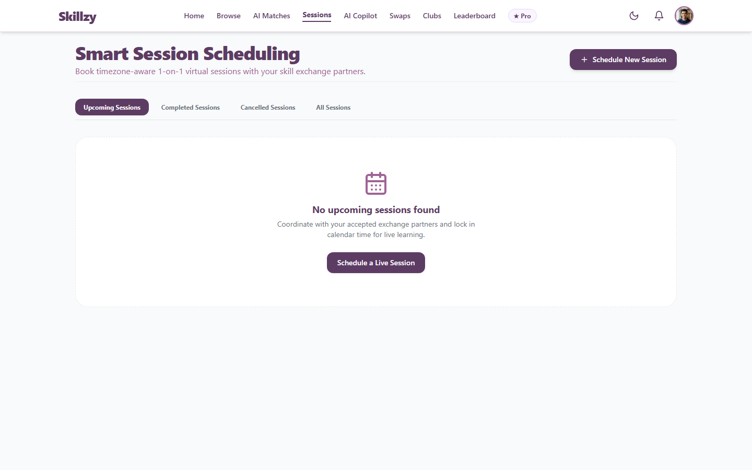
Figure: Classroom Sessions Calendar & Meeting Management
6.7 Community Guilds & Discussion Hubs
Topic-specific skill clubs with participant rosters, discussion threads, and scheduled community workshops:
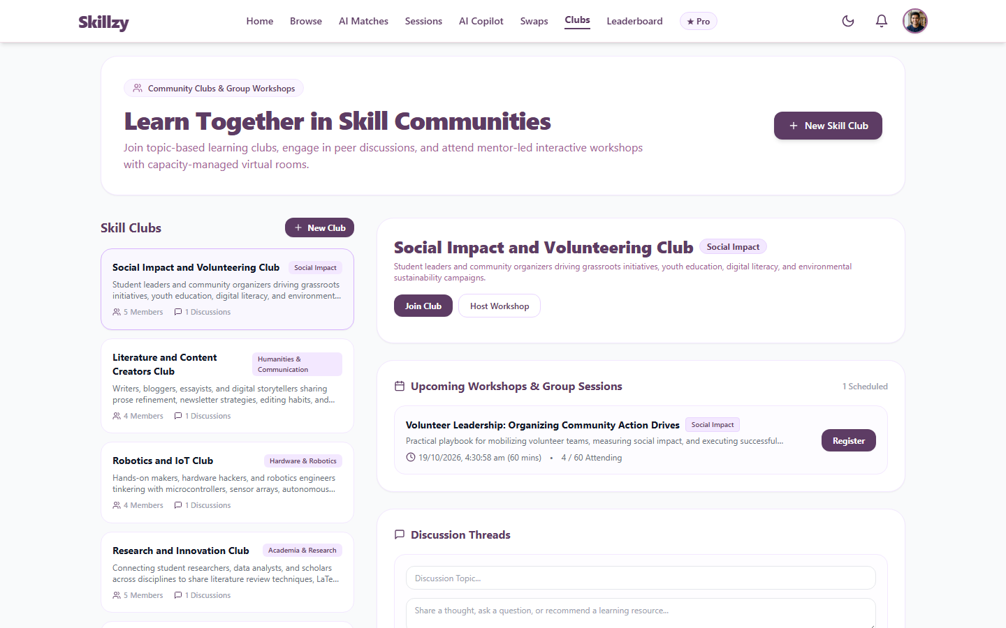
Figure: Community Guilds and Collaborative Discussion Threads
6.8 Gamification & Platform Leaderboard
Reputation leaderboard highlighting top educators, level thresholds, skill badges, and active learning streaks:
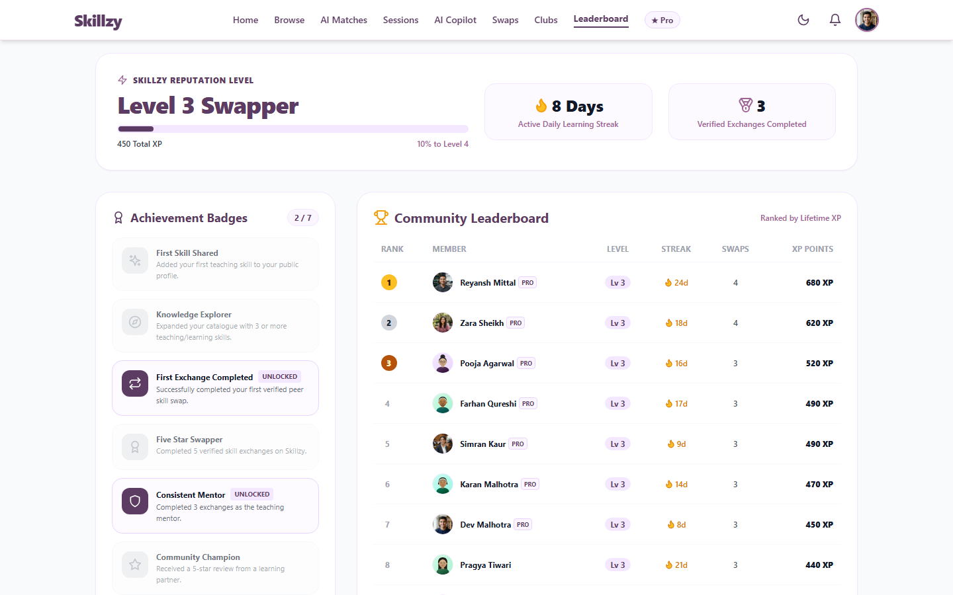
Figure: Platform Reputation Leaderboard, XP Progression, and Achievement Badges
6.9 User Profile & Verified Portfolio
Profile view showcasing offered/wanted skills, verified portfolio projects, time-credit balances, and peer reviews:
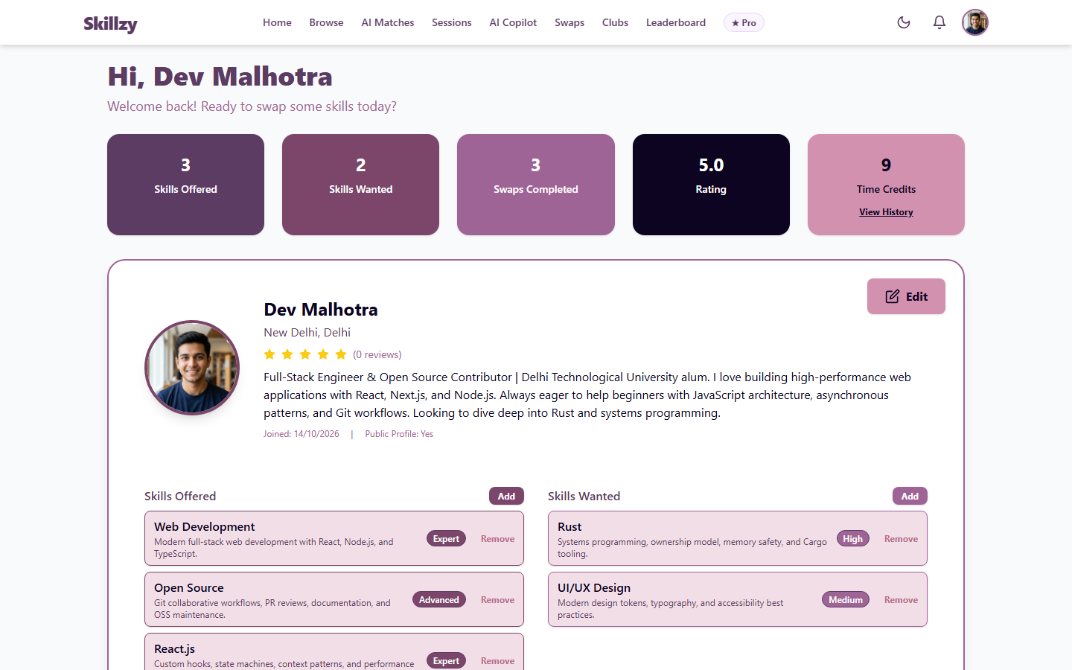
Figure: Authenticated User Profile with Verified Project Portfolio
6.10 Pro Membership & Subscription Billing
Pro membership comparison, server-enforced pricing, and UPI QR payment gateway with deep-link redirection:
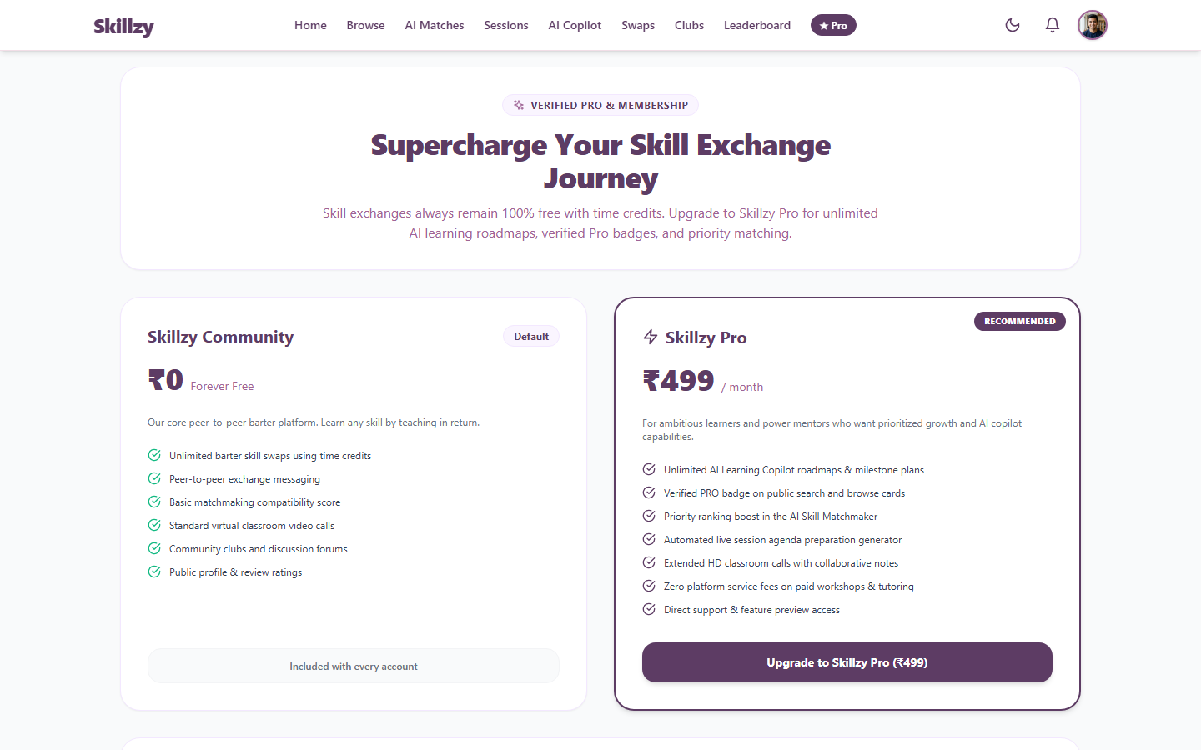
Figure: Pro Membership Tiers and UPI Payment Gateway Integration
6.11 Admin KPI Dashboard & Provider Health Monitoring
Administrative command center displaying platform metrics, provider status (MongoDB, Gemini, LiveKit, Razorpay), and audit logs:
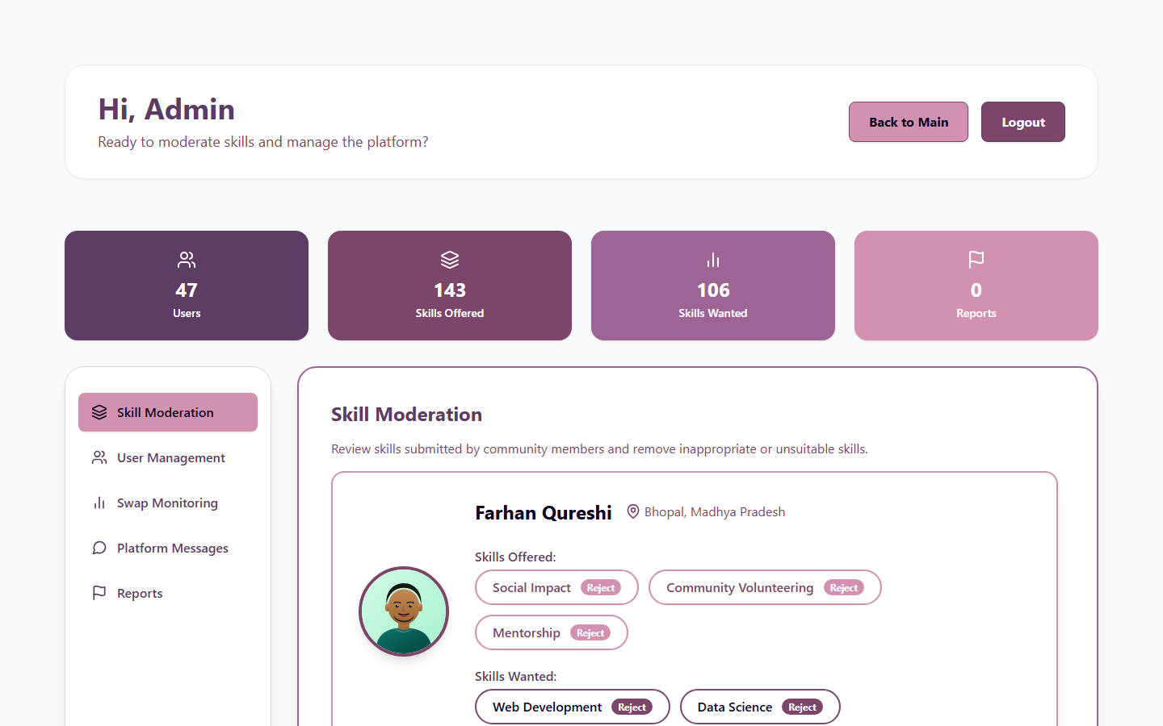
Figure: Admin KPI Command Dashboard with Real-Time Provider Health Status
7. Production Verification & Quality Checklist
Verification Item | Target Standard | Validation Result | Status
Frontend Production | Vercel Edge Deployment | HTTP 200 OK at https://skillzy-seven.vercel.app/ | PASSED
Backend Production | Render Node Web Service | HTTP 200 OK at https://skillzy-api-41dz.onrender.com/ | PASSED
API Healthcheck | Render /api/health | Connected to MongoDB Atlas replica set, 200 OK | PASSED
Database Seeding | MongoDB Atlas Cluster0 | 45+ realistic Indian profiles, skills, reviews, and clubs | PASSED
Production Bundle | Create React App Webpack | 147 kB gzipped bundle, zero compilation errors | PASSED
SPA Routing | Vercel Rewrite Manifest | client/vercel.json active, zero 404s on page refresh | PASSED
Visual Verification | Full Application Audit | 11 high-resolution screenshots captured and embedded | PASSED
Source Control | GitHub Public Repository | github.com/lokeshpurohit1212/skillzy synced and tagged | PASSED

