Module 1: Critical Thinking – Assignments
Assignment Name: Option #2: RStudio Installation and swirl
Task : Lessons 1-10, 12, 14, and 15, System Date screenshot
Student Name : Lokesh Prabakaran
1: Basic Building Blocks
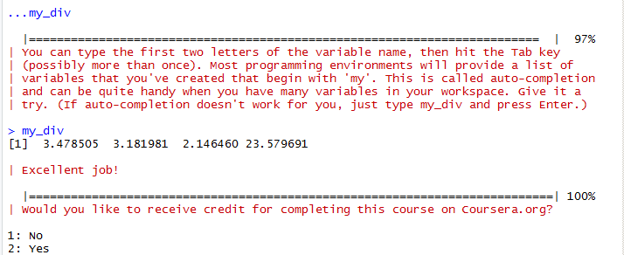

2: Workspace and Files
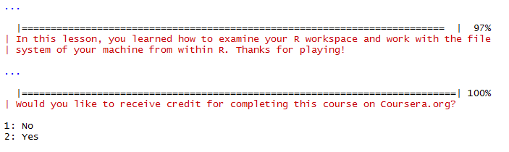

3: Sequences of Numbers
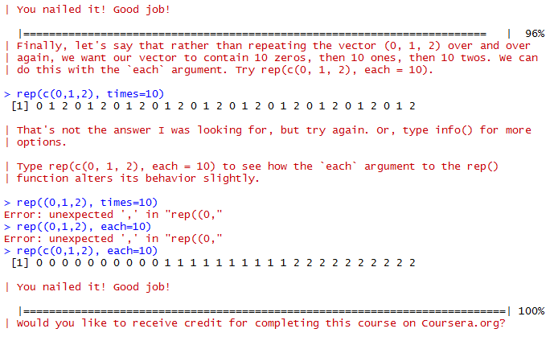

4: Vectors
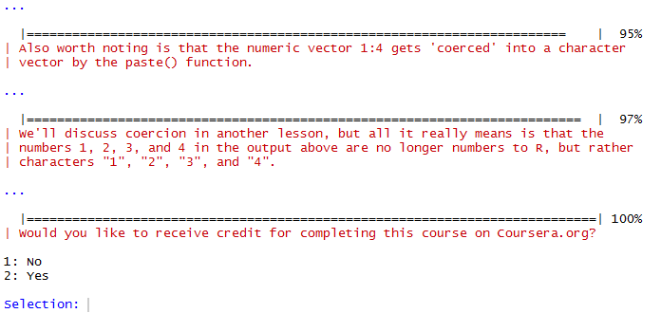

5: Missing Values

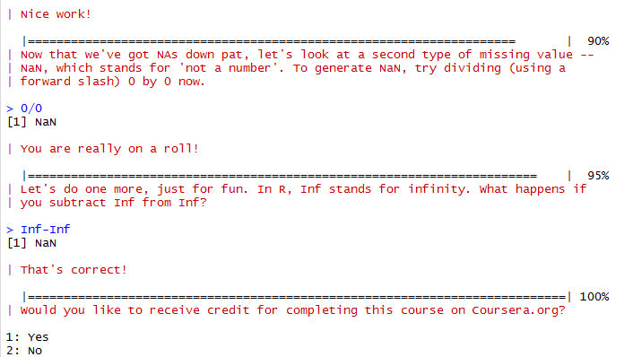

6: Subsetting Vectors
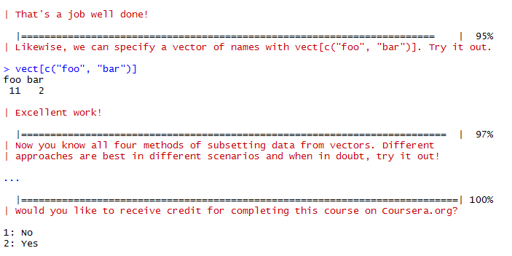

7: Matrices and Data Frames
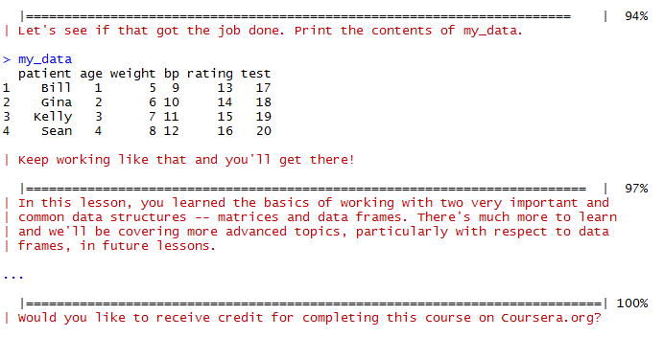

8: Logic
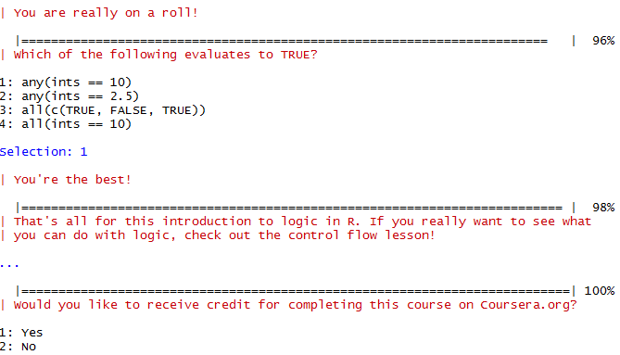

9: Functions
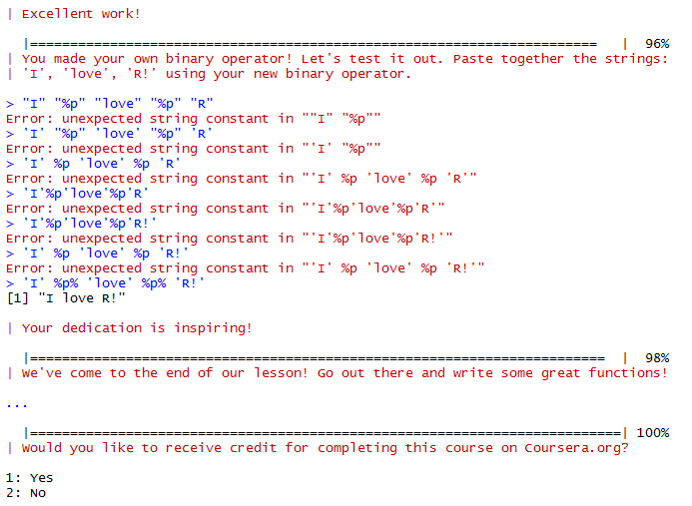
10: lapply and sapply
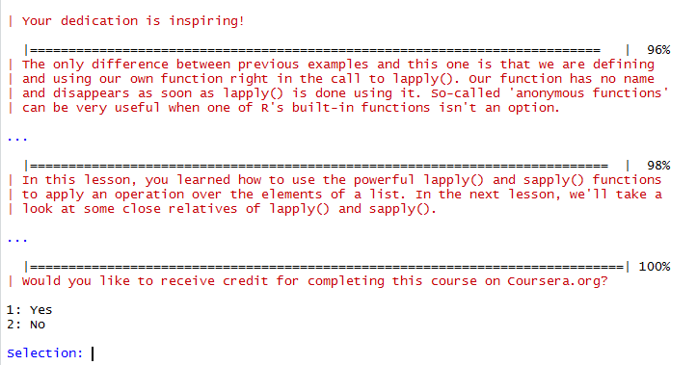
12: Looking at Data
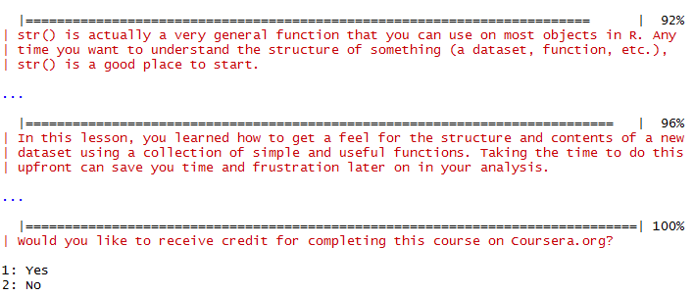

14: Dates and Times
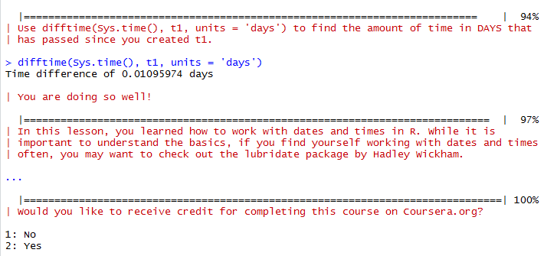

15: Base Graphics
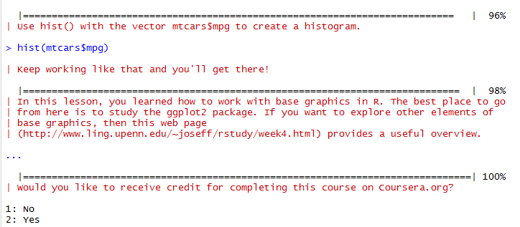

System Date:
