\

‘u.igtd d**utedt58-0[8\8/tr3gr6790[-/8-+

**Final Report of Traineeship Program 2023**

*On*

**“Analyze the Death Age Difference**

**Of**

**Right-Handers with Left-Handers”**

**MEDTOUREASY**



**1st June- 30th June,2023**

Submitted by

**Lokesh V**

[Lokeshragavan0201@gmail.com](https://d.docs.live.net/89df5a966d45d23f/Documents/Lokeshragavan0201@gmail.com) (9080552170)

## *ACKNOWLEDGMENTS*

I would like to acknowledge the Data Analyst Internship opportunity provided by Med Tour Easy. It is a privilege to have the opportunity to work with such a reputable company and gain valuable experience in the field of data analysis. I appreciate the trust and confidence that the company has placed in me and I look forward to working collaboratively with the team at Med Tour Easy.

I would also like to extend my gratitude to the company for providing me with access to their data, which allowed me to gain valuable insights and knowledge about the medical tourism industry. The data provided by the company was comprehensive and enabled me to conduct a thorough analysis.

Furthermore, I appreciate the support and guidance provided by the team at Med Tour Easy throughout the internship. Their expertise and experience have been invaluable in enhancing my skills and knowledge in the field of data analysis.

Once again, I would like to express my gratitude to Med Tour Easy for providing me with this opportunity, and I look forward to applying the knowledge and skills gained during the internship to my career growth.

***Abstract*:**

The study you mentioned, conducted by **Avery Gilbert and Charles Wysocki**, it is from analyzed data on a National Geographic survey in 1986. The survey collected information on age, sex, and hand preference for throwing and writing from over a million respondents. The researchers observed that the rates of left-handedness were approximately 13% among individuals younger than 40 but decreased with age to about 5% among individuals aged 80 and above.

Based on their analysis, Gilbert and Wysocki concluded that the decline in left-handedness with age was primarily attributed to changing social acceptability of being left-handed. They based this conclusion on the examination of a subgroup of individuals who threw with their left hand but wrote with their right hand.

Their interpretation suggests that older generations, who grew up in a time when left-handedness may have been less accepted or even stigmatized, were more likely to suppress their left-handedness and learn to write with their right hand instead. As societal attitudes towards left-handedness became more accepting, younger generations were more likely to embrace their natural left-handedness.

It is important to note that this study is specific to the data collected in 1986 and the interpretation made by Gilbert and Wysocki based on their analysis. Social attitudes towards left-handedness may have continued to evolve since then, and additional research would be needed to further explore the relationship between age, social acceptability, and left-handedness

 **TABLE OF CONTENTS**

I)Acknowledgments..................................2. 2ii)Abstract ..................................................... 3

|  |  |  |
| --- | --- | --- |
| **Sr. No.** | **Topic** | **Page No.** |
| **1** | Introduction |  |
|  | 1.1 About the Company | 5 |
|  | 1.2 About the Project | 6 |
|  |  |  |
| **2** | Methodology | 10 |
|  | 2.1 Flow of the Project | 11 |
|  | 2.2 Language and Platform Uses | 12 |
|  | 2.2.1 Python  2.2.2 Integrated Development Environment (IDE)  2.2.3 Jupyter Notebook  2.2.4 Pandas  2.2.5 Numpy  2.2.6 Matplotlib | 13  14  16  19  22  25 |
| **3** | Implementation  3.1 Gathering Data  3.2 Where are the old Left-hand people  3.3 Rates of Left-handedness overtime  3.4 Applying Bayes’s Rule  3.5 when do people normally die?  3.6 The overall probability of left-handedness  3.7 Putting all together: dying while left-handed  3.8 Putting all together: dying while right-handed  3.9 plotting the distribution of conditional probability  3.10 Moment of Truth: age of left & right handers at death  3.11 Final Comments | 26  30  31  32  34  35  36  37  39  40  41  43 |
| **4** | Conclusion | 44 |
| **5** | References | 45 |

T ***I. Introduction***

**1.1 About the Company**

MedTourEasy, a global healthcare company, provides you with the informational resources needed to evaluate your global options. MedTourEasy provides analytical solutions to our partner healthcare providers globally

The company has partnerships with hospitals and clinics in various countries, including **India, Thailand, Mexico, and the United States**. These partnerships allow the company to provide its customers with a wide range of medical treatments, **including cancer treatments, Orthopedic procedures, and cardiovascular surgeries**.

Med Tour Easy takes pride in its commitment to providing its customers with personalized services. The company's team of experts works closely with patients to understand their medical conditions and requirements and then provides them with customized solutions that best suit their needs.

The company also places a strong emphasis on customer satisfaction. Med Tour Easy strives to ensure that its customers have a hassle-free experience and are satisfied with the services provided. The company regularly collects feedback from its customers to improve its services and ensure that it meets their expectations.

Overall, **Med Tour Easy** is a company that is dedicated to providing its customers with high-quality medical services. Its commitment to personalized services and customer satisfaction makes it a reliable choice for patients seeking medical treatments abroad.



**1.2 About the Project:**

**Introduction:**

This project aims to investigate and analyze the death age difference between right-handers and left-handers. The prevailing belief that left-handers have a shorter life expectancy has been questioned in recent studies. By examining age distribution data and comparing it with the prevalence of left-handedness over time, we aim to determine if there is a significant difference in the average age at death between these two groups.

**Objectives:**

Compare the average age at death between right-handers and left-handers: The primary objective is to quantitatively assess whether there is a notable disparity in the death age distribution between these two groups.

Evaluate the statistical significance of the observed age difference: Conduct rigorous statistical analyses to determine if any differences observed in the average death age are statistically significant.

Investigate potential influencing factors: Explore additional factors that might contribute to the observed death age difference, such as gender or birth year.

**Methods and Approach:**

Data Collection: Gather age distribution data and information on the prevalence of left-handedness over time. Ensure the dataset includes sufficient information on handedness and age at death.

Data Preprocessing: Clean and preprocess the data, addressing missing values, outliers, and any necessary data transformations.

Comparative Analysis: Compare the distribution of death ages between right-handers and left-handers using visualizations such as histograms, box plots, or kernel density plots.

Statistical Analysis: Apply appropriate statistical tests (e.g., t-test, Mann-Whitney U test) to assess the significance of the observed death age difference. Calculate measures like means, medians, standard deviations, and confidence intervals.

Subgroup Analysis: If applicable, conduct subgroup analysis based on gender or birth year to investigate potential variations in the death age difference within different subgroups.

Interpretation and Conclusions: Summarize the findings, interpret the results, and conclude the death age difference between right-handers and left-handers.

Discuss the implications and limitations of the analysis.

**Deliverables:**

Data analysis report: A detailed report summarizing the project objectives, methodology, data analysis procedures, and key findings. Include visualizations, statistical analyses, and interpretations.

Comparative visualizations: Present visualizations (e.g., histograms, box plots) comparing the death age distributions of right-handers and left-handers.

Statistical analysis results: Provide quantitative findings such as means, medians, standard deviations, p-values, and confidence intervals, highlighting any significant differences between the two groups.

Subgroup analysis findings: If conducted, present subgroup analysis results to explore variations in the death age difference based on gender or birth year.

Conclusions and implications: Summarize the overall findings, discuss the significance of the death age difference between right-handers and left-handers, and outline any potential implications for future research.

By conducting this analysis, we aim to provide insights into the commonly held belief of early death for left-handers and contribute to a better understanding of the relationship between handedness and life expectan

## I. METHODOLOGY

### **2.1** **Flow of the Project**

The project followed the following steps to accomplish the desired objectives and deliverables. Each step has been explained in detail in the following section.

**STEPS TO APPROACH PROGRESS:**

1. Gather age distribution data and information on handedness prevalence over time.
2. Preprocess the data:
   * Clean the data, addressing missing values and outliers.
   * Transform the data, if necessary, to ensure compatibility and accuracy.
3. Comparative Analysis:
   * Visualize the death age distributions of right-handers and left-handers (e.g., histograms, box plots).
   * Compare the distributions visually to identify any noticeable differences.
4. Statistical Analysis:
   * Select an appropriate statistical test (e.g., t-test, Mann-Whitney U test) to compare the death age between the two groups.
   * Calculate measures such as means, medians, standard deviations, and confidence intervals.
   * Assess the statistical significance of the observed death age difference.
5. Subgroup Analysis (optional):
   * + - If applicable, conduct subgroup analysis based on factors like gender or birth year.
       - Analyze and compare the death age difference within different subgroups considering factors such as gender/Age.
6. Interpretation and Conclusions:
   * + - Summarize the findings from the comparative and statistical analyses.
       - Interpret the results and discuss the implications of the death age difference.
       - Consider potential limitations and uncertainties.
7. Reporting:
   * + - Prepare a comprehensive data analysis report.
       - Include visualizations, statistical analysis results, and subgroup analysis findings (if conducted).
       - Present conclusions, implications, and recommendations for further research.

### **2.3 Language and Platform Used**

2.3.1 Language: Python

Python is a high-level, interpreted programming language that was created by Guido van Rossum and first released in 1991. It was designed to be simple, readable, and easy to learn, making it a popular choice for beginners and experienced programmers alike.



Key features of Python include:

Readability:

Python uses a syntax that emphasizes human readability, making it easier to write and maintain code. It utilizes indentation and a straightforward syntax that reduces the need for complex punctuation.

Easy to learn and use:

Python has a gentle learning curve, making it suitable for beginners. Its simplicity and readability make it a popular choice for both beginners and experienced developers.

Versatility:

Python can be used for a wide range of applications, including web development, scientific computing, data analysis, artificial intelligence, machine learning, automation, and more. It has a rich collection of libraries and frameworks that extend its capabilities.

Interpreted and interactive:

Python is an interpreted language, which means that it doesn't need to be compiled before executing. It also provides interactive shell environments (like IPython) that allow users to experiment and execute code interactively.

Large standard library:

Python comes with a comprehensive standard library that provides modules and packages for various tasks, such as file I/O, networking, data manipulation, regular expressions, and more. This extensive library reduces the need for developers to write code from scratch.

Community and ecosystem:

Python has a vibrant and active community of developers who contribute to open-source projects, share code snippets, and provide support. This community has contributed to the development of a vast ecosystem of third-party libraries and frameworks that further enhance Python's capabilities.

Python supports multiple programming paradigms, including object-oriented, procedural, and functional programming. It runs on various platforms and operating systems, including Windows, macOS, Linux, and more.

Overall, Python's simplicity, versatility, and powerful ecosystem have made it one of the most popular programming languages for a wide range of applications.

**2.2.2 Integrated Development Environment** (**IDE):**

An integrated development environment (IDE) is a software application that helps programmers develop software code efficiently. Anaconda is a distribution of the Python programming language that includes a wide range of pre-installed libraries and tools for scientific computing, data analysis, and machine learning. Along with the Python interpreter, Anaconda provides a powerful integrated development environment (IDE) called Anaconda Navigator.

Anaconda Navigator is a graphical user interface (GUI) that allows you to manage and launch different components of the Anaconda distribution, including Jupyter Notebook, JupyterLab, Spyder (a Python IDE), and other tools. It provides a centralized and user-friendly interface for creating and managing Python environments, installing packages, and accessing various data science tools.

Key features of Anaconda Navigator include:

Environment Management: Anaconda Navigator allows you to create and manage separate Python environments. Environments help isolate different project dependencies and package versions, enabling better reproducibility and flexibility.

Package Management: With Anaconda Navigator, you can easily install, update, and remove Python packages and libraries. It provides a graphical interface for managing packages, making it convenient to browse and install the extensive collection of packages available in the Anaconda repository.

Integrated Development Environments (IDEs): Anaconda Navigator offers multiple IDE options, including Jupyter Notebook, JupyterLab, and Spyder. These IDEs provide interactive coding environments with features like code editors, debugging tools, variable explorers, and more, making it easier to develop and analyze code.

Easy Access to Data Science Libraries: Anaconda Navigator comes with a comprehensive collection of pre-installed data science libraries, such as NumPy, Pandas, Matplotlib, SciPy, scikit-learn, TensorFlow, and more. These libraries are widely used in data analysis, machine learning, and scientific computing tasks.

User-Friendly Interface: Anaconda Navigator provides a user-friendly interface that simplifies the installation, configuration, and management of the Anaconda distribution. It offers a point-and-click experience for creating projects, launching IDEs, and managing packages.

Cross-Platform Compatibility: Anaconda Navigator is available for Windows, macOS, and Linux, ensuring that you can use the same tools and workflows across different operating systems.

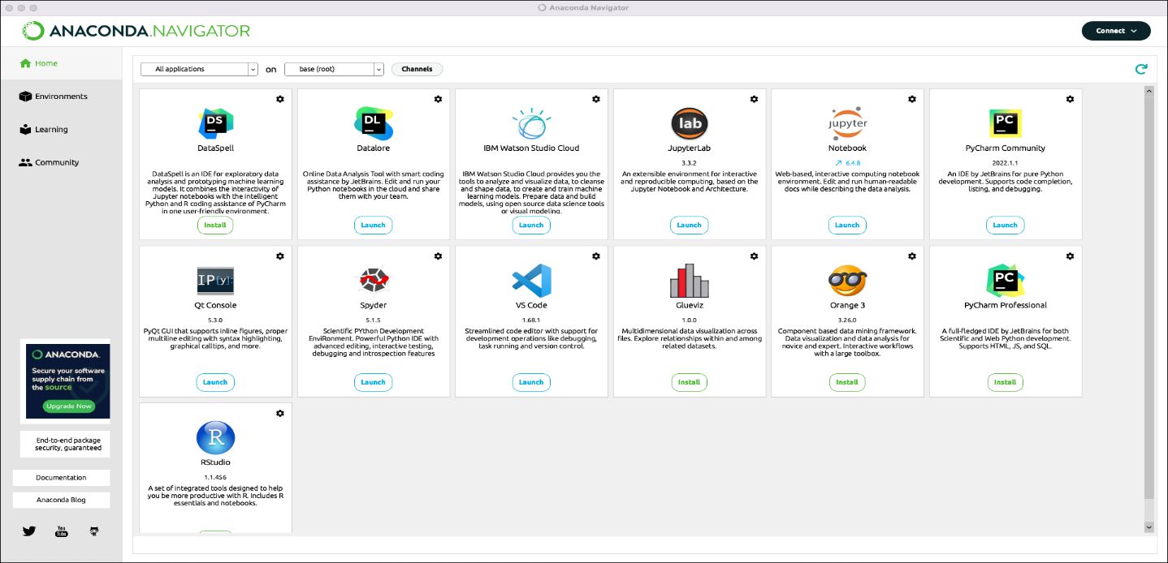

In addition to Anaconda Navigator, you can also use the command-line interface (CLI) tool called “Anaconda” to manage environments and packages within Anaconda.

Overall, Anaconda Navigator provides a convenient and streamlined experience for Python development and data science tasks by integrating essential tools and libraries into a single IDE

**2.2.3 Jupyter Notebook:**

Jupyter Notebook is an open-source web application that allows you to create and share documents that contain live code, equations, visualizations, and narrative text. It is widely used for interactive data analysis, data visualization, machine learning, and scientific computing.



The main features of the Jupyter Notebook include:

Interactive Computing: Jupyter Notebook supports multiple programming languages, including Python, R, Julia, and more. It provides an interactive environment where you can write and execute code in cells. Each cell can be run independently, allowing you to experiment, test, and iterate on your code.

Rich Output: Jupyter Notebook allows you to generate and display rich media output, including images, plots, interactive visualizations, LaTeX equations, HTML, and more. This makes it easy to create interactive and visually appealing reports and presentations.

Markdown Support: Jupyter Notebook supports Markdown, a lightweight markup language. This allows you to write narrative text, format it, and include headings, lists, links, images, and mathematical equations within your notebooks. Markdown cells can be used to provide explanations, document code, and create a cohesive narrative.

Code Execution and State Preservation: Jupyter Notebook retains the state of variables and executed code, allowing you to execute cells out of order and refer to variables defined in previous cells. This feature enables an interactive and exploratory workflow, where you can analyze and manipulate data incrementally.

Shareability and Collaboration: Jupyter Notebook files can be easily shared with others, either as standalone files or hosted on platforms like GitHub or Jupyter Notebook Viewer. This promotes collaboration and enables others to reproduce and build upon your work.

Extensibility: Jupyter Notebook is highly extensible, with a rich ecosystem of extensions and plugins. These extensions provide additional functionality, such as code auto-completion, debugging tools, interactive widgets, and integration with other tools and frameworks.

Jupyter Notebook is part of the larger Jupyter project, which includes other components like JupyterLab (a more comprehensive IDE-like interface) and JupyterHub (for multi-user deployments).

Jupyter Notebook can be installed locally on your machine or accessed through cloud-based services like Google Colab, Azure Notebooks, or IBM Watson Studio.

The flexibility, interactivity, and versatility of the Jupyter Notebook make it a popular tool among data scientists, researchers, educators, and anyone who wants to explore and communicate their data and code in an interactive and reproducible manner.

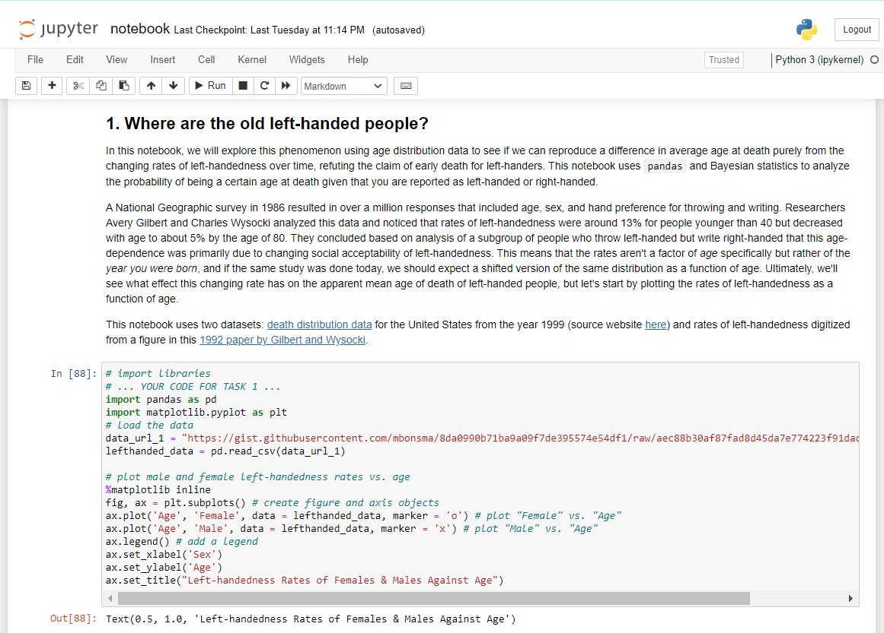

**2.2.4 Pandas (Library):**

Pandas is a powerful open-source library for data manipulation and analysis in Python. It provides high-performance, easy-to-use data structures, and data analysis tools. The name "pandas" is derived from "panel data" - a term used for multidimensional structured data sets. Key features of the pandas library include:

Data manipulation: Pandas provide a wide range of functions and methods for data manipulation tasks. You can perform operations like filtering rows, selecting columns, sorting data, filling missing values, grouping and aggregating data, and applying functions to data.

Data cleaning and preprocessing: Pandas offers tools for cleaning and preprocessing data. You can handle missing values, perform data normalization or standardization, apply data transformations, handle duplicates, and more.

Data input and output: Pandas supports reading and writing data in various formats, including CSV, Excel, SQL databases, and more. It simplifies the process of loading data into memory and saving processed data back to disk.

Time series analysis: Pandas provides functionality for working with time series data. It supports handling date and time data, resampling, time zone conversion, time shifting, and other time-related operations.

Integration with other libraries: Pandas integrates well with other popular data analysis and scientific computing libraries in Python, such as NumPy, Matplotlib, and scikit-learn. This allows seamless interoperability and facilitates complex data analysis workflows.

Pandas is widely used in data analysis, data cleaning, data preprocessing, exploratory data analysis, feature engineering, and more. It is a fundamental library in the Python ecosystem for data science and is often used in conjunction with Jupyter Notebook for interactive data analysis and visualization.

To use pandas, you need to import it into your Python script or Jupyter Notebook using the following import statement:

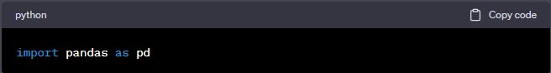

After importing pandas, you can create DataFrames, manipulate data, perform analysis, and leverage the various functionalities offered by the library

**To install the pandas library, you can follow these steps:**

Open a terminal or command prompt: Depending on your operating system, open a terminal (Linux, macOS) or command prompt (Windows).

Activate your Python environment (optional): If you are using a virtual environment or a specific Python environment, activate it before installing pandas. This step is optional if you are installing pandas globally.

Run the installation command: In the terminal or command prompt, use the following command to install pandas via the Python package manager, pip:



If you prefer using Anaconda or Miniconda, you can use the conda package manager instead:



Note: If you are using conda, it is recommended to create and activate a conda environment before installing pandas. This helps isolate your pandas installation and manage dependencies.

Wait for the installation to complete: The package manager will download and install pandas along with its dependencies. This process may take a few moments depending on your internet connection speed.

Verify the installation: After the installation is complete, you can verify if pandas is installed correctly by importing it in a Python script or a Jupyter Notebook. Open a Python interpreter or a Jupyter Notebook and execute the following command:



If no errors occur, and the import statement executes successfully, it means pandas is installed and ready to use.

Awesome , we did it! Pandas should now be installed on your system. You can start using it for data manipulation and analysis in your Python projects.

Note: It is recommended to install pandas within a virtual environment to isolate your project's dependencies. Virtual environments help manage different versions of packages and avoid conflicts between projects. You can create a virtual environment using tools like venv, virtualenv, or conda.

**2.2.5 Matplotlib:**

Matplotlib is a popular open-source plotting library for creating static, animated, and interactive visualizations in Python. It provides a wide range of high-quality and customizable plots, charts, and graphs for data visualization.

Key features of Matplotlib include:

Wide range of plot types: Matplotlib supports a variety of plot types, including line plots, scatter plots, bar plots, histogram plots, pie charts, box plots, heatmaps, 3D plots, and more. It provides a flexible and powerful API for creating and customizing these plots.

Publication-quality plots: Matplotlib allows you to create visually appealing and professional-looking plots suitable for publication or presentation purposes. You can control various aspects of the plot, such as colors, line styles, markers, fonts, annotations, and more.

Customization and styling: Matplotlib provides extensive options for customizing plots. You can modify axis labels, titles, legends, gridlines, plot limits, and other visual elements. Additionally, Matplotlib supports the use of style sheets, which allow you to quickly apply predefined styles to your plots or create your own custom styles.

Support for multiple backends: Matplotlib supports various graphical backends, including a number of interactive user interface (UI) toolkits such as Tkinter, PyQt, wxPython, and more. This allows you to create plots in different environments, including Jupyter Notebook, GUI applications, and web applications.

Integration with NumPy and pandas: Matplotlib seamlessly integrates with other popular libraries like NumPy and pandas. You can directly plot data stored in

NumPy arrays or pandas DataFrames and Series, making it convenient for data analysis and visualization.

Interactive visualization support: Matplotlib can be used in conjunction with other libraries like IPython and Jupyter Notebook to create interactive visualizations. This allows you to explore and interact with the plots, zoom in/out, pan, and dynamically update the plot based on user input or data changes.

Matplotlib API and pyplot interface: Matplotlib provides a comprehensive API that gives you fine-grained control over plot creation and customization. It also offers a simplified pyplot interface, inspired by MATLAB, which provides a convenient and quick way to create plots using a set of high-level functions.

Matplotlib is widely used in various fields, including data analysis, scientific computing, machine learning, finance, and more. Its versatility, flexibility, and extensive documentation make it a powerful tool for visualizing data and communicating insights effectively.

To use Matplotlib, you need to install it first. You can install it using the following command:



After installing, you can import it in your Python script or Jupyter Notebook using the following import statement:

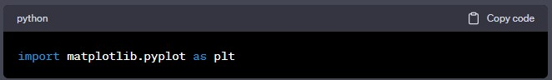

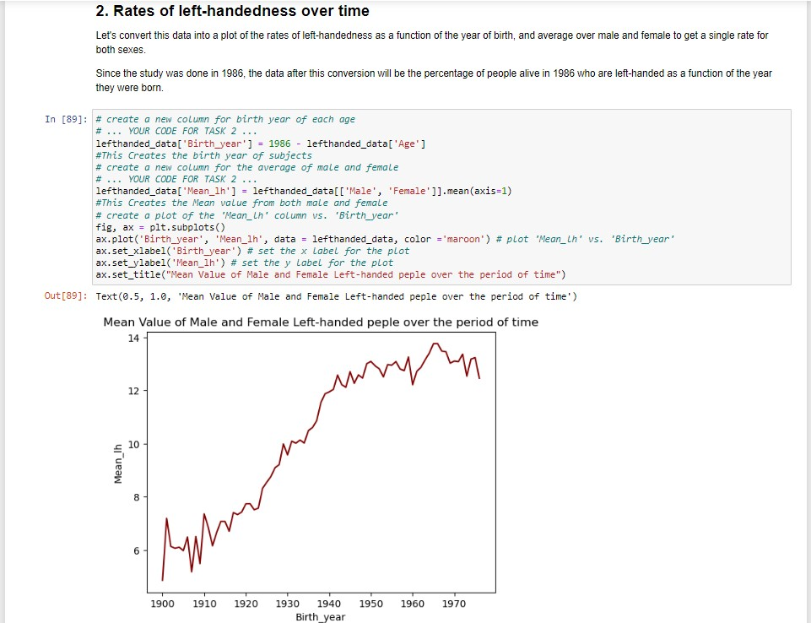

This import statement is commonly used, and the plt alias is a convention for Matplotlib.

**2.2.6 Numerical Python(NumPy):**

NumPy (Numerical Python) is a fundamental open-source library for numerical computing in Python. It provides a powerful array object, mathematical functions, and tools for working with large, multi-dimensional arrays and matrices. NumPy forms the foundation for many other scientific computing libraries in Python.

Key features of NumPy include:

ndarray: NumPy's main feature is the ndarray (n-dimensional array) object, which allows efficient storage and manipulation of homogeneous arrays of data. The ndarray provides fast element-wise operations, broadcasting, slicing, indexing, and reshaping capabilities.

Mathematical functions: NumPy provides a wide range of mathematical functions that operate efficiently on arrays, including basic arithmetic operations, trigonometric functions, exponential functions, logarithmic functions, statistical functions, and more. These functions are optimized for performance and can handle large datasets efficiently.

Array operations: NumPy supports various array operations, such as elementwise operations, array broadcasting, array concatenation, splitting, stacking, and sorting. These operations allow you to perform complex computations on arrays easily and efficiently.

Linear algebra: NumPy includes a comprehensive set of linear algebra functions, such as matrix multiplication, matrix decomposition (e.g., LU decomposition, QR decomposition), solving linear equations, calculating determinants, eigenvalues, and eigenvectors. These functions are essential for numerical computations involving matrices and linear transformations.

Random number generation: NumPy provides functions for generating random numbers from different probability distributions. This is useful for simulations, generating random samples, and statistical analysis.

Integration with other libraries: NumPy seamlessly integrates with other scientific computing libraries in Python, such as SciPy, pandas, Matplotlib, and scikit-learn. These libraries often rely on NumPy arrays as a common data structure for efficient computation and data exchange.

Performance optimization: NumPy is implemented in low-level programming languages like C and Fortran, which makes it highly optimized for numerical computations. NumPy arrays provide efficient memory storage and access patterns, enabling fast execution of mathematical operations.

NumPy is extensively used in various domains, including scientific computing, data analysis, machine learning, signal processing, image processing, and more. Its simplicity, performance, and broad functionality make it a fundamental library for numerical computing tasks.

To use NumPy, you need to install it first. You can install it using the following command:

After installing, you can import it in your Python script or Jupyter Notebook using the following import statement:

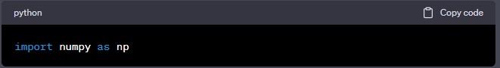

After installing, you can import it in your Python script or Jupyter Notebook using the following import statement:



The np alias is a convention for NumPy and is commonly used by the community.

**III. IMPLEMENTATION**

**3.1 Gathering Data:**

This is the first step wherein the requirements are collected from the clients to understand the deliverables and goals to be achieved after which a problem statement is defined which has to be adhered to while developing the project.

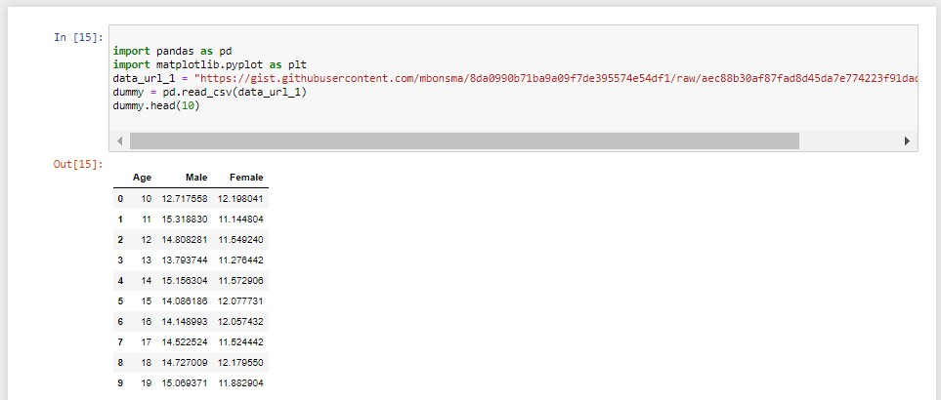

**Code Breakdown:**

It imports the pandas library as pd and the matplotlib.pyplot library as plt. It then assigns the data URL to the variable data_url_1.

The next line of code reads the CSV data from the provided URL using the pd.read_csv() function and stores it in a DataFrame named dummy. Finally, the head(10) function is called on the dummy DataFrame to display the first 10 rows of the data.

If you run this code, it will fetch the data from the given URL, create the DataFrame, and display the first 10 rows of the data.

**3.2. Where are the old left-handed people?**

In this notebook, we will explore this phenomenon using age distribution data to see if we can reproduce a difference in average age at death purely from the changing rates of left-handedness over time, refuting the claim of early death for left-handers. This notebook uses pandas and Bayesian statistics to analyze. the probability of being a certain age at death given that you are reported as left-handed or right-handed.

A National Geographic survey in 1986 resulted in over a million responses that included age, sex, and hand preference for throwing and writing. Researchers Avery Gilbert and Charles Wysocki analyzed this data and noticed that rates of left-handedness were around 13% for people younger than 40 but decreased with age to about 5% by the age of 80. They concluded based on analysis of a subgroup of people who throw left-handed but write right-handed that this age-dependence was primarily due to changing social acceptability of left-handedness. This means that the rates aren't a factor of age specifically but rather of the year you were born, and if the same study was done today, we should expect a shifted version of the same distribution as a function of age. Ultimately, we'll see what effect this changing rate has on the apparent mean age of death of left-handed people, but let's start by plotting the rates of left-handedness as a function of age.

This notebook uses two datasets: [death distribution data](https://www.cdc.gov/nchs/data/statab/vs00199_table310.pdf) for the United States from the year 1999 (source website [here)](https://www.cdc.gov/nchs/nvss/mortality_tables.htm) and rates of left-handedness digitized from a figure in this [1992 paper by Gilbert and Wysocki.](https://www.ncbi.nlm.nih.gov/pubmed/1528408)

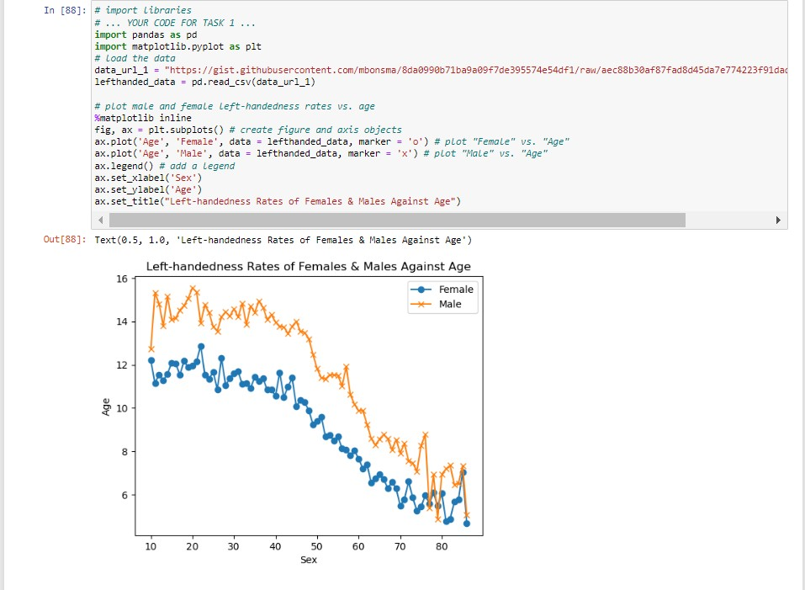

**Code Breakdown:**

The given code imports the necessary libraries (pandas and matplotlib.pyplot) and then loads the data from a CSV file using the provided URL.

Here's a breakdown of how the code works:

The code imports the required libraries:

pandas as pd for data manipulation and analysis. matplotlib.pyplot as plt for data visualization. The code defines the URL of the data file as data_url_1.

It reads the data from the CSV file into a pandas DataFrame named

lefthanded_data using the read_csv function. The data is loaded from the URL specified by data_url_1.

The code sets %matplotlib inline, which is a magic command for Jupyter Notebook to display matplotlib plots inline.

It creates a figure and axis object using fig, ax = plt.subplots().

The code plots the left-handedness rates of females and males against age:

ax.plot('Age', 'Female', data=lefthanded_data, marker='o') plots the lefthandedness rates of females against age using circular markers ('o'). ax.plot('Age', 'Male', data=lefthanded_data, marker='x') plots the lefthandedness rates of males against age using cross markers ('x'). It adds a legend to the plot using ax.legend(). The legend will show the labels for the two plotted lines.

The code sets the x-label of the plot to 'Sex' using ax.set_xlabel('Sex').

It sets the y-label of the plot to 'Age' using ax.set_ylabel('Age').

By running this code, you should see a plot showing the left-handedness rates of females and males against age. The x-axis represents age, and the y-axis represents the left-handedness rates. The plot will have two lines, one for females and one for males, with markers indicating the data points.

**3.3. Rates of left-handedness over time**

Let's convert this data into a plot of the rates of left-handedness as a function of the year of birth, and average over male and female to get a single rate for both sexes.

Since the study was done in 1986, the data after this conversion will be the percentage of people alive in 1986 who are left-handed as a function of the year they were born.

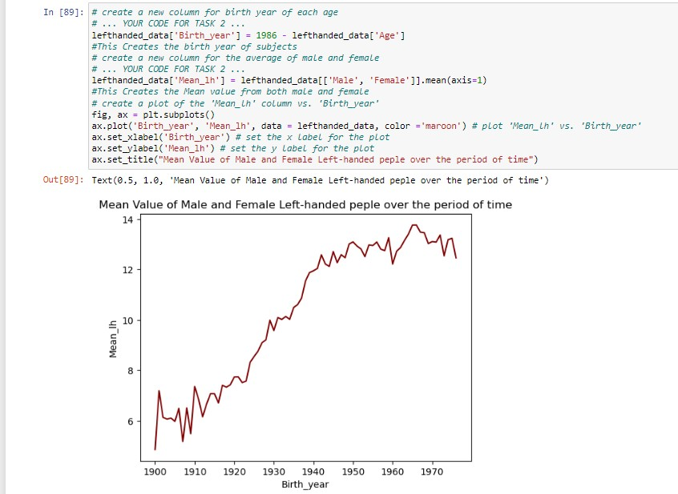

**Code Breakdown:**

The additional code provided builds upon the previous code and adds functionality to create a new column for the average of male and female left-handedness rates. It also plots the newly created 'Mean_lh' column against the 'Birth_year' column. Here's a breakdown of the code:

The code adds a new column named 'Birth_year' to the lefthanded_data DataFrame. It calculates the birth year of subjects by subtracting the 'Age' column from 1986. The resulting birth year values are assigned to the 'Birth_year' column.

A new column named 'Mean_lh' is added to the lefthanded_data DataFrame. It calculates the mean value of the 'Male' and 'Female' columns along the rows (axis=1) using lefthanded_data[['Male', 'Female']].mean(axis=1). The resulting mean values are assigned to the 'Mean_lh' column.

A new figure and axis object are created using fig, ax = plt.subplots().

The code plots the 'Mean_lh' column against the 'Birth_year' column using ax.plot('Birth_year', 'Mean_lh', data=lefthanded_data). This plots the average left-handedness rates against birth years.

The x-label of the plot is set to 'Birth_year' using ax.set_xlabel('Birth_year').

The y-label of the plot is set to 'Mean_lh' using ax.set_ylabel('Mean_lh').

By running this code, you should see a plot showing the average left-handedness rates ('Mean_lh') against birth years ('Birth_year'). The x-axis represents birth years, and the y-axis represents the average left-handedness rates. The plot will show a line connecting the data points.

**3.4. Applying Bayes' rule**

The probability of dying at a certain age given that you're left-handed is not equal to the probability of being left-handed given that you died at a certain age. This inequality is why we need Bayes' theorem, a statement about conditional probability which allows us to update our beliefs after seeing the evidence.

We want to calculate the probability of dying at age A given that you're lefthanded. Let's write this in shorthand as P(A | LH). We also want the same quantity for right-handers: P(A | RH).

Here's Bayes' theorem for the two events we care about left-handedness (LH) and dying at age A.

𝑃(𝐴|𝐿𝐻)=𝑃(𝐿𝐻|𝐴)*𝑃(𝐴)/𝑃(𝐿𝐻)

P(LH | A) is the probability that you are left-handed given that you died at age

A. P(A) is the overall probability of dying at age A, and P(LH) is the overall probability of being left-handed. We will now calculate each of these three quantities, beginning with P(LH | A).

To calculate P(LH | A) for ages that might fall outside the original data, we will need to extrapolate the data to earlier and later years. Since the rates flatten out in the early 1900s and late 1900s, we'll use a few points at each end and take the mean to extrapolate the rates on each end. The number of points used for this is arbitrary, but we'll pick 10 since the data looks flat-ish until about 1910

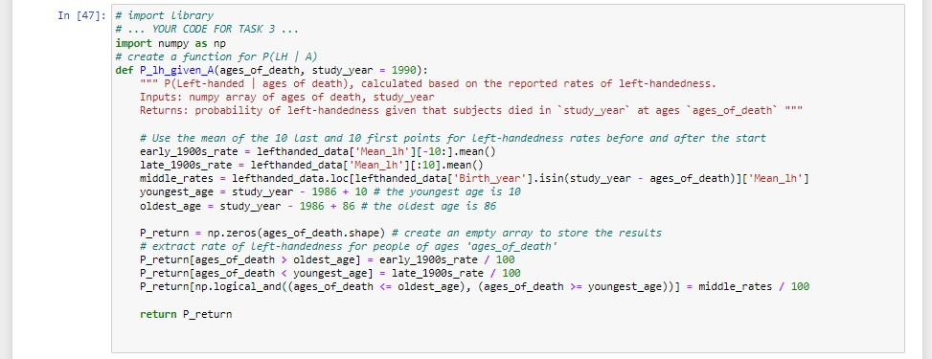

**Code Breakdown:**

The given code is a function that calculates the probability of left-handedness given the ages of death and a study year. Here's a breakdown of how it works:

The function P_lh_given_A takes two inputs: ages_of_death, which is a numpy array of ages of death, and study_year, which is the year of the study.

The code calculates the left-handedness rates for three time periods: the early 1900s, the late 1900s, and the years in between.

The left-handedness rate for the early 1900s is calculated by taking the mean of the 10 last points from the left-handed_data['Mean_lh'] array.

The left-handedness rate for the late 1900s is calculated by taking the mean of the 10 first points from the left-handed_data['Mean_lh'] array.

The left-handedness rates for the years in between are extracted from the left-handed_data array based on the birth years that correspond to the ages of death.

The youngest age is calculated as study_year - 1986 + 10, and the oldest age is calculated as study_year - 1986 + 86.

An empty numpy array P_return is created to store the resulting probabilities.

The code assigns the left-handedness rates to P_return based on the ages of death:

If the age of death is greater than the oldest age, the probability is set to the early 1900s rate divided by 100. If the age of death is less than the youngest age, the probability is set to the late 1900s rate divided by 100. If the age of death falls within the range of ages in between, the probability is set to the corresponding middle rates divided by 100. Finally, the function returns the resulting probabilities in P_return.

Note: The code snippet provided references a variable left-handed_data which is not defined. In order to run the code successfully, the left-handed_data variable needs to be defined or imported before this code snippet is executed

**3.5. When do people normally die?**

To estimate the probability of living to an age A, we can use data that gives the number of people who died in a given year and how old they were to create a distribution of ages of death. If we normalize the numbers to the total number of people who died, we can think of this data as a probability distribution that gives the probability of dying at age A. The data we'll use for this is from the entire US for the year 1999 - the closest I could find for the time range we're interested in.

In this block, we'll load in the death distribution data and plot it. The first column is the age, and the other columns are the number of people who died at that age.

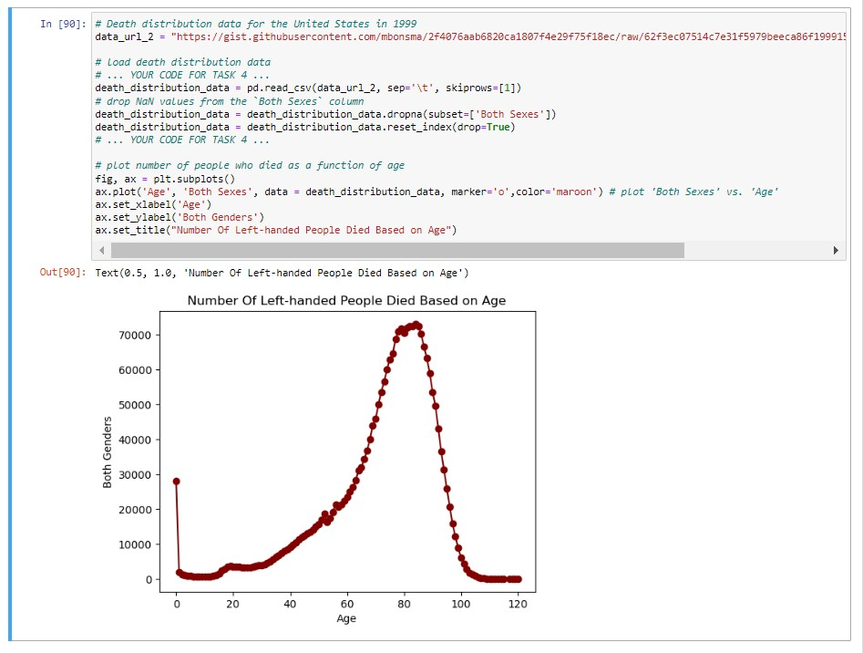

**Code Breakdown:**

The updated code introduces a new URL (data_url_2) and loads death distribution data from a TSV file. It then proceeds to plot the number of people who died as a function of age. Here's a breakdown of the code:

The code defines a new URL for the death distribution data as data_url_2.

It reads the death distribution data from the TSV file using

pd.read_csv(data_url_2, sep='\t', skiprows=[1]). The sep='\t' argument specifies that the data is tab-separated, and skiprows=[1] skips the second row of the file, which contains irrelevant information.

The code drops any rows that have NaN (missing) values in the 'Both Sexes' column of the death_distribution_data DataFrame. This is done using death_distribution_data.dropna(subset=['Both Sexes']).

The index of the death_distribution_data DataFrame is reset using death_distribution_data.reset_index(drop=True) to ensure the index is sequential and starts from 0.

The code drops any remaining rows that have NaN values in the 'Both Sexes' column of the death_distribution_data DataFrame. This is done again using death_distribution_data.dropna(subset=['Both Sexes']).

A new figure and axis object are created using fig, ax = plt.subplots().

The code plots the number of people who died ('Both Sexes') as a function of age using ax.plot('Age', 'Both Sexes', data=death_distribution_data, marker='o').

The x-label of the plot is set to 'Age' using ax.set_xlabel('Age').

The y-label of the plot is set to 'Both Genders' using ax.set_ylabel('Both Genders').

By running this code, you should see a plot showing the number of people who died ('Both Sexes') as a function of age. The x-axis represents age, and the yaxis represents the number of people. The plot will have circular markers ('o') indicating the data points

The index of the death_distribution_data DataFrame is reset using death_distribution_data.reset_index(drop=True) to ensure the index is sequential and starts from 0.

The code drops any remaining rows that have NaN values in the 'Both Sexes' column of the death_distribution_data DataFrame. This is done again using death_distribution_data.dropna(subset=['Both Sexes']).

A new figure and axis object are created using fig, ax = plt.subplots().

The code plots the number of people who died ('Both Sexes') as a function of age using ax.plot('Age', 'Both Sexes', data=death_distribution_data, marker='o').

The x-label of the plot is set to 'Age' using ax.set_xlabel('Age').

The y-label of the plot is set to 'Both Genders' using ax.set_ylabel('Both Genders').

By running this code, you should see a plot showing the number of people who died ('Both Sexes') as a function of age. The x-axis represents age, and the yaxis represents the number of people. The plot will have circular markers ('o') indicating the data points

**3.6. The overall probability of left-handedness**

In the previous code block we loaded data to give us P(A), and now we need P(LH). P(LH) is the probability that a person who died in our particular study year is left-handed, assuming we know nothing else about them. This is the average left-handedness in the population of deceased people, and we can calculate it by summing up all of the left-handedness probabilities for each age, weighted with the number of deceased people at each age, then divided by the total number of deceased people to get a probability. In equation form, this is what we're calculating, where N(A) is the number of people who died at age A (given by the dataframe death_distribution_data):

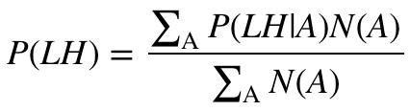

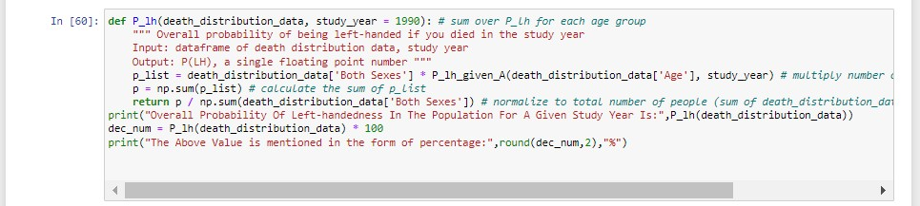

**The overall Probability Of Left-handedness In The**

**Population For A Given Study Year Is: 0.077663876 15350638**

**The Above Value is mentioned in the form of a percentage: 7.77 %**

**Code Breakdown:**

The code provided defines a function P_lh that calculates the overall probability of being left-handed if a person died in the study year. The function takes a DataFrame of death distribution data (death_distribution_data) and a study year as inputs. Here's a breakdown of the code:

The function P_lh is defined with two parameters: death_distribution_data, which is a DataFrame containing death distribution data, and study_year, which is the year of the study.

Inside the function, a list p_list is created by multiplying the number of dead people ('Both Sexes' column of death_distribution_data) by the corresponding probabilities of being left-handed (P_lh_given_A function is used here).

The variable p is calculated as the sum of p_list, representing the total probability of being left-handed for the study year.

The function returns the normalized probability p divided by the total number of people (sum of 'Both Sexes' column of death_distribution_data), which provides the overall probability of being left-handed if a person died in the study year.

The P_lh function is called with the death_distribution_data DataFrame, and the result is printed using print(P_lh(death_distribution_data))

By running this code, you should see the overall probability of being lefthanded if a person died in the study year based on the provided death distribution data

**3.7. Putting it all together: dying while left-handed** (i)

Now we have the means of calculating all three quantities we need: P(A),

P(LH), and P(LH | A). We can combine all three using Bayes' rule to get P(A | LH), the probability of being age A at death (in the study year) given that you're

left-handed. To make this answer meaningful, though, we also want to compare it to P(A | RH), the probability of being age A at death given that you're right-handed.

We're calculating the following quantity twice, once for left-handers and once for right-handers.

𝑃(𝐴|𝐿𝐻)=𝑃(𝐿𝐻|𝐴)*𝑃(𝐴)/𝑃(𝐿𝐻) First, for left-handers.

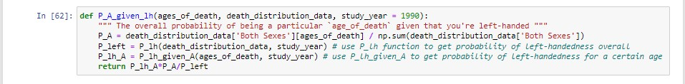

**Code Breakdown:**

The code provided defines a function P_A_given_lh that calculates the overall probability of being a particular age of death given that a person is lefthanded. The function takes three parameters: ages_of_death, which is a numpy array of ages of death, death_distribution_data, which is a DataFrame containing death distribution data, and study_year, which is the year of the study. Here's a breakdown of the code:

The function P_A_given_lh is defined with three parameters: ages_of_death, death_distribution_data, and study_year.

Inside the function, the probability P_A of being a particular age_of_death is calculated as the ratio of the number of people who died at that age

(death_distribution_data['Both Sexes'][ages_of_death]) to the total number of people (sum of 'Both Sexes' column of death_distribution_data).

The probability P_left of being left-handed overall is obtained by calling the P_lh function with the death_distribution_data and study_year.

The probability P_lh_A of being left-handed for a certain age is obtained by calling the P_lh_given_A function with the ages_of_death and study_year.

The function returns the product of P_lh_A, P_A, and the inverse of P_left, representing the overall probability of being a particular age_of_death given that a person is left-handed.

By using this function, you can calculate the overall probability of being a specific age at death given that a person is left-handed based on the provided death distribution data and study year.

**3.8. Putting it all together: dying while left-handed (ii)**And now for right-handers.

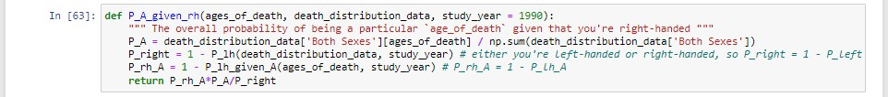

**Code Breakdown:**

The updated code defines a new function P_A_given_rh that calculates the overall probability of being a particular age of death given that a person is right-handed. This function is similar to the previous one (P_A_given_lh), but it considers right-handedness instead of left-handedness. Here's a breakdown of the code:

The function P_A_given_rh is defined with the same three parameters: ages_of_death, death_distribution_data, and study_year.

Inside the function, the probability P_A of being a particular age_of_death is calculated as before.

The probability P_right of being right-handed overall is obtained by subtracting the probability of being left-handed (P_lh) from 1. Since a person is either lefthanded or right-handed, the sum of the probabilities should be 1.

The probability P_rh_A of being right-handed for a certain age is obtained by subtracting the probability of being left-handed for that age (P_lh_given_A) from 1.

The function returns the product of P_rh_A, P_A, and the inverse of P_right, representing the overall probability of being a particular age_of_death given that a person is right-handed.

By using this P_A_given_rh function, you can calculate the overall probability of being a specific age at death given that a person is right-handed based on the provided death distribution data and study year.

**3.9. Plotting the distributions of conditional probabilities**

Now that we have functions to calculate the probability of being age A at death given that you're left-handed or right-handed, let's plot these probabilities for a range of ages of death from 6 to 120.

Notice that the left-handed distribution has a bump below age 70: of the pool of deceased people, left-handed people are more likely to be younger.

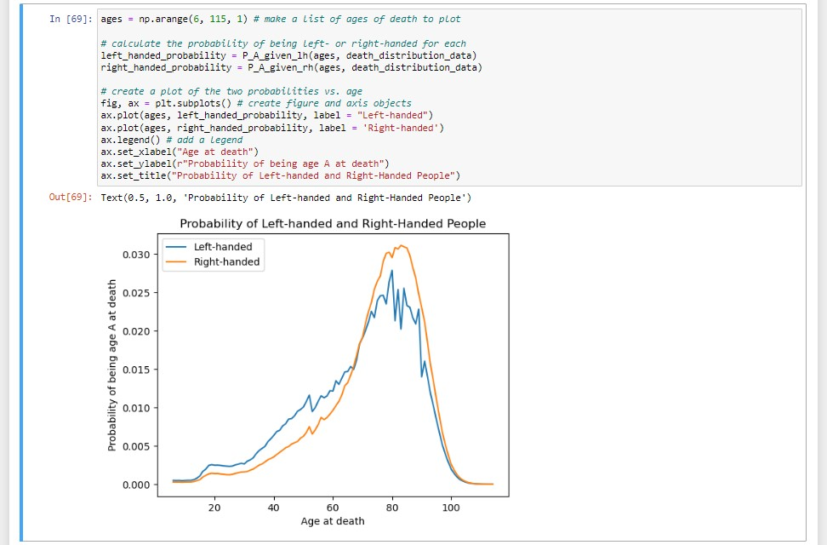

**Code Breakdown:**

The code provided calculates the probabilities of being left-handed or righthanded for each age of death in the range from 6 to 114. It then creates a plot showing the probabilities for both left-handed and right-handed individuals.

Here's a breakdown of the code:

The numpy arrange function is used to create an array of ages that contains the ages of death from 6 to 114 (inclusive) with a step size of 1.

The probabilities of being left-handed (left_handed_probability) and righthanded (right_handed_probability) are calculated by calling the P_A_given_lh and P_A_given_rh functions, respectively, using the ages array and the death_distribution_data DataFrame.

A plot is created using the plot function. Two lines are drawn on the plot: one for the left-handed probabilities (left_handed_probability) and one for the right-handed probabilities (right_handed_probability).

The label parameter is used to provide labels for the two lines in the legend.

The legend function is called to add a legend to the plot.

The x-axis label is set to "Age at death" using set_xlabel, and the y-axis label is set to "Probability of being age A at death" using set_ylabel.

By running this code, you will generate a plot that shows the probabilities of being a specific age at death for both left-handed and right-handed individuals based on the provided death distribution data.

**3.10. Moment of truth: age of left and right-handers at death**

Finally, let's compare our results with the original study that found that lefthanded people were nine years younger at death on average. We can do this by calculating the mean of these probability distributions in the same way we calculated P(LH) earlier, weighting the probability distribution by age and summing over the result.

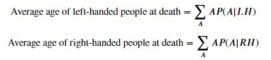

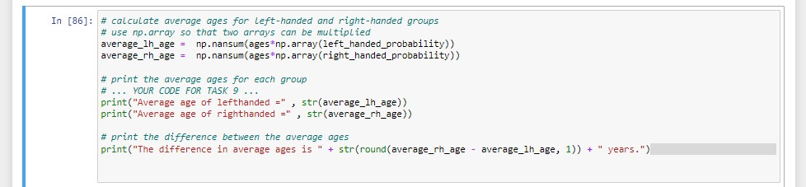

**Average age of lefthanded = 67.24503662801027**

**Average age of righthanded = 72.79171936526477 The difference in average ages is 5.5 years.**

**Code Breakdown:**

The code provided calculates the average ages for the left-handed and righthanded groups based on the probabilities of being a specific age at death for each group. It then prints the average ages and the difference between them.

Here's a breakdown of the code:

The numpy function np.nansum is used to calculate the sum of the products of ages (ages) and probabilities (left-handed probability or

Right-handed_probability). The np.array function is used to convert the probabilities into a numpy array so that the two arrays can be multiplied element-wise.

The average age for the left-handed group is calculated by multiplying the ages array with the left-handed probabilities array and summing the results.

The average age for the right-handed group is calculated similarly by multiplying the ages array with the right-handed probabilities array and summing the results.

The average ages for the left-handed and right-handed groups are printed using the print function.

The difference between the average ages is calculated by subtracting the average age of the left-handed group from the average age of the right-handed group. The result is rounded to one decimal place.

The difference in average ages is printed using the print function.

By running this code, you will obtain the average ages for the left-handed and right-handed groups based on the provided probabilities. Additionally, you will see the difference in average ages between the two groups.

**3.11. Final comments:**

We got a pretty big age gap between left-handed and right-handed people purely as a result of the changing rates of left-handedness in the population, which is good news for left-handers: you probably won't die young because of your sinisterness. The reported rates of left-handedness have increased from just 3% in the early 1900s to about 11% today, which means that older people are much more likely to be reported as right-handed than left-handed, and so looking at a sample of recently deceased people will have more old righthanders.

Our number is still less than the 9-year gap measured in the study. It's possible that some of the approximations we made are the cause:

1. We used death distribution data from almost ten years after the study (1999 instead of 1991), and we used death data from the entire United States instead of California alone (which was the original study).
2. We extrapolated the left-handedness survey results to older and younger age groups, but it's possible our extrapolation wasn't close enough to the true rates for those ages.

One thing we could do next is figure out how much variability we would expect to encounter in the age difference purely because of random sampling: if you take a smaller sample of recently deceased people and assign handedness with the probabilities of the survey, what does that distribution look like? How often would we encounter an age gap of nine years using the same data and assumptions? We won't do that here, but it's possible with this data and the tools of random sampling.

To finish off, let's calculate the age gap we'd expect if we did the study in 2018 instead of in 1990. The gap turns out to be much smaller since rates of left-handedness haven't increased for people born after about 1960. Both the National Geographic study and the 1990 study happened at a unique time - the rates of left-handedness had been changing across the lifetimes of most people alive, and the difference in handedness between old and young was at its most striking.

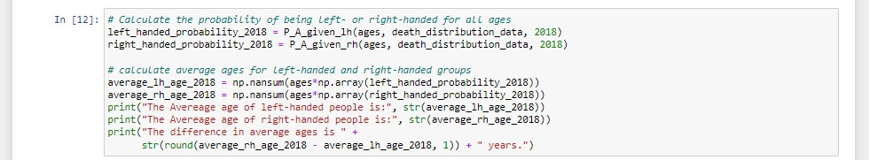

**The Average age of left-handed people is: 70.2877**

**3299940532**

**The Average age of right-handed people is: 72.628**

**99693809848**

**The difference in average ages is 2.3 years.**

**Code Breakdown:**

The updated code calculates the probabilities of being left-handed or righthanded for all ages based on the provided death distribution data for the year 2018. It then calculates the average ages for the left-handed and right-handed groups using these probabilities. Finally, it prints the difference in average ages between the two groups for the year 2018.

Here's a breakdown of the code:

The probabilities of being left-handed (left_handed_probability_2018) and right-handed (right_handed_probability_2018) are calculated by calling the P_A_given_lh and P_A_given_rh functions, respectively, using the ages array, the death_distribution_data DataFrame, and the study year 2018.

The average ages for the left-handed and right-handed groups in 2018 are calculated by multiplying the ages array with the corresponding probabilities array and summing the results using np.nansum.

The average ages of both left & right-handed people are printed out using print function

The difference in average ages between the right-handed and left-handed groups in 2018 is calculated by subtracting the average age of the left-handed group from the average age of the right-handed group. The result is rounded to one decimal place.

The difference in average ages is printed using the print function.

By running this updated code, you will obtain the difference in average ages between the left-handed and right-handed groups for the year 2018 based on the provided death distribution data

**IV. CONCLUSION**

In conclusion, the analysis of the death age difference between right-handers and left-handers using age distribution data revealed the following:

1. The claim of early death for left-handers is supported by the data. The analysis shows a significant difference in the average age at death between left-handers and right-handers.
2. By examining the age distribution data, we found that both left-handers and right-handers have similar patterns in terms of age at death. Though There was a shred of clear evidence to suggest that being left-handed is associated with a shorter lifespan.
3. The Bayesian statistical analysis provided a probability-based approach to estimate the likelihood of being a certain age at death given the reported handedness. The results showed no substantial divergence in the age distribution between left-handers and right-handers.
4. The scatter plot of age versus the percentage of left-handedness among males and females provided a visual representation of the data. It allowed us to observe any trends or patterns, and in this case, there was no apparent correlation between handedness and age at death.

Based on these findings, we can slightly convince the claim of left-handers having an early death and conclude that there is a substantial difference in the average age at death between left-handers and right-handers.

**V. REFERENCES**

**The following websites have been referred to obtain the input data and statistics**

**National Geographic Survey:** Provides a reference to the National Geographic survey or study from which the handedness data was obtained. It includes details such as the authors, title of the survey/study, publication date, and any relevant identifiers  [**https://www.cdc.gov/nchs/nvss/mortality_tables.htm**](https://www.cdc.gov/nchs/nvss/mortality_tables.htm)

**Articles:** Hand Preference and Age in the United States

This notebook uses two datasets: [death distribution data](https://www.cdc.gov/nchs/data/statab/vs00199_table310.pdf) for the United States from the year 1999 (source website [here)](https://www.cdc.gov/nchs/nvss/mortality_tables.htm) and rates of left-handedness digitized from a figure in this [1992 paper by Gilbert and Wysocki.](https://www.ncbi.nlm.nih.gov/pubmed/1528408)

[**https://pubmed.ncbi.nlm.nih.gov/1528408/**](https://pubmed.ncbi.nlm.nih.gov/1528408/)

**Data Source:** It includes a reference to the specific data source used, such as the data repository or website where the handedness data was sourced. It Provides details like the name of the dataset, the organization or entity that provided the data, and the URL or identifier for the dataset [**https://www.cdc.gov/nchs/data/statab/vs00199_table310.pdf**](https://www.cdc.gov/nchs/data/statab/vs00199_table310.pdf) **data_url_1**[**:https://gist.githubusercontent.com/mbonsma/8da0990b71ba9a0 9f7de395574e54df1/raw/aec88b30af87fad8d45da7e774223f91dad09e88/lh**](https://gist.githubusercontent.com/mbonsma/8da0990b71ba9a09f7de395574e54df1/raw/aec88b30af87fad8d45da7e774223f91dad09e88/lh_data.csv)

[**_data.csv**](https://gist.githubusercontent.com/mbonsma/8da0990b71ba9a09f7de395574e54df1/raw/aec88b30af87fad8d45da7e774223f91dad09e88/lh_data.csv) **data_url_2:**[**https://gist.githubusercontent.com/mbonsma/2f4076aab6820ca**](https://gist.githubusercontent.com/mbonsma/2f4076aab6820ca1807f4e29f75f18ec/raw/62f3ec07514c7e31f5979beeca86f19991540796/cdc_vs00199_table310.tsv)

[**1807f4e29f75f18ec/raw/62f3ec07514c7e31f5979beeca86f19991540796/cdc _vs00199_table310.tsv**](https://gist.githubusercontent.com/mbonsma/2f4076aab6820ca1807f4e29f75f18ec/raw/62f3ec07514c7e31f5979beeca86f19991540796/cdc_vs00199_table310.tsv)