Transit Gateway homework submission.
Name:
You need to paste all the required screenshots in this one document and upload it. You have 3 attempts and must upload every time you submit. I will grade the last attempt. No partial credit. Ensure all fields in the screenshots are legible (make sure I can read them).
- Show the 3 VPCs you created similar to the below. It must show the names (must have your last name) and IPv4CIDR blocks clearly. (7)
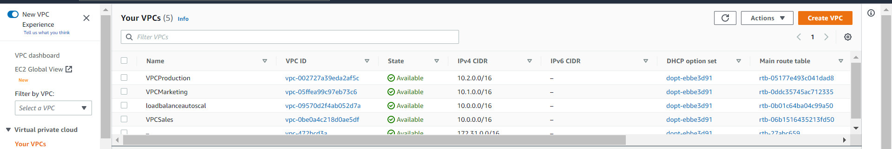
Paste the image here:

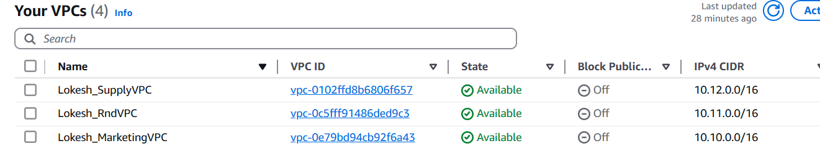

- Show the 6 stacks you created (3 VPCs and 3 EC2s) from the CloudFormation console similar to the below. It must show the stack names (must have your last name) and status: Create_Complete. (8)
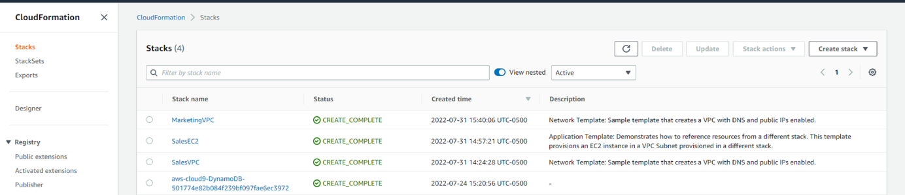

Paste the image here:
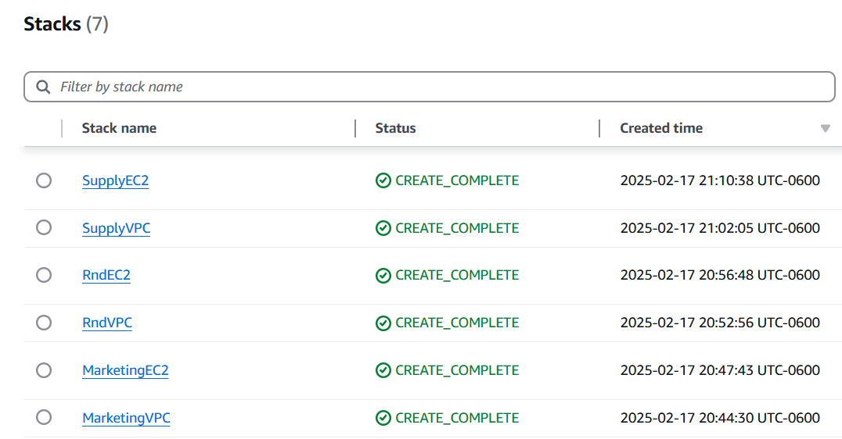

- Show the routes you created for the route table in the RND VPC, similar to the below. (7)
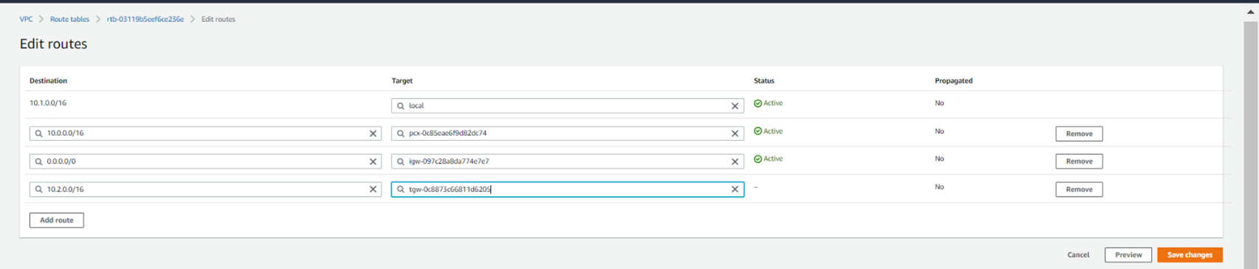
Paste the image here.

