PROJECT REPORT
SMART STUDENT ASSISTANT ROBOT (SSAR)
An Arduino Uno Based Interactive Educational Assistant for Students
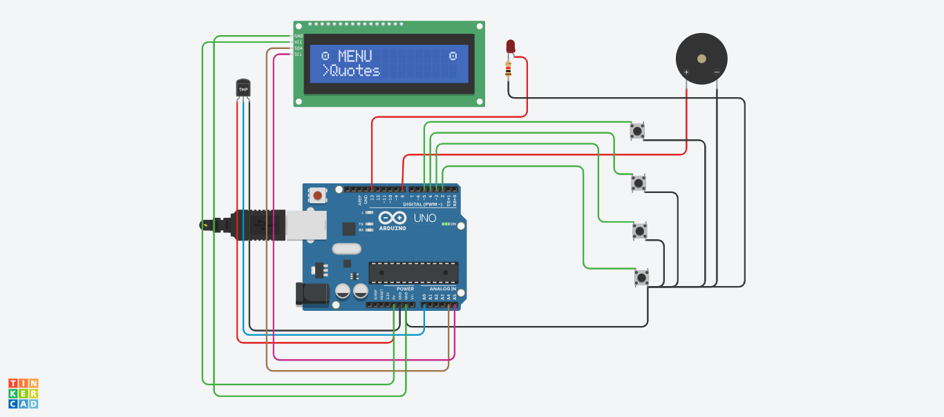
Built on Arduino Uno | 16×2 I2C LCD | TMP36 Sensor | Piezo Buzzer
Date: August 6, 2026
Platform: Tinkercad

1. Project Summary
Smart Student Assistant Robot (SSAR) is an Arduino Uno–based educational assistant designed to help students manage their daily study activities and maintain healthy habits. The system integrates an LM35-family TMP36 temperature sensor, a 16×2 I2C LCD display, push buttons, a buzzer, and an LED to provide an interactive and user-friendly experience.
The robot features an animated LCD interface with a menu-driven system that allows users to access functions such as temperature monitoring, a timer, a stopwatch, homework reminders, water reminders, stretch reminders, sleep reminders, motivational quotes, greeting messages, silent/beep mode, and flashlight control. These features are intended to improve time management, encourage healthy routines, and enhance study productivity.
The Arduino Uno acts as the central controller, processing inputs from the buttons and temperature sensor while controlling the LCD display, buzzer, and LED. The menu-based design enables easy navigation between different functions, making the robot simple to operate.

2. Objectives
- To design a low-cost, compact Arduino-based assistant that supports students in daily study and self-care routines.
- To implement a menu-driven user interface on a 16×2 I2C LCD that is easy to navigate using push buttons.
- To integrate a temperature sensor for real-time ambient temperature monitoring.
- To provide time-management tools such as a timer and stopwatch alongside habit-building reminders (water, stretch, sleep, homework).
- To add motivational and interactive features, including quotes, greetings, a silent/beep toggle, and a flashlight mode, to keep the assistant engaging.
- To demonstrate practical skills in embedded systems, sensor interfacing, and human–machine interaction using Arduino.

3. System Overview
At the core of the SSAR is an Arduino Uno R3 microcontroller board, which reads button presses and sensor data as inputs and drives the LCD, buzzer, and LED as outputs. The user interacts entirely through four push buttons that navigate a scrollable on-screen menu, selecting from functions such as “Quotes,” temperature display, timer, stopwatch, and various reminders. Feedback is given visually on the LCD and audibly through the piezo buzzer, with the LED used for indication and the flashlight function.
The following block-level flow summarizes how the system operates:
- Power-on → Arduino initializes the LCD and displays the main menu.
- User presses navigation buttons to scroll through menu options shown on the LCD.
- A select button confirms the chosen function (e.g., Timer, Stopwatch, Temperature, Reminders, Quotes).
- The Arduino executes the selected function, reading the TMP36 sensor if required, and updates the LCD accordingly.
- The buzzer sounds for alerts/reminders (unless silent mode is active), and the LED provides visual indication or flashlight functionality.
- The user can return to the main menu at any time to select another function.

4. Bill of Materials
The table below lists the components used in the project, based on the circuit design.
Ref. Designator | Qty | Component | Function
U1 | 1 | Arduino Uno R3 | Main microcontroller / system controller
U3 | 1 | 16×2 LCD (I2C, PCF8574 backpack, addr. 0x27) | Displays menu and function output
U2 | 1 | TMP36 Temperature Sensor | Measures ambient temperature
D1 | 1 | Red LED | Status indicator / flashlight
R1 | 1 | 1 kΩ Resistor | Current-limiting resistor for D1
S1–S4 | 4 | Pushbutton | Menu navigation and selection
PIEZO1 | 1 | Piezo Buzzer | Audible alerts and reminders

5. Circuit Diagram
The complete circuit was designed and simulated in Tinkercad. The Arduino Uno is powered via USB, and all peripherals are wired directly to its digital, analog, and power pins as shown below.

Figure 1: SSAR circuit diagram (Tinkercad)

6. Circuit Connections
Pin-level connections between the Arduino Uno and each peripheral are summarized below, as per the circuit design.
Component | Pin | Arduino Uno Pin
TMP36 Sensor (U2) | VCC / OUT / GND | 5V / A0 / GND
I2C LCD (U3) | VCC / GND / SDA / SCL | 5V / GND / SDA (A4) / SCL (A5)
LED D1 (via R1, 1kΩ) | Anode / Cathode | Digital pin / GND
Pushbutton S1 | Signal / GND | Digital pin / GND
Pushbutton S2 | Signal / GND | D2 / GND
Pushbutton S3 | Signal / GND | D3 / GND
Pushbutton S4 | Signal / GND | D4 / GND
Piezo Buzzer (PIEZO1) | + / – | Digital pin / GND
Note: Buttons S2, S3, and S4 are wired to digital pins D2, D3, and D4 respectively; S1, the LED, and the buzzer are wired to additional digital pins as shown in the Tinkercad schematic. Exact pin numbers for these three should be cross-checked against the Arduino sketch before final assembly.

7. Features

7.1 Menu-Driven Navigation
A scrollable menu on the 16×2 LCD lets the user browse and select from all available functions using the push buttons, keeping the interface simple and intuitive.

7.2 Temperature Monitoring
The TMP36 sensor continuously measures ambient temperature, which can be displayed on demand — useful for maintaining a comfortable study environment.

7.3 Timer and Stopwatch
Built-in timer and stopwatch functions help students allocate focused study sessions (e.g., using Pomodoro-style intervals) and track elapsed time for tasks.

7.4 Reminders
- Homework Reminder – prompts the user to complete pending assignments.
- Water Reminder – encourages regular hydration during study sessions.
- Stretch Reminder – nudges the user to take short movement breaks.
- Sleep Reminder – alerts the user to maintain a healthy sleep schedule.

7.5 Motivational Quotes & Greetings
The assistant displays motivational quotes and friendly greeting messages to keep students encouraged and engaged during study sessions.

7.6 Silent / Beep Mode
Users can toggle the buzzer on or off, allowing alerts to be either audible or silent depending on the study environment (e.g., a library).

7.7 Flashlight Mode
The onboard LED can be switched on to serve as a small flashlight, useful for reading in low-light conditions.

8. Working Principle
On power-up, the Arduino initializes the I2C LCD and displays the main menu. The four push buttons are read as digital inputs (typically configured with internal pull-up resistors), allowing the user to scroll up/down through menu items and select a function. Based on the selection, the Arduino executes the corresponding routine:
- For temperature monitoring, the analog voltage from the TMP36 on pin A0 is read, converted to a temperature value, and displayed on the LCD.
- For the timer and stopwatch, the Arduino tracks elapsed time using its internal clock (millis()) and updates the LCD in real time.
- For reminders and quotes, pre-programmed messages are shown on the LCD at set intervals or on user request, accompanied by a buzzer tone (unless silent mode is enabled).
- For flashlight mode, the Arduino drives the LED (D1) high through the 1 kΩ current-limiting resistor (R1).
This design keeps all logic centralized in the Arduino sketch, with the LCD, buzzer, and LED serving purely as output peripherals, and the buttons and sensor as the only inputs — resulting in a simple, single-controller architecture.

9. Applications
- Personal desktop companion for students to manage study time and daily routines.
- Classroom or hostel-room tool for building consistent healthy habits (hydration, breaks, sleep).
- Low-cost educational demonstration of embedded systems and sensor interfacing for electronics/robotics coursework.
- Base platform for further IoT or smart-home style student-assistant projects.

10. Advantages
- Affordable – built entirely from low-cost, readily available components.
- Compact and energy-efficient – suitable for a desk or study table.
- Simple, intuitive menu-based interface requiring no prior technical knowledge to operate.
- Combines productivity tools (timer, stopwatch, reminders) with wellbeing features (water, stretch, sleep reminders) in one device.
- Modular design that is easy to expand with additional sensors or features.

11. Future Scope
- Adding a Real-Time Clock (RTC) module for accurate, persistent timekeeping and scheduled reminders.
- Bluetooth or Wi-Fi connectivity for syncing reminders with a smartphone or web app.
- Voice command support for hands-free operation.
- A companion mobile application for remote configuration and notification history.
- Additional sensors (e.g., ambient light, sound level) to further support a healthy study environment.
- Rechargeable battery integration for portable, cordless use.

12. Conclusion
The Smart Student Assistant Robot (SSAR) demonstrates the practical application of embedded systems, sensor interfacing, human–machine interaction, and Arduino programming. By combining a temperature sensor, an I2C LCD, push buttons, a buzzer, and an LED under the control of a single Arduino Uno, the project delivers an affordable, compact, and energy-efficient personal study companion for students. Its expandable design leaves clear room for future enhancements such as RTC-based scheduling, wireless connectivity, voice commands, and mobile app integration, making it a strong foundation for further development.

