**Loan Status Prediction**

**(Classification Model)**

**Aim:**

The objective is to build a Machine Learning Model to predict the loan to be approved or to be rejected for an applicant.

**Data Provided:**

* Loan_ID
* Gender
* Married
* Dependents
* Education
* Self_Employed
* ApplicantIncome
* CoapplicantIncome
* LoanAmount
* Loan_Amount_Term
* Credit_History
* Property_Area
* Loan_Status

**Correlation Graph:**

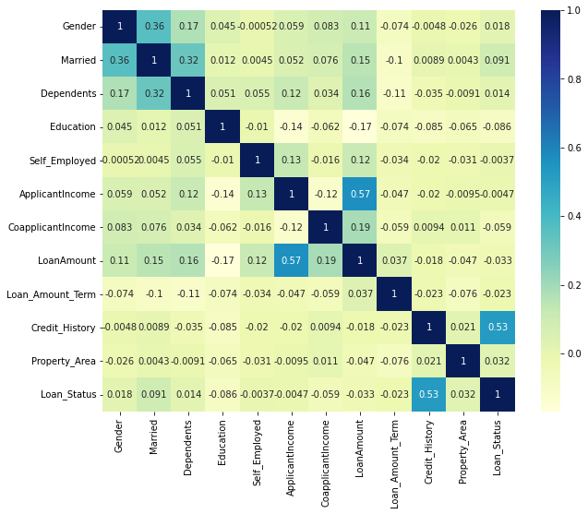

**Machine Learning models performed and their accuracy:**

* Decision Tree - 76%
* Random Forest - 83%
* Logistic Regression - 84%

**Project Conclusion:**

* There is a positive relationship between credit history and loan status, same also between the applicant income & loan amount.
* Here mens got more loans, being married and graduate were also factors that, results in loan approvals.
* According to Machine learing models we performed, 84% accuracy we got in the  Logistic Regression model which is the most suitable to make predictions.