🡪Aim - Our aim is to predict the reasons for users adopting our product.

🡪Adopted User - is a user who has logged into the product on 3 separate days in at least one 7-day period. (ie: The most frequent users of the product).

* There were 1656 adopted users out of 8823 users of the product.

Important Factors determining Adopted users:-

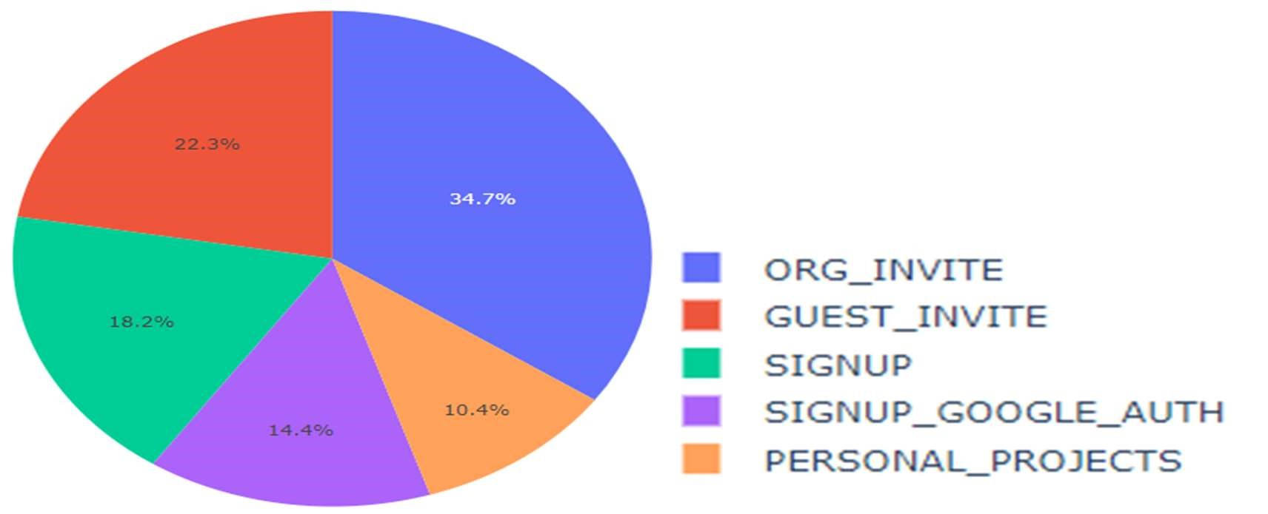

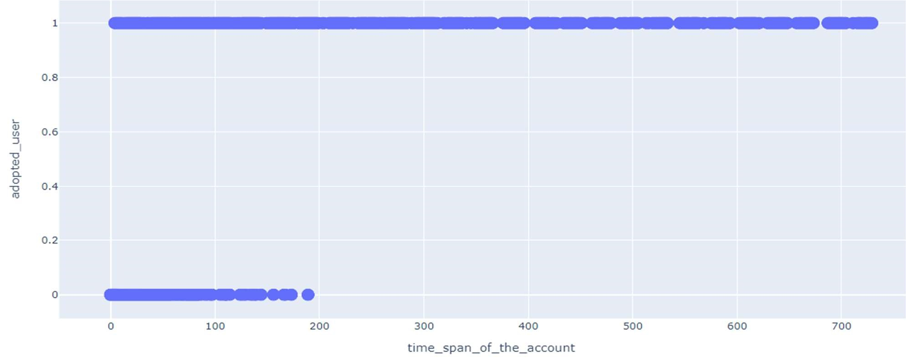

Interpretation of the results:-

* User adoption is higher when Creation_Source (how their account was created) is through Organisation invite & Guest invite. That is, When the user is invited to an organisation as a “full member (35%)” or “as a guest (22%)”.
* User adoption is higher when time span between the account created and last time it was used is more than 200 days.

Solution:

* By Inviting users through Organisational invite and by retaining users for a more than 200 days, we can increase the “future user adoption” .