**Technical Document**

**List of Scripts:**

* GameManager: Singleton Monobehaviour

Complete Game state control. Pass Game state to all other manager objects by abstract class GameStateAbstract **.**

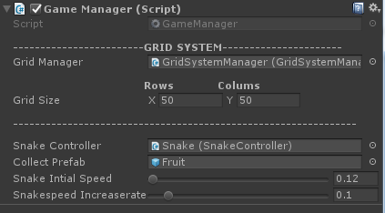

* **GameStateAbstract:** Inherit from MonoBehaviour

Subscribe/Unsubscribe Game state event to other modules.

* CameraManager: Inherit from GameStateAbstract
* BlurOptimized: Blur the screen which is took from **UnityStandardAssets.**
* CameraShake: To shake camera when GameOver reference from <http://wiki.unity3d.com/index.php/Camera_Shake>

Modified as per requirement

* GridSystemManager: Inherit from GameStateAbstract
* Creates Grid by using Serialized class **GridNode**
* VFXManager: Inherit from GameStateAbstract

Based on the game state activate vfx.

* VFXLineRenderer: Renders line based on Mouse/Touch swip
* Enables fadeout head spin particles when gameover
* InputManager: Inherit from GameStateAbstract

Handles Keyboard /Mouse swip based on game state and flags in the inspector for keyboard and mose.

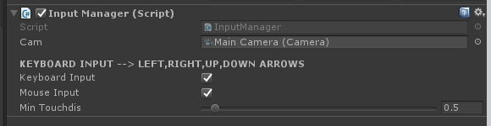

* ObstacleManager: Inherit from GameStateAbstract

Handles to spawn obstacles

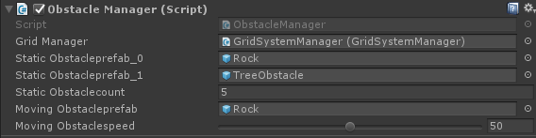

* UIManager: Inherit from GameStateAbstract

Switches UI canvas basesd on Game state

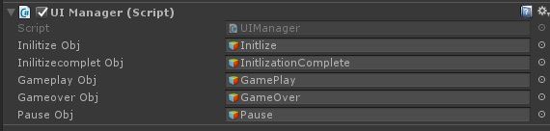

* SoundManager: Inherit from GameStateAbstract

Handles all sounds which is having List of Audio source with names

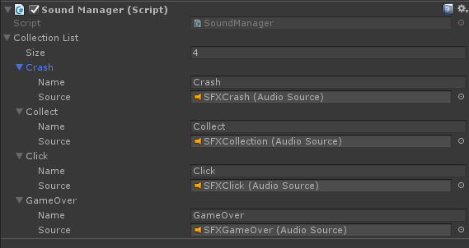

* poolManager: Singleton Monobehaviour
* MeshMerger: Took script from the URL <http://wiki.unity3d.com/index.php?title=MeshMerger> and modified as requirement.

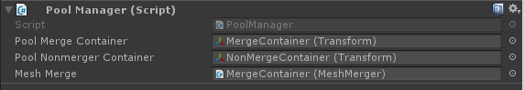

For Snake Control: created 2 scripts to handle snake movement from GameManager

* SnakeController – Handles initial position and holds snake head component.
* SnakeBlock – Handles to position the pieces of snake.

Other Helping Script:

* UIScoreComponent:For Pass Score to UI component from GameManager.
* ConstantsList: Holds all required constant variables of the game.