Content Management System
Table of Contents

Top Level Items 2
Add a Top Level Folder: 2
Add a Top Level File: 3
Editing Files & Folders 4
Editing a Folder: 4
Editing a File: 5
Editing a File’s Content: 6
Content Editor: 7
Versions 9

Top Level Items
Folders and files in the root directory of the site.

Add a Top Level Folder:
To add a folder, click on the “Add Folder” link in the “Add Top Level Item” box.

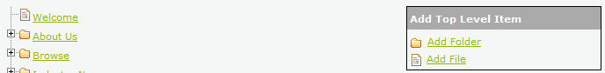
A pop-up will appear displaying the properties of the new folder.
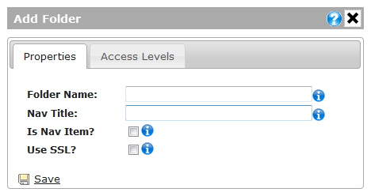
Fields:
“Folder Name”: the physical path to the folder.
“Nav Title”: the text displayed in the main navigation area of the web site.
“Is Nav Item”: whether or not this folder is displayed in the main navigation area.
“Use SSL”: if checked, encrypts the page. Usually used for e-commerce.
Click “Save” to create the new folder.

Add a Top Level File:
To add a top level file, click on the “Add File” link in the “Add Top Level Item” box.
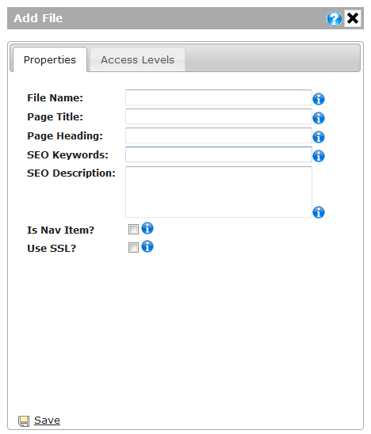
Fields:
“File Name”: the name of the file.
“Page Title”: the text displayed at the top of the browser.
“Page Heading”: the text displayed in the content area of the page.
“SEO Keywords”: the keywords used for search engine optimization.
“SEO Description”: the description used for search engine optimization.
“Is Nav Item”: whether or not this file is displayed in the navigation area.
“Use SSL”: if checked, encrypts the page. Usually used for e-commerce.
Click “Save” to create the new file.

Editing Files & Folders

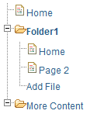
Editing a Folder:
To edit a folder’s properties click on the folder that you want to edit.

A pop-up should appear containing the current properties of the folder.
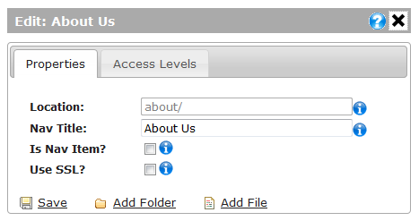
Fields:
“Location”: The location of the folder (this value cannot be modified).
“Nav Title”: the text displayed in the main navigation area of the web site.
“Is Nav Item”: whether or not this folder is displayed in the main navigation area.
“Use SSL”: if checked, encrypts the page. Usually used for e-commerce.
Actions:
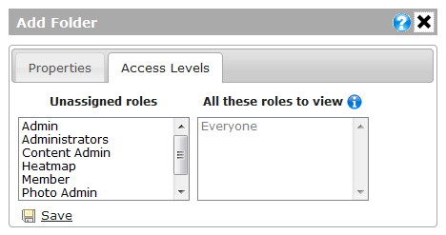
“Save”: Saves the new properties of the folder.
“Add Folder”: adds a subfolder in this folder and displays a box to edit the subfolders properties.
“Add File”: adds a file in this folder.
Access Levels:
On this tab you can decide which roles are allowed to view the contents of the folder.

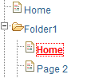
Editing a File:
To edit a file’s properties click on the file that you want to edit.

A pop-up should appear containing the current properties of the file.
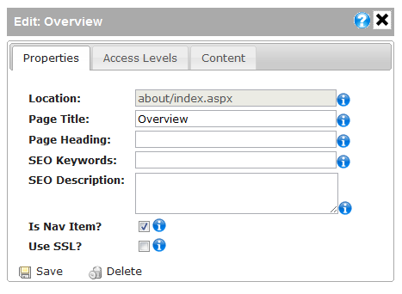
Property Fields:
“Location”: the path of the file (this cannot be modified).
“Page Title”: the text displayed at the top of the browser.
“Page Heading”: the text displayed in the content area of the page.
“Is Nav Item”: whether or not this file is displayed in the navigation area.
“Use SSL”: if checked, encrypts the page. Usually used for e-commerce.
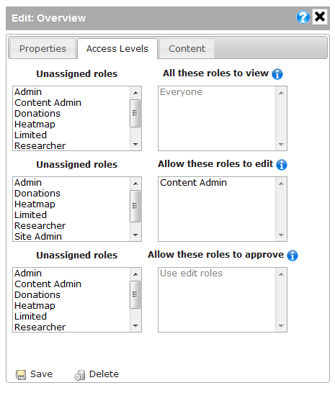
Access Levels:
The top two boxes handle who is allowed to view a page. The box on the left holds the available roles, while the box on the right contains the roles that are allowed to view this page. To assign a role, click on role in the left box. To un-assign a role, click on the role in the right box. If no roles are assigned, then everyone can view the page.
The middle two boxes handle who is allowed to edit a page. If no roles are added, then no one can edit the page.
The bottom two boxes handle who is allowed to approve content. The people in these roles are the only ones allowed to Approve and Publish content. If no roles are added, then the “Edit” roles are used.
Actions:
“Save”: saves the new properties of this page.
“Delete”: deletes the page as well as any content stored on the page.

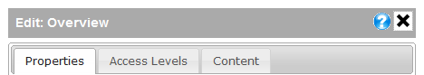
Editing a File’s Content:
After selecting the file, click on the “Content” tab in the pop-up window.

Note: the content tab will not appear if you are not in one of the specified Edit roles (on the Access Levels tab). If you just made changes to the Access Levels then you may need to click “Save” and then click back on the file in order to see the Content tab.
You will then be shown a preview of the current page’s content. If the page has more than one content area they will all show up here and be denoted by a grey box that reads: “Section:” followed by the content area’s name. To edit the content, double-click in the content area.
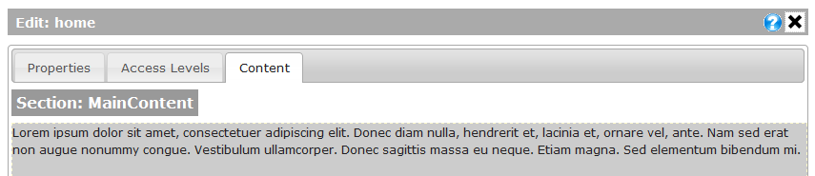
A content editor will appear.
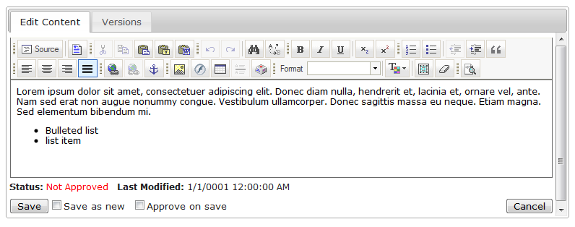

Content Editor:
This allows you to make changes to the text.
Buttons:
“Source”: a toggle for viewing and editing the html source code.

“Paste From Word”:
Gets text from your clipboard pastes it into the editor. Use this button only when pasting text from Microsoft Word.

“Insert/Edit Link”:
This is a hyperlink manager; it is for adding links to the page.

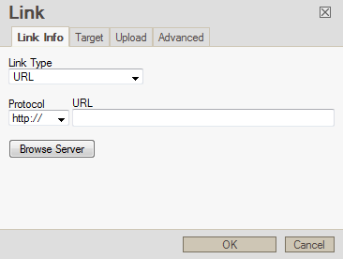
After clicking on it a new window will open containing the properties for the hyperlink.
Fields:
“Link Type”:
URL: link to another page or website.
E-Mail: link to an email address.
“URL”: the address to link to.
Click “OK” to insert or save changes to the hyperlink.
“Insert/Edit Image”:
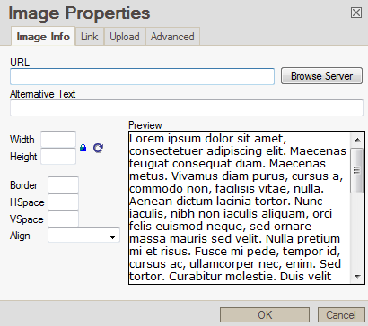
This inserts an image into the page. After clicking it a new window will appear.
Image Info Tab:
“URL”: the path to the image. Click “Browse Server” to view and select an image located on the server.
“Alternative Text”: This text is shown in the image’s place if the user cannot view the image.
“Width/Height”: The Dimensions of the image.
“Border”: the size (in pixels) of the border around the image. Use “0” to display no border.
“Align”: This aligns the image to different areas on the page.

Upload Tab: Use this tab to upload an image that is located on your local machine.
Actions:
“Save”: saves the page but doesn’t make the changes live
“Save as new”: saves this page as a new version so you will still be able to access the old copy and the new changes
“Approve on save”: checking this box will approve the new changes you just made; if the version you are editing is the published version then checking this box also publishes the changes. If you are not in the list of roles that can Approve content changes then someone in that list will have to approve any content changes you made.
“Cancel”: cancels any changes made to the page
“Status”: This shows whether or not the version you are editing has been approved.

Versions
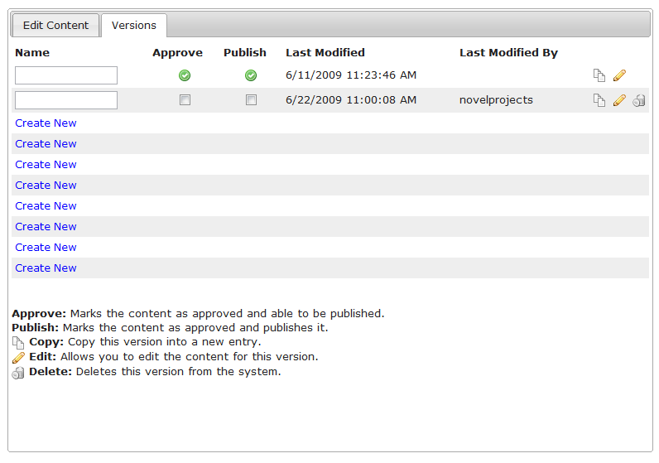
Another part of the content editor is the “Versions” tab.

In this tab you can view all of the different versions of the page. You can have a maximum of 10 versions per page.
Actions:
“Copy”: this creates a new identical version.

“Edit”: this opens the “Edit Content” tab with the text of that version.

“Delete”: this deletes that version.

“Approve”: this approves that version so it can be ready to be published.
“Publish”: this publishes that version.
“Create New”: this creates a new version.
“Name”: you can enter a name for the version in the textbox.

