8. Create a web page having frames as follows:

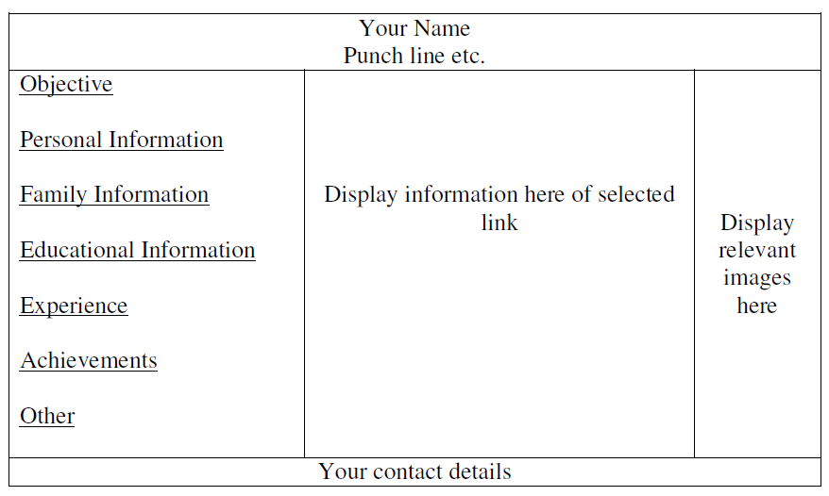

The frame which includes Objective, Personal Information ect. are the hyperlinks. Display the relevant information in the next frame on selecting the link. The colour scheme of hyper links should be as follows:

default – green

active – red

visited – blue

The information should be well formatted. Follow the instructions mentioned in the above format.