32. Write a c program to implement binary search tree.

#include<stdio.h>

#include<stdlib.h>

struct node {

int data;

struct node \*r;

struct node \*l;

};

void inorder(struct node\* root) {

if (root != 0) {

inorder(root->l);

printf("%d ", root->data);

inorder(root->r);

}

}

struct node\* create(int x)

{

struct node \*nn;

nn =(struct node\*) malloc(sizeof(struct node));

nn->data = x;

nn->l = 0;

nn->r= 0;

return nn;

}

struct node\* ins(struct node \*root,int x )

{

if(root==0)

{

return create(x);

}

if(x<root->data)

{

root->l=ins(root->l,x);

}

else

{

root->r=ins(root->r,x);

}

return root;

}

int main()

{

struct node \*root=0;

int choice;

do

{

printf("\nenter choice:\n 1-ins 2-inorder \n");

scanf("%d",&choice);

switch(choice)

{

case 1:

int x,r;

printf("enter data");

scanf("%d",&x);

if(root==0)

root=ins(root,x);

else

ins(root,x);

break;

case 2: inorder(root);

break;

default: printf("invalid choice");

}

}

while (choice!=0);

}

Output:

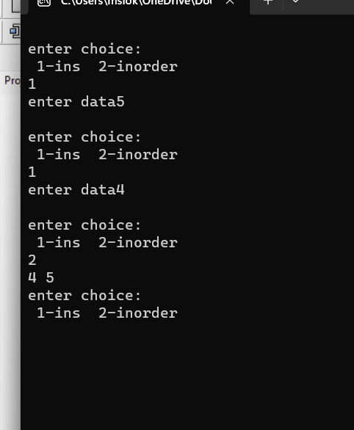

34. Write a C program to implement hashing using linear probing.

#include <stdio.h>

#include<stdlib.h>

#define s 5

int h[s];

void insert()

{

int key,index,i,hkey;

printf("\nenter a value to insert into hash table\n");

scanf("%d",&key);

hkey=key%s;

for(i=0;i<s;i++)

{

index=(hkey+i)%s;

if(h[index] == -1)

{

h[index]=key;

break;

}

}

if(i == s)

printf("\nelement cannot be inserted\n");

}

void search()

{

int key,index,i,hkey;

printf("\nenter search element\n");

scanf("%d",&key);

hkey=key%s;

for(i=0;i<s; i++)

{

index=(hkey+i)%s;

if(h[index]==key)

{

printf("value is found at index %d",index);

break;

}

}

if(i == s)

printf("\n value is not found\n");

}

void display()

{

int i;

printf("\nelements in the hash table are \n");

for(i=0;i<s; i++)

printf("\nat index %d \t value = %d",i,h[i]);

}

int main()

{

int j;

for(j=0;j<s;j++)

h[j]=-1;

int opt,i;

do

{

printf("\nPress 1. Insert\t 2. Display \t3. Search \t0.Exit \n");

scanf("%d",&opt);

switch(opt)

{

case 1:

insert();

break;

case 2:

display();

break;

case 3:

search();

break;

case 4:printf("invalid choice");

}

}while(opt!=0);

return 0;

}

output: 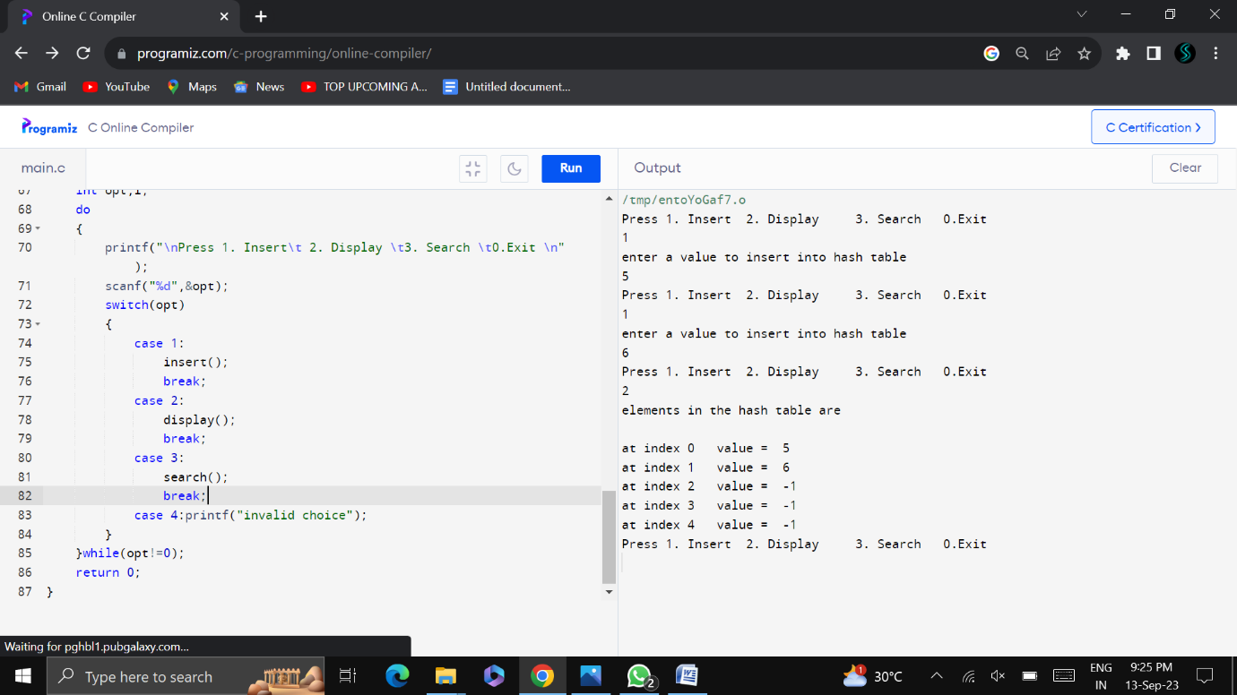

35.Bubble sort:

Program:

#include<stdio.h>

int main()

{

int a[10],i,j,t,n;

printf("enter size of array");

scanf("%d",&n);

printf("enter %d values\n",n);

for(i=0;i<n;i++)

scanf("%d",&a[i]);

for(i=1;i<n;i++) //no of passes

{

for(j=0;j<=n-1-i;j++) //no of comparisions

{

if(a[j]>a[j+1])

{

t=a[j];

a[j]=a[j+1];

a[j+1]=t;

}

}

}

for(i=0;i<n;i++)

printf("%4d",a[i]);

}

Output:

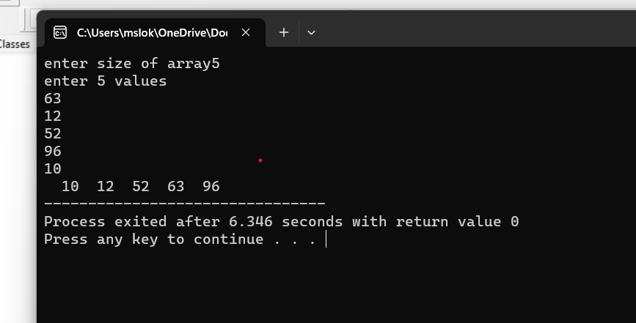

36.Insertion sort:

Program:

#include<stdio.h>

int main()

{

int a[10],i,j,t,n;

printf("enter size of array");

scanf("%d",&n);

printf("enter %d values\n",n);

for(i=0;i<n;i++)

scanf("%d",&a[i]);

for(i=1;i<n;i++)

{

t=a[i];

j=i-1;

while(j>=0 && a[j]>t) //dack traversal

{

a[j+1]=a[j];

j--;

}

a[j+1]=t;

}

for(i=0;i<n;i++)

printf("%4d",a[i]);

}

Output:

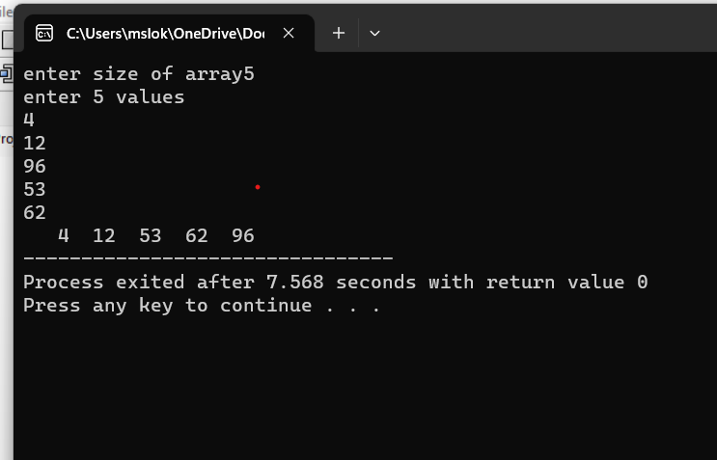

37.Selection sort:

Program:

#include<stdio.h>

int main()

{

int a[10],i,j,min,n,t;

printf("enter size of array");

scanf("%d",&n);

printf("enter %d values\n",n);

for(i=0;i<n;i++)

scanf("%d",&a[i]);

for(i=0;i<n-1;i++)

{

min=i;

for(j=i+1;j<n;j++)

{

if(a[j]<a[min])

{

min=j;

}

}

if(min!=i)

{

t=a[i];

a[i]=a[min];

a[min]=t;

}

}

for(i=0;i<n;i++)

printf("%4d",a[i]);

}

Output:

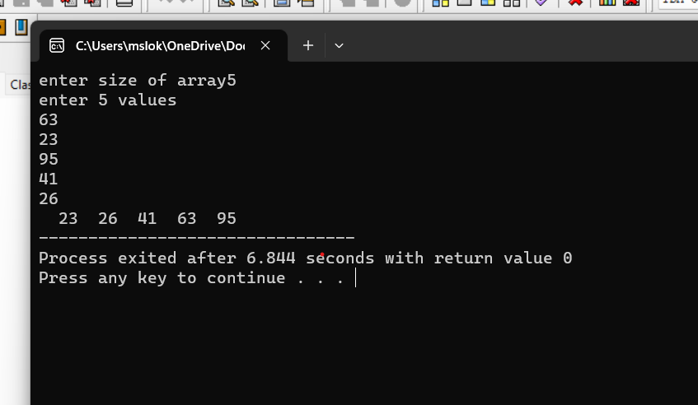

38. Write a c program to implement Quick sort.

Program:

#include<stdio.h>

int a,ub,lb;

void swap(int \*x,int \*y)

{

int t;

t=\*x;

\*x=\*y;

\*y=t;

}

int partition(int a[],int lb,int ub)

{

int pivot;

int s,e;

pivot=a[lb];

s=lb;

e=ub;

while(s<e)

{

while(a[s]<=pivot)

{

s++;

}

while(a[e]>pivot)

{

e--;

}

if(s<e)

{

swap(&a[s],&a[e]);

}

}

swap(&a[lb],&a[e]);

return e;

}

void quicksort(int a[],int lb,int ub)

{

if(lb<ub)

{

int l=partition(a,lb,ub);

quicksort(a,lb,l-1);

quicksort(a,l+1,ub);

}

}

int main()

{

int i, a[50],n,lb,ub;

printf("enter size of array");

scanf("%d",&n);

printf("enter elements\n");

for(i=0;i<n;i++)

scanf("%d",&a[i]);

lb=0,ub=n-1;

quicksort(a,lb,ub);

for(i=0;i<n;i++)

printf("%d ",a[i]);

}

Output:

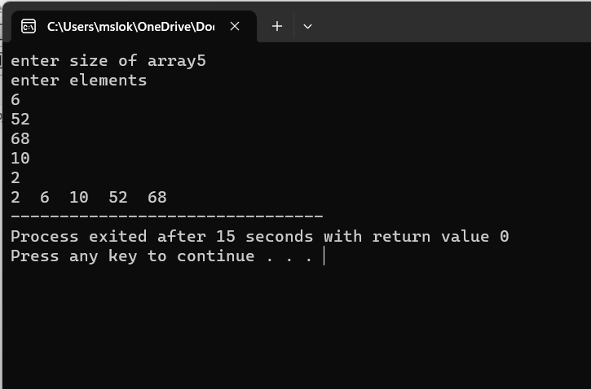

39.Write a C program to implement Merge sort

Program:

#include <stdio.h>

void merge(int arr[], int left, int mid, int right) {

int i, j, k;

int n1 = mid - left + 1;

int n2 = right - mid;

int L[n1], R[n2];

for (i = 0; i < n1; i++)

L[i] = arr[left + i];

for (j = 0; j < n2; j++)

R[j] = arr[mid + 1 + j];

i = 0;

j = 0;

k = left;

while (i < n1 && j < n2) {

if (L[i] <= R[j]) {

arr[k] = L[i];

i++;

} else {

arr[k] = R[j];

j++;

}

k++;

}

while (i < n1) {

arr[k] = L[i];

i++;

k++;

}

while (j < n2) {

arr[k] = R[j];

j++;

k++;

}

}

void mergeSort(int arr[], int left, int right) {

if (left < right) {

int mid = left + (right - left) / 2;

mergeSort(arr, left, mid);

mergeSort(arr, mid + 1, right);

merge(arr, left, mid, right);

}

}

int main() {

int n;

printf("Enter the number of elements: ");

scanf("%d", &n);

int arr[n];

printf("Enter %d elements:\n", n);

for (int i = 0; i < n; i++) {

scanf("%d", &arr[i]);

}

mergeSort(arr, 0, n - 1);

printf("Sorted array:\n");

for (int i = 0; i < n; i++) {

printf("%d ", arr[i]);

}

printf("\n");

return 0;

}

Output:

