1. **Create a new process by invoking the appropriate system call. Get the process identifier of the currently running process and its respective parent using system calls and display the same using a C program.**

#include<stdio.h>

#include<unistd.h>

int main()

{

printf("Process ID: %d\n", getpid() );

printf("Parent Process ID: %d\n", getpid() );

return 0;

}

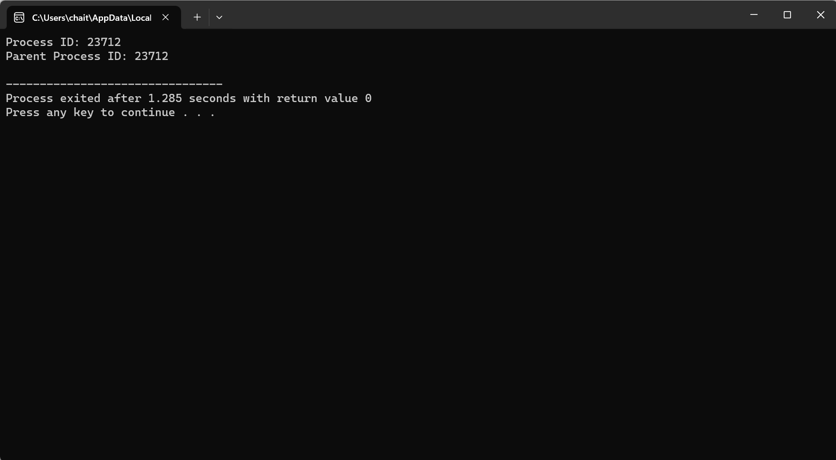

1. **Identify the system calls to copy the content of one file to another and illustrate the same using a C program.**

#include <stdio.h>

#include <stdlib.h>

#include <string.h>

void trimNewline(char* string) {

size_t length = strlen(string);

if (length > 0 && string[length - 1] == '\n') {

string[length - 1] = '\0';

}

}

int main() {

FILE *fptr1, *fptr2;

char readPath[1000], writePath[1000], readFilename[100], writeFilename[100];

char readFullPath[1100], writeFullPath[1100];

// For reading

printf("Enter the full directory path to open for reading (e.g., C:\\Users\\YourUsername\\Desktop):\n");

fgets(readPath, sizeof(readPath), stdin);

trimNewline(readPath); // Remove the newline character

printf("Enter the filename to open for reading:\n");

fgets(readFilename, sizeof(readFilename), stdin);

trimNewline(readFilename); // Remove the newline character

snprintf(readFullPath, sizeof(readFullPath), "%s\\%s", readPath, readFilename);

fptr1 = fopen(readFullPath, "r");

if (fptr1 == NULL) {

printf("Cannot open file %s\n", readFullPath);

exit(0);

}

// For writing

printf("Enter the full directory path to open for writing (e.g., C:\\Users\\YourUsername\\Desktop):\n");

fgets(writePath, sizeof(writePath), stdin);

trimNewline(writePath); // Remove the newline character

printf("Enter the filename to open for writing:\n");

fgets(writeFilename, sizeof(writeFilename), stdin);

trimNewline(writeFilename); // Remove the newline character

snprintf(writeFullPath, sizeof(writeFullPath), "%s\\%s", writePath, writeFilename);

fptr2 = fopen(writeFullPath, "w");

if (fptr2 == NULL) {

printf("Cannot open file %s\n", writeFullPath);

exit(0);

}

// Copying contents

char c = fgetc(fptr1);

while (c != EOF) {

fputc(c, fptr2);

c = fgetc(fptr1);

}

printf("\nContents copied to %s\n", writeFullPath);

fclose(fptr1);

fclose(fptr2);

return 0;

}

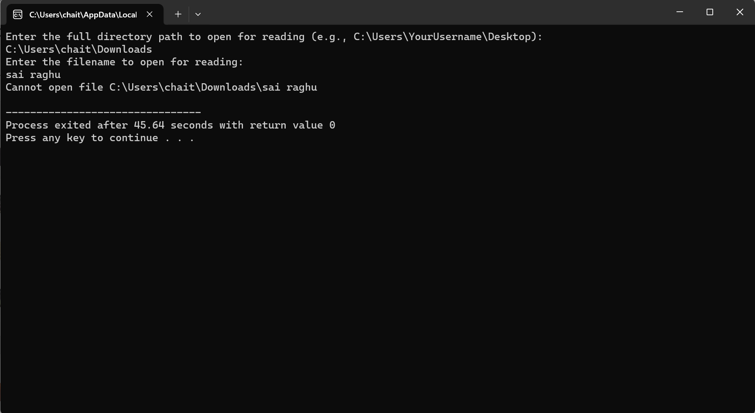

1. **Design a CPU scheduling program with C using First Come First Served technique with the following considerations. a. All processes are activated at time0. b. Assume that no process waits on I/O devices.**

#include <stdio.h>

int main() {

int processes[100][3]; // Array to store process details: [Process ID, Burst Time, Waiting Time]

int n, i, j, total_waiting_time = 0, total_turnaround_time = 0;

printf("Enter number of processes: ");

scanf("%d", &n);

// Input burst times for each process

printf("Enter Burst Time for each process:\n");

for (i = 0; i < n; i++) {

printf("P%d: ", i + 1);

scanf("%d", &processes[i][1]); // Index 1 stores Burst Time

processes[i][0] = i + 1; // Index 0 stores Process ID

}

// Calculate waiting time for each process

processes[0][2] = 0; // First process has 0 waiting time

for (i = 1; i < n; i++) {

processes[i][2] = processes[i - 1][2] + processes[i - 1][1]; // Waiting Time = Previous Waiting Time + Previous Burst Time

total_waiting_time += processes[i][2];

}

// Calculate turnaround time and display process details

printf("Process Burst Time Waiting Time Turnaround Time\n");

for (i = 0; i < n; i++) {

int turnaround_time = processes[i][1] + processes[i][2]; // Turnaround Time = Burst Time + Waiting Time

total_turnaround_time += turnaround_time;

printf("P%d\t\t%d\t\t%d\t\t%d\n", processes[i][0], processes[i][1], processes[i][2], turnaround_time);

}

// Calculate and display average waiting time and average turnaround time

float avg_waiting_time = (float)total_waiting_time / n;

float avg_turnaround_time = (float)total_turnaround_time / n;

printf("\nAverage Waiting Time= %.2f\n", avg_waiting_time);

printf("Average Turnaround Time= %.2f\n", avg_turnaround_time);

return 0;

}

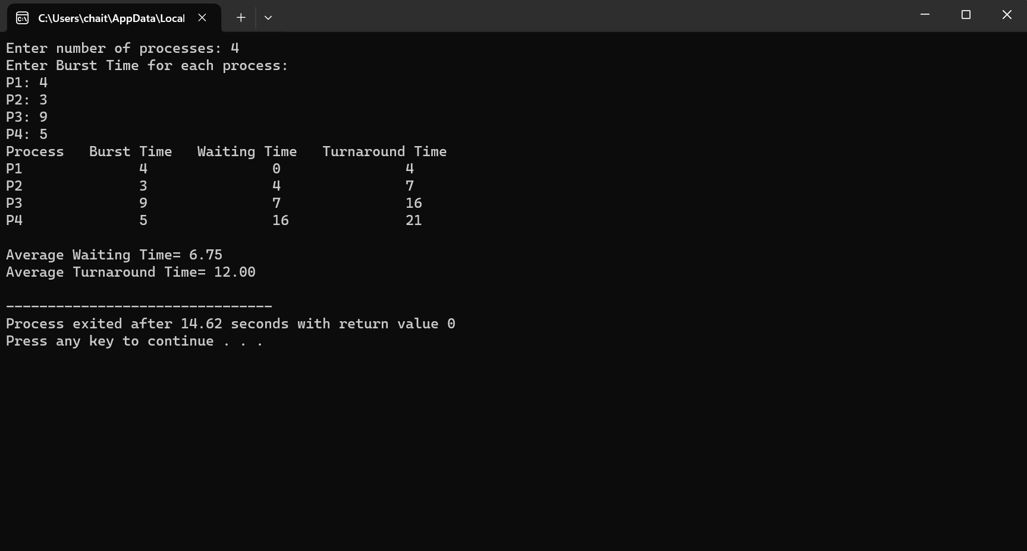

1. **Construct a scheduling program with C that selects the waiting process with the smallest execution time to execute next.**

#include<stdio.h>

int main() {

int bt[20], p[20], wt[20], tat[20], i, j, n, total = 0, pos, temp;

float avg_wt, avg_tat;

printf("Enter number of processes: ");

scanf("%d", &n);

printf("Enter Burst Time:\n");

for (i = 0; i < n; i++) {

printf("P%d: ", i + 1);

scanf("%d", &bt[i]);

p[i] = i + 1;

}

// Sort processes based on burst time (Selection Sort)

for (i = 0; i < n - 1; i++) {

pos = i;

for (j = i + 1; j < n; j++) {

if (bt[j] < bt[pos])

pos = j;

}

// Swap burst time and process IDs

temp = bt[i];

bt[i] = bt[pos];

bt[pos] = temp;

temp = p[i];

p[i] = p[pos];

p[pos] = temp;

}

wt[0] = 0; // Waiting time for the first process is always 0

total = 0;

// Calculate waiting time for each process

for (i = 1; i < n; i++) {

wt[i] = 0;

for (j = 0; j < i; j++)

wt[i] += bt[j];

total += wt[i];

}

avg_wt = (float)total / n; // Calculate average waiting time

total = 0;

printf("\nProcess Burst Time Waiting Time Turnaround Time\n");

for (i = 0; i < n; i++) {

tat[i] = bt[i] + wt[i]; // Calculate turnaround time

total += tat[i];

printf("P%d\t\t%d\t\t%d\t\t%d\n", p[i], bt[i], wt[i], tat[i]);

}

avg_tat = (float)total / n; // Calculate average turnaround time

printf("\nAverage Waiting Time= %.2f\n", avg_wt);

printf("Average Turnaround Time= %.2f\n", avg_tat);

return 0;

}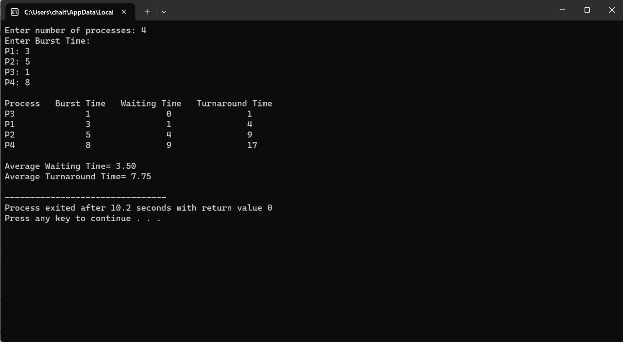

1. **Construct a scheduling program with C that selects the waiting process with the highest priority to execute next.**

#include<stdio.h>

struct Process {

char process_name;

int burst_time;

int waiting_time;

int turn_around_time;

int priority;

};

int main() {

int number_of_processes;

int total_waiting_time = 0;

struct Process temp_process;

int ASCII_number = 65;

int position;

float average_waiting_time;

float average_turnaround_time;

printf("Enter the total number of Processes: ");

scanf("%d", &number_of_processes);

struct Process processes[number_of_processes];

printf("\nPlease Enter the Burst Time and Priority of each process:\n");

for (int i = 0; i < number_of_processes; i++) {

processes[i].process_name = (char) ASCII_number;

printf("\nEnter the details of the process %c\n", processes[i].process_name);

printf("Enter the burst time: ");

scanf("%d", &processes[i].burst_time);

printf("Enter the priority: ");

scanf("%d", &processes[i].priority);

ASCII_number++;

}

// Sort processes based on priority (Highest priority first)

for (int i = 0; i < number_of_processes - 1; i++) {

position = i;

for (int j = i + 1; j < number_of_processes; j++) {

if (processes[j].priority > processes[position].priority)

position = j;

}

temp_process = processes[i];

processes[i] = processes[position];

processes[position] = temp_process;

}

processes[0].waiting_time = 0;

// Calculate waiting time for each process

for (int i = 1; i < number_of_processes; i++) {

processes[i].waiting_time = 0;

for (int j = 0; j < i; j++) {

processes[i].waiting_time += processes[j].burst_time;

}

total_waiting_time += processes[i].waiting_time;

}

average_waiting_time = (float) total_waiting_time / (float) number_of_processes;

// Calculate turnaround time for each process and display process details

printf("\n\nProcess_name\tBurst Time\tWaiting Time\tTurnaround Time\n");

printf("-----------------------------------------------------------\n");

int total_turnaround_time = 0;

for (int i = 0; i < number_of_processes; i++) {

processes[i].turn_around_time = processes[i].burst_time + processes[i].waiting_time;

total_turnaround_time += processes[i].turn_around_time;

printf("\t%c\t\t%d\t\t%d\t\t%d\n", processes[i].process_name, processes[i].burst_time, processes[i].waiting_time, processes[i].turn_around_time);

printf("-----------------------------------------------------------\n");

}

average_turnaround_time = (float) total_turnaround_time / (float) number_of_processes;

printf("\nAverage Waiting Time: %.2f\n", average_waiting_time);

printf("Average Turnaround Time: %.2f\n", average_turnaround_time);

return 0;

}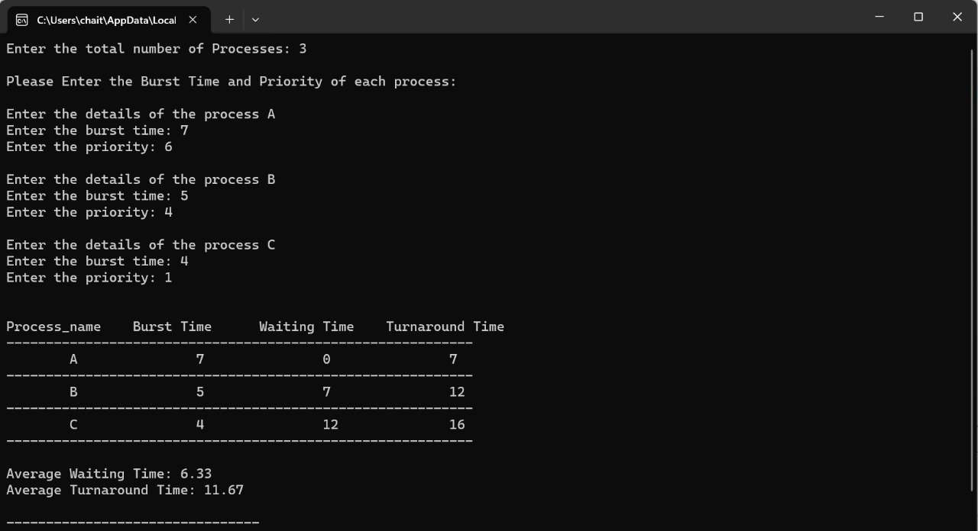

1. **Construct a C program to implement pre-emptive priority scheduling algorithm.**

#include<stdio.h>

int main()

{

int i, NOP, sum=0, count=0, y, quant, wt=0, tat=0, at[10], bt[10], temp[10];

float avg_wt, avg_tat;

printf("Total number of processes in the system: ");

scanf("%d", &NOP);

y = NOP;

// Input arrival and burst time for each process

for(i=0; i<NOP; i++)

{

printf("\nEnter the Arrival and Burst time of Process[%d]\n", i+1);

printf("Arrival time: ");

scanf("%d", &at[i]);

printf("Burst time: ");

scanf("%d", &bt[i]);

temp[i] = bt[i];

}

printf("Enter the Time Quantum for the process: ");

scanf("%d", &quant);

// Sorting processes based on arrival time

for(i=0; i<NOP-1; i++) {

for(int j=i+1; j<NOP; j++) {

if(at[i] > at[j]) {

int temp = at[i];

at[i] = at[j];

at[j] = temp;

temp = bt[i];

bt[i] = bt[j];

bt[j] = temp;

}

}

}

printf("\nProcess No\tBurst Time\tTAT\tWaiting Time\n");

for(sum=0, i = 0; y!=0; )

{

if(temp[i] <= quant && temp[i] > 0)

{

sum = sum + temp[i];

temp[i] = 0;

count=1;

}

else if(temp[i] > 0)

{

temp[i] = temp[i] - quant;

sum = sum + quant;

}

if(temp[i]==0 && count==1)

{

y--;

printf("Process No[%d]\t\t%d\t\t%d\t\t%d\n", i+1, bt[i], sum-at[i], sum-at[i]-bt[i]);

wt = wt + sum - at[i] - bt[i];

tat = tat + sum - at[i];

count = 0;

}

i = (i + 1) % NOP;

}

avg_wt = (float)wt / NOP;

avg_tat = (float)tat / NOP;

printf("\nAverage Turn Around Time: %.2f", avg_tat);

printf("\nAverage Waiting Time: %.2f\n", avg_wt);

return 0;

} 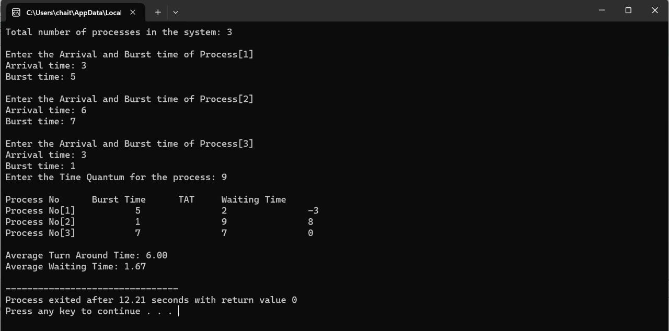

1. **Construct a C program to implement non-preemptive SJF algorithm.**

#include <stdio.h>

// Process structure

typedef struct {

int process_id;

int arrival_time;

int burst_time;

} Process;

// Function to perform non-preemptive SJF scheduling

void sjf(Process processes[], int n) {

int waiting_time[n], turnaround_time[n];

// Initialize waiting time and turnaround time arrays

for (int i = 0; i < n; i++) {

waiting_time[i] = 0;

turnaround_time[i] = 0;

}

// Sort processes based on arrival time

for (int i = 0; i < n - 1; i++) {

for (int j = 0; j < n - i - 1; j++) {

if (processes[j].arrival_time > processes[j + 1].arrival_time) {

Process temp = processes[j];

processes[j] = processes[j + 1];

processes[j + 1] = temp;

}

}

}

int total_waiting_time = 0;

int total_turnaround_time = 0;

int current_time = 0;

// Calculate waiting time and turnaround time

for (int i = 0; i < n; i++) {

// Calculate waiting time for current process

waiting_time[i] = current_time - processes[i].arrival_time;

if (waiting_time[i] < 0)

waiting_time[i] = 0;

// Calculate turnaround time for current process

turnaround_time[i] = waiting_time[i] + processes[i].burst_time;

// Update current time

current_time += processes[i].burst_time;

// Update total waiting time and total turnaround time

total_waiting_time += waiting_time[i];

total_turnaround_time += turnaround_time[i];

}

// Calculate average waiting time and average turnaround time

float avg_waiting_time = (float)total_waiting_time / n;

float avg_turnaround_time = (float)total_turnaround_time / n;

// Print results

printf("Process\tArrival Time\tBurst Time\tWaiting Time\tTurnaround Time\n");

for (int i = 0; i < n; i++) {

printf("%d\t%d\t\t%d\t\t%d\t\t%d\n", processes[i].process_id, processes[i].arrival_time, processes[i].burst_time, waiting_time[i], turnaround_time[i]);

}

printf("Average Waiting Time: %.2f\n", avg_waiting_time);

printf("Average Turnaround Time: %.2f\n", avg_turnaround_time);

}

int main() {

int n;

printf("Enter the number of processes: ");

scanf("%d", &n);

// Array to store processes

Process processes[n];

// Input process details

for (int i = 0; i < n; i++) {

printf("Enter arrival time and burst time for process %d: ", i + 1);

scanf("%d %d", &processes[i].arrival_time, &processes[i].burst_time);

processes[i].process_id = i + 1;

}

sjf(processes, n);

return 0;

}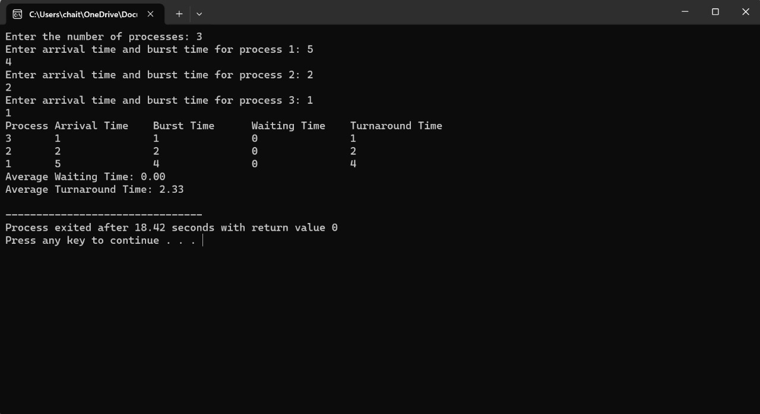

1. **Construct a C program to simulate Round Robin scheduling algorithm with C.**

#include<stdio.h>

#include<stdlib.h>

#define MAX_PROCESSES 10

struct Process {

int id;

int priority;

};

// Function to select the process with the highest priority

struct Process selectHighestPriority(struct Process processes[], int n) {

struct Process highestPriorityProcess = processes[0];

for (int i = 1; i < n; i++) {

if (processes[i].priority > highestPriorityProcess.priority) {

highestPriorityProcess = processes[i];

}

}

return highestPriorityProcess;

}

int main() {

struct Process processes[MAX_PROCESSES];

int n;

// Input the number of processes

printf("Enter the number of processes: ");

scanf("%d", &n);

// Input details of each process

printf("Enter details of each process:\n");

for (int i = 0; i < n; i++) {

printf("Process %d:\n", i + 1);

processes[i].id = i + 1;

printf("Priority: ");

scanf("%d", &processes[i].priority);

}

// Select the process with the highest priority

struct Process nextProcess = selectHighestPriority(processes, n);

// Display the selected process

printf("Process with the highest priority:\n");

printf("ID: %d\n", nextProcess.id);

printf("Priority: %d\n", nextProcess.priority);

return 0;

}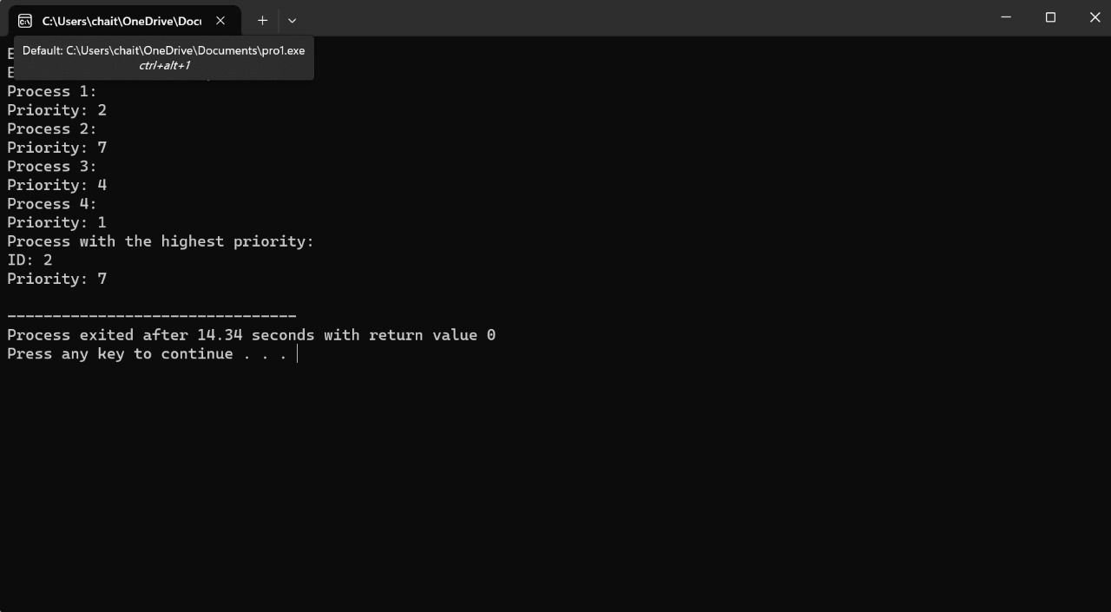

1. **Illustrate the concept of inter-process communication using shared memory with a C program.**

#include <stdio.h>

#include <stdlib.h>

#include <unistd.h>

#include <string.h>

#include <sys/ipc.h>

#include <sys/shm.h>

#include <errno.h>

#define SHM_SIZE 1024

int main() {

int shmid;

key_t key;

char *shm_ptr;

char buffer[SHM_SIZE];

// Generate a unique key

key = ftok(".", 'a');

if (key == -1) {

perror("ftok");

exit(EXIT_FAILURE);

}

// Create a shared memory segment

shmid = shmget(key, SHM_SIZE, IPC_CREAT | 0666);

if (shmid == -1) {

perror("shmget");

exit(EXIT_FAILURE);

}

// Attach the shared memory segment

shm_ptr = shmat(shmid, NULL, 0);

if (shm_ptr == (char *)-1) {

perror("shmat");

exit(EXIT_FAILURE);

}

// Writing data to the shared memory

printf("Enter data to write to shared memory: ");

if (fgets(buffer, sizeof(buffer), stdin) == NULL) {

perror("fgets");

exit(EXIT_FAILURE);

}

strncpy(shm_ptr, buffer, SHM_SIZE - 1); // Ensure null-terminated string

shm_ptr[SHM_SIZE - 1] = '\0'; // Null terminate explicitly

// Notify the reader that data is ready

printf("Data has been written to shared memory. Notifying the reader.\n");

*shm_ptr = '%'; // Notify by writing to shared memory

shm_ptr = NULL; // Reset shm_ptr

// Wait for the reader to finish reading

while (1) {

shm_ptr = shmat(shmid, NULL, 0); // Reattach the shared memory segment

if (shm_ptr == (char *)-1) {

perror("shmat");

exit(EXIT_FAILURE);

}

if (*shm_ptr == '%') {

break;

}

sleep(1);

}

// Detach the shared memory segment

if (shmdt(shm_ptr) == -1) {

perror("shmdt");

exit(EXIT_FAILURE);

}

// Delete the shared memory segment

if (shmctl(shmid, IPC_RMID, NULL) == -1) {

perror("shmctl");

exit(EXIT_FAILURE);

}

return 0;

}

THIS QUESTION CAN YOU USE THE ONLINE COMPILER

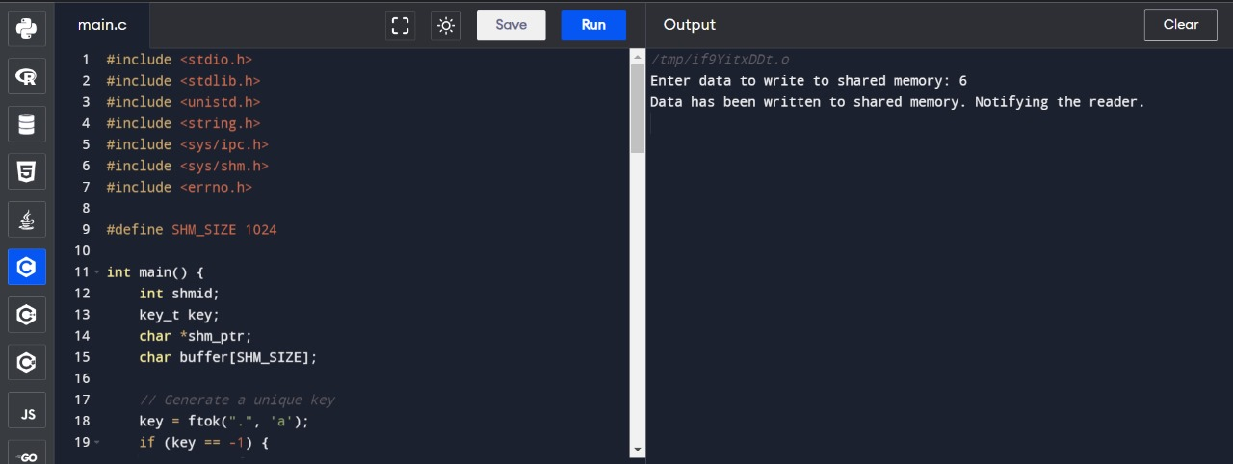

1. **Illustrate the concept of inter process communication using message queue with a C program.**

#include <stdio.h>

#include <stdlib.h>

#include <string.h>

#include <sys/msg.h>

#include <sys/ipc.h>

#include <unistd.h>

#include <errno.h>

#define MAX_MSG_SIZE 128

// Define a structure for the message

struct message {

long mtype;

char mtext[MAX_MSG_SIZE];

};

int main() {

key_t key;

int msgid;

struct message msg;

// Generate a unique key for the message queue

key = ftok(".", 'a');

if (key == -1) {

perror("ftok");

exit(EXIT_FAILURE);

}

// Create or access the message queue

msgid = msgget(key, 0666 | IPC_CREAT);

if (msgid == -1) {

perror("msgget");

exit(EXIT_FAILURE);

}

// Sender process

if (fork() == 0) {

// Construct message

msg.mtype = 1; // Message type

strcpy(msg.mtext, "Hello from sender!");

// Send message to the message queue

if (msgsnd(msgid, &msg, sizeof(msg.mtext), 0) == -1) {

perror("msgsnd");

exit(EXIT_FAILURE);

}

printf("Message sent from sender: %s\n", msg.mtext);

}

// Receiver process

else {

// Receive message from the message queue

if (msgrcv(msgid, &msg, sizeof(msg.mtext), 1, 0) == -1) {

perror("msgrcv");

exit(EXIT_FAILURE);

}

printf("Message received by receiver: %s\n", msg.mtext);

}

// Remove the message queue

if (msgctl(msgid, IPC_RMID, NULL) == -1) {

perror("msgctl");

exit(EXIT_FAILURE);

}

return 0;

}

THIS QUESTION CAN YOU USE THE ONLINE COMPILER

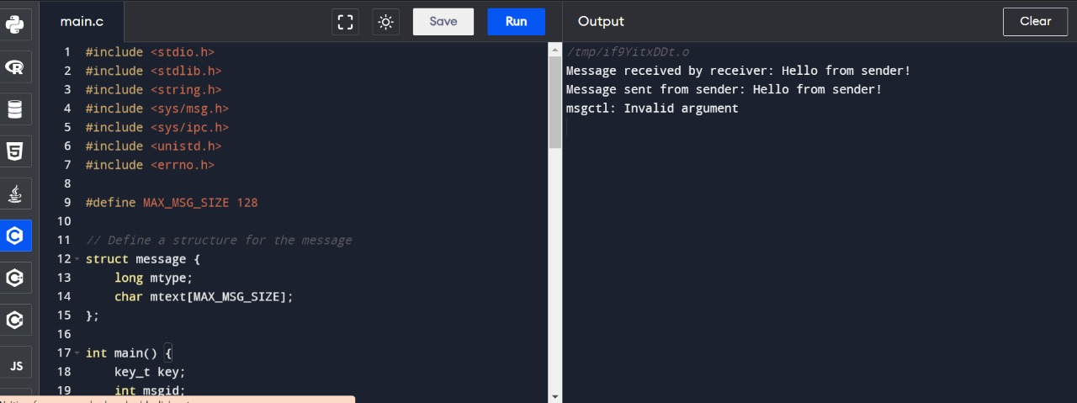

**11. Illustrate the concept of multi threading using a C program.**

#include <stdio.h>

#include <stdlib.h>

#include <pthread.h>

// Function executed by the first thread

void *threadFunction1(void *arg) {

printf("Thread 1 is running\n");

for (int i = 0; i < 5; i++) {

printf("Thread 1: %d\n", i);

}

printf("Thread 1 is finished\n");

return NULL;

}

// Function executed by the second thread

void *threadFunction2(void *arg) {

printf("Thread 2 is running\n");

for (int i = 0; i < 5; i++) {

printf("Thread 2: %d\n", i);

}

printf("Thread 2 is finished\n");

return NULL;

}

int main() {

pthread_t tid1, tid2; // Thread IDs

// Create the first thread

if (pthread_create(&tid1, NULL, threadFunction1, NULL) != 0) {

perror("pthread_create");

exit(EXIT_FAILURE);

}

// Create the second thread

if (pthread_create(&tid2, NULL, threadFunction2, NULL) != 0) {

perror("pthread_create");

exit(EXIT_FAILURE);

}

// Wait for the first thread to finish

if (pthread_join(tid1, NULL) != 0) {

perror("pthread_join");

exit(EXIT_FAILURE);

}

// Wait for the second thread to finish

if (pthread_join(tid2, NULL) != 0) {

perror("pthread_join");

exit(EXIT_FAILURE);

}

printf("Both threads have finished\n");

return 0;

}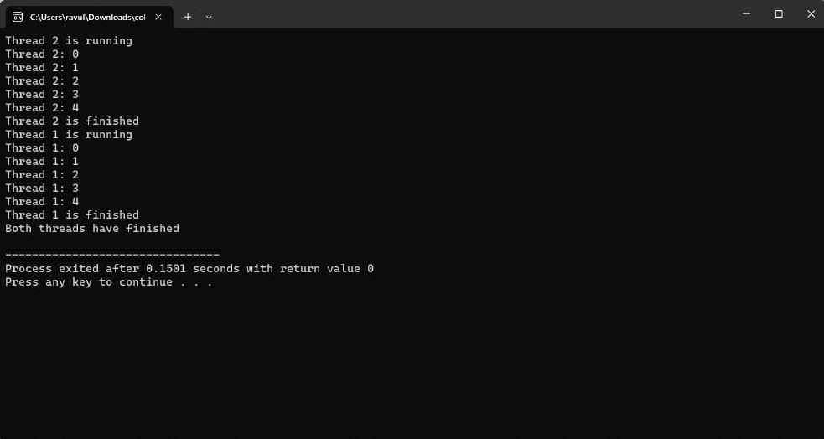

1. **Design a C program to simulate the concept of Dining-Philosophers problem.**

#include <stdio.h>

#include <stdlib.h>

#include <pthread.h>

#include <unistd.h>

#define NUM_PHILOSOPHERS 5

#define LEFT (id + NUM_PHILOSOPHERS - 1) % NUM_PHILOSOPHERS

#define RIGHT (id + 1) % NUM_PHILOSOPHERS

#define EATING_TIME 2

#define THINKING_TIME 1

pthread_mutex_t forks[NUM_PHILOSOPHERS];

void *philosopher(void *arg) {

int id = *(int *)arg;

while (1) {

printf("Philosopher %d is thinking\n", id);

sleep(THINKING_TIME);

printf("Philosopher %d is hungry\n", id);

pthread_mutex_lock(&forks[LEFT]);

pthread_mutex_lock(&forks[id]);

printf("Philosopher %d is eating\n", id);

sleep(EATING_TIME);

pthread_mutex_unlock(&forks[id]);

pthread_mutex_unlock(&forks[LEFT]);

}

return NULL;

}

int main() {

pthread_t threads[NUM_PHILOSOPHERS];

int ids[NUM_PHILOSOPHERS];

// Initialize mutexes

for (int i = 0; i < NUM_PHILOSOPHERS; i++) {

pthread_mutex_init(&forks[i], NULL);

}

// Create philosopher threads

for (int i = 0; i < NUM_PHILOSOPHERS; i++) {

ids[i] = i;

if (pthread_create(&threads[i], NULL, philosopher, &ids[i]) != 0) {

perror("pthread_create");

exit(EXIT_FAILURE);

}

}

// Join philosopher threads

for (int i = 0; i < NUM_PHILOSOPHERS; i++) {

if (pthread_join(threads[i], NULL) != 0) {

perror("pthread_join");

exit(EXIT_FAILURE);

}

}

// Destroy mutexes

for (int i = 0; i < NUM_PHILOSOPHERS; i++) {

pthread_mutex_destroy(&forks[i]);

}

return 0;

}

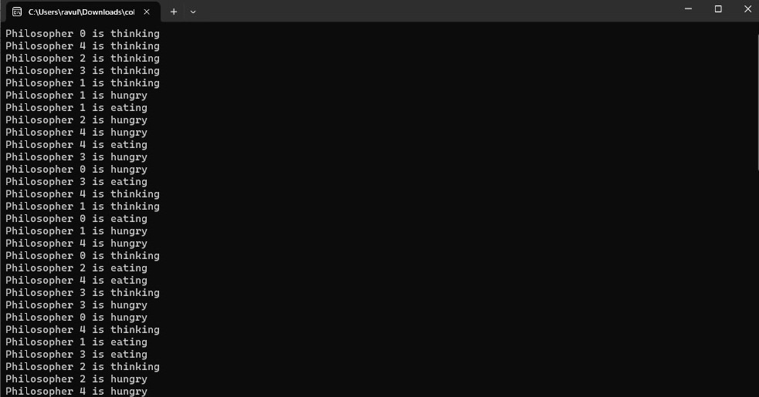

1. **Construct a C program for implementation the various memory allocation strategies.**

#include <stdio.h>

#include <stdlib.h>

#include <limits.h>

#define MEMORY_SIZE 100

// Memory block structure

struct MemoryBlock {

int id; // Process ID

int size; // Size of the memory block

int allocated; // Flag to indicate whether the block is allocated or free

};

// Function prototypes

void initializeMemory(struct MemoryBlock memory[], int size);

void printMemory(struct MemoryBlock memory[], int size);

void allocateFirstFit(struct MemoryBlock memory[], int size, int pid, int requestSize);

void allocateBestFit(struct MemoryBlock memory[], int size, int pid, int requestSize);

void allocateWorstFit(struct MemoryBlock memory[], int size, int pid, int requestSize);

int main() {

struct MemoryBlock memory[MEMORY_SIZE];

int choice, pid, requestSize;

// Initialize memory

initializeMemory(memory, MEMORY_SIZE);

// Menu

while (1) {

printf("\nMemory Allocation Strategies\n");

printf("1. First Fit\n");

printf("2. Best Fit\n");

printf("3. Worst Fit\n");

printf("4. Exit\n");

printf("Enter your choice: ");

scanf("%d", &choice);

switch (choice) {

case 1:

printf("Enter process ID and size: ");

scanf("%d %d", &pid, &requestSize);

allocateFirstFit(memory, MEMORY_SIZE, pid, requestSize);

break;

case 2:

printf("Enter process ID and size: ");

scanf("%d %d", &pid, &requestSize);

allocateBestFit(memory, MEMORY_SIZE, pid, requestSize);

break;

case 3:

printf("Enter process ID and size: ");

scanf("%d %d", &pid, &requestSize);

allocateWorstFit(memory, MEMORY_SIZE, pid, requestSize);

break;

case 4:

exit(EXIT_SUCCESS);

default:

printf("Invalid choice\n");

}

// Print memory after allocation

printMemory(memory, MEMORY_SIZE);

}

return 0;

}

// Initialize memory blocks as free

void initializeMemory(struct MemoryBlock memory[], int size) {

for (int i = 0; i < size; i++) {

memory[i].id = -1;

memory[i].size = 0;

memory[i].allocated = 0;

}

}

// Print memory blocks

void printMemory(struct MemoryBlock memory[], int size) {

printf("\nMemory Blocks:\n");

printf("%-8s %-8s %-8s %-12s\n", "Block", "ID", "Size", "Allocated");

for (int i = 0; i < size; i++) {

printf("%-8d %-8d %-8d %-12s\n", i, memory[i].id, memory[i].size,

memory[i].allocated ? "Allocated" : "Free");

}

}

// Allocate memory using First Fit strategy

void allocateFirstFit(struct MemoryBlock memory[], int size, int pid, int requestSize) {

int allocated = 0;

for (int i = 0; i < size; i++) {

if (!memory[i].allocated && memory[i].size >= requestSize) {

memory[i].id = pid;

memory[i].allocated = 1;

allocated = 1;

break;

}

}

if (!allocated)

printf("Memory allocation failed for process %d with size %d\n", pid, requestSize);

}

// Allocate memory using Best Fit strategy

void allocateBestFit(struct MemoryBlock memory[], int size, int pid, int requestSize) {

int bestFitIndex = -1;

int minFragmentation = INT_MAX;

for (int i = 0; i < size; i++) {

if (!memory[i].allocated && memory[i].size >= requestSize) {

int fragmentation = memory[i].size - requestSize;

if (fragmentation < minFragmentation) {

minFragmentation = fragmentation;

bestFitIndex = i;

}

}

}

if (bestFitIndex != -1) {

memory[bestFitIndex].id = pid;

memory[bestFitIndex].allocated = 1;

} else {

printf("Memory allocation failed for process %d with size %d\n", pid, requestSize);

}

}

// Allocate memory using Worst Fit strategy

void allocateWorstFit(struct MemoryBlock memory[], int size, int pid, int requestSize) {

int worstFitIndex = -1;

int maxFragmentation = INT_MIN;

for (int i = 0; i < size; i++) {

if (!memory[i].allocated && memory[i].size >= requestSize) {

int fragmentation = memory[i].size - requestSize;

if (fragmentation > maxFragmentation) {

maxFragmentation = fragmentation;

worstFitIndex = i;

}

}

}

if (worstFitIndex != -1) {

memory[worstFitIndex].id = pid;

memory[worstFitIndex].allocated = 1;

} else {

printf("Memory allocation failed for process %d with size %d\n", pid, requestSize);

}

}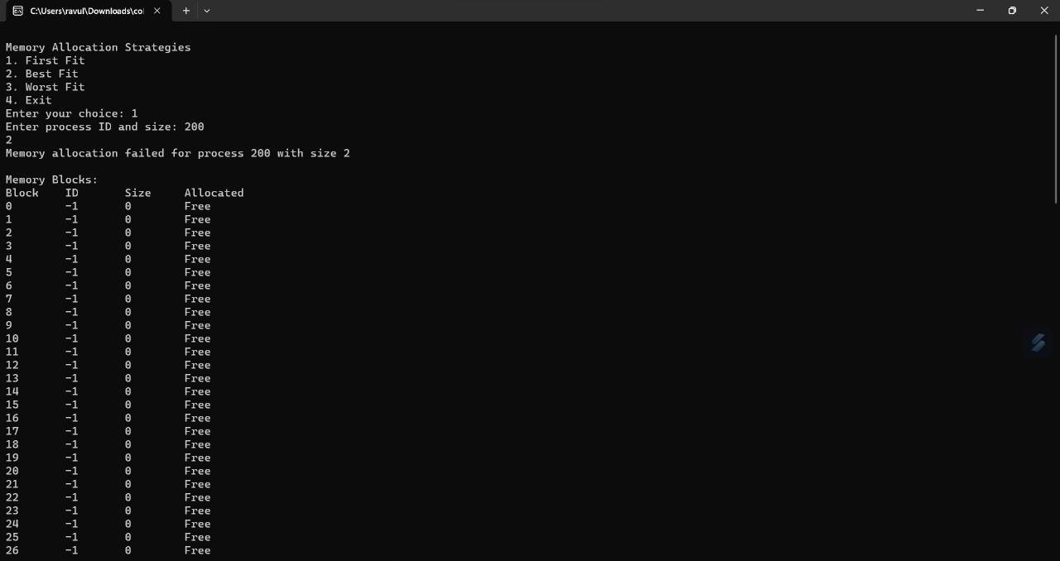

1. **Construct a C program to organize the file using single level directory.**

#include <stdio.h>

#include <stdlib.h>

#include <string.h>

#define MAX_FILENAME_LENGTH 50

// File structure

struct File {

int id;

char name[MAX_FILENAME_LENGTH];

};

// Directory structure

struct Directory {

struct File *files;

int fileCount;

int maxSize;

};

// Function prototypes

void initializeDirectory(struct Directory *dir, int maxSize);

void addFile(struct Directory *dir, int fileId, const char *fileName);

void deleteFile(struct Directory *dir, int fileId);

void listFiles(const struct Directory *dir);

void clearInputBuffer();

int main() {

struct Directory dir;

int choice, fileId;

char fileName[MAX_FILENAME_LENGTH];

// Initialize directory with a maximum capacity of 100 files

initializeDirectory(&dir, 100);

// Menu

while (1) {

printf("\nSingle-Level Directory Operations\n");

printf("1. Add File\n");

printf("2. Delete File\n");

printf("3. List Files\n");

printf("4. Exit\n");

printf("Enter your choice: ");

scanf("%d", &choice);

clearInputBuffer(); // Clear input buffer

switch (choice) {

case 1:

printf("Enter file ID and name: ");

scanf("%d %s", &fileId, fileName);

clearInputBuffer(); // Clear input buffer

addFile(&dir, fileId, fileName);

break;

case 2:

printf("Enter file ID to delete: ");

scanf("%d", &fileId);

clearInputBuffer(); // Clear input buffer

deleteFile(&dir, fileId);

break;

case 3:

listFiles(&dir);

break;

case 4:

// Free dynamically allocated memory before exiting

free(dir.files);

exit(EXIT_SUCCESS);

default:

printf("Invalid choice\n");

clearInputBuffer(); // Clear input buffer

}

}

return 0;

}

// Initialize directory

void initializeDirectory(struct Directory *dir, int maxSize) {

dir->fileCount = 0;

dir->maxSize = maxSize;

dir->files = (struct File *)malloc(maxSize * sizeof(struct File));

if (dir->files == NULL) {

printf("Memory allocation failed\n");

exit(EXIT_FAILURE);

}

}

// Add file to directory

void addFile(struct Directory *dir, int fileId, const char *fileName) {

if (dir->fileCount < dir->maxSize) {

struct File *file = &(dir->files[dir->fileCount]);

file->id = fileId;

strncpy(file->name, fileName, MAX_FILENAME_LENGTH - 1);

file->name[MAX_FILENAME_LENGTH - 1] = '\0'; // Ensure null-terminated string

printf("File '%s' added with ID %d\n", fileName, fileId);

dir->fileCount++;

} else {

printf("Cannot add file. Directory is full.\n");

}

}

// Delete file from directory

void deleteFile(struct Directory *dir, int fileId) {

int i, found = 0;

for (i = 0; i < dir->fileCount; i++) {

if (dir->files[i].id == fileId) {

printf("File '%s' with ID %d deleted\n", dir->files[i].name, fileId);

found = 1;

break;

}

}

if (found) {

for (int j = i; j < dir->fileCount - 1; j++) {

dir->files[j] = dir->files[j + 1];

}

dir->fileCount--;

} else {

printf("File with ID %d not found\n", fileId);

}

}

// List all files in directory

void listFiles(const struct Directory *dir) {

if (dir->fileCount == 0) {

printf("No files in directory\n");

} else {

printf("Files in Directory:\n");

for (int i = 0; i < dir->fileCount; i++) {

printf("File ID: %d, Name: %s\n", dir->files[i].id, dir->files[i].name);

}

}

}

// Function to clear input buffer

void clearInputBuffer() {

int c;

while ((c = getchar()) != '\n' && c != EOF);

}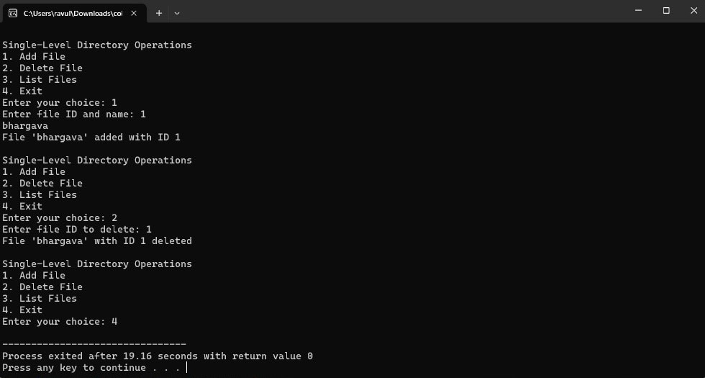

1. **Design a C program to organize the file using two level directory structure.**

#include <stdio.h>

#include <stdlib.h>

#include <string.h>

#include <unistd.h>

#include <sys/types.h>

#include <sys/stat.h>

#include <dirent.h>

#define MAX_FILENAME_LEN 256

#define MAX_FILES 100

void create_directory(const char *path) {

mkdir(path, 0777); // Creates a directory with full permissions

}

void organize_files(const char *source_dir, const char *dest_dir) {

// Create level1 directory

create_directory(dest_dir);

// Create level2 directories

for (int i = 0; i < 10; i++) {

char level2_dir[MAX_FILENAME_LEN];

snprintf(level2_dir, sizeof(level2_dir), "%s/level%d", dest_dir, i);

create_directory(level2_dir);

}

// Traverse source directory

DIR *dir;

struct dirent *entry;

dir = opendir(source_dir);

if (dir == NULL) {

perror("Error opening directory");

exit(EXIT_FAILURE);

}

// Process files

while ((entry = readdir(dir)) != NULL) {

if (entry->d_type == DT_REG) { // If it's a regular file

char source_file[MAX_FILENAME_LEN];

snprintf(source_file, sizeof(source_file), "%s/%s", source_dir, entry->d_name);

char dest_file[MAX_FILENAME_LEN];

snprintf(dest_file, sizeof(dest_file), "%s/level%d/%s", dest_dir, (entry->d_name[4] - '0'), entry->d_name); // Changed (entry->d_name[0] - '0') to (entry->d_name[4] - '0') to extract the file number correctly

rename(source_file, dest_file); // Move file to appropriate level2 directory

}

}

closedir(dir);

}

int main() {

const char *source_dir = "source";

const char *dest_dir = "level1";

// Create source directory

create_directory(source_dir);

// Simulate files in the source directory

FILE *fp;

char filename[MAX_FILENAME_LEN];

for (int i = 0; i < MAX_FILES; i++) {

snprintf(filename, sizeof(filename), "%s/file%d.txt", source_dir, i);

fp = fopen(filename, "w");

if (fp == NULL) {

perror("Error creating file");

exit(EXIT_FAILURE);

}

fclose(fp);

}

// Organize files

organize_files(source_dir, dest_dir);

printf("Files organized successfully!\n");

return 0;

}

THIS QUESTION CAN YOU USE THE ONLINE COMPILER

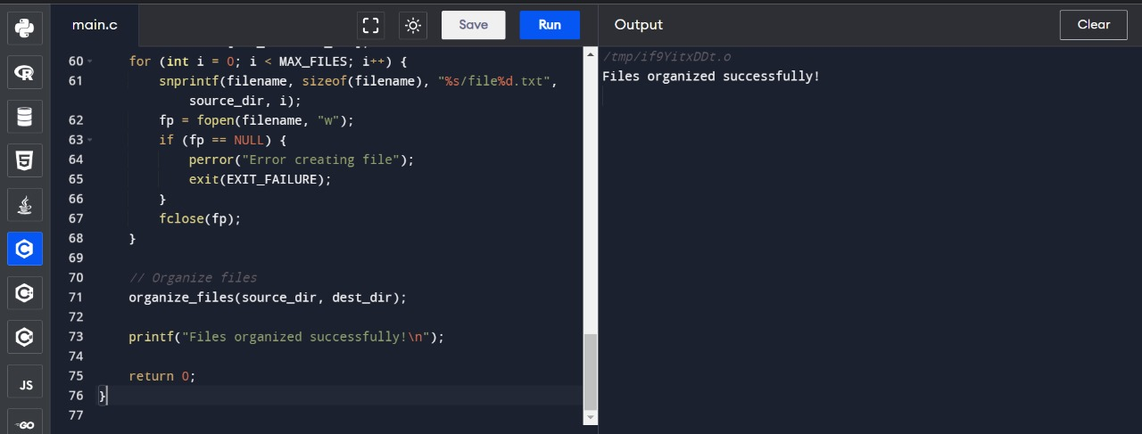

1. **Develop a C program for implementing random access file for processing the employee details.**

#include <stdio.h>

#include <stdlib.h>

#include <string.h>

#define MAX_EMPLOYEES 100

#define MAX_NAME_LENGTH 50

#define FILENAME "employees.dat"

// Structure to represent an employee

struct Employee {

int id;

char name[MAX_NAME_LENGTH];

float salary;

};

// Function to add a new employee record to the file

void addEmployee() {

FILE *file = fopen(FILENAME, "ab");

if (file == NULL) {

perror("Error opening file");

exit(EXIT_FAILURE);

}

struct Employee emp;

printf("Enter employee ID: ");

scanf("%d", &emp.id);

printf("Enter employee name: ");

scanf("%s", emp.name);

printf("Enter employee salary: ");

scanf("%f", &emp.salary);

fwrite(&emp, sizeof(struct Employee), 1, file);

fclose(file);

printf("Employee added successfully!\n");

}

// Function to search for an employee record by ID

void searchEmployee() {

FILE *file = fopen(FILENAME, "rb");

if (file == NULL) {

perror("Error opening file");

exit(EXIT_FAILURE);

}

int targetId;

printf("Enter employee ID to search: ");

scanf("%d", &targetId);

struct Employee emp;

int found = 0;

while (fread(&emp, sizeof(struct Employee), 1, file) == 1) {

if (emp.id == targetId) {

found = 1;

printf("Employee found!\n");

printf("ID: %d\n", emp.id);

printf("Name: %s\n", emp.name);

printf("Salary: %.2f\n", emp.salary);

break;

}

}

if (!found) {

printf("Employee not found!\n");

}

fclose(file);

}

// Function to update an existing employee record

void updateEmployee() {

FILE *file = fopen(FILENAME, "r+b");

if (file == NULL) {

perror("Error opening file");

exit(EXIT_FAILURE);

}

int targetId;

printf("Enter employee ID to update: ");

scanf("%d", &targetId);

struct Employee emp;

int found = 0;

while (fread(&emp, sizeof(struct Employee), 1, file) == 1) {

if (emp.id == targetId) {

found = 1;

printf("Enter new name: ");

scanf("%s", emp.name);

printf("Enter new salary: ");

scanf("%f", &emp.salary);

fseek(file, -sizeof(struct Employee), SEEK_CUR);

fwrite(&emp, sizeof(struct Employee), 1, file);

printf("Employee updated successfully!\n");

break;

}

}

if (!found) {

printf("Employee not found!\n");

}

fclose(file);

}

// Function to delete an existing employee record

void deleteEmployee() {

FILE *file = fopen(FILENAME, "r+b");

if (file == NULL) {

perror("Error opening file");

exit(EXIT_FAILURE);

}

int targetId;

printf("Enter employee ID to delete: ");

scanf("%d", &targetId);

struct Employee emp;

int found = 0;

while (fread(&emp, sizeof(struct Employee), 1, file) == 1) {

if (emp.id == targetId) {

found = 1;

emp.id = -1; // Marking as deleted

fseek(file, -sizeof(struct Employee), SEEK_CUR);

fwrite(&emp, sizeof(struct Employee), 1, file);

printf("Employee deleted successfully!\n");

break;

}

}

if (!found) {

printf("Employee not found!\n");

}

fclose(file);

}

// Main function to demonstrate the functionality

int main() {

int choice;

do {

printf("\nEmployee Management System\n");

printf("1. Add Employee\n");

printf("2. Search Employee\n");

printf("3. Update Employee\n");

printf("4. Delete Employee\n");

printf("5. Exit\n");

printf("Enter your choice: ");

scanf("%d", &choice);

switch (choice) {

case 1:

addEmployee();

break;

case 2:

searchEmployee();

break;

case 3:

updateEmployee();

break;

case 4:

deleteEmployee();

break;

case 5:

printf("Exiting...\n");

break;

default:

printf("Invalid choice! Please try again.\n");

}

} while (choice != 5);

return 0;

}

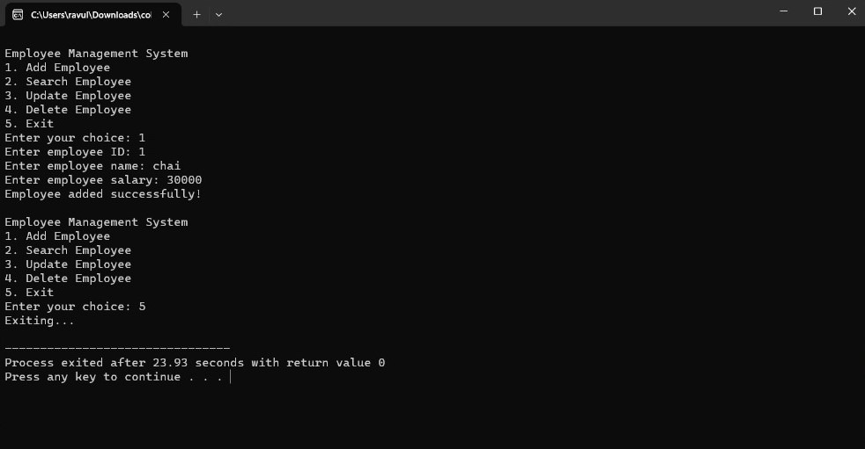

1. **Illustrate the deadlock avoidance concept by simulating Banker’s algorithm with C.**

#include <stdio.h>

#include <stdbool.h>

// Define the maximum number of processes and resources

#define MAX_P 10

#define MAX_R 10

// Function to calculate the need matrix

void calculateNeed(int need[MAX_P][MAX_R], int max[MAX_P][MAX_R], int alloc[MAX_P][MAX_R], int P, int R) {

for (int i = 0; i < P; i++)

for (int j = 0; j < R; j++)

need[i][j] = max[i][j] - alloc[i][j];

}

// Function to check if the requested resources are available

bool isSafe(int processes[], int avail[], int max[][MAX_R], int alloc[][MAX_R], int P, int R) {

int need[MAX_P][MAX_R];

calculateNeed(need, max, alloc, P, R);

bool finish[MAX_P] = {0};

int safeSeq[MAX_P];

int work[MAX_R];

for (int i = 0; i < R; i++)

work[i] = avail[i];

int count = 0;

while (count < P) {

bool found = false;

for (int p = 0; p < P; p++) {

if (!finish[p]) {

int j;

for (j = 0; j < R; j++)

if (need[p][j] > work[j])

break;

if (j == R) {

for (int k = 0; k < R; k++)

work[k] += alloc[p][k];

safeSeq[count++] = p;

finish[p] = true;

found = true;

}

}

}

if (!found) {

printf("System is not in safe state");

return false;

}

}

printf("System is in safe state.\nSafe sequence is: ");

for (int i = 0; i < P; i++)

printf("%d ", safeSeq[i]);

printf("\n");

return true;

}

// Main function

int main() {

int P, R;

printf("Enter number of processes: ");

scanf("%d", &P);

printf("Enter number of resources: ");

scanf("%d", &R);

int processes[MAX_P];

printf("Enter process IDs: ");

for (int i = 0; i < P; i++)

scanf("%d", &processes[i]);

// Available instances of resources

int available[MAX_R];

printf("Enter available instances of resources: ");

for (int i = 0; i < R; i++)

scanf("%d", &available[i]);

// Maximum R that can be allocated to processes

int max[MAX_P][MAX_R];

printf("Enter maximum resources that can be allocated to each process:\n");

for (int i = 0; i < P; i++) {

printf("For process %d: ", processes[i]);

for (int j = 0; j < R; j++)

scanf("%d", &max[i][j]);

}

// Resources allocated to processes

int allocation[MAX_P][MAX_R];

printf("Enter resources allocated to each process:\n");

for (int i = 0; i < P; i++) {

printf("For process %d: ", processes[i]);

for (int j = 0; j < R; j++)

scanf("%d", &allocation[i][j]);

}

// Check if the system is in safe state or not

isSafe(processes, available, max, allocation, P, R);

return 0;

}

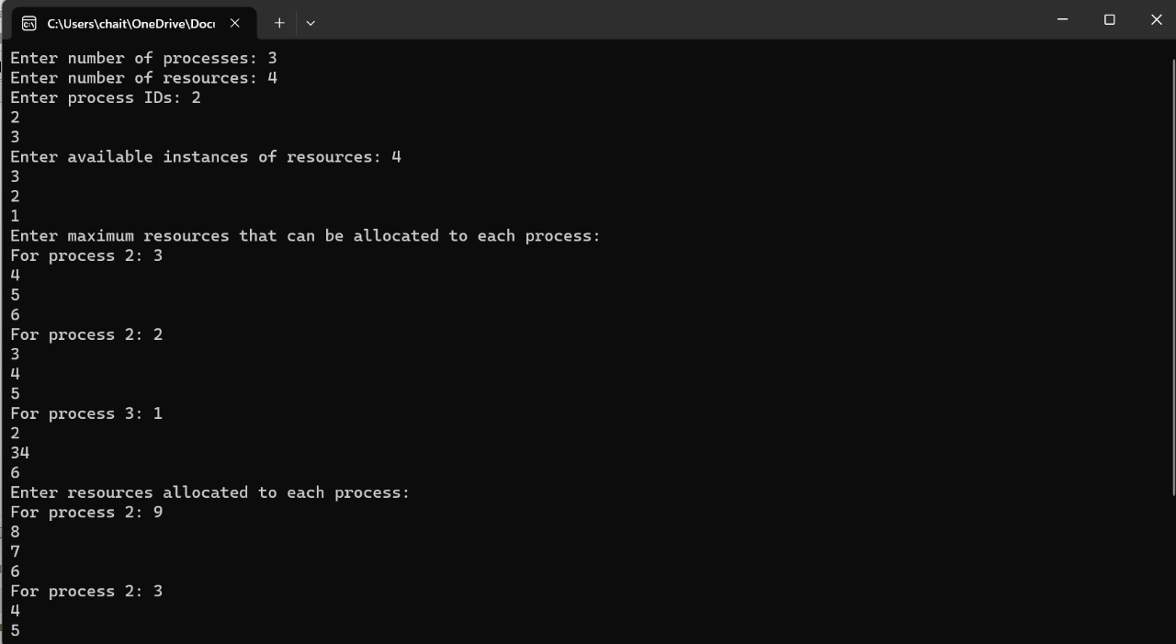

1. **Construct a C program to simulate producer-consumer problem using semaphores.**

#include <stdio.h>

#include <pthread.h>

#include <semaphore.h>

#include <unistd.h> // for usleep function

#define BUFFER_SIZE 5

sem_t empty, full;

pthread_mutex_t mutex;

int buffer[BUFFER_SIZE];

int in = 0, out = 0;

void *producer(void *arg) {

int item = 1;

while (1) {

sem_wait(&empty); // Wait for an empty slot in the buffer

pthread_mutex_lock(&mutex);

// Produce item

buffer[in] = item;

printf("Produced: %d\n", item);

item++;

in = (in + 1) % BUFFER_SIZE;

pthread_mutex_unlock(&mutex);

sem_post(&full); // Increment the count of full slots

usleep(500000); // Sleep for 500 milliseconds

}

pthread_exit(NULL);

}

void *consumer(void *arg) {

while (1) {

sem_wait(&full); // Wait for a full slot in the buffer

pthread_mutex_lock(&mutex);

// Consume item

int item = buffer[out];

printf("Consumed: %d\n", item);

out = (out + 1) % BUFFER_SIZE;

pthread_mutex_unlock(&mutex);

sem_post(&empty); // Increment the count of empty slots

usleep(500000); // Sleep for 500 milliseconds

}

pthread_exit(NULL);

}

int main() {

pthread_t producer_thread, consumer_thread;

pthread_mutex_init(&mutex, NULL);

sem_init(&empty, 0, BUFFER_SIZE); // Initialize empty semaphore with buffer size

sem_init(&full, 0, 0); // Initialize full semaphore with 0

// Create producer and consumer threads

pthread_create(&producer_thread, NULL, producer, NULL);

pthread_create(&consumer_thread, NULL, consumer, NULL);

// Wait for threads to finish (which will never happen, but for demonstration purpose)

pthread_join(producer_thread, NULL);

pthread_join(consumer_thread, NULL);

// Destroy semaphores and mutex

sem_destroy(&empty);

sem_destroy(&full);

pthread_mutex_destroy(&mutex);

return 0;

}

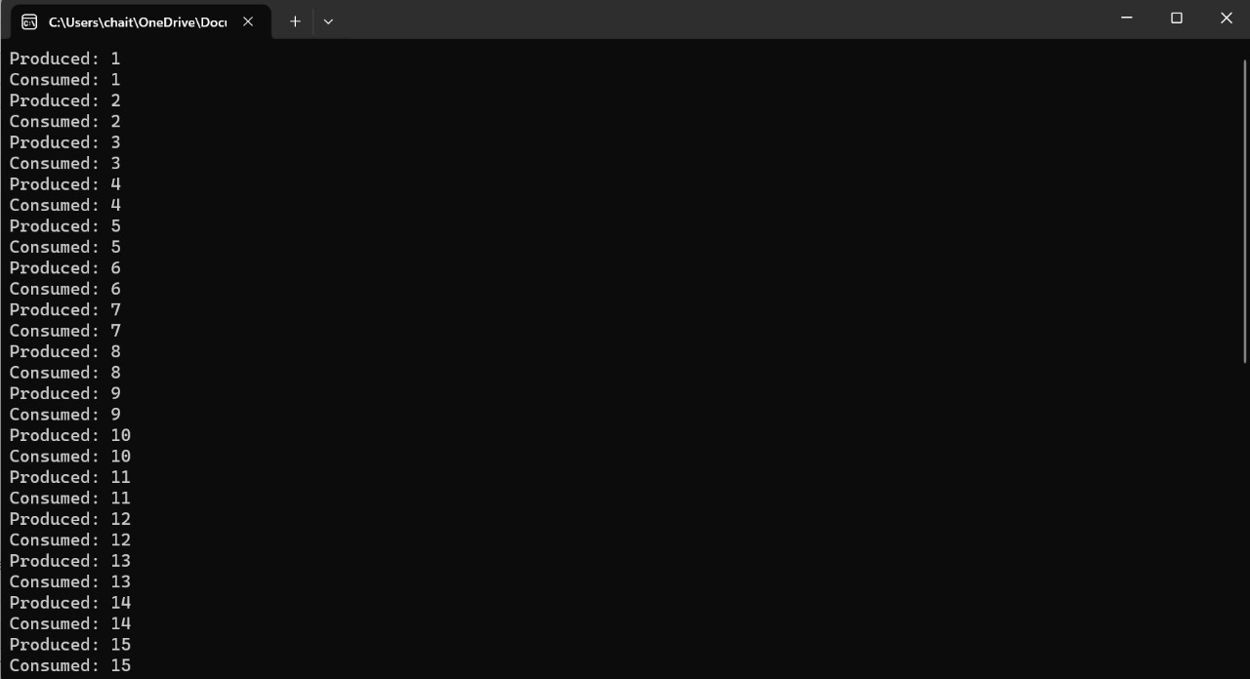

1. **Design a C program to implement process synchronization using mutex locks.**

#include <stdio.h>

#include <pthread.h>

#define NUM_THREADS 5

pthread_mutex_t mutex;

void *thread_function(void *thread_id) {

int tid = *((int*)thread_id);

// Lock the mutex before accessing shared resources

pthread_mutex_lock(&mutex);

// Critical section

printf("Thread %d is entering the critical section.\n", tid);

printf("Thread %d is in the critical section.\n", tid);

printf("Thread %d is leaving the critical section.\n", tid);

// Unlock the mutex after accessing shared resources

pthread_mutex_unlock(&mutex);

pthread_exit(NULL);

}

int main() {

pthread_t threads[NUM_THREADS];

int thread_ids[NUM_THREADS];

// Initialize the mutex

pthread_mutex_init(&mutex, NULL);

// Create threads

for (int i = 0; i < NUM_THREADS; ++i) {

thread_ids[i] = i;

pthread_create(&threads[i], NULL, thread_function, (void *)&thread_ids[i]);

}

// Join threads

for (int i = 0; i < NUM_THREADS; ++i) {

pthread_join(threads[i], NULL);

}

// Destroy the mutex

pthread_mutex_destroy(&mutex);

return 0;

}

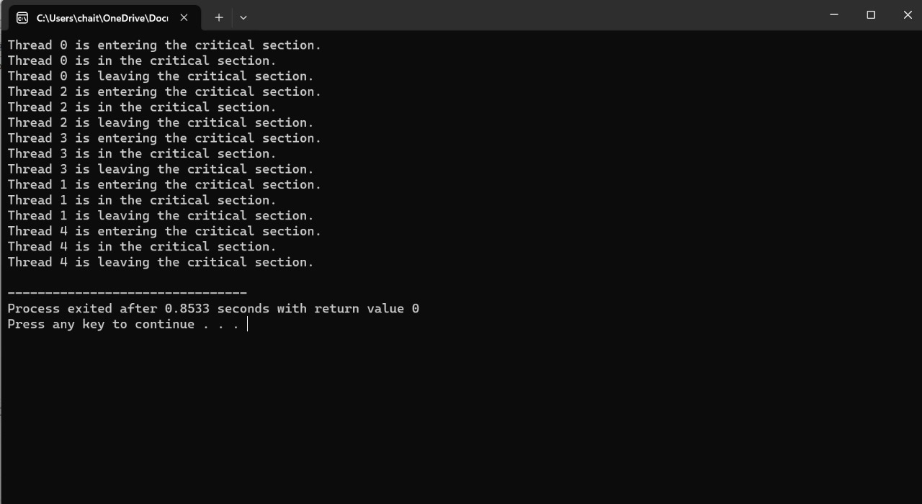

1. **Construct a C program to simulate Reader-Writer problem using Semaphores.**

#include <stdio.h>

#include <stdlib.h>

#include <dirent.h>

int main() {

DIR *directory;

struct dirent *entry;

// Open the current directory

directory = opendir(".");

if (directory == NULL) {

perror("Unable to open directory");

return EXIT_FAILURE;

}

// Read directory entries

while ((entry = readdir(directory)) != NULL) {

printf("%s\n", entry->d_name);

}

// Close the directory

closedir(directory);

return EXIT_SUCCESS;

}

THIS QUESTION CAN YOU USE THE ONLINE COMPILER

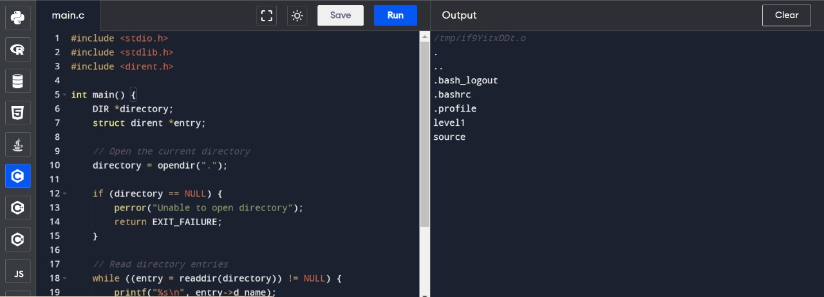

1. **Develop a C program to implement worst fit algorithm of memory management.**

#include <stdio.h>

#include <stdlib.h>

#define MAX_MEMORY 100

struct memory_block {

int size;

int allocated;

};

void worstFit(struct memory_block mem[], int n, int process_size) {

int i, worstFitIdx = -1;

for (i = 0; i < n; i++) {

if (!mem[i].allocated && mem[i].size >= process_size) {

if (worstFitIdx == -1 || mem[i].size > mem[worstFitIdx].size) {

worstFitIdx = i;

}

}

}

if (worstFitIdx != -1) {

mem[worstFitIdx].allocated = 1;

printf("Memory allocated successfully at position %d\n", worstFitIdx);

} else {

printf("No memory block available for allocation\n");

}

}

int main() {

int n, i, process_size;

printf("Enter the number of memory blocks: ");

scanf("%d", &n);

struct memory_block mem[MAX_MEMORY];

printf("Enter the size of each memory block:\n");

for (i = 0; i < n; i++) {

scanf("%d", &mem[i].size);

mem[i].allocated = 0;

}

printf("Enter the size of the process to be allocated: ");

scanf("%d", &process_size);

worstFit(mem, n, process_size);

return 0;

}

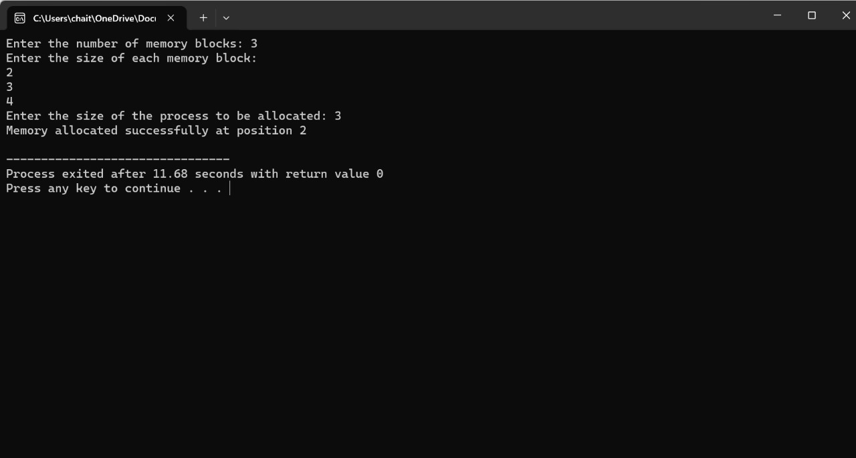

1. **Construct a C program to implement best fit algorithm of memory management.**

#include <stdio.h>

#include <stdlib.h>

#define MAX_MEMORY 100

struct memory_block {

int size;

int allocated;

};

void bestFit(struct memory_block mem[], int n, int process_size) {

int i, bestFitIdx = -1;

for (i = 0; i < n; i++) {

if (!mem[i].allocated && mem[i].size >= process_size) {

if (bestFitIdx == -1 || mem[i].size < mem[bestFitIdx].size) {

bestFitIdx = i;

}

}

}

if (bestFitIdx != -1) {

mem[bestFitIdx].allocated = 1;

printf("Memory allocated successfully at position %d\n", bestFitIdx);

} else {

printf("No memory block available for allocation\n");

}

}

int main() {

int n, i, process_size;

printf("Enter the number of memory blocks: ");

scanf("%d", &n);

struct memory_block mem[MAX_MEMORY];

printf("Enter the size of each memory block:\n");

for (i = 0; i < n; i++) {

scanf("%d", &mem[i].size);

mem[i].allocated = 0;

}

printf("Enter the size of the process to be allocated: ");

scanf("%d", &process_size);

bestFit(mem, n, process_size);

return 0;

}

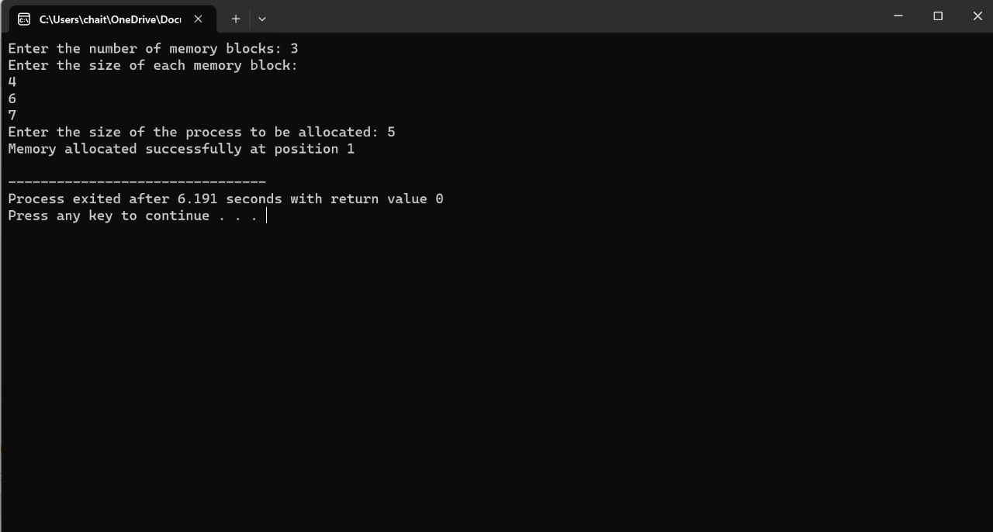

1. **Construct a C program to implement first fit algorithm of memory management.**

#include <stdio.h>

#include <stdlib.h>

#define MAX_MEMORY 100

struct memory_block {

int size;

int allocated;

};

void firstFit(struct memory_block mem[], int n, int process_size) {

int i;

for (i = 0; i < n; i++) {

if (!mem[i].allocated && mem[i].size >= process_size) {

mem[i].allocated = 1;

printf("Memory allocated successfully at position %d\n", i);

return;

}

}

printf("No memory block available for allocation\n");

}

int main() {

int n, i, process_size;

printf("Enter the number of memory blocks: ");

scanf("%d", &n);

struct memory_block mem[MAX_MEMORY];

printf("Enter the size of each memory block:\n");

for (i = 0; i < n; i++) {

scanf("%d", &mem[i].size);

mem[i].allocated = 0;

}

printf("Enter the size of the process to be allocated: ");

scanf("%d", &process_size);

firstFit(mem, n, process_size);

return 0;

}

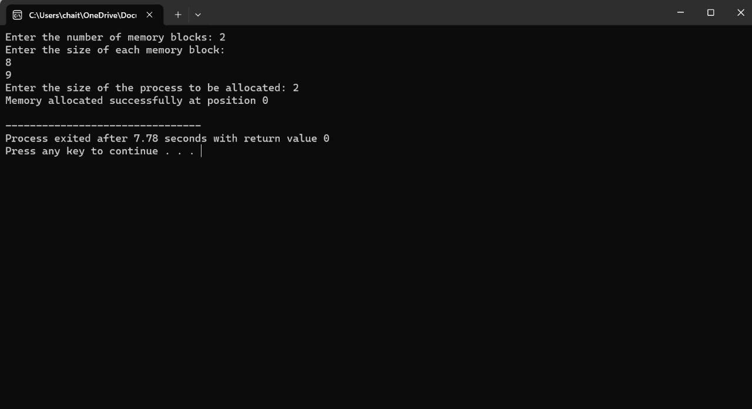

1. **Design a C program to demonstrate UNIX system calls for file management.**

#include <stdio.h>

#include <stdlib.h>

#include <unistd.h>

#include <fcntl.h>

#include <string.h>

#define BUFFER_SIZE 1024

int main() {

int fd; // File descriptor

ssize_t bytes_written, bytes_read;

char buffer[BUFFER_SIZE];

const char *file_path = "C:/Users/ravul/Downloads/collage detiles/R.collage/operating system sem-6/os lab/DAY3/Q24/Q24.cpp"; // Use forward slashes and escape backslashes

// Open a file (create if it doesn't exist, truncate if it does)

fd = open(file_path, O_WRONLY | O_CREAT | O_TRUNC, 0644); // Specify permissions manually

if (fd == -1) {

perror("open");

exit(EXIT_FAILURE);

}

// Write data to the file

const char *data_to_write = "Hello, world!\n";

bytes_written = write(fd, data_to_write, strlen(data_to_write));

if (bytes_written == -1) {

perror("write");

close(fd);

exit(EXIT_FAILURE);

}

printf("%ld bytes written to the file.\n", bytes_written);

// Close the file

close(fd);

// Open the file for reading

fd = open(file_path, O_RDONLY);

if (fd == -1) {

perror("open");

exit(EXIT_FAILURE);

}

// Read data from the file

bytes_read = read(fd, buffer, BUFFER_SIZE);

if (bytes_read == -1) {

perror("read");

close(fd);

exit(EXIT_FAILURE);

}

// Null-terminate the buffer to treat it as a string

buffer[bytes_read] = '\0';

printf("%ld bytes read from the file: %s\n", bytes_read, buffer);

// Close the file

close(fd);

return 0;

}

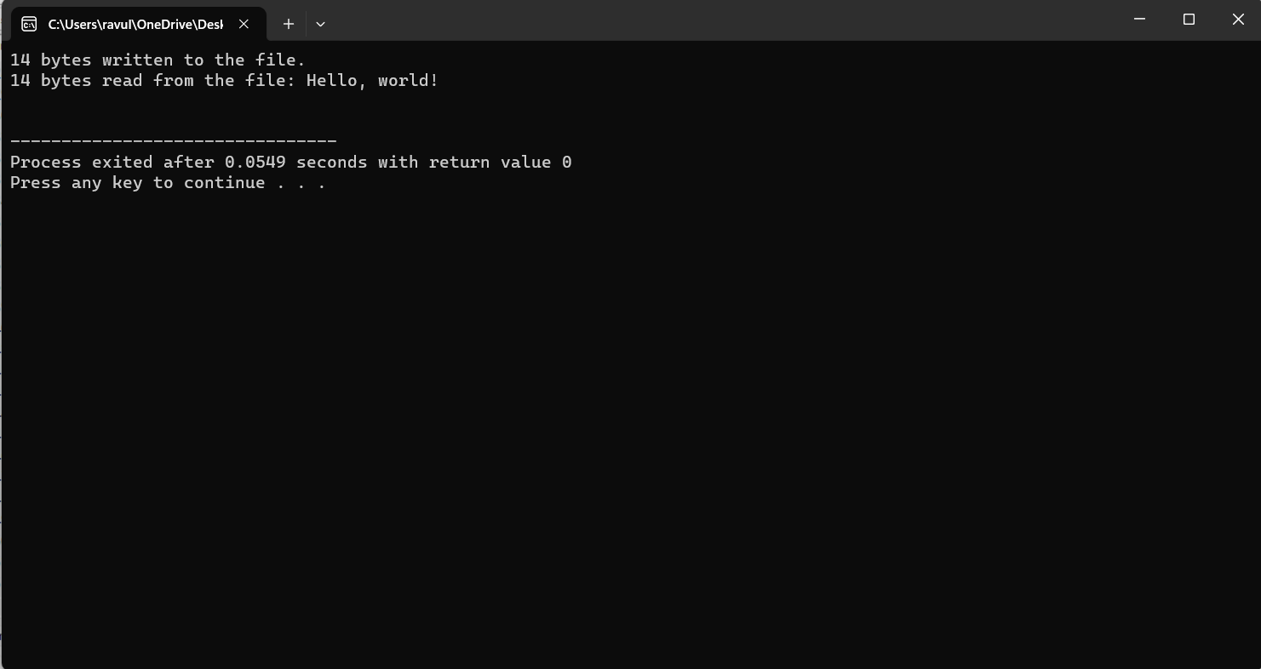

1. **Construct a C program to implement the I/O system calls of UNIX(fcntl, seek, stat, opendir, rea ddir)**

#include <stdio.h>

#include <stdlib.h>

#include <fcntl.h>

#include <unistd.h>

#include <sys/stat.h>

#include <dirent.h>

#include <string.h>

int main() {

// Open file using open

int fd = open("C:\\Users\\chait\\Downloads\\sse.txt", O_RDWR | O_CREAT, S_IRUSR | S_IWUSR);

if (fd == -1) {

perror("Error opening file");

exit(EXIT_FAILURE);

}

// Write to file

char *text = "Hello, World!\n";

write(fd, text, strlen(text));

// Move file pointer using lseek

off_t offset = lseek(fd, 0, SEEK_SET);

if (offset == -1) {

perror("Error seeking file");

exit(EXIT_FAILURE);

}

// Read from file

char buffer[100];

ssize_t bytes_read = read(fd, buffer, sizeof(buffer));

if (bytes_read == -1) {

perror("Error reading file");

exit(EXIT_FAILURE);

}

buffer[bytes_read] = '\0';

printf("File content: %s", buffer);

// Get file information using stat

struct stat file_info;

if (fstat(fd, &file_info) == -1) {

perror("Error getting file info");

exit(EXIT_FAILURE);

}

printf("File size: %lld bytes\n", (long long)file_info.st_size);

// Open directory using opendir

DIR *dir = opendir(".");

if (dir == NULL) {

perror("Error opening directory");

exit(EXIT_FAILURE);

}

// Read directory entries using readdir

struct dirent *entry;

printf("Directory contents:\n");

while ((entry = readdir(dir)) != NULL) {

printf("%s\n", entry->d_name);

}

// Close file and directory

close(fd);

closedir(dir);

return 0;

}

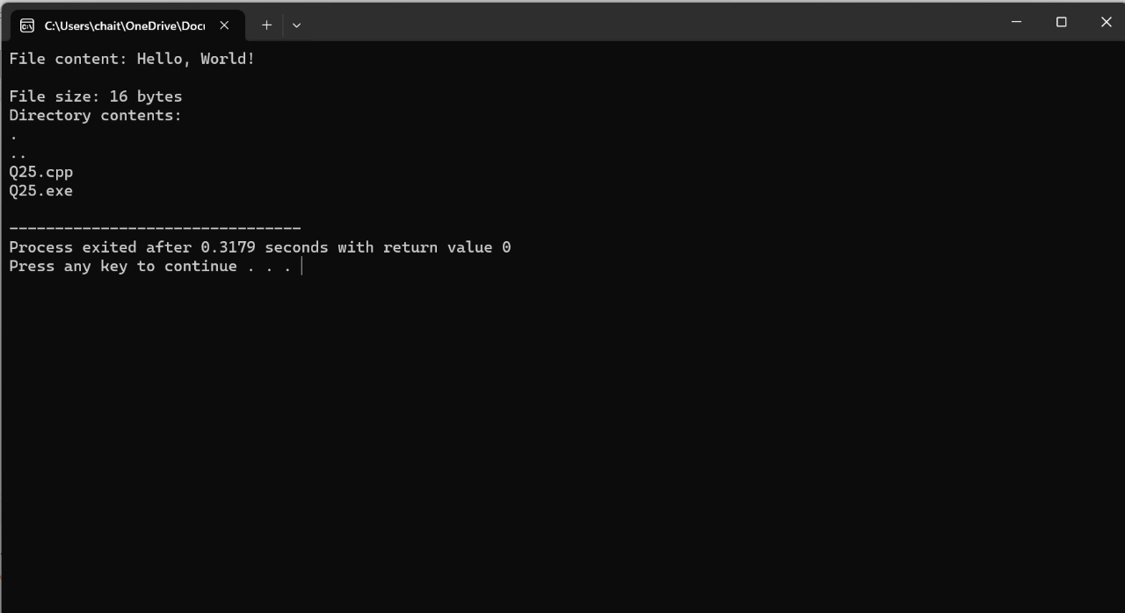

1. **Construct a C program to implement the file management operations.**

#include <stdio.h>

#include <stdlib.h>

int main() {

FILE *file;

char filename[] = "C:\\Users\\chait\\OneDrive\\Documents\\Day 4\\Q32";

char buffer[100];

// Create a file

file = fopen(filename, "w");

if (file == NULL) {

perror("Error creating file");

exit(EXIT_FAILURE);

}

printf("File created successfully.\n");

// Write to the file

fprintf(file, "Hello, world!\n");

printf("Data written to file.\n");

// Close the file

fclose(file);

printf("File closed.\n");

// Open the file for reading

file = fopen(filename, "r");

if (file == NULL) {

perror("Error opening file for reading");

exit(EXIT_FAILURE);

}

printf("File opened for reading.\n");

// Read from the file

fgets(buffer, sizeof(buffer), file);

printf("Data read from file: %s\n", buffer);

// Close the file

fclose(file);

printf("File closed.\n");

return 0;

}

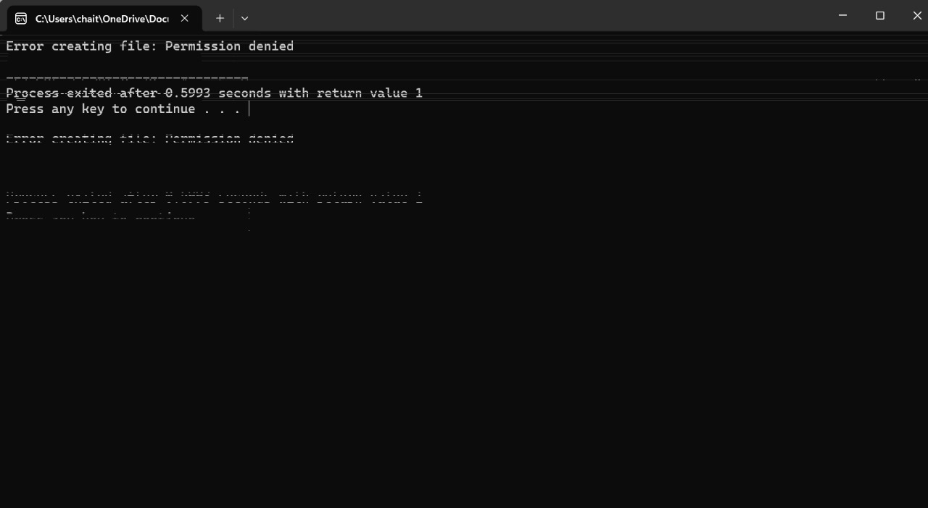

1. **Develop a C program for simulating the function of ls UNIX Command.**

#include <stdio.h>

#include <stdlib.h>

#include <dirent.h>

int main() {

DIR *directory;

struct dirent *entry;

// Open the current directory

directory = opendir("C:\\Users\\chait\\OneDrive\\Documents");

if (directory == NULL) {

perror("Unable to open directory");

return EXIT_FAILURE;

}

// Read directory entries

while ((entry = readdir(directory)) != NULL) {

printf("%s\n", entry->d_name);

}

// Close the directory

closedir(directory);

return EXIT_SUCCESS;

}

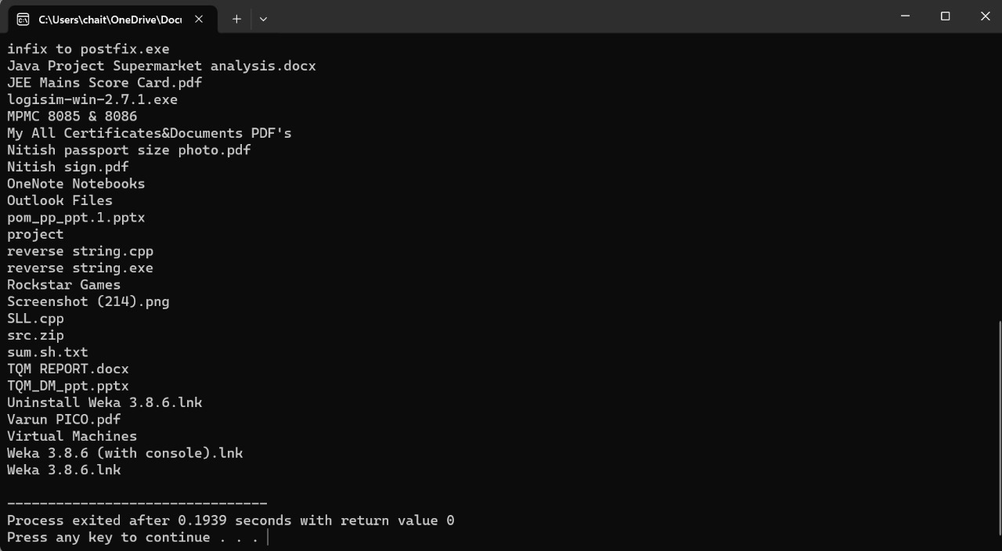

1. **Write a C program for simulation of GREP UNIX command.**

#include <stdio.h>

#include <stdlib.h>

#include <string.h>

#define MAX_LINE_LENGTH 1024

int main(int argc, char *argv[]) {

if (argc != 3) {

fprintf(stderr, "Usage: %s <pattern> <file>\n", argv[0]);

return EXIT_FAILURE;

}

const char *pattern = argv[1];

const char *filename = argv[2];

FILE *file = fopen(filename, "r");

if (file == NULL) {

perror("Error opening file");

return EXIT_FAILURE;

}

char line[MAX_LINE_LENGTH];

while (fgets(line, MAX_LINE_LENGTH, file) != NULL) {

if (strstr(line, pattern) != NULL) {

printf("%s", line);

}

}

fclose(file);

return EXIT_SUCCESS;

}

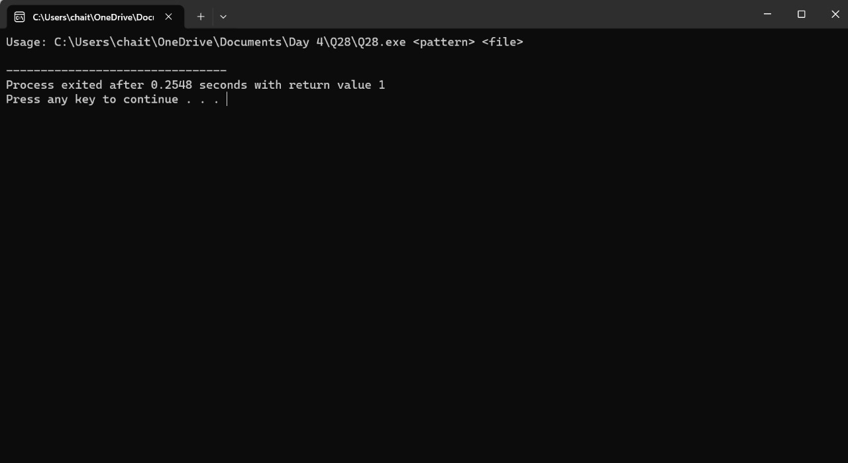

1. **Write a C program to simulate the solution of Classical Process Synchronization Problem.**

#include <stdio.h>

#include <stdlib.h>

#include <pthread.h>

#define BUFFER_SIZE 5

#define NUM_ITEMS 10

int buffer[BUFFER_SIZE];

int in = 0;

int out = 0;

pthread_mutex_t mutex;

pthread_cond_t full, empty;

void *producer(void *arg) {

int item;

for (int i = 0; i < NUM_ITEMS; ++i) {

item = rand() % 100; // Generate a random item

pthread_mutex_lock(&mutex);

while (((in + 1) % BUFFER_SIZE) == out) // Buffer is full

pthread_cond_wait(&empty, &mutex);

buffer[in] = item;

in = (in + 1) % BUFFER_SIZE;

printf("Produced item: %d\n", item);

pthread_cond_signal(&full);

pthread_mutex_unlock(&mutex);

}

pthread_exit(NULL);

}

void *consumer(void *arg) {

int item;

for (int i = 0; i < NUM_ITEMS; ++i) {

pthread_mutex_lock(&mutex);

while (in == out) // Buffer is empty

pthread_cond_wait(&full, &mutex);

item = buffer[out];

out = (out + 1) % BUFFER_SIZE;

printf("Consumed item: %d\n", item);

pthread_cond_signal(&empty);

pthread_mutex_unlock(&mutex);

}

pthread_exit(NULL);

}

int main() {

pthread_t producer_thread, consumer_thread;

pthread_mutex_init(&mutex, NULL);

pthread_cond_init(&full, NULL);

pthread_cond_init(&empty, NULL);

pthread_create(&producer_thread, NULL, producer, NULL);

pthread_create(&consumer_thread, NULL, consumer, NULL);

pthread_join(producer_thread, NULL);

pthread_join(consumer_thread, NULL);

pthread_mutex_destroy(&mutex);

pthread_cond_destroy(&full);

pthread_cond_destroy(&empty);

return 0;

}

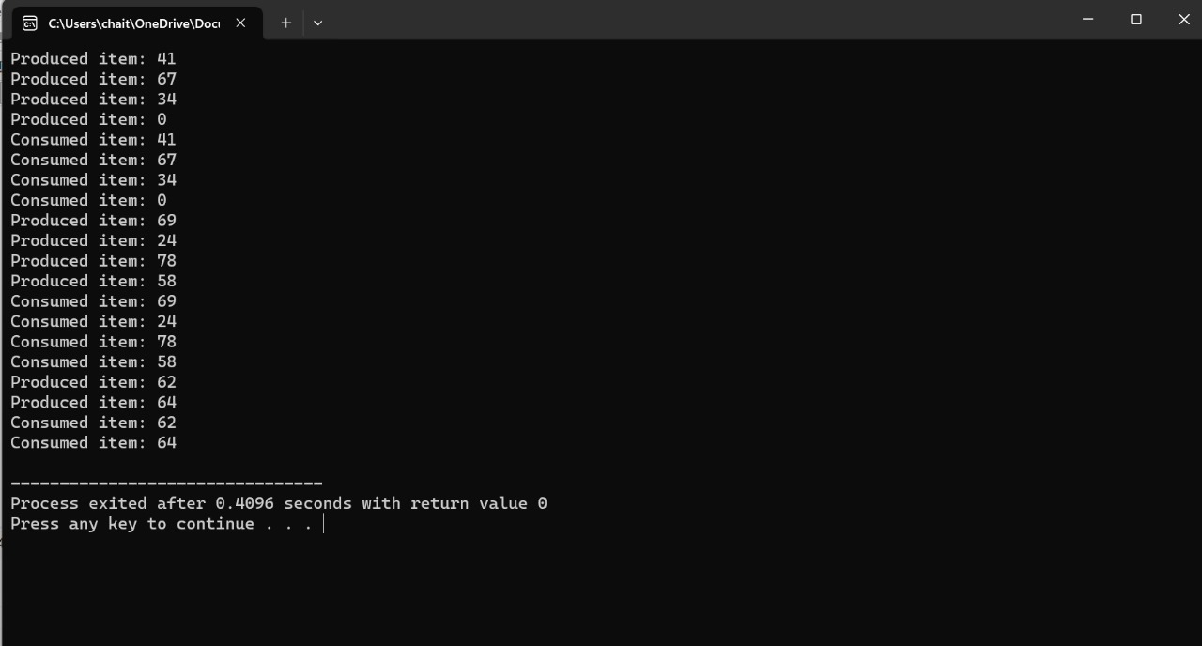

1. **Write C programs to demonstrate the following thread related concepts. (i)create(ii)join(iii)equal(iv)exit**

#include <stdio.h>

#include <stdlib.h>

#include <pthread.h>

#include <unistd.h>

void *thread_function(void *arg) {

int thread_id = *((int *)arg);

printf("Thread %d is running\n", thread_id);

sleep(2);

printf("Thread %d is exiting\n", thread_id);

pthread_exit(NULL);

}

int main() {

pthread_t thread1, thread2;

int id1 = 1, id2 = 2;

// Create thread 1

if (pthread_create(&thread1, NULL, thread_function, &id1) != 0) {

perror("Error creating thread 1");

exit(EXIT_FAILURE);

}

// Create thread 2

if (pthread_create(&thread2, NULL, thread_function, &id2) != 0) {

perror("Error creating thread 2");

exit(EXIT_FAILURE);

}

// Join thread 1

if (pthread_join(thread1, NULL) != 0) {

perror("Error joining thread 1");

exit(EXIT_FAILURE);

}

// Join thread 2

if (pthread_join(thread2, NULL) != 0) {

perror("Error joining thread 2");

exit(EXIT_FAILURE);

}

printf("Main thread exiting\n");

// Check if threads are equal

if (pthread_equal(thread1, thread2)) {

printf("Threads are equal\n");

} else {

printf("Threads are not equal\n");

}

return 0;

}

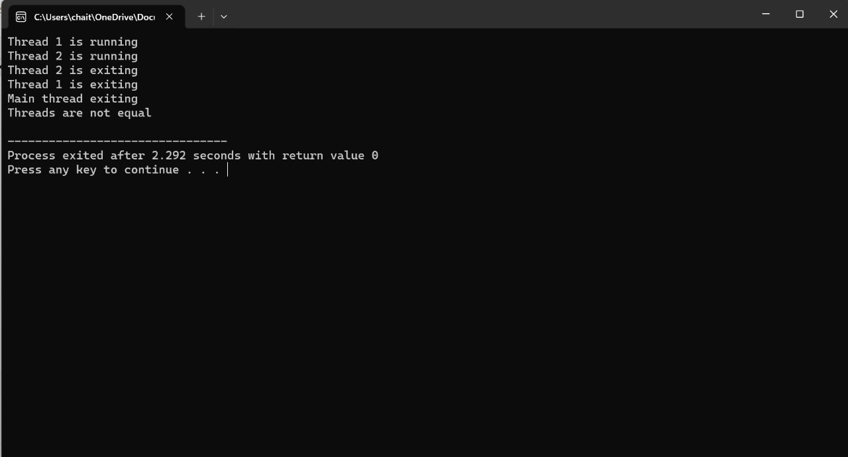

1. **Construct a C program to simulate the First in First Out paging technique of memory management.**

#include <stdio.h>

#include <stdlib.h>

#define PAGE_FRAMES 3

int main() {

int page_frames[PAGE_FRAMES];

int page_faults = 0;

int page_count;

int oldest_index = 0; // Index of the oldest page in the page frames

printf("Enter the number of pages: ");

scanf("%d", &page_count);

int pages[page_count];

printf("Enter the page reference string: ");

for (int i = 0; i < page_count; i++) {

scanf("%d", &pages[i]);

}

// Initialize page frames to -1 (indicating empty)

for (int i = 0; i < PAGE_FRAMES; i++) {

page_frames[i] = -1;

}

// Simulate FIFO paging

for (int i = 0; i < page_count; i++) {

int page = pages[i];

int found = 0;

// Check if page is already in page frame

for (int j = 0; j < PAGE_FRAMES; j++) {

if (page_frames[j] == page) {

found = 1;

break;

}

}

// Page fault: Replace the oldest page

if (!found) {

page_frames[oldest_index] = page;

oldest_index = (oldest_index + 1) % PAGE_FRAMES; // Update oldest page index

page_faults++;

}

// Print current state of page frames

printf("Page frames after reference %d: ", page);

for (int j = 0; j < PAGE_FRAMES; j++) {

printf("%d ", page_frames[j]);

}

printf("\n");

}

printf("Total page faults: %d\n", page_faults);

return 0;

}

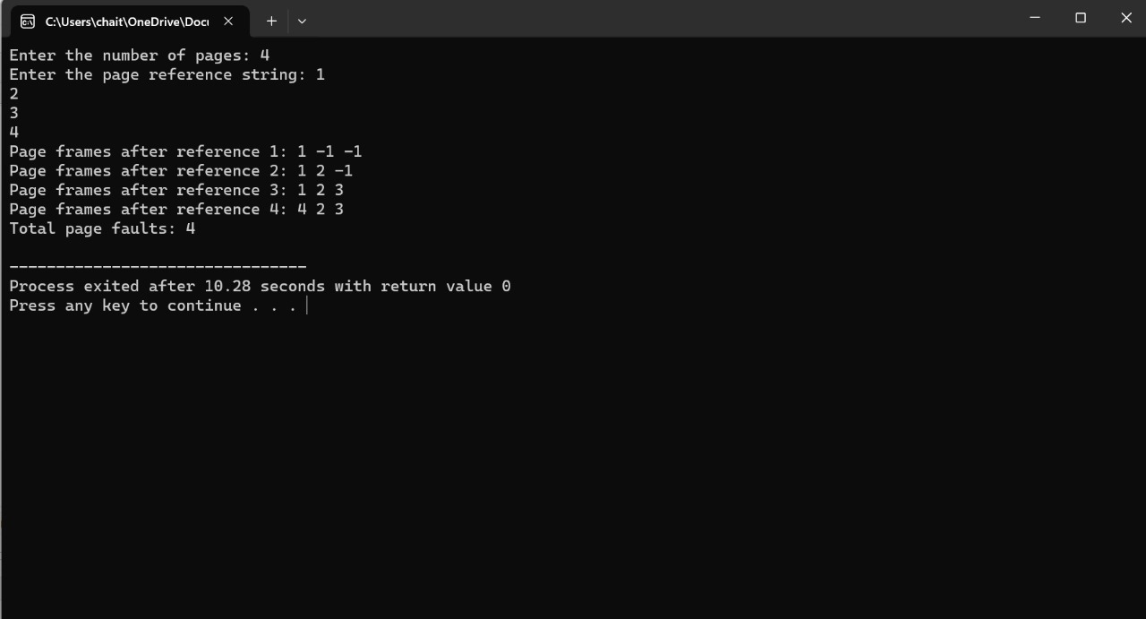

1. **Construct a C program to simulate the Least Recently Used paging technique of memory management.**

#include <stdio.h>

#include <stdlib.h>

#define PAGE_FRAMES 3

int main() {

int page_frames[PAGE_FRAMES];

int page_faults = 0;

int pages[] = {1, 3, 0, 3, 5, 6, 3}; // Reference string

int page_count = sizeof(pages) / sizeof(pages[0]);

// Initialize page frames to -1 (indicating empty)

for (int i = 0; i < PAGE_FRAMES; i++) {

page_frames[i] = -1;

}

// Simulate LRU paging

for (int i = 0; i < page_count; i++) {

int page = pages[i];

int found = 0;

// Check if page is already in page frame

for (int j = 0; j < PAGE_FRAMES; j++) {

if (page_frames[j] == page) {

found = 1;

// Update the page's position in page_frames (move to front)

for (int k = j; k > 0; k--) {

page_frames[k] = page_frames[k - 1];

}

page_frames[0] = page;

break;

}

}

// Page fault: Replace the least recently used page

if (!found) {

// Move all pages one step forward to make space for the new page

for (int j = PAGE_FRAMES - 1; j > 0; j--) {

page_frames[j] = page_frames[j - 1];

}

page_frames[0] = page;

page_faults++;

}

// Print current state of page frames

printf("Page frames after reference %d: ", page);

for (int j = 0; j < PAGE_FRAMES; j++) {

printf("%d ", page_frames[j]);

}

printf("\n");

}

printf("Total page faults: %d\n", page_faults);

return 0;

}

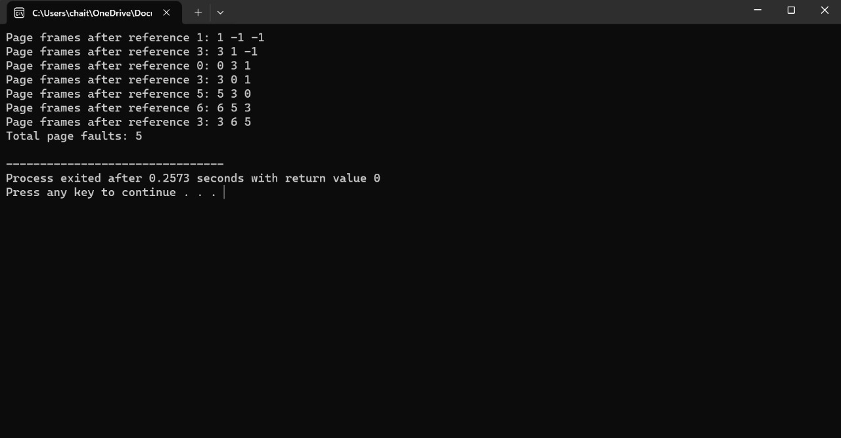

1. **Construct a C program to simulate the optimal paging technique of memory management.**

#include <stdio.h>

#include <stdbool.h>

#define NUM_FRAMES 3 // Number of frames in memory

// Function to find the optimal page to replace

int optimalPage(int pages[], int numOfPages, int frames[], int numOfFrames, int index) {

int res = -1, farthest = index;

for (int i = 0; i < numOfFrames; i++) {

int j;

for (j = index; j < numOfPages; j++) {

if (frames[i] == pages[j]) {

if (j > farthest) {

farthest = j;

res = i;

}

break;

}

}

if (j == numOfPages)

return i;

}

return (res == -1) ? 0 : res;

}

// Function to simulate optimal paging

void optimalPaging(int pages[], int numOfPages, int numOfFrames) {

int frames[numOfFrames], pageFaults = 0;

bool isPageFault;

for (int i = 0; i < numOfFrames; i++)

frames[i] = -1;

for (int i = 0; i < numOfPages; i++) {

isPageFault = true;

for (int j = 0; j < numOfFrames; j++) {

if (frames[j] == pages[i]) {

isPageFault = false;

break;

}

}

if (isPageFault) {

int index = optimalPage(pages, numOfPages, frames, numOfFrames, i + 1);

frames[index] = pages[i];

pageFaults++;

}

}

printf("Total Page Faults: %d\n", pageFaults);

}

int main() {

int numOfPages, numOfFrames;

printf("Enter the number of pages: ");

scanf("%d", &numOfPages);

printf("Enter the number of frames: ");

scanf("%d", &numOfFrames);

int pages[numOfPages];

printf("Enter the sequence of page references:\n");

for (int i = 0; i < numOfPages; i++)

scanf("%d", &pages[i]);

optimalPaging(pages, numOfPages, numOfFrames);

return 0;

}

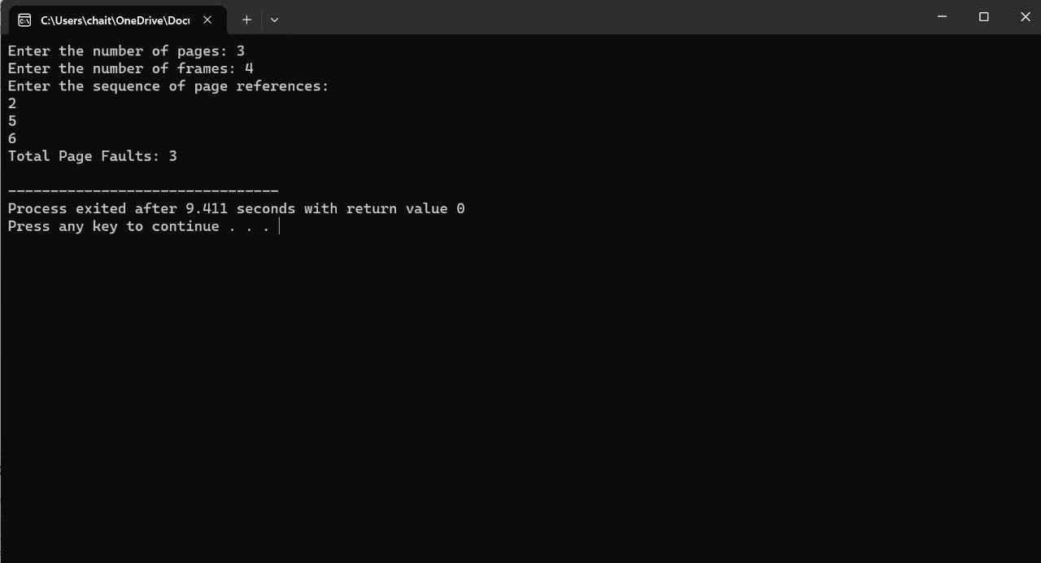

1. **Consider a file system where there cords of the file are stored one after another both physically and logically. Are cord of the file can only be accessed by reading all the previous records. Design a C program to simulate the file allocation strategy.**

#include <stdio.h>

#include <stdlib.h>

#include <stdbool.h>

#define DISK_SIZE 1000 // Total number of blocks on the disk

#define BLOCK_SIZE 512 // Size of each block (in bytes)

#define MAX_FILES 10 // Maximum number of files in the system

// Structure to represent a file

typedef struct {

int startBlock; // Starting block number of the file

int numBlocks; // Number of blocks allocated to the file

} File;

// Structure to represent the disk

typedef struct {

bool allocated[DISK_SIZE]; // Array to track allocated blocks on the disk

} Disk;

// Function to initialize the disk

void initializeDisk(Disk *disk) {

for (int i = 0; i < DISK_SIZE; i++) {

disk->allocated[i] = false;

}

}

// Function to allocate blocks to a file

bool allocateBlocks(Disk *disk, File *file) {

int blocksNeeded = file->numBlocks;

// Find contiguous free blocks

int consecutiveBlocks = 0;

for (int i = 0; i < DISK_SIZE; i++) {

if (!disk->allocated[i]) {

consecutiveBlocks++;

if (consecutiveBlocks == blocksNeeded) {

file->startBlock = i - blocksNeeded + 1;

break;

}

} else {

consecutiveBlocks = 0;

}

}

// Check if enough contiguous free blocks are found

if (consecutiveBlocks == blocksNeeded) {

// Mark allocated blocks on the disk

for (int i = file->startBlock; i < file->startBlock + blocksNeeded; i++) {

disk->allocated[i] = true;

}

return true;

} else {

printf("Error: Not enough contiguous free blocks.\n");

return false;

}

}

// Function to simulate file allocation

void simulateFileAllocation(Disk *disk, File files[], int numFiles) {

printf("Simulating file allocation strategy...\n");

for (int i = 0; i < numFiles; i++) {

printf("File %d: Blocks [%d-%d]\n", i+1, files[i].startBlock, files[i].startBlock + files[i].numBlocks - 1);

}

}

int main() {

Disk disk;

initializeDisk(&disk);

int numFiles;

printf("Enter the number of files: ");

scanf("%d", &numFiles);

if (numFiles > MAX_FILES) {

printf("Error: Exceeded maximum number of files.\n");

return 1;

}

File files[numFiles];

for (int i = 0; i < numFiles; i++) {

printf("Enter number of blocks for File %d: ", i+1);

scanf("%d", &files[i].numBlocks);

if (files[i].numBlocks <= 0 || files[i].numBlocks > DISK_SIZE) {

printf("Error: Invalid number of blocks for File %d.\n", i+1);

return 1;

}

if (!allocateBlocks(&disk, &files[i])) {

return 1;

}

}

// Simulate file allocation

simulateFileAllocation(&disk, files, numFiles);

return 0;

}

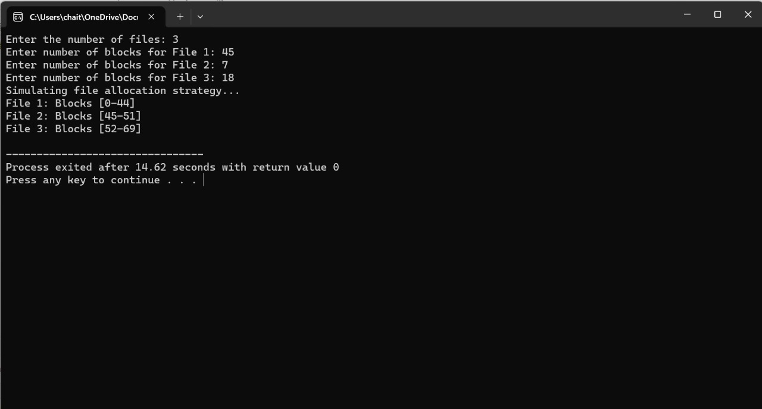

1. **Consider a file system that brings all the file pointers together into an index block. The ith entry in the index block points to the ith block of the file. Design a C program to simulate the file allocation strategy.**

#include <stdio.h>

#include <stdlib.h>

#define MAX_BLOCKS 100 // Maximum number of blocks in the file

#define BLOCK_SIZE 512 // Size of each block (in bytes)

// Structure to represent a block in the file

typedef struct Block {

char data[BLOCK_SIZE];

} Block;

// Structure to represent the index block

typedef struct IndexBlock {

int blockPointers[MAX_BLOCKS]; // Array to store block pointers

int numOfBlocks; // Number of blocks in the file

} IndexBlock;

// Function to simulate the file allocation strategy

void simulateFileAllocation(IndexBlock *indexBlock) {

printf("Simulating file allocation strategy...\n");

// Reading blocks using index block pointers

for (int i = 0; i < indexBlock->numOfBlocks; i++) {

printf("Reading Block %d: %s\n", i + 1, indexBlock->blockPointers[i] == -1 ? "Empty" : "Data");

}

}

int main() {

IndexBlock indexBlock;

indexBlock.numOfBlocks = 0;

// Initialize block pointers to -1 (indicating empty)

for (int i = 0; i < MAX_BLOCKS; i++) {

indexBlock.blockPointers[i] = -1;

}

printf("Enter the number of blocks in the file: ");

scanf("%d", &indexBlock.numOfBlocks);

// Check for valid number of blocks

if (indexBlock.numOfBlocks <= 0 || indexBlock.numOfBlocks > MAX_BLOCKS) {

printf("Invalid number of blocks.\n");

return 1;

}

// Simulate file allocation strategy

simulateFileAllocation(&indexBlock);

return 0;

}

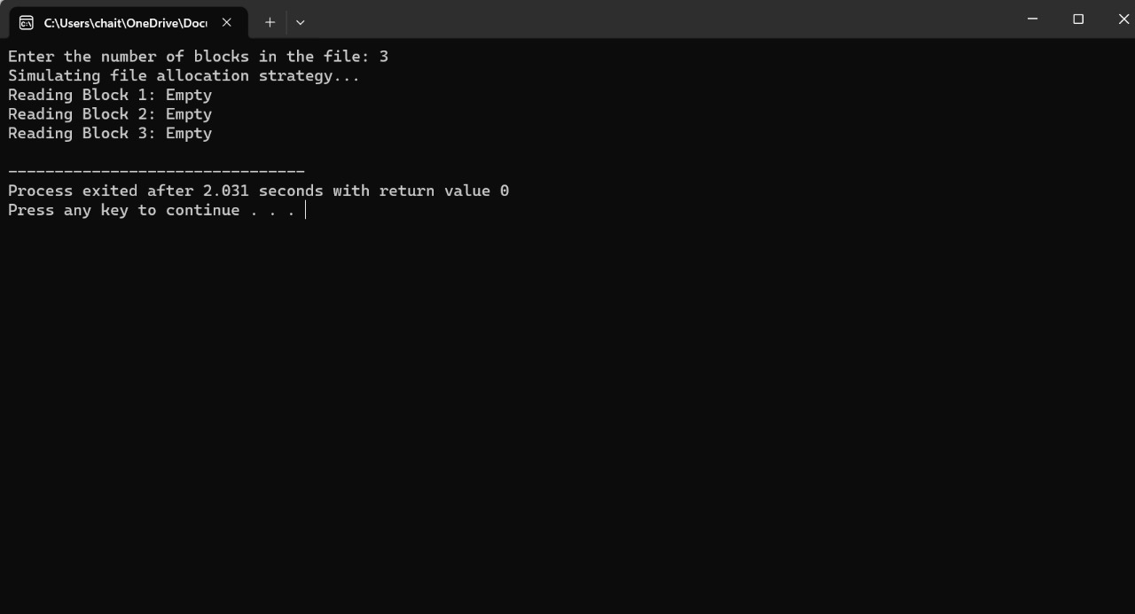

1. **With linked allocation, each file is a linked list of disk blocks; the disk blocks may be scattered anywhere on the disk. The directory contains a pointer to the first and last blocks of the file. Each block contains a pointer to the next block. Design a C program to simulate the file allocation strategy.**

#include <stdio.h>

#include <stdlib.h>

#include <stdbool.h>

#define BLOCK_SIZE 512 // Size of each block (in bytes)

// Structure to represent a block in the file

typedef struct Block {

char data[BLOCK_SIZE];

struct Block *next; // Pointer to the next block

} Block;

// Structure to represent a file

typedef struct File {

Block *firstBlock; // Pointer to the first block of the file

Block *lastBlock; // Pointer to the last block of the file

} File;

// Function to initialize a file

void initFile(File *file) {

file->firstBlock = NULL;

file->lastBlock = NULL;

}

// Function to add a block to the end of a file

void addBlockToFile(File *file, Block *block) {

if (file->firstBlock == NULL) {

// If file is empty, set the first block

file->firstBlock = block;

} else {

// Link the new block to the last block

file->lastBlock->next = block;

}

// Update the last block to the new block

file->lastBlock = block;

}

// Function to simulate the file allocation strategy

void simulateFileAllocation(File *file) {

printf("Simulating file allocation strategy...\n");

Block *currentBlock = file->firstBlock;

int blockCount = 0;

// Traverse the linked list of blocks

while (currentBlock != NULL) {

printf("Block %d: Data\n", ++blockCount);

currentBlock = currentBlock->next;

}

}

// Function to free memory allocated for file blocks

void freeFile(File *file) {

Block *currentBlock = file->firstBlock;

Block *nextBlock;

// Traverse the linked list of blocks and free memory

while (currentBlock != NULL) {

nextBlock = currentBlock->next;

free(currentBlock);

currentBlock = nextBlock;

}

// Reset file pointers

file->firstBlock = NULL;

file->lastBlock = NULL;

}

int main() {

File file;

initFile(&file);

int numOfBlocks;

printf("Enter the number of blocks in the file: ");

scanf("%d", &numOfBlocks);

// Create and add blocks to the file

for (int i = 0; i < numOfBlocks; i++) {

Block *block = (Block *)malloc(sizeof(Block));

block->next = NULL; // Initialize next pointer to NULL

addBlockToFile(&file, block);

}

// Simulate file allocation strategy

simulateFileAllocation(&file);

// Free memory allocated for file blocks

freeFile(&file);

return 0;

}

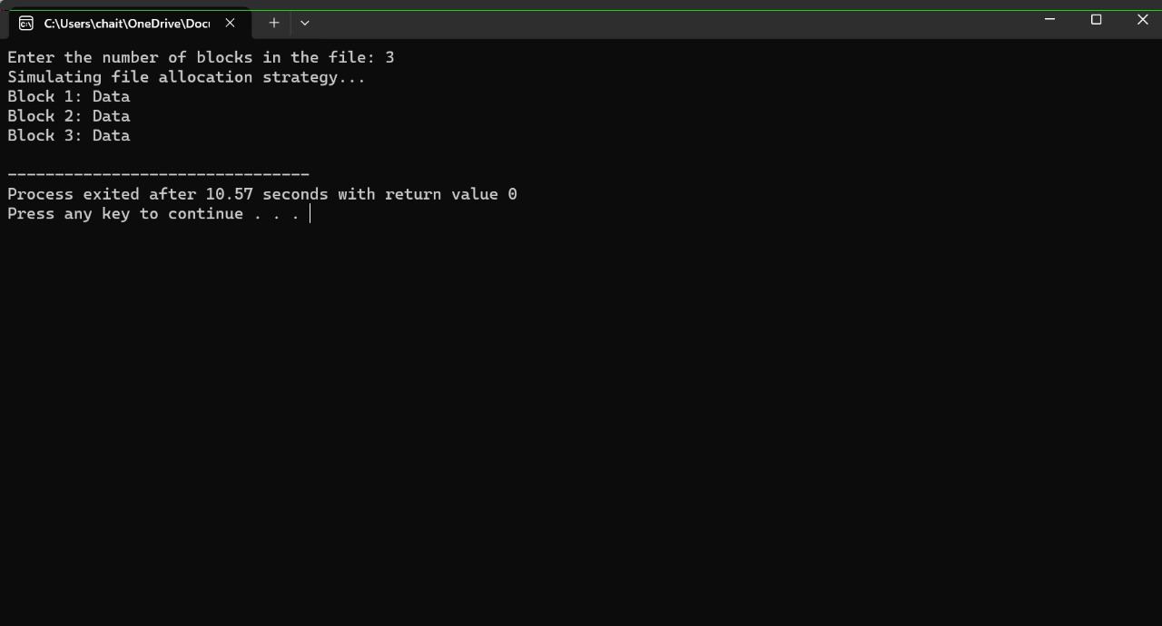

1. **Construct a C program to simulate the First Come First Served disk scheduling algorithm.**

#include <stdio.h>

#include <stdlib.h>

#include <math.h>

// Function to calculate total head movement

int calculateHeadMovement(int queue[], int head, int size) {

int totalMovement = 0;

// Traverse the queue and calculate head movement

for (int i = 0; i < size; i++) {

totalMovement += abs(queue[i] - head);

head = queue[i];

}

return totalMovement;

}

int main() {

int n; // Number of disk requests

printf("Enter the number of disk requests: ");

scanf("%d", &n);

int requestQueue[n]; // Disk request queue

printf("Enter the disk request queue:\n");

for (int i = 0; i < n; i++) {

scanf("%d", &requestQueue[i]);

}

int initialHead; // Initial position of the head

printf("Enter the initial position of the head: ");

scanf("%d", &initialHead);

int totalHeadMovement = calculateHeadMovement(requestQueue, initialHead, n);

printf("Total head movement: %d\n", totalHeadMovement);

return 0;

}

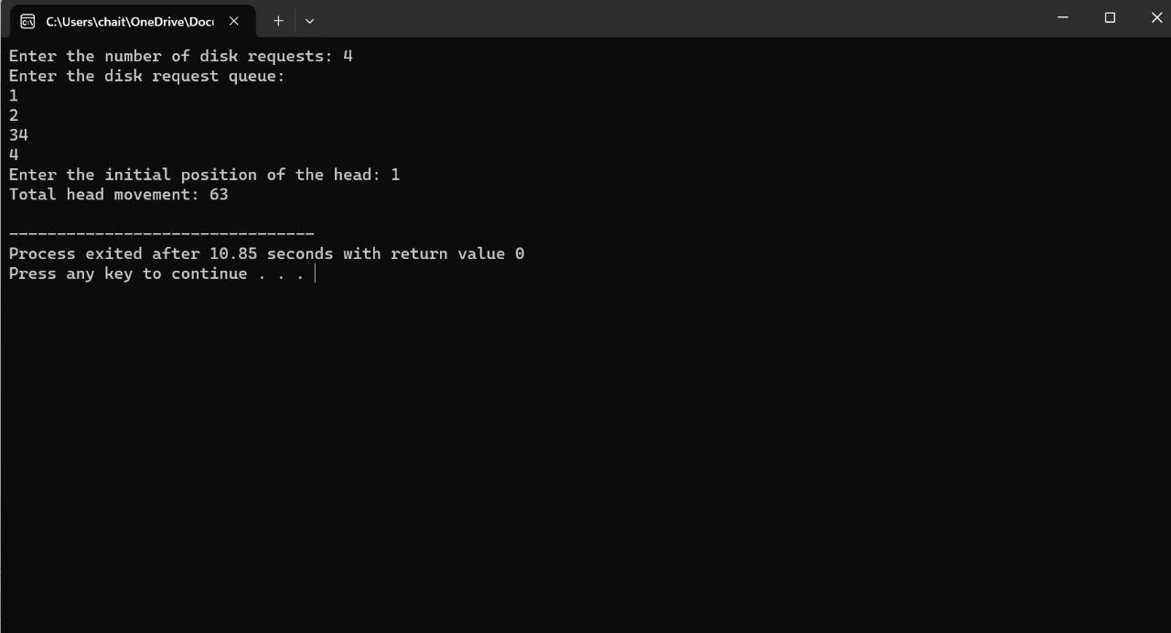

1. **Design a C program to simulate SCAN disk scheduling algorithm.**

#include <stdio.h>

#include <stdlib.h>

#define MAX_REQUESTS 1000

// Function to sort an array in ascending order

void sort(int arr[], int n) {

for (int i = 0; i < n - 1; i++) {

for (int j = 0; j < n - i - 1; j++) {

if (arr[j] > arr[j + 1]) {

int temp = arr[j];

arr[j] = arr[j + 1];

arr[j + 1] = temp;

}

}

}

}

// Function to simulate SCAN disk scheduling algorithm

int SCAN(int queue[], int head, int size, int direction) {

int totalMovement = 0;

int currentIndex = 0;

int i;

if (direction == 1) { // Moving towards higher cylinder numbers

// Find the index where head movement should change direction

for (i = 0; i < size; i++) {

if (queue[i] >= head) {

currentIndex = i;

break;

}

}

} else { // Moving towards lower cylinder numbers

// Find the index where head movement should change direction

for (i = size - 1; i >= 0; i--) {

if (queue[i] <= head) {

currentIndex = i;

break;

}

}

}

// Calculate head movement

for (i = currentIndex; i < size; i++) {

totalMovement += abs(queue[i] - head);

head = queue[i];

}

if (direction == 1) {

totalMovement += abs(head - 0); // Move to cylinder 0

head = 0;

for (i = currentIndex - 1; i >= 0; i--) {

totalMovement += abs(queue[i] - head);

head = queue[i];

}

} else {

totalMovement += abs(head - 0); // Move to cylinder 0

head = 0;

for (i = currentIndex + 1; i < size; i++) {

totalMovement += abs(queue[i] - head);

head = queue[i];

}

}

return totalMovement;

}

int main() {

int n; // Number of disk requests

printf("Enter the number of disk requests: ");

scanf("%d", &n);

int requestQueue[MAX_REQUESTS]; // Disk request queue

printf("Enter the disk request queue:\n");

for (int i = 0; i < n; i++) {

scanf("%d", &requestQueue[i]);

}

int initialHead; // Initial position of the head

printf("Enter the initial position of the head: ");

scanf("%d", &initialHead);

int direction; // Direction of head movement (1: towards higher cylinder numbers, 0: towards lower cylinder numbers)

printf("Enter the direction of head movement (1 for towards higher cylinder numbers, 0 for towards lower cylinder numbers): ");

scanf("%d", &direction);

sort(requestQueue, n); // Sort the request queue

int totalHeadMovement = SCAN(requestQueue, initialHead, n, direction);

printf("Total head movement: %d\n", totalHeadMovement);

return 0;

}

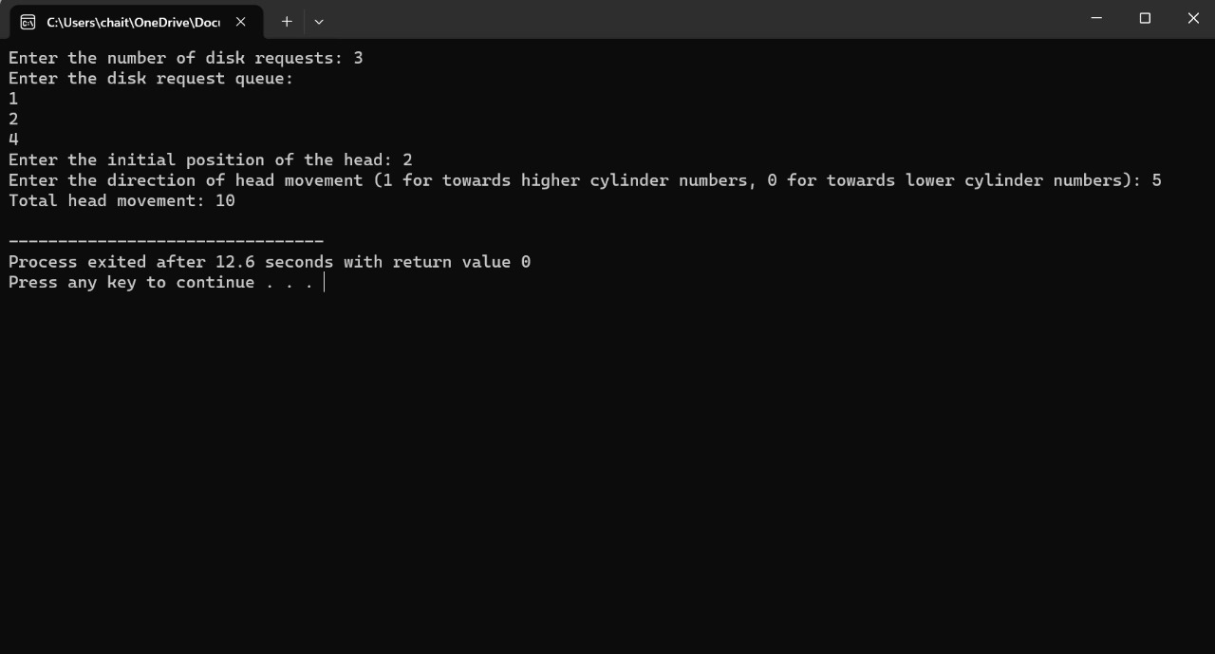

1. **Develop a C program to simulate C-SCAN disk scheduling algorithm.**

#include <stdio.h>

#include <stdlib.h>

#define MAX_REQUESTS 1000

// Function to sort an array in ascending order

void sort(int arr[], int n) {

for (int i = 0; i < n - 1; i++) {

for (int j = 0; j < n - i - 1; j++) {

if (arr[j] > arr[j + 1]) {

int temp = arr[j];

arr[j] = arr[j + 1];

arr[j + 1] = temp;

}

}

}

}

// Function to simulate C-SCAN disk scheduling algorithm

int CSCAN(int queue[], int head, int size, int direction) {

int totalMovement = 0;

int currentIndex = 0;

int i;

sort(queue, size); // Sort the request queue

if (direction == 1) { // Moving towards higher cylinder numbers

// Find the index where head movement should change direction

for (i = 0; i < size; i++) {

if (queue[i] >= head) {

currentIndex = i;

break;

}

}

} else { // Moving towards lower cylinder numbers

// Find the index where head movement should change direction

for (i = size - 1; i >= 0; i--) {

if (queue[i] <= head) {

currentIndex = i;

break;

}

}

}

// Calculate head movement

for (i = currentIndex; i < size; i++) {

totalMovement += abs(queue[i] - head);

head = queue[i];

}

if (direction == 1) {

totalMovement += abs(head - 0); // Move to cylinder 0

head = 0;

totalMovement += abs(head - queue[0]); // Move to the first cylinder after 0

head = queue[0];

for (i = 1; i < size; i++) {

totalMovement += abs(queue[i] - head);

head = queue[i];

}

} else {

totalMovement += abs(head - 0); // Move to cylinder 0

head = 0;

totalMovement += abs(head - queue[size - 1]); // Move to the last cylinder before 0

head = queue[size - 1];

for (i = size - 2; i >= 0; i--) {

totalMovement += abs(queue[i] - head);

head = queue[i];

}

}

return totalMovement;

}

int main() {

int n; // Number of disk requests

printf("Enter the number of disk requests: ");

scanf("%d", &n);

int requestQueue[MAX_REQUESTS]; // Disk request queue

printf("Enter the disk request queue:\n");

for (int i = 0; i < n; i++) {

scanf("%d", &requestQueue[i]);

}

int initialHead; // Initial position of the head

printf("Enter the initial position of the head: ");

scanf("%d", &initialHead);

int direction; // Direction of head movement (1: towards higher cylinder numbers, 0: towards lower cylinder numbers)

printf("Enter the direction of head movement (1 for towards higher cylinder numbers, 0 for towards lower cylinder numbers): ");

scanf("%d", &direction);

int totalHeadMovement = CSCAN(requestQueue, initialHead, n, direction);

printf("Total head movement: %d\n", totalHeadMovement);

return 0;

}

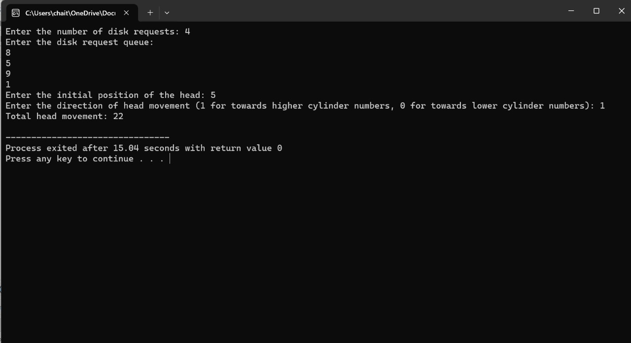

1. **Illustrate the various File Access Permission and different types users in Linux.**

#include <stdio.h>

#include <stdlib.h>

#include <sys/types.h>

#include <sys/stat.h>

#include <unistd.h>

#include <fcntl.h>

#include <string.h>

int main() {

char *filename = "testfile.txt";

char *content = "Hello, world!\n";

mode_t mode = S_IRUSR | S_IWUSR | S_IRGRP | S_IWGRP | S_IROTH; // Permissions: rw-rw-r--

// Create the file

int fd = open(filename, O_CREAT | O_WRONLY | O_TRUNC, mode);

if (fd == -1) {

perror("Failed to create file");

exit(EXIT_FAILURE);

}

// Write content to the file

if (write(fd, content, strlen(content)) == -1) {

perror("Failed to write to file");

exit(EXIT_FAILURE);

}

// Close the file

if (close(fd) == -1) {

perror("Failed to close file");

exit(EXIT_FAILURE);

}

// Simulate different users attempting to access the file

printf("Simulating different users accessing the file:\n");

// Owner

printf("Owner:\n");

if (access(filename, R_OK | W_OK) == 0) {

printf(" Read and write access granted\n");

} else {

printf(" Read and write access denied\n");

}

// Group

printf("Group:\n");

if (access(filename, R_OK | W_OK) == 0) {

printf(" Read and write access granted\n");

} else {

printf(" Read and write access denied\n");

}

// Others

printf("Others:\n");

if (access(filename, R_OK) == 0) {

printf(" Read access granted\n");

} else {

printf(" Read access denied\n");

}

return 0;

}

