1. Bar plot

library(ggplot2)

data=data.frame(

product=c("A", "B", "C", "D", "E"),

sales <- c(300, 450, 500, 350, 400),

year<-c(20,21,22,23,24)

)

ggplot(data,aes(x=product,y=sales))+

geom_bar(stat="identity",position="dodge",fill="orange")+

labs(title="bar plot",

x="product",

y="sales")+

theme_minimal()

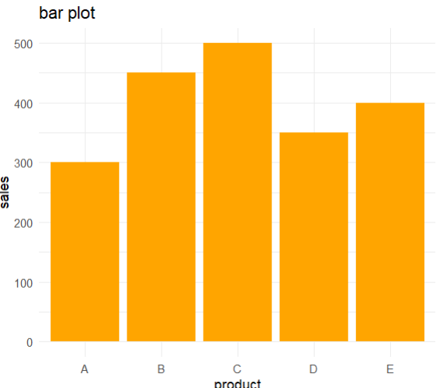

product <- c("A", "B", "C", "D", "E")

sales <- c(300, 450, 500, 350, 400)

year<-c(20,21,22,23,24)

barplot(sales,

names.arg=year,

main = "Sales by Product",

xlab = "Product",

ylab = "Sales",

col = "lightblue",

ylim = c(0, 600))

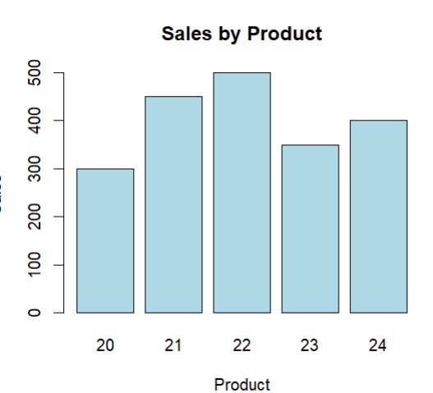

1. Box plot

class <- c(rep("A", 4), rep("B", 4))

scores <- c(85, 90, 78, 92, 88, 76, 80, 84)

data <- data.frame(Class = class, Scores = scores)

boxplot(Scores ~ Class, data = data,

main = "Exam Scores by Class",

xlab = "Class",

ylab = "Scores",

notch=FALSE,

horizontal = TRUE,

col = c("skyblue", "lightgreen"))

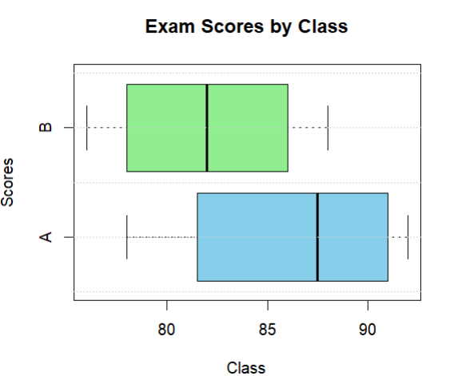

library(ggplot2)

ggplot(data, aes(x=Class,y=scores))+

geom_boxplot(fill="skyblue")+

labs(title = "boxplot",

x="class",

y="scores")+

theme_minimal()

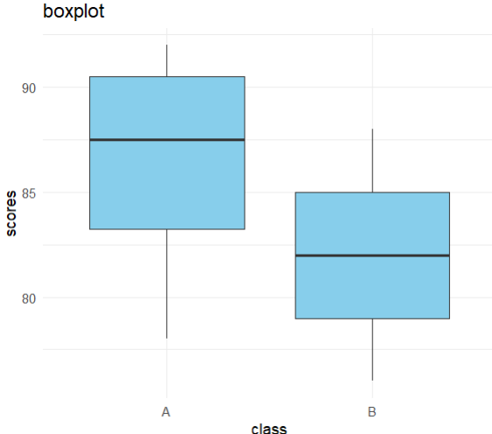

1. Density plot

weights <- c(60, 65, 70, 75, 80, 85, 90, 95, 100)

plot(density(weights),

main = "Density Plot of Weights",

xlab = "Weight (kg)",

ylab = "Density",

col = "blue",

lwd = 2)

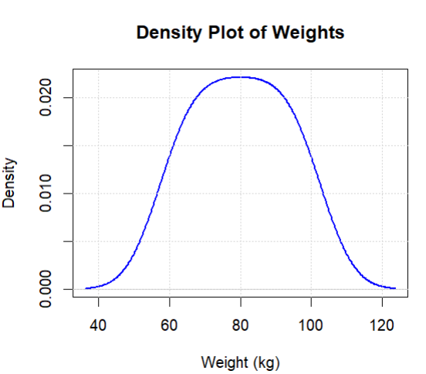

data=data.frame(Weights=weights)

library(ggplot2)

ggplot(data,aes(x=Weights))+

geom_density(fill="green")+

labs(title = "density plot")+

theme_minimal()

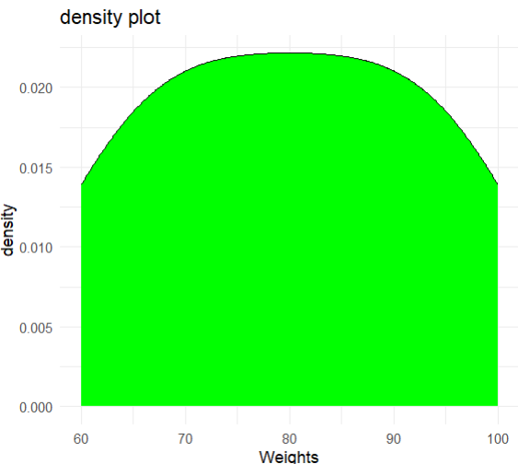

1. Facet plot

library(ggplot2)

month <- c("Jan", "Jan", "Feb", "Feb", "Mar", "Mar")

region <- c("East", "West", "East", "West", "East", "West")

sales <- c(200, 150, 220, 170, 210, 160)

data <- data.frame(Month = month, Region = region, Sales = sales)

ggplot(data, aes(x = Month, y = Sales, fill = Region)) +

geom_bar(stat = "identity", position = "dodge") +

facet_wrap(~ Region) +

labs(title = "Sales by Month and Region", x = "Month", y = "Sales") +

theme_minimal()

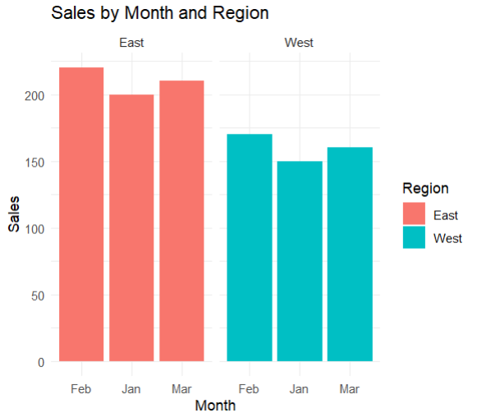

1. Heat Map

month <- c("Jan", "Feb", "Mar", "Apr", "May")

city_a <- c(5, 6, 7, 8, 9)

city_b <- c(10, 11, 12, 13, 14)

city_c <- c(15, 16, 17, 18, 19)

data<-data.frame(Months=month, CityA=city_a, CityB=city_b,CityC=city_c)

library(reshape2)

mdata=melt(data,id.vars="Months")

ggplot(mdata, aes(x=Months,y=variable,fill=value))+

geom_tile()+

scale_fill_gradient(low = "yellow",high = "red")+

labs(title="Heat Map",x="Months",y="cities")+theme_minimal()

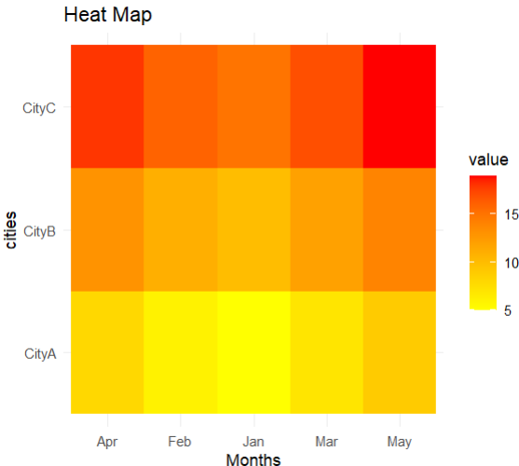

1. Histogram

age <- c(23, 54, 34, 56, 62, 23, 96, 56, 93, 32, 56, 23, 78, 87, 66)

data<-data.frame(Age=age)

hist(age,

main="histogram",

xlab="Age",

ylab="Frequency",

col="purple",

border="pink")

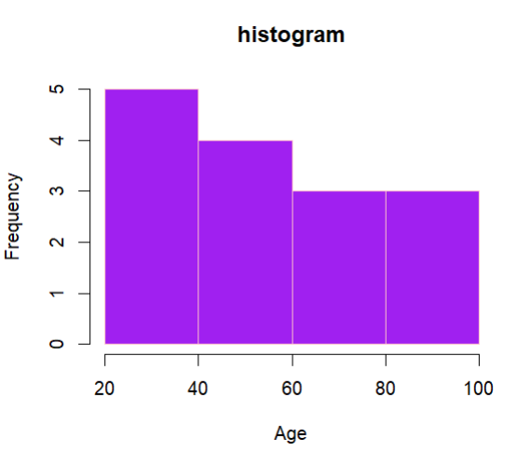

library(ggplot2)

ggplot(data,aes(x=Age))+

geom_histogram(bins=10,binwidth = 5,fill="green",color="red")+

labs(title = "histogram")+

theme_minimal()

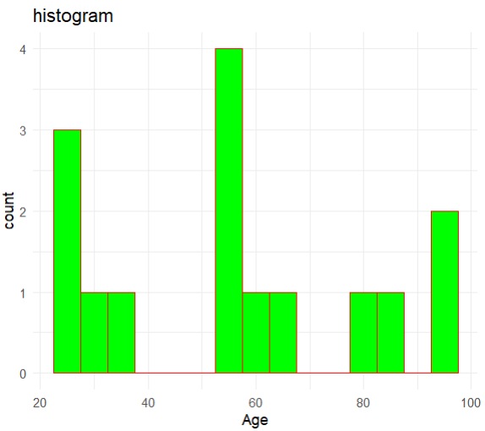

1. Line plot

year <- c(2010, 2011, 2012, 2013, 2014,2015,2016,2017,2018,2019,2020,2021,2022,2023,2024)

population <- c(1000, 2023,1010,4590,2329,2420,3451,4012,3221,4253,1212,3231,5323,1234,5665)

plot(year, population,

type = "o", # 'o' for both lines and points p-points, l-line

main = "Population Growth Over Years",

xlab = "Year",

ylab = "Population (millions)",

pch = 19, # Solid circle for points

col = "red",

lwd = 2) # Line width

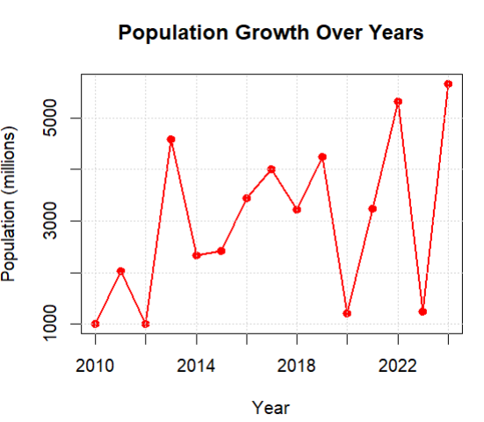

data<-data.frame(Year=year,Pop=population)

library(ggplot2)

ggplot(data,aes(x=Year,y=Pop))+

geom_point(color="pink",size=4)+

geom_line(color="blue",size=1)+

labs(title = "Line plot")+ theme_minimal()

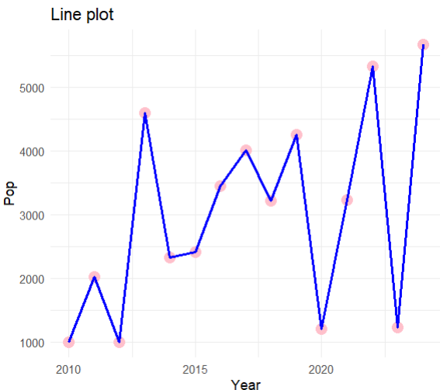

1. Pie chart

company <- c("A", "B", "C", "D")

market_share <- c(20, 30, 25, 25)

pie(market_share,

labels = company,

main = "Market Share by Company",

col = c("blue", "green", "coral", "yellow"))

le

gend("topright", legend = company, fill = c("blue", "green", "coral", "yellow"))

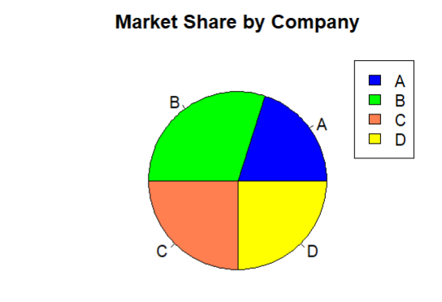

library(plotrix)

pie3D(market_share,

labels = company,

main = "Market Share by Company",

col = c("blue", "green", "coral", "yellow"),

explode = 0.1) # This will slightly explode the slices for better visibility

legend("topright", legend = company, fill = c("blue", "green", "coral", "yellow"))

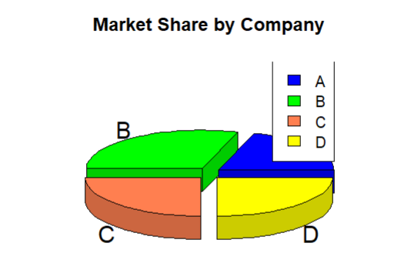

1. Scatter plot

weight <- c(60, 65, 70, 72, 75)

height <- c(170, 175, 168, 180, 178)

plot(weight, height,

main = "Scatter Plot of Weight vs Height",

xlab = "Weight (kg)",

ylab = "Height (cm)",

pch = 20, # Solid circle

col = "blue")

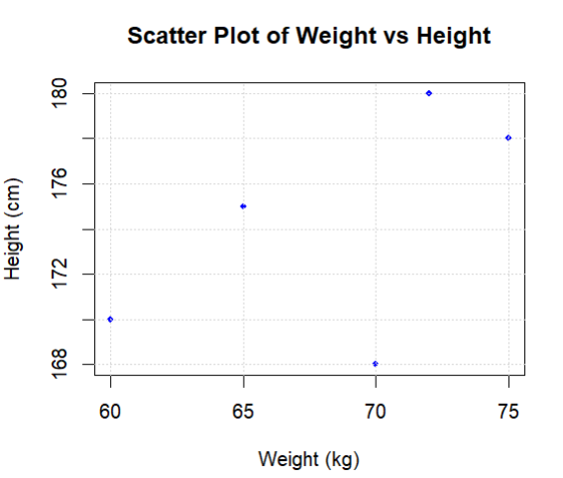

1. Violin plot

library(ggplot2)

group <- c(rep("X", 4), rep("Y", 4))

score <- c(80, 85, 78, 92, 88, 76, 80, 84)

data <- data.frame(Group = group, Score = score)

ggplot(data,aes(x=Group,y=Score,fill=Group))+

geom_violin(trim = FALSE)+

geom_jitter(position = position_jitter(0.2))+

labs(title = "violin plot")+theme_minimal()

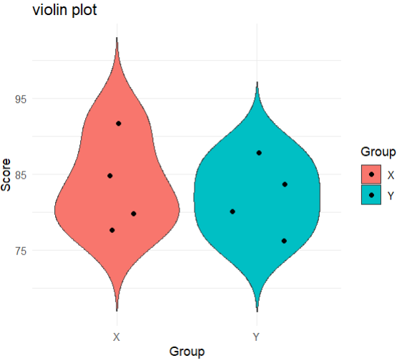

1. Area plot

year <- c(2015, 2016, 2017, 2018, 2019)

revenue <- c(30, 35, 40, 45, 50)

data <- data.frame(year, revenue)

ggplot(data,aes(x=year,y=revenue))+

geom_area(fill="yellow",alpha=0.4)+

geom_point(color="orange",size=3)+

geom_line(color="orange",size=1)+theme_minimal()

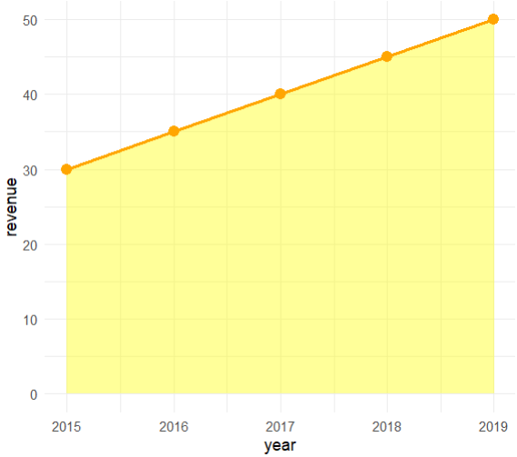

1. Calendar Heat map

library(ggplot2)

library(calendar)

data <- data.frame(

date = as.Date(c("2023-01-01", "2023-01-02", "2023-01-03", "2023-01-04", "2023-01-05")), count = c(10, 12, 15, 8, 20))

ggplot(data, aes(x = date, y = count)) +

geom_tile(aes(fill = count), color = "white") +

scale_fill_gradient(low = "lightblue", high = "darkblue") +

labs(title = "Daily Activity Count", x = "Date", y = "Activity Count") +

theme_minimal()

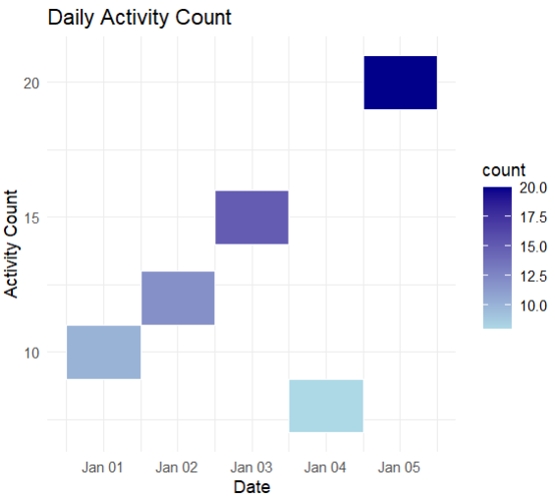

1. Chord diagram

library(circlize)

chord_data <- data.frame(

From = c("A", "A", "B", "B", "C"),

To = c("B", "C", "C", "D", "D"),

Value = c(10, 20, 15, 25, 30)

)

chordDiagram(chord_data)

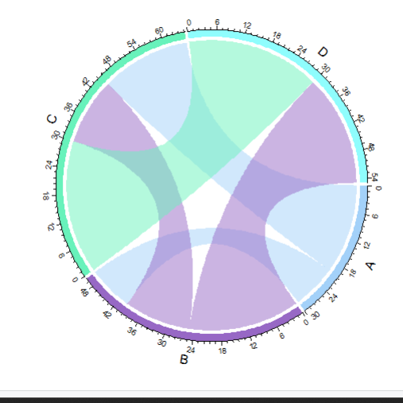

1. Density Rigid plot

library(ggplot2)

library(ggridges)

city <- c(rep("City1", 3), rep("City2", 3))

temperature <- c(20, 21, 19, 22, 23, 24)

data <- data.frame(city, temperature)

ggplot(data, aes(x = temperature, y = city, fill = city)) +

geom_density_ridges(alpha = 0.7) +

labs(title = "Temperature Distributions by City", x = "Temperature", y = "City") +

theme_minimal() +

theme(legend.position = "none")

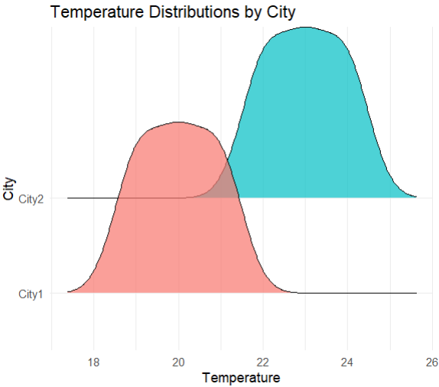

1. Dumbbell plot

# Create the dataset

product <- c("A", "B", "C", "D", "E")

before_campaign <- c(200, 300, 400, 500, 600)

after_campaign <- c(250, 350, 450, 550, 650)

data <- data.frame(product, before_campaign, after_campaign)

library(ggplot2)

library(ggalt)

ggplot(data,aes(x=before_campaign,xend=after_campaign,y=product))+

geom_dumbbell(color="orange",size=2)+

labs(title="dumbbell plot")+

theme_minimal()

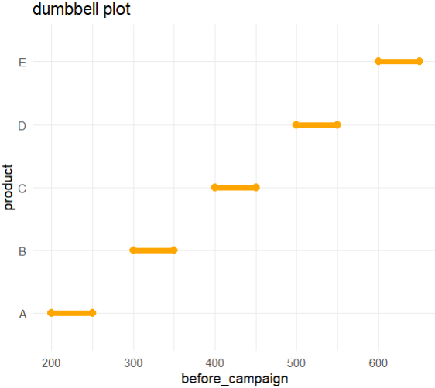

1. Hex bin plot

data <- data.frame(

x = rnorm(1000),

y = rnorm(1000)

)

library(ggplot2)

library(hexbin)

ggplot(data,aes(x=x,y=y))+

geom_hex(bins=30)+labs(title="hex bin plot ")+

scale_fill_gradient(low="skyblue",high = "blue")+

theme_minimal()

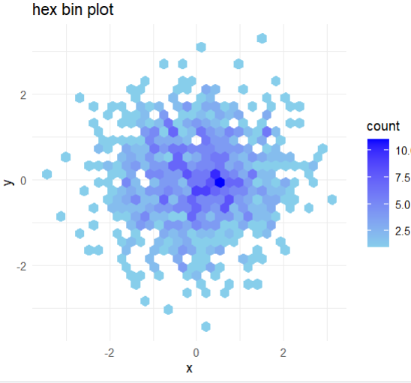

1. Lollipop plot

library(ggplot2)

region <- c("North", "South", "East", "West")

sales <- c(150, 200, 180, 210)

data <- data.frame(region, sales)

ggplot(data,aes(x=region,y=sales))+

geom_segment(aes(x=region,xend=region,y=0,yend=sales),color="skyblue",size=2)+

geom_point(color="blue",size=5)+

labs(title = "lollipop plot")+

theme_minimal()

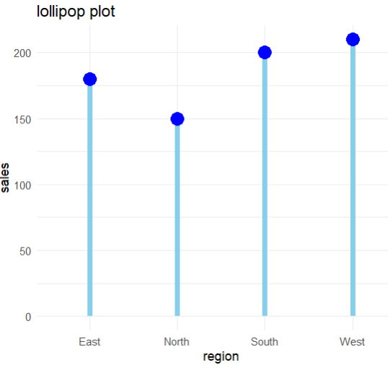

1. Spaghetti plot

library(ggplot2)

month <- c("Jan", "Feb", "Mar", "Jan", "Feb", "Mar")

product <- c("A", "A", "A", "B", "B", "B")

sales <- c(100, 150, 130, 120, 140, 160)

data <- data.frame(month, product, sales)

ggplot(data,aes(x=month,y=sales,group=product,color=product))+ # not fill color should be used

geom_line(size=2)+

geom_point(color="red",size=4)+theme_minimal()

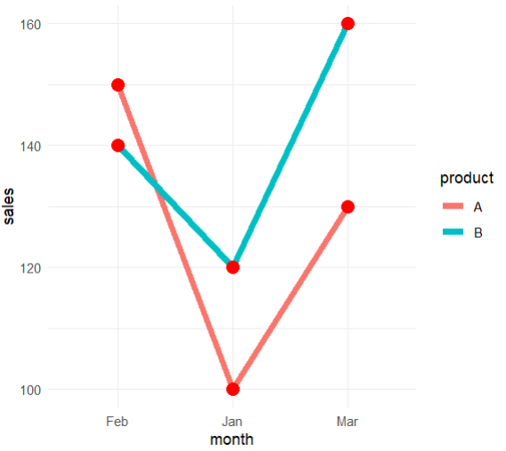

1. Step plot

library(ggplot2)

month <- c("Jan", "Feb", "Mar", "Apr", "May")

sales <- c(100, 200, 300, 400, 500)

data <- data.frame(month, sales)

ggplot(data,aes(x=month,y=sales,group=1))+ # group 1 is important

geom_step(color="pink",size=1)+

geom_point(color="red",size=2)+

theme_minimal()

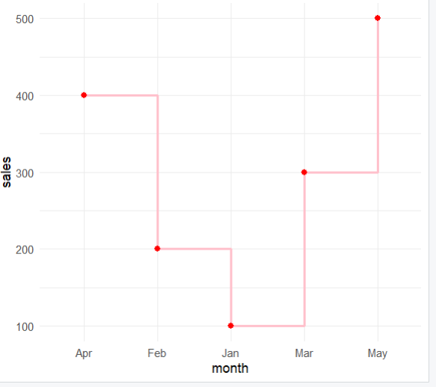

1. Water fall plot

library(waterfalls)

# Create a data frame with the appropriate structure

profit_loss_data <- data.frame(

labels = c("Jan", "Feb", "Mar", "Apr", "May"),

values = c(100, -20, 50, -10, 80)

)

waterfall(profit_loss_data, fill_by_sign = TRUE)

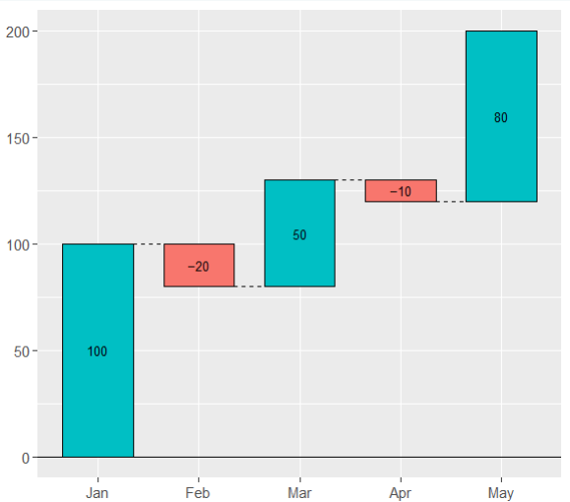

1. Line plot

data<- data.frame(

Month = c("January", "February", "March", "April", "May"),

Sales = c(15000, 18000, 22000, 20000, 23000)

)

library(ggplot2)

ggplot(data,aes(x=Month,y=Sales,group=1))+ # group 1

geom_line(color="red",size=1)+

geom_point(color="blue",size=1.5)+

labs(title="plots",x="X axis",y="Y axis")+

theme_minimal()

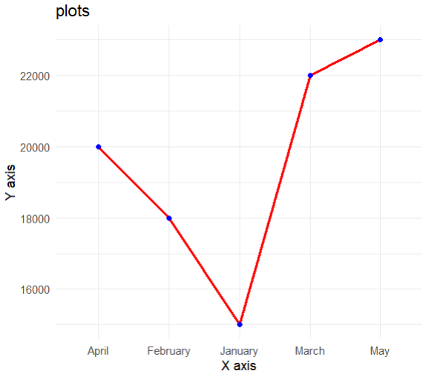

1. Bar Plot

data <- data.frame(

Product = c("Product A", "Product B", "Product C", "Product D", "Product E"),

Sales = c(50000, 40000, 35000, 30000, 25000)

)

library(ggplot2)

ggplot(data,aes(x=Product,y=Sales,fill=Product))+

geom_bar(stat = "identity",position = "dodge",)+

theme_minimal()

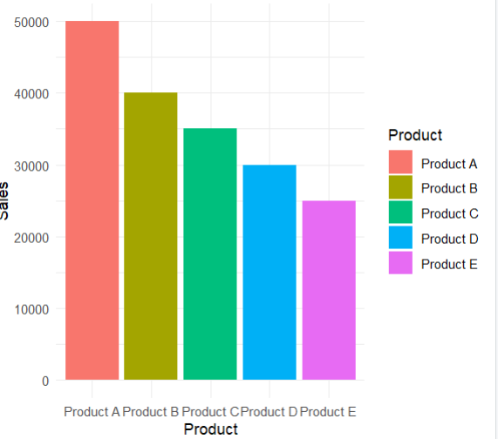

1. Scatter 3d plots

library(plotly)

data=data.frame(date=as.Date(c('2023-01-01', '2023-01-02', '2023-01-03', '2023-01-04', '2023-01-05')),temp = c(10, 12, 8, 15, 14),humid = c(75, 70, 80, 65, 72),wind = c(15, 12, 18, 20, 16))

plot_ly(data,x=~humid,y=~wind,z=~temp,type = "scatter3d",mode="markers",

marker=list(size=4,color=~temp,colorscale="viridis",showscale=TRUE ))%>%

layout(title="sactter 3d plot",

scene=list(xaxis=list(title="Humidity"),

yaxis=list(title="Wind"),

zaxis=list(title="Temp")))

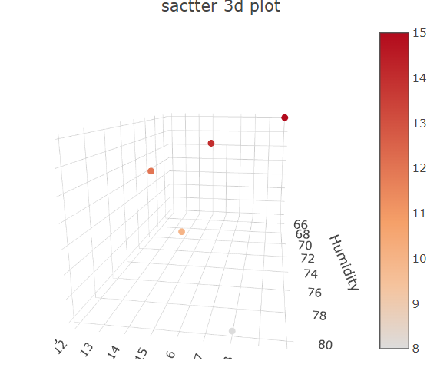

1. ggpairs

library(ggplot2)

library(GGally)

# Create the data frame

data <- data.frame(Date = as.Date(c('2023-01-01', '2023-01-02', '2023-01-03', '2023-01-04', '2023-01-05')),Temperature = c(10, 12, 8, 15, 14), Humidity = c(75, 70, 80, 65, 72), WindSpeed = c(15, 12, 18, 20, 16))

ggpairs(data[,-1])

cor(data[,-1])

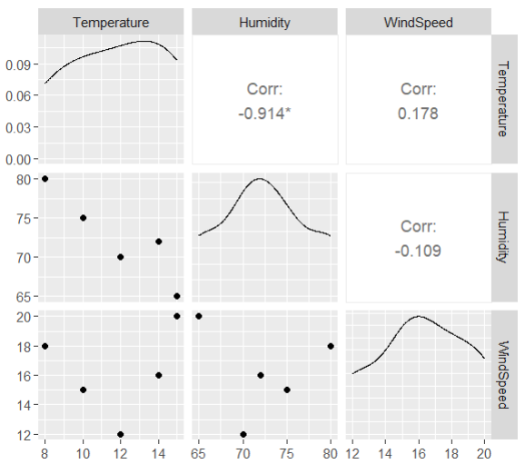

Temperature Humidity WindSpeed

Temperature 1.0000000 -0.9144470 0.1784559

Humidity -0.9144470 1.0000000 -0.1090199

WindSpeed 0.1784559 -0.1090199 1.0000000

1. 3D surface plot

library(plotly)

library(akima)

data <- data.frame(

Date = as.Date(c('2023-01-01', '2023-01-02', '2023-01-03', '2023-01-04', '2023-01-05')),

Temperature = c(10, 12, 8, 15, 14),

Humidity = c(75, 70, 80, 65, 72),

WindSpeed = c(15, 12, 18, 20, 16)

)

idata<-with(data,interp(Humidity,WindSpeed,Temperature))

plot_ly(

x=idata$x,

y=idata$y,

z=idata$z,

type = "surface"

)%>%

layout(title="suurface plot",

scene=list(

xaxis=list(title="humidity"),

yaxix=list(title="windspeed"),

zaxix=list(title="temperature")

))

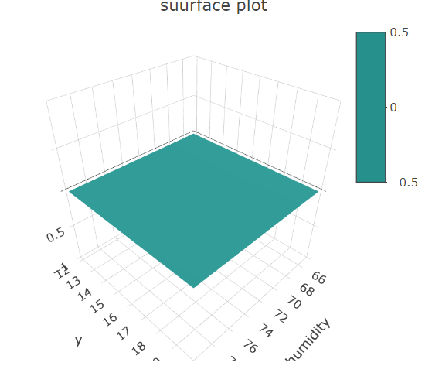

1. Stacked bar chart

library(ggplot2)

customer_data <- data.frame(

CustomerID = 1:5,

Age = c(25, 30, 35, 28, 40),

SatisfactionScore = c(4, 5, 3, 4, 5))

customer_data$AgeGroup <- cut(customer_data$Age, breaks = c(20, 30, 40, 50), labels = c("20-30", "30-40", "40-50"))

ggplot(customer_data, aes(x = AgeGroup, fill = factor(SatisfactionScore))) +

geom_bar(position = "stack") +

labs(title = "Distribution of Satisfaction Scores by Age Group", x = "Age Group", y = "Count", fill = "Satisfaction Score") +theme_minimal()

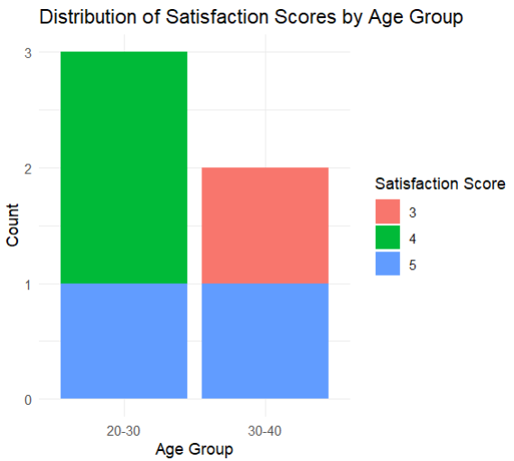

1. Stacked Area plot

user_interactions <- data.frame(

Date = as.Date(c("2023-01-01", "2023-01-02", "2023-01-03", "2023-01-04", "2023-01-05")),Likes = c(100, 120, 110, 130, 125), Shares = c(50, 60, 55, 70, 65), Comments = c(30, 35, 40, 25, 30))

library(reshape2)

user_interactions_melt <- melt(user_interactions, id.vars = "Date", variable.name = "Interaction", value.name = "Count")

ggplot(user_interactions_melt, aes(x = Date, y = Count, fill = Interaction)) +

geom_area(alpha = 0.6) + labs(title = "Distribution of User Interactions Over Time", x = "Date", y = "Count of Interactions") +theme_minimal()

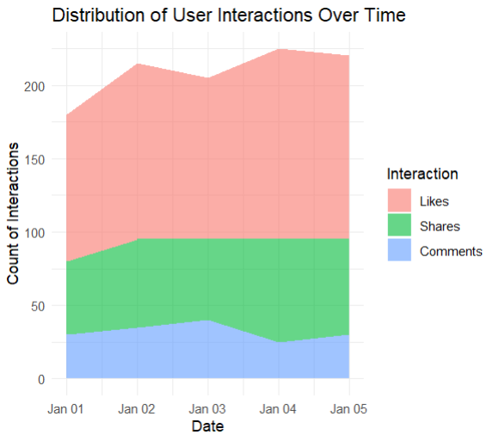

1. Bar, Scatter, Boxplot

data <- data.frame(

Product_ID = c(1, 2, 3, 4, 5),

ProductName = c("Laptop", "T-Shirt", "Refrigerator", "Sneakers", "Smartphone"),

Category = c("Electronics", "Clothing", "Appliances", "Footwear", "Electronics"),

Sales_Units = c(500, 1000, 300, 700, 800),

Revenue_Dollars = c(500000, 20000, 150000, 70000, 400000),

Discount_Percent = c(10, 20, 15, 25, 5)

)

ggplot(data, aes(x = Category, y = Sales_Units, fill = Category)) +

geom_bar(stat = "identity") +

labs(title = "Sales by Category", x = "Category", y = "Sales (Units)") +

theme_minimal()

ggplot(data, aes(x = Discount_Percent, y = Revenue_Dollars, color = Category)) +

geom_point(size = 4) +

labs(title = "Revenue vs Discount", x = "Discount (%)", y = "Revenue ($)") +

theme_minimal()

ggplot(data, aes(x = Category, y = Sales_Units, fill = Category)) +

geom_boxplot() +

labs(title = "Sales by Category", x = "Category", y = "Sales (Units)") +

theme_minimal()

1. Scatter plot smoothing

# 3. Relationship between renewable energy and CO2 emissions by scatterplot

ggplot(data, aes(x = RenewableEnergy, y = CO2Emissions)) +

geom_point() +

geom_smooth(method = "lm", se = FALSE, color = "blue") +

labs(title = "Relationship between Renewable Energy and CO2 Emissions", x = "Renewable Energy (%)", y = "CO2 Emissions (Mt)")

