**1. INTRODUCTION**

**1.1 WHAT IS AN IMAGE**

An image is a 2-D representation of information that which conveys meaning full data to the user. By means of image the information is easily exchange between the users. In present era the images play a key role in information technology.

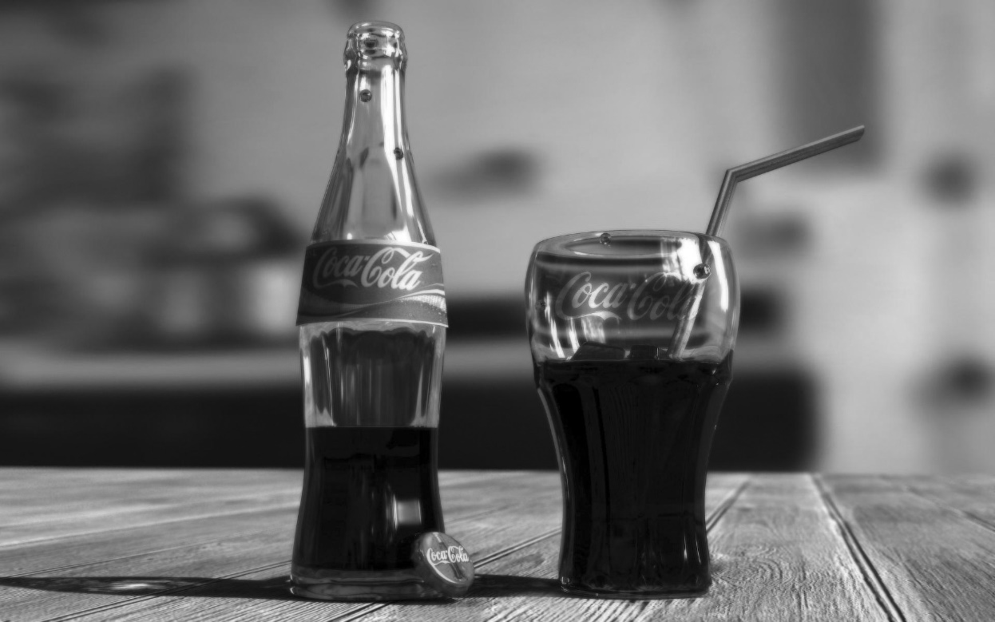

**Figure 1.1:**An image — an array or a matrix of pixels arranged in columns and rows.

In a (8-bit) grayscale image each picture element has an assigned intensity that ranges from 0 to 255. A gray scale image is what people normally call a black and white image, but the name emphasizes that such an image will also include many shades of gray.

There are two general groups of ‘images’: vector graphics (or line art) and bitmaps (pixel-based or ‘images’). Some of the most common file formats are:

* GIF - An 8-bit (256 color), non-destructively compressed bitmap format. Mostly used for web has several sub-standards one of which is the animated GIF.
* JPEG- A very efficient (i.e. much information per byte) destructively compressed 24bitbitmap format. Widely used, especially for web and Internet (bandwidth limited).
* TIFF - The standard 24bit publication bitmap format.
* PS-Postscript, standard vector format. Has numerous sub-standards and can be difficult to transport across platforms and operating systems.
* PSD- A dedicated Photoshop format that keeps all the information in an image.

## 1.2 PIXEL

Pixel is the smallest element of an image. Each pixel corresponds to any one value. In an 8-bit grayscale image, the value of the pixel between 0 and 255.The value of a pixel at any point corresponds to the intensity of the light photons striking at that point. Each pixel stores a value proportional to the light intensity at that particular location.

### Pel:

A pixel is also known as PEL. You can have more understanding of the pixel from the pictures given below. In the above picture, there may be thousands of pixels, that together make up this image. It will zoom that image to the extent that it can be able to see some pixels division. It is shown in the image below.

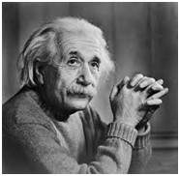



**Relationship with CCD:**

It is seen that how an image is formed in the CCD array. So a pixel can also be defined as “The smallest division the CCD array is also known as pixel” .Each division of CCD array contains the value against the intensity of the photon striking to it. This value can also be called as a pixel.

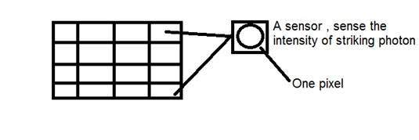

**1.3 RESOLUTION**

The resolution can be defined in many ways. Such as pixel resolution, spatial resolution, temporal resolution, spectral resolution. Out of which it is going to discuss pixel resolution. You have probably seen that in your own computer settings, you have monitor resolution of 800 x 600, 640 x 480 etc. In pixel resolution, the term resolution refers to the total number of count of pixels in an digital image. For example if an image has M rows and N columns, then its resolution can be defined as M X N.

In defining resolution as the total number of pixels, then pixel resolution can be defined with set of two numbers. The first number the width of the picture, or the pixels across columns, and the second number is height of the picture, or the pixels across its width. This can say that the higher is the pixel resolution, the higher is the quality of the image. This can define pixel resolution of an image as 4500 X 5500.

**Megapixels:**

To calculate mega pixels of a camera using pixel resolution.

Column pixels (width) X row pixels ( height) / 1 Million.

The size of an image can be defined by its pixel resolution.

Size = pixel resolution X bpp(bits per pixel).

Calculating the mega pixels of the camera**:**

Let’s say an image of dimension = 2500 X 3192.

Its pixel resolution = 2500 * 3192

= 7982350 bytes.

Dividing it by 1 million = 7.9

= 8 mega pixel (approximately).

**Aspect ratio:**

Another important concept with the pixel resolution is aspect ratio. Aspect ratio is the ratio between width of an image and the height of an image. It is commonly explained as two numbers separated by a colon (8:9). This ratio differs in different images, and in different screens. The common aspect ratios are:

1.33:1, 1.37:1, 1.43:1, 1.50:1, 1.56:1, 1.66:1, 1.75:1, 1.78:1, 1.85:1, 2.00:1, etc.

**Advantage:**

Aspect ratio maintains a balance between the appearances of an image on the screen, means it maintains a ratio between horizontal and vertical pixels. It does not let the image to get distorted when aspect ratio is increased.

**For example:**

This is a sample image, which has 100 rows and 100 columns. If needed to make is smaller, and the condition is that the quality remains the same or in other way the image does not get distorted, here how it happens.

**Original image:**



Changing the rows and columns by maintain the aspect ratio in MS Paint.

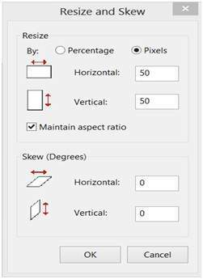

**Result:**

reduced aspect ratio

Smaller image, but with same balance. You have probably seen aspect ratios in the video players, where you can adjust the video according to your screen resolution. Finding the dimensions of the image from aspect ratio: Aspect ratio tells us many things. With the aspect ratio, you can calculate the dimensions of the image along with the size of the image.

**1.4 COLOURS**

For science communication, the two main colour spaces are RGB and CMYK.

The RGB colour model relates very closely to the way to perceive colour with the r, g and b receptors in our retinas. RGB uses additive colour mixing and is the basic colour model used in television or any other medium that projects colour with light. It is the basic colour model used in computers and for web graphics, but it cannot be used for print production.

The secondary colours of RGB – cyan, magenta, and yellow – are formed by mixing two of the primary colours (red, green or blue) and excluding the third colour. Red and green combine to make yellow, green and blue to make cyan, and blue and red form magenta. The combination of red, green, and blue in full intensity makes white.

In Photoshop using the “screen” mode for the different layers in an image will make the intensities mix together according to the additive colour mixing model. This is analogous to stacking slide images on top of each other and shining light through them.



**Figure1.2:** The additive model of RGB. Red, green, and blue are the primary stimuli for human colour perception and are the primary additive colours.

**CMYK:**

The 4-colour CMYK model used in printing lays down overlapping layers of varying percentages of transparent cyan (C), magenta (M) and yellow (Y) inks. In addition a layer of black (K) ink can be added. The CMYK model uses the subtractive colour model.



**Figure 1.3**: The colours created by the subtractive model of CMYK don't look exactly like the colours created in the additive model of RGB most important, CMYK cannot reproduce the brightness of RGB colours.In addition, the CMYK gamut is much smaller than the RGB gamut.

**Gamut:**

The range, or gamut, of human colour perception is quite large. The two colour spaces discussed here span only a fraction of the colours that can see. Furthermore the two spaces do not have the same gamut, meaning that converting from one colour space to the other may cause problems for colours in the outer regions of the gamut.



**Figure1.4**: This illustration clearly shows the different gamuts of the RGB and CMYK colour spaces. The background is the CIE Chromaticity Diagram (representing the whole gamut of human colour perception).

**1.5 IMAGE PROCESSING**

**What is Image Processing**

Image processing is the field that use various image processing algorithms on digital images. The image processing is the subcategory of the digital signal processing for processing the digital signals and perform operations on analog signal and convert into digital signal into discrete form.

(Or)

The image processing is the process of performing the operations on image to improve the quality and also as well as for degrade the quality, the some of the image processing techniques are shown below.

1. Image Fusion
2. Image Compression
   1. Lossey compression
   2. Lossless compression
3. Image Segmentation.
4. Encryption and Decryption on image.

Image Processing is a method to convert an image into digital form and perform some operations on it, in order to get an enhanced image or to extract some useful information from it. It is a type of signal dispensation in which input is image, like video frame or photograph and output may be image or characteristics associated with that image. Usually Image Processing system includes treating images as two dimensional signals while applying already set signal processing methods to them.

It is among rapidly growing technologies today, with its applications in various aspects of a business. Image Processing forms core research area within engineering and computer science disciplines too.

Image processing basically includes the following three steps.

* Importing the image with optical scanner or by digital photography.
* Analyzing and manipulating the image which includes data compression and image enhancement and spotting patterns that are not to human eyes like satellite photographs.
* Output is the last stage in which result can be altered image or report that is based on image analysis.

**Purpose of Image processing**

The purpose of image processing is divided into 5 groups. They are:

1.      Visualization - Observe the objects that are not visible.

2.      Image sharpening and restoration - To create a better image.

3.      Image retrieval - Seek for the image of interest.

4.      Measurement of pattern – Measures various objects in an image.

5.      Image Recognition – Distinguish the objects in an image.

**Types**

The two types of methods used for Image Processing are Analog and Digital Image Processing. Analog or visual techniques of image processing can be used for the hard copies like printouts and photographs. Image analysts use various fundamentals of interpretation while using these visual techniques. The image processing is not just confined to area that has to be studied but on knowledge of analyst. Association is another important tool in image processing through visual techniques. So analysts apply a combination of personal knowledge and collateral data to image processing.

Digital Processing techniques help in manipulation of the digital images by using computers. As raw data from imaging sensors from satellite platform contains deficiencies. To get over such flaws and to get originality of information, it has to undergo various phases of processing. The three general phases that all types of data have to undergo while using digital technique are Pre- processing, enhancement and display, information extraction.

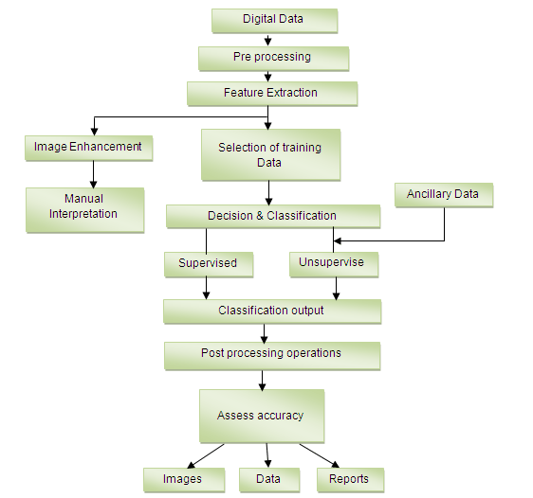

**Figure 1.5:** Flow Diagram for image processing

**1.6 APPLICATIONS OF IMAGE PROCESSING**

1.      **Intelligent Transportation Systems** – This technique can be used in Automatic number plate recognition and Traffic sign recognition.

2.    **Remote Sensing** – For this application, sensors capture the pictures of the earth’s surface in remote sensing satellites or multi – spectral scanner which is mounted on an aircraft. These pictures are processed by transmitting it to the Earth station. Techniques used to interpret the objects and regions are used in flood control, city planning, resource mobilization, agricultural production monitoring, etc.

3.      **Moving object tracking** – This application enables to measure motion parameters and acquire visual record of the moving object. The different types of approach to track an object are:

* Motion based tracking
* Recognition based tracking

4.      **Defense surveillance** – Aerial surveillance methods are used to continuously keep an eye on the land and oceans. This application is also used to locate the types and formation of naval vessels of the ocean surface. The important duty is to divide the various objects present in the water body part of the image. The different parameters such as length, breadth, area, perimeter, compactness are set up to classify each of divided objects. It is important to recognize the distribution of these objects in different directions that are east, west, north, south, northeast, northwest, southeast and south west to explain all possible formations of the vessels. We can interpret the entire oceanic scenario from the spatial distribution of these objects.

5.      **Biomedical Imaging techniques** – For medical diagnosis, different types of imaging tools such as X- ray, Ultrasound, computer aided tomography (CT) etc are used. The diagrams of X- ray, MRI, and computer aided tomography (CT) are given below.

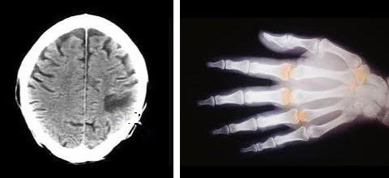

Some of the applications of Biomedical imaging applications are as follows:

* Heart disease identification– The important diagnostic features such as size of the heart and its shape are required to know in order to classify the heart diseases. To improve the diagnosis of heart diseases, image analysis techniques are employed to radiographic images.
* Lung disease identification – In X- rays, the regions that appear dark contain air while region that appears lighter are solid tissues. Bones are more radio opaque than tissues. The ribs, the heart, thoracic spine, and the diaphragm that separates the chest cavity from the abdominal cavity are clearly seen on the X-ray film.
* Digital mammograms – This is used to detect the breast tumour. Mammograms can be analyzed using Image processing techniques such as segmentation, shape analysis, contrast enhancement, feature extraction, etc.

6.      **Automatic Visual Inspection System** – This application improves the quality and productivity of the product in the industries.

* Automatic inspection of incandescent lamp filaments – This involves examination of the bulb manufacturing process. Due to no uniformity in the pitch of the wiring in the lamp, the filament of the bulb gets fused within a short duration. In this application, a binary image slice of the filament is created from which the silhouette of the filament is fabricated. Silhouettes are analyzed to recognize the non uniformity in the pitch of the wiring in the lamp. This system is being used by the General Electric Corporation.
* Automatic surface inspection systems – In metal industries it is essential to detect the flaws on the surfaces. For instance, it is essential to detect any kind of aberration on the rolled metal surface in the hot or cold rolling mills in a steel plant. Image processing techniques such as texture identification, edge detection, fractal analysis etc are used for the detection.
* Faulty component identification – This application identifies the faulty components in electronic or electromechanical systems. Higher amount of thermal energy is generated by these faulty components. The Infra-red images are produced from the distribution of thermal energies in the assembly. The faulty components can be identified by analyzing the Infra-red images.

**1.7 CURRENT RESEARCH & FUTURE**

A wide research is being done in the Image processing technique.

1.      Cancer Imaging – Different tools such as PET, MRI, and Computer aided Detection helps to diagnose and be aware of the tumour.

2.      Brain Imaging – Focuses on the normal and abnormal development of brain, brain ageing and common disease states.

3.      Image processing – This research incorporates structural and functional MRI in neurology, analysis of bone shape and structure, development of functional imaging tools in oncology, and PET image processing software development.

4.      Imaging Technology – Development in image technology have formed the requirement to establish whether new technologies are effective and cost beneficial. This technology works under the following areas:

* Magnetic resonance imaging of the knee
* Computer aided detection in mammography
* Endoscopic ultrasound in staging the oesophageal cancer
* Magnetic resonance imaging in low back pain
* Ophthalmic Imaging – This works under two categories:

5.      Development of automated software- Analyzes the retinal images to show early sign of diabetic retinopathy

6.      Development of instrumentation – Concentrates on development of scanning laser ophthalmoscope

**Future**

We all are in midst of revolution ignited by fast development in computer technology and imaging. Against common belief, computers are not able to match humans in calculation related to image processing and analysis. But with increasing sophistication and power of the modern computing, computation will go beyond conventional, Von Neumann sequential architecture and would contemplate the optical execution too. Parallel and distributed computing paradigms are anticipated to improve responses for the image processing results.