**DEPARTMENT OF COMPUTER SCIENCE AND ENGINEERING**

**Y.S.R. ENGINEERING COLLEGE OF YOGI VEMANA UNIVERSITY**

**PRODDATUR -516360, Y.S.R. (Dt.), A.P.**

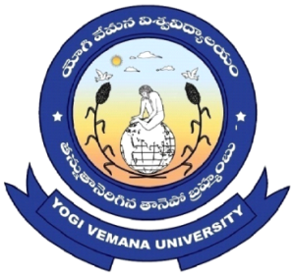

**CERTIFICATE**

This is to certify that the project report entitled “MULTIRESOLUTED IMAGE FUSION USING MDWT” is submitted by **T.LOKESH** in partial fulfillment of the requirement for the award of the Degree of BACHELOR OF TECHNOLOGY in COMPUTER SCIENCE AND ENGINEERING, Y.S.R. ENGINEERING COLLEGE OF YOGI VEMANA UNIVERSITY, Proddatur, is a record of bonafide work carried out by them under my guidance and supervision.

|  |  |
| --- | --- |
| **PROJECT GUIDE**  **Dr.S.KIRAN,**  **Assistant Professor,**  **Department of CSE.**  **YSR Engineering College of YVU,**  **Proddatur.** | **HEAD OF THE DEPARTMENT**  **Dr. C. NAGARAJU,**  **Associate Professor,**  **Department of CSE.**  **YSR Engineering College of YVU,**  **Proddatur.** |
| **INTERNAL EXAMINAR** | **EXTERNAL EXAMINER** |