**5. RESULTS**

**5.1 Results and Discussion**

The fusion algorithms developed in chapter (3) are evaluated using the images shown in Figure (5.1). The ground truth image is shown Figure (5.2a) and the images to be fused are shown in Figure (5.2b&c). Both Figure (5.2b) and Figure (5.2c) are complementary to each other. In first image (I1) upper side aircraft is out of focused and the other aircraft is in focus as shown in Figure (5.2b) and vice versa in image I2 as shown in Figure (5.2c).

The out of focus has been created by blurring the portions of the reference image with a Gaussian mask using diameter of 12 pixels. The fused (left side) along with the error (right side) images are shown in Figure (5.3) to (5.5). The error image is the difference between reference Ir and fused images. One can observe that the fused image preserves all the useful information from the two source images.

The fusion quality evaluation metrics are shown in Table (5.1) to (5.3). The best results are shown in bold. In case of DCT-FP, DCT-FP with MDWT, DCT-MR, DCT-MR with MDWT, DCT-LP, and DCT-LP with MDWT based image fusion techniques, DCT-LP with MDWT based image fusion gives better results with high levels of decomposition. It could be because of series of quasiband passed images which are localized in both space and spatial frequencies. Moreover, DCT-LP with MDWT is simple and computationally efficient while compared to other fused algorithms. Higher level of decomposition used in fusion process gives better performance.

Fusion by Laplacian Pyramid with MDWT with higher level of decomposition showed small PFE and high PSNR that shows the fused image is very similar to the ground truth image. Similarly, SD and SF are high that shows that the fused image having good contrast and retain the overall activity.

(5.1)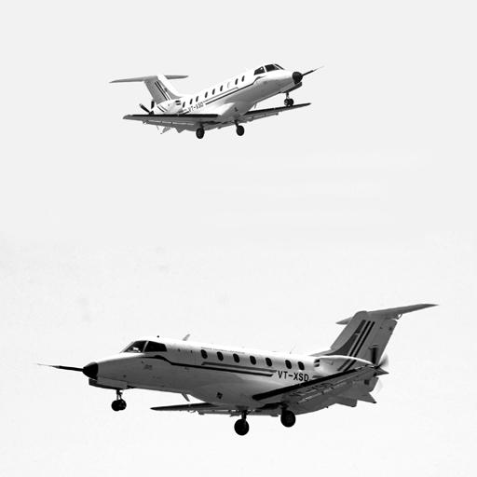

**Figure 5.1:** Ground truth image

(5.2 b)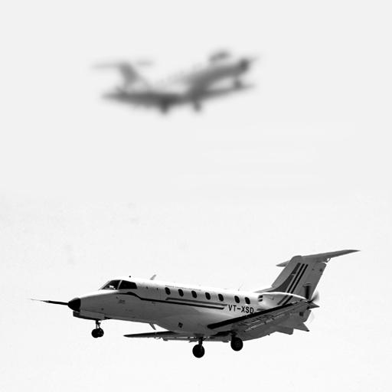( 5.2c)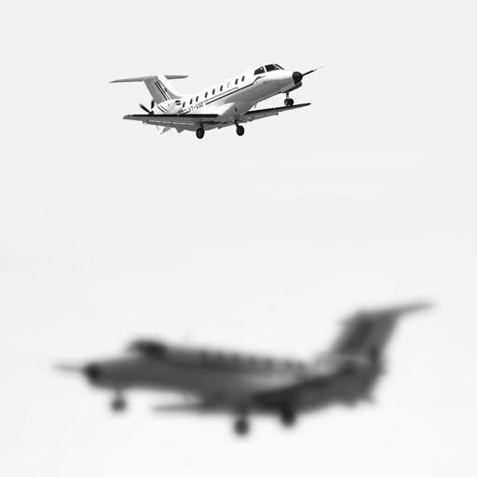

**Figure 5.2b&c:** Images to be fused

**5.2 TABLEAR RESULTS**

**Table 5.1:** Fusion quality evaluation metrics for frequency partition

|  |  |  |  |  |  |  |  |  |  |  |
| --- | --- | --- | --- | --- | --- | --- | --- | --- | --- | --- |
|  | Partition scale factor ( f) | | | | | | | | | |
| **DCTFP** | **MDWT** | **DCTFP** | **MDWT** | **DCTFP** | **MDWT** | **DCTFP** | **MDWT** | **DCTFP** | **MDWT** |
| **FP_LEVELS** | FP-0.0 | FP-0.0 | FP-0.2 | FP-0.2 | FP-0.6 | FP-0.6 | FP-0.8 | FP-0.8 | FP-1 | FP-1 |
| **RMSE** | 7.2059 | 6.8983 | 8.4578 | 8.3867 | 9.2816 | 9.2751 | 9.3462 | 9.4155 | 9.3692 | 9.5371 |
| **PFE** | 3.0913 | 2.9594 | 3.6284 | 3.5979 | 3.9818 | 3.979 | 4.0095 | 4.0392 | 4.0194 | 4.0914 |
| **MAE** | 5.319 | 5.032 | 4.1324 | 3.8787 | 3.3589 | 2.9684 | 3.1858 | 3.0012 | 2.9994 | 3.0559 |
| **Dent** | 0.0277 | 0.0212 | 0.0339 | 0.0339 | 0.0339 | 0.0339 | 0.0339 | 0.0339 | 0.0339 | 0.0339 |
| **CC** | 0.9995 | 0.9996 | 0.9993 | 0.9994 | 0.9992 | 0.9992 | 0.9992 | 0.9992 | 0.9992 | 0.9992 |
| **SNR** | 30.1971 | 30.576 | 28.8057 | 28.8791 | 27.9984 | 28.0045 | 27.9382 | 27.874 | 27.9168 | 27.7625 |
| **PSNR** | 39.5879 | 39.7774 | 38.8922 | 38.9289 | 38.4886 | 38.4916 | 38.4584 | 38.4264 | 38.4478 | 38.3706 |

**Table 5.2:** Fusion quality evaluation metrics for 1D multi-resolution DCT

|  |  |  |  |  |  |  |  |  |  |  |
| --- | --- | --- | --- | --- | --- | --- | --- | --- | --- | --- |
|  | No. of decomposition levels (K) | | | | | | | | | |
| **DCTMR** | **MDWT** | **DCTMR** | **MDWT** | **DCTMR** | **MDWT** | **DCTMR** | **MDWT** | **DCTMR** | **MDWT** |
| **MR_LEVELS** | MR-1 | MR-1 | MR-2 | MR-2 | MR-3 | MR-3 | MR-4 | MR-4 | MR-5 | MR-5 |
| **RMSE** | 9.2094 | 9.1713 | 8.6819 | 8.6102 | 7.8772 | 7.7838 | 7.2165 | 7.0824 | 7.1312 | 6.9399 |
| **PFE** | 3.9508 | 3.9345 | 3.7245 | 3.6938 | 3.3793 | 3.3393 | 3.0959 | 3.0384 | 3.0593 | 2.9772 |
| **MAE** | 3.4854 | 2.9626 | 3.9874 | 3.6812 | 4.4183 | 4.2094 | 4.6468 | 4.4491 | 4.9385 | 4.7197 |
| **Dent** | 0.0339 | 0.0339 | 0.0339 | 0.0339 | 0.0338 | 0.0336 | 0.0338 | 0.0333 | 0.0324 | 0.0308 |
| **CC** | 0.9992 | 0.9992 | 0.9993 | 0.9993 | 0.9994 | 0.9994 | 0.9995 | 0.9995 | 0.9995 | 0.9996 |
| **SNR** | 28.0663 | 28.1023 | 28.5786 | 28.6506 | 29.4235 | 29.527 | 30.1843 | 30.3472 | 30.2876 | 30.5238 |
| **PSNR** | 38.5225 | 38.5405 | 38.7786 | 38.8146 | 39.2011 | 39.2529 | 39.5815 | 39.663 | 39.6332 | 39.7513 |

**Table 5.3:** Fusion quality evaluation metrics for LP1D

|  |  |  |  |  |  |  |  |  |  |  |
| --- | --- | --- | --- | --- | --- | --- | --- | --- | --- | --- |
|  | No. of pyramid levels (K) | | | | | | | | | |
| **DCTLP** | **MDWT** | **DCTLP** | **MDWT** | **DCTLP** | **MDWT** | **DCTLP** | **MDWT** | **DCTLP** | **MDWT** |
| **LP_LEVELS** | LP-1 | LP -1 | LP -2 | LP -2 | LP -3 | LP -3 | LP -4 | LP -4 | LP -5 | LP -5 |
| **RMSE** | 9.0762 | 9.083 | 8.0763 | 8.0861 | 6.3372 | 6.3421 | 4.3533 | 4.3566 | 3.42 | 3.3919 |
| **PFE** | 3.8937 | 3.8966 | 3.4647 | 3.4689 | 2.7186 | 2.7208 | 1.8675 | 1.869 | 1.4672 | 1.4551 |
| **MAE** | 2.9947 | 2.8931 | 2.8107 | 2.6634 | 2.484 | 2.3503 | 1.909 | 1.7686 | 1.6385 | 1.4699 |
| **Dent** | 0.0339 | 0.0339 | 0.0339 | 0.0339 | 0.0335 | 0.0327 | 0.0332 | 0.0313 | 0.0315 | 0.0276 |
| **CC** | 0.9992 | 0.9992 | 0.9994 | 0.9994 | 0.9996 | 0.9996 | 0.9998 | 0.9998 | 0.9999 | 0.9999 |
| **SNR** | 28.1928 | 28.1863 | 29.2067 | 29.1961 | 31.313 | 31.3062 | 34.5746 | 34.5678 | 36.6704 | 36.7419 |
| **PSNR** | 38.5858 | 38.5825 | 39.0927 | 39.0874 | 40.1458 | 40.1425 | 41.7767 | 41.7733 | 42.8246 | 42.8603 |

**5.3 IMAGE RESULTS**

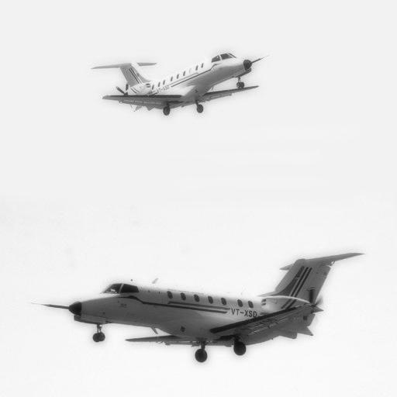

**Figure 5.3.a:** DCTFP result Input image to be fused



**Figure 5.3.b:** Fused and error image using frequency partition technique

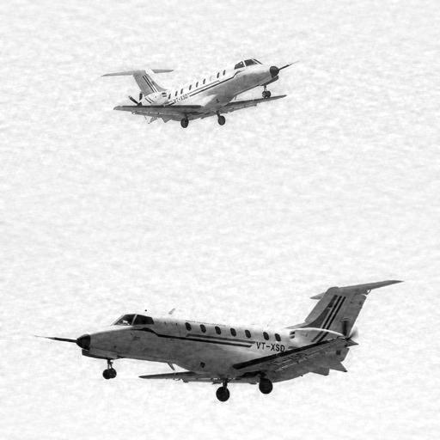

**Figure 5.4.a:** DCTMR result as Input image to be fused



**Figure 5.4.b:** Fused and error image using frequency 1D multi-resolution analysis (MSDCT)

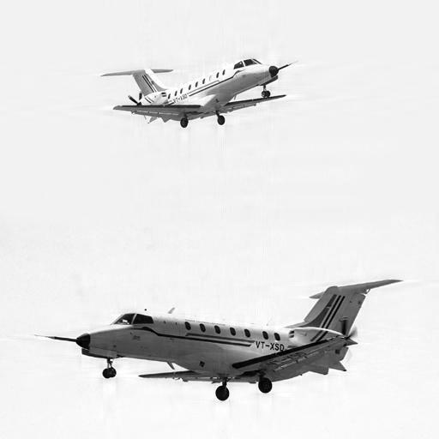

**Figure 5.5.a:** DCTLP result as Input image to be fused



**Figure 5.5.b:** Fused and error image using Laplacian pyramid analysis

**5.4 GRAPHS**

**Figure 5.6:** Comparison DCTFP and MDWT

**Figure 5.7:** Comparison DCTLP and MDWT

**Figure 5.8:** Comparison DCTMR and MDWT