Table of Contents

1. Test Approach 2

2. Test Case Design 2

3. Test Environment: 3

4. Test Execution: 4

5. Test Monitoring and Reporting 7

6. Test Tool 8

This Document provides the details about how to provide the API Testing

API testing is Performed based on set of documents starting from Test Cases, Test plan/Test strategy, Traceability matrix,

# Test Approach

The Semaphore API will be Tested using Postman.

# Test Case Design

1. In this stage Test cases are Written in ADO based on the requirements for Semaphore API Features.
2. All the test cases are Mapped to the requirements or features using traceability matrix.
3. API tests are Written in Postman, based on test cases.
4. API Tests are Mapped with test case in ADO or using traceability matrix.

The below table represents the traceability matrix for Semaphore API.

1. For Example, Test case 1:

|  |  |  |  |  |  |
| --- | --- | --- | --- | --- | --- |
| Req_Id | Req_Desc | Test_Case_Id | Test_Case_Desc | Test_Results | Comments |
| 1 | Acquire Lock When No Blocking Semaphore Exists | Task-83xx1  Task-83xx2 | Acquire Lock | Pass | Process Key  Bearer Token  URL  Acquisition Time |

1. For Example, Test case 2:

|  |  |  |  |  |  |
| --- | --- | --- | --- | --- | --- |
| Req_Id | Req_Desc | Test_Case_Id | Test_Case_Desc | Test_Results | Comments |
| 2 | Release Lock When Blocking Semaphore Exists | Task-83xx3  Task-83xx4 | Release Lock | Pass | Process Key  Bearer Token  URL  Acquisition Time  Release Time |

The above screenshot represents the test case in ADO for Semaphore API.

# Test Environment:

In this stage we will prepare the test environment using the postman tool and configuring the Semaphore API, Data base to refer the row in a table, turbine UI to trigger the graphs.

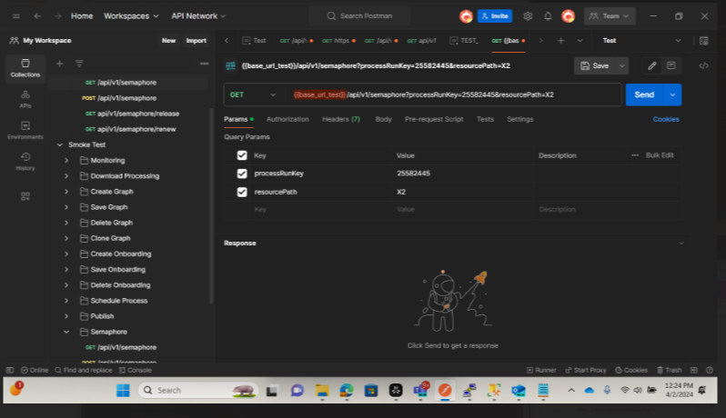

The above screenshot shows the postman request for the process run key.

The above screen shot shows the process run key present in the Semaphore DB.

The Above Screenshot shows the process key present in the Turbine UI.

# Test Execution:

In This Stage We run the test case and validate the API test results for expected against the Actual results.

Here are a few examples of semaphore API methods used where in client send the request and server respond.

1. GET Request

1. The above screenshot shows the postman GET request for the process run key.

1. POST Request

Scenario 1: To acquire a lock if no blocking semaphores exist.

The Above Screenshot shows the to trigger the POST request in swagger.

Scenario 2: To reject when acquiring and another exclusive semaphore exist for different process key.

The Above Screenshot shows the POST request to acquire the Lock.

The Above Screenshot shows the Swagger URL for POST request to acquire the lock for the request body.

# Test Monitoring and Reporting

This is the final stage where we monitor the results and report the test results to the stakeholders through email. We generate the detailed reports from the collections in the post man including any issues/findings.

The Above Screenshot shows the Execution results for monitoring and reporting how it looks in Postman for to be consider as example only for pass scenarios.

The Above Screenshot shows the Execution results for monitoring and reporting how it looks in Postman for to be consider as example only for pass and failed scenarios.

How to generate reports in postman for **enterprise** edition

<https://learning.postman.com/docs/reports/reports-overview/>

# Test Tool

How to use the tool to support testing please follow the below link

[Postman Learning Center](https://learning.postman.com/docs/designing-and-developing-your-api/testing-an-api/)