**Hybrid Automation Framework**

**(Java, Selenium, TestNG, Maven & Page Object Model)**

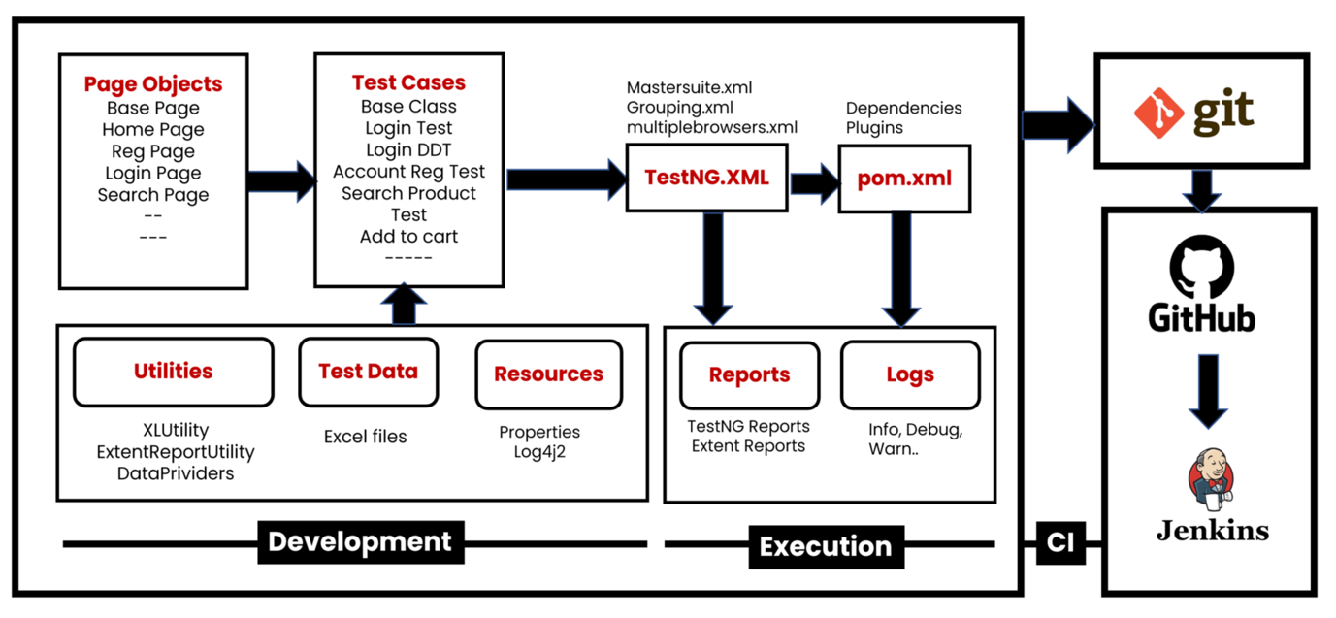

**Create Folder Sructure**

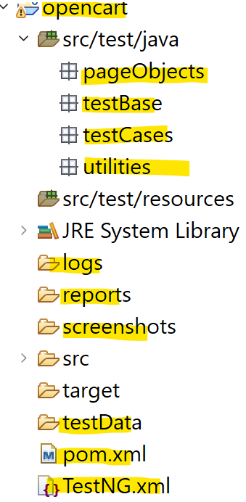

**Development of Hybrid Driven Framework**

**1) Test case: Account Registration**1.1: Create BasePage under "**pageObjects**" which includes only constructor. This will be invoked by every Page Object Class constructor (Re-usability).  
1.2: Create Page Object Classes for HomePage, RegistrationPage under **pageObjects** package. (These classes extends from BasePage).--> by inheritance.  
1.3: Create AccountRegistrationTest under "**testCases**"  
1.4: Create BaseClass under **testBase** package and copy re-usable methods.  
1.5: Create re-usable methods to generate random numbers and strings in BaseClass.

**2) Adding logs to test case (log4j2) 🡪 to capture the logs for debugging purposes**2.1: Add **log4j2.xml** file under **src/test/resourses**.  
2.2: Update BaseClass.  
2.3: Add log statements to AccountRegistrationTest.

**3) Run Tests on Desired Browser/Cross Browser/Parallel can be configured in testNG.xml to parameterize the test data.**

3.1: Create testng.xml file to Run Test Cases and parameterize browser name and OS to BaseClass →setup() method.

3.2: Update BaseClass →setup() method, launch browser based on conditions.

3.3: Maintain separate xml to run tests multiple browsers parallelly.

**4) Read Common values from config.properties file.**4.1: Add config.properties file under **src/test/resoures**.  
4.2: Update BaseClass →setup() method, add script to load config.properties file.

4.3: Replace hard coded values in Test Cases like url, username, password etc...

**5) Login Test Case**

5.1: Create and update page object classes. LoginPage, MyAccountPage – new classes HomePage – update by adding login link element

5.2: Create LoginTest

5.3: Add entry testng.xml

**6) Data Driven Login Test**

6.1: Prepare test data in Excel, place the excel file inside the **testData** folder.

6.2: Create ExcelUtility class under **utilities** package.

6.3: Update Page Object class MyAccountPage , add logout link element)

6.4 : Create DataProviders class in **utilities** package to maintain data providers for data driven tests.

6.5: Create LoginDataDrivenTest under **testCases** package.

6.6: Add an Entry in testng.xml file

**7) Grouping Tests.**

7.1: Add all test cases into specific group (sanity, regression , master etc.).

7.2: Also add BaseClass methods setup() & teardown() to all groups.  
7.3: Create separate TestNG xml file(grouping.xml) to run groups and include groups which we

want to execute.

**8) Add Extent Reports to Project 🡪 this is used to generate the customization of reports.**

8.1: Create ExtentReportUtility utility class under **utilities** package.

8.2: Add captureScreen() method in BaseClass

8.3: Add ExtentReportUtility (Listener class) entry in testng.xml file.

8.4: Make sure WebDriver is *static* in BaseClass, we refer same driver instance in ExtentReportUtility.

**9) Run Failed Tests.**

test-output→testng-failed.xml 🡪 to run only the failed test cases explicitly.

**10) Run Tests on Selenium Grid - this is used to run parallel testing to save the time.**

**Grid Setup:**

* Download selenium-server-4.15.0.jar and place it somewhere.
* Run below command in command prompt to start Selenium Grid

java -jar selenium-server-4.15.0.jar standalone

* URL to see sessions: http://localhost:4444/

10.1: Add **execution_env=local/remote** in config.properties file under resources folder.

10.2: Update setup() method in the BaseClass (capture execution environment from config.properties file then add required capabilities of OS & Browser in conditions).

10.3: Run the tests from testng.xml

**11) Run Tests using Maven pom.xml, Command Prompt & run.bat file. 🡪** to trigger manually run of automation suite at a time.

**12) Push the Code to Git & GitHub Repository 🡪** maintaining the versioning of the code base for automation scripts/suite in the central repo.

**13) Run Tests using Jenkins.** 🡪 either you can automatically trigger the automation suite or manually trigger the suite from the central repo.