GEOGRAPHY PROJECT

Name: Nathasha.B.Deelok

Class: 9B

Topic: Rotation and Revolution

Submitted on: 22-05-2024

Submitted to: Rajashree mam

Signature:

MATHS PROJECT

Name: Nathasha.B.Deelok

Class: 9B

Topic: Statistics

Submitted on: 22-05-2024.



Submitted to: Madhavi mam

Signature:

HISTORY AND CIVICS PROJECT

Name: Nathasha.B.Deelok

Class: 9B

Topic: The Era of Sangam Age

Submitted on: 22-05-2024.

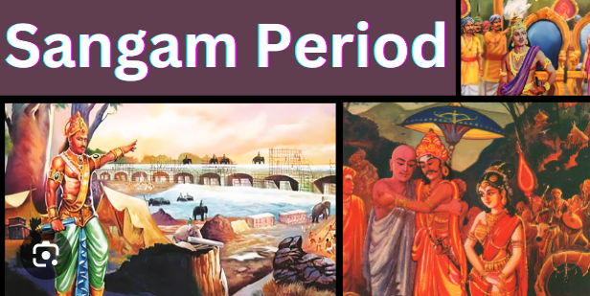

Submitted to: Manjula mam

Signature

ENGLISH PROJECT

Name: Nathasha.B.Deelok

Class: 9B

Topic: Julius Ceasar

Submitted on: 22-05-2024.

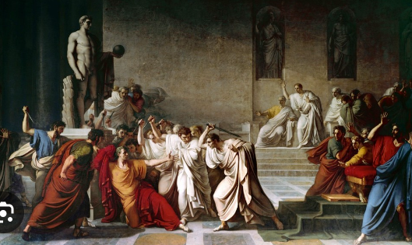

Submitted to: Vidya Kamat Mam

Signature: