**Learning Team Communications**

The collaborative Learning Team experience is an integral part of the University of Phoenix learning model. You can see what team you are on and who the other team members are by clicking the **Learning Teams** tab in the Class Roster. The Learning Team roster displays names, contact information, and location.

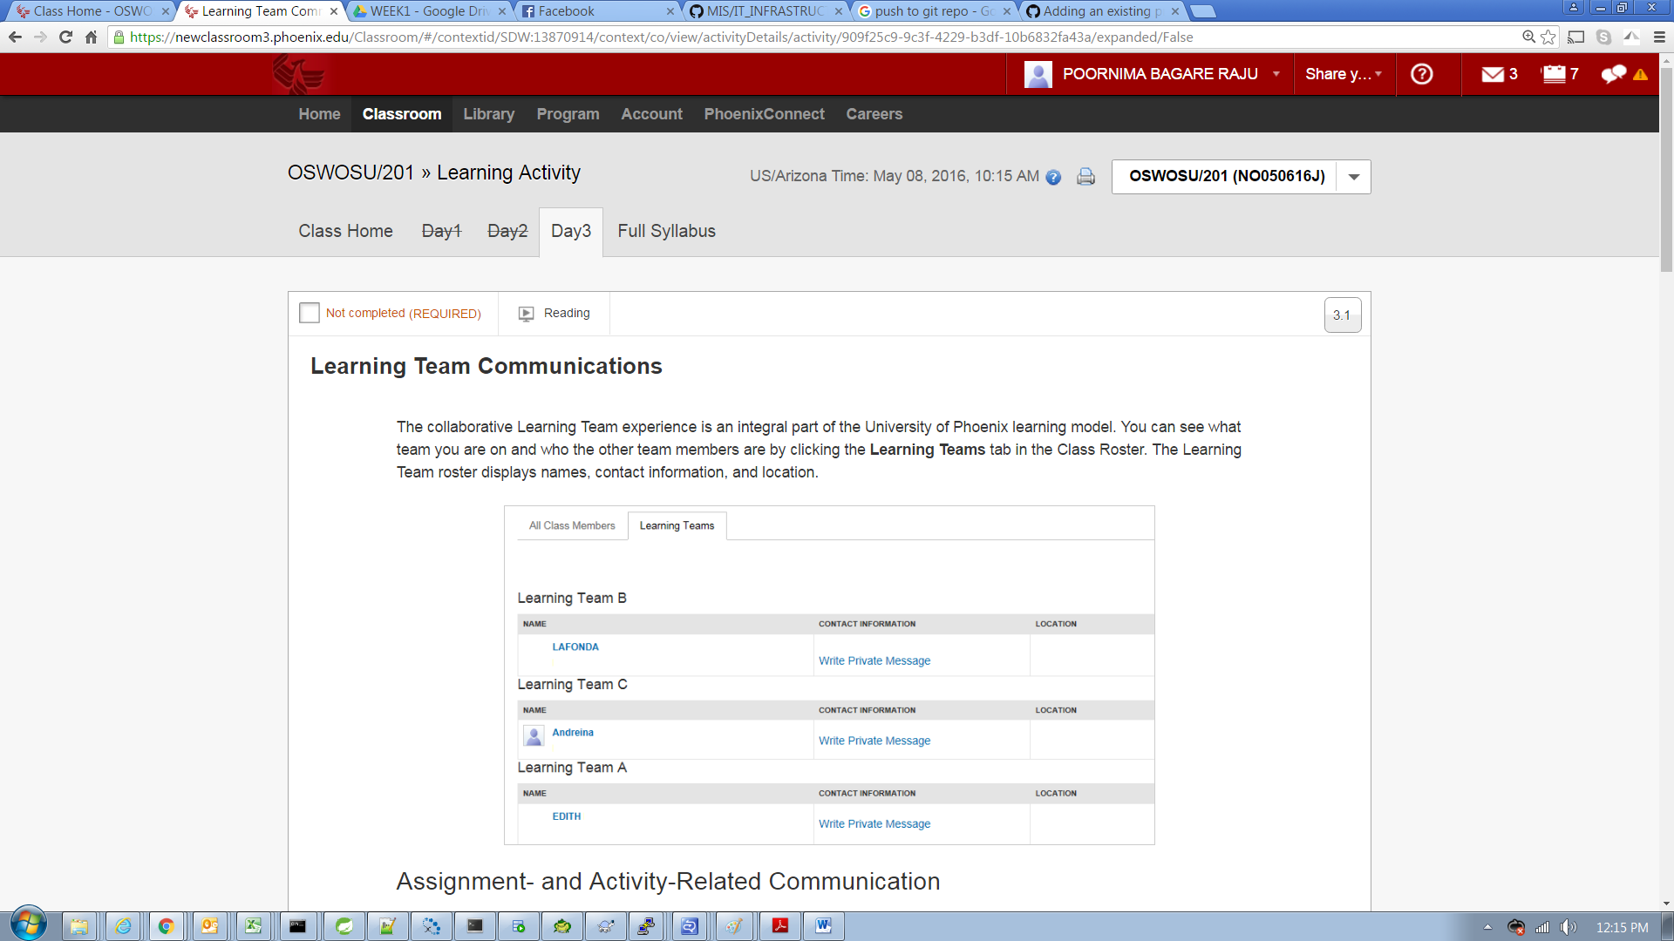

## Assignment- and Activity-Related Communication

Following the object-based discussion model, Learning Teams meet, communicate, and participate in the assignment streams and activity streams that are designated as Learning Team assignments and activities.

Teams no longer need to worry about forum organization and threading. Instead, team members simply navigate to the Learning Team assignment or activity due for the week and begin their discussion and communication in that activity stream. Students can share files with the team by uploading files in the discussion area for the assignment or activity. Each team member can download a copy of the shared file for further editing or discussion.

In the Online Learning System classroom, students could see all activity in the Learning Team forums, including another team’s activity. Students can only see the Learning Team activity for the team they are assigned to.

## Nonassignment and Nonactivity Communication

Individuals in Learning Teams may want to communicate about things unrelated to weekly assignments and activities, such as schedules or general questions. Team members can use the productivity tools located on the right side of every page for nonassignment and nonactivity communication.

Team members have easy access to e-mail and chat using the productivity tools. Clicking any of the icons will display a drop-down menu for the selected item. The Productivity Tools menu can be seen and accessed from every page on eCampus.

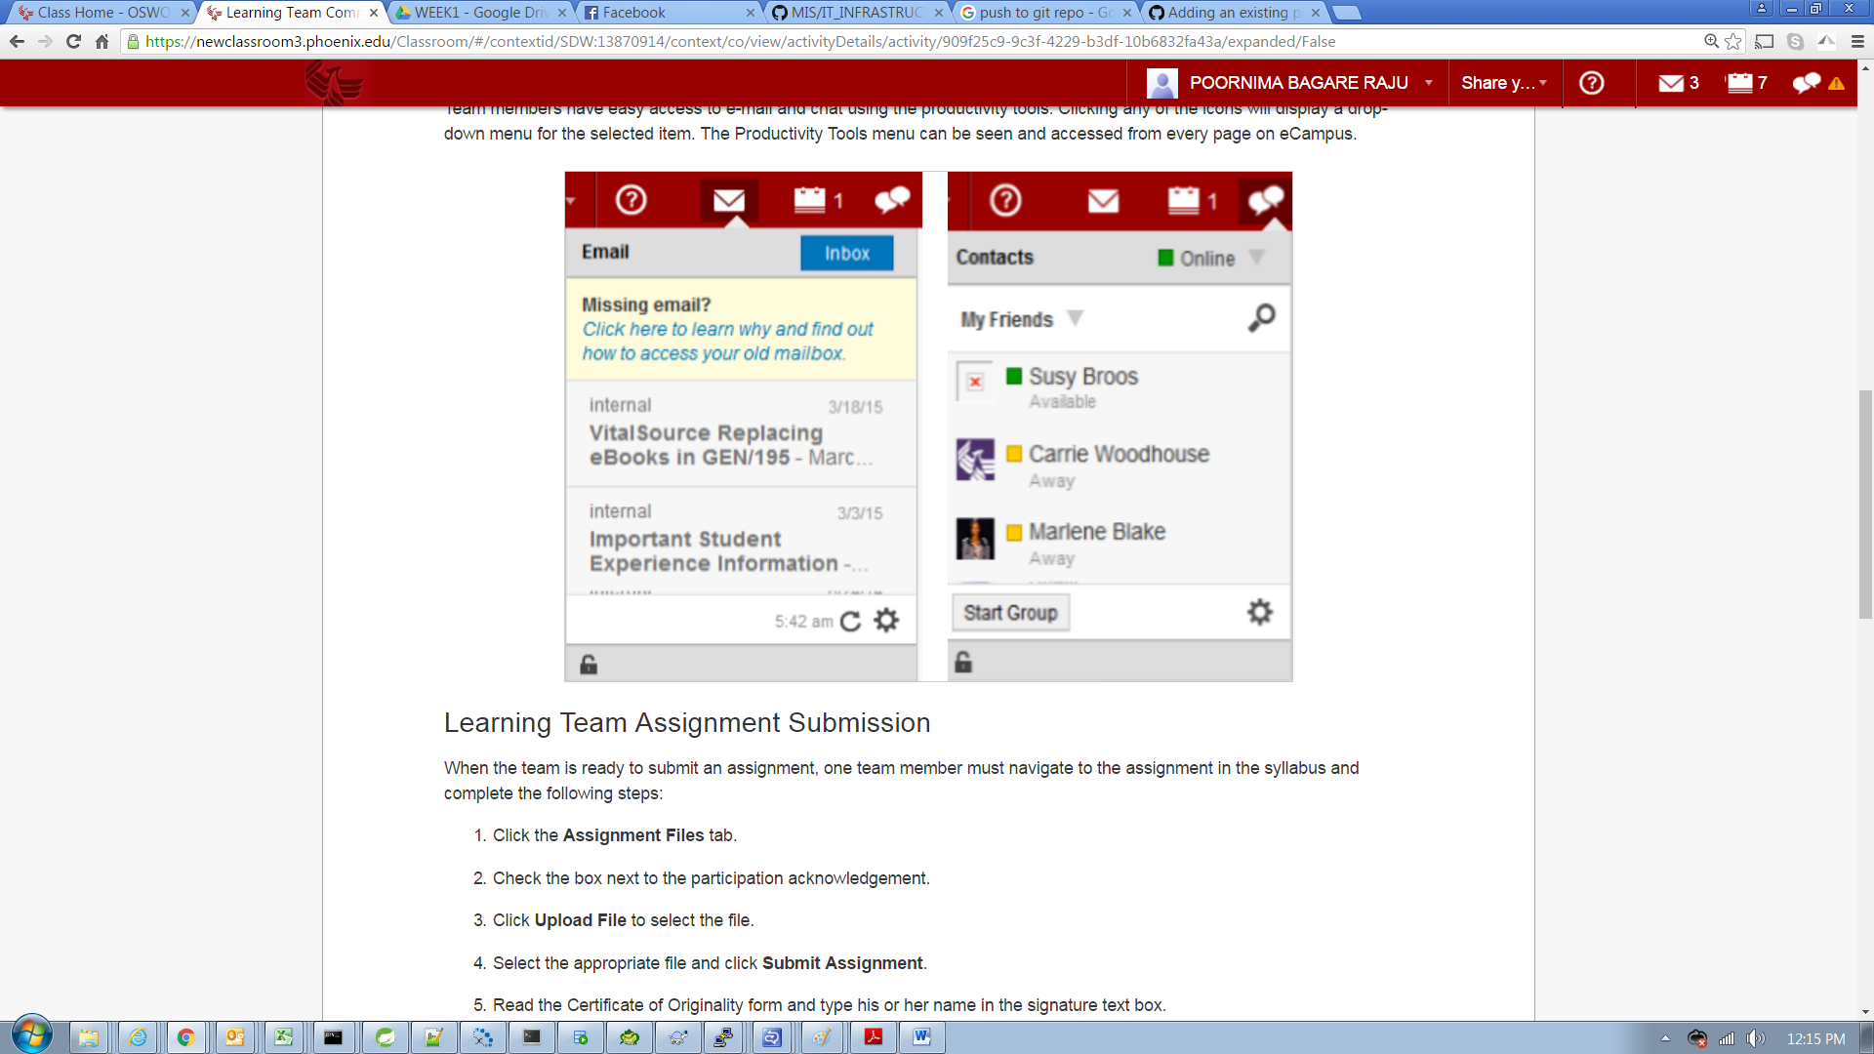

## Learning Team Assignment Submission

When the team is ready to submit an assignment, one team member must navigate to the assignment in the syllabus and complete the following steps:

1. Click the **Assignment Files** tab.
2. Check the box next to the participation acknowledgement.
3. Click **Upload File** to select the file.
4. Select the appropriate file and click **Submit Assignment**.
5. Read the Certificate of Originality form and type his or her name in the signature text box.
6. Click **Complete Submission** to finalize the assignment submission process.

Team members can view their submission status and feedback in the Feedback tab.