**Learning Team Frequently Asked Questions**

## Where do I see which team I'm on?

Select the **Learning Teams** tab in the Class Roster to find your team and teammates.

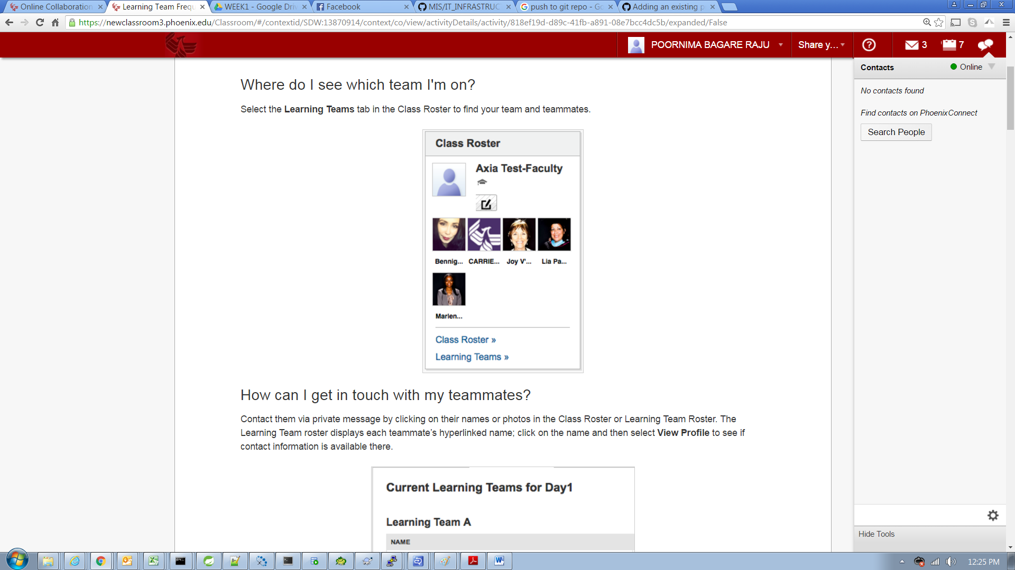

## How can I get in touch with my teammates?

Contact them via private message by clicking on their names or photos in the Class Roster or Learning Team Roster. The Learning Team roster displays each teammate’s hyperlinked name; click on the name and then select **View Profile** to see if contact information is available there.

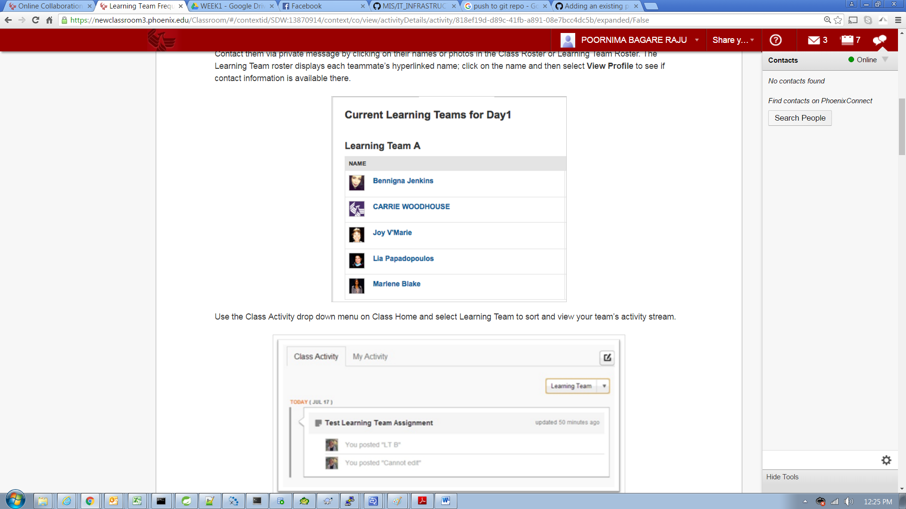

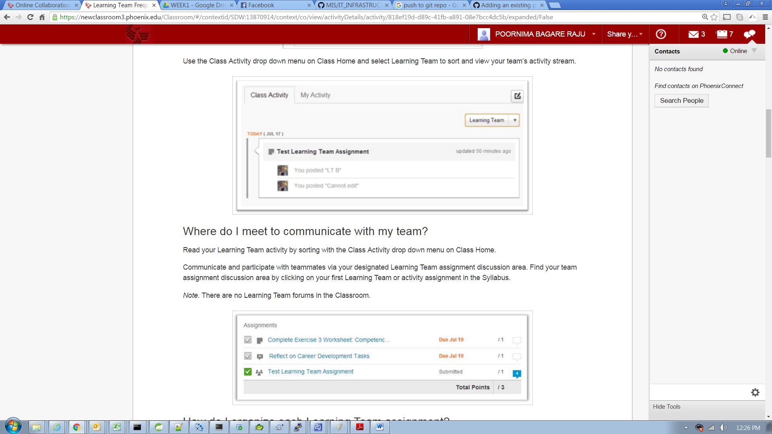

## How do I organize each Learning Team assignment?

Navigate to the Learning Team assignments or activities due for the week via the Syllabus, and begin your discussion and communication under that activity or assignment’s discussion area. Teams do not need to worry about forum organization and threading.

Upload documents and graphics to share with your team by attaching them to the activity’s or assignment’s discussion area. Each team member can access the file by downloading a copy of the shared file for further editing or discussion.

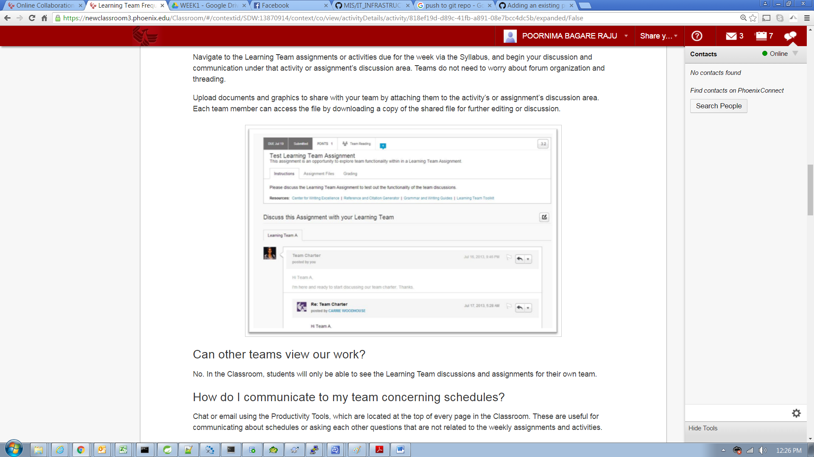

## Can other teams view our work?

No. In the Classroom, students will only be able to see the Learning Team discussions and assignments for their own team.

## How do I communicate to my team concerning schedules?

Chat or email using the Productivity Tools, which are located at the top of every page in the Classroom. These are useful for communicating about schedules or asking each other questions that are not related to the weekly assignments and activities.

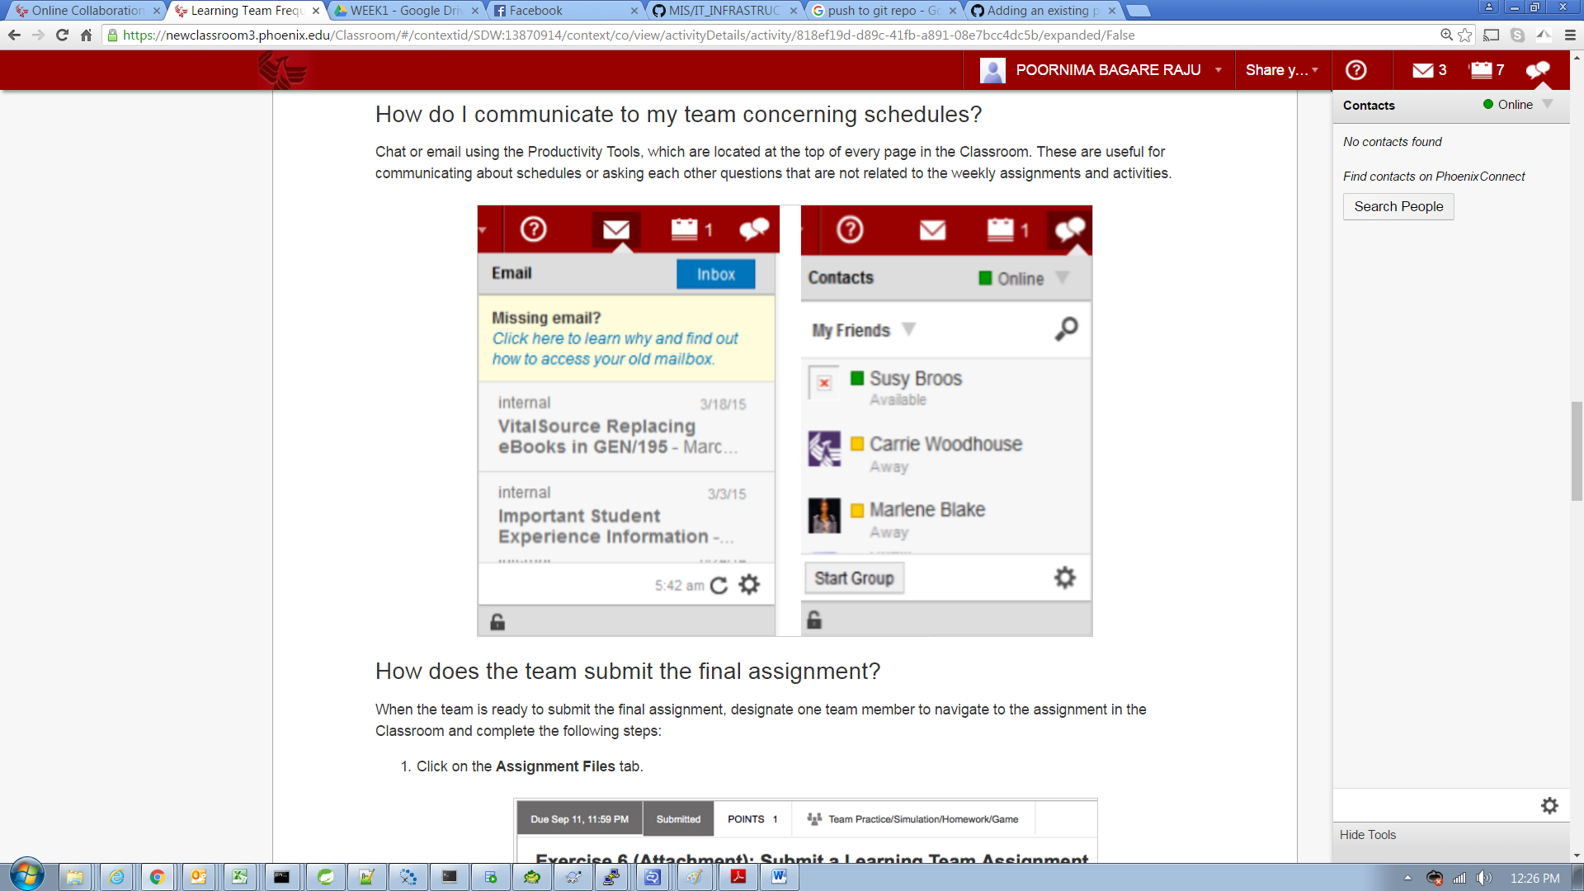

## How does the team submit the final assignment?

When the team is ready to submit the final assignment, designate one team member to navigate to the assignment in the Classroom and complete the following steps:

1. Click on the **Assignment Files** tab.

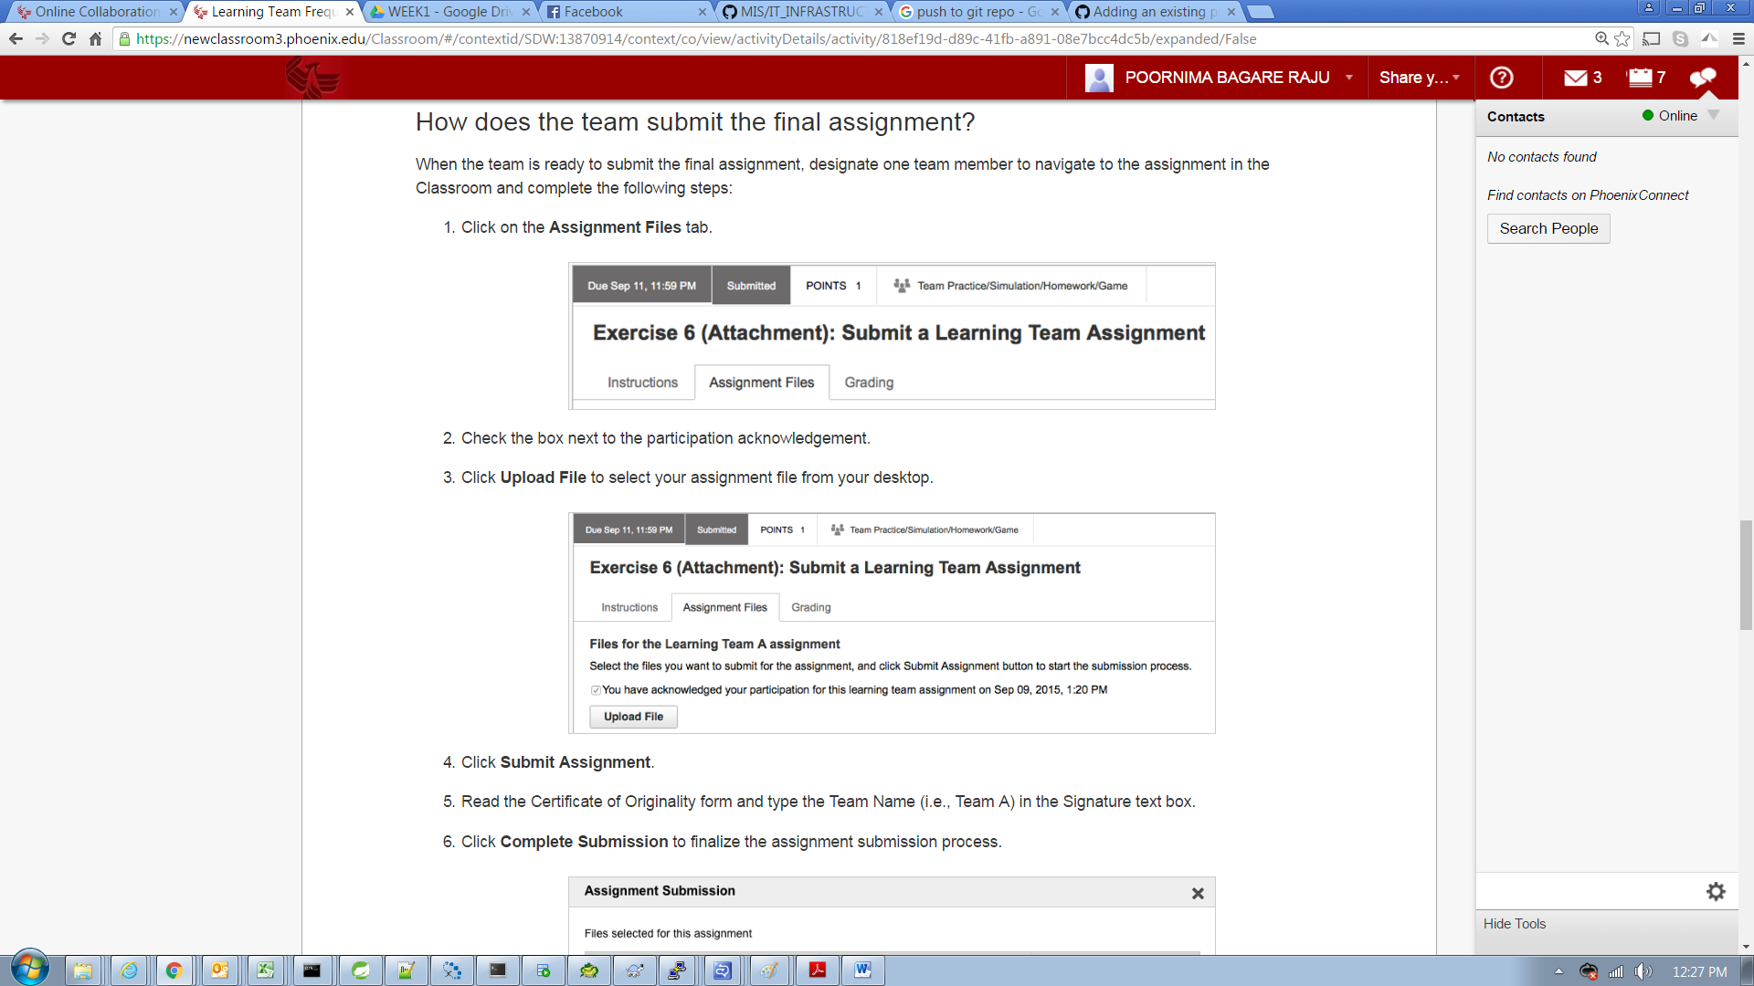

1. Check the box next to the participation acknowledgement.
2. Click **Upload File** to select your assignment file from your desktop.  
   
3. Click **Submit Assignment**.
4. Read the Certificate of Originality form and type the Team Name (i.e., Team A) in the Signature text box.
5. Click **Complete Submission** to finalize the assignment submission process.  
    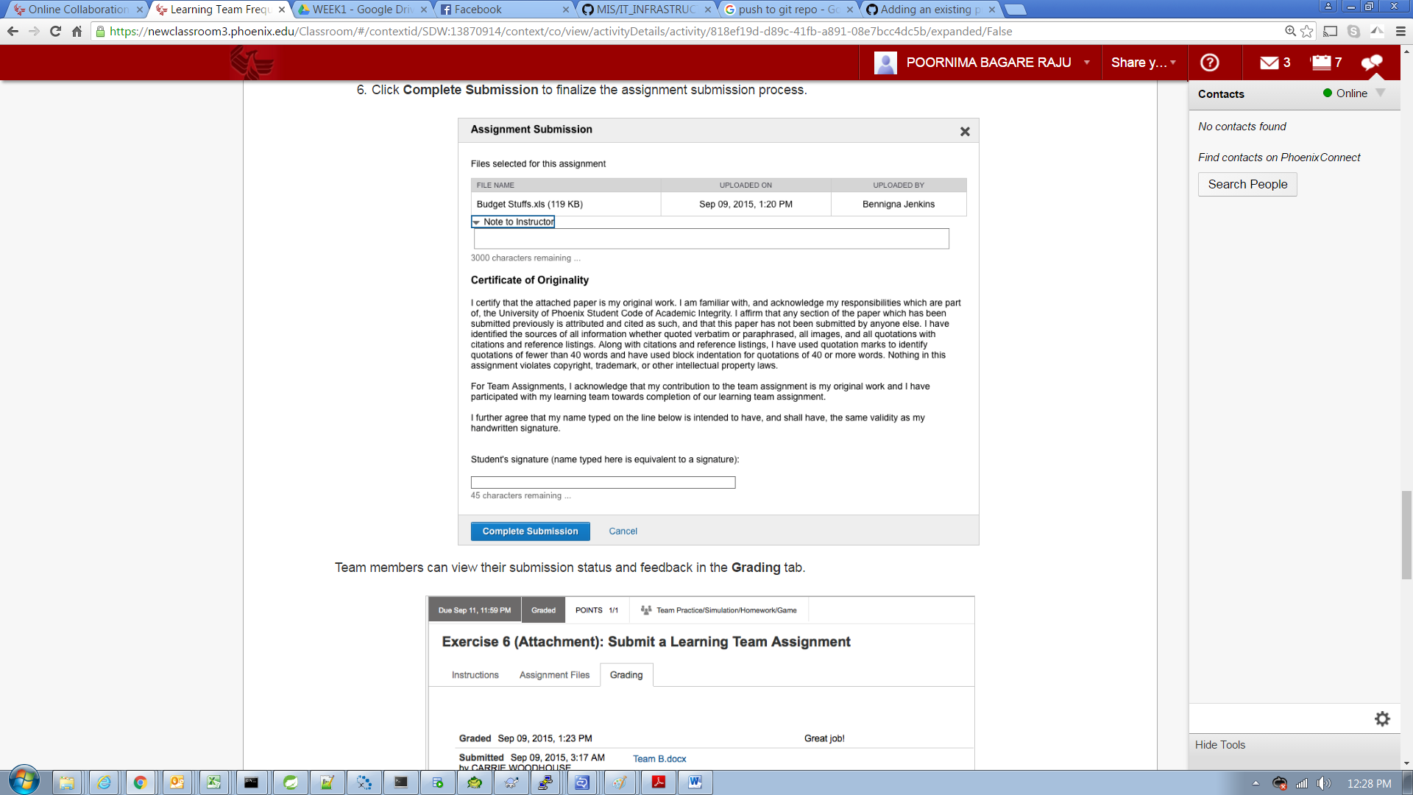

Team members can view their submission status and feedback in the **Grading** tab.

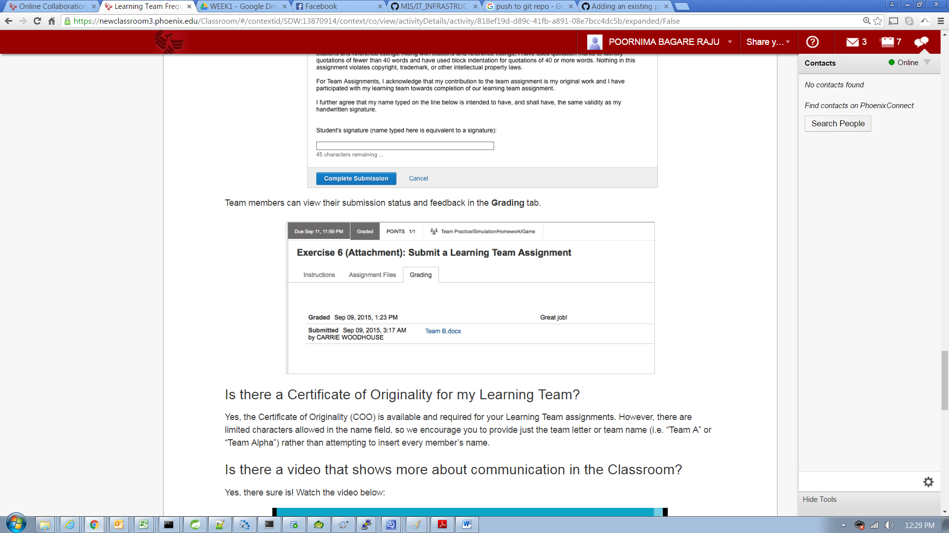

## Is there a Certificate of Originality for my Learning Team?

Yes, the Certificate of Originality (COO) is available and required for your Learning Team assignments. However, there are limited characters allowed in the name field, so we encourage you to provide just the team letter or team name (i.e. “Team A” or “Team Alpha”) rather than attempting to insert every member’s name.

## Is there a video that shows more about communication in the Classroom?

Yes, there sure is! Watch the video below: